TCI & THE HEMP INDUSTRY
SUBMISSION TO THE PRODUCTIVITY COMMISSION ENQUIRY ON AGRICULTURE
PRESENTED BY
CHARLES B. KOVESS LL.B. (HONS), LL.M., CSP, MAICD
CEO & INTERNATIONAL MARKETING DIRECTOR
COMMITTEE MEMBER, AUST INDUSTRIAL HEMP ALLIANCE

www.textilecomposite.com.au

RE-ENERGISING AND REVITALISING THE HEMP INDUSTRY
(AND OTHER BAST CROPS SUCH AS FLAX, KENAF AND RAMIE)
& CREATING NEW AGRICULTURAL AND
ECONOMIC GROWTH POSSIBILITIES

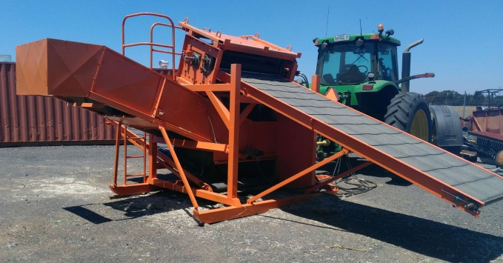
USING A PATENTED ‘DECORTICATOR’ MACHINE THAT SIGNIFICANTLY REDUCES THE COST OF PROCESSING HEMP & OTHER BAST CROPS FROM THE FIELD

DEVELOPED BY TEXTILE & COMPOSITE INDUSTRIES PTY LTD, AN AUSTRALIAN COMPANY

- New, fascinating and profitable applications for one of the world’s oldest materials.
- Eco-friendly, low water usage, minimal weed problems, removes carbon from the atmosphere, rejuvenates land.
- Can supplement cotton or replace it in quality garment manufacture.
- Can be used in building products, cosmetics, health products, paper and apparel amongst many other applications.
- With TCI’s Australian technology, the cost of processing is brought down to commercial levels – a world breakthrough!
- Legal in most countries around the world – industrial hemp contains insignificant levels of the hallucinogenic THC that is the psycho-active chemical present in marijuana.

INTRODUCTION
Textile & Composite Industries Pty Ltd (“TCI”), an Australian Company, has developed, under a patent licence, a revolutionary machine for efficiently extracting high-quality and valuable fibres from industrial hemp, and other bast crops such as flax, kenaf and ramie.
This exciting, challenging and valuable development process has required the investment of significant time, money and energy since 1994. Many obstacles have been faced and overcome.
TCI’s innovative technique has been demonstrated and proven over several years of field trials in Australia, United Kingdom, Italy, China, and Canada. It has consistently produced a new type of grown cellulose fibre which is superior in quality and strength to any other natural fibre.
TCI’s technique reduces the cost of processing and production significantly.
Industrial hemp is not marijuana and is not hallucinogenic. It is legal to grow it in Australia and over 100 countries. It is not yet legal to grow industrial hemp in USA, but it is legal in Canada. There is significant lobbying occurring in the USA to reverse the 1937 Federal laws that prohibit the growing of industrial hemp. To date, at least 30 states in the USA have legalised hemp farming.

The TCI Decorticator Machine and patents
A series of prototype decorticating machines have been built to prove concepts and develop the technology to the point of commercialisation, and TCI is now actively marketing the capabilities of its revolutionary decorticating machine to farmers and agricultural cooperatives and organisations all around the world.
The machine is ready to be manufactured to order, by contracted engineers in Australia, New Zealand, and Hungary for use in respective markets.
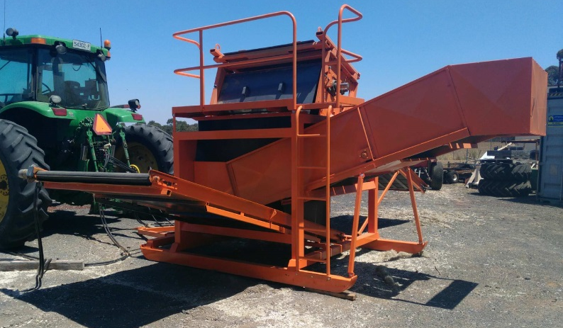
The patents protect TCI’s unique and revolutionary process that decorticates hemp stems and other bast crops while green or from dry sheaves, without the need for costly, damaging and time- consuming ‘retting’. ‘Retting’ is a word derived from the Dutch word that means ‘rotting’; until now, the process for separating fibre from the core has been via a rotting process of the crop that badly damages the crop and reduces the available fibre and hurd for commercial use by up to 80%. This is why hemp fibre has been so expensive compared to cotton and synthetic fibres, and why most hemp fibre has lost its natural strength, thereby restricting its use in composite materials.
The technology has been tested and proven and shows that the TCI method and technology extracts the fibre from the hemp plants in a fraction of the time taken by other methods. The method produces a much higher quality and larger quantity of fibre and that fibre is a much more valuable hemp fibre than traditional methods can produce. The hurd (‘core’) produced is also of a higher quantity and quality, and therefore also more valuable.

A new sustainable agricultural economic boost
TCI, in conjunction with its development partners and international agents, is promoting the growing of hemp and other bast crops, is licensing its decorticating technologies and is helping growers to best manage the production, distribution and marketing of fibre, hurd, and hemp seed and grain products through advice and market knowledge.
TCI’s business activities are promoting environmentally sound and sustainable development policies and policies that encourage employment in rural areas and the creation of new economic development possibilities, including the manufacture and distribution of hemp and other bast crop products as close as possible to the area of production.
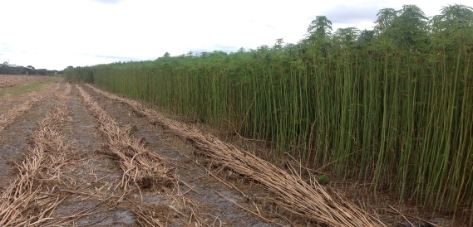
To increase the willingness of farmers to ‘take the leap’ and plant industrial hemp, TCI is willing to guarantee a ‘floor price’ for all hemp processed by its decorticator machine. TCI will buy all such hemp from anywhere in the world at a price that generates an adequate return and protects the grower from unsaleable product. TCI will also be contracting farmers to grow industrial hemp. TCI will harvest and process the crop, sell the fibre, hurd and seed, and pay the farmer.

A key benefit of hemp production is that it does not need any toxic herbicides, pesticides, or other artificial farm chemicals, unlike cotton, and is close to a perfect product for Organic and Biodynamic farm production. Some drier countries, such as Australia, do require irrigation, at a rate of approximately one to two megalitres of water per hectare, depending on rainfall.
A number of Governments around the world are starting to see the economic advantages of the hemp industry and are supportive of TCI in its vision in various practical ways.
At this stage, Australian farmers are most likely to be involved in growing industrial hemp, harvesting it with the TCI process, and then sending the fibre overseas for textiles processing. It is hoped that fibre can eventually be processed for textiles in Australia. The fibre can also be used in Australia immediately for manufacturing composite materials, replacing fibreglass and, in some cases, expensive carbon fibre.
The hurd can be used in Australia for many applications, including in the building industry, paper manufacture, and for the best possible horse bedding material. Her Royal Highness, the Queen, is reported as only permitting hemp hurd to be used as bedding for her thoroughbred horses!

The value of hemp and other bast crop fibres
The separated fibre is suitable for a range of uses including high quality textiles, apparel textiles and blending fibres as well as industrial fibres, fibre-glass replacement, carbon fibre replacement, building products and specialised paper fibres.
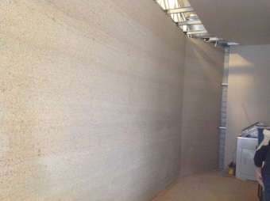

HEMP as fibre-glass replacement
HEMP WALL ON
LOCATION IN BALLAN

Since the invention of the Cotton Gin in the 1750’s, it has been difficult for hemp fibre to compete commercially with cotton. TCI’s new technology fundamentally changes this scenario. This new technology and its lower cost base will allow enterprises in any part of the world to grow and convert fibre locally for the global fashion market and will give them the ability to regain market share lost to Asian production.
TCI’s unique and revolutionary technology allows cost-effective and efficient production of both textiles and composite materials using quality hemp fibre. The process is fully-controlled and virtually instantaneous, unlike the traditional ‘retting’ methods which are wholly subject to weather conditions over many weeks. Growers using the TCI process will be in a position to provide the market with consistent quality and reliable deliveries. See the pictures referred to in the Appendix.
Output samples have been generated to prove the efficacy of TCI’s process – including fibre, yarn, and woven and knitted pieces of cloth and articles of clothing. In addition, non-woven samples have been produced via needle punching, which would be perfect for naturally anti-bacterial bandages. These samples further demonstrate the value of TCI’s technology.

Global markets for cotton and fibres
The global market for fibre is approximately 89 million tonnes pa, of which cotton comprises 29 million tonnes. Land that can produce cotton is doing so; demand grows by 7% per annum and is met by synthetics due to cotton shortages. Hemp fibre extracted with TCI’s machines will service the annual natural fibre production shortfall. China’s demand for quality hemp fibre far outstrips current supply.
Unlike cotton, hemp and other bast crops are crops which can be grown in Europe, thus generating urgently needed jobs and industries.
Major findings of independent university studies show:
1. The TCI decorticator demonstrated good separation of bast fibre material. The relative quantities of plant components produced were very similar to a careful manual separation.
2. Projections suggest a TCI machine with 500 BHP installed power could reduce the cost of hemp fibre production to prices comparable to cotton.
Hemp produced in the traditional way costs between four times and 10 times the cost of cotton, so TCI’s technology significantly improves the economics of this industry by producing it close to parity.

TCI’s patented decorticator machine
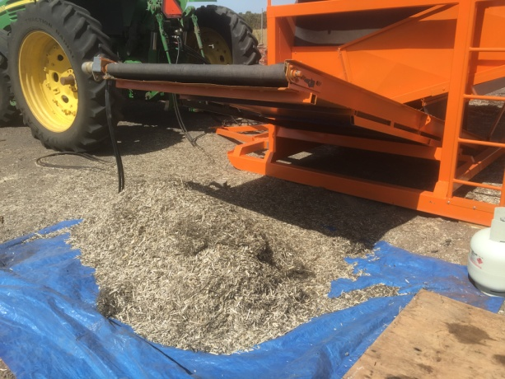
There is one model machine using TCI’s technology that is available, the D8. This machine is pictured in this White Paper.
The D8 Decorticator is a static machine that is conveyor fed. See the pictures referred to in the Appendix.
The D8 is mounted on skids and can be towed by tractor to the slashed crop. It is powered by the hydraulics of the tractor, which needs to be at least 120 hp. Workers then feed the stems on to the conveyor that feeds into the machine and then handle the two output streams of material - the hurd and the fibre. It is as fast as it can be practically hand fed, and TCI considers that throughput of between one to two tonnes per hour is achievable.
Alternatively, the D8 can be stationed at a central point, and nearby hemp farmers can bring their harvested stems to the Decorticator for processing. This type of arrangement would be particularly attractive to Canadian hemp seed producers with ‘waste’ hemp stalks, and US marijuana growers with ‘waste’ stalks. The machine is as fast as it can be hand fed, or conveyor fed. With good materials handling systems and logistics, TCI considers that the D8 can process up to five tonnes per hour. Remember that if five tonnes is fed in, five tonnes must come out!
The D8 Static system works on green and dry sheaves and also hemp seed producing varieties. This fibre is stronger than fibre glass, and is capable of replacing both fibreglass and carbon fibre in many products.
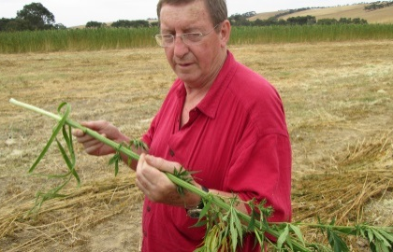
Hemp fibre in its best condition is fresh and green standing in the field. When decorticated with the D8, it produces the strongest fibre which has been evaluated by Aeronautical Engineers as similar in strength to the most costly manmade fibre of all: carbon fibre. Carbon fibre sells for around US$22 per kg or US$10 per pound, and the TCI green harvested fibre can replace carbon fibre in many products.

The output from the use of this machine has immediate valuable application. The hurd is ready for hempcrete and building materials, as well as ethanol, horse bedding, paper and other uses. The fibre can be used in composites without degumming.
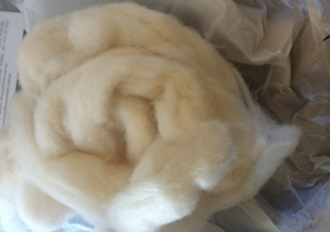
UNDEGUMMED FIBRE DEGUMMED FIBRE

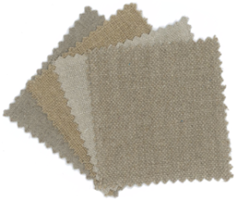
The fibre can be degummed in a Dye Works kier and associated machinery as shown in miniature on the website mentioned below. This step is required to utilise the fibre for textiles.

The whole process can be mechanised to produce a fibre which can be spun and woven on standard cotton systems into quality textiles for apparel and furnishings.
A turnkey system to progress from field to textiles has been designed by TCI and will create fibre with a value of approximately $35,000/tonne as cloth. This process will include degumming, spinning and weaving. The return on investment is attractive. The economic development opportunities, particularly job creation, for rural areas is worthy of examination.

Additional Resources:
Industrial hemp applications related videos: visit the TCI website: www.textilecomposite.com.au

17 August 2016

APPENDIX
The TCI Decorticator Technology Presentation is available upon request. It is a 56MB power point presentation that explains in pictures the hemp journey from the field through to value-added products.
See also the demonstration video of the D8 in action in Australia, at youtube.com/watch?v=nUL5P3NB1hg&feature=youtu.be

