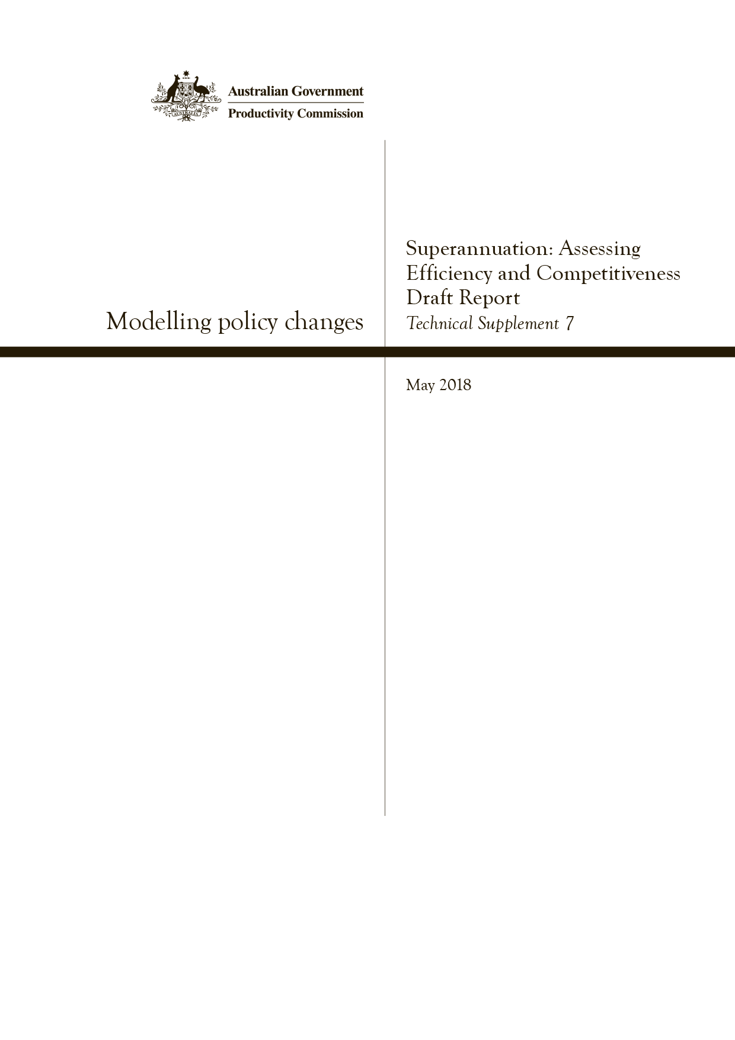
Modelling policy changes
Technical Supplement 7, Superannuation: Assessing Efficiency and Competitiveness, Productivity Commission Draft Report, May
Superannuation: Assessing Efficiency and Competitiveness, Productivity Commission Draft Report
Commonwealth of Australia 2018
Except for the Commonwealth Coat of Arms and content supplied by third parties, this copyright work is licensed under a Creative Commons Attribution 3.0 Australia licence. To view a copy of this licence, visit http://creativecommons.org/licenses/by/3.0/au. In essence, you are free to copy, communicate and adapt the work, as long as you attribute the work to the Productivity Commission (but not in any way that suggests the Commission endorses you or your use) and abide by the other licence terms.
Use of the Commonwealth Coat of Arms
Terms of use for the Coat of Arms are available from the Department of the Prime Minister and Cabinet’s website: https://www.pmc.gov.au/government/commonwealth-coat-arms
Third party copyright
Wherever a third party holds copyright in this material, the copyright remains with that party. Their permission may be required to use the material, please contact them directly.
Attribution
This work should be attributed as follows, Source: Productivity Commission, Modelling policy changes, Technical Supplement 7.
If you have adapted, modified or transformed this work in anyway, please use the following, Source: based on Productivity Commission data, Modelling policy changes, Technical Supplement 7.
An appropriate reference for this publication is:
Productivity Commission 2018, ‘Modelling policy changes’, Technical Supplement 7 to the Draft Report Superannuation: Assessing Efficiency and Competitiveness, Canberra, May.
Publications enquiries
Media, Publications and Web, phone: (03) 9653 2244 or email: mpw@pc.gov.au

The Productivity Commission
The Productivity Commission is the Australian Government’s independent research and advisory body on a range of economic, social and environmental issues affecting the welfare of Australians. Its role, expressed most simply, is to help governments make better policies, in the long term interest of the Australian community.
The Commission’s independence is underpinned by an Act of Parliament. Its processes and outputs are open to public scrutiny and are driven by concern for the wellbeing of the community as a whole.
Further information on the Productivity Commission can be obtained from the Commission’s website (www.pc.gov.au).

Technical supplement 7: modelling policy changes
This technical supplement describes the data and assumptions used by the Commission in modelling the potential effects on superannuation funds of the adoption of the assisted employee choice model (chapter 12) and an elevated threshold for MySuper authorisation (chapter 13). The model projects how the number of MySuper member accounts and MySuper assets might change for each fund in the five years following the introduction of the new arrangements. The intention of the model is to test whether the policy changes recommended for the default system present any system stability risks because of asset movements those policy changes may induce in the MySuper segment. It does not cover fund assets outside of MySuper.
The Commission asked the Australian Prudential Regulation Authority (APRA) to review its approach to modelling the potential impacts of alternative default models and APRA confirmed that the methodology and underlying assumptions were reasonable and consistent with APRA’s understanding of the industry. However the views and conclusions in the report based on the modelling undertaken are solely those of the Productivity Commission.
The model allows for three categories of MySuper product — those that:
- are included in the ‘best in show’ shortlist
- lose default status as a consequence of the elevated MySuper threshold
- retain default status, but are not on the shortlist.
The model also enables testing of the potential impacts on individual funds of different shares of new workforce entrants, and job changers, workforce re-entrants and other existing members choosing or switching to a shortlisted product.
Consistent with the assisted employee choice model:
- new workforce entrants who do not choose a fund are allocated sequentially to shortlisted products
- job changers and workforce re-entrants stay with their existing fund if they do not choose a fund on starting a new job.
The data underpinning the projections were drawn from annual MySuper statistics published by APRA for 2017. Data on net investment returns informed the assumptions on the up to 10 funds that were shortlisted for the ‘best in show’ list under the proposed new default arrangements and the assumption on which funds would likely lose MySuper authorisation and thus default status. Data on the number of MySuper member accounts held by each fund were used in projecting account numbers per fund under the assisted employee choice model. The projections drew on the assumptions detailed below (table 7.1 and following text). These projections were then used to project annual rollovers out of each non-shortlisted fund and into shortlisted funds. And the member account projections were combined with 2017 MySuper data for each fund on employer and member contributions, net insurance flows, operating expenses and non-operating expenses to project these quantities. Further to the movement of member accounts due to the new default arrangements, other projections were used to estimate the change from year to year in each fund’s MySuper assets. These include: funds’ investment expense ratios to estimate investment expenses and net earnings were calculated assuming a tax rate of 15 per cent.

Table 7.1 Values assumed for different elements of the model
Assumptions | Value taken
Annual growth in: | (%)
New workforce entrants | 2
Job turnover and workforce re-entrants | 2
Exits of members from MySuper products | 5
Wages (nominal) | 3
Annual share of each group that chooses/switches to a shortlisted product:a | (%)
New workforce entrants | Up to 90
Job changers and workforce re-entrants | Up to 70
MySuper members (who are not starting a new job) | Up to 10
Choice members in MySuper products that lose default status | 50
Default members in MySuper products that lose default status | 100
Annual rate of: | (%)
Inactive accounts that are voluntarily consolidated to a shortlisted product | Up to 10
Investment income | 5
Mobility among membersb
High | 17.8
Medium | 13.5
Low | 8.9
Number of: | (no.)
First-time entrants in year preceding system modernisation | 470 000
People retiring and exiting MySuper accounts per year | 32 520c
Accounts held per member at the point of retirement | 1.2
Lost and inactive accounts transferred to the Australian Tax Office | 0

a Values preceded by ‘Up to’ are the highest rates used in sensitivity testing the modelling. b The estimated level of mobility among a fund’s members (due to both job change and workforce re-entry) was based on the share of its members aged 25 and under on the assumption that a younger membership would tend to be more mobile. Rates of job change were drawn from ABS (2017) and inflated to take account of workforce re-entry. c Estimated as 40 per cent of the total number of retirees in the 12 months to February 2017 from ABS (2017).
Source: ABS 2017 (Participation, Job Search and Mobility, Australia, February 2017, Cat. no. 6226.0.)
Additional key assumptions:
- Potential movements of members between MySuper products and other segments of the system are ignored. (An implicit assumption is that such moves offset each other.)
- Job changers and workforce re-entrants who choose a shortlisted product roll over their existing balance to their new account, as do existing MySuper members who switch but are not starting a new job.
- Member numbers are proxied by active accounts (taking into account the fact that some members retain multiple active accounts).
- People are assumed to exit MySuper products for retirement from age 60 years.
- Super Guarantee contributions of default members in MySuper products that lose default status are transferred to shortlisted funds as soon as a product loses authorisation.
- Each closed account removes the average MySuper account balance from a fund’s assets.

Data on longer-run and shorter-run net investment returns delivered similar broad conclusions.

