Submission to the Productivity Commission Inquiry into the
National Education Evidence Base

Social Ventures Australia
May 2016
For further information please contact:
Patrick Flynn
Director Policy and Advocacy

Table of Contents

Executive Summary 3
Summary of Recommendations 5
Introduction 7
Social Ventures Australia 8

Evidence for Learning 11

Response to the Issues Paper 13
Section 1: What has the Commission been asked to do? 18
Section 2: Objectives and framework 23
Section 4: Issues and Opportunities 44
Section 5: Institutions, data governance and
prioritising reform 50

Executive Summary

The goals of Australia’s education system have been articulated and refined over many years to include the development of the intellectual, social and moral wellbeing of young Australians as well as contributing to the economic prosperity and social cohesion of the nation. Funding for education has also increased substantially over the previous two decades. Yet against most international measures, Australia’s education performance has gone backwards.
Against that backdrop, the purpose of an education evidence base and any changes to the current data, research and evidence systems must be to improve educational outcomes of Australia’s children.
To achieve this it is essential to grow a thriving and dynamic evidence ecosystem. The ecosystem must allow for active monitoring of improvements and deteriorations in learning outcomes. However, monitoring is insufficient. The ecosystem must also create a virtuous cycle of innovation in schools and the broader education systems where successful approaches are adopted with fidelity and poor performing initiatives are wound down.
A healthy ecosystem requires the production of different kinds of data and evidence, synthesis and translation of this evidence for use by teachers and principals in schools and support for continuous evaluation and improvements in practice.
At present, several key elements are missing.
Whilst there are many factors that contribute to a child’s educational achievement - including the profound impact of a child’s home environment - the most significant in-school factor is the quality of teaching in the classroom.
An exceptional teacher, equipped with the most effective programs, has a far greater impact on student learning than an ineffective teacher. Over several years of schooling, this can make a substantial difference to a student’s chance of success in life and contribution to society.
To build a ‘world class education system’, Australia needs an evidence base with robust data on the efficacy of different educational approaches that is accessible to all school leaders and teachers and which they use to change daily practices in classrooms.
This led us to make three primary recommendations to the Inquiry which are supported by a list of specific actions in the Summary of Recommendations.
Design the future evidence ecosystem -
That the Productivity Commission (PC) should make findings and recommendations on the structure of an effective education evidence ecosystem, including identifying the roles and responsibilities of different institutions and agencies in the production, storage, synthesis, dissemination and adoption of education evidence, as well as an explicit role for frontline professionals implementing and evaluating the learning impact of approaches.
Testing ‘what works and why’ in schools and early learning centres is essential to improvement -
That data gathered (whether administrative, qualitative or quantitative, universal or a sample), should be designed to support research and evaluation of the efficacy and efficiency of approaches used in schools and early learning environments. This includes through rigorous evaluations using experimental methods such as randomised controlled trials (to understand the ‘what’) paired with robust secondary analysis and crucial qualitative information (to understand the ‘why’).
Only evidence in action has impact -
That adequate support is given to the effective engagement with the evidence base by frontline professionals who are ultimately responsible for realising the learning dividends from the investment. This means evidence is translated into useful forms including guidelines for effective implementation, is promoted through networks trusted by educators and is continuously evaluated for impact in their context.
Social Ventures Australia seeks to play a constructive role in the collective endeavour of building a national education evidence base to improve education outcomes.
We are actively building and sharing evidence about effective policies and programs with school leaders and teachers, through a new social enterprise; Evidence for Learning (E4L). E4L provides free, online summaries of global education evidence through the Teaching & Learning Toolkit and supports the creation of rigorous evidence via randomised controlled trials on programs in schools through its Learning Impact Fund. E4L is well supported in this endeavour by the successful UK Educational Endowment Foundation, which was funded by the UK government, and E4L is also supported by the Commonwealth Bank.
We hope to be a valuable contributor to the efforts of the Commission to improve the data and evidence landscape in Australian education. We are keen to share our expertise and experiences with the Commission to support this Inquiry and would welcome opportunities to engage the Commission over the course of the Inquiry.

Summary of Recommendations

Scope of the Inquiry
The Commission should:
- Adopt a broad interpretation of the scope of the evidence base including data on children younger than 4 years old whether in early childhood education and care programs or not, and young people outside the formal school sector; and
- Consider including school based assessment data and administrative processes coming from new sources outside of traditional school providers.

Objectives and Framework
The Commission should:
- Expand the focus of the Inquiry and include a consideration of the “educational research literature (particularly with respect to analyses of ‘what works’ in teaching and learning in schools)”. Such expansion is essential to adequately define the types of data required to understand ‘what works and why’ and how best to promote this knowledge to practitioners so that we realise the benefits of an investment in a national education evidence base;

- Adopt a broad definition of the national education objectives consistent with those in the Melbourne Declaration to enable young Australians to “become successful learners, confident and creative individuals, and active and informed citizens”;

- Define the ‘education evidence base’ and ‘education data’ broadly in order to:
- Include data collected through rigorous program evaluations (such as randomised control trials - RCT) on both quantitative learning outcomes and qualitative conditions and capabilities to answer questions on ‘what works and why’
- Include data on emerging characteristics such as ‘21st Century Skills’ and non-cognitive skills as measures and instruments improve
- Include data on contextual factors that influence student outcomes (e.g. student background factors) and other ‘external determinants’
- Include data on ‘within-system determinants’ such as teacher and school leader capabilities with a particular focus on data relating to research and evidence use
- Include data on direct and indirect costs of program implementation

- Note the special opportunity that access to administrative datasets provides to reducing the costs of conducting RCT (both for primary measures and background characteristics).

- Include consideration of the costs and benefits of supporting ‘knowledge mobilisation’ to frontline professionals recognising this as a crucial investment in order to actually improve educational outcomes.

Issues and Opportunities
The Commission should:
- Consider an independent body to commission, conduct, report on and promote rigorous evaluations of school programs in the form of a ‘what works’ centre similar to those emerging in other countries.

- Consider requiring programs seeking government funding to submit themselves to an independent evaluation which is then published and freely available, thereby supporting a culture and standard of transparent, non-partisan evidence generation.

- Recognise the need for investment in knowledge translation and mobilisation through support for ‘implementation science’ and ‘improvement science’ models and subject proposed approaches to equally rigorous evaluations of impact and outcomes.

Institutions, data governance and prioritising reform
The Commission should:
- Give priority to those reforms that are expected to have the highest impact on the quality of teaching in the classroom

- Make recommendations to fill the research gap of experimental evidence on the learning impact of programs and approaches being used in schools

- Make recommendations to fill the ‘research use’ gap of evidence engagement and adoption by frontline professionals

Introduction

The importance of this Inquiry
Social Ventures Australia welcomes this Inquiry and the opportunity it creates for a comprehensive review of how Australia can “create a more robust national education evidence base for effective policy and program development to meet our national education objectives and lift our national productivity.” We are also encouraged that the terms of reference recognises the importance of identifying “opportunities to collectively invest further, and how we can improve the effectiveness of our investment through a more streamlined, comprehensive and collaborative national approach”.
Australia has had clear objectives for educational outcomes for a considerable length of time, including the Melbourne Declaration Goals that have been in place since 2008. These goals have been supported by annual national testing of school students under the NAP program, with national, state and territory NAPLAN results reported publicly through My School website since 2008. And this has been supplemented by international testing through PISA, TIMSS and PIRLS since 2000. Over this same period of time Australia has considerably increased the total funding made available to school education to achieve our educational goals.
Despite this focus and increased funding support, the data on student outcomes suggests that Australian students’ academic performance has not improved significantly. On the whole, NAPLAN data has been largely flat since 2008, PISA data shows declines in Australian students’ performance in relative terms (compared to high performers) as well as static or declining performance for Australian students in absolute terms. It is clear that there is more work to do to meet the aspiration set out in the Inquiry’s terms of reference to “build a world class education systems that equips children to succeed in an increasingly competitive world.”
There is also an increase in the financial and operational autonomy for Australian government schools. School leaders have more control over the investments they make to improve the learning environment and opportunities for the students in their care. But this means they also require better information and support to ensure that their choices deliver the best educational return possible.
In this environment a national educational evidence base that supports the sector to improve educational outcomes is both timely and important.

Social Ventures Australia and our view on education
Social Ventures Australia (SVA) works to improve the lives of people in need. We focus on keys to overcoming disadvantage in Australia, including great education, sustainable jobs, stable housing and appropriate health, disability and community services. By offering funding, investment, and advice we support partners across sectors to increase their social impact. We are a non-profit organisation established in 2002 by The Benevolent Society, The Smith Family, WorkVentures and AMP Foundation.

Key drivers for improving educational opportunity for all
SVA has identified a ‘driver tree’ for our practice areas in Education, Employment, Housing and First Australians. These drivers have been selected based on their evidence of high impact and improved outcomes. SVA uses the driver tree to prioritise our investments and activities. If a venture or program does not address one or more of the drivers we cannot have confidence that we will be making the best possible impact for our investment.
In education we have a vision for Australia where there is an equal opportunity to access high quality education and to develop the skills to participate fully in society, regardless of background.
Ensuring a high quality education that improves life chances for young Australians cannot be addressed simply in primary and secondary school years; it begins in early childhood experiences and continues past secondary education with meaningful transitions to further study or employment. It also cannot be confined to formal school settings, home and community influences play a significant role in setting the potential for children to benefit from formal education and in the impact schools can have even in their own work.
For these reasons our driver tree covers three education phases - Early Years, K-12 and School-to-work transitions. And it considers Formal Education and the Home/Community environment in each phase.
It’s also for this reason that we will argue later for a broader definition of the data that is relevant to improving learning outcomes of Australia’s children and the need to consider opportunities to link data on learning outcomes with other childhood wellbeing indicators. We note that the Australian Research Alliance for Children and Youth (ARACY) has created The Nest Action Agenda, which provides a national framework of goals and action areas for children’s wellbeing, which should serve as a useful starting point for considering which kinds of data should be collected and linked.
SVA has worked with a number of ventures and partners to improve education outcomes for Australian children. These include: Goodstart Early Learning; Beacon; AIME; National Exceptional Teachers for Disadvantaged Schools; as well as internal SVA ventures Bright Spots Schools Connection and Evidence for Learning.

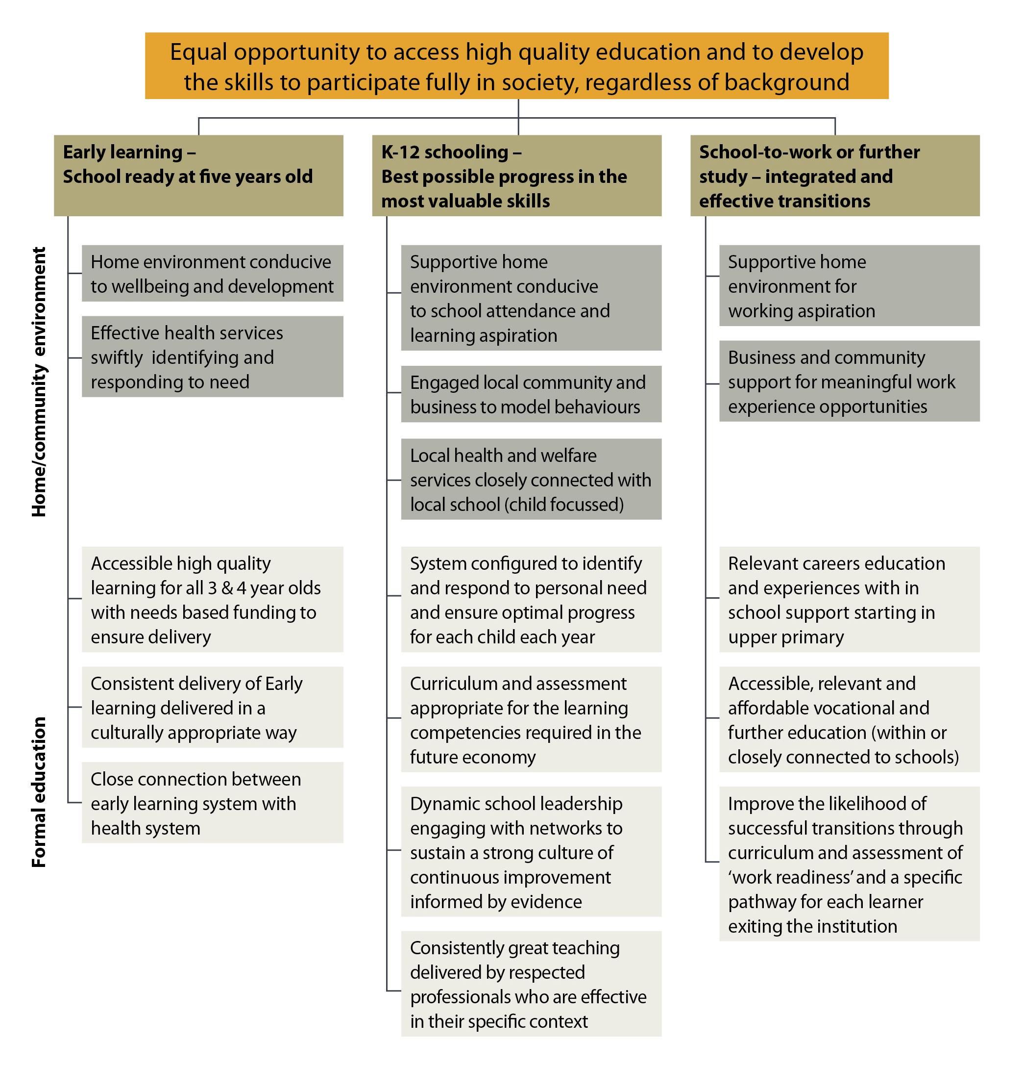

We have taken a special interest in the formal K-12 schooling sector of our driver tree, though we recognise the significant impact of early learning to learning outcomes, and the role of high quality early childhood education programs both in preparation for school but also for improving life chances.
Within the K-12 schooling sector we have chosen to focus on two drivers as areas that we, as an organisation, could have most impact on:
- Dynamic school leadership engaging with networks to sustain a strong culture of continuous improvement informed by evidence; and
- Consistently great teaching delivered by respected professionals who are effective in their specific context.
Evidence strongly supports the high impact that improvements in these two areas can make:
- The biggest ‘in school’ factor to improve impact is high quality teaching. An exceptional teacher, equipped with the most effective approaches, has a far greater impact on student learning than an ineffective teacher.
- Consistency is a problem - bigger ‘in school’ variance in teaching quality and student outcomes and between schools
- School leadership creates the culture and conditions for consistently good practice
Over several years of schooling, this can make a huge difference to a student’s chance of success in life. And potential broader economic benefits are considerable.
SVA believes that supporting school leaders and teachers to embrace and engage with evidence to better inform their decision making is crucial if we are to cost effectively improve educational outcomes. To that end, we are incubating a new social enterprise that addresses some of the barriers to evidence-informed policy and practice.

Key Activities
E4L is an evidence broker; we are an intermediary between researchers, policy makers, funders (public and private) and school practitioners with an explicit goal of lifting the learning impact of approaches and programs in schools.
We do this through building, sharing and encouraging the use of evidence to strengthen school decision making leading to improved educational outcomes for learners.

Build evidence through the Learning Impact Fund
E4L creates new high quality evidence through a Learning Impact Fund that pairs programs in schools with experienced independent evaluators to conduct rigorous research on their impact on learning. The Fund makes grants for empirical evidence generation with a search for causation, quantitative measures of learning gain and the counterfactual (e.g. randomised controlled trial where possible) as well as secondary measures and qualitative factors. It produces freely available, plain English reports for use by school leaders showing the months’ of learning gain, the cost to implement and the strength of evidence.

Evidence for Learning - A new social enterprise to help great practice become common practice
Evidence for Learning (E4L) is a new non-profit incubated by Social Ventures Australia with its foundation partners, the UK’s Education Endowment Foundation and the Commonwealth Bank. It was created to begin to address shortcomings identified in the education evidence ecosystem in Australia.
Our vision is an Australia where evidence informed approaches raise the learning impact for 5-18 year olds, so that all children, regardless of background, make the best possible progress. We currently support the K-12 school sector but there is potential to support early childhood in the future.
Our purpose is to support educators to improve their learning impact by increasing the evidence of what works and why, making this more widely available and actively used in classrooms, schools and systems.
E4L’s scope is national and cross-sectoral (across government, Catholic and independent education providers).
Critically, we are independent of all providers and funders of schooling, program and service providers, researchers and agencies. This enables us to commission, develop, present and promote evidence to school leaders and teachers to assist them make better investment decisions. In order to be effective we collaborate closely with all education sector stakeholders.
The full presentation of E4L’s work can be found at www.evidenceforlearning.org.au.

Share evidence through the Teaching & Learning Toolkit
The Teaching and Learning Toolkit is a free online summary of global educational research. The Toolkit aims to:
- Support evidence-informed decision-making in Australian schools;
- Provide guidance for principals, teachers and schools on how to use their resources to improve educational outcomes for their students, particularly those from low-income families;
- Act as an introduction to educational research.
The Toolkit was developed by two charities based in the UK, the Education Endowment Foundation and the Sutton Trust, in collaboration with academics at Durham University. In 2015, the Teaching and Learning Toolkit was launched, with support from the Department for Education and Training in Victoria, Social Ventures Australia and a number of other organisations around the country.
The Toolkit synthesises international and Australian research, to estimate the average impact, cost and evidence strength of a wide range of educational interventions. The Toolkit is a live resource that will be updated regularly as new studies are published in Australia or overseas.

Encourage use of evidence with practical implementation support and networks
Evidence for Learning is developing implementation resources and practice guides for high impact or frequently used approaches to help schools get the best benefit from their approaches. This aims to:
- Move beyond statements of effect, into actionable resources for schools
- Speak in the language and form that busy educators will find useful in order to increase the likelihood that they will embrace and implement evidence based approaches
- Be made available through existing or emerging professional networks that educators are most comfortable working in and currently use to assist their decision making

Response to the Issues Paper
For ease of reference, our submission follows the structure and questions in the Issues Paper, save for a general statement below. We have only responded to sections 1,2,4 and 5 of the Issues Paper.

General Statement
We have developed a conceptual model of an ‘evidence ecosystem’ that improves educational outcomes both for individuals and as a system. We refer to these concepts and models in our responses and recommendations where relevant.
We have also identified two important gaps in Australian education’s existing evidence ecosystem and in the Commission’s conception for a future national education evidence base which are set out at the end of this section.
Our response is focussed on K-12 schooling as this is where we have greatest expertise. However as our ‘driver tree’ above shows, we recognise the high importance of early childhood education and care. Whilst we believe that most of the statements we make throughout our response are applicable to the early childhood and care sector we do not contend this is automatically the case.

An evidence ecosystem that improves educational outcomes
If our purpose is to improve educational outcomes, then we need an environment that helps all in the system to continuously learn; researchers, policy makers, practitioners and the wider community. And not just to know what can make things better or worse but to develop the know-how necessary to actually make things better. Where this occurs we see an evidence ecosystem that is flourishing.
In school education, the most important place where we make things better is the classroom. They are the place where the highest impact on learning occurs, and school leaders create the culture for consistently great teaching practice, so we must design, build and configure systems to support school leaders and teachers to make more impactful choices.
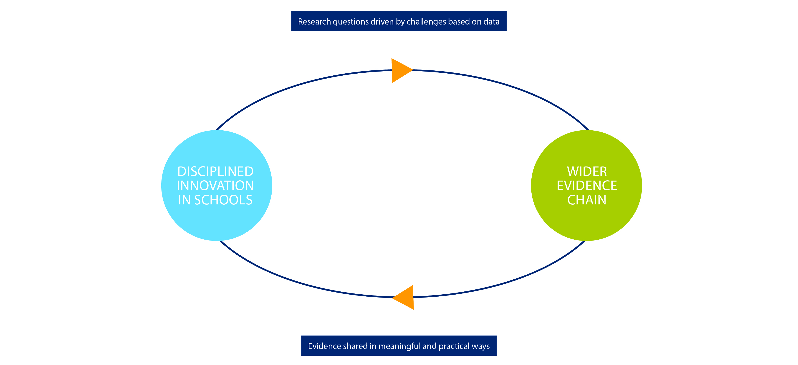
The focus of an education evidence ecosystem, then, must be to enable and support better decision making by school leaders, leading to better teaching practices in classrooms, ultimately improving the learning impact for students. We conceive this ecosystem as having two important cycles intimately connected and reinforcing as shown in the following diagram.

School leaders and teachers are the centre of this work. The activity of schools and the data and evidence they generate (through a cycle of disciplined innovation) is the starting point that informs and feeds into research questions. The work of the wider evidence chain is then shared back to schools in meaningful and practical ways.
Our conception of this ‘evidence ecosystem’ is informed by three principles:
- To effect change in practice, we need to understand how research will be used by practitioners. “Creating evidence ecosystems … requires coordinated efforts from a wide range of stakeholders [but] it is imperative that professionals drive these developments. Yes, policymakers have a responsibility to ensure there is a coherent overall system, and indeed, researchers have a duty to produce high quality research, yet it is frontline professionals who … should be at the heart of evidence–informed practice”.
- Placing frontline professionals at the heart of the work requires updates to thinking about their role in research and evidence. They cannot be seen as passive recipients of knowledge ‘built elsewhere’ but as active generators of new knowledge through the evaluation of impact in their own context. “School leaders need to be continually working with their staff to evaluate the impact of all on student progression. Leaders need to create a trusting environment where staff can debate the effect they have and use the information to devise future innovations… Schools need to become incubators of programs, evaluators of impact and experts at interpreting the effects of teachers and teaching on all students”.
- The relationship between frontline professionals engaging in disciplined innovation in their schools and the actors in the wider evidence chain must be seen as one of mutual dependence in the shared endeavour to improve educational outcomes. “Envision national networks of teachers and schools engaged with researchers and program developers around select[ed] high-leverage educational problems. These networks would aim to inform educators as to what is more likely to work where, for whom, and under what conditions. Moreover, as educators used this knowledge, the knowledge itself would evolve and be further refined through its applications”.
We have considered the activities that must occur in the two areas of (1) disciplined innovation in schools which is supported by (2) the wider evidence chain that support our conception of a healthy evidence ecosystem.

Disciplined Innovation in Schools
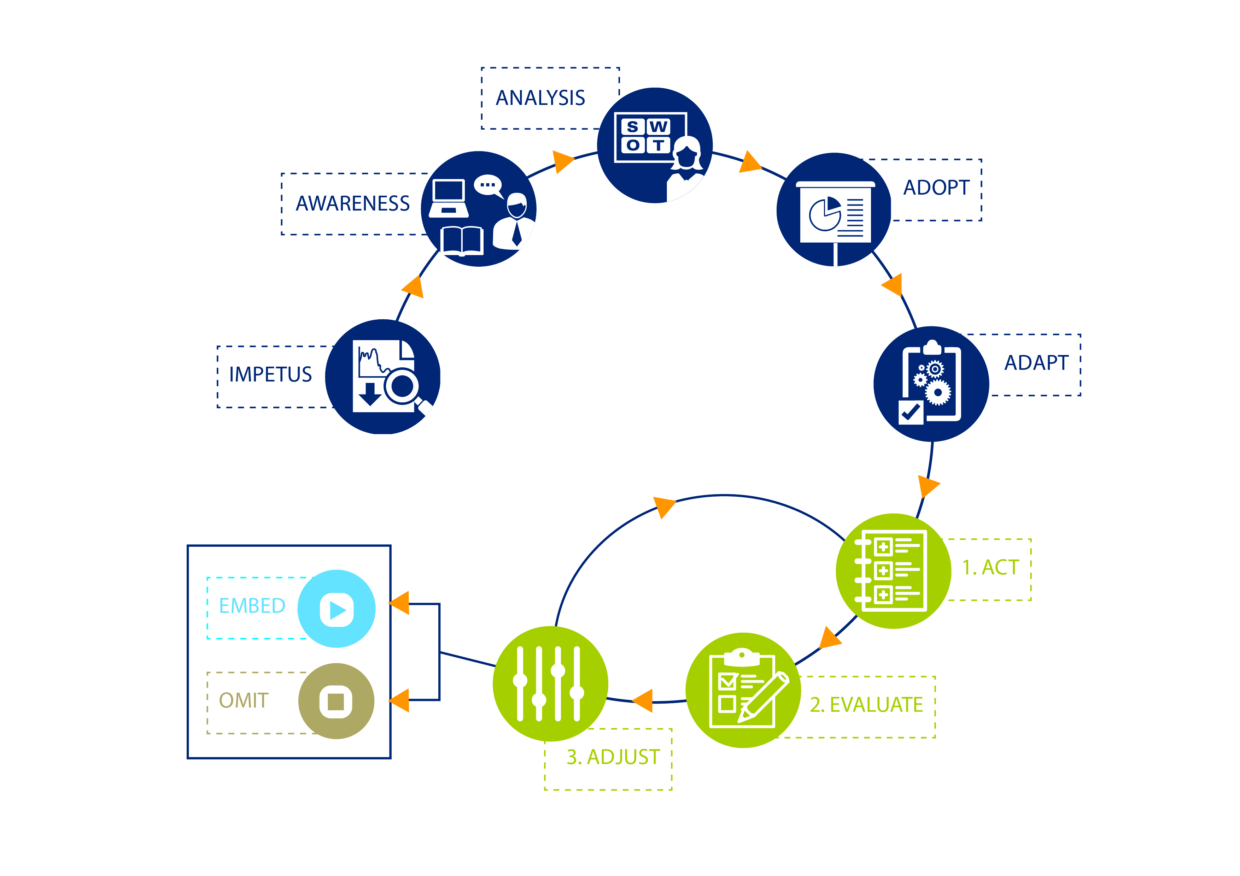

This process shows a way school leaders can ensure the approaches they choose in their school are informed by, and responsive to evidence. All stages need to be data and evidence informed. This doesn’t replace the importance of professional judgement - it should enhance and improve it.
In summary:
- The Impetus must come from school level data and appreciation of local needs;
- School leaders need to have an Awareness of which approaches have good evidence of success and be able to easily distinguish them from the plethora of available information
- Analysis of the evidence-based approaches entails understanding of the conditions that have led to prior success and consideration of whether it is likely to provide similar benefit in the specific local context
- Intentional Adoption and Adaptation of the program includes the use of ‘implementation science’ to articulate the ‘theory of change’ and manage the barriers to success (including staff training and use of measures to determine efficacy in that context)
- Implementation is conducted in a mini cycle of Act, Evaluate and Adjust that ensures active learning to make immediate difference and generates new data and knowledge for sharing with the wider evidence chain, and
- A deliberate decision to Embed or Omit (discard) the program based on the local evidence of impact; choosing what to stop doing is as important as choosing what to keep doing.
All of this work in schools should be supported by activities in the wider evidence chain that are geared to producing and communicating evidence that teachers and school leaders can understand and use to improve their practice.

Wider Evidence Chain
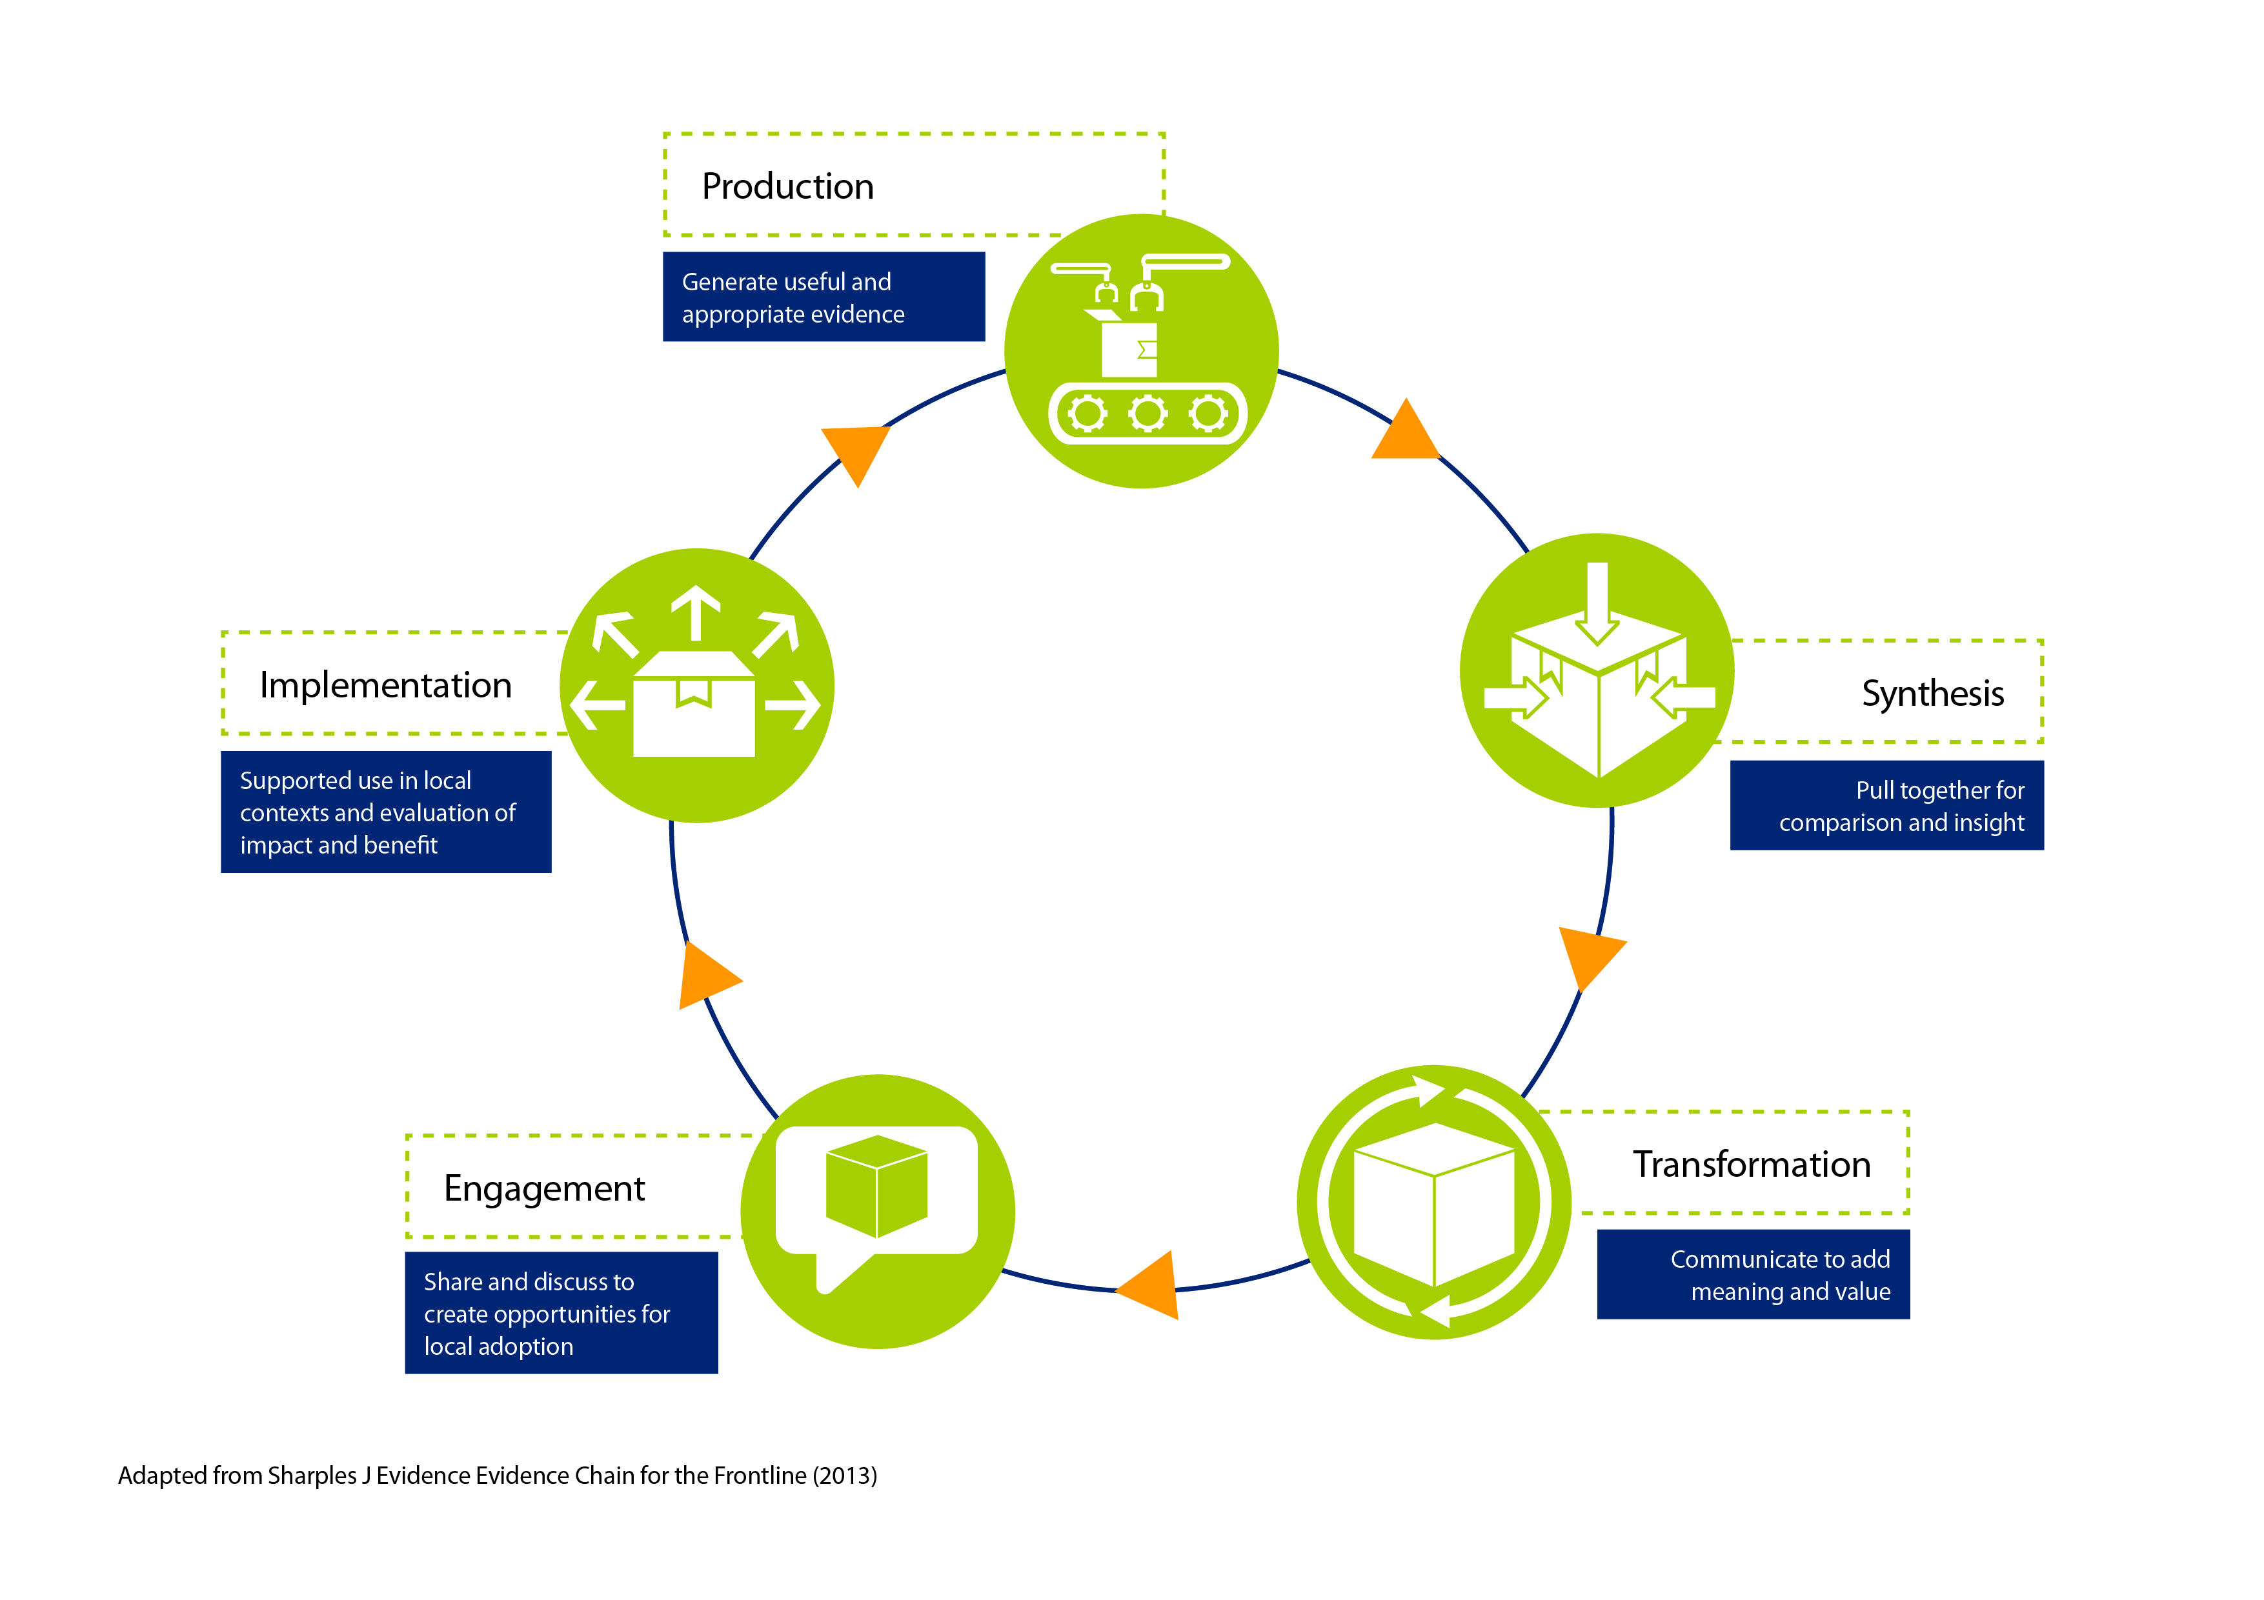

This cycle begins with new knowledge generation in the production stage, based on the questions generated from data and evidence in the school cycle running in networks of schools. But to be useful and used this evidence needs to be synthesised in comparison to similar research on the same topic and transformed into plain English with additional contextual information, such as costs and key success factors. Finally it needs to be effectively shared through authentic and engaged networks of frontline professionals who are supported in implementation (as they engage in disciplined innovation in their school) in order to realise the benefits of the evidence-informed change.
While there is substantial focus on the production of data in Australia, including throughout the Commission’s Issues Paper, there is a particular lack of experimental evidence in education. There is also a lack of focus on engagement with evidence by practitioners and ensuring that approaches are implemented with impact.

What is missing in the Australian evidence ecosystem
There are two important gaps in our current ecosystem, which are critical to address if a national education evidence base is to meet its purpose of improving educational outcomes.

There is a lack of high quality evidence of the actual learning impact of approaches and programs in schools.
Addressing this gap, through more experimental research effectively translated for action, is a very cost effective way to better inform and target substantial system investments at the macro level and at the micro level to assist school leaders make more impactful decisions. There is good cost/benefit for doing this now, but the returns are even greater with specific improvements in national data collections, which can drive down the cost of experimental research.

There is a gap in stimulating and meeting the ‘demand side’ of evidence use; the needs of frontline professionals who ultimately deliver the learning impact.
A national evidence base is not valuable if it is not actually used to make changes that improve educational outcomes. The Issues Paper does not adequately consider the important conditions that are required for evidence to be used by policy makers and practitioners. Substantial effort needs to be directed to understanding and responding to the ways in which frontline professional’s best engage with data and evidence to lift their impact and thereby improve educational outcomes.
These two points are themes throughout our response to the Issues Paper.

Section 1:
What has the Commission been asked to do?

Scope of the Inquiry - questions page 3
Does the interpretation of the scope of the terms of reference accord with yours?
We note that the terms of reference request the Inquiry to advise on the “the national approach to collecting and using data for early childhood education and care and schools, and other information as relevant, to improve Australia’s educational outcomes” as well as “the information required to provide a comprehensive evidence base to inform policy development in early learning and school education now and in the future.”
We therefore submit that the scope of the Inquiry should include consideration of:
- The types of information required to develop policies and practices that directly relate to improving educational outcomes. This should include data on the costs and effectiveness of specific interventions or programs - often referred to as the ‘what works’ evidence base but also the specific factors that make them impactful in practice: ‘what works, for whom, under what conditions’;
- How this information should be collected nationally, including the appropriate use of evaluation techniques, especially experimental research using methods such as randomised controlled trials (RCT);
- How information contained within the national education evidence base should be used, including how it is made available to key users such as school leaders, teachers and parents/students as well as policy-makers, service providers and researchers in education, health and other social service sectors; and
- How key users are supported and encouraged to engage effectively with the education evidence base through professional learning and enhanced professional networks.
Further, in considering the benefits of alternate approaches, the Inquiry should focus on the nexus between the particular types of evidence that are or could be generated and each type’s likely support for improving educational outcomes.
In particular, should the scope of the evidence base include data on children younger than 4 years old (or prior to the year before compulsory schooling begins)? If so, why, and should it cover all children, or only those attending early childhood education and care programs outside the home?
Should the evidence base include data on young people who have left school before completing Year 12, or who do not attend school for other reasons (for example, home-schooled children)?
We have responded to these questions as a group.
In light of the evidence outlined earlier on the drivers of education outcomes, we recommend that the Inquiry should adopt a broad interpretation of the scope of the education evidence base such that it does include or can be linked to data on children younger than 4 years old, whether in early childhood education and care programs or not, and young people outside the formal school sector.
The evidence of the relative impact of investment in the early years on outcomes later in life is very strong, including on education outcomes.
High-quality early learning has a significant positive effect on a child’s development, well-being and readiness for school. For children from disadvantaged backgrounds, it has the double benefit of reducing risk factors at home.
Children who do not receive a high-quality early education are:
- 25% more likely to drop out of school
- 40% more likely to become a teenage parent
- 60% more likely never to attend higher education
- 70% more likely to be arrested for a violent crime.
International cost-benefit analysis shows that for every dollar spent on effective early childhood intervention, there is a US$7 return to society.
Nobel Laureate in Economics James Heckman created the Heckman Curve, which visually communicates the rate of return on investment in human capital over children’s development periods:
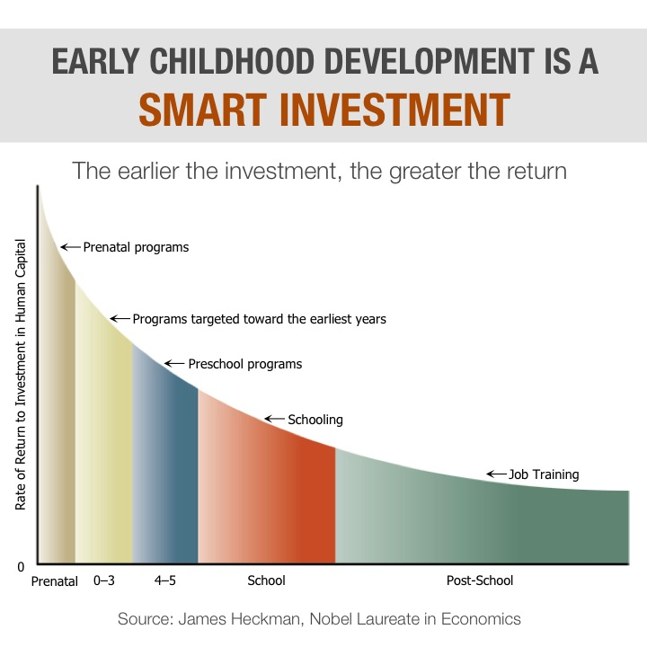
As described in SVA’s driver tree, we believe it is critical that improving educational outcomes is understood across formal education stages and between institutions and the home/communities in which those institutions operate.
International studies show that a child who is developmentally vulnerable at the start of school is likely to have poor outcomes throughout their life. A rich learning environment at home helps children reach cognitive development milestones, and have better reading, vocabulary, general information and letter recognition skills – all factors that contribute to educational attainment.
Comorbidities such as domestic violence, abuse, parental addiction or unstable housing can all contribute to a home environment that is not conducive to learning and development.
As such, it’s essential to include data and evidence relating to these factors in strategies to improve learning outcomes in schools.
While Australia has good overall levels of student attainment and achievement, we also have a stronger link between performance and socioeconomic status than the average OECD country. Nearly 60% of the most disadvantaged students in Australia are in schools classed as disadvantaged – well above the OECD average and substantially higher than in any comparable OECD country.
- On average, disadvantaged children perform below their peers and are more likely to drop out before completing high school
- By the age of 15, students in the bottom socioeconomic quartile can be almost three years behind those in the top quartile
- In the OECD’s PISA 2012 survey, Indigenous Australians scored so much lower in mathematical, scientific and reading literacy that the score indicated they were about two and a half years behind their non-Indigenous colleagues in all three categories
- The survey also showed that metropolitan schools have more high performers and fewer low performers than schools in more remote areas.
Including these home, community and environmental factors as data in the education evidence base enables better evaluation of the impact of programs and practices in formal early childhood and school settings. Very importantly, it also supports educators to understand the growth or gain that has resulted from their specific activities, controlling for the environmental background of the learners. This avoids blanket attainment measures, which fail to assess progression in learning outcomes rather than absolute markers, as well as false causality.
Linking these data need not be an insurmountable data matching exercise, and can include statistical techniques like regression analysis of particular data sets to identify cohorts or factors which warrant greater investigation across multiple sets which in turn form part of the impetus for program development.
Commonwealth and State Governments have already begun this approach in other areas of policy with data matching projects relating specifically to vulnerable families (between Commonwealth Department of Human Services and the NSW Department of Family and Community Services) and on education outcomes for Indigenous students (between the Commonwealth, South Australia and Northern Territory Governments).
We also encourage the Inquiry to consider an even broader scope that includes data from new sources, such as new providers of services to schools. In recent years there has been significant growth in online learning support products which are gathering valuable data on learner needs and progress. This trend is expected to continue and it would be prudent for the Inquiry to consider the potential for including these kinds of data in support of that national education evidence base. We note the work of the National Schools Interoperability Program and the national Data Strategy Group convened by the Australian Department of Education in developing models for the inclusion of such data in the resources available for schools and systems.
We note the reference in the Issues Paper to the Commission’s other inquiry into “the benefits and costs of increasing the availability and use of public and private data by Australian individuals and organisations” and believe that these kinds of data should be also be considered within the scope of the education evidence base.

Section 2:
Objectives and framework
We do not support the Commission’s proposal “that the main focus of this inquiry is about the underlying data, rather than on educational research literature (particularly with respect to analyses of ‘what works’ in teaching and learning in schools)”.
We submit that this is a false dichotomy - it is neither feasible nor desirable to attempt to separate the ‘research purposes of data’ from recommendations about the types of data required to collect to build a comprehensive evidence base. If the inquiry is to meet the terms of reference, which defines the purpose of the national education evidence base to improve educational outcomes, it is essential that the Inquiry’s scope includes data, evidence and analyses “relating to ‘what works’ in teaching and learning in schools”. Furthermore as developments in the areas of ‘improvement science’ and ‘implementation science’ show, we also need to understand “what works, for whom, under what conditions” and how best to turn this knowledge into effective change by practitioners.
We agree with the description of Australia’s national educational objectives, specifically a broader view such as that in the Melbourne Declaration to enable young Australians to “become successful learners, confident and creative individuals, and active and informed citizens”. We acknowledge that this entails an evidence base that includes non-cognitive domains as well as traditional academic domains.
We also agree with the terms of reference that Australia’s educational system needs to equip “children to succeed in an increasingly competitive world” and enables Australia to “lift [its] national productivity”. And that this entails appreciation, definition and evaluation of potentially new skills and knowledge required for a modern developed economy and wider society.

Questions page 7

Does your understanding of the terms ‘education data’ and ‘education evidence base’ accord with the definitions presented here? If not, how would you describe these concepts and their relationship?

We refer to the evidence ecosystem model in the introduction to our response. We submit that data and evidence use by frontline professionals is an essential component of a national education evidence base.
As noted in the preceding section, we do not support the Commission’s proposal “that the main focus of this inquiry is about the underlying data, rather than on educational research literature (particularly with respect to analyses of ‘what works’ in teaching and learning in schools).”
In order for the national education evidence base to support the improvement outcomes articulated in the terms of reference, other forms must be included. We consider that:
- The ‘national education evidence base’ should be broadly defined as per the ‘broader definition’ provided in Box 2 of Issues Paper. This broader definition should include:
  - The ‘what works’ research outputs that build on education data (ie, a quantitative analysis of The data, with robust causal analysis),
  - The ‘for whom and under what conditions’ evidence that provide essential context to understand the potential for impact in practice (ie secondary analyses and qualitative measures captured during trials) and
  - The translation and dissemination of knowledge in forms that are useful for key users, particularly school leaders and teachers
- ‘Education data’ should encompass both quantitative and qualitative data holdings relating to programs and outcomes as well as the conditions required to achieve these outcomes. This should include:
  - Data collected through program evaluations (such as RCTs) on both quantitative learning outcomes and qualitative conditions and capabilities (such as audits and surveys)
  - Data on contextual factors that influence student outcomes (e.g. student background factors) including both ‘within-system determinants’ and ‘external determinants’.
We provide greater detail on these types of data in our ‘response to the questions on page 13’ below.
Do you agree that the objective of a national education evidence base should be to improve education outcomes? Are there other objectives that should be included?
We agree the objective of the national education evidence base should be to improve the education outcomes both for individuals and the broader community. However, we note the interconnectedness between education outcomes and outcomes in other domains, including health, wellbeing and the broader economy. Therefore, the objective of the national education evidence base should recognise improved outcomes in these interrelated domains.
The development of Life Chances research in the United Kingdom provides a useful reference point for the ‘spill-over’ impacts of improved education outcomes. As we highlighted earlier, there is also evidence that in Australia there are stronger links between socioeconomic status and learning outcomes than in other OECD countries. Both directions need to be considered.

Key drivers of life chances throughout childhood
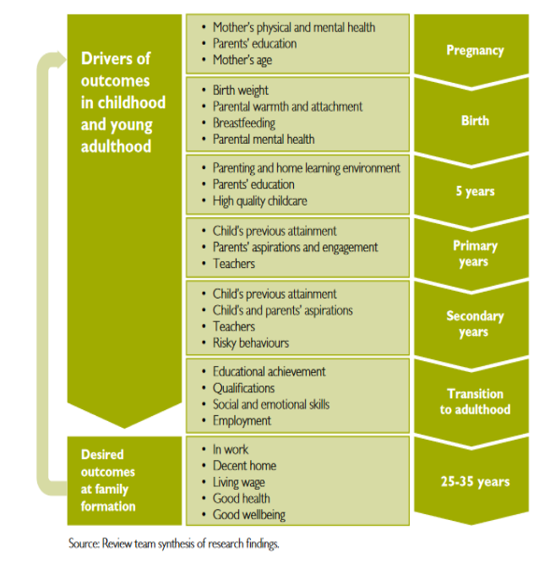

What education outcomes do you see as relevant? For example, outcomes in traditional academic domains (such as literacy and numeracy), outcomes in non-cognitive domains (such as communication and interpersonal skills).

What education outcomes do you see as beyond the scope of this inquiry?

Can all relevant education outcomes be measured? What approaches can be used in accounting for outcomes that may be difficult to measure?

We are responding to these questions together.
Identifying the education outcomes we, as a community, value is clearly important. It is just as important to prioritise among the outcomes we seek to achieve, given the finite resources (both money and time) available for education. Ideally, the outcomes we seek should be clearly defined and measurable so that our progress can be monitored.
Broadly, these should be in line with and contribute directly to the outcomes identified in the Melbourne Declaration highlighted earlier.
We know that student outcomes in traditional academic domains, such as literacy and numeracy, matter greatly. A strong body of research demonstrates the relationship between achieving a minimum level of proficiency in academic domains, which some have called ‘basic skills’, and better life outcomes. There are also large returns to incremental improvements in educational achievement.
Australia has made significant progress in defining and measuring academic outcomes, particularly in the areas of literacy and numeracy. For example, through the National Assessment Program, Australia has developed a clear framework for assessing students’ educational outcomes in literacy, numeracy and science. Australia also participates in the Programme for International Student Assessment (PISA), Trends in International Mathematics and Science Study (TIMSS) and Progress in International Reading Literacy Study (PIRLS) international assessment programs, which provide valuable data on student achievement against underlying standards as well as Australian students’ relative performance compared to other countries. The National Assessment Program also assesses students on their knowledge and skills in Civics and Citizenship and ICT.
However, we consider that more work needs to be done to ensure that students are assessed not just on what they know, but the extent to which they can apply this knowledge in useful ways today and in the future. This work is essential if to monitor progress towards the so-called ‘21st century skills’ that we know are important contributors to future success.
We note that Australian governments have already recognised the importance of this work. According to the Melbourne Declaration, a ‘successful learner’ must be ‘creative, innovative and resourceful’, ‘solve problems in ways that draw upon a range of learning areas and disciplines’, ‘collaborate, work in teams and communicate ideas’ and be ‘able to make sense of their world and think about how things have become the way they are’.
There has been a push in recent years to further define ‘21st century skills’ and develop an ability to measure them more effectively including through assessment of collaborative problem solving in the PISA 2015 cycle. Australian researchers and institutions have been at the forefront of this work. Further support should be provided to continue this work and ensure that robust approaches to measuring outcomes in these areas are integrated into Australia’s existing national, state and school level assessment and monitoring frameworks. Failure to do so will result in an overemphasis on the more discrete academic outcomes currently favoured, with implications for what is taught in schools and what students learn - after all, what gets measured gets managed.
In addition to traditional academic and so-called 21st century skills, there is evidence that a range of non-cognitive skills are also associated with improved educational outcomes. Such skills include interpersonal skills, motivation, self-control, resilience or ‘grit’, for example. Resilience, for example, has been identified by the OECD as a measures the ability of children who have experienced significant disadvantage to succeed in formal education. The extent to which a causal relationship exists between many of these skills and improved education and life outcomes is less clear. It is also less clear how possible it is for school teachers to intervene to foster a child’s non-cognitive skills and how this might best be done. This is an area where additional research is required.
In Australia, the Foundation for Young Australians’ recent reports on the New Work Order and the concomitant New Basics skills that young people will need, along with VicHealth and the CSIRO’s “Bright Futures” report on megatrends affecting youth mental health, provide useful initial evidence and framing locally.
It is clear that there is a significant challenge in identifying and measuring the range of cognitive and non-cognitive outcomes that are important, as well as distinguishing between the education and broader social outcomes that we, as a community, value and seek to foster. While we continue to grapple with these challenges, we consider it is important to collect sample data on a range of factors to improve our understanding of Australian children’s life course through various stages. Linked data on a child’s personal and background characteristics, data across stages, such as infancy, early childhood, school education through to further education or work, and across a range of intermediate education, health and social outcomes, would provide a rich source of information that could improve our understanding of the factors that influence the ultimate life outcomes we care about.
There are a number of surveys that collect data on these stages and outcomes, including the Longitudinal Study of Australian Children, the Longitudinal Surveys of Australian Youth, the Census of Population and Housing, the Australian Early Development Census and educational outcome assessments including PISA, NAPLAN and others. Linking these data sets can provide deep insights into the types of factors that bear on the prospects of success for a child and what policy makers and others might do to enhance this further.
Recent work by the Australian Bureau of Statistics linking up separate data sets to examine socioeconomic factors and student achievement in Queensland and early childhood outcomes in Tasmania demonstrates the potential value of these efforts and should be extended further.
Identifying the education outcomes we intend to strive for, and developing robust approaches to measuring our progress, is a critical first step on the path to improvement. If we stop here, however, it is very likely that our efforts will result in little change. As Hanushek cautioned, when bringing together the views of a widely regarded panel of economists on school improvement in the United States, ‘we do not see that simply announcing high goals and developing commensurate standards are likely by themselves to lead to accomplishing those goals’.
He further emphasised that ‘there is little evidence that the development of standards and the associated measurement of achievement by themselves will lead to noticeably improved student performance.’ The evidence since 1995 confirms the maxim: you don’t fatten the pig by weighing it.

Questions page 13

What data should be collected nationally?

How would these data support the objective of improving educational outcomes?

We are responding to these questions together.
National data collections should be tailored to the primary objective of improving educational outcomes. To achieve that objective, the data must allow actors at all points in the education system to learn and act based on that learning. Pursuant to this, different types of data will be required for different purposes, including:
- Informing school and classroom practices, to maximise the effectiveness of educational expenditure and the use of teachers’ and students’ time in the pursuit of better education outcomes
- Informing programs and activities related to the promotion of evidence-based practices and the capability of frontline professionals to effectively implement these practices
- Informing education policy design and resource allocation at the national, state/territory, sector and individual school levels
- Informing national educational goals over time
- Monitoring students’ progress towards these goals and early identification of particular groups of students that may require additional support
- Benchmarking educational performance between different jurisdictions and sectors within Australia and between Australia and other countries, to identify where further improvement is necessary and where lessons can be learnt
It is not necessary for all types of data to be collected all of the time. For example, to target teaching to the learning needs of individual students, a teacher must collect detailed diagnostic data to build a clear picture of where each one of their students is in their learning. This picture must be updated frequently through regular classroom assessment and feedback.
However, to monitor the progress of a school or education system towards specific educational outcomes, it will generally be sufficient to collect data on a representative sample of students, on a less frequent basis, such as through annual NAPLAN collections or through international collections such as the Programme for International Student Assessment (PISA), Trends in International Mathematics and Science Study (TIMSS) and Progress in International Reading Literacy Study (PIRLS) which are conducted every three to five years. In many instances, particular sets of data may be able to serve multiple purposes.

In our General Statement we identify two critical gaps in the current education evidence base being:
- Empirical knowledge about which approaches work in schools and why they work; and
- How best to engage with, and support frontline professionals to implement evidence based programs.
To meet these two purposes we need national data that better supports the generation of new knowledge and evidence in both of these areas.

Data to support empirical knowledge about which programs work in schools and why they work
There is a critical gap in Australia in the production of robust evidence on the effectiveness of teaching approaches and interventions in the classroom.
This gap can be addressed by collecting data to identify what works and what doesn’t, specifically through rigorous evaluations using experimental methods including randomised controlled trials, with robust secondary analyses. In doing so, we must further understand ‘what works, for whom, under what conditions’. ‘Understanding variation in educational outcomes and responding effectively to it are the core goals of improvement research. Improvement science offers a very systematic but also highly practical set of principles and methods for advancing this learning.’
The types of data required here are:

Achievement data - the ‘what?’

Robust measures of academic achievement relevant to intended benefit of the program being evaluated (e.g. literacy and numeracy) through standardised instruments.
Where possible, the data collected on student outcomes should be broadened to include data on the types of ‘21st century skills’ and, potentially, non-cognitive skills such as resilience, that will likely be required to lead a productive and fulfilling life in the future.
Note that this data is not required for all students nationally but only for the participants in the trial, representing a statistically valid sample. Whilst not essential, the ability to use existing administrative data on achievement can significantly reduce the costs for the conduct of RCTs. We comment further on this in the Issues and Opportunities section below.
Data on students’ background characteristics - the ‘for whom?’

Data collections on school and student background characteristics, and longitudinal survey data tracking children across key transitions from early childhood to school and from school to further study or work, are important to understand the effects of the intervention on students with different backgrounds. Does the intervention benefit all students similarly? Is it more or less effective for students with disadvantaged backgrounds? As noted above, linking up disparate data sets will enable a more thorough understanding of how different factors affect learning outcomes and where the most promising avenues for intervention might be.
Examples of relevant data are location, gender, socioeconomic status, parental educational attainment, school attendance, and health and medical diagnoses.

Data on the specific conditions in schools - the ‘under what conditions?’

Building on recent advances in ‘implementation science’ and ‘improvement science’ we also need to gather (or access prior) wider data on schools that indicate the conditions in which the change occurred. These data are critical for understanding the context for the observed changes in the quantitative measures.
Having data available (or linked to) on the specific conditions in a school compared to national data would be very helpful in understanding the required ‘in school’ conditions.
To build our understanding of what these factors are, and how they can be influenced, we should collect a broader range of data across potential determinants such as:
- Cost of programs
  - Direct costs - such as licence, equipment and materials
  - Staff costs for professional learning and then cost to deliver
  - Indirect costs
- Conditions at school level
  - General working conditions within schools, including working hours, class sizes, access to support staff and school leadership
  - The amount and type of resources available for teaching
  - School culture, including the approach to evidence, evaluation and feedback

- Professional capability of school leaders and teachers
  - The quality of initial teacher education and the quality and amount of ongoing professional development teachers and school leaders undertake
  - The extent and quality of collaboration with teaching peers, researchers and other key stakeholders built into regular practice
  - Teacher and school leader accreditation at each of the four levels of AITSL’s Professional Standards for Teachers and Professional Standard for Principals
  - The amount and type of resources available for teaching
  - Teacher remuneration, accountability and performance management arrangements
  - Teacher career paths, development of leadership capacity and reasons for exiting the profession.

Data on these factors could be collected through:
- Regular surveys of a representative sample of teachers and school leaders, ideally on a longitudinal basis and linked back to student outcomes data
- Rigorous program-level evaluations of teacher and school leader professional learning programs
- Well-designed case studies to provide a more in-depth perspective

Some data on factors that may impact teaching quality are already collected through existing surveys, including the Staff in Australian Schools and PISA surveys and one-off surveys designed for specific academic research. However, there would be benefit in adopting a more systematic approach to collecting data on a broader range of factors that may influence teaching quality, linked to student outcome data, and making it widely available to researchers and policy makers. This would enable researchers and policy-makers to better target their future efforts to areas that show the most promise.

Data to build knowledge of how best to engage with, and support frontline professionals to implement evidence based programs.

We need to gather data about the most effective forms of evidence dissemination and engagement with frontline professionals. We need to understand the capability of frontline professionals, individually and collectively, to engage with evidence and effectively implement evidence based approaches. Data and evidence on effectiveness is as important here as it is on educational interventions. There is growing recognition of this need internationally and emerging bodies of evidence about factors affecting the use of data and research evidence in schools.
Two international and two Australian examples are useful to cite here.
In 2014, the EEF opened a themed funding round on Research Use in Schools to investigate, through RCTs, which methods of research dissemination and use are most effective in changing teachers’ practice and students’ academic achievement. In one trial, “The Literacy Octopus: Communicating and Engaging with Research,” the same research findings about literacy instruction are being communicated to Key Stage 2 teachers in eight different ways. Another trial, “Research Learning Communities,” will test ‘whether evidence champions are effective at promoting research use in their school, when supported by a research community of peers from local schools and an academic facilitator.’ Results of these pilots have just been released, and they indicated that, ‘It would seem that structured and bespoke support for teachers, focusing on specific actions for implementation and in-class support is a necessary (if not sufficient) condition for making sure research has an impact. Importantly, the independent evaluations noted that the engagement of senior leaders in Research into Practice was critical to its success; they noted that time constraints affected teachers’ ability to commit to the Research Champion model.’ These results indicate that we should collect data about (1) the kinds of support that results in changed practice; (2) the role of senior leadership in supporting evidence-informed practice; and (3) the time necessary to prepare for and make changes. Further, the trials in this round will begin reporting in early 2017 and will provide a rich body of knowledge on which to decide what kinds of data to collect about research dissemination and use, with a focus on the most promising avenues.
In the United States, the Carnegie Foundation for the Advancement of Teaching promotes a method of educational improvement which they call Networked Improvement Communities (NICs), which are:
- Focused on a well-specified common aim;
- Guided by a deep understanding of the problem, the system that produces it, and a shared working theory to improve it;
- Disciplined by the methods of improvement research to develop, test, and refine interventions; and
- Organised to accelerate interventions into the field and to effectively integrate them into varied educational contexts.
These communities keep ’measureable improvements in valued student outcomes’ central to their work and integrate existing research evidence. These characteristics of NICs imply both individual and collective characteristics that are necessary for research evidence to translate into continually improving practice and improved student outcomes. A deeper review of the Carnegie Foundation’s work could guide the development of appropriate instruments for data collection on research use for improving student outcomes.
Complementing the Carnegie Foundation’s focus on improvement science, the newly-established Centre for Evidence and Implementation (CEI) focuses on using implementation science to improve the lives of children, their families and communities facing adversity. A key focus in implementation science is on the attitudes practitioners have toward adopting evidence-based practices and the kinds of interventions that are effective in shifting those attitudes to enable the uptake of evidence-based practices. Within the field, researchers have developed valid and reliable instruments to measure such qualities as ‘proactive leadership, knowledgeable leadership, supportive leadership, and perseverant leadership’ for implementing evidence-based practices. These instruments could generate very useful data about the capability that exists among teachers and school leaders to implement evidence-based practices.
Another Australian example is the not-yet-published research of Mark Rickinson and Kate de Bruin on research use by education policy makers in one Australian state. The research questions in this study are indicative of the kind of data that should be collected:
- What types of evidence are used?
- Who are the key players in the process?
- How, when and where does evidence use happen, not happen?
- Why does it happen or not happen (drivers, barriers, influences)?
- So what could be done to improve evidence use in the future?
The frameworks and data collected in this study could be used for data collection on research use
The four examples cited above demonstrate the advances being made in how research evidence is being used to improve student outcomes and how to measure research use. Based on this emergent work, we suggest that the following kinds of data would be useful to include in the education evidence base:
- Penetration and usage of the approach
- Costs of the approach
- Degree of change in attitudes as a result of activity
- Degree of change in practice as a result of activity

Data related to teachers’ and school leaders’ capability to engage with and use research, including:
- Measures of the attitudes and opinions about using evidence;
- Measures of the skills and capabilities to implement evidence based practices for improvement in their students’ outcomes; and
- Measures of the ability to capture data and evaluate impact at the local level.
There are emerging survey tools and instruments that could be adopted for an Australian evidence base. For example:
- The USA’s National Centre for Research in Policy and Practice has the Survey of Practitioners’ Use of Research (SPUR) which has already produced one report
- The UK’s National Foundation for Education Research has also developed a survey that to measure teachers’ research use

What characteristics should the data possess in order to support the processes of monitoring progress, evaluating policies and programs and/or informing policy development?
As noted above, national data collections to strengthen the education evidence base should be tailored to the primary objective of improving educational outcomes. Different types of data, with different types of characteristics, will be required for different purposes.
For some purposes, it will be appropriate to collect data on all students at a particular point in time to develop a baseline assessment of the population using a standardised instrument (such as the Australian Early Development Census). More often, it will be sufficient for national monitoring, benchmarking and policy design purposes to collect information on a representative sample of students or teachers on an annual basis or every few years. ‘Deep dives’ into particular areas, through detailed surveys or case studies, would also further enrich the evidence base and help target future research and policy design. In all instances, it is important to invest enough in the data collection process to ensure data is of sufficient quality that it can be used with confidence.

Which aspects of administrative datasets are likely to be most useful to inform policy development?

Administrative datasets are one important input when considering the layers of data required to answer questions of whether the system it is reaching its ultimate outcomes, but sits side by side other datasets which include national testing, school based reporting, primary research and longitudinal studies.

While not their primary purpose, existing administrative datasets are also an important source of data for designing randomised controlled trials in a more cost effective way.

Effective randomisation requires that the intervention group and the control group are broadly equivalent in terms of the key characteristics that may have an impact on the effectiveness of the program or intervention being evaluated. Depending on the nature of the trial, these characteristics may include school size, location, sector, ICSEA or teacher/student ratio and student gender, socioeconomic status and prior educational achievement, for example. Data on these characteristics is often contained in administrative data sets. Providing evaluators with easier access to this data would reduce the cost of the randomisation process.

Further, in some instances, student learning outcomes data (for example ACER Progressive Achievement Test data) that is already collected for other purposes and is held by schools, system administrators or other bodies can be used in randomised controlled trials to evaluate the effectiveness of an intervention. Again, enabling easier access to this data can reduce the cost of the evaluation process.

In the United Kingdom and the United States randomised controlled trials using data from existing administrative data sets have become much more common in recent years. The experience in these countries demonstrates that barriers to accessing administrative data sets, including confidentiality, privacy and data security, can be overcome.

What additional research or policy activity would be enabled by this data collection?

As highlighted above, we recommend investing in the production of robust evidence on the effectiveness of teaching approaches and interventions in the classroom - that is, finding out ‘what works, for whom, under what conditions’. Specifically, we recommend greater use of rigorous evaluations using experimental methods, including randomised controlled trials with rigorous secondary analysis and detailed qualitative information. The data collections we outline above would allow the production of this robust evidence and would allow policy makers to make better-informed decisions.
A growing evidence base of what works and why is essential to make progress in lifting student outcomes. It can empower teachers to lift the quality of teaching and enable policy makers to design more effective policies to support teachers and schools.
Knowing with confidence what doesn’t work and why is just as important. Often a promising approach may fail to produce the expected impact because of a lack of clarity about how it should be implemented in schools. Further research, including evaluations of the approach under different conditions, can help develop practical guidance for schools and policymakers about how to maximise the benefits of the approach on the ground. The process of evaluation and refinement is discussed below in the case study on the EEF’s reviews of teaching assistants in the UK. Where approaches or interventions are repeatedly found to have minimal impact (or a negative impact) on student learning in a variety of implementation contexts, they should be discontinued to free up critical resources for more effective programs.

Who would use this data and who is the beneficiary of any additional activity?

Data on student learning outcomes and background characteristics is an important input for evaluators in designing and conducting RCTs. Improving the quality and accessibility of these data sources would assist in evaluating education approaches and interventions to produce a stronger evidence base around what works (and why), what doesn’t (and why) and the relative cost of different approaches.
For the strengthened evidence base to improve learning outcomes, it must have a direct impact on classroom practices or the external determinants that affect student learning. Therefore, the critical next step involves translating education evidence into a practical, highly accessible format that provides clear guidance to those who have the biggest impact on student learning outcomes.
Translating and distributing this evidence, through the Teaching & Learning Toolkit for example, ensures it is available to teachers and school leaders as well as government policy-makers in education and other fields, philanthropists and non-government service providers. The objective should be to reduce as much as possible the costs these users face in finding robust evidence so as to increase the probability that this evidence will be used to inform school and classroom practices and design better education policies.
Closing the research/practice gap by encouraging greater use of a strengthened education evidence base would deliver a significant, positive impact on student learning. Better use of evidence will clearly benefit all students by increasing the effectiveness of education expenditure across the board. Depending on the types of programs and interventions evaluated through RCTs, specific groups of students would also be expected to benefit through improved understanding of how to overcome particular challenges. This could include, for example, developing more effective programs to assist struggling readers or to close the gap in education outcomes between Indigenous and non-Indigenous students.
The Teaching & Learning Toolkit already includes an initial set of evidence summaries that provides practical information for school leaders and teachers as well as policy makers. The potential payoff from using this evidence - either by adopting new practices that have a stronger evidence base or by discontinuing practices that have minimal or negative impact - is significant. For example, schools can boost a student’s average yearly learning:
- By around 4 months, through the adoption of a phonics programs to teach reading and writing, at a cost of around $60 per student.
- By around 5 months, through the adoption of a structured peer tutoring program, at a cost of around $280 per student.
- By around 4 months, through the cessation of grade repetition policies targeting students with low academic achievement, saving around $8000 per student who repeats a year (or around $200 million for each new cohort of Prep/Kindergarten students in Australia).
Indeed, some of the largest learning benefits from adopting a more rigorous approach to evaluating education approaches are likely to come not from adopting approaches with marginally larger impacts but from discontinuing programs that have been shown to have only a very weak positive impact, no impact at all or a negative impact on student learning.
Analysis of the outcomes of RCT evaluations overseas suggest there is likely to be significant opportunities to identify time and cost savings in the Australian education system. These savings could then be diverted to more effective programs. In fact, despite showing initial promise, many if not most programs evaluated using RCTs demonstrate few or no positive effects. For example, the US Department of Education’s Institute for Education Science commissioned RCT evaluations of 90 education interventions between 2002 and 2013. Of these, only 11 interventions (12%) were found to produce positive effects. The remaining 79 interventions produced either weak or no positive effects.
Improving education outcomes has significant benefits both for the individual child and for the broader community. The benefits for children of improved outcomes are well documented. They range from increased lifetime income, lower unemployment, improved health and longevity and greater life satisfaction. The benefits are also inter-generational: the children of parents with higher levels of education tend to enjoy better life outcomes themselves.
The benefits of improved school educational outcomes for the broader community are discussed below.

What costs are associated with collecting and administering the data?

The costs associated with collecting and administering data varies widely according to the type and purpose of the data, as well as its level of sensitivity. Our response focuses primarily on the costs associated with collecting evidence of program effectiveness through the use of RCTs and of translating and distributing this evidence to key users, including school leaders and teachers.
Costs associated with collecting evidence of education program effectiveness through RCTs
It is generally assumed that RCTs are very expensive to run. This is often true in the medical research setting. Key contributors to the expense of running RCTs include the cost of delivering the intervention tested, the cost of recruiting a sufficiently large sample for the intervention and the control group to identify potentially modest intervention effects, and the cost involved in designing and administering an instrument to measure pre- and post-test outcomes.
While RCTs evaluating education programs or interventions can be expensive, depending on their design, it is possible to conduct RCTs at a relatively low cost. Two strategies in particular can bring the cost down.
The first is to pilot a prospective program or intervention that appears promising through a phased implementation approach so that schools (or teachers) are randomly assigned in advance to the intervention or the control group. This approach significantly decreases the cost of an RCT because the cost of the intervention itself would have been incurred anyway.
The second strategy is to evaluate the effectiveness of the program or intervention using data on student outcomes that are already collected for other purposes, where possible.
Low cost RCTs are a growing feature of the policy evaluation landscape in the United Kingdom and the United States. The Behavioural Insights Team within the UK Cabinet Office advises it has conducted RCTs of different public sector programs at little additional cost to those already incurred through running the program as usual and the routine monitoring of outcomes. Within education, the UK EEF’s experience is highly instructive. It has made more than 100 grants to education projects since its inception in 2011, most of which have been evaluated by RCTs. The grant values, including both program and evaluation costs, have ranged widely, from GBP100,000 to more than GBP1,000,000. Evaluation costs as a percentage of program costs range from 5% to more than 100%, with an overall average of about 15% across all of EEF’s trials.
In the United States, the Coalition for Evidence-Based Policy has also argued strongly for the feasibility of robust, low cost RCTs, pointing to a number of successful examples of RCTs evaluating programs in the early childhood, school education and criminal justice sectors that ranged in cost from $US50,000 to $US300,000 each.
In the recent Australian context, for the first two grants in Evidence for Learning’s Learning Impact Fund, evaluation costs are approximately 25% of program delivery costs.

An example of a low-cost RCT: the New York City Teacher Incentive Program

Between 2007 and 2010, the New York City Department of Education and the United Federation of Teachers implemented a $US75 million teacher incentive program in low performing New York City schools. The effectiveness of the program in improving student outcomes was simultaneously evaluated using a low cost RCT.
The teacher incentive program provided annual bonuses to schools that improved student outcomes across a range of measures, such as academic performance, graduation rates and attendance. Schools that met the improvement thresholds across all target measures received a bonus of $US3000 per teacher (equivalent to $US180,000 for the average school) to be distributed as determined by the school. Schools that met 75% of the target measures received 50% of the total bonus available.
The RCT evaluation sampled 396 low performing New York City schools. Schools were assigned to the intervention group or to a control group via a lottery. The RCT relied on existing administrative datasets, such as student test scores already collected by the state, to evaluate the impact of the program on student outcomes. The trial found the incentive program had no or negligible impact on student achievement, attendance, graduation rates or behaviour and the program was subsequently discontinued.
By using random assignment to intervention and control groups to test the pilot program as well as existing administrative data sets to evaluate outcomes, the cost of the RCT was kept to around $US50,000.

In some instances, the costs of conducting a robust RCT will be significantly higher, particularly if the intervention would not otherwise be piloted or if the instruments required to assess outcomes need to be developed from scratch or are time intensive to administer. However, even in these circumstances, an RCT is often still likely to be a cost effective option especially if the impact on student learning is expected to be relatively large and knowing this would build a stronger case for diverting resources away from more popular but less effective programs. Further, where RCTs demonstrate a weak or negative impact on student learning leading to the cessation of a program that is widely used, the value of the savings that result (both in terms of direct cost as well as teacher and student time) can be significant. In this regard, as suggested by the UK Cabinet Office, it is better to ask what the costs are of not conducting an RCT - that is, how much money will be wasted if an intervention is implemented that has no benefit on student learning.
Robust RCTs are also likely to be more cost effective in the long run compared to other forms of program evaluation. As Cook (2002) notes, ‘being more efficient about reducing causal uncertainty, fewer [experiments] are needed for the same degree of confidence in the causal conclusion drawn. This can still be true even if individual experiments turn out on average to be more expensive that their non-experimental counterparts’.

Costs associated with increasing research use through effective translation and distribution of evidence of education program effectiveness

As we noted above, better evidence of education program effectiveness will not lead to better education outcomes for students unless the evidence is actually used by teachers, school leaders and others to do more of what works and less of what doesn’t.

There is substantial research that shows that changing practice is challenging for teachers as well as other professionals. There are many barriers to improving practice. Among these are:
- Limited access to robust evidence about the effectiveness of different educational approaches and interventions or sound guidance on how to implement programs ‘on the ground’ (resulting in very high search costs for individual schools and teachers)
- Weak system and school leadership practices that place a low priority on evaluating existing approaches and trialling alternates to improve student outcomes
- Insufficient time, resources, training and peer collaboration to support teachers to improve their practice by adopting new approaches
- Weak networks that do not encourage the flow of evidence to where it’s needed most.

Overcoming these barriers to actioning stronger evidence on what works will require a range of strategies and additional investment.

Inevitably, there are costs associated with creating these conditions. As an indicative example, one of the professional learning programs of which we are aware that aligns with the evidence Timperly has summarised in her Best Evidence Synthesis for the New Zealand Department of Education runs over two terms at an estimated cost of $3,500 per teacher, (including full costs for relief teaching and the delivery of the program). To do something at similar cost for all 340,000 teachers and specialist support staff in Australia would cost more than $1.15 billion. This represents a cost of about $300 per student, based on ABS data of just over 3.75 million students in Australian schools in 2015.

An important, less costly, first step in encouraging teaching practice to incorporate a stronger evidence-base is to significantly increase the accessibility of evidence about what works and why, alongside practical implementation guidelines for school leaders and teachers about how they can make it work in their schools and classrooms.

The Teaching & Learning Toolkit provides one example of a low cost approach to translating and distributing evidence on effectiveness to a wide range of users in a widely accessible format. Alongside reviews of effectiveness, based on robust program evaluations, the Toolkit also provides concrete information on potential costs of adoption and practical guidelines on implementing different programs in different settings.

It is instructive to note that in the UK some 64% of school leaders now use their Teaching & Learning toolkit to inform decisions about spending Pupil Premium funding, up from 36% who used research in 2012.

In Australia, the Teaching and Learning Toolkit is delivered presently at a cost of less than $1,000,000 per annum, with the potential to increase the number of practical resources and educator support for an additional $1,000,000 per annum.
Therefore, in comparison to the costs of collecting the data and evidence that underpin the national education evidence base, the costs associated with translating evidence into useful practice summaries and disseminating evidence to key users are minimal.

This is a good example of the need for evidence generation to be closely tied to evaluation of programs in schools and for research knowledge to be supplemented with additional resources to support schools make the changes that will ultimately lead to more effective and efficient outcomes at both school and policy levels.

What costs and benefits fall on the broader community?
As evaluation evidence is a public good, it is likely to be under provisioned without government support. However, our view is that the costs of this support will be significantly outweighed by the benefits that flow from helping to place teaching on a stronger evidence-based footing.
The costs of collecting evidence on education approaches effectiveness through the use of RCTs and distributing evidence to key users are likely to be limited to the direct costs of providing government funding for these efforts. However, these efforts are also likely to bring very substantial benefits to the broader community.
In particular, the broader community is likely to benefit from increased economic returns. Many economists have found large positive economic returns from improvements in student learning. The potential magnitude of returns has been subject to debate and is sensitive to the specific assumptions used in the modelling.

An example of effective translation, dissemination and implementation support - EEF’s Campaign on Teaching Assistants

England now spends around 4bn GBP per annum on teaching assistants. However the EEF’s review of the evidence of their impact shows on average a very small learning gain. Positive effects that were found only occurred when teaching assistants worked in structured settings with high-quality support and training. When teaching assistants are deployed in more informal, unsupported instructional roles, they can actually impact negatively on pupils’ learning outcomes. In order to improve the value from the massive investment in teaching assistants, the EEF commissioned rigorous trials to improve the evidence base of how to use teaching assistants more impactfully. They identified six projects involving teacher assistant led literacy/numeracy interventions - all with positive impact on student learning of 3-4 months gain).
This enabled the EEF to develop a guidance for schools which provides clear and practical recommendations for when and how to most effectively use teaching assistants both in and out of classrooms. And finally it has also encouraged the EEF to develop further support tools for schools to check their readiness to effectively deploy teaching assistants and to engage in self-assessment.
Helping schools make their investment in teaching assistants more effective has been recognised by the UK’s National Audit Office in their 2015 review of Funding for Disadvantaged Pupils. It noted that the “EEF has made evidence-based recommendations on teaching assistant deployment. The Department is currently considering introducing standards for teaching assistants.”⁹³
Two widely cited reports for the OECD, by Hanushek and Woessmann use PISA data to model the impact of boosting student learning on GDP growth.
Both reports find very significant economic benefits from improving the quality of schooling. Their 2015 report, Universal Basic Skills, finds that lifting Australia’s PISA scores by 25 points by 2030 would deliver a total benefit to Australia worth US$3,863bn over an 80 year period (in 2015 dollars). Once the impact of higher quality education has worked through the labour force, Australia’s long run GDP growth rate could be expected to be 0.49 percentage points higher than it otherwise would be.
The report also modelled the economic benefit of achieving universal enrolment in schooling and lifting each country's lowest performing students to the OECD’s minimum proficiency standard. For Australia, the total value of this reform is estimated at US$1,504bn over an 80 year period (in 2015 dollars), with the long-run GDP growth rate an estimated 0.20 percentage points higher.
In addition to the large economic benefits that would result from these reforms, Hanushek and Woessmann emphasise that ensuring universal basic skills for every child is likely to reduce inequality within countries by reducing differences in income.
The findings of these reports is at the higher end of other estimates of the economic returns to better education. However, even using significantly more conservative assumptions, the authors argue the economic benefits of lifting the quality of education ‘far exceeds any conceivable costs of improvement’.
In addition to the direct economic benefits, research strongly indicates that improving children’s educational outcomes will have large benefits to the community in terms of better social outcomes, including better health, higher levels of civic and social engagement and lower levels of crime.

Section 4:
Issues and Opportunities
We note that this section is broken down into six sub-sections. Our responses are limited to the last three: (1) Data capture, processing and management (technological adaptation); (2) Technology (scope to improve data collection and dissemination); (3) Research capacity (skills, resourcing, infrastructure).

Data capture, processing and management (technological adaptation) - questions page 28

Is a fear of exposing program failure a serious impediment to data development and use? What can be done to overcome this?

Fear of program failure is an impediment, both in governments and among external developers (for-profit and non-profit). Quite naturally, program developers are often invested in the solution they have developed rather than ensuring the problem gets solved and so restrict access to data they have about their program’s effectiveness or refuse to consent to independent evaluations of their programs.
We submit that if the people buying the programs--school leaders and policy makers--demanded rigorous independent evaluation (including costs and benefits), then program developers would be more inclined to submit their work to better scrutiny. Governments could incentivise this demand in five ways: (1) ensuring that training for school leaders includes research and data literacy; (2) at the pilot or development stage, only funding programs that consent to rigorous independent evaluation; (3) at a larger scale, only funding programs with rigorous evidence of impact on student learning; (4) supporting the independent collection and presentation of the cost-effectiveness of different programs and approaches; and (5) incentivising use of evidence by embedding evidence use requirements in operational frameworks (e.g. AITSL teaching standards; school strategic planning processes) and funding arrangements.

What characteristics of education data restrict or enhance the scope for using randomised controlled trials to create evidence about the effectiveness of education policies and programs in Australia?

We have noted above in the ‘educational data’ scope question the importance of including a wider range of data on ‘what works, for whom, under what conditions’ and the high value of RCTs (combined with qualitative analysis) in answering these questions.
Over the last three months, Evidence for Learning has been developing three randomised controlled trials on Australian educational programs, all focused on numeracy. In this work, having nationally comparable and large-scale data sets such as those generated from NAPLAN and ACER’s Progressive Achievement Tests (PAT) has made designing trials easier, in terms of both (1) data for selection prior to randomising and (2) relevant post-intervention data. This would also be true in literacy (NAPLAN & PAT) and science (PAT). There are not similar tests in most other outcome areas, for example in other subject areas or the General Capabilities in the Australian Curriculum. Not having existing nationally comparable and large-scale data sets in these areas means that, in setting up RCTs, we would need to use outcome measures that were not widely known among education practitioners, which would mean evaluation results might be perceived as less relevant. Also, not having those data sets means that individual trials are more expensive.

Technology (scope to improve data collection and dissemination) - questions page 29

What are the main barriers to the greater adoption of technology (including mobile devices) to improve the quality and/or timeliness of data collection, processing and use?
Currently the large majority of schools do not have all relevant data in a form most useful to them unless they compile it themselves.
For example, a secondary school we work with gathers local individual student data from entry to post-graduation and enters it in spreadsheets they have created. The school integrates that with data provided by the state education department and ACARA for use in instructional decision-making at faculty and teacher level. The school has contracted with a web developer to create a website where students can create individualised portfolios demonstrating their development of the general capabilities, which parents and prospective employers can see. Teachers also use these portfolios (as they are being created) to guide their instructional decisions. The school has created this data infrastructure for itself, as there is no existing technology provided by the state department of education to meet these needs.
Developing and promoting tools that link disparate data sources and create useful dashboards and data visualisations would assist schools who do not have the resources or wherewithal to develop their own environments. We note the work of the National Schools Interoperability Program and the national Data Strategy Group convened by the Australian Department of Education in developing models for the inclusion of such data in the resources available for schools and systems.

How can these barriers be best overcome?
Creating valuable end products of the data and evidence is powerful to encourage users to adopt technology. If educators, who will in many case be the generators of key data, are motivated to gather and share because of the timely and useful return of actionable knowledge they will be more likely to work to overcome the barriers
Another effective way to overcome barriers to adoption of technology is to develop the desire in key users to use robust evidence efficiently to inform decision making. We refer to our response to Analytical and Research capability question below on the most effective ways of enhancing the capabilities of schools and teachers to use the education evidence base to improve student outcomes.

What new or alternative technologies could be utilised to improve the quality, timeliness and cost of data collection, processing and use?
Platforms, tools or services that allow schools to link the external data they receive with local data they generate for their own use would be highly beneficial.
Such tools might allow them to obtain diagnostic information based on current (linked) data and evidence, select programs likely to address their current needs and map their programs to their strategic plan. It should support their implementation of specific projects with defined measures and timely data presentation so they can make adjustments. The technology should also allow a school to create relevant reports for key stakeholders, including students, teachers, parents, school leadership and education departments.

Analytical and Research capability - questions page 31

What are the most effective ways of enhancing the capabilities of parents, schools and teachers to use the education evidence base to improve student outcomes?

There is considerable and helpful research on the most effective ways to encourage the practical use of research by educators. This research leads to two key conclusions: (1) evidence needs to be actively worked into authentic professional networks, and (2) in order for evidence to be used to best effect, system leaders must invest in building the capacity of teachers and school leaders to do so.
If the education evidence base is going to make a difference to student outcomes, then it must recognise the social reality in which educators make decisions. Within schools, using research involves teachers and school leaders “making sense of conclusions from research, deliberating about their relevance to the current context, and creating policies that reflect agreements about what the research suggests they should do in that context.” Using research is thus “not simply the product of bureaucratic rationality or individual leaders’ action, but rather is embedded in a dynamically changing ecology of actors and organisational units and connections among them.”
In making key decisions, teachers and school leaders “draw on trusted networks and want reliable ways to synthesize evidence from any study with evidence from their personal experience and peers.” Despite this desire, a wide cross-section of educators engaging with the William T. Grant Foundation report that research “findings rarely penetrated the networks they drew upon when trying to make decisions about ongoing work or possible changes.” Recognising this reality, the education evidence base must generate research and data products that can be easily worked into these networks, and findings from the evidence base must be communicated in ways that speak to these networks by actors who are trusted within them.
Even when evidence penetrates educators’ social networks, it does not always lead to teachers and school leaders changing their actions to align to and draw on the evidence. When educators engage only superficially with evidence, they may “appropriate a label” from the evidence or “appropriate surface features” of the evidence, which would lead at best to temporary or conditional changes in their practice. Educators may have one of various beliefs or behaviours that act as barriers to understanding and acting on the evidence.
In work for the 2014 SVA Education Dialogue, we identified the following six potential barriers to adopting a new, evidence-informed practice.
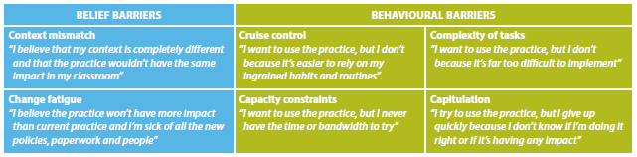

To change student outcomes, educators’ practice must move beyond this superficial engagement and surmount these barriers. System leaders, intermediary organisations and providers of professional learning must create conditions that cause educators to deeply understand and act on the conceptual underpinnings of the evidence. These conditions include a learning architecture that makes it easier to learn new evidence and a set of social learning processes that will make the evidence easier to spread through existing networks.

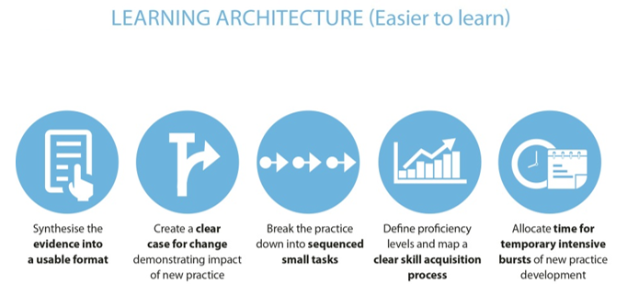
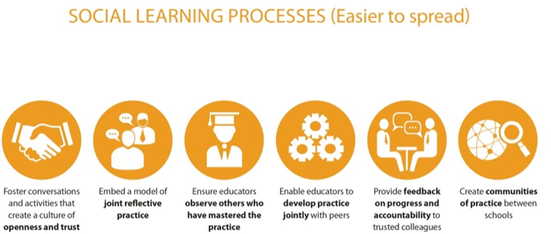

In creating these conditions, Honig and colleagues indicate that it is especially important that system leaders support these processes with financial and human resources and appropriate communication. They should also participate in the process. Otherwise, it is easy for practitioners to remain blocked by their barriers to change.
These conditions are consistent with those synthesised by Timperly and her colleagues, which outline the features of professional learning and development for teachers that have an impact on student learning outcomes. The findings overviews on pages xxvii, xxxii, xxxvi, and xl of the Synthesis are collectively a particularly useful summary.

How effective have the different jurisdictional approaches to facilitating education research been in building research capacity?

What lessons have been learned from their introduction?

Does one model stand out as a model for other jurisdictions to adopt?

We are responding to these questions as a group.
Through the Learning Impact Fund we are working with a number of state Departments of Education looking (in different ways) at co-funding independently administered RCTs on programs which they are currently supporting or are considering for future funding. In exploring the potential for each project, the Department has played a critical role; without their involvement, program developers would be unlikely to submit their program for an independent evaluation.

The involvement of Departments also send researchers a signal that randomised controlled trials are an important part of their decision-making process regarding significant program expenditure, which will give researchers the incentive to build their capacity to run randomised controlled trials.
In setting up our Learning Impact Fund and being explicit that we are interested in funding randomised controlled trials, we have had a number of research groups and organisations commit to developing their capacity to deliver RCTs (or to transfer their RCT delivery capacity into schools) so that they can be on our panel of evaluators. This has been in response to a small pool of funds ($4 million). If more significant funding for this type of research were available, research groups would have greater incentive to increase their capacity to deliver this kind of rigorous research.
This experience speaks to the importance of institutional structure and disciplinary culture in creating an environment in which randomised controlled trials are an important part of the norm. As Cook indicates, “The discipline-based difference in the frequency of experiments may also be due to political will and disciplinary culture. Random assignment is common in the health sciences because it is institutionally supported there by funding agencies, publishing outlets, graduate training programs, the clinical trials tradition, and practices in government health-action agencies”.
Finally, experience from the EEF in the UK and the NCRPP in the USA seems to show that one critical success factor for evidence brokers is their actual and perceived independence from governments or funders and operators of school systems. In overcoming the identified barriers to adoption of evidence based programs, it is seen as particularly important that the motivation of the promoters of the evidence are unimpeachable and untied to any particular outcome of the research or evidence that they report on and promote. Trust in the expertise and independence of those commissioning and conducting research trials is an important consideration. “In the policy realm, random assignment should be in independent hands and carried out by staff with a recent history of successful randomization in complex field settings.”

Section 5:
Institutions, data governance and prioritising reform

What data governance arrangements might work best

General response to questions on page 33
As we are not current owners or managers of educational data we are not well placed to make a detailed submission on the questions in this section. However, through Evidence for Learning’s Learning Impact Fund we seek to fund research trials that will rely on data gathered and managed in any future national evidence base.
Over the last three months, Evidence for Learning has been developing three randomised controlled trials on Australian educational programs, all focused on numeracy. In this work, having nationally comparable and large-scale data sets such as those generated from NAPLAN and ACER’s Progressive Achievement Tests (PAT) has made designing trials easier, in terms of both (1) data for selection prior to randomising and (2) relevant post-intervention data. This would also be true in literacy (NAPLAN & PAT) and science (PAT).
There are not similar tests in most other outcome areas, for example in other subject areas or the General Capabilities in the Australian Curriculum. Not having existing nationally comparable and large-scale data sets in these areas means that, in setting up RCTs, we would need to use outcome measures that were not widely known among education practitioners, which would mean evaluation results might be perceived as less relevant. Also, not having those data sets means that individual trials are more expensive.
We recognise the complexity and challenges associated with streamlining or normalising data governance arrangements. The trials that we seek to fund and run through Evidence for Learning would be a strong beneficiary from arrangements that enable nationally comparable data sets on student achievement.

Assessing costs and benefits to prioritise reform - questions page 33

What reforms are likely to be the most beneficial?
We agree with the Commission’s approach to prioritise reforms that will be most beneficial. As noted in other parts of this submission we recommend that the Commission be guided by determining which reforms will have the biggest impact on improving educational outcomes. Improving the quality of teaching in the classroom via effective approaches has the highest impact. So reforms that support this specific improvement agenda will yield the greatest benefit.
We submit that there are two reforms that offer large gains in improving the quality of teaching in the classroom:
- Filling the research gap of experimental evidence on the learning impact of programs and approaches being funded and used in schools, through an increase in funding and support for methods such as RCTs in schools. This would be best done by a body independent of governments.; and
- Ensuring evidence based practices are understood and adopted by educators through funding specific activities that improve frontline professionals’ engagement with evidence and ability to implement with impact.

How should reform options be prioritised?
All reform options should be evaluated against their specific impact on improving educational outcomes, their cost-effectiveness, and their feasibility. If a reform is expressed as general capacity or capability, the evaluation should include consideration of what other reforms or activities would be required in order for that reform to actually lead to improvements in educational outcomes.
How long would these reforms take to implement?
Both recommended reforms can be implemented in modest form relatively quickly, without requiring new national agreements or legislative changes and with the ability to scale or expand if they show effective improvements on educational outcomes.
- Improving the evidence base of effectiveness of ‘in-school’ programs through experimental trials (such as RCTs) can commence immediately through additional funding and support of initiatives like Evidence for Learning’s Learning Impact Fund. In modest form, the research trials can rely on the existing data sources, however as noted in this submission there are great opportunities for lower cost RCTs whenever administrative data is available for research purposes.
- Improving the likelihood of educators to engage with evidence can commence immediately through funding and promotion of evidence sources and they can use existing initiatives and programs, for example the response to TEMAG to include building evidence and data skills, AITSL to support improvement aligned to professional standards, and funding bodies like Evidence for Learning to disseminate and promote evidence.

Ministerial Council on Education, Employment, Training and Youth Affairs, 2008, The Melbourne Declaration, viewed 23 May 2016, <http://www.curriculum.edu.au/verve/_resources/National_Declaration_on_the_Educational_Goals_for_Young_Australians.pdf
Hattie, J 2003, ‘Teachers Make a Difference: What is the Research Evidence?’, Distinguishing Expert Teachers from Novice and Experienced Teachers, pp.2. viewed 23 May 2016, <https://www.det.nsw.edu.au/proflearn/docs/pdf/qt_hattie.pdf>
Productivity Commission 2016, ‘National Education Evidence Base’, Productivity Commission Issues Paper, pp.iii.
Ibid., pp.iii
Ministerial Council on Education, Training and Youth Affairs 2008, ‘Melbourne Declaration on Educational Goals for Young Australians’, MCEETYA.
Ministerial Council on Education, Training and Youth Affairs 2008, ‘Melbourne Declaration on Educational Goals for Young Australians’, MCEETYA.
Masters, G 2016, ‘Five Challenges in Australian School Education’, Policy Insights, pp. 5, figure 1.
Productivity Commission 2016, ‘National Education Evidence Base’, Productivity Commission Issues Paper, pp.iii.
See for example https://www.studentsfirst.gov.au/independent-public-schools/ and http://www.dec.nsw.gov.au/about-the-department/our-reforms/local-schools-local-decisions
Bentley, T. Cazaly, C. 2015, ‘The Shared Work of Learning: Lifting Educational Achievement Through Collaboration’, Mitchell Institute Research Report, pp.18; Lamb, S. Jackson, J. Walstab, A. & Huo, S. 2015, ‘Educational Opportunity in Australia 2015: Who succeeds and who misses out?’, Centre for International Research on Education Systems, Victoria University, for the Mitchell Institute, Melbourne, pp.v.
Australian Research Alliance for Children and Youth 2014, ‘The Nest action agenda’, viewed 24 May 2016, https://www.aracy.org.au/documents/item/182.
Hattie, J 2003, ‘Teachers Make a Difference: What is the Research Evidence?’, Distinguishing Expert Teachers from Novice and Experienced Teachers, pp.3. Viewed 20 May 2016, <https://www.det.nsw.edu.au/proflearn/docs/pdf/qt_hattie.pdf>
Leigh A. (2010) Estimating teacher effectiveness from two year changes in students’ test scores Economics of Education Review 29: 480-488.
PISA 2012 : how Australia measures up / Sue Thomson, Lisa De Bortoli, Sarah Buckley. p276
OECD 2009, ‘Improving School Leadership: The Toolkit’, OECD, viewed 20 May 2016, <http://www.oecd.org/edu/school/44339174.pdf>
Hattie, J 2003, ‘Teachers Make a Difference: What is the Research Evidence?’, Distinguishing Expert Teachers from Novice and Experienced Teachers, pp.3. Viewed 20 May 2016, <https://www.det.nsw.edu.au/proflearn/docs/pdf/qt_hattie.pdf>
See for example E. and L. Woessmann, L.. (2015), ‘Universal Basic Skills: What Countries Stand to Gain’, OECD Publishing, Paris. DOI, viewed 23 May 2016,:< http://dx.doi.org/10.1787/9789264234833-en>; OECD . (2010), ‘The High Cost of Low Educational Performance: The Long-run Economic Impact of Improving PISA Outcomes’, PISA, OECD Publishing, Paris. DOI, viewed 23 May 2016,: http://dx.doi.org/10.1787/9789264077485-en
Sharples, J 2013, ‘Evidence for the Frontline: A Report for the Alliance for Useful Evidence’, Alliance for Useful Evidence, pp.24.
Hattie, J 2015, ‘What Works Best in Education: the Politics of Collaborative Expertise’, Pearson, pp.15.
Bryk, A. 2015, ‘2014 AERA Distinguished Lecture: Accelerating How We Learn to Improve’, Educational Researcher, pp.473.
Productivity Commission 2016, ‘National Education Evidence Base’, Productivity Commission Issues Paper, pp.iii.
Steering Committee for the Review of Government Service Provision 2015, ‘Why Investments in Early Childhood Work’, Report on Government Services, Viewed on 20 May 2016, <http://www.theounce.org/who-we-are/why-investments-in-early-childhood-work>
A. Reynolds, et al. 2001, ‘Age 21 Cost-Benefit Analysis of the Title I Chicago Child-Parent Center Program - Executive Summary’, Chicago Longitudinal Study, Viewed 20 May 2016, <http://www.cehd.umn.edu/icd/research/cls/Cbaexecsum4.html >
Heckman, J 2016, ‘The Heckman Curve’, viewed 20 May 2016, < http://heckmanequation.org/content/resource/heckman-curve>
Australian Institute of Family Studies 2015, ‘’The Longitudinal Study of Australian Children: Annual Statistical Report 2014’, Melbourne AIFS, pp. 63, viewed 20 May 2016 <http://www.growingupinaustralia.gov.au/pubs/asr/2014/asr2014.pdf>
Mahuteau, S. & Mavromaras, K. 2013, ‘An Analysis of the Impact of Socioeconomic Disadvantage and School Quality on the Probability of School Dropout’, National Institute of Labour Studies, pp. 7, viewed 20 May 2016, <http://www.flinders.edu.au/sabs/nils-files/publications/working-papers/WP%20197.pdf>
Thomson, S. De Bortoli, L. and Buckley, S. 2013, ‘PISA in brief : highlights from the full Australian report : PISA 2012 : how Australia measures up’, Australian Council for Educational Research, pp. 21, viewed 20 May 2015, <http://research.acer.edu.au/cgi/viewcontent.cgi?article=1014&context=ozpisa>
Ibid., pp.18.
Ibid., pp.20
Burgess, V.2015, ‘Poor use of public sector data blocking success in the digital economy’, Financial Review, viewed 23 May 2016, http://www.afr.com/technology/poor-use-of-publicsector-data-blocking-success-in-the-digital-economy-20151202-gld9tq
National Schools Interoperability Program 2016, viewed 23 May 2016, < <http://www.nsip.edu.au/>
Productivity Commission 2016, ‘National Education Evidence Base’, Productivity Commission Issues Paper, pp.3.
Ibid., pp.4.
Ibid., pp.4.
Ibid., pp.4.
Bryk, A. ‘2015, ‘2014 AERA Distinguished Lecture: Accelerating How We Learn to Improve’, Educational Researcher, pp.473; Carnegie Foundation 2016, ‘The Six Core Principles of Improvement’, viewed 22 May 2016, <http://www.carnegiefoundation.org/our-ideas/six-core-principles-improvement/>
See http://nirn.fpg.unc.edu/
Productivity Commission 2016, ‘National Education Evidence Base’, Productivity Commission Issues Paper, pp.4.
Ibid., pp.7.
Field, F. 2010, ‘The Foundation Years: Preventing Poor Children Becoming Poor Adults’ Cabinet Office, London, viewed 23 May 2016 http://www.bristol.ac.uk/poverty/downloads/keyofficialdocuments/Field%20Review%20poverty-report.pdf
Hanushek, E. and Woessmann, L. 2015, ‘Universal Basic Skills: What Countries Stand to Gain’, OECD Publishing, Paris, viewed 23 May 2016, <http://dx.doi.org/10.1787/9789264234833-en>
See, for example, Leigh, A. (2008), ‘Returns to Education in Australia’ Economic Papers: A journal of applied economics and policy, 27: 233–249. doi: 10.1111/j.1759-3441.2008.tb01040.x
Santiago, P. Donaldson, G. Herman, J.Shewbridge, C. 2011, ‘OECD Reviews of Evaluation and Assessment in Education’,OECD, Australia,
Ministerial Council on Education, Training and Youth Affairs 2008, ‘Melbourne Declaration on Educational Goals for Young Australians’, MCEETYA, pp.8.
Assessment & Teaching of 21st Century Skills Project 2009-2012, viewed 23 May 2016, <http://www.atc21s.org>; Griffin, P. and Care, E. (Eds.), 2015, ‘Assessment and teaching of 21st Century skills: Methods and approach’, Dordrecht: Springer.
PISA 2015 Cycle
OECD 2011, ‘Against the Odds: Disadvantaged Students Who Succeed in School’, OECD Publishing, viewed 23 May 2016, <http://www.oecd.org/edu/school/programmeforinternationalstudentassessmentpisa/48373847.pdf>
Leslie Gutman, L. & Schoon, I. 2013, ‘The impact of non-cognitive skills on outcomes for young people: literature review’, Education Endowment Foundation, viewed 23 May 2016, <https://v1.educationendowmentfoundation.org.uk/uploads/pdf/Non-cognitive_skills_literature_review.pd>
Foundation for Young Australians 2015, ‘The New Work Order: Ensuring Young Australians have Skills and Experience for the Jobs of the Future, not the Past’, Alpha Beta, viewed 23 May 2016, <http://www.fya.org.au/wp-content/uploads/2015/08/fya-future-of-work-report-final-lr.pdf >
Foundation for Young Australians 2016, ‘The New Basics: Big data reveals the skills young people need for the new work order’, Alpha Beta, viewed 23 May 2016, <http://www.fya.org.au/wp-content/uploads/2016/04/The-New-Basics_Update_Web.pdf>
Vic Health & CSIRO 2015, ‘Bright Futures: Megatrends impacting mental wellbeing of young Victorians over the coming 20 years’, Victorian Health Promotion Foundation, Melbourne, viewed 23 May 2016, <https://www.vichealth.vic.gov.au/media-and-resources/publications/youth-megatrends-report >
ABS, 4261.6 Educational outcomes, experimental estimates, Tasmania, 2006-2013 (Released 28 July 2014) http://www.abs.gov.au/AUSSTATS/abs@.nsf/Latestproducts/4261.6Main%20Features12006-2013?opendocument&tabname=Summary&prodno=4261.6&issue=2006-2013&num=&view=; ABS, 4261.3 Educational outcomes, experimental estimates, Queensland 2011 (Released 15 December 2014) http://www.abs.gov.au/AUSSTATS/abs@.nsf/Latestproducts/4261.3Main%20Features12011?opendocument&tabname=Summary&prodno=4261.3&issue=2011&num=&view=.
Hanushek, E. 1995, ‘Outcomes, Costs, and Incentives in Schools’ in National Research Council Board on Science, Technology, and Economic Policy’, Improving the Performance of America’s Schools, pp. 41-46.
Ibid., pp.41-46.
Masters, G. N. (2013) Reforming educational assessment: Imperatives, principles and challenges, ACER, accessed 23 May 2016 available at: http://research.acer.edu.au/cgi/viewcontent.cgi?article=1021&context=aer p 3.
Black, P. and Wiliam, D. (1998) Inside the black box: Raising standards through classroom assessment, Granada Learning; Hattie, J. (2009) Visible learning: A synthesis of meta-analyses in education, Routledge, p 173; Goss, P., Hunter, J., Romanes, D., Parsonage, H., 2015, Targeted teaching: how better use of data can improve student learning, Grattan Institute p. 19 accessed 23 May 2016 available at https://grattan.edu.au/report/targeted-teaching-how-better-use-of-data-can-improve-student-learning/;
Bryk, A. 2015, ‘2014 AERA Distinguished Lecture: Accelerating How We Learn to Improve’, Educational Researcher, pp.473.
Education Endowment Foundation 2016, ‘Themed Rounds’, viewed 23 May 2016, <https://educationendowmentfoundation.org.uk/funding/closed-rounds/ >
Education Endowment Foundation 2016, ‘The Literacy Octopus: Communicating and Engaging with Research’, viewed 23 May 2016, <https://educationendowmentfoundation.org.uk/evaluation/projects/the-literacy-octopus-communicating-and-engaging-with-research/>
Education Endowment Foundation 2016, ‘Research Learning Communities’, viewed 23 May 2016, <https://educationendowmentfoundation.org.uk/evaluation/projects/research-learning-communities/>
Richardson, J. 2016, ‘Fidelity vs. flexibility’, Education Endowment Foundation, viewed 24 May 2016, https://educationendowmentfoundation.org.uk/news/fidelity-vs.-flexibility/.
Bryk, A. 2015, ‘2014 AERA Distinguished Lecture: Accelerating How We Learn to Improve, Educational Researcher, pp.??
Centre for Evidence Implementation 2016, Save the Children Australia, viewed 23 May 2016, <http://www.cei.org.au/>
Aarons, G.A. & Sawitsky, A.C. 2006, ‘Organizational Culture and Climate and Mental Health Provider Attitudes Toward Evidence-Based Practice,’ Psychological Services. Volume 3, issue 1, pp.:61-72.
Aarons, G.A. Ehrhart, M.G. & Farahnak, L.R. 2014, ‘Implementation Leadership Scale: Development of a Brief Measure of Unit Level Implementation Leadership’, Implementation Science, vol. 14, issue. 9, pp.?? viewed 23 May 2016, <http://www.ncbi.nlm.nih.gov/pubmed/24731295>
http://ncrpp.org/pages/our-work
http://ncrpp.org/assets/documents/NCRPP_Technical-Report-1.pdf
http://www.nfer.ac.uk/research/projects/measuring-support-for-pupil-progress--development-of-baseline-and-outcomes-surveys.cfm
Torgerson, C & Torgerson, D. 2016, ‘Randomised Trials in Education: An introductory handbook’, Education Endowment Foundation, viewed 23 May 2016, <https://educationendowmentfoundation.org.uk/public/files/Evaluation/EEF-RandomisedTrialsInEducationHandbook.pdf>
Haynes, L. Service, O. Goldacre, B. & Torgerson, D. 2012, ‘Test, Learn, Adapt: Developing Public Policy with Randomised Controlled Trials’, UK Cabinet Office, p. 31, viewed 23 May 2016, <https://www.gov.uk/government/uploads/system/uploads/attachment_data/file/62529/TLA-1906126.pdf>
Phonics programs focus on developing ‘phonemic awareness’, enabling students to identify sound patterns in English and decode new words by ‘sounding them out’ and ‘blending’ sound-spelling patterns. Research indicates a phonics approach is more effective on average than other approaches for teaching early reading, such as ‘whole language’ instruction, although other approaches may be more beneficial for struggling older readers. http://evidenceforlearning.org.au/toolkit/phonics/
Peer tutoring involves placing students in pairs or small groups to provide each other with support and feedback to consolidate classroom learning. Research studies have found peer tutoring benefits all students, regardless of whether they take on the role of tutor or tutee. http://evidenceforlearning.org.au/toolkit/peer-tutoring/
On average, students who repeat a year fall 4 months behind their peers of similar achievement levels who do not repeat. Students who repeat are not likely to catch up, even with the additional year of schooling, and are also more likely to drop out of school altogether. http://evidenceforlearning.org.au/toolkit/repeating-a-year/ In Australia, 8.4% of students repeat a grade at some stage of their schooling; OECD 2013, ‘Education Policy Outlook: Australia’, OECD Publishing, viewed 23 May 2016, <http://www.oecd.org/education/EDUCATION%20POLICY%20OUTLOOK%20AUSTRALIA_EN.pdf>; Romanes, D. & Hunter, J. 2015, ‘Grade Repetition: There are Better Ways to Move Kids Forward than by Holding them Back’, The Conversation, viewed 23 May 2016, <https://theconversation.com/grade-repetition-there-are-better-ways-to-move-kids-forward-than-by-holding-them-back-47269>
Coalition for Evidence-Based Policy2013, ‘Randomized Controlled Trials Commissioned by the Institute of Education Sciences Sicne 2002: How many found positive versus weak or no effects’, viewed 23 May 2016, <http://coalition4evidence.org/wp-content/uploads/2013/06/IES-Commissioned-RCTs-positive-vs-weak-or-null-findings-7-2013.pdf>
See, for example, OECD 2010, ‘Improving Health and Social Cohesion through Education, Educational Research and Innovation’, OECD Publishing, Paris. DOI, viewed 23 May 2016, <http://dx.doi.org/10.1787/9789264086319-en>; Grossman, M. and R. Kaestner (1997), “Effects of education on health”, in: J.R. Behrman and N. Stacey, eds., The Social Benefits of Education (University of Michigan Press, Ann Arbor, Michigan) 69-123.
Rosen, L. Manor, O. Engelhard, D. & Zucker, D. 2006, ‘In Defense of the Randomized Controlled Trial for Health Promotion Research’, American Journal of Public Health, volume 96, no.7, pp.1181–1186, viewed 23 May 2016, <http://www.ncbi.nlm.nih.gov/pmc/articles/PMC1483860/>
Haynes, L. Service, O. Goldacre, B. & Torgerson, D. 2012, ‘Test, Learn, Adapt: Developing Public Policy with Randomised Controlled Trials’, UK Cabinet Office, pp. 15-16, viewed 23 May 2016, <https://www.gov.uk/government/uploads/system/uploads/attachment_data/file/62529/TLA-1906126.pdf>; Rosen, L. Manor, O. Engelhard, D. & Zucker, D. 2006, ‘In Defense of the Randomized Controlled Trial for Health Promotion Research’, American Journal of Public Health, volume 96, no.7, pp.1181–1186, viewed 23 May 2016, <http://www.ncbi.nlm.nih.gov/pmc/articles/PMC1483860/>
Coalition for Evidence-Based Policy 2013, ‘Demonstrating how low-cost randomised control trials can drive effective social spending’, viewed 23 May 2016, <http://coalition4evidence.org/wp-content/uploads/2014/02/Low-cost-RCT-competition-December-2013.pdf>; Haynes, L. Service, O. Goldacre, B. & Torgerson, D. 2012, ‘Test, Learn, Adapt: Developing Public Policy with Randomised Controlled Trials’, UK Cabinet Office, pp. 15-16, viewed 23 May 2016, <https://www.gov.uk/government/uploads/system/uploads/attachment_data/file/62529/TLA-1906126.pdf>
Ibid., pp.15-16.
Coalition for Evidence-Based Policy 2013, ‘Demonstrating how low-cost randomised control trials can drive effective social spending’, viewed 23 May 2016, <http://coalition4evidence.org/wp-content/uploads/2014/02/Low-cost-RCT-competition-December-2013.pdf>
Fryer, R.G. 2011, ‘Teacher Incentives and Student Achievement: Evidence from New York City Public Schools’, National Bureau of Economic Research Working Paper 16850, pp.5-6, viewed 23 May 2016, <http://www.nber.org/papers/w16850.pdf>; Coalition for Evidence-Based Policy 2013, ‘Demonstrating how low-cost randomised control trials can drive effective social spending’, viewed 23 May 2016, <http://coalition4evidence.org/wp-content/uploads/2014/02/Low-cost-RCT-competition-December-2013.pdf>
Haynes, L. Service, O. Goldacre, B. & Torgerson, D. 2012, ‘Test, Learn, Adapt: Developing Public Policy with Randomised Controlled Trials’, UK Cabinet Office, viewed 23 May 2016, <https://www.gov.uk/government/uploads/system/uploads/attachment_data/file/62529/TLA-1906126.pdf>
Haynes, L. Service, O. Goldacre, B. & Torgerson, D. 2012, ‘Test, Learn, Adapt: Developing Public Policy with Randomised Controlled Trials’, UK Cabinet Office, pp. 26-27, viewed 23 May 2016, <https://www.gov.uk/government/uploads/system/uploads/attachment_data/file/62529/TLA-1906126.pdf>
Cook, T. D. 2002, 'Randomized Experiments in Educational Policy Research: A Critical Examination of the Reasons the Educational Evaluation Community has Offered for not Doing Them,' Educational Evaluation and Policy Analysis, Vol. 24, No. 3, pp. 176-7, viewed 22 February 2016, <http://www.jstor.org/stable/3594164.>
Timperly, H. Wilson, A. Barrar, H. & Fung, I. 2007, ‘Teacher Professional Learning and Development: Best Evidence Synthesis Iteration’, Iterative Best Evidence Synthesis Program, Wellington, New Zealand: Ministry of Education, viewed 20 May 2016 <https://www.educationcounts.govt.nz/__data/assets/pdf_file/0017/16901/TPLandDBESentireWeb.pdf>
Elmore, R. 2002, ‘Bridging the Gap Between Standards and Achievement: The Imperative for Professional Development in Education’, Washington, DC: Albert Shanker Institute; Jensen, B. Hunter, J. Sonnemann, J. and Cooper, S. 2014, ‘Making time for great teaching’, Grattan Institute.
Honig, M.I. Venkateswaran, N. McNeil, P. & Twitchell, J.M. 2014, ‘ Leaders’ Use of Research for Fundamental Change in School District Central Offices: Processes and Challenges,’ in K.S Finnegan and A.J. Daly, eds. Using Research Evidence in Education: From the Schoolhouse Door to Capitol Hill, Springer International Publishing, pp.37-52.
Timperly, H. Wilson, A. Barrar, H. & Fung, I. 2007, ‘Teacher Professional Learning and Development: Best Evidence Synthesis Iteration’, Iterative Best Evidence Synthesis Program, Wellington, New Zealand: Ministry of Education, viewed 20 May 2016 <https://www.educationcounts.govt.nz/__data/assets/pdf_file/0017/16901/TPLandDBESentireWeb.pdf>
http://www.abs.gov.au/ausstats%5Cabs@.nsf/0/9448F2F814FA0311CA2579C700118E2D?Opendocument
http://www.abs.gov.au/ausstats/abs@.nsf/Latestproducts/4221.0Main%20Features502015?opendocument&tabname=Summary&prodno=4221.0&issue=2015&num=&view=
‘Funding for disadvantaged pupils’ UK National Audit Office 29 June 2015 page 9 https://www.nao.org.uk/report/funding-for-disadvantaged-pupils/
See for example, Appleton S, Atherton P and Bleaney M. ‘International School Test Scores and Economic Growth’ 2008 Centre for Research in Economic Development and International Trade Research Paper No 08/04 available at https://ideas.repec.org/p/not/notcre/08-04.html; Altinok, N. (2007). Human Capital Quality and Economic Growth. Institute for Research in Sociology and Economics of Education Working Paper No. DT 2007/1, Paris. Available at https://hal.archives-ouvertes.fr/halshs-00132531v1/document; Barro R. ‘Education and Economic Growth’ in Helliwell J. F. The Contribution of Human and Social Capital to Sustained Economic Growth and Well-Being. OECD 2001.
Education Endowment Foundation 2016, ‘Teaching Assistants’, Education Endowment Foundation, viewed 23 May 2016, https://educationendowmentfoundation.org.uk/evidence/teaching-learning-toolkit/teaching-assistants/ Maximising the Impact of Teaching Assistants 2016, ‘Research: The Deployment and Impact of Support Staff’, viewed 23 May 2016, http://maximisingtas.co.uk/research/the-diss-project.php Education Endowment Foundation 2016, ‘Six of the best: how our latest reports can help you support teaching assistants to get results’, Education Endowment Foundation, viewed 23 May 2016, https://educationendowmentfoundation.org.uk/news/six-of-the-best-how-our-latest-reports-can-help-you-support-teaching-assist/ Sharples, J. Webster, R. & Blatchford, P. 2015, ‘Making the Best Use of Teaching Assistants: Guidance Report’, Education Endowment Foundation, viewed 23 May 2016, https://educationendowmentfoundation.org.uk/public/files/Publications/Campaigns/TA_Guidance_Report_MakingBestUseOfTeachingAssisstants-Printable.pdf? Education Endowment Foundation 2016, ‘Making the Best Use of Teaching Assistants: A Self-Assessment Guide’, Education Endowment Foundation, viewed 23 May 2016, https://educationendowmentfoundation.org.uk/public/files/Publications/Campaigns/TA_RAG_SelfAssessmentGuide.pdf National Audit Office 2015, ‘Funding for disadvantaged pupils’, UK National Audit Office, pp.9, viewed 23 May 2016
OECD, E. Hanushek and L. Woessmann. (2015), Universal Basic Skills: What Countries Stand to Gain and OECD E. Hanushek and L. Woessmann. (2010), The High Cost of Low Educational Performance
OECD 2015, p 50. The authors modelled the impact over an 80 year period to correspond to average life expectancy at the outset of the reform. The value of the reform is the discounted value of future increases in GDP until 2095 due to the reform, expressed in US dollars (PPP). The authors modelled the impact over an 80 year period to correspond to average life expectancy at the outset of the reform.
OECD 2015, p 63. The value of the reform is the discounted value of future increases in GDP until 2095 due to the reform, expressed in US dollars (PPP). In Australia’s case, ensuring all students achieve universal basic skills at PISA’s minimum standard of proficiency would imply an increase in Australia’s PISA score of around 10 points.
OECD 2015, p 11
Jensen B. 2010 Investing in our teachers, investing in our economy, Grattan Institute, Melbourne, pp 17-18.
OECD . (2010), ‘The High Cost of Low Educational Performance: The Long-run Economic Impact of Improving PISA Outcomes’, PISA, OECD Publishing, Paris. DOI, pp.9, viewed 23 May 2016,:
OECD,. (2010), ‘Improving Health and Social Cohesion through Education, Educational Research and Innovation’, OECD Publishing, Paris. DOI. viewed 23 May 2016,:< http://dx.doi.org/10.1787/9789264086319-en>
National Schools Interoperability Program 2016, viewed 23 May 2016, < <http://www.nsip.edu.au/>
Penuel, W.R. & Coburn, C.E. 2014, ‘“Introduction to Part: Research Use at the School and District Level,’ in K.S. Finnigan & A.J. Daly, eds, Using Research Evidence in Education: From the Schoolhouse Door to Capitol Hill, Springer International Publishing, pp. 10.
ibid., pp. 9.
Granger, R.C. 2014, ‘Foreword’, Using Research Evidence in Education: From the Schoolhouse Door to Capitol Hill, in K.S. Finnegan and A.J. Daly, eds, Springer International Publishing, pp. ix.
ibid., pp. vii.
Honig, M.I. Venkateswaran, N. McNeil, P. & Twitchell, J.M. 2014, ‘Leaders’ Use of Research for Fundamental Change in School District Central Offices: Processes and Challenges,’ in K.S Finnegan and A.J. Daly, eds. Using Research Evidence in Education: From the Schoolhouse Door to Capitol Hill, Springer International Publishing, pp.37.
Social Ventures Australia 2014, ‘Overcoming Barriers to Spreading Effective Practice,’ Social Ventures Australia, viewed on 18 May 2016: http://socialventures.com.au/assets/SVA-Education_Overcoming-Barriers-to-Spreading-Effective-Practice.pdf
Bush, J. 2014, ‘Spreading What Works in Education,’ SVA Quarterly, Issue 11, viewed 18 May 2016, <http://www.socialventures.com.au/sva-quarterly/spreading-what-works-in-education/ >
Honig, M.I. Venkateswaran, N. McNeil, P. & Twitchell, J.M. 2014, ‘Leaders’ Use of Research for Fundamental Change in School District Central Offices: Processes and Challenges,’ in K.S Finnegan and A.J. Daly, eds. Using Research Evidence in Education: From the Schoolhouse Door to Capitol Hill, Springer International Publishing, pp. 37-8.
Timperly, H. Wilson, A. Barrar, H. & Fung, I. 2007, ‘Teacher Professional Learning and Development: Best Evidence Synthesis Iteration’, Iterative Best Evidence Synthesis Program, Wellington, New Zealand: Ministry of Education, viewed 20 May 2016 <https://www.educationcounts.govt.nz/__data/assets/pdf_file/0017/16901/TPLandDBESentireWeb.pdf>
Cook, T.D., 2002, 'Randomized Experiments in Educational Policy Research: A Critical Examination of the Reasons the Educational Evaluation Community has Offered for not Doing Them,' Educational Evaluation and Policy Analysis, Vol. 24, No. 3, pp.183. viewed 22 February 2016, <http://www.jstor.org/stable/3594164>.
Education Endowment Foundation viewed 23 May 2016, < https://educationendowmentfoundation.org.uk/>
National Centre for Research in Policy and Practice, viewed 23 My 2016, <http://ncrpp.org/>
Cook, T.D. 2002, 'Randomized Experiments in Educational Policy Research: A Critical Examination of the Reasons the Educational Evaluation Community has Offered for not Doing Them,' Educational Evaluation and Policy Analysis, Vol. 24, No. 3, pp.184, viewed 22 February 2016 <http://www.jstor.org/stable/3594164>.
Hattie, J 2003, ‘Teachers Make a Difference: What is the Research Evidence?’, Distinguishing Expert Teachers from Novice and Experienced Teachers, pp.3. Viewed 20 May 2016, https://www.det.nsw.edu.au/proflearn/docs/pdf/qt_hattie.pdf

