PART 1.
My name is Anna Yanga. My birthdate is XX XXXXXX 1992. I live with my Mum- Pat and Dad- Nap. They and big sister- Margarita are important in my life. I complete this story with help from my Mum.

I have been in the SLF program (Supported Living Fund) since 2013 (I was then 21 years old), then went into the NDIS system since September 2016. Being recipient of SLF Funding made it easy to transition to NDIS. My programs simply continued. These programs are geared to reach my goal of living independently or semi- independently in a small place like a granny flat or apartment.
My story: I am now 25 years old. I have autism and am non-verbal. I live at home with my family. I attend Day Programs at Flintwood Castle Hill (Salisbury Site) 3 times a week. I also go out in the community on weekends. I like Art and Music. I also like reading books, Writing, Maths, ABC22 and The Wiggles. I also like doing chores such as food preparation and cooking. My most favourite thing is shopping in malls. I can do lots of things now! I wasn't always like this. Now I participate more- at home and in the community.
As a child and up to age 20 I cried a lot. I was upset most times. I was so frustrated that I could not communicate. I could not communicate when I was in pain and where it hurts. I just constantly cried and showed my frustration by self harming- bashing my face and violently hitting my head on the walls. At age 18, I bashed my mum who was closest to me because of frustration. And also scratched and squeezed people who were in my way when I was very upset and angry. Why did not my mum understand me? She was the closest person to me, she should know me well. Mum was so hurt and feeling inadequate that she asked the social worker to put me in their list for supported accommodation. But this idea made mum so very sad that she needed help herself as she felt like losing her mind. Deep inside, she could not live without me.
Mum called ASPECT for specialized help. The Behaviour Intervention Service (BIS) for adolescents, at that time helped sort us out. They offered counselling and special training program called 'RECIPE FOR SUCCESS'. The team of 2 professionals guided us closely through the process. We had regular meetings with all the services involved in Anna's life, such as home and health, school, respite, music therapy and later, day programs. We drew a holistic care plan where the centre is Anna and her individual/ particular needs. It was not simply a behaviour management plan because first and foremost the behaviours occur as a result of a need. The function of the behaviour is to express a need. If the difficulties were removed, there would be no behaviour. So we started by getting medical examinations of myself. True enough there were issues- impacted molars needed to be removed, we found out my left eye could not see due to cataracts (so young for cataracts, why?). Eczemas were giving me lots of discomfort .It was too noisy at home- mum and dad were always quarrelling- they were very tired and frustrated as they couldn't stop working due to financial obligations. They needed to focus on me more. I needed full time attention. I still do.
My medical issues have now been sorted. My impacted molars have been removed in an operation at Nepean Hospital. While there, mum asked for a scan of my brain to see if everything is all right after years of banging my head on walls. That was all good. I was taken to an immunologist to sort out my eczemas. It was found out that I have a skin condition- atopic dermatitis. We are now able to manage this condition with the specialist's recommendations. Foremost is to constantly moisturize and avoid heat and direct sunlight on my affected skin. Mould and grass give me rash and hives. Now I know what to avoid. Since little, mum had used creams and cortisone on me.
In Feb 2016 the eye specialist did further test on the health of my eyes. It was found out that I did not always have cataracts. They could have been brought about by the use of cortisone for years on my skin. I will undergo a surgery next week to extract the cataracts on my left eye and replace it with an intraocular lens. We are all hoping that this will improve my quality of life. I use my right eye a lot in training- reading, watching, painting, playing music, cooking, shopping and doing Maths. I do lots of close-up desk work. I'm excited with the result of my surgery. Hope all goes well.
Things I like: Let me tell you about the things that I love and how I'm tracking. With the NDIS fund, I have been able to attend a lot more training and therapies to try and achieve my personal goals. I now regularly do Art such as Drawing and Painting under Janet Foster Artist. I now have Speech Therapy every Tuesday as well. During the past year I have learned lots of signs and have learned to use the IPad to communicate. I'm a wizz at making my own visuals with 'SEE ME TALK' app. I download photos from google and draw pictures myself with Crayola Tools on IPad to use as pictures for my visuals in SEE ME TALK. I have regular everyday exercises on my treadmill and exercise bike which my neurologist had advised. My epilepsy medicine make me gain weight easily. I also do a lot of walking inside shopping centres. Walking in open field is bad for my allergies and dermatitis. I suffer a lot when I get sinusitis and it makes me hit my face. Back to Speech, this year I'm learning more about 'feelings' and 'sentences'. I'm also very interested with money skill as I do a lot of shopping- one of my favourite things! In Music I'm learning to make sounds and make lovely music with instruments. I really enjoy it. After my therapists had a talk with us, we agreed that I will learn about 'feelings' in both sessions.
In the past couple years I have had lots of improvement, there are 4 main highlights: I have attended 4 night parties, I have performed in Flintwood's EOY Concert 2 years in a row, I've had an Art exhibition and I mastered counting Australian money! In Dec 2015 at the Flintwood's EOY Concert, a whole segment was dedicated to my recent experiences and achievements in Art and Speech. In Dec 2016, I performed in a musical, 'Mary Poppins' where I was the cook. I talked with my IPAD. I got to wear great costumes in the dialogs and dance numbers.
In Music I try to sing on the microphone. I am able to produce some sounds. Songs that my therapist and I sing are: Good morning to Anna, So Good, Shout, You Can Call on Me, Jingle Bells, Goodbye to Anna and heaps more! At Speech I'm learning sentences, things around the house, things boys and girls wear, telling time and weather, greetings, celebrations and following directions. Once a week I have a tutor who help me improve in my writing and all lessons from Speech. The tutor also teach me domestic chores.
We have had a lot of positive great results for the year 2016 from all the programs Mum has organized for me to try and achieve my goals in Art, Money Skill, Health, Well-being, Communication, Confidence and Happiness. In this next year which we've entered, we would like to gear a bit closer again to the ultimate goal of Independence. That is, Anna will continue with her loved programs of Art Therapy and some serious Painting sessions there too. Also Music Therapy where she is now giving out more sounds in her vocalization/singing exercises. In Music she is also learning to take turns and exercise listening all of which are preparation for speech. Will Anna be able to talk later on? It is possible according to her speech therapist. Anna will also continue to attend Speech Therapy where a milestone has been reached. She can now understand the monetary value of the Australian coins and bills. She can add quite well and now she is fast learning subtraction, so she is learning how to give change in her shopping exercises. Anna loves her Ipad. The few apps we have bought in the last 2 years are still serving her well. Actually she is still learning most of them. 'See Me Talk' app is the best. Anna can now let us know of her choices, wants, feelings- at home and in the community. The 'Fun with Directions' app is helping Anna build her listening skills and follow directions. Her teachers/therapists say that she is so motivated to learn. Her calm behaviour is making way for her unprecedented learning. This coming year we will give lots of accomodation to improve Anna's health. Already the fitness exercises are making her aware of 'good posture'. Anna's cataracts in both eyes sometimes pose a challenge to her love of close-up work such as drawing, colouring, painting and writing and ipad games. The specialist ordered deeper eyeglasses to her usual ones to help support her sight. We are monitoring her eyes as well as her teeth and gums (dental). We apply QV Cream on Anna 6 times a day (twice on entire body and 4x on the upperbody) to manage her dermatitis. We are avoiding use of cortisones all together as they helped not just in damaging Anna's skin more but also her sight. Lots of hard work and dedication required but we reap rewards when we see Anna give smiles.
So you see, with all the training funded by the NDIS, Anna has gone from NO PARTICIPATION TO FULL PARTICIPATION in all aspects of everyday life; from the sad frustrated individual she was to a busy happy person with new found confidence. Hopefully we can continue on this year and in the future until Anna gains independence.
Thank you for all the support.
ANNA YANGA with Mum PAT.
PART 2: About Anna and her Art.

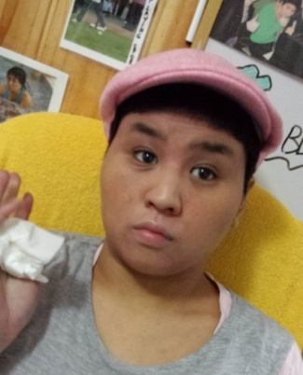
About Anna
Anna 25, was born with severe autism. She is tactile defensive and non-verbal. Anna is now a happy young woman in her life's journey. Until late her life has been far from the same. Anna is now getting help like never before through the NDIS. There are many people who love and support her to achieve her goals in life.
About Anna's Art
Anna has been doing Art with Janet for 2 years now. She started with Clay Art which she found a bit of a struggle because she is tactile defensive. Nonetheless, she liked rendering color to her projects by ‘glazing’ them and seeing the finished product. She’s very good with the brush. She paints every single day!
She has learned some techniques from Janet such as ‘outlining’ to bring out an object in the painting. She has also learned to combine primary colors to produce secondary colors and tertiary colors. Together they have experimented with different medium to produce unique effects and texture in the painting.
Shapes and balloons are prominent in Anna’s art. She is most confident drawing them and moulding clay into shapes. However with some encouragement she can go outside that comfort zone and draw other subjects like faces, animals, insects and vegetation. She also likes to choose and copy images from pictures by free hand.
Art is really close to Anna’s heart. Like any woman she loves shopping, but she mostly buys art materials such as paints, brushes and projects such as ‘paint by number’ and colorful craft. Bubbles and balloons also make Anna very happy.
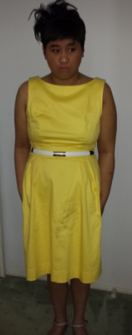
When it comes to painting, Anna’s concentration is enormous. She can just go on and on and on and on. We’re so glad we let Anna give Art Therapy a go. It has added new dimension to her sense of purpose and enjoyment.

PART 3: Anna's newly found confidence in pictures.

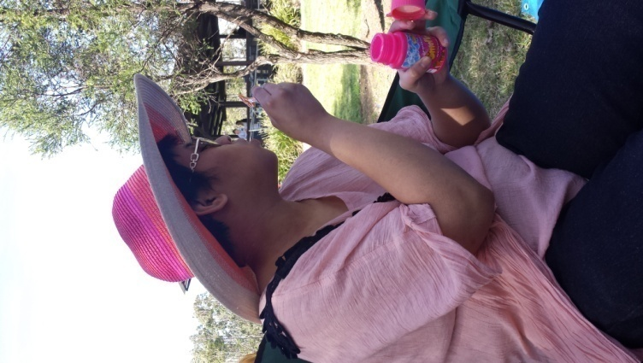
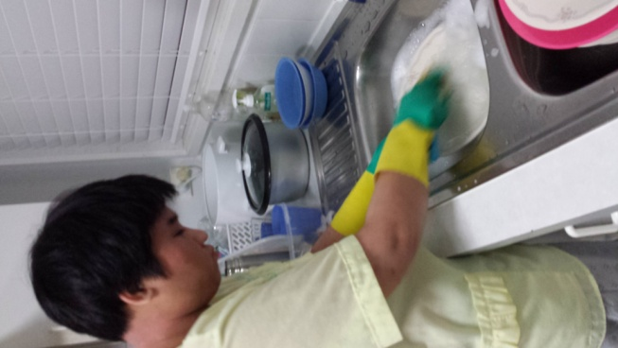
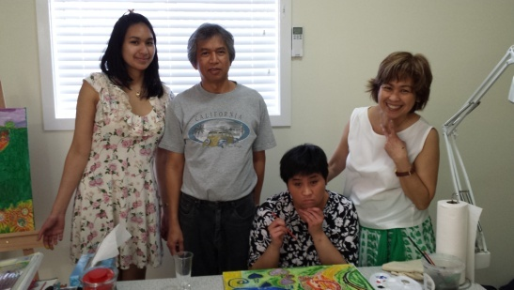
A budding artist.
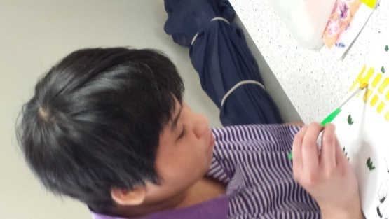
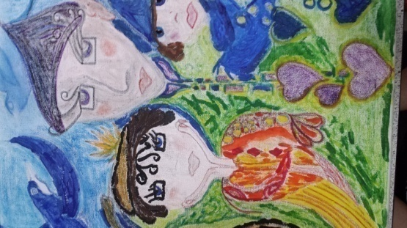
Since Anna's sister moved out, she took over the chore of washing dishes for the family. Her training paid off.
Anna loves to blow bubbles. She likes it when kids chase and try to pop them. Also calming for her.

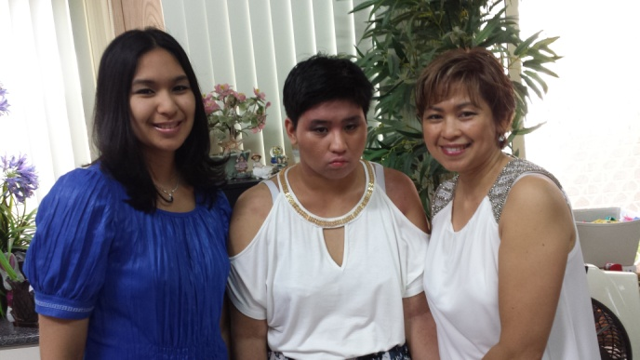
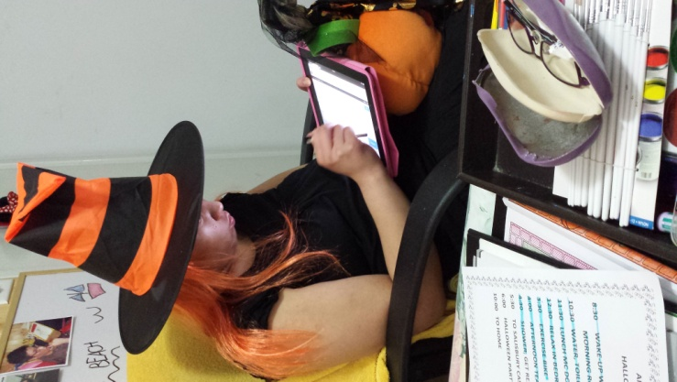
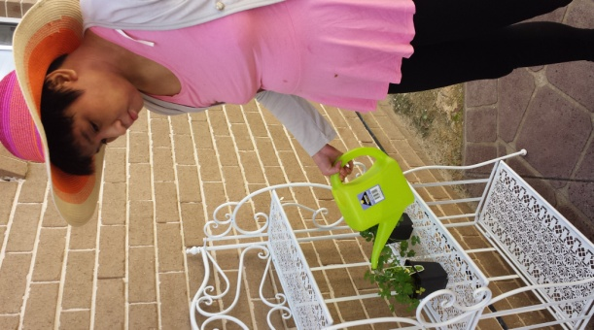
Ready for the Witches' Ball.
To the Christmas Party!
We have a grassless garden for Anna to look after.
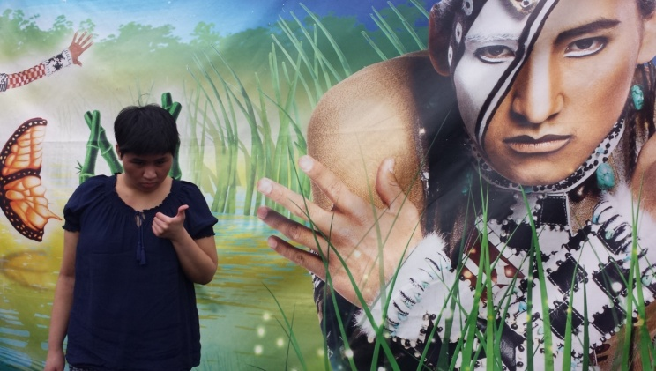
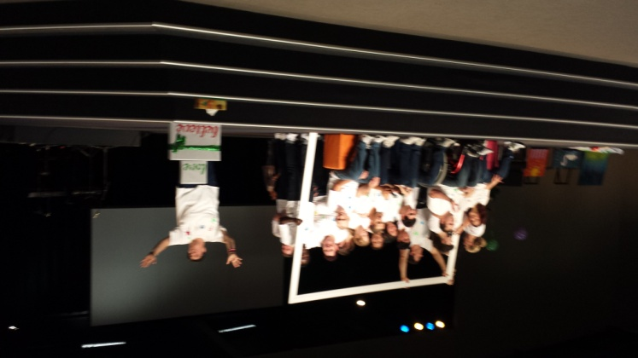

Anna performed on stage!
Anna at 'Cirque du Soleil'.

