Evaluating Reforms of Workplace Relations
John Freebairn
Many of the potential reforms of the Workplace Relations Framework, and in particular changes to minimum wages and penalty rates considered in the Productivity Commission Issue Paper 2, which offer improvements in aggregate economic efficiency will also create some losers as well as winners. It is important to include an assessment of the redistribution effects of such reforms. This submission offers a simple economic model framework to assess the wage and employment effects, and the efficiency and redistribution effects, of lower minimum wages and lower penalty rates.
- Model
A simple model has a labour demand and supply function, and a product pricing function. In practice the labour functions could refer to the aggregate labour market or to specific components such as for the low paid directly affected by minimum wages or those working non-standard hours affected by penalty rates. Similarly the product pricing function could refer to an aggregate of all goods and services or to more specific categories of products which are relative intensive users of low wage employment or of non-standard hours employment.
Labour demand, D, depends on a number of variables including labour costs to the employer, labour productivity, the macroeconomic state of the economy, other factor input costs. Employer labour costs include not just wages paid to employees, W, but also labour on-costs of employer superannuation, payroll tax, workers compensation, leave provisions, and costs of hiring, training and firing. Labour productivity depends on employee human capital, capital and technology, and flexibility of the industrial relations system. Clearly, many other dimensions of government policy, including different aspects of policy affecting workplace relations discussed in the Productivity Commission Issues Papers, in addition to regulations on W can affect labour demand.
Labour supply, S, depends on a number of variables including the employer paid wage, W, direct and indirect taxes on the employee which reduce private purchasing power, social security payments, both rates and eligibility conditions affecting unemployment income, other sources of income, education and other demographic factors. Again, different dimensions of government policy in addition to wage regulations can and do influence labour supply.
A competitive market with flexible wages would equate labour demand, D, to labour supply, S, to determine employment, E, and the wage rate, W. Note that long run equilibrium would include a component of frictional and structural unemployment, often referred to as the natural rate of unemployment or the non-accelerating rate of inflation unemployment. The simple model expressing labour demand, D = f(W; other things constant), and labour supply, S =f(W; other things constant), is illustrated in Figure 1.

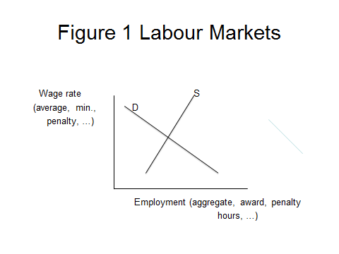
In a market based economy prices for goods and services, P, are set with reference to costs of production, including labour costs, and their main component wages, W. Other explanatory variables for product prices include costs of materials, capital and other inputs, and technology. In longer run competitive equilibrium, and also for many forms of market power models, changes in wages per unit product are passed forward approximately 100 per cent as changes in product prices. That is, there is a price-cost function of the form P = f(W; other things constant).
- Regulated Wages
Suppose the Workplace Relations Framework includes regulations setting the market wage above the market clearing wage; if the regulated wage is below the market wage the regulation becomes a non-binding or ineffectual constraint. The regulation could be the minimum wage, and likely with some flow-on increase to other lower level award wages, or penalty rates for some categories of non-standard hours of employment (but not necessarily all categories).
Figure 2 builds on Figure 1 to illustrate. The long run equilibrium market clearing labour market equates labour demand, D, and supply, S, for employment level E and wage rate W. Binding wage regulations set a higher wage, W’ > W. The higher wage in turn generates a fall in employment from E to E’, and an increase in unemployment of E – E’.
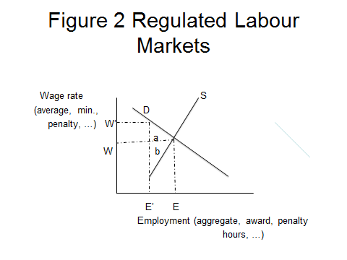
The following redistribution and efficiency effects of lower regulated wages than otherwise can be noted:
- Those currently employed on the binding wage, the insiders, lose some of their remuneration, namely by the amount of the regulated wage reduction, W’ – W
- Those newly employed at the lower wage who gain employment, E – E’, are better off. With employment they gain in net the triangle b. Arguably they gain even more from participation in “regular” society. The magnitude of the employment gain will be larger the more elastic demand, and clearly as noted in the Issues Papers there is much uncertainty about this parameter, and the larger the regulated wage above the market clearing wage.
- The lower wage flows into lower production costs, and with competitive markets lower product prices, particularly for products which are relatively intensive users of minimum wage or penalty rate paid employees; competition among firms means very little if any of the lower wage will be retained as higher profits in the long run. The net efficiency gain from lower prices is given by triangle a. That is, some of the benefits of less binding wage restrictions are passed on to all households as lower prices for goods and services.
- A net national efficiency gain of the triangle a plus b.

- Further Observations
At least two other points are worth making about redistribution effects of the current regulations on wages in Australia.
First, minimum wages initially introduced in the Harvestor case were for a very different world to today. There was very little in the way of a social security system and no income tax system. These systems are more direct and effective instruments for achieving society equity goals than regulated minimum wages. ABS and HILDA data shows that about a half of low wage employees are in middle and high income families. While early 20th century employment primarily was full-time employment, today about 30 per cent of the workforce have part-time employment, and they are over represented among those on minimum wages and receiving penalty rates on weekends. Changes in social attitudes and growth of the 24/7 economy mean that the perceived cost of employment, and shape of the labour supply curve, for weekend work and evenings have worked to reduce the required incentives to work outside the Monday to Friday, 8am to 6pm hours, time period; but with less effect for night shifts.
Second, the foregoing simple model misses some important life cycle dynamics. For a share of the low paid, observed low pay employment now is part of an investment in human capital that leads to much higher paying careers in the future. For some of those denied employment by too high regulated wages, the opportunity to acquire human capital and future average or above wages is lost.
- Conclusion
Reducing regulated minimum wages and penalty rates which hold wages above their market clearing rate would result in a net efficiency gain. But also, lower wages would involve a very visible loss to insiders. By contrast, those who benefit, including not only those who gain employment, and for some of these the chance to accumulate human capital and higher future wages, but also the general public gain from lower product prices and higher real wages, are less obvious and understood in the national debate.
Modern Australia with its progressive income tax and social security systems has more direct and effective instruments to address society equity objectives than the minimum wage instrument. A strategy of reducing minimum wages and penalty rates may need to consider a broader reform package involving complementary changes to these more direct redistribution policy levers.

