IEUA
Independent Education Union of Australia

Response to the Productivity Commission draft report on Education Evidence Base

October 2016

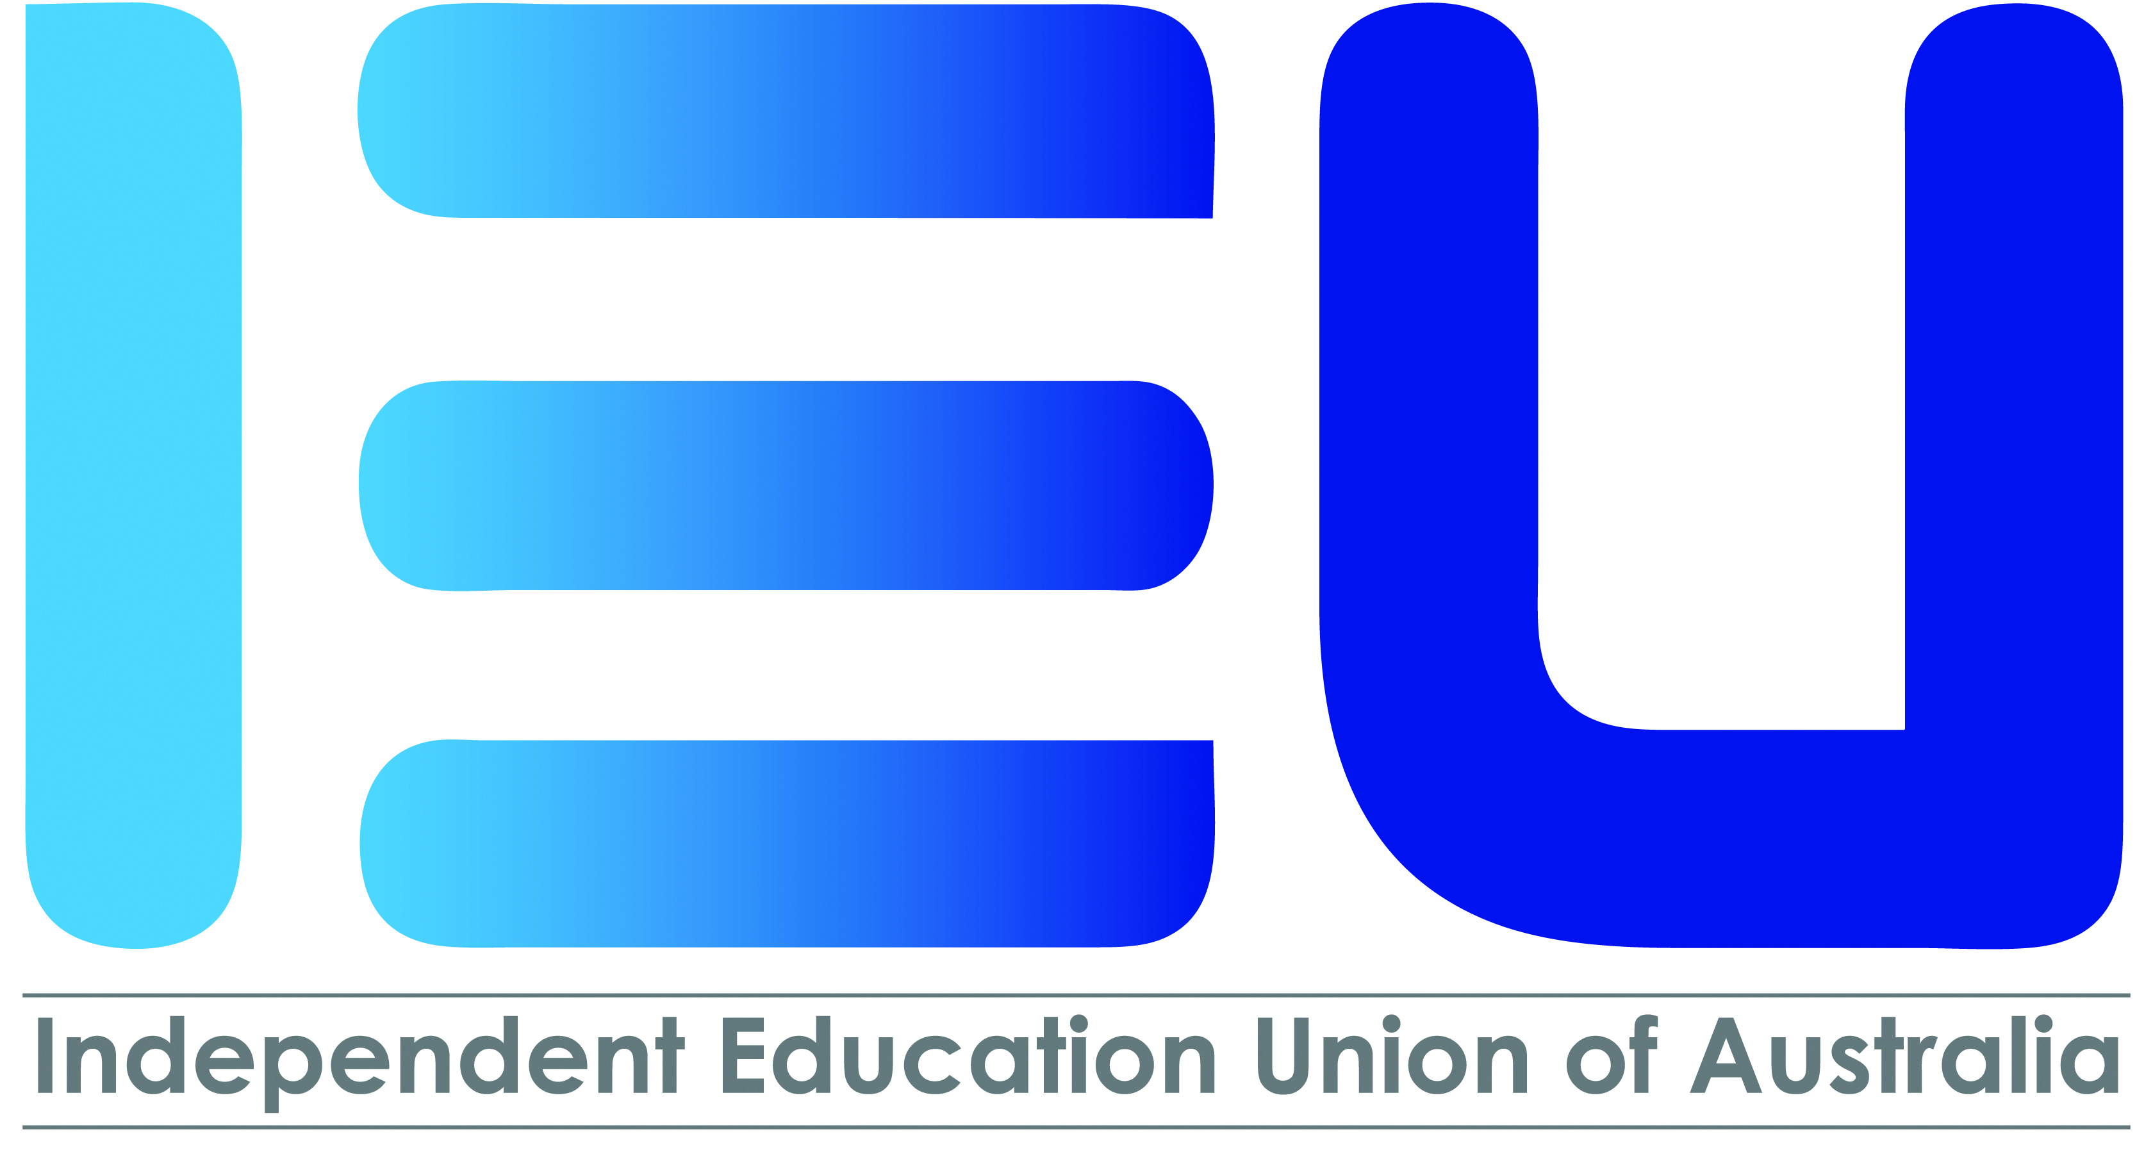

Introduction

- The Independent Education Union of Australia (IEUA) is pleased to have the opportunity to make a response to the Productivity Commission draft report on Education Evidence Base.

- The IEUA is the federally registered union that represents workers, including teachers, principals, and school support staff, in Catholic, other faith-based and community independent schools across all the states and territories of Australia. While the majority of members of the IEUA are teachers, the membership of the IEUA also consists of workers engaged as teacher aides, administrative staff, gardeners, cleaners and caterers.

- Membership of the IEUA is also diverse in respect to the types of workplaces included in its coverage. These range from very large schools with significant resources to extremely small rural schools with very limited resources. The variety of schools represents great diversity. These include a wide variety of faith based and non-denominational schools, including, Catholic schools, Independent schools, Islamic schools, Anglican schools, Jewish schools, Steiner schools, Lutheran schools, Montessori schools, and privately run post-secondary providers. The union currently has a membership of over 75,000.

Commentary

- While welcoming some of the findings and observations in the report the IEUA is greatly concerned about a number of the proposed directions in the report, an acceptance of increasing data sets with little or no rationale and continued failure to consult with the profession.

- The IEUA notes that the report correctly finds that the increasingly ‘tied’ school education funding arrangements with an emphasis on ‘performance measurement’ and accountability have inevitably failed to realise substantial changes or improvements. The report notes that Australia’s governments have increased investment in education and concentrated on implementing ‘reforms focussed on monitoring, performance benchmarking and reporting against national standards’ (p.3). And like other countries that have used similar reforms the results have been disappointing and there is now ‘a growing consensus that increased resourcing and an accountability focus, alone, are insufficient to achieve gains in education outcomes’ (p.3).

- The IEUA agrees with the Productivity Commission’s finding that to improve outcomes these ‘top-down’ monitoring reforms need to be complemented with ‘bottom-up’ evaluation of what works best in education policies, programs and teaching practices. There is a realisation that ‘measuring and monitoring performance does not automatically lead to insights as to what policy and practice can do to help students to learn better, teachers to teach better, and schools to operate more effectively’ (p.6).

- Unfortunately the report, like successive Australian governments’ policy settings, fails to act on the central and critical element in this finding. Namely, that the profession has been and continues to be in processes like this report, marginalised from the debate and in some instances formally excluded.

- The IEUA is pleased that the Productivity Commission also agreed with the IEUA submission that considerable effort and resources are already allocated to collect data about the early childhood education and care (ECEC) and school sectors. It found that the potential of these collections is not being fully realised with many challenges including privacy, prior consent, unique student identifiers, data quality and costs still to be resolved.

- Again, the IEUA would argue that the potential of such collections will always be diminished when the profession is excluded from the discussion.

- As further illustration of this central issue the IEUA was surprised to discover in the report two major activities underway by two national education authorities. These activities have not been the subject of consultation with the profession or its Union.

- The report refers to the work of the Australian Curriculum, Assessment and Reporting Authority (ACARA) on including assessments of personal and social capability in the National Assessment Program (p.13) and the Australian Institute for Teaching and School Leadership (AITSL) undertaking work on a national minimum dataset that will provide more comprehensive and continuous data on school teachers (p.13).

- Both of these projects have implications for the work of our members, the privacy of their personal data (in the second instance) and workload issues for all our members in schools. Once again, further data collection without acknowledgement of the considerable, and under utilised mountain of information that currently exists about students and staff.

- In relation to the federal government’s current policy to implement a national measure of student achievement in Year 1, the IEUA would put on record its rejection of the need for this further intrusion and additional accountability measure.

- The IEUA rejects the notion that there is a data gap, and that such a measure will shed light on the impact of early achievement on later outcomes. The IEUA would contend that any examination of the activity of teachers in classrooms in the first two years of schooling would illustrate an extraordinary level of data collection of the individual learning outcomes of every student. Perhaps an actual visit to classrooms to observe the reality of these learning environments would assist ‘policy makers’ in a real understanding.

- Accordingly, a national benchmarking exercise would not benefit either the students or teachers but would simply be another national reporting instrument that would adversely impact on the time and day-to-day learning programs in schools.

- The IEUA welcomes and endorses the Productivity Commission recommendation to review current national assessment and reporting requirements and undertake sample testing rather than full cohort/census testing. Such a move would not only provide the sufficient data base for governments to monitor performance but very importantly lessen the workload and stress on teachers, schools and students that has significantly increased under the current regimen of national assessment.

- The IEUA has concerns about a number of other elements traversed in the report and at this point, and in the absence of detailed recommendations or proposals, will simply flag general concern about the propositions.

Some Concerns for the IEU

- The potential changes to privacy legislation –
  - forgoing privacy if it is in the public interest research purposes,
  - obtaining prior consent regarding the use and disclosure of personal information at the point of enrolment or beginning of data collection,
  - removal of restrictions on de-identified data.

- Unique student identifier. Will this lead to a unique teacher identifier? For what purpose and who protects teacher interests and privacy?

- The new body/institution created to be responsible for the implementation of the evaluative research framework, which is accountable to, and funded by, all governments. Would this body also exclude representation by and of the profession?

The IEUA would be happy to further elaborate on this response.

Chris Watt
Federal Secretary

