Netsweeper Tax Enforcement & Collection
Advancedr Network
& Web Security
August 22, 2017

Enquiry into Collection Models for GST on Low Value Imported Goods
Presentation to the Australian Productivity Commission – PART A (PUBLIC)

Introduction
Netsweeper Inc. provides market leading web content filtering and web threat management that protects more than 500 million users around the world. With 18 years of experience in internet law enforcement and control, Netsweeper’s solutions ensure compliance with regulations, defend against web-based threats and help to deliver a positive, productive, and safe Internet experience.
For more information, see these references from the Netsweeper website:
https://www.Netsweeper.com/live-stats/
https://www.Netsweeper.com/products/GST-enforcement-and-collection/
https://www.youtube.com/watch?v=fikZbE8lnEc&t=4s
We have answered the questions and comments as they appeared in order they were asked in.
Due to the nature of this document being made public, Proprietary Details will be outlined in another separate confidential document (PART B)
Thank you for the opportunity to present to the Commission.
Sincerely

_______________________________________
Perry Roach, CEO, Netsweeper

Submission to the Commission:
Thank you for the opportunity to participate in a submission to this enquiry by the Australian Productivity Commission.
It is our intention to advise, respond, propose, and outline a solution from Netsweeper that we see as a hybrid of the three explored models, ie vendors, intermediaries and borders, however adding a much needed local and offshore Netsweeper enforcement and collection systems solution.
Netsweeper will outline the tools and offering that enables the tax department and customs to enforce and take on the tasks of e-commerce tax collection locally and outside of Australia.
Current models of discussion push the burden away from the tax department and do not address the needs of customs, thereby increasing the chances of zero execution.

We will proceed to:
- answer the information requests
- submit a confidential outline as to why neither the vendor and/or the parcel delivery proposal is not the most efficient way to execute a solution
- outline Netsweeper’s solution in detail and proposed costs.

INFORMATION REQUEST The Commission invites comment on the likely impacts of the adoption of the legislated model or alternatives on Australian consumers, including:
• To what extent would the different alternatives entail higher prices for consumers and/or additional processes or delays to purchases they make?
All costs for a solution will be ultimately passed on to the consumer (just as bricks and mortar retailers do now). Goals become two-fold, 1. execute the tax collections. 2. execute a solution with the lowest costs.
With several stakeholders adding in their new increased tax collection processes, the compound effect of this will increase all local and international costs to the consumer.
Netsweeper’s solution automates the stakeholders’ inputs, creates data sets that are interoperable which further reduces the overall total costs.
With the proposed current and alternatives, there is still “no enforcement”, leaving the level of costs to the vendors, delivery companies, creating open cost hikes (which will be itemized or blamed on the government) and will most certainly entail higher prices.
If the hidden issue of e-commerce counterfeit goods is not addressed, higher prices will most certainly increase for all stakeholders due to continued demand for actual goods sales not being executed with the relevant company/seller.
• Would these effects alter consumer shopping patterns and preferences?
− how sensitive are consumers to prices, and to potential delivery delays and administrative processes, when shopping online?
Consumers’ sensitivities are directly related to the cost and convenience of the goods and services. When the proposed legislative model introduces interoperability, consumers will find alternatives. With enforcement not being clearly addressed with the proposed legislative model, exponential delays will occur. It appears that customs’ requirements have been passed by due to “no appropriate systems being in place”.
Netsweeper’s automated solution connects to current and future customs software and can deliver data in real time, complying with customs’ current and future requirements.
− to what extent would consumers switch activity to bricks-and-mortar outlets or domestic online vendors, or between several types of online foreign suppliers?
There is a mass movement toward new payment systems and methods. Consumers will continue to move to new e-commerce applications with their personal devices and applications.
Bricks and mortar retailers have a unique opportunity to transform their business models and to reduce their costs by moving to e-commerce or hybrid models as long as they can last and weather the storm of current methods of e-commerce.
It must be taken into consideration whether the legislative model as proposed will fit the transformation of bricks and mortar businesses and not further hinder this process of competition - to clarify, the legislated model or alternatives must accommodate bricks and mortar delivery logistic requirements and more.
• How would these changes affect consumer welfare?
The fundamental challenge is that the legislated model or alternatives do not execute any clear zero tolerance and enforcement. E-commerce without enforcement still leaves huge leakage on the table causing governments to look for new tax revenues sources. If the legislated models do not work and do not level the playing field the bricks and mortar companies will fail more quickly. As e-commerce grows more and more counterfeit goods will be shipped with no safety controls due to little enforcement.

INFORMATION REQUEST The Commission invites views and evidence on the likely impact on Australian businesses of imposing GST on online purchases from overseas, including:
• To what extent would imposing GST on online purchases from overseas have a material effect on the competitiveness of domestic retailers?
All legislation should apply to both local and overseas retailers. A level playing field for local retailers both for e-commerce and bricks and mortar must be executed to allow competition to occur in a fair and equal manner. Local e-commerce retailers will be more competitive with a technology that is enforced 100% ensuring equal tax collection and processes.
Each step towards a level playing field for domestic retailers is a step towards improved price competitiveness as compared to their 10% price disadvantage today.
The majority of counterfeit goods come from outside Australia. If enforcement of GST and other e-commerce related issues such as enforcing a ban on counterfeit goods is applied, local businesses would have more to offer and e-commerce would have to legitimize their goods and services. this would have a material effect on the competitiveness of domestic retailers.
For more information on this see
http://www.thecounterfeitreport.com/
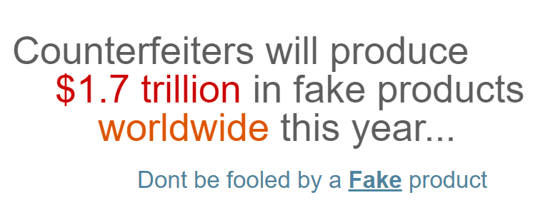
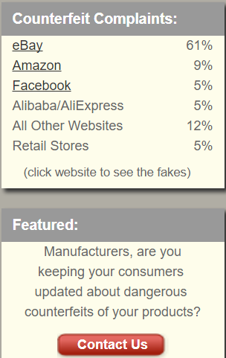
− which parts of retailing would be most affected?
The world is changing quickly, so the answer is all parts of retail will be affected. Retail will have to adapt to a new business model. An example here is Aldo shoes. you go in and they have one size of every pair. You purchase these and your shoes are delivered to you immediately via their warehouse or the next day. Additional effects will be fewer jobs, less retail space needed, lower inventory required, and lower overheads.
The value of the retail and land space will go down due to supply and demand so the government will receive less property taxes, less income taxes from workers and less GST contribution from bricks and mortar sales.
E-commerce services should strive to enforce tax locally and offshore with zero tolerance through a 100% collection rate with Netsweeper. Retail and services are greatly affected due to the new e-commerce economy and the off-shore processes in place now.
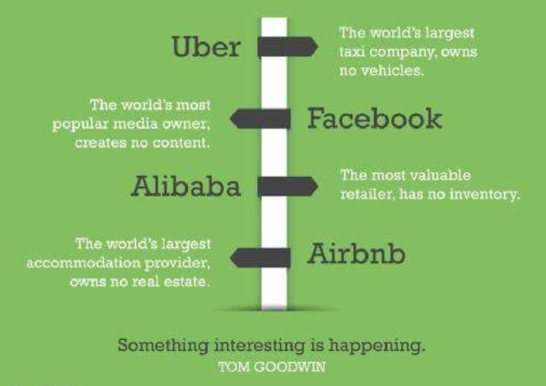
• Would there be effects on other Australian businesses?
A majority of governments Netsweeper has spoken with are worried about e-commerce services delivered inside their country, however the billings are offshore, ie through uber, netflix, airbnb and many others. This adds huge complexities around jurisdictional government capabilities. Netsweeper will collect and enforce uber, netflix, airbnb and other similar offerings anywhere in the world for Australia. A level playing field is required for Australian businesses due to the virtuality of these services that are being offered.
Another group of countries is moving to prevent the delivery of prescription drugs disguised as other goods without the proper levies, taxes, FDA controls and other problems that e-commerce creates. This will change the way that people in Australia purchase their medications. Netsweeper enforces and collects all e-commerce transactions.
Other effects on Australian businesses will be the growing reach of e-commerce and the underestimation of the actual size of e-commerce in Australia and the world.
The concern of underestimation leaves a material amount of the taxpayer’s money on the table which is not remitted to the Australian tax office. Governments require data from single sources to truly define, measure, analyze and control. Netsweeper offers centralized interoperable data sets that can be prioritized to each country’s needs and meet and exceed customs visibility and tool requirements.
For more information on this, see:
https://www.webalive.com.au/future-of-Australian-e-commerce/
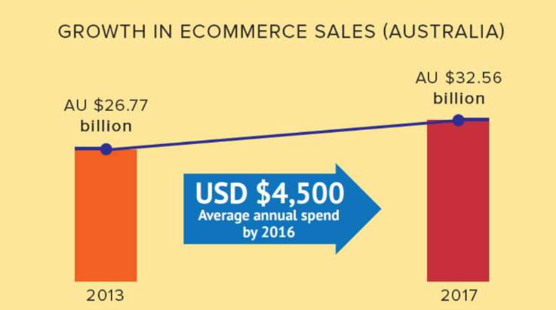
The Commission is seeking information and evidence on these and other matters to help it gauge the likely effects of the legislated model and to identify any possible improvements. (Detailed questions for participants are set out in section 5).
INFORMATION REQUEST The Commission seeks views and evidence on compliance rates under the legislated model, including:
• What level of compliance can be expected?
The level of compliance indications around the world that Netsweeper has seen show anywhere from 10% to 50% levels of taxation of remittance. This really depends on what is measured. Netsweeper remits “all e-commerce” and with Netsweeper the enforcement model for Australia will obtain the data and ensure the GST remittance.
− are Treasury’s estimates of compliance rates realistic?
This depends on what is being measured or at least on the Australian Government’ss definition of what is being measured. All of the world’s e-commerce travels through a payment process stack now, and there will be very different payment process stacks in the near future, bypassing traditional current payment systems.
Netsweeper believes that the Australian Government’s definition of what is e-commerce is vastly underestimated (ie. $4 billion vs $30 billion) and the amount remitted is over estimated, all leading to material amounts of the citizens money being left on the table. Netsweeper can augment the Australian Government’s current plans and materially improve the remittance plans overcoming the jurisdictional and overseas challenges.
− what lessons can be drawn from countries’ experiences implementing a vendor model for digital goods?
Lessons or challenges are:
- the root challenge of e-commerce tax enforcement/collection is “self-assessment”
- there is no enforcement of e-commerce tax collection
- e-commerce is virtual in the world wide web
- encryption of e-commerce allows no visibility
- volume of on lines e-commerce payment sites/systems.
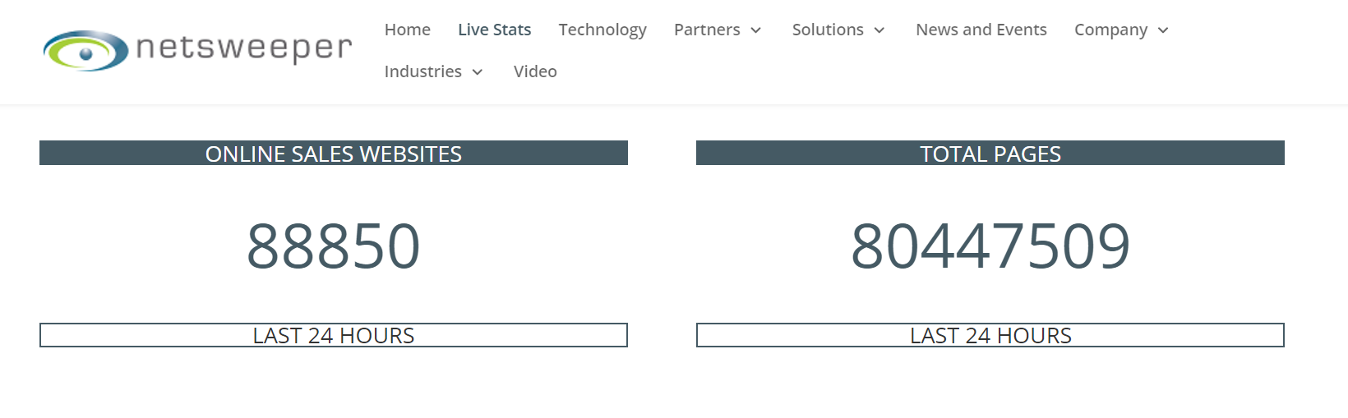
- governments want to have the vendors remit their GST however vendors will not comply without enforcement.
- how do we disburse the GST use tax? who buys and who uses the goods/services. countries need to prioritize policies and leave technology to Netsweeper.
- who should collect the GST? who owns this ultimately. the government should control and own the collection and enforcement of GST. this is Netsweeper’s model.
- current estimated on line e-commerce is under estimated. governments want to hit targets leaving citizens money on the table
- governments have little jurisdiction outside of their state/country.
- customs says, “we are used to processing container loads of running shoes, now we process thousands of shoes a day, one pair at a time”
- retail stakeholders want a fair playing field. e-commerce transactions must pay the same tax
- downloads and other virtual purchases create huge challenges. (e.g. 3d printing files)
- illegal and counterfeit goods and services dominate e-commerce
- this is a big data project. who owns it?
- interoperability challenges due to many stakeholders/contributors/changes
- food and drug challenges – and what happens with a defective product now?
- conflict of interest with vendors collecting/controlling governments money
- governments want additional servers above and beyond GST and cannot expect transport companies and vendors to keep doing this for them. Netsweeper can api/connect and deliver information into other departments, customs, consumer affairs
• To what extent will overseas vendors and EDPs voluntarily comply?
The response from vendors and EDP’s was an indication that they are not in agreement with the laws. They can respond in this manner as there is NO Enforcement built into the process.
− what factors will contribute to rates of compliance among them?
There are many factors that contribute to compliance of vendors and EDPs;
- vendors continually complain about costs, processes and do not want to do be responsible to collect
- “adding tax collection capability to our platform only for Australia will cause major disruption to our global business, not to mention the significant financial investment we would have to make to build such processes and systems”
- cost of each merchant is different based on location size and more
- mass number of vendors now and in the near future. www.Netsweeper.com/livestats
- interoperability of data with millions of vendors, hundreds of countries/states/provinces
- any/all costs to consumer will be passed on. vendors will cost more with not input to limits.
- encryption – no audit, no visibility. no way to know the rate of compliance.
- where should the marketplaces or vendors pay sales tax
- no enforcement on vendors
- this proposed process restricts other opportunities to use the platform down the road. (e.g. reporting income, other customers data, levies, more.)
- conflict of interest (vendors collecting tax is a material conflict of interest:
    - counterfeit goods, laws, revenue conflict. vendors will not shut down their revenues
    - vendors will not self-enforce
    - us postal and terminal fees – apply around the world subsidize of delivery
    - vendors have large lobbyist budgets to change in their best interest
    - control of the economies money? do you really want to enable the revenues in their controls?
    - delay of remittance
    - vendors traditionally cashflow their business with governments remittance.
    - multiple law suits currently between vendors and tax offices globally for many reasons. (google Italy and amazon)

− how will complying affect their competitiveness with other vendors in the market?
Compliance will be different per vendor as there is no enforcement.
Vendors will continue to be incentivated not to remit tax.
− how effective will the ATO enforcement activities be?
The answer to this must follow the ATO’s definition of e-commerce and how remittance is measured. The need to know the transactions and the remittance level will determine the delta and the effectiveness. Netsweeper provides the data, the remittance and the enforcement to execute.
− will some vendors ‘over-comply’, for example by ignoring standard exemptions to GST or purchases by registered businesses?
Yes, with millions of vendors views and the lack of interoperability there will be material dynamics of remittance. Netsweeper has several processes to overcome these challenges.
INFORMATION REQUEST
• Are there changes to the legislated model, or other actions that government or others could take, that would increase compliance rates?
Yes. These are:
Input Enforcement
- treat e-commerce the same everywhere, in Australia, outside Australia, downloads, packages, goods purchased in Australia and processed via e-commerce outside of Australia.
- recognize the issues of igambling, counterfeit goods with e-commerce and solve at the same time.
- augment and take on the full responsibility and ownership of collections and enforcement process with a tool maker partner like Netsweeper.
- recognize the under estimation of what the total value of all e-commerce, stop casting a wider tax net and stop all the leakage.
- find another way to highly integrate customs and the standardization of what customs is built on.
- look closer into a partnership like Netsweeper.
- consider all the stakeholders and meet each of their needs now instead of trying to move forward and patch this later.
INFORMATION REQUEST The Commission is seeking views and evidence on compliance costs and their effects under the legislated model. The issues include:
• What level of compliance costs can be expected under the model?
All stakeholders have expressed material costs that cause great doubt in the proposed models. In some cases, and based on the governments definition and estimation the costs will be larger than the remittance. Whatever are the costs they will be passed onto the consumer which will reduce the amount of money in the economy and continue to take this offshore or outside of Australia. The fact is that due to no enforcement and the Government’s intention to push this back to the other stakeholders, costs can be any amount the stakeholders want to make them with no audit or jurisdiction capabilities.
− are the CIE’s estimates of compliance costs reasonable as a baseline?
No, with millions of vendors and EDP’s, there is no way to estimate the reasonableness and change what millions want to charge.
− how costly would it be for foreign vendors and EDPs to establish or reconfigure systems to enable the assessment and remittance of GST?
The costs are based on many factors, exchange, high value, low value regions. vendors and EDP’s claim it will be more than the tax itself. When the law enforcement demanded EDP’s and CC companies to police i-gambling, this was not a success.
− how much of a burden is collecting vendors’ GST registration numbers for transporters?
Transporters regards this as a huge burden. Physical transporters cannot address downloads.
The burden extends to the different levels of what the service should be for the customer not many other stakeholders.
• Are there changes to the legislated model, or other actions that government or others could take, that would reduce compliance costs?
Netsweeper suggests a 100% zero tolerance law that applies and is open to all vendors, EDP’s and new stakeholders that we do not know about.
• In what ways and to what extent will compliance costs on foreign vendors, EDPs or redeliverers impact the supply of foreign goods to the Australian market?
As the barriers increase to do business in the Australian e-commerce, supply will reduce.
− to what extent will such costs be translated into higher prices for imported goods?
Costs form all stakeholders will be passed on at each stage and level. Higher prices are part of this.
− how probable is it that overseas vendors (including small vendors), EDPs or redeliverers will cease servicing the Australian market?
The choice is to still service Australia however not to remit the tax – little will change without enforcement.
− how will other countries’ progress towards implementing a vendor-based model in their jurisdictions affect overseas vendors’ and EDPs’ decisions in the Australian market?
Having millions of vendors and EDPs remitting the tax with no interoperability will result in a current comparable situation. The number of vendors that remit voluntarily will remain well below 30%.
INFORMATION REQUEST An overarching thrust to the Parcel Processing Taskforce’s model is to advocate for, and make greater use of, electronic and automated processing methods, especially in the international mail stream.
• How have international mail processing techniques evolved in recent years, and how can they be expected to evolve in the near future?
International payment systems are in an extreme flux now. many fintech companies are being funded and there are many issues with the current system especially the conflict with the credit cards and the banks.
Smart phones, apps and many other factors will change the way people process and pay.
- the payment eco-system has problems. it is unstable.
- banks are in dispute with credit card companies mostly due to chip monopoly and fees.
- hundreds of new payment technologies. adoption is everything in payments, it’s all about the network effect
- chicken and egg dilemma has plagued industry
you will not get adoption unless you solve everyone's issues.

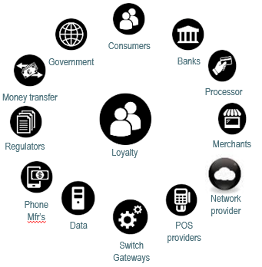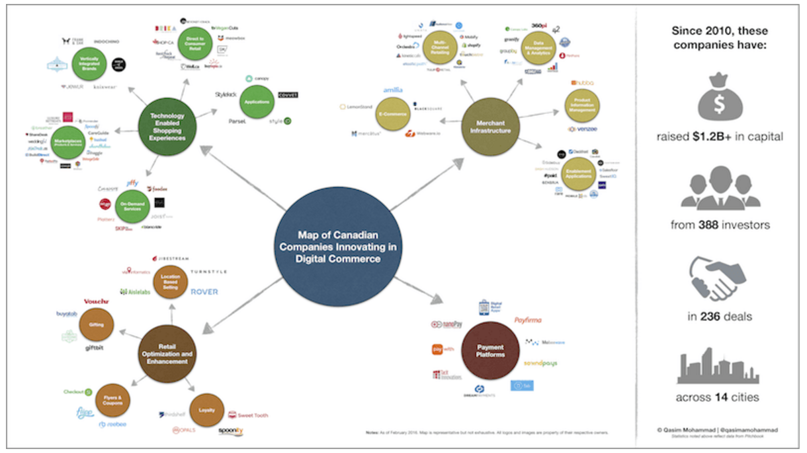

If parcel processing has improved (or will improve), how significant are the (likely) per-parcel cost reductions?
The sheer volume of current vendors and the extreme growth of new vendors will always challenge the cost structures of parcel delivery. with no enforcement, each will charge the most they can get away with.
• To what extent will (have) these changes enhance(d) the viability of the Taskforce’s model?
The Taskforce estimated collection costs for its proposed model in the international mail and cargo streams, but attached a low degree of reliability to the estimates, and cost parameters may have shifted in the intervening years.
Costs will be what the transporters need these to be with no enforcement.
• Are the Taskforce’s cost estimates reasonable and still relevant? How have more recent developments impacted on this?
Costs to process the overall logistics will always increase with time. Automation will come with the larger companies however costs for the smaller new companies will stay high.
The Commission’s early view is that the rate of compliance under the Taskforce’s model would be relatively high.
• What compliance rates would be likely under the Taskforce’s model?
The result of how high will depends on the definitions and will clearly not cover all packages delivered. Per Parcel costs do not address downloads.
• Are there avenues for non-compliance under the Taskforce’s model and, if so, how could these be narrowed or closed?
Yes, ensure there is enforcement. Interoperability of data is very difficult with the massive number of vendors, delivery company’s local and internationally.
• How would the compliance costs be shared between the Australian Government, transporters, consumers and other parties under the Taskforce’s model?
Costs should be passed to the consumer.
The Taskforce’s model requires that transporters take responsibility for collecting GST from consumers on the low value imported goods they deliver.
• How would transporters go about collecting GST under this model, and how would this impact consumers?
Deliver the goods and collect the money. It will be an inconvenience to consumers and this will be seen as another transaction to the customer’s
The Taskforce suggested an optional vendor model (for ‘appropriately regulated overseas suppliers’) could apply in concert with its core border/transporter model and laid out some criteria for appropriate vendors.
• Do these criteria appropriately balance compliance risks and border compliance costs with the desire to encourage use of the optional vendor model?
No, see challenges described above.

