\
Email: nick@mitiamoIT.com.au
Web: mitiamoIT.com.au

Telecommunications Universal Service Obligation Inquiry
Submission from Mitiamo IT – Nick Marlow - to Productivity Commission Public Enquiry

Thank you for the opportunity to provide input into this matter which is of critical importance to Regional, Rural & Remote Australia.
I operate an IT services business in North Central Victoria, based near the small township of Mitiamo. My clients are mainly farmers, small business owners and families. I deal with pretty much anything to do with computers and telecommunications.
The state of telecommunications in our area is very poor, and it is similar to much of Regional, and especially Rural and Remote Australia.
Myself, trying to run my business, I struggle with poor mobile phone reception on a daily basis. I see most people in our community struggling with the same problems. People are desperate for better phone reception, and waste substantial amounts of time climbing onto sheds, silo’s etc. just to answer a phone call. Businesses everywhere depend on being able to make and answer phone calls immediately, and this situation puts businesses in our community at a significant disadvantage over their competitors.
Then there is the issue of internet connectivity. Put simply, the current internet situation is inadequate to the point where businesses and families will move if the situation does not improve. Some parts of our community are lucky enough to have access to decent ADSL or NBN Fixed Wireless, however many areas miss out, being stuck with either 3G/4G cellular wireless. The reliability of all other available internet types is generally very poor, and the data allowances are inadequate for modern businesses and families.
Despite government claims to the contrary, the NBN does not provide a universal service. NBN Fixed Line and Fixed Wireless services are generally adequate for carrying telephone calls, however the NBN Sky Muster satellite service is not fit for this purpose, and cannot be made fit for this purpose by any means currently known to man.
The Sky Muster service has, to date, been plagued by “teething issues” which have carried on for so long that they can no longer be reasonably considered teething issues. However, even once these are fixed, (if they get fixed) the delay/latency that is inherent in any satellite based system, and the very limited amount of data available means that Sky Muster is not suitable for a landline replacement telephone service.
When the satellite is working reliably, the latency issue can be reduced to the point of being bearable most of the time. However this only works if only one party to the telephone call is using satellite. If both parties are using satellite, then the latency doubles, and renders it virtually unusable. People in Rural and Remote areas tend to telephone each other, so this matters greatly. To illustrate this, please see the below drawing which shows the first half of the round-trip path the signal must take if I use make a VoIP call via Sky Muster to a client also using VoIP over Sky muster:
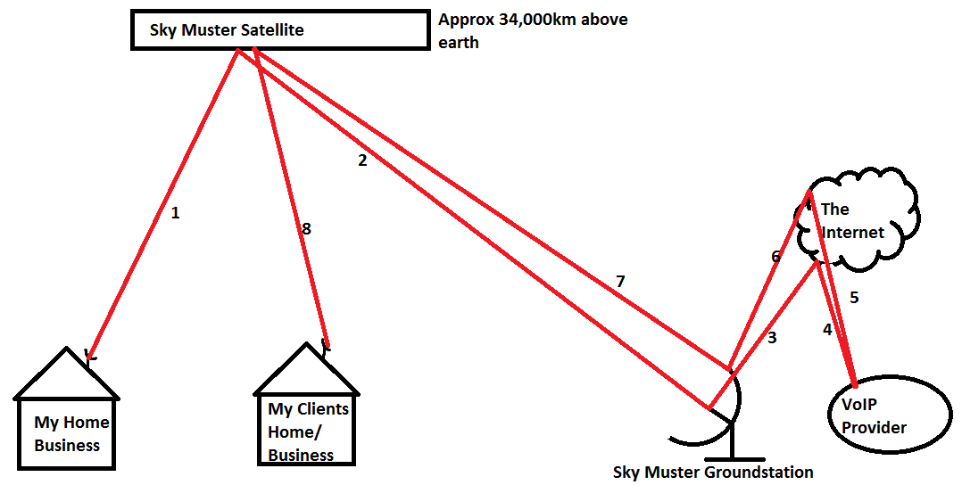
Once the signal gets to the destination (My Clients Home/Business) it then has to turn around and go all the way back. Due to both parties using satellite, the delay is double the normal satellite delay.
This shows that, ignoring the transmission time from the internet part of it, simply focusing on the satellite parts, the total round-trip distance is roughly (34,000km x 4) x 2 (return trip) = 272,000km, which is going to result in a delay of over 1 second – this is like calling overseas years ago before the undersea cables where installed, and is a massive step down from the low latency landline phone network.
Satellite phones can be better than this, however satellite phones tend to use low-earth orbit satellites, which are much closer to earth, and, therefore have less delay. Sky Muster does not use low earth orbit satellites.
What this proves is that NBN Satellite is not a suitable carriage service for transporting a landline replacement telephone service. Until a suitably reliable, low latency, high speed internet connection with decent data limits is universally available, VoIP cannot be used as a landline replacement in much of rural and remote Australia.
While the mobile phone networks leave most of Australia’s inhabited landmass unserved, mobile phones cannot be used as a landline replacement.
The inquiry draft report overview suggests that internet accessibility gaps are likely to be small and concentrated. This is incorrect. The areas are huge, and spread throughout most of the nation. Most of Australia (by landmass) will have no NBN internet except through satellite.
The report suggests that the Mobile Blackspot program could be a better use of the USO money. This may be the case in some more densely-populated areas, however, in many areas, especially those more isolated areas, mobile phone reception will never be feasible, no matter how much money is spent. A million dollar phone tower is not viable if only 1 or 2 households or businesses are within its range.
Many small towns and outlying areas are currently able to access ADSL internet through their phone line. If the phone line goes, they will be stuck using NBN Sky Muster Satellite, a vastly inferior service, with very limited capacity. Adding these people onto Sky Muster will either cause congestion, or result in further reduction in data quotas. These people are most likely to be in Sky Muster “spot-beams” that NBN’s own projections show as already likely to be “congested” or “severely congested” in the future, as per this diagram from NBN:
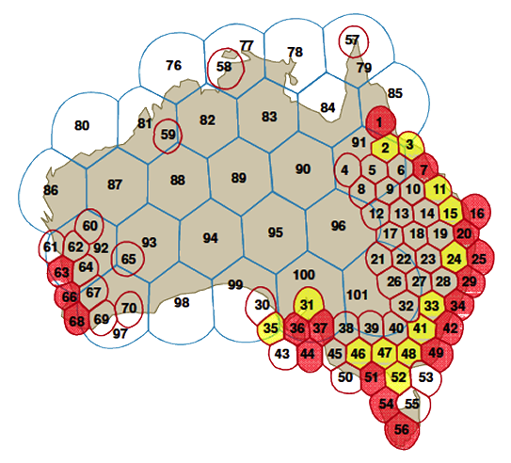
Diagram showing NBN Co satellite beams and risk of congestion as determined in the Fixed Wireless/Satellite Strategic Review (FWSat SR).
Source: NBN 2014 Satellite / Fixed Wireless Strategic Review.
While some fine-tuning of the USO model may be beneficial, it is absolutely imperative that the landline mobile phone network is maintained in Regional, Rural and Remote Australia. And the maintenance of the landline network is completely dependent on the USO. If the USO goes, people will die as a direct result, as they will be unable to reliably call 000 in an emergency. Businesses will fail. People will leave. The rural population decline will accelerate further.
Telstra’s maintenance of the telephone network has become very poor. Much of the documentation of the network is incorrect and no longer properly maintained, plastic bags and duct tape are used to waterproof cables, and I know of several cases within 20km of my current location where Telstra have done “temporary” repairs which consisted of running a new telephone line above ground, either directly on the ground, strung along a fence, or overhead, strung from tree to tree to fence. These “temporary repairs” were done after the 2011 floods and seems to have become permanent. Given the enormous taxpayer contributions to the USO, surely the government needs to be holding Telstra to account, and demanding that the maintenance is done correctly.
To summarize, a removal of the USO cannot occur until a telecommunications network exists that is able to universally facilitate reliable, low latency telephony. There is no such network currently in existence in Australia (except for the landline telephone network), nor is there plans for any such network. Therefore it logically follows that the USO MUST STAY and that any attempts to remove the USO at this stage are undeniably going to result in several hundred thousand people being left without an acceptable telephone service. This cannot be allowed to happen.
Thank you for taking the time to read my submission. Please think very carefully about the consequences of any action which may result in a worsening of the already dreadful and dangerous telecommunications situation in Regional, Rural and Remote Australia.
Yours Sincerely,
Nick Marlow

Mitiamo IT

