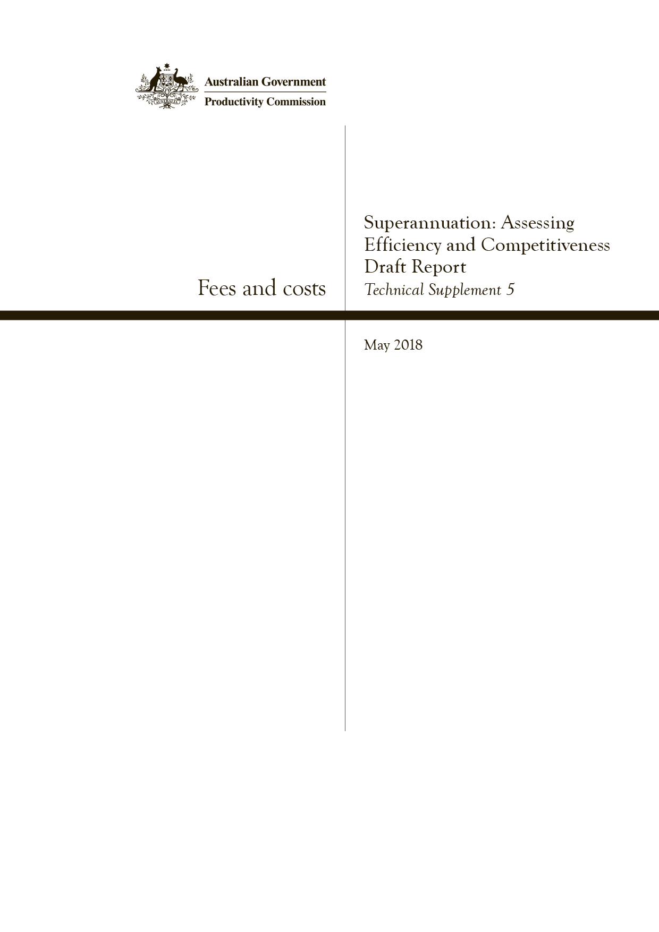
Fees and costs
Technical Supplement 5,Superannuation: Assessing Efficiency and Competitiveness, Productivity Commission Draft Report
Commonwealth of Australia 2018
Except for the Commonwealth Coat of Arms and content supplied by third parties, this copyright work is licensed under a Creative Commons Attribution 3.0 Australia licence. To view a copy of this licence, visit http://creativecommons.org/licenses/by/3.0/au. In essence, you are free to copy, communicate and adapt the work, as long as you attribute the work to the Productivity Commission (but not in any way that suggests the Commission endorses you or your use) and abide by the other licence terms.
Use of the Commonwealth Coat of Arms
Terms of use for the Coat of Arms are available from the Department of the Prime Minister and Cabinet’s website: https://www.pmc.gov.au/government/commonwealth-coat-arms
Third party copyright
Wherever a third party holds copyright in this material, the copyright remains with that party. Their permission may be required to use the material, please contact them directly.
Attribution
This work should be attributed as follows, Source: Productivity Commission, Fees and costs, Technical Supplement 5.
If you have adapted, modified or transformed this work in anyway, please use the following, Source: based on Productivity Commission data, Fees and costs, Technical Supplement 5.
An appropriate reference for this publication is:
Productivity Commission 2018, ‘Fees and costs’, Technical Supplement 5 to the Draft Report Superannuation: Assessing Efficiency and Competitiveness, Canberra, May.
Publications enquiries
Media, Publications and Web, phone: (03) 9653 2244 or email: mpw@pc.gov.au

The Productivity Commission
The Productivity Commission is the Australian Government’s independent research and advisory body on a range of economic, social and environmental issues affecting the welfare of Australians. Its role, expressed most simply, is to help governments make better policies, in the long term interest of the Australian community.
The Commission’s independence is underpinned by an Act of Parliament. Its processes and outputs are open to public scrutiny and are driven by concern for the wellbeing of the community as a whole.
Further information on the Productivity Commission can be obtained from the Commission’s website (www.pc.gov.au).

Technical supplement 5: fees and costs
This technical supplement documents the data sources used to analyse fees and costs in chapter 3 of the Commission’s draft report. Section 5.1 details the data sources used, and section 5.2 discusses the methodological issues encountered in the analysis. This technical supplement should be read in conjunction with both appendix B (on data sources) and technical supplement 4 (on investment performance), which document in more detail the data sources used, and the transformation of private research firm data used in the draft report.
Feedback and commentary on the data, assumptions and methodologies set out in this technical supplement are welcome as the Commission prepares its final report.

5.1 Data sources
This section lists the main data sources used in the Commission’s analysis of fees and costs, their pros and cons, and how (if relevant), each database was used by the Commission (table 5.1). The Commission has utilised data:
- collected by regulators — Australian Prudential Regulation Authority (APRA) and the Australian Tax Office (ATO) — including publicly released data and data provided to the Commission on a confidential basis
- purchased on a proprietary basis from private research firms
- collected through the Commission’s own survey of funds (appendix C; technical supplement 2).
Appendix B outlines the coverage of the datasets used in the draft report in greater detail.

Table 5.1 Summary of data sources for fees and costs
Data | Time series | Pros | Cons | How used?a,b
Regulator data
APRA | For costs:  2004 to 2017  For fees:  2014 to 2017 | Comprehensive coverage of APRA-regulated funds  Comprehensive product-level data for MySuper products | Investment fee revenue data have not been collected from many funds  No product-level data for choice products  No data by asset class | Costs for APRA-regulated funds by service (administration, investment, total) and by broad fund type (profit and not-for-profit) (figures 3.4, 3.6, 3.15)  Fee revenue for APRA-regulated funds by service (administration, investment, activity, advice, other, total), by fund type (corporate, industry, public sector, retail), by fund size and for MySuper segment (figures 3.3, 3.14, 3.17, 3.18)
ATO | 2010 to 2016 | Comprehensive coverage of SMSF segment | SMSF cost data not fully comparable with APRA cost data | SMSF costs by service type (administration, investment, total), by asset balance band and for new SMSFs (figures 3.21–3.23)
Private research firm data
SuperRatings | 2006 to 2017 | Generally has greater coverage of APRA funds than other research firms | Limited identification of default products prior to MySuper  Possible selection bias | Advertised fees for products of APRA-regulated funds by service (administration, investment, total), in accumulation and retirement segments, in MySuper and choice segments, by fund size, by broad fund type (for-profit and not-for-profit) and by asset class (proxied by option-level data) (figures 3.2, 3.5, 3.7–3.15)
Rainmaker | 1998 to 2017 | Identifies default products prior to MySuper | Less coverage of APRA system than SuperRatings  Possible selection bias | Advertised fees for products of APRA-regulated funds in default segment by service (investment, total), by fund type (industry, public sector, retail and corporate) and by fund size (figures 3.19, 3.24, 3.25)
CEM Benchmarking | 2016 | A source  of comparable international investment costs data | Limited sample of funds for some regions  Possible selection bias | Unable to be compared with Australia due to poor quality responses to funds survey

a The figure references are to chapter 3 of the draft report. b Unless otherwise evident, ‘total’ fees mean those faced by an inactive member and are the sum of administration and investment fees.

Regulator data

APRA
The Commission relied on various statistics provided by APRA.
- The Annual Superannuation Bulletin contains key aggregate superannuation statistics. It was the Commission’s primary source of data on fee revenue and costs.
- The Annual Fund-level Superannuation Statistics report contains detailed profile and structure, financial performance position, fee and membership information for APRA-regulated funds. The Commission used these statistics to measure costs relative to assets, including by fund type, and as the key source of data on assets and member accounts for various subsets of the APRA system.
- The Quarterly MySuper Statistics report contains relatively comprehensive product-level data for MySuper products. The Commission used these statistics to analyse trends in MySuper fees, and to analyse the impact of MySuper on fees.
- The Commission relied on unpublished APRA data on member accounts to assess costs per member account.
A general strength of APRA data is that all APRA-regulated funds are covered, including the fees that were actually paid by members to their fund (as opposed to advertised fees). However, the data are subject to inconsistent reporting by funds, especially for investment management fees (section 5.2). This makes it difficult, if not impossible, to estimate the full costs that funds are incurring and that members are paying for.
The MySuper data are generally of superior quality, owing to the fact that they are collected at the product level and include indirect investment and other costs. However, the data are only available from the introduction of MySuper in 2013.

ATO
The ATO’s Self-managed superannuation funds: A statistical overview 2015–2016 is the primary source of the Commission’s data on self-managed super funds (SMSFs). Data are collected by the ATO directly from SMSF trustees on an annual basis.
The ATO’s SMSF data include member demographics, member assets, asset allocations and costs. The Commission used these data to measure SMSF costs relative to assets and to help inform its analysis of average member costs in the SMSF segment of the market.
The Commission also relied upon unpublished SMSF data provided by the ATO. The Commission used these data to analyse how costs relative to assets vary by the size of SMSFs, including for both investment and administration services, and for new SMSF establishments.
Because of how the data are collected by the ATO (and thus the nature of the data), SMSF data are not comparable with APRA data (section 5.2).

Private research firm data

SuperRatings
The Commission used SuperRatings data to inform its analysis of fees in the APRA-regulated system, including the trend in fees by service (investment and administration), by market segment (including for-profit and not-for-profit) and by asset class, as well as fee dispersion. SuperRatings data were also used to help inform the Commission’s analysis of fund margins.
SuperRatings data have a higher coverage of APRA funds than other research firms. In contrast with APRA data, SuperRatings data include comprehensive product and option level data, and include investment management fees and indirect investment management costs.
In SuperRatings data, administration fees include a fixed-dollar and percentage-based fees. These fees cover asset administration fees, member administration fees and several other administrative fees that would be incurred by inactive members. Administration fees do not therefore include activity-based fees such as platform fees.
SuperRatings fees data are the advertised fees for the balanced investment option of each product as reported by funds, including through product disclosure statements and fund websites. If a product does not have a balanced option, SuperRatings used the option that most closely aligns with a balanced option. SuperRatings’ approach reflects that most assets are in balanced options.
To estimate trends in advertised fees across the superannuation system for various fund types and asset classes, the Commission weighted the SuperRatings fee data by an estimate of the value of assets in each product. The value of assets in each product were derived as follows.
- The Commission used product-level asset data from SuperRatings where available.
- Otherwise the Commission used APRA fund-level asset data. APRA fund-level data were merged with SuperRatings data on the basis of the Australian Business Number for each fund, which the Commission found to be a reliable unique identifier of funds across different datasets.
- Fund-level asset data were apportioned across products based on the share of member accounts in the SuperRatings product data. Where member account data were missing, assets were apportioned equally between a fund’s products.

Rainmaker
The Commission also used product-level data from Rainmaker, which were sourced from funds’ annual reports, Product Disclosure Statements and other public information. The Commission has transformed the data and undertaken its own linking of investment options over time.
In the analysis of the relationship between fees and net returns, Rainmaker fee data were weighted by APRA fund-level asset data. Where APRA fund-level data were not available, asset data were obtained from Rainmaker or from annual reports. Additional details about how the Commission transformed the Rainmaker dataset to create an historically linked option-level dataset are provided in technical supplement 4.
Rainmaker data were also used in the Commission’s analysis of the impact of the introduction of MySuper on fee levels. Rainmaker identified (some but not all) funds’ default investment options in their database. Fees for these options can (subject to sense checking) be used as proxies for the fees on ‘predecessors’ of MySuper products. This makes it particularly suited to the analysis of the impact of the introduction of MySuper on the default market. Like SuperRatings, Rainmaker fee data include some indirect investment costs.
As noted in appendix B, the coverage of the Rainmaker dataset is lower than for SuperRatings.

CEM Benchmarking
The Commission purchased data from CEM Benchmarking of Canada to gauge the level of investment management costs in other countries across individual asset classes (table 5.2; figure 5.1). The Commission’s intention was to compare these costs with Australian data collected from the Commission’s funds survey. As discussed in chapter 3, the poor response rate to the funds survey has prevented the Commission from making this comparison in the draft report.
The Commission will write to fund CEOs to seek these data again. Subject to the provision of those data by funds, the Commission will expand its analysis to an international comparison of investment management costs by asset class, with the intention to release a supplementary paper for feedback prior to finalising the draft report.

Table 5.2 International comparison: investment management costsa
Asset weighted average cost in basis points, 2016
 | Defined contribution systems |  | Defined benefit systems
 | US |  | US | Canada | Nether-  lands | UK | Rest of  Europe | Asia-  Pacific | Total  average
Public stock – domestic | 21.1 |  | 15.5 | 15.7 | na | 12.6 | na | na | na
Public stock – global | 26.6 |  | 27.1 | 25.4 | 15.3 | 21.5 | 7.4 | 16.9 | na
Public stock – total | 21.3 |  | 21.3 | 23.2 | 15.3 | 19.7 | 7.4 | 16.9 | 18.3
Fixed income – core domestic | 14.3 |  | 9.1 | 7.2 | na | 11.5 | na | na | 8.6
Fixed income – all other | 46.7 |  | 20.9 | 17.4 | na | 12.1 | na | na | 12.2
Fixed income – total | 15.1 |  | 15.9 | 12.0 | 9.8 | 12.1 | 5.9 | 3.1 | 11.3
Cash | 10.9 |  | 3.4 | 14.4 | 7.6 | 7.6 | 1.1 | na | 5.0
Balanced | 21.6 |  | na | na | na | na | na | na | na
Listed property | 25.8 |  | 36.5 | 41.0 | 9.0 | 74.1 | 17.7 | na | 18.8
Unlisted property | 43.4 |  | 127.2 | 56.6 | 100.4 | 73.4 | 55.2 | 77.7 | 103.0
Total property | 36.9 |  | 121.4 | 56.3 | 55.9 | 73.5 | 52.9 | 77.7 | 93.2
Private equity | na |  | 327.9 | 241.1 | 340.3 | 274.6 | 323.4 | 310.9 | 306.1
Unlisted infrastructure | na |  | 196.2 | 67.0 | 153.1 | 159.0 | 95.6 | 88.4 | 92.4
Hedge funds | na |  | 194.3 | 234.8 | 147.9 | 237.1 | 238.6 | 207.7 | 203.0
Natural resources | na |  | 141.7 | 71.5 | 147.7 | 83.9 | 53.3 | 88.6 | 111.4
Global tactical asset allocation | na |  | 49.6 | 8.1 | 15.7 | 27.1 | 63.0 | 25.7 | 35.8
Commodities | na |  | 52.8 | 5.3 | 12.0 | 45.1 | 2.7 | 49.8 | 28.2

a Costs include fees paid to third party managers such as indirect costs. na denotes not available.
Source: CEM Benchmarking.

Figure 5.1 International investment management costs
Asset weighted average cost, 2016
Source: CEM Benchmarking.
CEM Benchmarking was the only source of data on investment management costs by asset class that the Commission could identify. Yet, in some instances, the underlying sample in the CEM database is not large (table 5.3).

Table 5.3 Number of funds and assets in CEM dataset
2016
 | Units | Defined contribution systems |  | Defined benefit systems
 |  | US |  | US | Canada | Nether-  lands | UK | Rest of  Europe | Asia-  Pacific | Total
Total funds | no. | 146 |  | 168 | 77 | 24 | 36 | 10 | 4 | 323
Corporate | no. | 117 |  | 99 | 33 | 9 | 3 | 0 | 0 | 144
Public | no. | 24 |  | 59 | 30 | 1 | 29 | 7 | 3 | 131
Other | no. | 5 |  | 10 | 14 | 14 | 4 | 3 | 1 | 48
Total assets | US$ | 1 017 |  | 3 617 | 1 211 | 922 | 391 | 1 115 | 694 | 8 124
Estimated coverage  of assets | % | 8 |  | 40 | 81 | 76 | 17 | na | na | na

na denotes not available.
Source: CEM Benchmarking.

5.2 Methodological issues
Assessing fees and costs, and what they mean for members, is not straightforward. Data on fees and costs come from disparate sources, sometimes employing different conceptual frameworks such that the data are not readily comparable. There are also data quality issues, with considerable data gaps constraining the capacity to undertake even quite basic analysis. Several methodological considerations were encountered by the Commission and are outlined below.

There are gaps in reported investment management costs
As noted in chapter 3, APRA data contain gaps in reported investment management costs, particularly indirect costs paid to related parties. In 2016, for example, about 25 per cent of funds reported zero investment management costs to APRA (these funds represent about $315 billion in assets). Of these funds, 84 per cent were (generally small) retail funds.
Further, there is likely to be significant underreporting of indirect investment costs (although the precise extent of it cannot be directly quantified). Indirect investment costs are deducted from an investment return before those returns are paid back to members, but because these are not charged as direct investment fees to the member, they are not captured in APRA fee data. This omission materially influences estimates of fee revenue, given that costs that are netted off investment returns (and ultimately paid for by the member) are not explicitly reported as fees. This has implications for the analysis of particular indicators on costs (and their alignment with fees).

The difference between advertised fees and fee revenue data
Broadly speaking, there are two ways of evaluating trends in fees: by analysing the fees advertised in product disclosure statements (and collected by research firms — sometimes referred to as ‘sticker’ fees); or by analysing fee revenue collected by funds (and reported to APRA). Conceptually, advertised fees would capture the unit price of what an individual member will pay for a particular product, or an element within a product (such as the ability to switch options), whereas fee revenue data capture what members actually pay in aggregate dollar terms at the fund level.
In practice, the fees in advertised fee data are notably higher than in fee revenue data (as a percentage of assets). This reflects that advertised investment fees include (though not fully) the indirect costs disclosed in product disclosure statements (from which the research firm data are largely sourced). This is discussed above.
While advertised fees do not necessarily provide a complete picture of the fees an individual member might pay (as this could depend on a range of factors including whether they access specialised advice services), it does provide a consistent basis on which to assess fee trends, and in any case will capture a significant majority of fees incurred by members.
In contrast, fee revenue in a given year could be impacted by differences in how members use their accounts, rather than differences in the underlying fee structures that members actually face. The Commission has used both data sources to analyse fees, but is aware of the differences between them.
Two further differences between advertised fees and fee revenue paid by members are worth noting.
- Some members are given a rebate on particular fees (for example, in some employer-based plans). However, it is unlikely that fee rebates materially affect segment-level trends in fees paid by members. In 2016, total fee rebates across funds represented just 4 per cent of total fees. This amounts to around 0.03 per cent of total assets.
- Funds technically source fee revenue from sources other than members, and these would not be picked up in advertised fees because product disclosure statements are conceptually relevant only to members. Again, however, this is unlikely to materially affect differences between advertised fees and fee revenue. In aggregate, member fees constituted 93 per cent of total fee revenue (figure 5.2).

Figure 5.2 Members pay the vast majority of funds’ feesa
Fee revenue relative to assets, by fund type, 2017
a The ‘Other’ category of fee revenue captures revenue largely from funds’ reserves or the RSE licensee.
Source: APRA 2018, Annual Superannuation Bulletin, June 2017, released 28 March 2018, tables 4a and 6a.

What is a ‘representative member’?
The fees charged to members by superannuation funds depend on a range of factors, including the extent to which fees are levied as a percentage of the member’s account balance. Therefore, the Commission has employed the concept of a ‘representative member’ with a fixed account balance in its analysis of advertised fees.
The concept of a ‘representative member’ is used by APRA (in its MySuper reporting framework) and by a number of research firms and rating groups, with the convention being to use an account balance of $50 000.
Consistent with this, the Commission has focused its analysis of fees for a representative member in the accumulation phase on representative account balances of $50 000, but has also considered fees for alternative representative balances. Likewise, in the retirement phase, in which there are higher average balances, the Commission used several representative balances ranging up to $500 000, and compared these with fees in the accumulation phase.

There are challenges when comparing APRA and ATO data
Data limitations and differences in methodologies affect comparisons of costs for SMSFs with APRA-regulated funds. While the methodology used by the ATO (to estimate SMSF costs) is similar to that used by APRA (to estimate APRA-regulated funds’ costs), the data collected are invariably different and in some instances not suitable for direct comparison.
- SMSF costs are based on reported annual returns and not on actual expenditures (as APRA data are). The annual return of SMSFs may include costs that would not be treated as operating expenses in APRA’s institutional fund data, such as insurance premiums and deductions related to capital gains.
- SMSFs do not report the ‘opportunity costs’ associated with the (unpaid) time and effort of trustees, whereas all labour costs would be reflected in the expenses captured for institutional funds. In this respect, SMSF expenses data are likely to be underestimated.
- Establishment costs incurred by members of SMSFs are not distinguished from operating costs in the ATO data (this is because these costs are capital in nature and thereby not deductible from assessable income for tax purposes). These large upfront costs can raise estimates of SMSF costs relative to institutional funds, whose administration costs closer approximate variable operating costs for the fund.
Taken together, the above factors suggest that any comparison of SMSF costs with APRA-regulated funds’ costs is complicated by the structural differences between the two. This means that, in general, costs for SMSFs and institutional funds cannot be compared on a completely like-for-like basis.

