**WORKPLACE RELATIONS INQUIRY**

**PRODUCTIVITY COMMISSION**

**GPO BOX 1428**

**CANBERRA CITY 2601**

**SUBMISSION**

**BY EAST COAST APPRENTICESHIPS**

**ABSTRACT**

**This inquiry** will assess the impact of the workplace relations framework and make recommendations about how the laws can be improved to maximise outcomes for Australian employers, employees and the economy ensuring that workers are protected and that businesses are able to grow, prosper and employ.

**This submission** will draw attention to the unique role of apprenticeships and the important contribution this often forgotten element of the nation’s work force makes to “…outcomes for Australian employers, employees and the economy.” It will present that an essential feature of the workplace relations framework is to safeguard and nurture apprentices given that:

* apprentices contribute to address the nation’s skill shortages
* apprentices become future tradespersons
* apprenticeships offer a valuable career pathway to our youth
* apprentices are not ‘hire company’ services
* apprentices generate approximately $4.7 billion in expenditures each year [[1]](#footnote-1)
* graduated apprentices (tradespersons) make a substantial contribution to the economy

# Introduction

A review of the current Industrial Relations Framework should not exclude the role and contributions of the apprenticeship scheme in Australia.

Legislation makes reference to apprenticeships recognising the important place apprentices have in our Workplace Relations Framework. Yet in stark contrast, there is an absence of any reference to apprenticeships in the Productivity Commission’s Issues Papers for this review.

The aim of this submission is to bring to the attention of the Inquiry the importance of safeguarding and inclusion of the apprentice in this Review.

Legislation differentiates between apprentices and other workers yet by definition an apprentice is an employee with a place in any Industrial Relations Framework. As such, it is important to consider the impact on apprentices of any future changes to this Framework for while they can claim to be employees, there are also practical and legal differences. Among those differences are the employment arrangements that incorporate Training Contract obligations and essential supervision requirements not a feature of most other employees.

The uniquely Australian concept of the group training scheme managing apprentices also holds a special relevance in the Industrial Relations Framework. For too long, confusion created by coupling group training and hire companies has obscured roles, responsibilities and obligations.

These significant and unique differences as they relate to apprentices should be identified and incorporated into future Industrial Relations Frameworks ensuring clarity in any recommended changes to legislation.

# Matters within the Terms of Reference of the Review

The following matters have been defined in the Inquiry Papers and are addressed in the following paragraphs in relation to apprentices:

* Unemployment, underemployment and job creation
* Fair and equitable pay and conditions for employees, including the maintenance of a relevant safety net
* Small businesses
* Productivity, competitiveness and business investment
* The ability of business and the labour market to respond appropriately to changing economic conditions
* Patterns of engagement in the labour market
* The ability of workers to flexibly manage and engage with their employees
* Barriers to bargaining
* Red tape and the compliance burden for employers
* Industrial conflict and days lost due to industrial action
* Appropriate scope for independent contracting

### Unemployment, Underemployment and Job Creation.

Opportunities and contributions offered through the apprenticeship scheme are significant when considering the implications of an Industrial Relations Framework on unemployment, underemployment and job creation. This is particularly so for the category of unemployed youth.

*“Apprenticeships are a key pathway to meet the skills needs of Australian industry and engage young people in employment and training.” – The Honourable Wayne Swan, MP Budget Speech 2010-11*

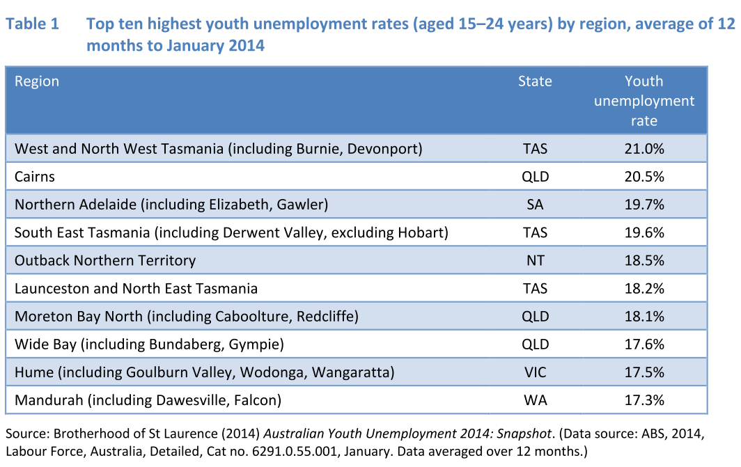

A dominant feature of apprenticeships is that it is a pathway to sustainable employment achieving higher skilled levels over time. Apprenticeships also offer a unique feature of security to an employer. An indentured apprentice cannot just walk away when an offer of higher wages is made by another employer. In a sense, the apprentice might be regarded as a more ‘guaranteed’ element of the workforce during the indenture period.

The need to replace retiring tradespersons is a national imperative and secures the importance of apprenticeships into the future. In a world where manufacturing is regularly moving off-shore, the need for tradespersons to engage in construction, commissioning and maintaining the essentials of Australian living such as buildings, infrastructure, energy distribution, communications, transport and food distribution will remain.

### Fair and equitable Pay and Conditions for employees, including the maintenance of a relevant safety net.

For apprentices the current framework for pay and conditions is in a state of complexity and confusion. The standing debate on whether an apprentice wage is a living wage or training wage continues to polarise debate. The introduction of the Modern Award sought to simplify aspects of the Industrial Relations Framework but *Notional Agreement Preserving State Awards (NAPSA)* for apprentices continue to apply. In Queensland, NAPSA were to be reviewed and transitioned after a proposed review in 2009. NAPSA remain in place today and for those who remained on these awards, they now face a risk of being accused of ‘price gouging’ were they to move to the Modern Award. This was a real and significant business risk during the down turn experienced after the Global Financial Crisis and the slump in the building and construction sector. The review into the Industrial Relations Framework must reconcile NAPSA[[2]](#footnote-2) and Modern Award conflicts.

### Small Business.

*In a study of the structure of Australian business, the Department of Employment Workplace Relations and Small Business (1999) found that approximately one million enterprises, 95 per cent, of the 1 051 900 enterprises in Australia were private-sector 'small-enterprises'. [[3]](#footnote-3)*

The largest employer group for apprentices is small and medium businesses.[[4]](#footnote-4) SMEs contribute to training and incubate our future tradespersons in far larger numbers than larger businesses. Some bigger contractors tend to ‘poach’ skills when required in large numbers. This was most evident in the bush communities of Queensland in recent Coal Seam Gas (CSG) developments when tradespersons were stripped from towns often leaving communities without the skills and service they needed.

A review of the Industrial Relations Framework should nurture this training effort and encourage it in small businesses.

### Productivity, Competitiveness and Business Investment.

Drawing on the documented success of the National Apprenticeships Program (NAP), the contribution of adult apprentices in this model provided immediate productivity improvements and significant net cash benefits. With one major client, Bechtel Australia these benefits were acknowledged and results such as a 98% retention rate and completions of qualifications in less than 18 months are on record. Out of the 10,000+ NAP registrations, the current database has over 3,000 adult Australians eligible and committed to upskill in an adult apprenticeship and agreeing to work anywhere in Australia under Fly-in Fly-out arrangements.

This enormous skills pool of resident Australians remains an untapped wealth for future productivity, competitiveness and business investment.

A review of the Industrial Relations Framework must consider the emerging unique roles and contributions of adult apprentices and the process and benefits of up-skilling our work force generally.

### The ability of Business and the Labour Market to respond appropriately to Changing Economic Conditions.

Responding to changing economic conditions can have serious impacts on the security and stability of the national work force. Two features are highlighted. Firstly, mass redundancies can be a consequence of downturns and economic change. Within the nation we have established frameworks and standing procedures to deal with natural disasters but none evident for negative economic events that lead to mass redundancies. At times of downturn efforts to prepare for the inevitable upturn are not realised. A more formal structured procedure and identified staffing arrangement to manage mass redundancies might be a feature of legislative review. This would help the labour market in those darkest of hours.

The benefits of switching focus on to training in downturns should be explored and realised. An industrial relations framework that sought to better prepare and accommodate these cyclic downturns would offer a greater focus on training and secure national benefits.

### Patterns of Engagement in the Labour Market.

In recent years, there are new listings in what had been the historical common patterns in labour market participation. One is the growing importance of up-skilling existing workers and the other is the growing demand for adult entry into apprenticeships.

The National Apprenticeships Program has identified a significant untapped pool of Australian workers with high levels of talent, skills and experience. This national asset can be a major contributor to the nation’s skill requirements in a most cost effective and timely manner. We face a time when a large portion of the nation’s aging workforce is considering and approaching retirement. With such retirement in large numbers there will be a huge experience loss to industry. This loss cannot be replaced in the short-term with new graduated apprentices but upskilling experienced older workers can mitigate some of this loss.

As demonstrated in the success of the National Apprenticeships Program, uncompromised and very efficient and effective upskilling can be a feature of the legitimate apprenticeship model for adults. The Industrial Relations Framework must accommodate this pattern of engagement in the Labour Market.

A product of an aging population and social change is the increasing age of applicants for traditional apprenticeships. A standard apprentice candidate is a person between 17-20 years of age with vehicle and licence. Yet over 60% of applicants for traditional apprentices these days are over 21 years of age. Current Industrial Relations differentiate between the 17-20 year old applicant and those over 21 in wages and conditions.

A review of the Industrial Relations Framework should consider the implications of encouraging upskilling, promoting adult apprenticeships and the relevance of wage differentials.

### The ability of Workers to flexibly Manage and Engage with their Employees.

Under the current Framework, the apprentice has less flexibility to engage with employers because of the legal obligations and requirements of Vocational Education Legislation, formal Training Contracts and implications of essential supervision in the workplace. An apprentice cannot choose when he attends essential training off-the-job. Such training must be completed during working hours with the apprentice denied the option of flexible attendance outside of working hours including weekends.

In the case of Group Training arrangements, the engagement with Employers is further complicated for the apprentice with the Group Training Organisation as the common law employer but the apprentice engaging day to day in the workplace with a Host Employer.

A review of the Industrial Relations Framework should review and consider the clarity of this important right of the apprentice.

### Barriers to Bargaining.

In the history of enterprise bargaining, it could be claimed that at no time has the employee group of apprentices ever been involved in bargaining. Is it about time that this legitimate employee group be invited to the bargaining table?

A review of the Industrial Relations Framework should examine this fundamental issue and consider a framework of legitimate representation.

### Red tape and the Compliance Burden for employers.

The contributory role played by Group Training is often underestimated when it comes to red tape and compliance. Small and medium enterprises play such an important role in national productivity when they engage a significant portion of all apprentices. Yet quite often they do not have the staffing levels or experience and time to adequately address legislative, administrative and compliance obligations and requirements for apprentices. The uniquely Australian concept of group training was originally created by the ACTU and Lend Lease Foundation to accommodate this and to promote the apprentice pathway to meet the nation’s skills requirements embedded into traditional trades.

A review of the Industrial Relations Framework should examine the roles and responsibilities between SMEs/Host Employers and Group Training to improve an efficient and effective interface.

### Industrial conflict and days lost due to Industrial Action.

When industrial conflict or action occurs there are legislated restrictions on the involvement of apprentices. As a legitimate element of a work force, by definition an employee, should an apprentice be denied a voice in such actions? A review of the Industrial Relations Framework should consider the current legislation and restrictions placed on apprentices. This would be particularly important given that the trend is moving quickly towards more adult apprenticeships.

### Appropriate scope for Independent Contracting.

In the current workplace, apprentices can bear the consequences of existing legislation that contains little or no reference to apprenticeships but can have a significant implication. One such example is referred to in the Issue Paper 5 as Sham Contracts. When this practice is observed and a qualified tradesperson virtually ‘prostitutes’ themselves for less than award conditions in downturn periods, the implication can be the ‘displacement’ of apprentices. This is particularly noticeable in group training where Group Training Organisations (GTOs) provide legitimate wages and allowances under current Industrial Instruments to apprentices as a legal obligation. Charge-out rates are determined based on these legitimate statutory costs plus the GTO’s administration charges.

Where Sham Contracts exist, the cost of tradespersons can fall below the true costs of apprentices and in difficult times, employers will send apprentices back to the GTO. This is a good example of why the Industrial Relations Framework must consider apprentices and safeguard their positions in the workplace.

# Additional Remarks

Some additional remarks that are offered to the Inquiry include:

### Contribution to Nation’s Skills Shortage.

The *National Skills Needs List (NSNL)* records traditional trades that are identified as experiencing a national skills shortage. The list is based on detailed labour market research and analysis undertaken by the Department of Employment. Addressing the list depends substantially on the recruitment, retention and completion of Australian apprenticeships.

Other smaller contributions to skills shortages include the *Trades Recognition Australia (TRA)* which is a skills assessment service provider specialising in assessments for people with trade skills gained overseas or in Australia, for the purpose of migration and skills recognition.

TRA is influenced by fluctuations in the numbers of permanent migrants, fluctuations that can be significant. Temporary migration is highly susceptible to changes in policies affecting the permanent Migration Program, particularly those concerning skilled migration.[[1]](http://www.aph.gov.au/About_Parliament/Parliamentary_Departments/Parliamentary_Library/pubs/BN/2012-2013/SkilledMigration" \l "_ftn41) In 2008–09 over one-third of the Migration Program was made up of people granted permanent residence after initial entry to Australia on a temporary basis, including former international students and temporary skilled workers.[[2]](http://www.aph.gov.au/About_Parliament/Parliamentary_Departments/Parliamentary_Library/pubs/BN/2012-2013/SkilledMigration" \l "_ftn42) In 2010–11, almost nine in ten people granted a permanent employer sponsored visa were people who had originally entered Australia as temporary skilled workers (on subclass 457 visas).[[3]](http://www.aph.gov.au/About_Parliament/Parliamentary_Departments/Parliamentary_Library/pubs/BN/2012-2013/SkilledMigration" \l "_ftn43)

While TRA and subclass 457 offer a contribution, it remains Australian apprentices who make the most substantial contribution to the skill needs of the nation.

### Apprentices create Tradespersons.

Over the past two decades, much of Australia’s manufacturing sector has been decimated by a shift to off-shore production where labour costs cannot be matched under Australian Industrial Relations. In stark contrast, items manufactured off-shore must still be fitted and maintained by Australian tradespersons. Currently retirement rates are around 6% of our workforce. This rate creates two challenges. Firstly, the 6% loss must be replaced predominantly through apprenticeships. Of far greater urgency is the replacement of the experience lost when older workers retire. In the short-term a newly graduated apprentice cannot replace this experience loss.

However, initiatives such as the National Apprenticeships Program[[5]](#footnote-5) which creates the opportunity for adults with industry experience but not the formal qualification to upskill can mitigate this experience loss.

It remains that the Australian apprentice underwrites and sustains the future of traditional trade skills in all critical sectors of industry. The training and transition of apprentices to tradespersons operates within the Industrial Relations Framework and must be accommodated.

### Apprenticeships offer a Valuable Career pathway to our Youth.

A major challenge for Government(s) in 2015 is high levels of youth unemployment. In some cases, the 15-24 year participation rates are the lowest levels seen since before 2002.

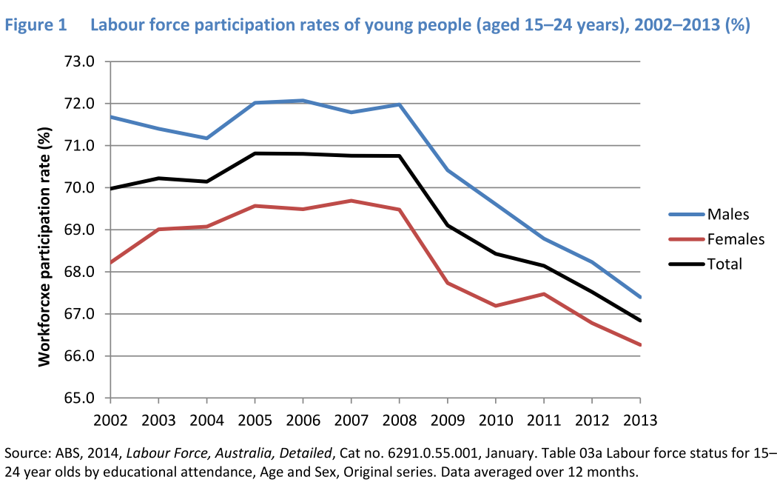

An apprenticeship and trade career is a very attractive pathway for many young Australians and a ‘first choice’’ career path. It is noted that over much of the same period that youth unemployment figures were rising there was a corresponding decline in the commencements of apprenticeships.

Figure 3 Trades and non-trades5,6 commencements,2,3 seasonally adjusted,1 2004–14 (’000)



Reference: Extract from NCVER - Apprentices and trainees June Quarter 2014

### Apprentices are not ‘hire company’ Services.

The Industrial Relations Framework must recognise the inherent difference between apprentices employed through group training and employees working for Hire Companies. There is a need for apprentices to complete the *On-the-Job* training requirements of a formal Training Agreement while being carefully supervised. This is quite different to a Hire Company employee skilled and capable of performing a task **without supervision**.

For the apprentice it is a training obligation exercised under supervision. Legislation must protect and nurture this unique arrangement in the workplace and clearly separate group training from hire companies.

### Apprentices generate approximately $4.7 billion in Expenditures each Year.

Over the period 1995-2014, an average of 172,095 trade apprentices were engaged in Training Contracts nationally.

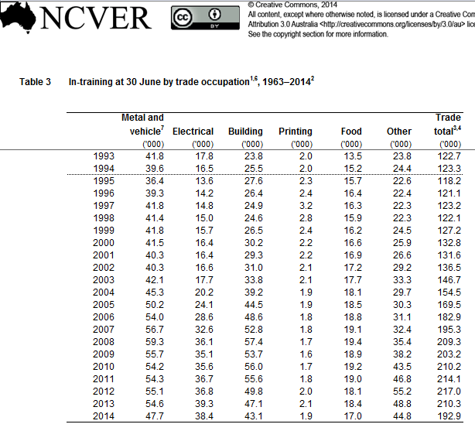

Those apprentices generated expenditure of approximately $4.3 billion in wages and allowances over this period. A further $430 million per annum was generated expenditure for training. [[6]](#footnote-6) The total is $4.7 billion per annum. If these figures are extrapolated over the life of the apprenticeship the financial implications are considerable.

It is essential that the Industrial Relations Framework and legislation safeguards this national investment and financial contribution.It is expected that a majority of graduating apprentices will engage in the industry for many years. This commitment makes a substantial contribution to our economy. The skills and experience of these tradespersons also enriches our lives and the essential physical structure of our society.

### The Law and Apprentices.

The following Acts and Regulations carry references to apprentices:

* Fair Work Act 2009 (C2014C00342)
  + Volume 1
  + Volume 2
* Crimes Act 1914 (C2014C00788)
  + Volume 2 only
* Family Law Act 1975 (C2014C00355)
* Income Tax Assessment Act 1997 (C2015C00020)
  + Volume 1
  + Volume 2
  + Volume 3
  + Volume 10
* Migration Regulations 1994 (F2015C00065)
  + Volume 1
* Social Security Act 1991 (C2015C00024)
  + Volume 1
  + Volume 2
  + Volume 3
  + Volume 4
* Tradespersons' Rights Regulation Act 1946
* Youth Allowance Consolidation Act 2000
* Work Health and Safety Act 2011 (C2014C00471)

It is of interest to also consider those Acts that do not reference apprentices when there might be an argument that they should. Included in this category might be:

* [Affirmative Action (Equal Employment Opportunity for Women) Act 1986](http://www.comlaw.gov.au/Details/C2004A03332)
* Age Discrimination Act 2004
* Building and Construction Industry Improvement Act 2005

Legislation can have many purposes: to regulate, to authorize, to proscribe, to provide (funds), to sanction, to grant, to declare or to restrict.

The relevance of some Federal legislation in relation to apprentices is the direct and indirect impact on apprentices. An example where the direct impact is in evidence is Restricted Trade Callings.

### Restricted Trade Calling.

Restrictions apply to the rights of employers to employ staff under the age of 18 years to certain jobs, or 'callings'. Employers may not employ a person under the age of 18 years in jobs that appear in the list of restricted callings, unless the prospective employee:

* has completed a qualification or statement of attainment relevant to the calling; or
* is employed by the employer as an apprentice or trainee in the calling under the registered training contract.

In Queensland, the jobs, or callings, to which this restriction applies, are declared in accordance with Section 64(1) of the [Further Education and Training Act 2014](https://www.legislation.qld.gov.au/LEGISLTN/CURRENT/F/FurtherEdTrngA14.pdf). 119 jobs or callings are identified in Queensland.

The Industrial Relations Framework and legislation should consider these State declared restricted callings and determine whether they should be harmonised into national legislation.

### Recommendations on Matters for Review.

Based on the matters outlined above, the following should be incorporated into the Review by the Commission into the Industrial Relations Framework:

1. Acknowledge the importance of safeguarding and inclusion of the apprentice into this review.
2. Determine and recommend legislative changes that improve the clarity around the place of the apprentice in the workplace and under the Industrial Relation Framework.
3. Establish clear legislative reference to the difference between apprentices, Group Training apprentices and Hire Company employees.
4. Define and incorporate into legislation the unique role of Group Training relative to apprentices in the workplace.

Prepared by:

Alan Sparks, AM, BEM

Chief Executive Officer

**East Coast Apprenticeships**

**Traditional Group Training – “Quality Service with Integrity”**

1. Expenditure is defined for this purpose as wages, allowances and training costs [↑](#footnote-ref-1)
2. **Terminating NAPSAs -** Under Item 3 of Schedule 5 of the *Fair Work (Transitional and Consequential Amendments) Act 2009* [Cth], Fair Work Australia can terminate modernisable instruments, such as NAPSAs. A Schedule of the NAPSAs, pre-reform awards, Australian Pay and Classification Scales (APCS) and State reference transitional awards to be terminated is usually attached to the decision. [↑](#footnote-ref-2)
3. Brett Freeland and Katrina Ball, National Centre for Vocational Education Research Paper presented to 9th Annual VET Training Research Conference, Coffs Harbour Education Campus 4-7 July 2000 [↑](#footnote-ref-3)
4. For the purposes of this paper a small business is defined as a business employing less than 20 people. Small businesses tend to have the following management or organisational characteristics: independent ownership and operations; close control by owners/managers who also contribute most, if not all the operating capital; and principal decision-making by the owners/managers. In comparison, medium businesses - businesses employing 20 or more people, but less than 200 people. [↑](#footnote-ref-4)
5. The National Apprenticeships Program was sponsored by the Australian Government and was developed and implemented by East Coast Apprenticeships. It offers adults a successful upskilling pathway in less than 18 months. [↑](#footnote-ref-5)
6. An average wage of $25,000 multiplied against the numbers of apprentices annually equals $4,302,375,000 pa. Where Government funded training averages $10,000 per apprentice over the four year term of the apprenticeship the expenditure is approximately 172,095 X ($10,000/4)=$430,237,500 pa Total expenditure in this simplistic analysis = $4.732 billion pa. [↑](#footnote-ref-6)