Human Services Inquiry
Productivity Commission

Online submission via
http://www.pc.gov.au/inquiries/current/human-services/make-submission

Dear Commissioners
Thank you for the opportunity to comment on the Productivity Commission Issues Paper Human Services: Identifying sectors for reform.
TEAMhealth: mental health in the Northern Territory’s Top End
As a skilled non-government organisation (NGO) TEAMhealth provide mental health services in the community across the Top End of the Northern Territory (NT). TEAMhealth provide a range of recovery focused services including residential rehabilitation for people with severe and persistent mental illness, community housing, individual recovery and group based support, aged care, together with early intervention support, mental health promotion, suicide prevention and education.
TEAMhealth achieved accreditation to the National Standards for Mental Health Services in 2014 and continues to focus on ensuring quality service provision and the pursuit of goals with TEAMhealth participants.

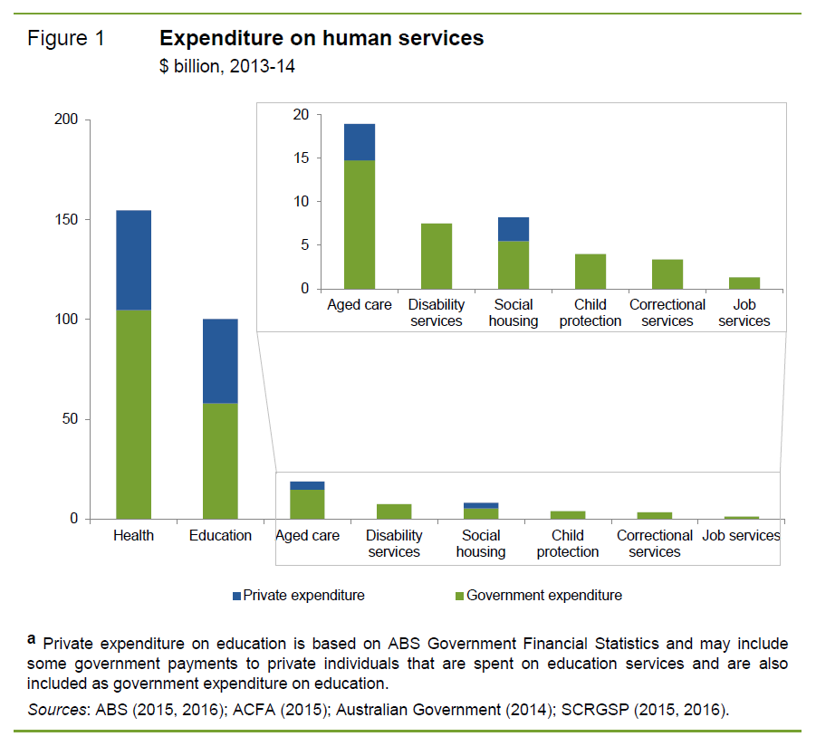
Human services and TEAMhealth
In terms of the human services definition (summarised in Figure 1 of the Issues Paper - shown here), TEAMhealth operate support services in mental health related disability services, social housing and aged care. We collaborate extensively with the acute and primary health care sector as we support individuals and with the education sector (among others) in our suicide prevention and mental health education work.
Our services are provided across the age range from infants and their families through every age and stage to the elderly accessing our aged care services.
We operate in Darwin/Palmerston/Katherine and surrounding regions and in remote communities in the Top End (Maningrida, Gunbalanya, Nauiyu (Daly River).

Mental health
As a mental health provider we are subject to competition through the Aged Care reforms (Consumer Directed Care), Community Housing and through the evolving National Disability Insurance Scheme (NDIS). As you would be aware the NDIS elements related to mental health (psychosocial disability) are still quite unclear and in flux. Many participants of programs that are currently funded through the Commonwealth and the Northern Territory Governments will be ineligible for the NDIS and there is broad and significant concern about how people such as these will be support in the future.
We compete actively in tender processes and are preparing to operate effectively in the “market based” environment of the NDIS.
TEAMhealth is within a community mental health sector that has been subject to constant change and reform. The outsourcing of Commonwealth funding to the PHN (Primary Health Networks) for mental health, and alcohol and other drugs is another element that is impacting on the sector, its participants, and their families and upon the workforce.

Northern Territory Aspects
Around 40% of TEAMhealth participants are Aboriginal and Torres Strait Islander people. Within the NT, approximately 30% of our population are Aboriginal and Torres Strait Islander background and around 60% of these people live in remote Northern Territory.
Consideration of competition and contestability in the NT and its remote environments is challenging and should only be done in a co-design process over an extended period. Within the area of mental health, social and emotional wellbeing and suicide prevention co-design is essential and community involvement over a long period is crucial.

Information to support your inquiry – “one size does not suit all”
Below I have included links to a number of resources that highlight important aspects of the mental health arena and aspects of remote service provision that should be considered in your inquiry into the competition, contestability and user choice within human services.
I have also provided a link to the TEAMhealth website and direct you to our Annual Reports which provide examples of the supports people are accessing and the individual positive outcomes being achieved together through continuity of support, trust and strong individual and community relationships.

Information links – “one size does not suit all”

TEAMhealth website | http://www.teamhealth.asn.au/
Mental health,  Community mental health,  National Disability Insurance Scheme | https://mhaustralia.org/general/letter-disability-reform-council-2017-productivity-commission-review-ndis  https://mhaustralia.org/report/commissioning-and-contracting-better-mental-health-outcomes-report  http://www.cmha.org.au/goals.html  https://myplace.ndis.gov.au/ndisstorefront/release-mental-health-papers.html  http://www.vicserv.org.au/images/PDF/VICSERV_publications/June_2015_Learn-and-Build-in-Barwon_Final.pdf  http://www.vicserv.org.au/images/documents/June_2015_Learn_and_Build_in_Barwon_-_NDIS_Case_Studies.pdf
Remote service provision  (NPY Women’s Council),  National Disability Insurance Scheme | http://www.npywc.org.au/wp-content/uploads/2012/04/NPY-Position-NDIS-Oct-2013.pdf  http://www.cadr.org.au/images/files/Remote_Indigenous_Service_Delivery_010614.pdf
Aboriginal organisations and working in the NT | http://www.amsant.org.au/apont/our-work/non-government-organisations/apo-nt-ngo-principles/
NT PHN  (Primary Health Network needs analysis should be available soon) | http://www.ntphn.org.au/

I look forward to the opportunity to comment on the preliminary findings report in September 2016.
Sincerely
Signed electronically
Helen Egan
Chief Executive Officer
15.07.2016

