Australian Communications and Media Authority submission
Response to the Productivity Commission draft inquiry report into the telecommunications Universal Service Obligation
february 2017

Canberra
Red Building
Benjamin Offices
Chan Street
Belconnen ACT
PO Box 78
Belconnen ACT 2616
T +61 2 6219 5555
F +61 2 6219 5353
Melbourne
Level 32
Melbourne Central Tower
360 Elizabeth Street
Melbourne VIC
PO Box 13112
Law Courts
Melbourne VIC 8010
T +61 3 9963 6800
F +61 3 9963 6899
Sydney
Level 5
The Bay Centre
65 Pirrama Road
Pyrmont NSW
PO Box Q500
Queen Victoria Building
NSW 1230
T +61 2 9334 7700 or 1800 226 667
F +61 2 9334 7799
Copyright notice
http://creativecommons.org/licenses/by/3.0/au/
With the exception of coats of arms, logos, emblems, images, other third-party material or devices protected by a trademark, this content is licensed under the Creative Commons Australia Attribution 3.0 Licence.
We request attribution as © Commonwealth of Australia (Australian Communications and Media Authority) 2017.
All other rights are reserved.
The Australian Communications and Media Authority has undertaken reasonable enquiries to identify material owned by third parties and secure permission for its reproduction. Permission may need to be obtained from third parties to re-use their material.
Written enquiries may be sent to:
Manager, Editorial and Design
PO Box 13112
Law Courts
Melbourne VIC 8010
Email: candinfo@acma.gov.au

Introduction 1
Developments in the communications sector 2
Trends in the use of fixed and mobile services 2
Trends in payphones 3
Satisfaction with communications services 4
Modernised universal service framework—key considerations 6
NBN satellite services 7
Potential role for the ACMA in designing tender arrangements 8
Retail provider of last resort 8
Transitional issues 10
Overview of transitional considerations 10
Timeframe for transition 10
Phasing out the STS USO 11
Phasing out the payphone USO 13
Consumer safeguards—key considerations 15
Telecommunications consumer safeguards objectives 15
Availability, accessability and affordability 17
Effective operation of communication services 18
Safety, privacy and security of communication services 19
Conclusion 20

Introduction
The Australian Communications and Media Authority (the ACMA) welcomes the opportunity to provide a submission in response to the Productivity Commission’s (the PC’s) draft report into Australia’s Telecommunications Universal Service Obligation (USO). This submission builds on our earlier submission to the issues paper released by the PC in June 2016 to inform this inquiry.
In this submission, the ACMA does not address every finding or recommendation in the PC’s draft report. However, it seeks to assist the PC’s considerations to finalise its report by providing:
- relevant research published since the ACMA’s submission to the issues paper
- observations on the proposed universal service framework outlined in the draft report, with a focus on recommendations that specify a role for the ACMA
- potential transitional issues in response to the PC’s recommendations to abolish the existing USO contractual arrangements
- considerations about the relationship between the PC’s proposed universal service framework and the broader telecommunications consumer safeguards framework.

Developments in the communications sector
In our submission in response to the issues paper, the ACMA provided a range of data and research to inform the PC’s considerations. Since then, the ACMA has published a number of new research reports that have relevance to this inquiry.
This section of the submission to the draft report draws upon recently released data and research that the ACMA considers may assist the PC in its considerations of a new baseline universal service objective.

Trends in the use of fixed and mobile services
The ACMA’s Communications report 2015–16 shows a continued decline in the use of fixed-line phones at home and a continued rise in adult Australians having only a mobile phone.
At June 2016, research shows that 31 per cent of adult Australians, or approximately 5.78 million people, have only a mobile phone with no fixed-line phone at home. This is a 94 per cent increase over the five years to June 2016. This steady increase in mobile phone-only subscribers is matched by the steady reduction in fixed-line phone subscribers. The number of adult Australians with a fixed-line phone at home fell from 78 per cent in June 2012, to 68 per cent by June 2016. The five-year trend for mobile only and fixed-line phone services is shown in Figure 1.
- Home phone: fixed line and mobile only—five-year trend

Source: ACMA communications reports, 2011 to 2016; mobile phone-only—Roy Morgan Single Source; home phone—ACMA consumer survey.
ACMA research also examined the differences in use of fixed-line phone and mobile services between capital cities and regional areas.
At June 2016, 69 per cent of adult Australians in regional areas had a fixed-line phone service, compared to 67 per cent in capital cities and 68 per cent in Australia overall.
At June 2016, 96 per cent of adult Australians said they had a mobile phone. There is no significant difference between regional areas and capital cities for those who own or use a mobile phone (95 per cent and 96 per cent, respectively). There is also little difference between the proportions of adults who are solely dependent on their mobile for voice communications—30 per cent of adult Australians outside capital cities live in households that are mobile-only, with no fixed-line phone. By comparison, 32 per cent of adults living in capital cities are mobile phone-only.
However, the type of mobile phone used shows more variation according to geography. While 82 per cent of adults living in capital cities use a smartphone, for those living in regional areas, the figure is 75 per cent. This difference is reflected in the way Australians use their phone. Among mobile phone users, 58 per cent of Australians living in regional areas accessed the internet using their mobile phone, nine percentage points lower than their capital city counterparts.
- Home phone and mobile phone by location

Source: Roy Morgan Single Source, June 2016.
Base: Australians aged 18 years and over.

Trends in payphones
Figure 3 shows that the use of payphones by adult Australians declined from June 2013 to 2015, before stabilising at six per cent.
- Payphone use trend over the past five years

Source: ACMA communications reports 2011 to 2016; mobile phone-only—Roy Morgan Single Source; home phone—ACMA consumer survey.
The decline in the number of payphones slowed over 2015–16, with numbers falling by five per cent to 24,573 payphones. At the same time, there was an increase of 2.6 per cent in the number of Telstra-operated payphone sites, from 15,170 to 15,568.
At 30 June 2016, 69.6 per cent of payphones were operated by Telstra. The remaining payphones were provided by other companies, hotels, clubs and convenience stores.

Satisfaction with communications services
Consumer satisfaction with different aspects of communications services such as call quality, service reliability and the speed of repairing faults has been reported in the ACMA communications report for several years. Reports from 2014 to 2016 reveal that the overall level of consumer satisfaction across the different aspects of communications services has remained relatively stable.
Consumer satisfaction with aspects of fixed-line phones, mobile phones and internet for the 2015–16 year is detailed in Figure 4.
For fixed-line services, the highest levels of satisfaction were for service reliability, with 93 per cent of consumers satisfied or very satisfied. Line rental cost recorded the highest levels of dissatisfaction (25 per cent dissatisfied or very dissatisfied).
For mobile phones, the quality of voice calls recorded the highest levels of satisfaction (94 per cent), while call/service costs recorded the highest levels of dissatisfaction (16 per cent).
For internet services, the highest levels of satisfaction were recorded for billing information (91 per cent), while data speeds recorded the highest levels of dissatisfaction (27 per cent).
- Consumer satisfaction with aspects of their communications services (percentage)
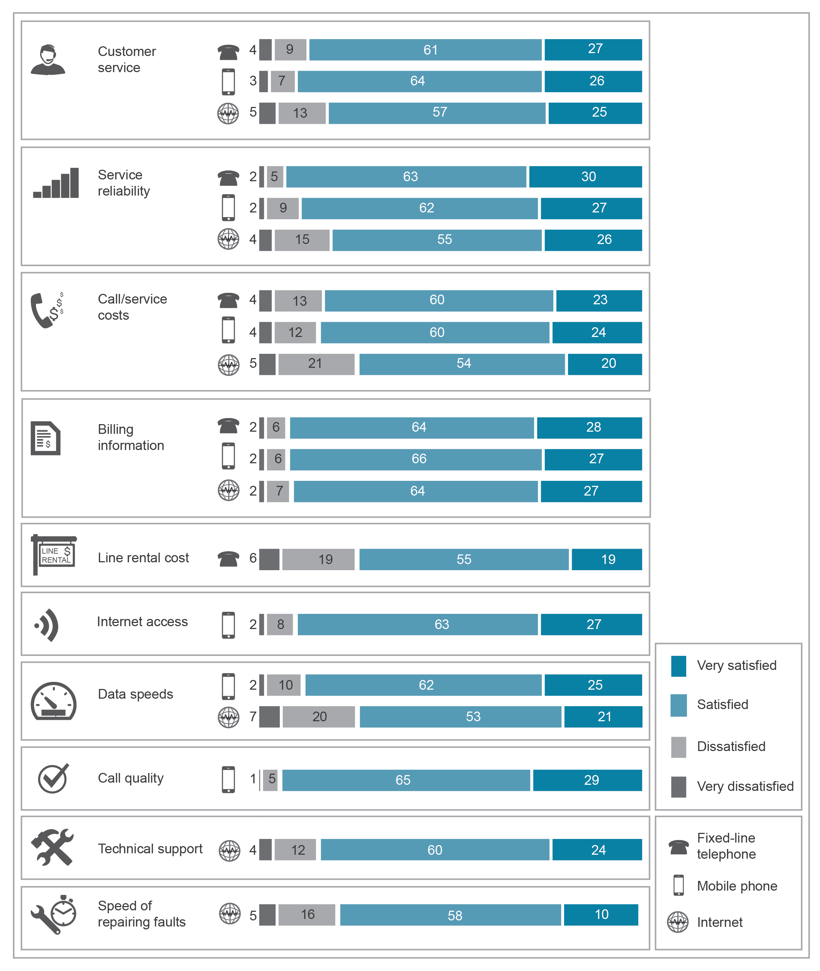
Source: ACMA Communications report 2015–16.
Base: Australians aged 18 years and over.

Modernised universal service framework—key considerations

Key design principles
The ACMA supports the PC’s conclusion that the USO is no longer fit-for-purpose. The current communications environment calls for a modernised set of universal services objectives. The ACMA agrees that some objectives can potentially be delivered by the market, and that only where market failure exists may it be necessary for objectives to be delivered via government interventions. The ACMA also agrees that it may be possible for such interventions to be highly targeted.
As noted by the PC, the USO is one of a number of interventions used to deliver outcomes related to availability, accessibility and affordability. These interventions currently include a mix of direct regulation, contractual obligations and direct subsidies.
By comparison with today’s communications environment, the telecommunications sector in which the USO was developed appears to have been relatively stable. The current telecommunications sector is characterised by a broadly competitive retail environment, continuously evolving consumer expectations and widespread use of a large range of products and services. It is also shaped by government interventions including the rollout of the NBN network and the Mobile Black Spot Programme.
The ACMA also notes that there is a range of factors that make designing and implementing a modern universal service regime challenging. These include technological developments, Australia’s vast rural and regional areas with their relatively low population densities and evolving industry structures.
In reframing universal service objectives and policies, the ACMA notes that the PC’s draft report adopts a number of design principles similar to those outlined by the ACMA in its July 2016 submission.
Key design principles include having clarity around objectives and, as far as possible, harnessing market solutions in the delivery of universal service objectives. If, after sound analysis, there is a need for government intervention, such interventions should be appropriately targeted and designed to minimise market and competitive distortions.
Increasingly, there will be a multi-layered set of obligations; that is, obligations operating separately at the infrastructure and retail layers, but which will interact with each other. Given these interactions, such obligations need to be carefully designed so that they deliver a coherent outcome for consumers. To achieve this, there needs to be a clear line of sight between the intervention and the outcome for the consumer.
The ACMA considers there may be scope for the final report to provide clearer links between the proposed universal service framework and relevant service standards. These may include elements of existing standards, as well as new standards that are developed specifically for the new framework.
The telecommunications sector is dynamic: changes are constant and driven by change in both the supply and demand sides. As examples of developments expected in the next few years, the PC’s draft report makes reference to the completion of the NBN infrastructure rollout, the launch of 5G technologies, and increased use of Internet of Things applications and virtual reality. The ACMA’s Communications report 2015–16 also identifies the increasing take-up of over-the-top messaging, voice and video calling services as a driver of change.
Given these expected developments, and others that cannot be foreseen, any new universal service framework must enable service standards to be updated, when necessary, to keep pace with these sectoral changes. The ACMA considers that, at a minimum, the proposed universal framework should include:
- clear and transparent processes or triggers for determining when service standards should be reviewed and/or amended
- details about the form service standards should take (for example, contractual arrangements or regulatory instruments)
- recognition that the amendment of standards should minimise costs to government, industry and consumers, and limit market distortions.
In providing this view, the ACMA notes that any service standards that support the proposed universal service framework may overlap in scope or interact with:
- outcomes of the Department of Communications and the Arts (DoCA’s) proposed consumer safeguards review
- safeguards established in the draft legislation for the Statutory Infrastructure Provider regime, or safeguards that may subsequently be established under that regime.
Aspects of these issues are explored later in this submission.

NBN satellite services
The PC’s report considers whether the NBN satellite service is able to support voice services that adequately meet the proposed universal service objective. This includes the ability for consumers to have a baseline voice service that also provides reliable access to the emergency call service. Information provided to the ACMA, in the context of its consumer and regulatory functions, indicates that there are potential latency problems associated with providing a voice service over the NBN satellite service. The ACMA understands that these problems may be related to the primary design objective of the NBN satellite service, which is optimising the provision of broadband services, rather than optimising the provision of voice services.
The ACMA also notes that the PC is considering the technical difficulties associated with determining the appropriate (and frequently changing) boundaries of adequate mobile coverage within the NBN satellite footprint. These difficulties may complicate estimating or modelling the number of premises that will lack a reliable baseline voice service within this footprint.
Accordingly, the ACMA suggests that the PC’s final report adopts a cautious and conservative approach to these estimations.

Potential role for the ACMA in designing tender arrangements
The PC proposes three options to address the provision of voice services within the NBN’s satellite footprint where it is determined that there is no mobile coverage and government intervention is warranted:
- a competitive tender to select providers of retail voice services in parallel with the provision of satellite data services
- funding Telstra to provide a baseline voice service
- funding NBN to augment its networks to support or deliver a baseline voice service.
The PC expresses a preference for the first option.
The draft report states that such tender arrangements could be implemented by the ACMA, given its expertise in telecommunications technologies and previous role in the 2001 USO contestability arrangements. The ACMA is aware that this is a highly specialised market and the design of the procurement is critical to its success. Should the ACMA be tasked with designing and conducting such a tender, it would be mindful of relevant lessons from the previous competitive tendering processes for contestable USO services and Extended Zones arrangements. These include the importance of managing the risk that a tender may be attractive to potential participants, where:
- the tender is divided into small areas or populations that are insufficient to create economies of scale
- functional requirements are unnecessarily prescriptive about what features are to be delivered and how, discouraging cost-efficient or innovative solutions
- one provider already owns a large proportion of existing fixed network infrastructure in a given area, which may give it a competitive advantage due to these costs being sunk
- the tender specifies a predetermined subsidy or contract period that limits the ability to achieve a reasonable return on investment.
Decisions regarding the provision of retail voice services within NBN’s satellite footprint, if required, are ultimately a matter for government. However, the ACMA considers itself well placed to design and conduct any such tendering arrangements. In particular, the ACMA notes that it possesses:
- knowledge and expertise regarding current and emerging telecommunications technologies
- experience in adjusting regulatory settings in response to distinctive features of new technologies
- economic expertise, applied in recent years to the design and implementation of complex spectrum pricing and allocation arrangements.

Retail provider of last resort
An important precursor to deciding whether a tender is required will be identifying those geographic areas where there is no (or minimal) retail provider presence for the delivery of a service. The identification of these areas, and the potential number of consumers in areas requiring a service, will be important to successfully meet the proposed universal service objective. A key issue will be to ensure that any lag in service provision is minimised. Important factors to consider, irrespective of whether or not tendering arrangements are ultimately used, include:
- mechanisms to identify consumers requiring a service
- estimating the number of customers and geographical vicinity of those customers to each other
- in the case of voice services, assessing the extent to which existing infrastructure can be adequately utilised to deliver a baseline service.

Transitional issues

Overview of transitional considerations
If the government adopts the draft recommendations, it will be important to determine the most appropriate transition pathway from the existing USO to a new universal service framework. It is clearly in everyone’s interest for this transition process to occur as smoothly as possible for all stakeholders (consumers, industry and government).
The PC has identified that the Telstra Universal Service Obligation Performance Agreement (TUSOP Agreement) currently in place between Telstra and the Australian Government would need to be re-negotiated to phase out both the Standard Telephone Service (STS) and payphone USO modules. The ACMA is of the view that, in connection with any renegotiation, the government may wish to consider whether primary and secondary legislative instruments that underpin the existing USO regime may need to be modified. These instruments comprise:
- Part 2 and Schedule 2 of the Telecommunications (Consumer Protection and Service Standards) Act 1999 (TCPSS Act)
- Carrier Licence Conditions (Telstra Corporation Limited) Declaration 1997
- Telecommunications Universal Service Obligation (Standard Telephone Service–Requirements and Circumstances) Determination (No.1) 2011
- Telecommunications Universal Service Obligation (Payphone Performance Standards) Determination (No. 1) 2011
- Telecommunications Universal Service Obligation (Payphone Performance Benchmarks) Instrument (No. 1) 2011
- Telecommunications Universal Service Obligation (Location of Payphones) Determination 2011
- Telecommunications Universal Obligation (Payphone Complaint Rules) Determination 2011
- Telecommunications Universal Obligation (Payphone Public Consultation on the Location or Removal of Payphones) Determination 2011.
The form and timing of such changes will be integral to a smooth transition. In this section of the submission, the ACMA examines key transitional issues.

Timeframe for transition
The most appropriate time to withdraw the current USO should be a key consideration when developing transitional arrangements. While some of the transitional options proposed by the PC would result in removing the USO quickly, this is likely to add additional complexity to contractual negotiations and any complementary legislative changes.
The development of transitional arrangements should also take into account the potential interaction between a new universal service objective and other related telecommunications consumer safeguards. This topic is discussed in the next section of this submission.
Above all, the transitional arrangements should ensure that end users are not inadvertently disadvantaged during the transition process. Businesses and consumers will benefit from having time to understand the changes and what they will mean for them. Consequently, there will be a need to clearly communicate changes to the USO to businesses and consumers.
Industry should also be made aware of how the transition process will operate, and how it may affect their service offerings and regulatory obligations. This will enable them to assist customers during the transition.

Phasing out the STS USO
The PC sought feedback on three potential options for removing the STS USO:
- changing the scope of the STS USO requirement in Part 2 of the TCPSS Act to trigger a re-negotiation of the TUSOP Agreement
- delay phasing out the STS USO until the full NBN infrastructure rollout is completed in 2020
- progressively phasing out the STS USO as the NBN rolls out.
The existing USO arrangements are complex and careful planning is essential before they are dismantled.

Timing and avoiding consumer harm
Consideration of each of the above options should take into account their respective potential to cause (or minimise) difficulties for different categories of stakeholders. The ACMA suggests a detailed assessment of the level of complexity and risk for industry, businesses and consumers arising from each option.
Based on recent data from the Australian Competition and Consumer Commission, the PC suggests that there is likely to be a retail presence across the entire NBN footprint. However, the ACMA considers it prudent to have arrangements in place so that any gaps that become evident in the availability of retail service provision can be quickly addressed before the withdrawal of the STS USO.
During the transitional period, no businesses or consumers should be left without access to a replacement voice service of suitable quality. Continuity of service, more generally, should also be a priority, to ensure that all citizens have access to the emergency call service, and that citizens with particular needs have access to the services they require.

Administrative complexity and potential consumer confusion
Option 3 would enable a rapid start to phasing out the STS USO with consequential cost savings in USO payments. However, the ACMA believes there is a risk that a less-than-careful implementation of this option may lead to consumer confusion and increased complexity in administering the USO.
If the STS USO is gradually removed, it potentially creates a scenario where different universal arrangements would apply, depending on whether NBN services were available.
It is likely that keeping track of the areas where requirements under the current USO apply, and where STS USO requirements had been removed would be complex. It could involve administering two different sets of regulatory (and potentially contractual arrangements), the application of which would be in constant flux while the NBN rollout is in progress.
The ACMA also considers that implementation of option 3 would also need to be carefully managed to avoid consumer confusion about their rights. It could lead to erroneous perceptions of a two-tiered system, where certain citizens have better protections than others, depending on where they work or reside. Communicating this arrangement to consumers would need careful planning if there were two USO schemes applying in parallel during transition.

Satellite quality of service
While the PC draft report recognises that the NBN satellite service may not provide an adequate quality voice service, the transitional options are presented on the assumption that satellite will provide a baseline voice service.
The ACMA considers determining the adequacy (or not) of the NBN satellite network to deliver a baseline voice service is necessary before the transition to new USO arrangements takes place. Consumers who reside in locations that are within the NBN satellite footprint, but where mobile coverage is lacking or patchy, may be at risk of losing access to an acceptable baseline voice service.

Priority assistance continuity
A companion consumer safeguard to the USO is priority assistance. This safeguard ensures that there is at least one service provider offering people with life-threatening medical conditions an urgent connection and repair service. It also provides an ongoing heightened level of service reliability.
Under current arrangements, Telstra is the only provider that is required to offer this service, under a provision of its carrier licence conditions. Other providers may offer specific priority assistance services. These providers must comply with the industry code ACIF C609:2007 Priority assistance for life threatening medical conditions. Providers may also offer services that are similar to priority assistance services, but do not align exactly with ‘priority assistance’, as defined in Telstra’s carrier licence or the code. An example is Optus’ Special Assistance service.
At 30 June 2016, there were 211,259 priority assistance customers. This is an increase from 186,745 in the previous year. The continuing demand for priority assistance indicates that the availability of the service remains important to consumers with serious medical conditions. Under current contracts between Telstra and the government, Telstra can supply priority assistance over a fixed-line NBN service. However, it is not permitted to do so over NBN fixed wireless or satellite services. Presently, the Copper Continuity Obligation (CCO) provides the means of delivering priority assistance in these parts of the NBN footprint.
The PC report proposes that it may be possible to remove the CCO entirely, either if the NBN satellite service is deemed able to provide an adequate baseline voice service, or an alternative arrangement for delivering an adequate baseline voice service is established. In considering transitional options that involve changes to the CCO, the ACMA suggests continuity of the provision of priority assistance services should be a consideration.

Standard Telephone Service concept
The concept of the STS is a foundation of the current telecommunications consumer protection framework, including the existing USO. For example:
- the Customer Service Guarantee is based on connecting and repairing faults with an STS
- the National Relay Service provides individuals who are deaf, or who have a speech- or hearing-impairment access to a standard telephone service on terms, and in circumstances, that are comparable to the access other Australians have to an STS.
The ACMA notes that one of the options proposed by the PC to transition the STS module of the TUSOP Agreement is to amend the TCPSS Act to change the scope of the STS USO. If this option were to be adopted, the ACMA considers that a detailed analysis is required to consider the implications of any changes, and mitigate any unintended consequences. It may be appropriate to undertake this analysis as part of the DoCA’s proposed consumer safeguards review.
The ACMA considers that any changes to the STS may also be affected by any ministerial declaration made under section 8J of the TCPSS Act. It would be prudent for the analysis proposed above to take account of any such declaration.

Phasing out the payphone USO

Regulatory settings

The PC recommends that government immediately commence negotiations with Telstra with a view to abolishing the payphones module of the TUSOP Agreement. Should this recommendation be accepted, consideration should be given to the future of Telstra’s statutory obligations in this area.
The ACMA monitors and regulates Telstra’s performance in relation to its payphone USO obligations via five legislative instruments under the TCPSS Act:
- Telecommunications Universal Service Obligation (Payphone Performance Standards) Determination (No. 1) 2011
- Telecommunications Universal Service Obligation (Payphone Performance Benchmarks) Instrument (No. 1) 2011
- Telecommunications Universal Service Obligation (Location of Payphones) Determination 2011
- Telecommunications Universal Service Obligation (Public Consultation on the Location or Removal of Payphones) Determination 2011
- Telecommunications Universal Service Obligation (Payphone Complaint Rules) Determination (No. 1) 2011.
If any of these instruments are considered redundant, the ACMA suggests that the timing of their removal should be considered in line with any associated changes in contractual obligations.

Program for community telecommunications services
The PC recommends that there may be a need to replace the payphone USO with a funding program for community telecommunications services.
The ACMA recognises that such a program may serve to expand the achievement of a new universal service objective that is focused on a baseline broadband service. The ACMA considers that such a program should be flexible in nature for the types of services to be delivered, the form of procurement and the criteria for approval.
It is possible that services to be delivered by this program may include the continuation of payphones in some areas. However, the criteria for allocating funds under this program should also facilitate the provision of facilities that support the way Australians do, and will, use communications-related services, including their use of mobile and broadband services. Examples could include community Wi-Fi and phone charging services. Building flexibility into the criteria would assist in meeting the overall objectives of universal (broadband, including voice) availability, while also fulfilling accessibility and affordability objectives. For example, the ACMA understands that many homeless people may have access to an affordable mobile service, but frequently lack an opportunity to charge their phones.
In addition to the forms of services to be provided, the ACMA suggests careful consideration be given to the intended user groups and target locations for the proposed program. While the PC has suggested that locations outside of mobile coverage areas be targeted, the ACMA considers the criteria should be flexible enough to meet situations where locations may have mobile coverage but other shortcomings related to availability, accessibility or affordability exist. For instance, public housing in large rural areas with mobile coverage should still have the ability to benefit from such a program that may include access to free or affordable Wi-Fi services.

Competitive tendering arrangements
The ACMA notes that the PC recommends that competitive tendering arrangements be used as much as possible to assist in the efficient allocation of program funding.
The ACMA’s views on competitive tendering arrangements for universal services are outlined in the previous section of this submission. However, three key issues may be relevant within the context of a proposed community telecommunications program.
Firstly, to the extent that a component of the program may facilitate the continued provision of communication services in particular areas, due consideration should be given to the inherent advantages that Telstra is likely to have, given its long history with payphone service provision. This not only includes Telstra’s familiarity with payphone regulatory settings, but also its operational advantages in terms of its existing payphones sites having access to power and existing network infrastructure.
Secondly, appropriate performance requirements would need to be specified as part of the awarding of any contract following a tender process.
Thirdly, there may be value in designing a tender that encourages participation from medium and smaller retail providers that may be more familiar with local consumer requirements.

Consumer safeguards—key considerations
The ACMA notes that the PC’s draft recommendations have implications for the broader set of telecommunications consumer safeguards interconnected with the USO. The PC may consider that these wider implications should be examined as part of the government’s intended review of telecommunications consumer safeguards.
This section of the submission outlines a number of enduring objectives for telecommunications consumer protections, which apply more broadly than simply to ensure universal service. The ACMA suggests that these be taken into account in any wider review of telecommunications safeguards.

Telecommunications consumer safeguards objectives
The ACMA supports the PC’s draft recommendation that a broad-ranging review of the telecommunications consumer safeguards is required. This position recognises that while many of the components of the existing consumer protection framework remain relevant, others are being sorely tested by the substantial changes in the telecommunications market over the past two decades. The ACMA’s 2011 paper, Broken concepts–The Australian communications legislative landscape (updated in 2013), explored these problems in detail. At the same time, the ACMA considers that a sector-specific consumer protection framework is still required. Indeed, a similar view is expressed in the May 2016 draft report of the review of the ACMA, which notes that ‘… the unique complexity of communications products and services mean that it is appropriate to retain sectoral regulation to complement general consumer law.’
The ACMA has, for a number of years, been considering the elements of telecommunications consumer protection that are enduring. Our 2011 paper, Enduring concepts–Communications and media in Australia, in particular, articulated the ACMA’s views and thoughts on these issues. More recently, the continuing changes in the telecommunications landscape—such as the rollout of the NBN and changing consumer behaviours—are again prompting the need to consider the telecommunications regulatory framework.
As part of his address to the CommsDay Congress in October 2016, acting ACMA Chairman Richard Bean offered insights into the ACMA’s approach to these issues:
From the ACMA’s perspective, we look for a framework that promotes consumer confidence—so that citizens can constructively engage with old and new communications products, where consumers have the tools available to evaluate products and services, and where they have the confidence to change their own communications practices to take advantage of innovations—all useful outcomes that are consistent with, and reflect the unique characteristics of contemporary communications.
The acting ACMA Chairman identified five areas of enduring public interest in the communications market:
- Access to both services and devices—there is a continued expectation of a need for connectivity in emergency situations. Facilitating access to communication for specific segments of the community (as outlined in the PC’s draft report) is also a fundamental consideration.
- Affordability—there is a customer expectation that telecommunications services are affordable and competitively priced. There is also an expectation for a meaningful choice of providers.
- Availability—consumers can expect that a service will be connected in a reasonable timeframe and be reliable, both in terms of quality and service delivery.
- Capability—consumers are able to utilise services to maximise their benefits.
- Customer service—consumers can reasonably expect that pre-sale information about products and services is provided in a comprehensible format and that service problems are addressed in a timely manner.
The ACMA considers that these areas represent enduring consumer expectations that are likely to apply, even as technologies, products and services provided by the communications industry change over time.
To articulate this thinking further, the ACMA has identified nine overarching consumer protection objectives, illustrated in Figure 5 below. These objectives build on the public interest areas identified above and can be broadly grouped into three categories:
- the first category relates to the availability, accessibility and affordability of communications services
- the second category relates to the effective operation of communication services
- the third category relates to safety, privacy and security of communication services.
The objectives are discussed below.
- Enduring telecommunications consumer objectives
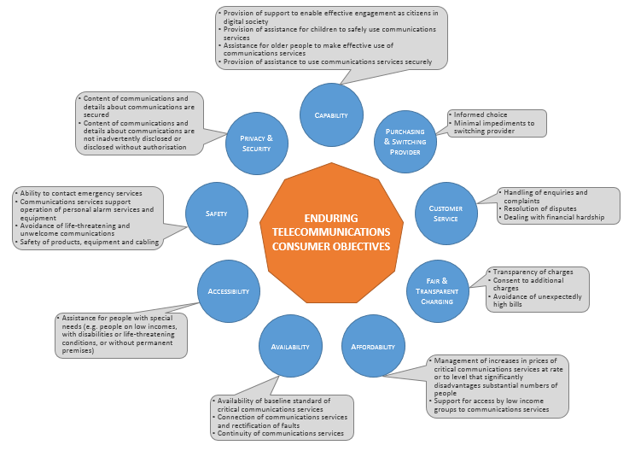

Availability, accessability and affordability
Both the existing USO and the PC’s proposed universal service framework seek to address the objectives of availability, accessibility and affordability.
Further, it can be noted that there are a number of particular regulatory consumer safeguards that have historically been closely linked to the delivery of the USO. The ACMA considers it appropriate that these should be carefully evaluated should the government decide to alter the existing USO arrangements.

Impact of proposed universal service framework on existing safeguards
A key consumer protection for the availability of consumer services is the customer Service Guarantee (CSG), which has also been a proxy for measuring the delivery of the STS USO. The PC notes that the practice by some service providers of requiring potential customers to waive their CSG rights before commencing supply of service has increased over the last few years. This has led to less customers being covered by the CSG.
Should the government look to alter USO arrangements, the future of the CSG (a retail level protection) should be evaluated in light of the NBN rollout. This is because any application of CSG-like protections at the retail level is dependent on a corresponding commitment by the wholesale provider (nbn or another infrastructure provider) regarding connection and repair times. Accordingly, consideration should also be given to the interaction between the CSG (or any similar retail level protections that may replace it), and connection and fault rectification arrangements at the wholesale level.
The CSG is complemented by the National Reliability Framework (NRF). The NRF has the objective of improving the reliability of poorly performing parts of, and voice services in, Telstra’s copper network, particularly in regional and rural Australia.
The current NRF has three levels of operation. The first level examines the general reliability of fixed phone services in different regions of Australia, while the other two levels are concerned with identifying localised areas and individual services that do not meet minimum levels of reliability.
The ACMA considers that, as Telstra’s copper network assets are transferred to the nbn, it is appropriate to give early consideration to whether any regulatory arrangements are necessary to maintain (or potentially improve) the reliability of these assets under nbn ownership.

Targeted assistance programs
The PC’s draft report notes that targeted assistance programs are more appropriate for addressing gaps in universal service than an across-the-board universal service obligation. However, it appears to the ACMA that the PC’s draft report does not address the accessibility and affordability of communications services in as much detail as the availability of communications services.
Given that the analysis in the draft report suggests that the accessibility and affordability of communications services is not consistently adequate, the ACMA considers that it would be appropriate to give more detailed consideration to these factors should USO arrangements be altered.
The ACMA supports the PC’s draft recommendation of a stocktake of telecommunications assistance programs as a starting point for this exercise. It may be appropriate that this detailed stocktake and analysis be undertaken as part of the government’s proposed consumer safeguards review.

Effective operation of communication services
The second category of objectives relates to the effective operation of a communications service:
- consumers receiving a satisfactory minimum level of customer service
- charging being accurate and transparent
- markets operating competitively
- individual providers offering pre-sale information so that consumers can make informed choices and move between providers.
Achieving these objectives, and having effective safeguards that underpin them, are closely related to the universal services framework:
- Issues with the connection to, and provision of, communication services will necessarily lead to customers contacting their provider to resolve the issue. While providers must have satisfactory customer service and complaints-handling processes, the resolution of these issues for fixed network services is ultimately dependent on the delivery of the service at the infrastructure (or wholesale) layer.
- There is a relationship between affordability and fair/transparent charging arrangements. Transparent charging and usage arrangements assist consumers to manage expenditure on communications services. Safeguards such as spend management tools (for example, usage alerts) provide additional protections against unexpectedly high bills.
- A competitive market that allows consumers to make informed choices about providers and results in minimal impediments to switching providers will improve accessibility outcomes. Existing safeguards such as the Telecommunications Consumer Protections Code and number portability codes underpin these objectives.

Safety, privacy and security of communication services
The third category of objectives relates to the safety, privacy and security of communication services.
Public safety, specifically access to emergency services, has historically underpinned the existing universal service obligation. Ensuring that priority assistance access to a STS is available to those who require it has also supported this objective.
Consumers are able to make the most of their communications services when arrangements are in place to support the safe and secure operation of these services at the consumer, retail and infrastructure layers. Furthermore, consumer confidence in communications services is increased when they understand privacy protections; facilitating trust in, and engagement with, new technologies and services.
With the complexity and constantly changing nature of communications services, consumers require helpful information that enables them to understand, negotiate and use communications services to their greatest advantage.
The existing telecommunications consumer protection regime includes a broad range of safeguards that, together, address each of these enduring objectives. Any proposed changes to a universal service framework must similarly consider how to continue to fulfil these nine objectives.
While the USO is key to meeting certain specific consumer objectives, it cannot be considered in isolation. Any redefinition of the universal service objective or the USO will impact the broader consumer safeguards universe. Therefore, it is important that any new universal services framework is considered as part of the broader set of consumer safeguards discussed above. Should the government accept the PC’s new universal framework, the ACMA considers there will be a need for these enduring consumer objectives and their method of delivery to be re-evaluated.

Conclusion
The ACMA supports the PC’s conclusion that that the current USO is no longer fit-for-purpose. It also supports the PC’s draft recommendation that the objective for universal telecommunications services should be redefined to provide a baseline broadband service to all Australian premises, with regard to its accessibility and affordability.
The ACMA considers the design principles set out in the PC’s draft report are sound. However there is a need for the new universal service objective to be responsive to inevitable changes in the telecommunications landscape as technology, consumer expectations, the structure of the market and patterns of use evolve over time.
The ACMA supports the PC’s view that, under the proposed universal service arrangements, there may be a need for targeted inventions by government where market failure is evident. The ACMA stands prepared to take responsibility for, or support any, such interventions. This may include where service availability gaps are identified that necessitate the need to identify a retail provider of last resort. The ACMA is well placed to implement a competitive tender to obtain the services of appropriate retail offerings, drawing on our current and previous experience in conducting tenders.
The transitional arrangements towards a new universal service objective require careful analysis and planning to minimise consumer detriment. In weighing up its final recommendations to government, the ACMA encourages the PC to consider the timing of the different transitional options proposed and any related changes to implement new arrangements. To help the transition occur smoothly, there will also be a need to clearly communicate changes to the USO to consumers and the telecommunications industry itself along the way.
The PC draft recommendations have implications for broader telecommunications consumer safeguards which, although are distinct from the current USO, share close linkages. The ACMA notes that DoCA intends to conduct a review of telecommunications consumer safeguards, which the PC urges be prioritised. While not comprehensive, the ACMA presents in its submission a set of enduring consumer safeguards based around the concepts of availability, accessibility, affordability, safety, privacy, security and effective operation of telecommunications services.
While such consumer safeguard elements may be further considered in the context of the DoCA review, the suite of safeguard issues raised in this submission—such as the importance of ensuring the ability to connect to emergency services—has direct linkages with the PC’s universal service framework.
If you have any questions about any of the issues raised in this submission, please call Vince Humphries.

Roy Morgan Single Source, Australian adults, June 2016.
Source: ACMA communications reports 2013 to 2016. There is some variation in the reported levels of satisfaction within the service component categories, however, research findings between 2016 and previous years cannot be directly compared due to changes in the scale used to assess satisfaction.
Source: ACMA Communications report 2015–16.
Recommendation 5.1 of the draft report.
Recommendations 7.2 and 7.5 of the draft report.
The Customer Service Guarantee, Priority Assistance and National Reliability Framework.
Noting the assumption in the draft report that fibre and fixed wireless networks are able to support voice services to an acceptable standard.
Recommendation 7.2 of the draft report.
Recommendation 9.1 of the draft report.
Information request 9.1 of the draft report.
ACMA Communications report 2015–16 (p. 123). The figure quoted includes figures from Telstra and iPrimus. The latter was the only company at 30 June 2016 to voluntarily offer priority assistance services in line with the relevant industry code (although this was limited to customers with priority assistance already active on their landline).
Recommendation 9.2 of the draft report.
Recommendation 7.5 of the draft report.
Recommendation 7.5 of the draft report.
Recommendation 9.3 of the draft report.
The full text of the speech is available at www.acma.gov.au/theACMA/Newsroom/Newsroom/Speeches/commsday-congress-2016.

