Australian Veterans Alliance
THE CASE FOR
THE COMMONWEALTH SUPERANNUATION CORPORATION
TO BE INCLUDED IN
THE ROYAL COMMISSION INTO
THE FINANCIAL SERVICES SECTOR

Table of Contents
BACKGROUND 2
ADMINISTRATION OF THE SUPERANNUATION TRUST DEED 4
Initial Assessment of Member for Invalidity Benefits 4
Classification of Invalidity Benefits 5
Provision of Incorrect Information on FORM 6 Documents for the Purposes of Family Law 6
Mr Campbell’s Challenge to the Correctness of the Information Provided by the CSC on Form 6 Documents to the Family Law Court 7
Determination 2016 9
Implications for Family Law Matters 10
Meaning of Unsplittable Interest 10
Case Study 12
Taxation 13
Australian Taxation Office Private Rulings 14
Unjust Outcomes under Taxation 15
MODEL LITIGANT STANDARDS 17
Modal Litigant Standard – Avoiding Litigation 17
Modal Litigant Standard – Acting with the highest Professional Standards 18
Modal Litigant Standard – Taking Advantage of a Less Resourced Claimant 19
Modal Litigant Standard – Nature 20
EXTRA SCRUTINY 22
CONCLUSION 23
RECOMMENDATIONS 24

BACKGROUND
By Letters Patent dated 14 December 2017 (Letters Patent), The Honourable Kenneth Madison Hayne AC QC was appointed to be a Commission of inquiry and was authorised to inquire about matters concerning financial services entities in Australia (Royal Commission).
For the purposes of the Royal Commission, the Letters Patent define “financial services entity” as follows:
“financial services entity means:
…
(d) a person or entity that:
(i) is an RSE licensee or a registrable superannuation entity (within the meaning of the Superannuation Industry (Supervision) Act 1993); or
(ii) has any connection (other than an incidental connection) to such a RSE licensee; or
…
but does not include an entity that is a Commonwealth company or Commonwealth entity (both within the meaning of the Public Governance, Performance and Accountability Act 2013).”
In practice, “financial services entity” as defined in the Letter Patent, excludes the Commonwealth Superannuation Corporation (CSC) from participating in the Royal Commission.

The CSC is the Trustee of 11 Superannuation Schemes, four of which have been specifically created for the benefit of the Australian Defence Force (ADF) (ADF Schemes). It is important to note that members of the ADF cannot elect to have their superannuation contributions made to a fund of their choice, nor can they transfer their employer contributions to another superannuation fund. This means that current and former ADF personnel do not have the freedom to move their superannuation to another fund should they be dissatisfied with the Trustee’s conduct.

In recent years, several issues have arisen with respect to the way the CSC administers the ADF Schemes. Specifically, these issues relate to members who are in receipt of invalidity payments (Veteran Beneficiaries).
These issues relate to:
1. the CSC’s inability to administer the ADF Schemes in accordance with their respective Trust Deeds and governing legislation;
2. the lack of regulatory review of the CSC’s conduct to ensure that it is meeting its obligations under its Trust Deeds;
3. the CSC’s persistent failure to conduct itself honestly, fairly and transparently in its dealings with its members/beneficiaries and in accordance with Modal Litigant Rules; and
4. the CSC’s inability to resolve issues and complaints made by its members in accordance with natural justice principles.
In this document, we have outlined specific examples of the CSC’s conduct which has fallen short of the professional standards and benchmarks of conduct expected not only by a financial services provider, but more importantly, as a Commonwealth Government entity.
We submit that the CSC should receive the same level of scrutiny as any other financial services entity included in the Royal Commission.
In addition, we submit that by excluding the CSC from the Royal Commission, the Royal Commission would fail in upholding the fundamental right of all Australians “to be treated honestly and fairly in their dealings with banking superannuation and financial services providers. The highest standards of conduct are critical to the good governance and corporate culture of those providers.”

ADMINISTRATION OF THE SUPERANNUATION TRUST DEED

Initial Assessment of Member for Invalidity Benefits
The Military Superannuation and Benefits Act 1991 (MSBS Act) together with the Military Superannuation Benefits Trust Deed (Trust Deed) require that the CSC obtain an independent medical assessment for a member who has been injured as a result of their service to the ADF and has made an application to receive Invalidity Benefits.

The purpose of this assessment is to determine the extent of the injuries and the impact that the injuries have on the member.

Following independent medical assessment, the CSC’s Board Members can make an informed decision as to the level of incapacity suffered by the member and the member’s capacity to undertake remunerative work.
Paragraph 3 of the MSBS Trust Deed provides as follows:
“Subject to the SIS Act, in exercising its functions and powers CSC must have regard to:
(a) the interests of members and the Commonwealth;
…”
Mr Campbell was medically discharged from the ADF in 2007. At that time, it was the policy of the ADF not to release ADF medical records to discharging personnel. However, both the Department of Veteran Affairs (DVA) and the CSC were given access to a medically discharged service person’s medical records.

Upon discharge, Mr Campbell was required to attend an assessment conducted by Medical Doctors contracted by the CSC. The reports provided by these doctors described Mr Campbell as being in “excellent physical health” with no medical evidence of any injury.

The CSC failed to provide the Medical Doctors with Mr Campbell’s ADF medical records (which it had in its possession) which contained surgical reports and information concerning several musculoskeletal injuries sustained by Mr Campbell during his service, and which contained the injuries/conditions which formed the basis of his medical discharge. Because of this incomplete Medical Assessment, Mr Campbell received a Class B Invalidity Benefit.

Mr Campbell decided to appeal the CSC’s classification of his Invalidity Benefit. This process required Mr Campbell to submit his appeal within 28 days of the CSC’s decision and to provide further information to supports his claim, but not evidence of anything the CSC had relied upon in its decision.

This placed Mr Campbell in a difficult situation as Mr Campbell did not have access his ADF medical records at the time and the Medical Doctors were not provided with the medical records in CSC’s possession.

Mr Campbell produced a further report from a Surgeon, yet this new evidence was ignored with another CSC employed Doctor stating ‘excellent physical health’.
At the time, due to family situations and total bewilderment Mr Campbell decided to not to pursue the matter. It was not until he was able to access his ADF medical records in 2014 via a Freedom of Information application, that upon reviewing his medical records, Mr Campbell received confirmation of the extent of his injuries and made an application to the CSC to review their initial classification. The CSC denied Mr Campbell’s request on the premise the likelihood of success was minimal.

On 15 August 2015, Mr Campbell wrote to the CSC in response to their refusal to review his initial classification, highlighting the bias of the system and the lack of transparency in the assessment and classification process.

The failure on behalf of the CSC to ensure that all relevant information was provided to the Medical Doctors for review and assessment, has resulted in:
- CSC acting in direct contravention of their Trust Deed, specifically, to act in the best interest of its members; and
- Mr Campbell being denied natural and procedural justice in his application for Invalidity Benefits as well as his request for a review of his classification in light of the disparity between CSC doctor reports and those contained within his ADF medical records.
Mr Campbell’s experience is not an isolated event. There are many Veteran Beneficiaries who have had similar issues with the classification process for Invalidity Benefits.

Classification of Invalidity Benefits
An Invalidity Benefit represents the insurance component of the funds being paid to a Veteran Beneficiary who have been injured during their service, and is compensatory in nature. Invalidity Benefits are also classified as compensation for the purposes of ‘offsetting’ payments provided to Veterans by DVA.

The CSC classifies and reports invalidity payments made to Veteran Beneficiaries as “lifetime pensions”. Not only is this incorrect, but it also results in inequitable and unjust outcomes for Veteran Beneficiaries in family law and taxation matters.

This Family Law issue was initially brought to the CSC’s attention on the 10th September 2014 via the CSC internal complaint process. The CSC denied any wrongdoing and Veteran Beneficiaries have ventilated the issue in various forums.
Because of the CSC’s conduct, Veteran Beneficiaries have had to commence proceedings in the Superannuation Complaints Tribunal, Federal Court of Australia and these issues are currently the subject of a Test Case in the Administrative Appeals Tribunal concerning taxation.

The Legislation which supports the position that “invalidity payments” are not “lifetime pensions” is set out below.

Military Superannuation and Benefits Act 1991
Rule 29 of Part 3, Division 2 of the Military Superannuation and Benefit Rules (contained in MSBS Act) (MSBS Rules) provides as follows:
“Effect of change of invalidity classification on pension and preserved benefit
29. (1) Where a person who is classified as Class A or Class B is reclassified as Class C:
(a) the pension payable to him or her under rule 27 or 28 is cancelled;…”
This means that the invalidity benefit can be reviewed and may result in reclassification or cancellation, which is not a characteristic of a “lifetime pension”.

In its Financial Report for the years 2016-2017, the CSC acknowledged the reviewable nature of the benefit.
The report states at page 67:
“Invalidity classification review
Members classified Class A or Class B are not guaranteed an invalidity benefit for their lifetime and may be subject to periodic medical reviews by CSC or its delegate until the member reaches age 55. Members can also initiate a classification level review.
Members classified Class C at retirement are not subject to periodic reviews but can request the initial classification be reconsidered. Their request must be made within 30 days of when the initial classification was determined.”

If a Veteran Beneficiary re-enlists in the ADF, the benefit ceases in accordance with Rule 36 of the MSBS Rules.

For Veteran Beneficiaries in receipt of an invalidity benefit being paid under the Defence Force Retirement and Death Benefits Act 1973 (DFRDB Act), Part V, Paragraphs 34 and 35 provide that this benefit is reviewable and can cease. Again, supporting the argument that an invalidity benefit is not a “lifetime pension” and the contention that the CSC is incorrectly classifying and reporting invalidity payments.

As stated above, the incorrect classification of the invalidity benefit has resulted in particularly unfair and inequitable outcomes for Veteran Beneficiaries who have been involved in property settlement applications before the Family Law Court of Australia.

Provision of Incorrect Information on FORM 6 Documents for the Purposes of Family Law
A member of a superannuation fund (or their partner/spouse), may request information about their superannuation interest from the Trustee of their Superannuation Trust for the purposes of Family Law.

The Trustee of the Superannuation Trust must provide information in accordance with the Family Law (Superannuation) Regulations 2001 (FLS Regulations) as provided for by Section 90MZB(3) of the Family Law Act 1975 (FL Act).

When a person is in receipt of an invalidity benefit, the Trustee of the Superannuation Trust must provide such information in accordance with Regulation 63 of the FLS Regulations.

The CSC is failing to provide the correct information in Form 6 documents for its Veteran Beneficiaries.

Sub-regulation 63(3) of the FLS Regulations deals with superannuation interests which are in the payment phase. Specifically, Sub-regulation 63(3)(b) provides that:
“...
(b) if the member is receiving ongoing pension payments in respect of a pension other than an allocated pension or a market linked pension:
(i) the amount of annual pension benefit payable to the member at the appropriate date; and
(ii) a statement indicating whether the pension benefit is a lifetime pension or a fixed-term pension; and …”

Because the CSC has been classifying invalidity payments as “lifetime pensions”, they have not been issuing Form 6 documents for Veteran Beneficiaries in accordance the requirements of Sub-regulation 63(3)(b))(ii) (above), the superannuation interest is being incorrectly valued for the purposes of Family Law which is in turn, resulting in unfair and inequitable outcomes for the Veteran Beneficiary.

By failing to provide correct information on the Form 6 documents in accordance with the regulations, the CSC is failing to property administer its obligations under its Trust Deed and it is failing to observe statutory obligations. This is not an isolated event.

Mr Campbell’s Challenge to the Correctness of the Information Provided by the CSC on Form 6 Documents to the Family Law Court
On 10 September 2014, Mr Bradley Campbell, a recipient of an invalidity benefit paid under the MSBS Act, made a complaint to the CSC disputing the accuracy of the information concerning his superannuation interest provided by the CSC in a Form 6 document to the Family Court.
Specifically, Mr Campbell challenged the CSC’s classification of his invalidity benefits as a “Defined Benefit Interest” which Mr Campbell contended, is not the case in law.

On 9 October 2014, the CSC advised Mr Campbell that he was wrong and if he did not agree, he could take the complaint to the Superannuation Complaints Tribunal (SCT) for review.

On 14 October 2014, Mr Campbell referred his complaint to the SCT.
In its decision dated 4 January 2016, the SCT found Mr Campbell’s complaint to be ‘frivolous and without merit’.

On 29 February 2016, Mr Campbell appealed the decision of the SCT to the Federal Court of Australia (Federal Court).

On 15 July 2016, the Federal Court handed down its Decision in favour of Mr Campbell (Federal Court Decision) and referred the case back to the SCT for its review (SCT Review).

In the Federal Court Decision, Logan J concluded as follows:
“49 A conclusion that reg 5(2) operated to exclude Mr Campbell’s vested entitlement to an invalidity pension benefit from the class of “defined benefit interests” necessarily means that the neither reg 64 nor reg 64A supplied an applicable means of valuing that component of his superannuation interest.
50 Another consequence of this exclusion is that Mr Campbell’s vested entitlement to an invalidity pension benefit is, for the purposes of the FLSR an “accumulation interest”. This is because reg 3 defines such an interest to mean “a superannuation interest, or a component of a superannuation interest, that is not a defined benefit interest or a small superannuation accounts interest”. There has never been any suggestion that Mr Campbell’s invalidity benefit entitlement constitutes a “small superannuation accounts interest”.
51 What follows from this is that, to the extent that the Tribunal upheld the adoption by the CSC of a defined benefit method of valuation in respect of Mr Campbell’s invalidity benefit, it erred in law. The effect of s 14AA of the Complaints Act is that it ought to have held that CSC’s decision was thus taken to be unfair and unreasonable.”
It is important to note that the CSC did not appeal the Federal Court Decision but continued to provide incorrect information on the Form 6 documents for other member/beneficiaries which in turn were provided to the Family Court for the purposes of splitting superannuation interests.

On 12 August 2016, the SCT’s review process commences and Mr Campbell and the CSC is required to make submissions.

While Mr Campbell was engaged in the SCT Review, Mr Campbell engaged with the Commonwealth Office of the Attorney-General to expeditiously resolve the issue. The Attorney-General did not provide Mr Campbell with any feedback or any proposals for resolution of the matter, however, it attempted to “fix” the issue by way enacting legislation which retrospectively “legalised” the CSC’s incorrect reporting of superannuation interests on the Form 6 provided to the Family Court.

On 10 November 2016, a disallowable legislative instrument was tabled in the Commonwealth Parliament seeking to retrospectively allow for the incorrect reporting of the information provided on the Form 6 provided to the Family Court.

On 17 November 2016, the SCT was notified of the existence of the instrument which was passed by the Senate in June 2017.

In April 2017, the SCT handed down its Amended Decision which found that the SCT did not err in its previous Decision having regard to the legislative intent of the legislation which was before Parliament.

We make the following observations with respect to the dispute resolution process described above:
- The process took approximately 15 months to complete.
- At Paragraph 51 of the Federal Court Decision, Logan J found that the CSC erred in law, however the SCT appeared to ignore this finding in the SCT Review.
- Although the CSC did not appeal the decision of the Federal Court, it continued to demonstrate a complete disregard for the Rule of Law by continuing to issue incorrect Form 6 documents for the purposes of Family Law (see Attachment 1) (this was before the legislative amendment was tabled in Parliament).
- It would appear that the CSC, in collusion with Attorney-General’s Department, attempted to circumvent the law by introducing legislation that would not only resolve the issue in the CSC’s favour, but “legitimise” the CSC’s misconduct.
- The Veteran/Beneficiary was denied procedural fairness and natural justice.

Following the Federal Court Decision, the CSC:
- failed to consider the application of the Family Law (Superannuation) (Provision of Information – Military Superannuation and Benefits Scheme) Amendment Determination 2005 (No. 01) (Determination 2005) in determining which information should be included on a Form 6 document for the purposes of family law. Incidentally, the Determination 2005 was made under Regulation 64(7) of the FLS Regulations;
- formed the view that information provided on Form 6 documents which was to be supplied in accordance with Regulation 63 of the FLS Regulations, was essentially the same as that provided under Regulation 64. However, this view is incorrect as Regulation 63 deals with accumulation interests, whereas Regulation 64 deals with defined benefits.
- failed to realise that despite their best efforts to circumvent the issue through changes to the legislation, the change would not apply to the benefits, which were the subject of Mr Campbell’s complaint.
Due to the CSC’s apparent ability to circumvent the law (despite being obligated to act in the best interests of its member as provided for in its Trust Deed), it should be held to higher standards than non-government controlled superannuation schemes.

Determination 2016
As outlined above, the CSC, in consultation with the Attorney-General’s Department intended to resolve Mr Campbell’s complaint by introducing legislation (with retrospective application) to “legalise” the CSC’s reporting of incorrect information on Form 6 documents for the purposes of law family.

On 10 November 2016, the Attorney General made the Family Law (Superannuation) (Provision of Information – Military Superannuation and Benefits Scheme) Amendment Determination 2016 (Determination 2016).

The Determination 2016 was made under Sub-regulation 63(6B) of the FLS Regulations which provides as follows:
“(6B) If, under regulation 43A, the Minister has approved a method or factors to be used to determine the gross value of the superannuation interest, the Minister may, by written determination, provide either or both of the following:
(a) that the trustee is not required to provide the information about the interest mentioned in one or more paragraphs of subregulations (2) and (3);
(b) that the trustee must provide other information, as specified in the determination, about the interest.”

The CSC and the Attorney-General failed in their attempts to essentially “cover up” any alleged wrongdoing by the CSC as Regulation 43A of the Family Law (Superannuation) Regulations 2001 (the authority), does not apply to Mr Campbell’s invalidity payment and therefore, Determination 2016 could not be used to resolve Mr Campbell’s complaint. A response to the Determination 2016 is attached.

As the Determination 2016 was a direct response to Mr Campbell’s complaint to the SCT and was made before the judicial process had concluded, it also raises questions as to whether:
- Mr Campbell was afforded procedural fairness and natural justice; and
- the CSC (and the Attorney-General) observed the requirement to behave as model litigants.

Implications for Family Law Matters
When a couple separates or divorces, the Family Court may order that their superannuation interests are split. For the purposes of Family Law this is to be done fairly, justly and equitably with respect to dividing the property of the relationship.
A superannuation interest under the MSBS is comprised of two parts; the employer contribution and the member contribution.

The member contribution is an ordinary Accumulation Interest and is subject to valuation and splitting orders.

When a Member Beneficiary is discharged from military service on medical grounds and meets the requirements set out in the MSBS Trust Deed, the employer contribution of their superannuation interest ceases to exist. The member no longer has any Superannuation holdings other than the member benefit. There is no money or entitlement with respects to the employer benefit.

In practice, this means that employer contributions are given to consolidated revenue, and the Veteran Beneficiary receives an invalidity benefit (from consolidated revenue), which is compensatory, reviewable in nature and paid fortnightly.

The facts throughout this document proves the Valuation method provided by the CSC on a members Form 6 request, do not apply to the Invalidity benefit.

Meaning of Unsplittable Interest
We submit that an Invalidity benefit paid to a Veteran Beneficiary may, in certain circumstances, meet the definition of an Unsplittable Interest.

Regulation 11 of the FLS Regulations provides a definition for “unsplittable Interest”. If an interest meets this definition, then it must be stated on the Form 6 provided to the member. Currently, the CSC is not reporting an Invalidity Benefit as an unsplitable interest.

Regulation 11(1A) of the FLS Regulations provides as follows:
“For subregulation (1), the superannuation interest of the member spouse must be:
(a) an interest other than 1 in respect of which the whole or remaining part of the benefits are being paid to the member spouse as:
(i) a lifetime pension or fixed-term pension that the member is no longer entitled to commute; or
(ii) a lifetime annuity or fixed-term annuity; and
(b) an interest with a withdrawal benefit in relation to the member spouse of less than $5 000.”

There is the possibility that the Invalidity Benefit is at times the ‘the whole or remaining part’ of a benefit being paid to the member spouse.

The employer benefit is foregone and converted to an Invalidity benefit when a member is retired on grounds of invalidity and meets the requirements as stipulated in the Trust Deed. This then forms the ‘accumulation interest’ in question.

The employee contribution is comprised of a separate accumulation benefit that can be ‘rolled’ over to another fund. If this option is taken, ‘the whole or remaining part’ of the member spouse’s superannuation interest is comprised of the Invalidity Benefit ‘accumulation’ interest.

It stands to reason that due to the reviewable nature of the Invalidity Benefit, that it is an interest other than a life time pension or fixed term pension as required under Regulation 11 (1A)(a)(i), and the withdrawal benefit is less than $5000 as per Regulation 11(1A)(b).

“Withdrawal Benefit” is defined in the FLS Regulations Definitions as follows:
"withdrawal benefit ":
(a) for a member of a regulated superannuation fund, an exempt public sector superannuation scheme or an approved deposit fund, has the meaning given by subregulation 1.03(1) of the SIS Regulations; and
(b) for a member of an RSA, has the meaning given by subregulation 1.03(1) of the RSA Regulations; and
(c) for a member who has a small superannuation accounts interest, means the balance of the member's account; and
(d) for a member of any other eligible superannuation plan, means the total amount of benefits that would be payable to the member if the member voluntarily ceased to be a member of the plan.
This Definition directs the definition of “withdrawal benefit” as provided for in Regulation 1.03 of the SIS Regulations, which provides as follows:
"withdrawal benefit ", in relation to a member of a superannuation entity, means the total amount of the benefits that would be payable to:
(a) the member; and
(b) the trustee of another superannuation entity or an EPSSS in respect of the member; and
(c) an RSA in respect of the member; and
(d) another person or entity because of a payment split in respect of the member's interest in the superannuation entity;
if the member voluntarily ceased to be a member.”

This means the total amount of the benefits that would be payable to the member as an accumulation interest, if the member voluntarily ceased to be a member. If I voluntarily ceased to be a member, my withdrawal amount would be nil. The amount is nil as there is no benefit held in my accumulation account. You can choose today’s date, and you will find there is no physical value or fund balance held by the CSC in relation to my benefit.

If the member has rolled over or withdrawn their member benefit, I submit that the Invalidity benefit is in fact, an unsplittable interest. This would render any valuation unnecessary.

Case Study
This case study demonstrates the detrimental effects that may be suffered by Veteran Beneficiaries’ due to the CSC reporting incorrect information on Form 6 documents.
We have assumed both parties are 30 years old and the nonveteran spouse is working.

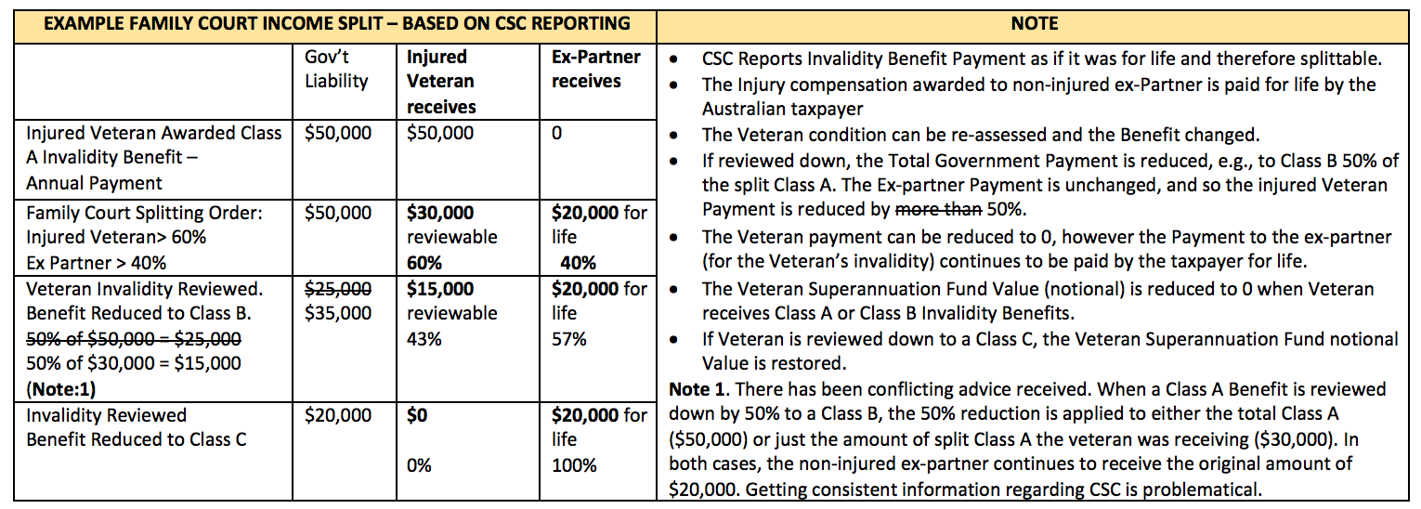

The effect of incorrect information being included on Form 6 documents, is that a Veteran Beneficiary’s invalidity benefit (which is a compensation payment) has been split and reduced. This raises a number of issues, including:
- the splitting does not take into consideration the Veteran Beneficiary’s reliance on that income to survive;
- the splitting is effectively transferring a portion of a compensation payment to someone who has not been injured (i.e. the Veteran Beneficiary’s spouse);
- the Veteran Beneficiary’s spouse receives superannuation before reaching retirement age, for life, while the Veterans payment is still able to be reviewed and cease;
- a Veterans invalidity benefit is included as income and as superannuation, effectively double dipping. The incorrect valuation is made up of the yearly benefit. It simply cannot be both income and an actuarially calculated amount using that same yearly amount.
To receive $20,000 per annum in superannuation contributions, a person would need to earn $222,222 per year. The spouse is now in receipt of such superannuation payments without having met the statutory requirements being retirement age, death or invalidity. There seems to be a special ‘married to a veteran’ clause.

In these circumstances, the Veteran’s Beneficiary’s spouse does not have an injury and is therefore able to generate their own income stream. Therefore, if the Veteran Beneficiaries’ spouse is 30 years old at the time of property settlement, they would be able to deposit that money into their superannuation fund and at age 65 would have a retirement benefit of approximately $1.2 million dollars. (based on a compounding return of 3%)

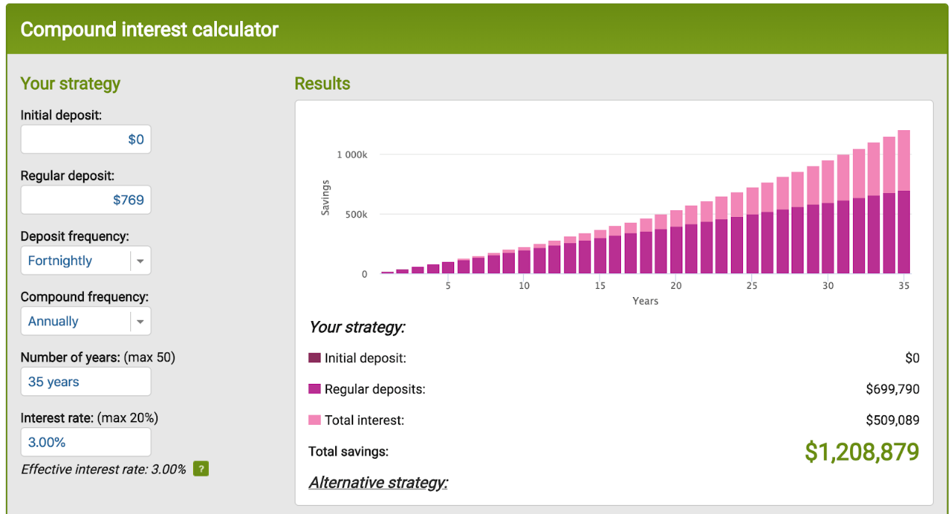

Turning to the Veteran Beneficiary who is no longer able to work and must rely on invalidity benefits to survive. They do not have an ability to save $20,000 per year and are also faced with the possibility of having their invalidity benefits reviewed and downgraded (as the Case Study demonstrates).

An Incapacity Payment is a payment made by the Department of Veteran Affairs to a Veteran who incapacitated for work and is undertaking a rehabilitation program. The Attorney General Stated in the Senate that these (Incapacity) payments represent the economic loss compensation for Veterans.
The initial compensation package for this Veteran under this scheme is $50,000 per annum.

Incapacity Payments paid by DVA to a Veteran are offset dollar for dollar with Invalidity Benefits paid by the CSC to the Veteran. Offsetting payments is carried out to ensure that the Australian Government is not paying compensation twice for the one compensable injury.

The DVA has the obligation to increase the total invalidity/incapacity benefit paid to the veteran to a minimum of 75% of their retiring wage. Incapacity payments that were previously offset are now received by a Veteran Beneficiary when a payment has been split following Family Court proceedings.
This means that:
- Initially, the Veteran receives $50,000 per annum.
- Following property settlement in Family Law proceedings the Veteran receives $30,000 per annum and the Veteran spouse receives $20,000 per annum.
- After the Veteran applies to DVA for incapacity payments, the Veteran receives $50,000 per annum and the Veteran spouse receives $20,000 per annum which means that the Australian Government is paying twice for the same compensable injury, with one payment going to someone without injury.
Due to the incorrect reporting of information on Form 6 documents by the CSC, the Veteran Beneficiary’s compensation payment is being split in Family Court proceedings, which means a Veterans spouse is now receiving lifetime compensation payment for an injury they did not incur and the government is paying compensation twice for the same injury. The most unfair and unjust aspect of the CSC’s conduct is that the Veteran Beneficiary is not being properly compensated for the injury they incurred during their service.

In addition, the table below shows the effect that the incorrect information on Form 6 documents can have on the division of an entire property pool for the purposes of Family Law.
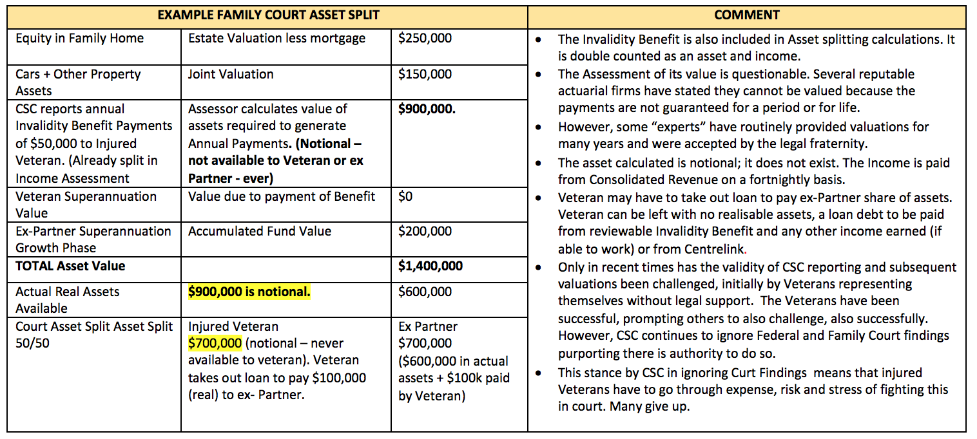

Taxation
Following the Decision of Campbell v Superannuation Complaints Tribunal [2016] FCA 808 several queries were forwarded to the Australian Taxation Office (ATO) requesting clarification as to whether Veteran Beneficiaries were being taxed correctly.

The ATO responded to the queries stating veterans could rely on the following legislation with respect to taxation:
“INCOME TAX ASSESSMENT REGULATIONS 1997 – REG 995.1.03
Payments that are not superannuation income stream benefits
A payment from an interest that supports a superannuation income stream is not a superannuation income stream benefit if:
(a) The conditions to which the superannuation income stream is subject allow for the variation of the amount of the payments of benefit in a year in circumstances other than:
(i) The indexation of the benefit under the rules of the product; or
(ii) The application of the family law splitting provisions; or
(iii) The commutation of the benefit (including commutation to pay a surcharge liability); or
(iv) The payment of an assessment in excess contributions tax; and
(b) The person to whom the payment is made elects, before a particular payment is made, that that payment is not to be treated as a superannuation income stream benefit.”

The average Invalidity Benefit is not a substantive amount, and is not a true reflection of what the Veteran has lost with respect to his or her earning capacity. However, the application of this legislation to Invalidity Benefits, meant that Veteran Beneficiaries could make ends meet.

The advice received from the ATO also indicated that this is how Injured Veterans Invalidity benefits would be taxed going forward.
This legislation was subsequently repealed by the Treasury Laws Amendment (Fair and Sustainable Superannuation) Regulations 2017 (TLAFSS Regulations).

The repeal of the legislation was not common knowledge within the Veteran community and there was no mention of intention to repeal this legislation in the ATO’s response to their queries.

A Freedom of Information Application (FOI Application) was made to the ATO.
The bundle provided in response to the FOI Application contained an email dated 11 June 2016 from Mr James O’Halloran to Darryl Richardson, Alexander Affleck et al, making a direction to withhold any information about new laws from letters to Veterans who had forwarded queries. (Attachment 3)

Based on the information provided by the ATO (in its Private Rulings), many Veterans made significant financial decisions unaware that the legislation they were told could be used, would be repealed. Going forward, this meant the subsequent increase in taxation would affect their ability to repay loans and make ends meet.

When Veterans became aware of the effects that the new legislation would have on their Invalidity Benefits, they questioned the decision of the Australian Government in repealing this legislation.
The Australian Government responded by way of Media Release.

The Australian Government branded Veterans as “loophole chasers” and proceeded to present incorrect information to the public despite the following facts:
- Regulation 995.1.03 of the Income Tax Assessment Regulations 1997 (ITA Regulations)had been in force for approximately 20 years prior to the enactment of the TLAFSS Regulations, yet the CSC had never advised their beneficiaries of the ability to use it. Other superannuation funds openly advised their members of this election.
- Veterans had lodged private rulings as early as mid-2015.
- Critical information was withheld by the ATO.
- The taxation treatment as a lump sum provided recognition of the compensatory nature of the payments.
- To be labelled the way they were, showed the Government did not respect their veterans at that point in time.
- The removal of the election left many Veterans struggling financially because of the reliance on ATO guidance.

Australian Taxation Office Private Rulings
Unconvinced that an Invalidity Benefit meets the definition of a Superannuation Income Stream, Mr Campbell, subsequently lodged his tax return as a Superannuation Lump Sum (in accordance with Regulation 995-1.03 of the ITA Regulations).

To be a Superannuation Income Stream, the benefit must meet the Definition of a pension in accordance with the Superannuation Industry (Supervision) Regulations 1994 - Regulation 1.06 Meaning of Pension (Act, s 110), in particular, Regulation (9A) (The Pension Question).
The ATO changed it back to a Superannuation Income Stream without providing Mr Campbell with a reason for doing so. Mr Campbell enquired as to the reasons why this had occurred, and was subsequently informed by the ATO that it relies upon third party information when processing tax returns. Consequently, Mr Campbell was advised to take up the issue with the CSC.

Mr Campbell contacted the CSC which informed Mr Campbell that it relies upon information provided by the ATO. In addition, it advised that his Invalidity Benefit was a Superannuation Income Stream when he made an election under Regulation 995-1.03 of the ITA Regulations. Mr Campbell was left with no clear guidance as to who is responsible for the taxation treatment of an invalidity benefit.

Upon receiving this advice, Mr Campbell applied to the ATO for a Private Ruling seeking to clarify this issue. He asked the ‘Pension question’. The ATO amended Mr Campbell’s application without consent, to ‘is the benefit a Superannuation Income Stream’, to which their answer was yes, but the ATO did not offer any explanation as to how they came to this conclusion.

Mr Campbell lodged a complaint with the Inspector General of Taxation and after some 6 months, the ATO was informed they had not followed the Taxpayers’ Charter but nothing could be done about it. He is left without any legal explanation as to why his tax has been changed back.

Mr Campbell has lodged an appeal with the Administrative Decisions Tribunal.

The reason an invalidity benefit does not meet the definition is because of the reviewable nature. The benefit is not purchased, it is not an annuity, it is not paid for life and does not meet the requirements of the Regulations.

Again, the CSC/ATO are treating these reviewable benefits as a lifetime pension. The ATO have acknowledged the reviewable nature in previous private rulings.

Unjust Outcomes under Taxation
There has been no recognition by the ATO or the CSC that Invalidity Benefits are compensatory in nature.

Compensation payments ordinarily have a tax-free element, not a tax offset.
The incorrect reporting by CSC of these payments means that Veteran Beneficiaries are required to pay tax that they are not legally required to pay.

In addition, the was a failure by the CSC to advise Veteran Beneficiaries of their ability to elect to have Invalidity Benefits treated as a Superannuation Lump Sum for taxation purposes. This ability has been law since 1997.

The ‘is it a pension’ question has been asked countless times of the CSC via direct email and by letters and emails to the local members of Veterans. Not once has it been answered. The CSC attempts to close the matter by only addressing the first part of the question – the more general part. They have always ignored and evaded the fundamental part of the question relating to sub regulation 9A.
As a consequence, 226 Veteran Beneficiaries have lodged complaints with the SCT in an attempt to clarify and resolve the issue. As part of the complaint process, the CSC direct Veteran Beneficiaries to the SCT and once a complaint has been lodged, proceed to advise the SCT they do not have the jurisdiction to handle the complaint. This is clearly an ineffective and unjust dispute resolution process.

There are long term grievances between the CSC and Veteran Beneficiaries. The CSC has failed in its fiduciary duty to inform its members, at time of discharge, that they could make an election to have their invalidity payments treated in more than one way, Veteran Beneficiaries were unaware of any problems until the Campbell Case spiked interest.

There is a real possibility that the CSC are not administering their other Superannuation Schemes in accordance with their respective trust deeds and in accordance with the law.

MODEL LITIGANT STANDARDS
The Rule of Law Institute of Australia explains Model Litigant Rules as follows:
“Model litigant rules, or model litigant obligations, are guidelines for how a government body ought to behave before, during, and after litigation with another government body, a private company, or an individual.
These guidelines are integral to the rule of law, because there is sometimes a substantial imbalance of power in litigation with the government. Government bodies may have access to substantial resources, powers to investigate and compel people to provide information, and more experience and specialist expertise in dealing with complex and contentious legal matters.
It is vital that government bodies should not be ‘out to get’ people, but should be acting in the public interest, according to law.
As a result, governments at a State and Federal level across Australia have produced a range of guidelines known as model litigant rules.
…
However, these guidelines are not designed to prevent the government body from “acting firmly and properly to protect their interests,” taking “all legitimate steps” to pursue or defend claims, or even from “pursuing litigation in order to clarify a significant point of law even if the other party wishes to settle the dispute.”

The guidelines are designed to tread a middle ground. On the one hand, they recognise that a government body is often better-resourced than small companies or individuals, and is supposed to lead by example, protecting the public interest as opposed to its own private interest.

On the other hand, the guidelines also must recognise that government bodies pursuing or defending claims are doing so on behalf of the public, and the public’s rights ought not to be undermined in the face of genuine litigation. This is particularly so when the government body is up against, for example, a very well-resourced individual or company.”

Below there are several examples which demonstrate the CSC failure to observe Modal Litigant Rules either acting by itself or in connection with another Australian Government Department.

Modal Litigant Standard – Avoiding Litigation
Appendix B of the Legal Services Directions 2017 provides:
“(e) where it is not possible to avoid litigation, keeping the costs of litigation to a minimum, including by:
(i) not requiring the other party to prove a matter which the Commonwealth or the agency knows to be true”
Adopting a Position Contrary to Law
The CSC have failed to uphold their obligation to avoid litigation on an issue they know to be true by adopting a position that is contrary to that provided by law.

In Campbell v Superannuation Complaints Tribunal [2016] FCA 808, the CSC adopted the position that an Invalidity Benefit is a defined benefit and a lifetime pension for the purposes of Family Law. The CSC’s position fails to acknowledge Rule 22 of the MSBS Act which provides that the payment is reviewable and therefore cannot be a lifetime pension.
By adopting this position, they have essentially given Mr Campbell no option but to litigate the matter.

Garnishing of Invalidity Benefits
The CSC has been allowing for the garnishing of Invalidity Payments by other Government Departments in contravention of Regulation 13.13 of the SIS Regulations and Section 45 of the MSBS Act.

When this issue was brought to the attention of the CSC, they ignored it and the issue has now been escalated to the SCT.

In both examples, the CSC has forced the Veteran Beneficiary to commence legal proceedings because of its failure to observe and properly administer the law.

Modal Litigant Standard – Acting with the highest Professional Standards
Appendix B of the Legal Services Directions 2017 provides:
“Note 2: In essence, being a model litigant requires that the Commonwealth and Commonwealth agencies, as parties to litigation, act with complete propriety, fairly and in accordance with the highest professional standards. The expectation that the Commonwealth and Commonwealth agencies will act as a model litigant has been recognised by the Courts. See, for example, Melbourne Steamship Limited v Moorhead (1912) 15 CLR 133 at 342; Kenny v State of South Australia (1987) 46 SASR 268 at 273; Yong Jun Qin v The Minister for Immigration and Ethnic Affairs (1997) 75 FCR 155.”

The CSC failed to comply with its obligation to act with complete propriety, fairly and in accordance with the highest professional standard when, instead of appealing a decision, they deliberately ignored the decision of Logan J in the Federal Court Decision by continuing to provide incorrect information on Form6 documents for Family Court proceedings.

The CSC also maintained that they did not make any mistake as they were relying on the enactment of a legislative instrument (which had retrospective application) to cover their wrong doing, thus circumventing the law and failing to act in accordance with Professional Standards.

The CSC advised the SCT of the legislative change one (1) day after final submissions were due, implying that it knew nothing of the legislative amendments, when in fact it was a consultative party to the creation of that instrument.

The SCT relied on the proposed legislative change, which was passed on 14 June 2017, when handing down the Review Decision finding in favour of the CSC on 11 April 2017. This was despite the fact a Motion for Disallowance was before the Senate and the legislative instrument had not passed Parliament. The SCT also ignored Mr Campbell’s submissions with respect to Regulation 43A.

The CSC’s conduct with respect to having the laws changed to essentially legitimise their conduct was manifestly unfair as Mr Campbell was not afforded the natural justice or procedural fairness provided by courts and tribunals. The unjust conduct of the CSC in Mr Campbell’s case has placed Mr Campbell in a difficult financial position.

It is our understanding a legislative instrument with retrospective application cannot be enacted if it would result in a negative outcome for an individual or entity affected by its enactment. This has not been the case for Mr Campbell.

Modal Litigant Standard – Taking Advantage of a Less Resourced Claimant
Appendix B of the Legal Services Directions 2017 provides:
“(f) not taking advantage of a claimant who lacks the resources to litigate a legitimate claim”

The Australian Government Solicitor (AGS), who represented the CSC in Mr Campbell’s proceedings, forwarded a letter to Mr Campbell threatening Mr Campbell with costs should Mr Campbell be unsuccessful with his claim. This was despite the fact that it was a test case (as there was no case law available on these matters) and the case was in the public’s interest.

The AGS also threatened Mr Campbell with costs should he be unsuccessful at both Federal Court Appeals.

It is important to note that during the Federal Court Appeal, Justice Logan reminded the CSC via the AGS, of their obligations under the Model Litigant Standards and that it was the primary duty of the AGS to ensure that justice prevailed. In fulfilling that duty, Justice Logan strongly recommended that the AGS organise funding for Mr Campbell, as at the time he was a self-represented litigant.

The AGS did not assist Mr Campbell in obtaining legal representation, nor did it offer to fund such representation. However, Mr Campbell eventually secured legal representation thanks to the benevolence of the Queensland Returned Services League.

Upon obtaining legal representation, Mr Campbell was advised to amend his Appeal. This meant that the hearing dates had to be vacated and the parties were ordered to attend mediation on the issues raised in the Amended Appeal. Mr Campbell was ordered to pay $5,500 in connection with the amendment to his appeal. To a person who is surviving on an Invalidity Benefit, who has also recently lost over $200pw in disposable income (ATO Issue), this is a significant amount of money.

If, as Justice Logan recommended, the AGS ensured that Mr Campbell had been properly funded (due to the fact it was a test case and a public interest case), Mr Campbell would have had sufficient time to amend his appeal without incurring additional costs.

The Question: Is an Invalidity Benefit a Superannuation Lump Sum?
Hundreds of Veteran Beneficiaries have asked the ATO how a reviewable Invalidity Benefit paid through the CSC, under both the Military Superannuation Benefit Scheme and the Defence Force Retirement & Death Benefits Scheme, should be treated in accordance with Taxation Law.
The ATO currently treats these benefits as a Superannuation Income stream.

This process has involved private rulings, self-amended taxation returns, objections, private meetings, complaints to the Inspector General of Taxation, Letters to Ministers, Applications to the Administrative Appeals Tribunal, numerous conciliation conferences and the matter is now awaiting the Decision of the Administrative Appeals Tribunal.

Modal Litigant Standard – Nature
The Nature of the Modal Litigant Standards provides as follows:
The obligation to act as a model litigant requires that the Commonwealth and Commonwealth agencies act honestly and fairly in handling claims and litigation brought by or against the Commonwealth or a Commonwealth agency.

The ATO took nearly 18 months to provide Private Rulings to Veteran Beneficiaries. The ATO is ordinarily required to make a Private Ruling within sixty (60) days of receiving and application.

Throughout the Private Ruling process, the ATO withheld vital information about an upcoming legislation change which would affect a Veteran Beneficiaries ability to elect to have their Superannuation Income Stream treated as a Superannuation Lump Sum for taxation purposes.

Rather than providing full and frank disclosure to Veteran Beneficiaries, the ATO made an active decision to withhold vital information to better ‘assist the pitch’ (James O’Halloran internal memo). This conduct is misleading, deceptive and demonstrates a complete disregard for the consequences that may flow on to the Veteran Beneficiary.

Many Veteran Beneficiaries made significant financial commitments based on their Private Rulings. Consequentially, once the legislative change became common knowledge, many Veteran Beneficiaries found themselves in a precarious financial position.

Veteran Beneficiaries lodged objections with respect to their Private Rulings which were later rejected by the ATO. This has forced Veterans into legal action.

Veteran Beneficiaries then queried the CSC as to whether their Invalidity Benefits meet the definition of Regulation 1.06 of the Superannuation Industry Supervision Regulations 1994 (SIS Regulations). The CSC claimed they receive guidance from the ATO on this matter.

Example
Mr Campbell amended his tax return for several financial years and reported his benefit as a Superannuation Lump Sum. The ATO changed Mr Campbell’s tax return to a Superannuation Income Stream on the basis that they rely on third party information, (i.e. information provided by the CSC) despite the Australian Taxation System being a self-reporting system as espoused in the Tax Payer’s Charter.
The ATO would not provide Mr Campbell with an explanation as to why they changed his amended tax returns and was advised to take the issue up with the CSC.

Mr Campbell took the issue to the CSC, which refused to provide the legislative basis upon which they provided such information to the ATO. The CSC advised Mr Campbell that his benefit was an Income Stream because of Mr Campbell’s acceptance of the ATO’s Private Ruling. This response did not answer the question asked.

Mr Campbell applied to the ATO for a Private Ruling clarifying whether his Invalidity Benefit was a pension for the purposes of the SIS Regulations. The ATO took it upon itself to change the question of law contained in Mr Campbell’s Application for Private Ruling without first consulting Mr Campbell.

Mr Campbell lodged a complaint with the Inspector of General Taxation (IGT). After six months of investigation, the IGT found that the ATO had not done what it was supposed to have done, but there was nothing that could be done to remedy the situation.

If the ATO and the CSC had carried out their respective functions in accordance with the law and in accordance with Modal Litigant Standards, Veteran Beneficiaries would not have had to commence litigation in the Administrative Decisions Tribunal (ADT) to resolve this issue.

Incidentally, there are three cases being heard concurrently in the ADT. To the ATO’s credit, it has provided Test Case Litigation Funding to two of the Applicants as one Applicant initially refused the ATO’s offer.

Mr Campbell and many other injured veterans are left paying $100’s of dollars a week in tax without explanation.

EXTRA SCRUTINY
The Department of Treasury has suggested that it is not necessary for the CSC to be subject to the scrutiny of the Commission because it is subject to additional scrutiny beyond that applied to other funds.
At (Attachment 4) the Treasurer attempts to provide examples of this additional oversight noting:
“…the Governance of Australian Government Superannuation Schemes Act 2011…imposes governance arrangements. In addition, the CSC is subject to the Public Governance, Performance and Accountability Act 2013…is subject to Parliamentary Scrutiny through the Senate Estimates process and audit by the Auditor General…”

The reference to two Acts simply confirms that there is no independent oversight of the CSC, and that it is all conducted by government organisations.

Having reviewed Hansard and contacting the Australian National Audit Office, we are yet to discover any person, organisation or department that can independently review and scrutinise the issues discussed in this document.

Attempts to have these issues looked at in detail, have failed. Trevor Evans MP is Mr Campbell’s local representative and he has made multiple representation to his office. Not one question has been raised about this issue on the floor of parliament. The legislative change was pushed through parliament without debate. There was no scrutiny of this very important ‘retrospective’ legislation. There was no real consultation with affected members.

One example of a letter sent to Trevor Evans MP is available at (Attachment 5). This letter has never been answered.

CONCLUSION
The Royal Commission’s TOR state:
‘…all Australians have the right to be treated honestly and fairly in their dealings with banking superannuation and financial services providers. The highest standards of conduct are critical to the good governance and corporate culture of those providers…”

This document provides details and evidence that Veterans have not been treated honestly, fairly and transparently by the CSC and related Government Departments, and that they are not being treated in accordance with the law.

The CSC has blatantly ignored its obligations under The Model Litigant Obligations which has imposed.

What this document shows is an ingrained culture of denial, deceit and lack of respect for the CSC’s own fiduciary requirements and that of the Model Litigant Standards that have led to poor governance and a contentious corporate culture.

It would be fair to say, as a Government entity, the CSC should be the shining light of the Financial Services Industry, acting with Efficient, Effective, Economic and Ethical standards as required by Commonwealth standards.

It is evident that there has been little scrutiny with respect to the way the CSC conducts business. The inclusion of the CSC in to the Commission would afford an opportunity to an open, independent and unbiased look at such conduct.

When asked by Mr Campbell in the Longman electorate, why the CSC is not included in the TOR, the Prime Minister himself stated the best way to honour the Veterans of the past, is to look after the Veterans of today.

It is pertinent that the Prime Minister is aware of these issues, as it directly affects the men and women who have each sacrificed something in their service to their nation.

I put to you, one way to look after the Veterans of today is to afford them the same rights as every other Australian. Include the CSC in the Royal Commission.

RECOMMENDATIONS
In order to uphold every Australian’s right to be treated honestly and fairly in their dealings with banking, superannuation and financial service providers, we make the following requests with respect to conduct of the CSC.
- That the CSC are included in The Royal Commission into Misconduct in the Banking, Superannuation and Financial Services Industry, to ensure that their conduct is independently and properly scrutinized and that they are administering their Superannuation Schemes in accordance with the law.
- That any breaches of fiduciary duty by the CSC are independently and properly investigated and that appropriate action is taken to remedy any breaches.
- That the CSC is independently and properly investigated for withholding medical information from medical assessors thus resulting in incorrect assessments and classifications for Member Beneficiaries.
- That the CSC is independently and properly investigated for colluding with other Government Departments in an attempt to cover up its conduct with respect to its maladministration of its Superannuation Schemes by way of retrospective legislation.
- That the CSC be independently and property investigated for reporting incorrect information on Form 6 documents to the Family Court for the purposes of valuing superannuation interests.
- That the CSC provide a proper explanation as to why it ignored a Federal Court Decision and continued to provide information on Form 6 documents contrary to that Decision.
- That the CSC provide a proper explanation as to its position as to why an invalidity payment, (at its simplest, is an insurance/compensation payment for injury AND a reviewable benefit (and therefore NOT a lifetime pension)), is being treated, managed and taxed as a lifetime pension resulting in significant adverse effects for the veterans and their families.
- That the CSC be investigated for its deliberate and continued breaches of the Model Litigant Standards.
- That such misconduct and abhorrent culture be allowed to be reviewed like other Financial institutions thus far.

I would like to take this opportunity to personally thank the Prime Minister for affording me the opportunity to present this very detailed brief to the Minister for Veteran affairs.
I kindly request that a copy of this document is provided to Prime Minister Malcolm Turnbull as this matter is of national importance as it concerns the health and wellbeing of Australia’s military veterans.
I also kindly request for the opportunity to discuss these matters in person, with the Minister for Veterans Affairs.
I look forward to receiving your response.
Kind regards,
Bradley Campbell
M: 0428 580 043

Attachment 1

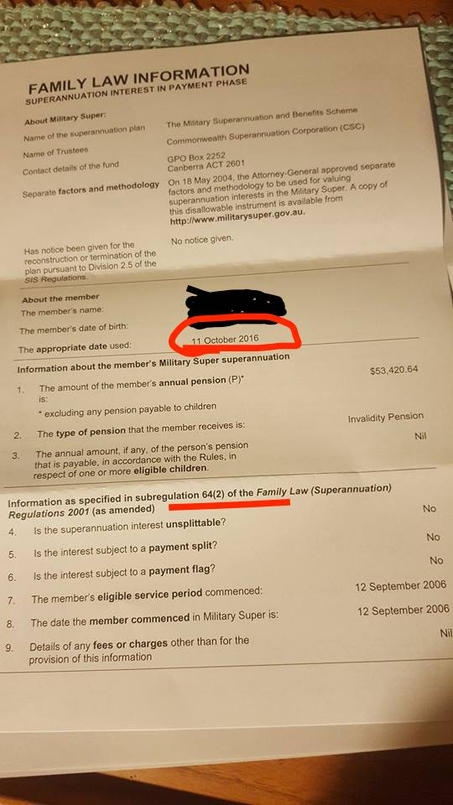

Attachment 2

THE AUTHORITY.
Regulation 42(2)(a) of the FLSR.

Regulation 42(2) of the FLSR states “If the pension is payable for the life of the member spouse, the gross value of the superannuation interest at the relevant date is to be determined using:
(a) “if, under regulation 43A, the Minister has approved a method or factors to be used to determine the gross value of the interest--the approved method or factors; or”
The condition for regulation 42(2) of the FLSR to apply is “if the payment is guaranteed for life”. The issue of whether an Invalidity Benefit payable under the MSBS is payable for life has been previously addressed by the Courts, prominently as stated in Hanlon & Edgar [2008] FamCA 195 (26 March 2008) at paragraph 255 where his honour states “The husband’s entitlement to a pension is not fixed, it is variable, if there is a subsequent review”.
Further to the above authority I refer to C & F [2006] FMCAfam 64 (31 January 2006) at Paragraph 23 which contains a submission written by the CSC themselves where they state “………….as they are pension payments made because of ill health opposed to payments made for permanent incapacity within the meaning of the Superannuation Industry (Supervision) Act 1983 (SIS Act). Under the MSBS Act a person does not have to be permanently incapacitated within the meaning of the SIS Act to become eligible to receive an invalidity benefit”.
The nature of the Invalidity Benefit in question is best explained in Campbell v Superannuation Complaints Tribunal [2016] FCA 808 paragraph 48:
“Mr Campbell’s circumstances may well offer an explanation as to why defined invalidity entitlement components were excluded from the definition of “defined benefit interest”. A person’s invalid condition may over time either improve or deteriorate, leading, possibly, to the revision or even elimination of an invalidity payment entitlement by virtue of the application of the terms of a superannuation plan to their present circumstances. In the case of the MSBS, regard to the rules discloses that a member’s classification as “A”, “B” or “C” admits in certain circumstances of later reclassification. It is therefore not just the prospect that a member spouse may never suffer invalidity giving rise to an entitlement to be paid an invalidity benefit that lends uncertainty to the valuation of that component of the person’s superannuation interest. Uncertainty may also attend that valuation even in the event of initial qualification for an invalidity benefit.”

The MSBS rules His Honour refers to, is contained in the CSC’s own trust deed, that an Invalidity Pension is reviewable, as seen here: https://www.legislation.gov.au/Details/F2016C00682. Part 3 Division 2 para 23, which states “Reclassification in respect of incapacity
- Where CSC or the Committee, at any time, is satisfied that there has been such a change in the percentage of incapacity in relation to civil employment of an invalidity pensioner that his or her classification should be altered, CSC or the Committee may reclassify him or her in the appropriate classification set out in rule 22 according to the percentage of his or her incapacity in relation to civil employment.”
Any such review could result in a change and or cancellation of the Invalidity Pension. This means that the Invalidity Pension is in fact, not a lifetime pension as per the requirements of Regulation 42(2) of the FLSR.
From this evidence, I submit that Regulation 43A is not applicable in relation to the Invalidity Benefit as regulation 43A is an “Approval of methods and factors for determining gross value of superannuation interest being paid as a life pension.”
To postulate otherwise is simply unconscionable.

LEGISLATIVE CHANGE
The CSC purports the legislative change in response to the Campbell case, applies to those benefits.
The Family Law (Superannuation) (Provision of Information—Military Superannuation and Benefits Scheme) Amendment Determination 2016 was the legislative instrument dated the 10th November 2016.
The authority is listed as:
3 Authority
This instrument is made under subregulation 63(6B) of the Family Law (Superannuation) Regulations 2001.

Sub regulation 63 (6B) states:
(6B) If, under regulation 43A, the Minister has approved a method or factors to be used to determine the gross value of the superannuation interest, the Minister may, by written determination, provide either or both of the following:
(a) that the trustee is not required to provide the information about the interest mentioned in one or more paragraphs of subregulations (2) and (3);
(b) that the trustee must provide other information, as specified in the determination, about the interest.

The construct of this Subregulation is that ‘if’ under regulation 43A, the Minister has approved a method or factors, then the Minister may make a written determination.
Given the fact Reg 43A does not apply to these benefits, the determination cannot be applied.
The Determination 2016 was a direct response to the Campbell case and was constructed before the Judicial process had concluded. This raises questions of procedural fairness. Final submissions were given to the SCT one day before the CSC ‘advised’ the SCT about the legislative change, which they were just handed by the Attorney General’s office, and which they suggested knew nothing about.
A response to the failings of the Determination is provided below.
The explanatory memorandum for the Determination 2016, states:
The ‘default’ methods contained in the Regulations for valuing superannuation interests are not appropriate for some superannuation
interests. As such, regulations 38 and 43A provide that the Attorney-General may approve, in writing, alternative valuation methods. The
Family Law (Superannuation) (Methods and Factors for Valuing Particular Superannuation Interests) Approval 2003 (the Approval) has been made for this purpose. It contains methods and factors for determining the value of superannuation interests in more than 30 superannuation schemes. The Approval is a legislative instrument and has been registered on the Federal Register of Legislation. The method and factors approved for MSBS superannuation interests are set out in Part 4 of Schedule 1 of the Approval.
Response: The method and factors mentioned above rely on Reg 43A which does not apply to these benefits.

This instrument responds to uncertainty that may exist following a judgment of the Federal Court of Australia in Campbell v Superannuation Complaints Tribunal [2016] FCA 808 on 15 July 2016 as to whether the existing Determination applies to MSBS invalidity pension interests (which are a subset of MSBS pension interests). In this case, the Court concluded that invalidity pensions under the MSBS are ‘accumulation interests’ as defined in regulation 3 of the Regulations, rather than ‘defined benefit interests’ as defined in regulation 5. On this understanding, the correct source of power for the Attorney-General to make a determination applying to these interests is subregulation 63(6B).
Response: The Minister has attempted to obfuscate the true ‘source of power’ by referring to Reg 63 (6B). There was no uncertainty that existed. This is not a lifetime pension and to value it as such is unconscionable.

This instrument amends the existing Determination to provide that it is also made under subregulation 63(6B). This clarifies that the Determination applies to all MSBS superannuation interests for which the Attorney-General has approved a method and factors in Part 4 of Schedule 1 of the Approval, whether they are characterised as accumulation interests or defined benefit interests. This removes any doubt that the trustee of the MSBS can provide eligible persons with appropriate, scheme-specific information about their MSBS superannuation interests, including military invalidity pension interests, in the context of family law superannuation splitting.

Response: This is true, the determination does apply to all MSBS Superannuation Interests that the methods and factors apply to. However an invalidity benefit is not encapsulated as suggested.

The instrument commences on 26 May 2005. This is the date that the Family Law (Superannuation) (Provision of Information — Military Superannuation and Benefits Scheme) Amendment Determination 2005 (No. 1) (the 2005 amendments) commenced. These amendments inserted into the existing Determination a new section (section 6) which sets out the information requirements for MSBS superannuation interests in the payment phase and for which the Attorney-General has approved methods and factors under regulation 43A. The amendments in the current instrument relate to these interests.
Response: Here the Minister actually states the correct ‘source of power’. As discussed, this does not apply.

Accordingly, the retrospective amendment which clarifies the source of authority for making the Determination in respect of a subset of MSBS pension interests, will not affect the rights of a person so as to disadvantage the person, nor impose liabilities on a person.
Response: The retrospective nature of the Determination does disadvantage recipients of an Invalidity Benefit. It is providing the incorrect information to those persons unfortunate enough to be going through a divorce. To have a benefit valued for life when there is no guarantee of receiving the amount it is valued at, also imposes a liability on that person with respect to the distribution of their property. A person may have to give up their right to other property to retain their right to their compensation payment. The valuation of a benefit being paid at $60,000 would be valued into the $1M+ range. The benefit can cease, yet your settlement is adjusted on the premise the member will receive the amount in full.

Section 3 — Authority
Section 3 provides that the instrument is made under subregulation 63(6B) of the Regulations. Subregulation 63(6B) gives the Attorney-General the power to make a written determination setting out the information that a trustee is required to provide, or not provide, about a superannuation interest, if the Attorney-General has approved a method or factors to be used to determine the gross value of the interest under regulation 43A.

It is important that the Determination applies to all MSBS superannuation interests for which the Attorney-General has approved methods and factors under regulation 43A.

It applies to accumulation interests for which the Attorney-General has approved a method or factors under regulation 43A.
Response: Again, the true ‘source of power’ is revealed. It does not apply.

The amendment is to remove any doubt as to the application of section 6(a) to MSBS superannuation interests characterised as accumulation interests (such as invalidity pension interests). The substantive information requirements are unchanged.
Response: This is untrue and will be covered in FORM 6 INFORMATION below.

The instrument makes technical amendments to clarify the Determination’s source of power. While the instrument will have retrospective commencement, it does not breach the limits on retrospective commencement set out in section 12 of the Legislation Act 2003 in that the clarification will not affect the rights of a person so as to disadvantage the person, nor impose liabilities on a person.

Response: As previously discussed, this is quite simply not true. The technical amendments do not apply to these benefits.

Statement of Compatibility with Human Rights

Prepared in accordance with Part 3 of the Human Rights (Parliamentary Scrutiny) Act 2011

Family Law (Superannuation) (Provision of Information—Military Superannuation and Benefits Scheme) Determination 2016

This Disallowable Legislative Instrument is compatible with the human rights and freedoms recognised or declared in the international instruments listed in section 3 of the Human Rights (Parliamentary Scrutiny) Act 2011.
Response: This is at best misleading. A letter was drafted to Trevor Evans MP’s office dealing with this exact issue. No response was given. (Attachment 5)

Attachment 3

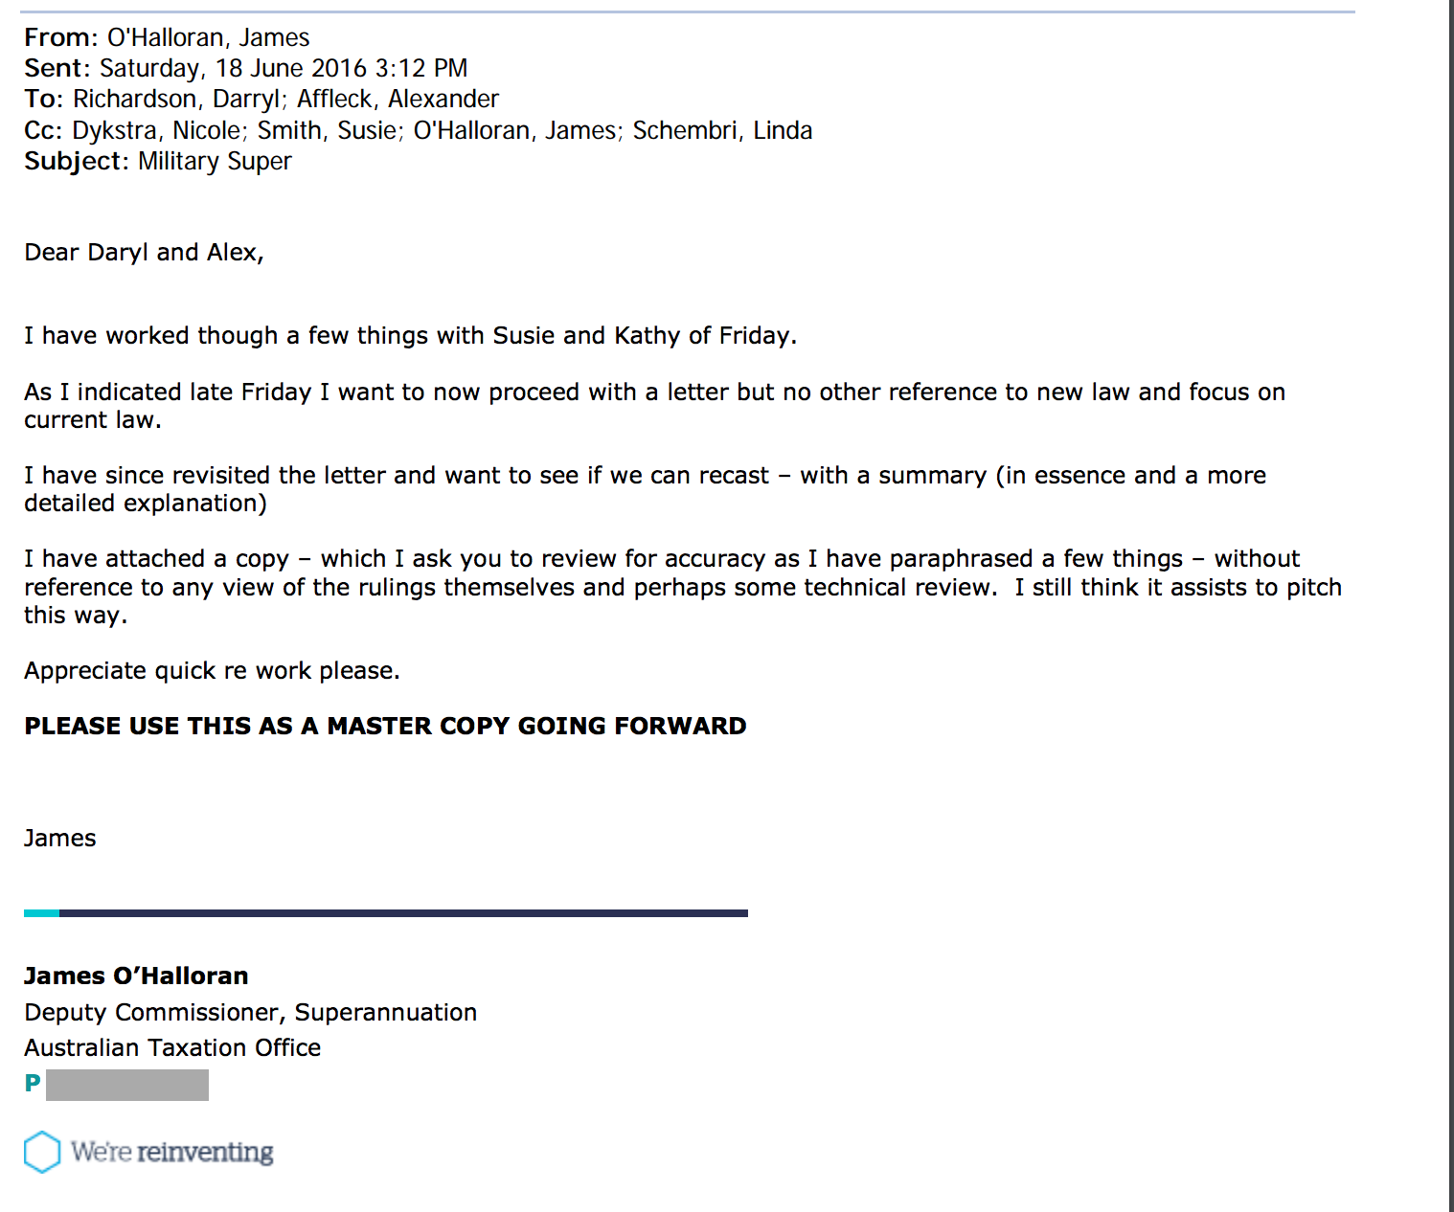
Attachment 4

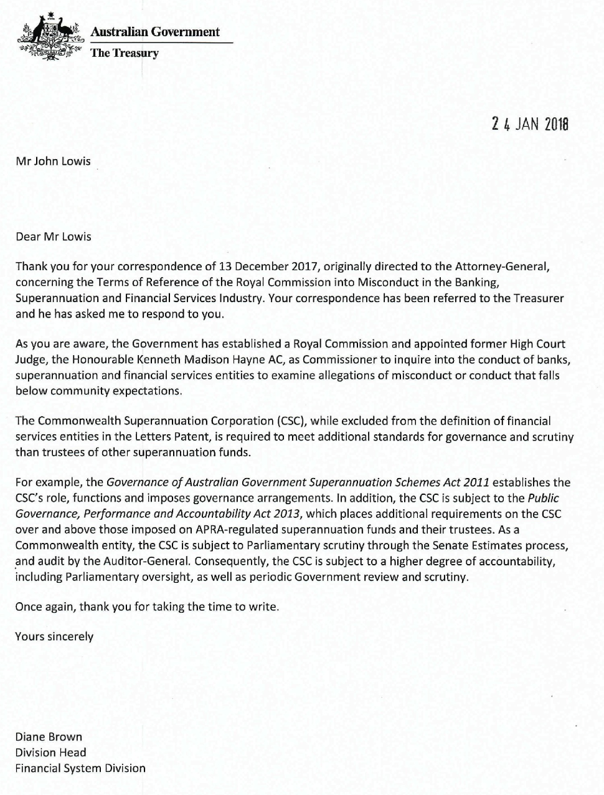

Attachment 5

HI Penny,

I received the correspondence from the AG’s office. Thank you for forwarding that.

Will you continue to ask questions and push the point?

The response is full of lame excuses to be honest.

Yes, my pension is subject to the Family Law super splitting regime. But that regime does not allow the AG’s office to apply his Methods for valuation to my pension. It is not a lifetime pension.

If you also go back to the Senate Hansard when super splitting laws were introduced, the AG’s office stated it was not the intention to split compensation in the courts.

He has also forgotten the fact that members of the PSS and CSS don’t have their pensions split under this regime. Why is that?
Is there a level of importance as to which Federal Government employee’s invalidity benefit is subject to the Family Law super splitting regime? Is it just a plain, cold and hard fact the Government simply does not care about looking after veterans?

What has the AG done about the CSC acting inappropriately?
Is it not his offices responsibility in ensuring that Government Departments abide by the model litigant legislation?

Further the AG contends that, “The scheme specific information is more useful to eligible persons than the ‘default’ information provided for in the regulations.” How is splitting a payment the AG’s office originally said should not be split (compensation), more useful to the eligible person? The FLSR actually provides a method of valuing an accumulation interest in the payment phase. One that fits my Invalidity Benefit.

Further, the AG has not mentioned the fact that the CSC is a party to a law dispute. He mentions in his letter to Senator Lambie that it is not appropriate for him to interfere with or comment on the handling of specific cases. Yet here he is changing legislation.

It does not matter how you angle this. This has been nothing more than an attempt to circumvent the court’s findings. The CSC broke the law. They failed to apply the FLSR and SIS Act as they should be applied. Changing the legislation to attempt to make it so they haven’t, is quite simply mischievous and wrong.

Further, is the AG or even your office now going to push to have DFRDB and MSBS added to the exclusion under Reg 12 of the FLSR. It is apparent now that you can change legislation. This would also have no bearing on my case as it would not need to be made retrospectively. It would merely protect those that protect you in the future.

Human rights violation.

I note the explanatory memorandum states:

‘Family Law (Superannuation) (Provision of Information—Military Superannuation and Benefits Scheme) Determination 2016
This Disallowable Legislative Instrument is compatible with the human rights and freedoms recognised or declared in the international instruments listed in section 3 of the Human Rights (Parliamentary Scrutiny) Act 2011.’
HUMAN RIGHTS (PARLIAMENTARY SCRUTINY) ACT 2011 - SECT 3, 1, (c) refers us to:

DEPARTMENT OF FOREIGN AFFAIRS AND TRADE
CANBERRA
International Covenant on Civil and Political Rights
(New York, 19 December 1966)
Entry into force generally (except Article 41): 23 March 1976
Entry into force for Australia (except Article 41): 13 November 1980
Article 41 came into force generally on 28 March 1979
and for Australia on 28 January 1993
AUSTRALIAN TREATY SERIES
1980 No. 23 [REPRINT]
Australian Government Publishing Service
Canberra
(c) Commonwealth of Australia 1998

PART II, Article 2 states:

‘3. Each State Party to the present Covenant undertakes:
(a) To ensure that any person whose rights or freedoms as herein recognized are violated shall have an effective remedy, notwithstanding that the violation has been committed by persons acting in an official capacity;
(b) To ensure that any person claiming such a remedy shall have his right thereto determined by competent judicial, administrative or legislative authorities, or by any other competent authority provided for by the legal system of the State, and to develop the possibilities of judicial remedy;
(c) To ensure that the competent authorities shall enforce such remedies when granted.’

My legal rights as contained within the Family Act 1975 and the Family Law (Superannuation) Regulations 2001 were violated. This is confirmed in Justice Logan’s findings in my Federal court case. Part ll, article 2, of the International covenant on civil and political rights, clearly states that any person whose right has been violated shall have an effective remedy. It also states, that person claiming such a remedy shall have his right thereto determined by competent judicial, administrative or legislative authorities, or by any other competent authority provided for by the legal system. That person is also entitled to judicial remedy and such remedies shall be enforced.

I fail to find anywhere in Justice Logan’s orders a suggestion that the judicial remedy involved the CSC changing legislation, to excuse themselves from the requirements contained within Reg 63 of the FLSR. The CSC legislating their way out of their violation of a person’s legal rights does not uphold my rights as conferred by the International covenant on civil and political rights. Will I still be afforded a right to remedy this violation once the case is settled?

I suggest this disallowable legislative instrument is not compatible with the human rights and freedoms recognised or declared in International instruments listed in section 3 of the Human Rights (Parliamentary Scrutiny) Act 2011.

Model Litigant Rules

The CSC has an obligation to act as a model litigant. This means:
“Note 1 The obligation applies to litigation (including before courts, tribunals, inquiries, and in arbitration and other alternative dispute resolution processes) involving Commonwealth Departments and agencies,”
“In addition, lawyers engaged in such litigation, whether Australian Government Solicitor, in-house or private, will need to act in accordance with the obligation and to assist their client agency to do so.”

“Note 2 In essence, being a model litigant requires that the Commonwealth and its agencies, as parties to litigation, act with complete propriety, fairly and in accordance with the highest professional standards. The expectation that the Commonwealth and its agencies will act as a model litigant has been recognised by the Courts.”
“Note 3 The obligation to act as a model litigant may require more than e ‘more’ than merely acting honestly and in accordance with the law and court rules.
It is a court expectation that the CSC uphold these requirements.

Fiduciary duty.

Aside from failures in adherence to model litigant behaviour, the CSC and the AG have failed in their fiduciary duty as trustees.

A Fiduciary (Trustee) is someone who has undertaken to act for or on behalf of another in a particular matter in circumstances which give rise to a relationship of trust and confidence. The distinguishing obligation of a fiduciary is the obligation of loyalty. The Principal (ie member or beneficiary) is entitled to the single-minded loyalty of his fiduciary (ie the Trustee). The core liability has several facets. A fiduciary must act in good faith; he must not make a profit out of his trust; he must not place himself in a position where his duty and his interest may conflict; he may not act for his own benefit or the benefit of a third person without the informed consent of the principal. This is not intended to be an exhaustive list, but it is sufficient to indicate the nature of fiduciary obligations. They are the defining characteristics of the fiduciary.
– Bristol & West Building Society v Mothew [1998] Ch 1 at 18 per Millet LJ

The CSC clearly had a role in the progress of this legislation. The purpose of the legislation is to reduce liability (retrospectively) on the CSC regarding the provision of information. The CSC had a fiduciary duty to act in the best interests of its beneficiaries as a trustee. Not only did the CSC act covertly (with respect to its clients/beneficiaries) in this matter, it has acted in its own best interest to the detriment of its clients.

In Australia, in the leading Australian formulation of the fiduciary duty, Mason J explained that the 'critical' feature of fiduciary relationships was that the fiduciary 'undertakes or agrees to act for or on behalf of or in the interests of another person in the exercise of a power or discretion which will affect the interests of that other person in a legal or practical sense.'21 This statement has been quoted with approval in Australia on many occasions.22
- THE ROLE OF STATUS IN THE LAW OF OBLIGATIONS: COMMON CALLINGS, IMPLIED TERMS AND LESSONS FOR FIDUCIARY DUTIES, Paper presented at the University of Alberta, 18 July 2013 and DePaul University conference, Chicago, 19-20 July 2013, James Edelman

The timing and specificity of this legislation can leave no doubt as to its intention and certainly gives rise to questions regarding collusion, misleading behaviour and failings to act in the best interest of electorate members and clients/beneficiaries of the CSC.

The failure in fiduciary duty by the CSC goes to the heart of this entire matter before the SCT. The CSC should have provided correct information for the accurate completion of Form 6 applications during Family Court proceedings. It did not. By not defining invalidity pensions correctly (as found by Justice Logan in Campbell vs. CSC) the CSC did not act in the best interest of its clients.

The AG and his department, in progressing this legislation, have acted only in the best interest of the CSC and government. It is very difficult to see how adherence to either model litigant rules and fiduciary duty has been achieved here at all.

I am hoping you feel the same as I do. This is quite simply not good enough. This is the Federal government telling its constituents, ‘If we violate your rights and you challenge us, we will simply change the law if you are successful’
That is not a message that will bode well in the next election.

I am not sure what your next move is, but I thank you for your time with this matter.

Kind regards,

Brad Campbell

