Intellectual Property
Productivity Commission
GPO Box 1428
CANBERRA CITY ACT 2601

Re – Public enquiry on Australia’s intellectual property system

Australian Grain Technologies Pty Ltd (AGT) was established in 2002 and has grown to be Australia largest cereal breeding company. AGT has breeding centres across Australia developing new wheat and barley varieties for the Australian agricultural sector

As with all other major cereal breeding companies in Australia, AGT relies upon the intellectual property rights we receive through the registration of Plant Breeders Rights (PBR) for our new varieties. The rights obtained under PBR ensure that AGT is able to generate sufficient returns from the commercialisation of our varieties to invest back into further breeding and thereby improved genetic gains. Such gains ensure improved productivity for all cereal growers.
In it’s recent “Issues Paper” The Commission seeks evidence from plant breeders and other stakeholders (particularly farmers and farmer representatives) on whether the introduction of PBRs has led to a more productive and profitable agriculture sector in Australia than would have been the case under general IP protections.”
AGT tenders the attached comments for consideration
Kind regards

Andrew Cecil
General Manager – Business
Australian Grain Technologies Pty Ltd

Is there quantitative evidence to show that the introduction of PBRs led to an increase in the quality and quantity of new plant varieties, and an increase in the role of the private sector in plant breeding?
Plant Breeder’s Rights, which enabled the collection of End Point Royalties (EPRs), has allowed wheat breeding to transition successfully to a private investment model. Prior to 2001, >95% of wheat breeding activity was publically funded. After 2005, all wheat breeding transitioned to a completely private investment model. Investment levels rose dramatically, and are now more than twice the level they were prior to privatisation. This very large increase in investment is beginning to translate into greater rates of genetic gain. By way of example, Figure 1 shows the commercial rate of genetic gain for one of the breeding programmes (Roseworthy, South Australia) that made the transition from public funding to private investment. This PBR enabled private breeding model has led to the direct investment of multinational seed companies such as Limagrain, Syngenta, Monsanto, Bayer and Dow. Much of this increase in wheat breeding investment has only occurred in the last 5 years, and so given the long product development cycle (10-12 years), it is likely that the next 15 years will see even greater rates of genetic gain.

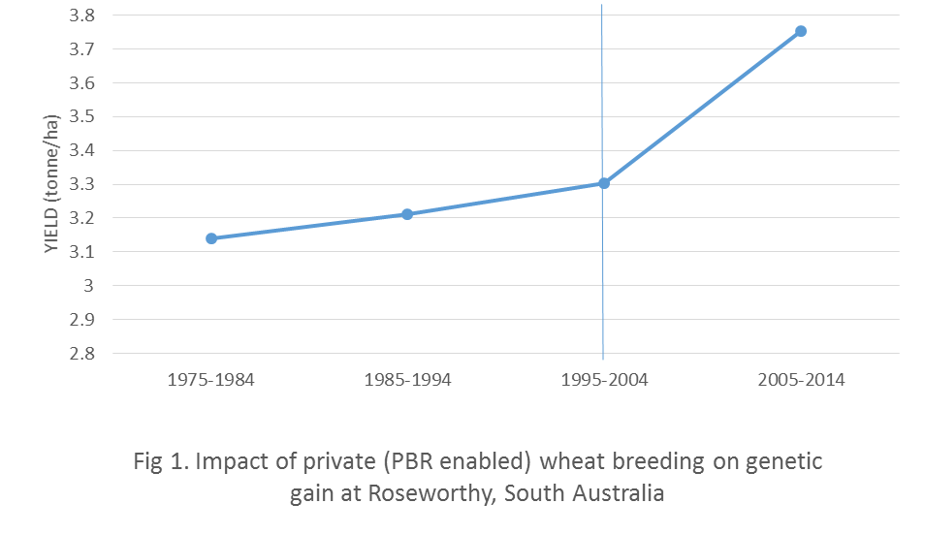
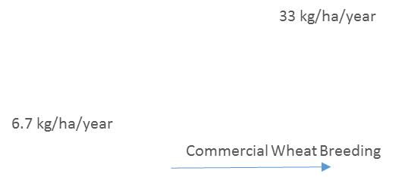

Are the protections afforded under PBRs proportional to the efforts of breeders?
Cecil & Kuchel
Is there evidence the introduction of PBRs has contributed to the development of Australia’s seed export industry? Is this a suitable role for IP policy?
NOT AGT
How adaptable is the system of PBRs to technological change? Should PBR legislation be amended in light of technological developments, or can new high-value plant varieties (however they are developed) be adequately supported by patent laws?
Cecil & Kuchel

How adaptable is the system of PBRs to technological change? Should PBR legislation be amended in light of technological developments, or can new high-value plant varieties (however they are developed) be adequately supported by patent laws?
Breeding technologies have changed considerably since the PBR legislation was enacted. In ways that could not have been envisaged when the PBR Act was instituted. This is impacting upon plant breeders in two major ways:
- Publically available technologies such as molecular markers have made the process quicker and more efficient. It has also allowed breeders to make changes to varieties at a genetic level that are not always expressed as a clear and measurable phenotypic change. The current PBR legislation requires that there be a distinct and stable phenotypic difference between the new candidate variety and other existing varieties. While it is accepted that the change of 1 base pair within the genome should not be enough to constitute breeding the PBR Act needs to contemplate how it will deal with such situations where changes are economically valuable, but not suitable for proving distinctness (ie grain yield, wheat quality etc)

- A significant problem for PBR owners is now arising when patented technologies begin to interface with PBR varieties. These may be patented technologies that increase the speed of breeding or a technology that introduces a new and/or novel trait to the plant species.
Plant breeding is a long term process. In cereals it can take 10 to 12 years from the cross to release of the variety. 10 to 12 years of investment before a return can be envisaged. This is not too different from industries where patenting is the norm (ie pharmaceuticals, pesticides).
When PBR is granted the PBR recipient gives other plant breeders (very loose definition) a free and unencumbered right to use the PBR variety for breeding purposes and for the creation and commercial release of new plant varieties. This works well when all participants are creating new varieties that are then also protected under PBR. The new plant breeder does not need to seek a license from the original plant breeder to use the original variety within their breeding program. In this action breeders provide the new variety to the “breeding community”, give unfettered rights for breeding purposes, seek no claim upon the newly created variety, and thereby contribute to a process of continuous improvement. In this way, the PBR system (with regard to future improvements) is analogous to the GNU open source license use for many innovative software products (eg Linux).
The patenting system differs in that once a patent is granted other potential users of the patent do NOT get an automatic right to use or improve on that IP. While they can use the IP under a research exemption once they decide to commercialise a product using that IP or have developed an improvement to that IP they then need to seek and negotiate a license from the original patent holder prior to any commercial use.
It is therefore possible for a holder of a patent, which allows faster plant breeding or insertion of a novel trait into a plant, to access the released PBR lines and incorporate their technology into a PBR line. By definition under the PBR act this would likely be considered breeding. The Patent owner would then have rapidly achieved an improved version of the original PBR owner’s variety and have no obligation to seek a license from that original owner or to return the new variety back into the breeding community via PBR. Yet should that original PBR owner themselves use the patent owners IP to do the same they would be infringing their IP.
This cross over and different treatment of these two types of IP rights is problematic. There is a “Structural Arbitrage” where patent owners have easy unencumbered access to the IP of PBR owners, however, PBR owners do not have easy access to patented technologies.
The “free ride” of a patent owner to use the PBR IP of plant breeder puts at risk the level of investment a plant breeder is likely or willing to make. It is unreasonable that a plant breeder should invest 10 to 12 years developing a new variety obtaining PBR and then having the variety “sniped” by a patent owner thereby preventing the original breeder form obtaining a fair return on their investment. This is a MAJOR concern for ongoing investment in plant breeding in Australia and the improvements in performance required by Australian farmers. Without continued and increased levels of investment in “back-bone” plant breeding, rates of genetic gain will be reduced and Australia’s agricultural economy will suffer. These new technologies can be embraced, but the supplier of long term genetic gain (plant breeding) should be protected so that private investment will continue to thrive.
A PROPOSED SOLUTION
To overcome this “Structural Arbitrage” should a patent owner want to use their patented IP for breeding purposes or incorporate their patented IP into PBR protected lines they should have two choices
- Create the new line, containing the patented IP, place it back through the PBR system, and extinguish their patent rights, so ALL plant breeders have free and unencumbered access to the new variety containing the patented technology, or;
- Rely solely on their patent rights but in doing so be excluded from using a PBR variety without first negotiating a license from that PBR owner for access to that owners IP

Option 2. License from PBR Owner required if existing PBR variety is used with patented technology to create a new variety, and, the new variety and the patented technology is NOT made freely available through returned to the PBR system for all breeders to use under the breeding exemptions under the PBR Act
Option 1. License from PBR Owner NOT required if existing PBR variety is used with patented technology to create a new plant variety, and, the new variety and patented technology is made freely available through the breeding exemptions under the PBR Act
PBR—Continuous improvement through shared access to newly created (registered) IP
NEW VARIETY
NEW VARIETY
NEW VARIETY
NEW VARIETY
NEW VARIETY

NEW VARIETY
In summary, it is proposed that the PBR act be strengthened through the following changes:
- The breeding rights exemption be strengthened to the effect that “by crossing with a PBR protected variety, the breeder agrees to protect all commercial progeny through the same PBR system”. This would ensure continuity of the breeder’s right exemption from generation to generation.
- That the PBR Act include a requirement that: “Any and all IP associated with a PBR protected variety is provided, unfettered, for continued breeding”
- The PBR Act state that “The use of a PBR variety with a patented technology will require a license from the PBR owner unless the breeder (creator) of the new variety, that incorporates the patented technology, makes the new variety and patented technology freely available to all plant breeders under the breeders rights exemption of the Act.
These changes would protect investment in plant breeding, while also allowing patent holders the ability to either build on the work of other plant breeders, or to generate their own germplasm to carry their patented IP to farmers.
Are IP rights too easy or hard to enforce in Australia, and if so, why?
From the cereal industry perspective PBR rights are made more difficult to enforce simply due to the very large number of potential growers of any new variety (estimated to be 40,000 plus entities). The tracking of these growers, their production and sales adds a significant inefficiency and cost to the cereal breeding sector.
The cereal breeding sector has long sought the right to impose an obligation on the purchasers of PBR protected varieties (grain buyers and traders) to report their purchases to the PBR owners. This would greatly reduce the PBR owner’s compliance costs as they would need to interact with buyers numbering in the hundreds rather than growers numbering in the tens of thousands.
While a good majority of grain buyers, including the major Australian cereal buying entities, do assist the PBR owners on a voluntary basis, the nature of the cereal industry means there are a large number of short term traders and domestic users that refuse to assist the breeders of the varieties.
In 2005, the Government asked The Advisory Council on Intellectual Property (ACIP) to:
inquire, report and make recommendations to the Australian Government on issues relating to the enforcement of plant breeder’s rights in Australia and to consider possible strategies to assist Australian plant breeder’s rights holders effectively enforce valid rights. The review should include a consideration of whether any practices and procedures relating to the enforcement of Plant Breeder’s Rights (PBR) are appropriate to be referred to the Federal Magistrates Court.
ACIP recommended 22 legislative and procedural changes. The most significant recommendations that were made to government include;
- Making a new right applying to the purchase of propagating material available to PBR owners, to enable the industry to collect royalties more efficiently
- Including PBR matters within the jurisdiction of the second tier of the Federal Court to provide PBR owners with an appropriate forum for enforcing their rights
- Introducing an Information Notice system that enables PBR owners to obtain information from alleged infringers on the source of plant material
- Introducing powers to enable Customs to seize goods at the border that allegedly infringe PBR
- Introducing exemplary damage provisions into the Plant Breeder’s Rights Act 1994 (the PBR Act)
- ACIP also recommended that no changes be made to the farm saved seed provisions
Since the release of the Government response to the ACIP final report in June 2010, only matter that has been amended is to include PBR matters within the jurisdiction of the second tier of the Federal Court.
It is our view that there is still a serious deficiency that requires amendment in the PBR Act to allow PBR owners to enforce their right upon a “Purchaser” of their PBR variety. Such an amendment would provide significant efficiency and productivity gains to the cereal breeding sector

