Bradley Moggridge

Submission to the Productivity Commission National Water Reform public inquiry, Draft Report released 15 September 2017.

Thank you for the opportunity to provide a response to the National Water Reform Draft Report.

NSW was let off very lightly in the Draft Report considering what damage they have done.

My recommendations
- Must be State Accountability for not doing anything
- Indigenous led research via National First Peoples Think Tank or Centre of Excellence
- National First Peoples Water Advisory Body to develop new NWI Indigenous provisions
- National First Peoples Water Strategy
- National First Peoples Water Holder (National not just MDB)
- Change the Federal Water Act (as Water Act doesn’t allow for Culture in eWater/CEWH)

What PC did not report on was the destruction of the NSW Aboriginal Water Initiative (AWI) even after the Module To The National Water Initiative (NWI) Policy Guidelines For Water Planning And Management Engaging Indigenous Peoples In Water Planning And Management (2017), lauded the AWI as best practice:
- The sacking of confident, skilled Aboriginal water staff from 11 positions in a team structure through to the Change Management with only 3 positions in 3 separate units.
- The breakdown of the 11 roles: 4 x Permanent roles, 4 x funded under Murray Darling Basin Implementation Funding and 3 x temporary roles.
- The sacked staff who loved their job, have struggled to find stable employment in water in the regional areas like Kempsey, Inverell, Dubbo, Queanbeyan, Wollongong or Buronga where they are located.
- Only 1 team member from the AWI has remained in Aboriginal water, one other has sort employment in the Regulation section of DPI Water. Ex-Staff who have been for interviews within NSW DPI are advised not to talk or mention the AWI (yes you read it) as part of the feedback, like the State wants any record wiped.
- Writing to the Secretary and Minister in late 2016 to ask why they disbanded the AWI, paraphrasing the response was that the AWI provided departmental cultural awareness and now Aboriginal values are mainstreamed and with that Aboriginal staffs are reduced to give advice not engage as that is the Water Planners role as discussed in Taylor et al 2017.
- The undoing of four and half years of hard work to build up the capacity of staff, community and government on Aboriginal water values.
- Destruction of a strong AWI governance structure, procedures, policies and most importantly the expectations of NSW Aboriginal people to be engaged along with an impact on licensing for Aboriginal specific purpose licences as AWI was to link data to inform cultural licences and provide point of contact
- AWI developed internal protocols on how to do business and reporting:
  - Team Protocols
  - Cultural Protocols
  - Operational Community Engagement Plan
  - Draft Communications and Engagement Strategy
  - Governance Model
  - We report Quarterly and Annually on our progress
  - Dispute Resolution
- The loss of corporate and community knowledge and highly trained Aboriginal water staff.
- The loss of Aboriginal community trust and involvement in future engagement processes.
- The potential loss of existing information provided by Aboriginal communities to inform planning and licensing processes (as per Information Use Agreement terms).
- The failure of data input into the then secure Aboriginal Water Initiative System (AWIS) Oracle now Cloud based database, which was developed at a cost of over $20,000. The further implications are that community may request the withdrawal of the existing data uploaded with no AWI administrator or guaranteed protection.
- The potential risk of non-accreditation of 22 Water Resource Plans (WRP) under the Murray Darling Basin Plan including 13 Groundwater WRPs and 9 Surface Water WRPs based on inability to satisfy Part 14 Chapter 10 for having regard to Indigenous Objectives, Outcomes, Values and Uses and also Cultural Flows.
This also includes a lack of opportunity to inform the Basin Plan required 22 WRP Risk Assessments and 22 WRP Water Quality and Salinity Management Plans.
- The failure of Leaderships own key Principles of "sound consultation" and also a lack of opportunity of Aboriginal staff in career progression and “succession planning” within DPI and NSW Government with only 3 Aboriginal identified positions available in 3 different units at non compatible grades 2 x Grade 7-8’s and 1 x 11-12.
- The failure of the broader DPI and Industry to comply with NSW State Plan 2021, under specifically Goals 1, 22 and 26 under the original funding model.
- The failure of the broader DPI and Industry to comply with PSC NSW Public Sector Aboriginal Employment Strategy 2014-17 by the sacking of permanent Aboriginal employees by 25%, that is disgraceful.
- The failure of DPI Water to meet the Water Management Act 2000 for Water Sharing Plans, Water Resource Plans and Floodplain Management Plans specifically:
3 Objects (c) including:
(iii) benefits to culture and heritage, and
(iv) benefits to the Aboriginal people in relation to their spiritual, social, customary and economic use of land and water,
5 Water management principles:
The principles set out in this section are the water management principles of this Act.
Generally:
(e) geographical and other features of Aboriginal significance should be protected, and
(f) geographical and other features of major cultural, heritage or spiritual significance should be protected.
- A loss of effective Aboriginal input into Interagency Regional Panels (IRP) and Stakeholder Advisory Panels (SAPs) as the AWI was the only mechanism to provide such input especially for rule development, flow requirements, buffer distances, licensing and reviews of water plans.
- Now Aboriginal Elders are expected to sit on SAP’s with limited capacity and understanding of Water Managements = recipe for failure.
- The reality and failure to provide valuable Aboriginal input and engagement to the 9 Long Term Environmental Watering Plans being developed by OEH.
- The failure of NSW DPI water to comply with COAGs National Water Initiative especially clauses 25(ix) and 52-54.
  - NSW does not have a mechanism for positive Native Title Determinations to allocate water for Native Tile.
- The reality and failure of DPI Water to physically provide an AWI delegate to sit on the National Cultural Flows Research Committee.
- The reality for DPI to physically provide an Aboriginal representative for the OEH’s Aboriginal Heritage Reforms Interagency Advisory Group as appointed by you the Secretary.
- The failure of the agreed United Nations Declaration on the Rights on Indigenous People's (UNDRIP) specifically Article’s 3, 19, 25, 32 (2).

Also stated in the MDBA’s Position Statement 14A, NSW is at risk of not meeting:
- a planned approach to properly engaging Traditional Owners (e.g. adequate time, appropriate venues and resources) that results in an Indigenous Engagement Strategy that guides preparation of the water resource plan
- identification and involvement of appropriate Traditional Owners throughout all stages of the water planning process
- Traditional Owners are properly notified of the opportunity to be involved in the water resource planning process, (e.g. print, phone, electronic and personal media and town meetings)
- information about water resource planning processes and content provided is clear to Traditional Owners
- use of appropriate tools and mechanisms for recording, understanding and incorporating Aboriginal objectives and outcomes.

The AWI Team Leader could not always ensure the Aboriginal Water Initiative team members at DPI Water a concrete future in the organisation but ensured there was a healthy training budget for the team members to undertake significant training and capacity building, some of the courses completed:
  - Entire Team - Media training with Rachel Friend
  - Entire Team - 4WD
  - Entire Team - GIS
  - Facilitation Skills
  - 2 x staff completed NSW Frontline Management Program
  - Entire Team - Recruitment and Selection Training
  - Executive Development Training
  - Introduction to Management Training
  - Expanding your Leadership
  - Entire Team - First Aid Training
  - Project Management
  - Professional Writing Skills
  - 4 x staff completed Cert IV Training and Assessment
  - 2 x AWI Staff enrolled in Water/NRM Masters and Graduate Diploma courses. 1 graduated from the Graduate Diploma 2016 and the other has 2 subjects remaining for the Masters in 2017.
  - Public Service Commission Indigenous Leadership 2 x Senior Facilitators were accepted 2016
  - Entire Team - Defensive Driving

This is what is left of the Aboriginal Water Initiative after 4 and half years:
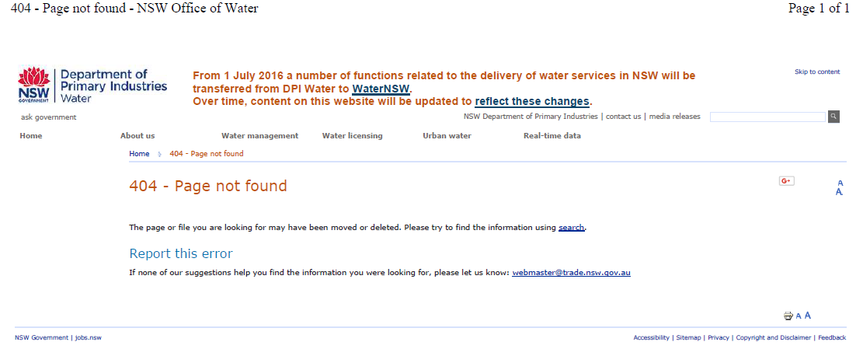

National Water Commission [NWC]. (2011). The National Water Initiative—securing Australia’s water future: 2011 assessment. NWC, Canberra.

Taylor, K.S., Moggridge, B.J., and Poelina, A. (2017). Australian Indigenous Water Policy and the impacts of the ever-changing political cycle. Australasian Journal of Water Resources, 20(2), 132-147.

GOAL 1 Improve the performance of the NSW economy GOAL 22 Protect our natural environment GOAL 26 Fostering opportunity and partnership with Aboriginal people
25. The Parties agree that, once initiated, their water access entitlements and planning frameworks will: ix) recognise indigenous needs in relation to water access and management; Indigenous Access 52. The Parties will provide for indigenous access to water resources, in accordance with relevant Commonwealth, State and Territory legislation, through planning processes that ensure: i) inclusion of indigenous representation in water planning wherever possible; and ii) water plans will incorporate indigenous social, spiritual and customary objectives and strategies for achieving these objectives wherever they can be developed. 53. Water planning processes will take account of the possible existence of native title rights to water in the catchment or aquifer area. The Parties note that plans may need to allocate water to native title holders following the recognition of native title rights in water under the Commonwealth Native Title Act 1993. 54. Water allocated to native title holders for traditional cultural purposes will be accounted for.
Article 3 Indigenous peoples have the right to self-determination. By virtue of that right they freely determine their political status and freely pursue their economic, social and cultural development. Article 19 States shall consult and cooperate in good faith with the indigenous peoples concerned through their own representative institutions in order to obtain their free, prior and informed consent before adopting and implementing legislative or administrative measures that may affect them. Article 25 Indigenous peoples have the right to maintain and strengthen their distinctive spiritual relationship with their traditionally owned or otherwise occupied and used lands, territories, waters and coastal seas and other resources and to uphold their responsibilities to future generations in this regard. Article 32 2. States shall consult and cooperate in good faith with the indigenous peoples concerned through their own representative institutions in order to obtain their free and informed consent prior to the approval of any project affecting their lands or territories and other resources, particularly in connection with the development, utilization or exploitation of mineral, water or other resources.

