Copy
Opening with the Key note and closing statement from my last post draft submission; If the micro plastics and the more invasive polymers are not halted at the waste stream source, the entire Australian Fishery’s and symbolic industries are at risk of having a polymer contaminated ocean food chain (Try and eat that)
(Figure 1) This sea surface plastic concentrations map of Australia produced by the CSIOR; as you can observe when interpreting the data, it is quickly observable that the proximity for the given highest concentrations for sea surface plastic is around Mackay central Qld.
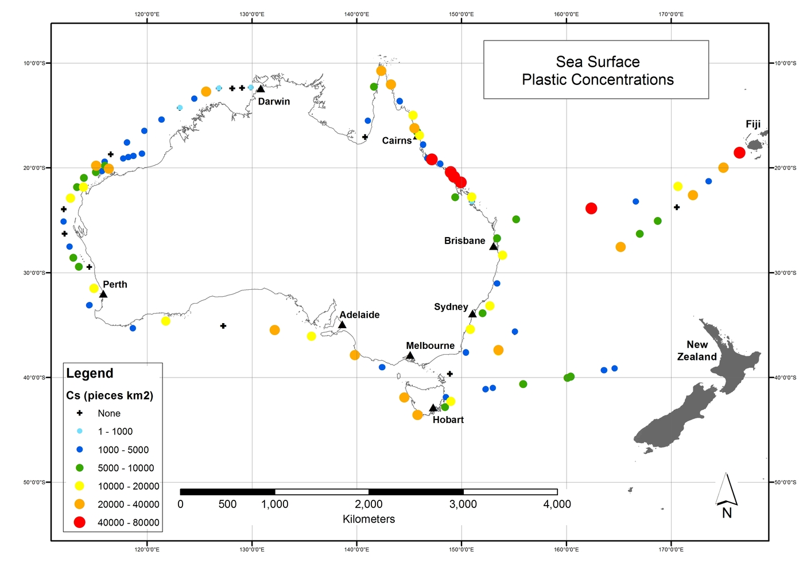Figure 1 above Figure 2 blow
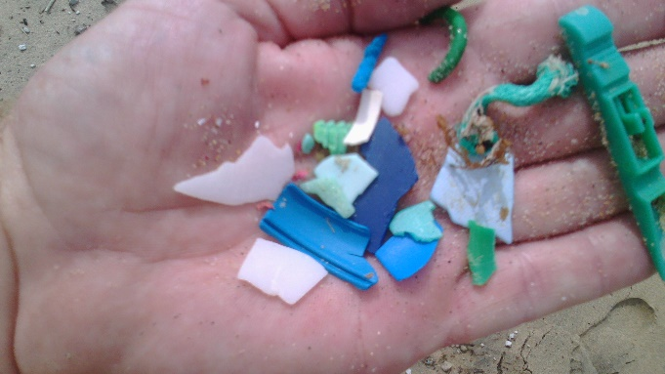
This micro plastic sample collated from beach environment testing around Mackay (Figure 2), displays the precursory 3-5mill and binary 5-15mill micro plastic. Not tested for was the lesser than 2mill the polymers so small as to be visible only with a microscope.
In Australian waters, you can expect to find anything from a few thousand to more than 40,000 pieces of plastic per square kilometre

This powerful narration, for micro plastics is stupefying by its simplicity; the micro plastics mimic the ocean environmental components that are naturally occurring - sea grass, the small bottom of the food chain marine life’s, the way the ocean waves and currants manipulate the micro plastic into a lure like behaviours; in the same manner as a manufactured plastic fishing lure- the list is not limited

Figure 3: free range harvested fish, cleaned and gutted, note the amount of Micro Plastics the gut contained
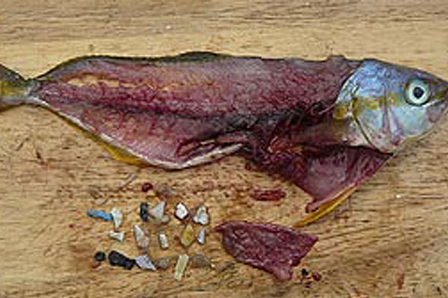
Our ecosystems are internationally dually noted as safe; by safe I imply the Australian water and land environment when placed in prospective “we are”, “we were” one of the marked leaders in food production. If we do not address the solid waste stream in to the environment and the sea surface plastic concentrations it will slowly evolve to destroy Australian fish reserves and there will be not bequesting of this industry beyond a generation or two.
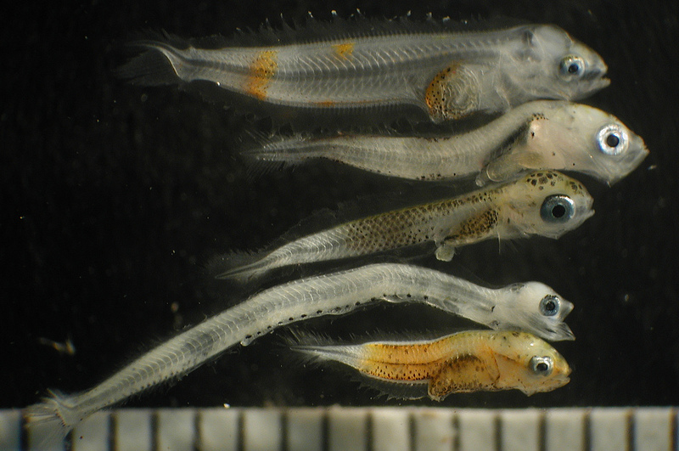
Young fish are getting hooked on consuming micro plastic particles instead of their usual diet of zooplankton, a new Swedish study has warned. The findings renewed calls to ban plastic micro beads as one way to tackle the dire situation. (NOAA Photo Library | Flickr ) Figure 4
“The start of the food chain”

Figure 4 Citation; Researchers from Uppsala University in Sweden discovered that exposure to high polystyrene concentrations makes larval perch choose plastic over their natural food composed of zooplankton. As a consequence, the young perch are slower, smaller and more prone to predation.
“Fish reared in different concentrations of micro plastic particles have reduced hatching rates and display abnormal behaviours,” said lead study author and marine biologist Oona Lönnstedt. “The micro plastic particle levels tested in the current study are similar to what is found in many coastal habitats in Sweden and elsewhere in the world today.”
According to the team, larvae exposed to micro plastic particles — defined as those less than 5 mm (0.2 inch) in size and hail from fragmented large plastic waste — remained much less active than those reared in waters free from such particles.
They also ignored the smell of predators. The plastic-exposed ones were eaten over four times more quickly than control fish, with the former all dead within two days.
- See more at: http://www.techtimes.com/articles/162773/20160603/tiny-ocean-fish-prefer-to-eat-plastic-over-plankton.htm#sthash.vyQPsUic.dpuf

The studies are all damming; fish not only eat micro plastics in stage one for entering food chain we eat. Considering the chemical polymers are instigating physiological evolutionary events in fish species as emulated by marine biologist Oona Lönnstedt. Researchers studying the branch of biology dealing with the functions and activities of living organisms and their parts, including all physical and chemical processes and or the organic processes or functions in an organism or in any of its parts. However, they have not yet asked the biggest question as yet and the question is –
“If micro plastics impact on fish species adversely that humans predated on, will this effected a change in human behaviour’s and impacted human biology with increased cancers, birth defects the list is not limited”?

Does it matter that the entire Australian Fishery’s is at risk from Micro Plastics, “yes” the economic impacted and the depletion of safe ocean derived food, “contains a vast foot print that is not limited”.
Whether the marine capacity to assimilate micro plastic waste is not finite, this too is relevant.
Conclusion; a marked reduction in the flow of solid waste into the environment would elevated and have a persevering action in, on ,for the entire Australian Fishery’s.

In closing - “To remain indifferent to the challenges we face is indefensible. If the goal is noble, whether or not it is realized within our lifetime is largely irrelevant. What we must do therefore is to strive and persevere and never give up.” – Dalai Lama

Thanks Lance Payne
I have all so include a low technical systems control solution that should be implement asp in Qld

So ask a question can you get a river entrapment system to remove solid waste before it enters the ocean environment. I found this company and make just what I was looking for-

http://www.tradeenviro.com.au/weed-and-debris-booms/
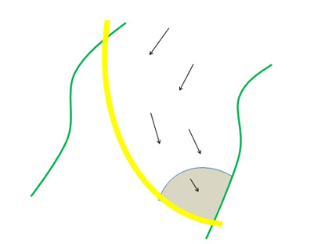
As the solid waste is contained, in the grey shaded zone the solid waste then when trapped. It can then be reclaimed back out of the environment. As this removal procedure is in the upper surfaces its general impacted on fish stocks transcending the river systems negated to the point of non-consequential. Key point; small fiscal investment high environmental positive impacted

My thoughts are “why is not this type of equipment- a weed and debris boom; already not deployed through Australia?”

