Submission to Productivity Commission – Reforms to Human Services

10 Feb 2017

Lee O’Dowd Austen

This paper will discuss the problem of holding government accountable for delivering public value.

I have worked for various government departments as a public servant or as a government contractor for about 16 years. In that time I have noticed that members of the public have recourse to judging the effectiveness of government mainly through 3 crude methods:

- The surplus or deficit of the fiscal budget under the government’s charge
- Information reported by the media
- Whether or not the government gets re-elected

But none of these is a direct measure of effectiveness. Rather;

The budget Measures the amount of money collected and spent on the broad and ill defined aims of the government

The media Measures the aspirations and discontents of various individuals and special interest groups, including indirectly, the parties who might support their ongoing viability by purchasing advertising space

Getting re-elected Measures only the effectiveness of the previous two measures

Not having an objective method of measuring government performance means that the private interests and biases of the the agents involved in this system, the ministers, public servants and the owners of media, necessarily take precedence over meaningful outcomes for the tax paying, voting public.

How does the system work now?
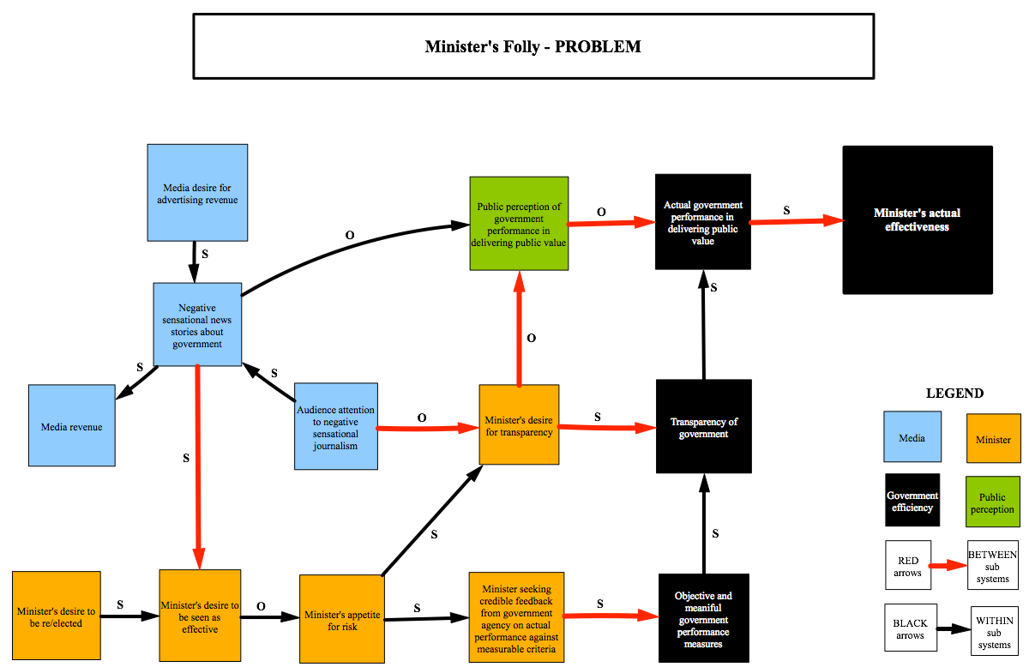
Figure 1. Minister’s Folly

How did we get into a social / political system where the people with the power to make laws and spend our tax are not held accountable in a meaningful way? Here’s a quick timeline of events that lead us from the formation of the political system of NSW, to the laws that govern it today.

1840 Treaty of Waitangi recognises Maori ownership of lands in New Zealand

1841 New Zealand and NSW colonies separated from each other

1855 NSW granted responsible independent government by the British crown

1901 NSW cedes some powers to the newly federated Commonwealth of Australia Government

1902 NSW Constitution Act defines form and powers of NSW Government

2006 NSW Pledge of Loyalty Act amends the requirement that ministers pledge loyalty to only the Queen of England, in favour of pledging loyalty to BOTH the Queen and her heirs AND to Australia and the people of NSW.

(NSW Consolidated Acts 2016) (Wikipedia 2016)

Throughout the history of all the legislation that constitutes the NSW State Government, the 2006 NSW Pledge of Loyalty act is the only measure that appears to relate to performance or efficacy. As this act merely requires ministers to ‘pledge loyalty’ (see Appendix A) it only imposes on them to produce an ‘output’, i.e. loyalty, and not an ‘outcome’ like, health services, budget surpluses, public transport or even value for money. This very subjective measure leaves each minister to decide how loyalty might be interpreted and applied from day to day, without any means of redress from the public.

This meagre limit on the minister’s actions is imposed in a broader system environment dominated by competition for capital. All system participants must compete for capital in order to provide for their primary biological needs, their social needs and so on. There are many types and groupings of participants in this system. One notable group is the mainstream news media.

Media

The journalists, producers and owners of news media compete for capital in the broader system by creating news stories that will attract the attention of the largest possible number of people, then while viewers pay attention to the news story a space is created to insert commercial advertising. This space is rented by industry (another system participant group) to promote the sale of their products and services or otherwise promote their interests.

What’s the best way to attract and keep people’s attention? The field of psychology that studies motivation has recognised the relative motivational power of fear over hope for many years (Psychology Today 2016). This means that if you want the best chance of keeping viewers glued to the TV set, you should use stories and perspectives that evoke fear. Such fear might include fear of physical danger, fear of loss and so on.

Sensationalism helps here. The Oxford dictionary defines sensationalism as:

NOUN
[MASS NOUN]
1
(Especially in journalism) the presentation of stories in a way that is intended to provoke public interest or excitement, at the expense of accuracy:
media sensationalism

(Oxford Dictionary 2016)

Mainstream news media uses sensationalism to great effect in capturing the attention of viewers, and turning that attention into income from advertising revenue. As most people in NSW are interested in how their tax is being spent, the news media focusses a large portion of its reports on the activities of government.

The Minister

Basically, the minister is motivated to do the things that it takes to get elected. The main way that incumbent or prospective ministers try to convince people to vote for them is by appearing to be effective in delivering the outcomes that the voter wants.

When negative stories are played on the news about government it also impacts on individual ministers, creating fear in them that they will be seen as ineffective. This decreases their desire to do anything risky that might result in failure or the perception of failure.

This decrease in the minister’s appetite for risk means that they are not likely to seek out any information that supports the media to portray them as ineffective. This makes measuring the real outcomes of the departments that ministers are in charge of a risky proposition. Any time we seek meaningful feedback about progress in a complex project, we are bound to find problems. Ministers do seek meaningful feedback about the outcomes created by government, but never their own government, rather they seek feedback & insights about the outcomes of past governments whom are currently in opposition in order to generate fear in the mind of the voter about the consequences of letting those wasteful, incompetent and ineffective reprobates back into public office.

This dynamic leads to:

    - a lack of transparency into government affairs
    - the false public perception that everything is going along well enough
    - idealistic government election campaigns that set vague and unmeasurable goals
    - a lack of incumbent ministers enquiry into the effectiveness of their departments

Government Efficiency

In government departments, as with other places of employment, the tendency is to do what is required of you. So, as ministers do not routinely ask for meaningful feedback on the effectiveness of their departments, public servants do not routinely give it. Government departments are full of well educated and highly paid staff who want meaningful and effective work almost as much as the wage that supports their lifestyle. At times, various colleagues and I have proposed various ways to start setting measurable goals and track progress to meeting them. These efforts are always resisted, usually passively, sometimes actively.

Because of this, there are no objective, meaningful performance measures that we can either contribute to or learn from in order to improve our practice. This impacts our ability to report anything meaningful about the broad outcomes of our efforts to either the minister or the public. It also impacts our ability to judge the effectiveness of our own work, even for ourselves. This makes us ineffective and means we have no chance of delivering value for money to the tax paying public.

What’s wrong with that?

The system we are considering is intended to produce the outcome of ‘wellbeing’ or ‘fairness’ for its stakeholders. In its current form, all system stakeholders must take responsibility for contributing resources, but only a few have the power to direct them. This leads to the central problem that the intended outcome of the system is blocked by the properties of the system itself because the private motivations of the agents are at odds with the intended outcomes, i.e., the minister can either attend to his personal gain or the gain of others, but not both.

Personal gain ends up determining the outcomes because there is no system property that limits the potential outcomes, to the desired outcomes. Designing a system in a way that makes unintended outcomes impossible is the only way to avoid Murphy and his annoying law (Fresco 2016).

Of course, it would be very brave to claim that a social / economic / political system could be designed in a way to completely eliminate the possibility of unintended outcomes. Systems dynamics modeling of this kind of complex system necessarily simplifies a very dynamic situation into a static representation. This is both the strength and the weakness of systems dynamic modeling. Because of this we can only use any observations or prescriptions as a guiding principle. Still, the observations are powerful and point to several potential solutions that may improve the outcomes of the system in question for its stakeholders.

What the system model in Figure 1 suggests is that any approach that addresses the central problem of agent’s private motivations interfering with system outcomes could potentially improve system performance. With this in mind, potential solutions include:

- Abandon representative politics in favour of direct democracy
    - Representing the views of large numbers of people is probably impossible and anyway, is bound to favour the most vocal and articulate groups, who also tend to need the least external representation. One way to avoid this problem would be to allow all system participants to register as creators and voters of individual laws and policies on a central ‘government of the people style’ website that is merely administered according to the will of the entire population by the people who were formerly ministers.

- Ban political parties
    - Being a member of a political party means that once internal debates are called to a close, you must ‘tow the party line’ despite your personal views, or those of your constituent voters, remaining unresolved. At first glance this ‘middle ground’ system bias appears the best and most balanced approach to accounting for the views of the largest number of system beneficiaries; but in fact the system quality produced by the affiliation of supposedly like-minded party members favours moderation over innovation, is not even an aggregation of views and as it forms compromised versions of all views, probably represents none. (apple pie popularity quote)

- Change the electoral system to favour population proportionate representation of political views
    - The current electoral system is mathematically biased in favour of conservative views. In Australia (including NSW), representatives in parliament are elected on the basis of people casting votes on one party or another within equally populated geographic areas (NSW Consolidated Acts 2016). Under this method if say, 51% of people in each geographic area vote for the Blue Party, the result is that the Blue Party wins100% of government and the parties who received the other 49% of votes receive 0% of government.
    - A more representative group could be elected by simply abolishing geographic boundaries, allowing all system participants to vote for all possible representatives. The result would be a proportionate representation of views in government.

- Impose a publicly scrutable performance standard on ministers
    - The system described in Figure 1 has no external reference to judge success or failure by. Rather, it relies only on the intent of the agents that constitute it. Imposing an external standard that prescribed success criteria, performance measures and full transparency would immediately remove the counter productive impact of the private interests of media and ministers on the outcomes of the system. Of course, the nature and details of such a standard would have to be well thought out in terms of broader system impact, but as a basic requirement they could include something like S.M.A.R.T. project goals (Specific, Measurable, Agreed, Realistic, Time-framed). To ensure the rigour and completeness of such a standard it should also meet the requirements of qualification with the International Standards Organisation.

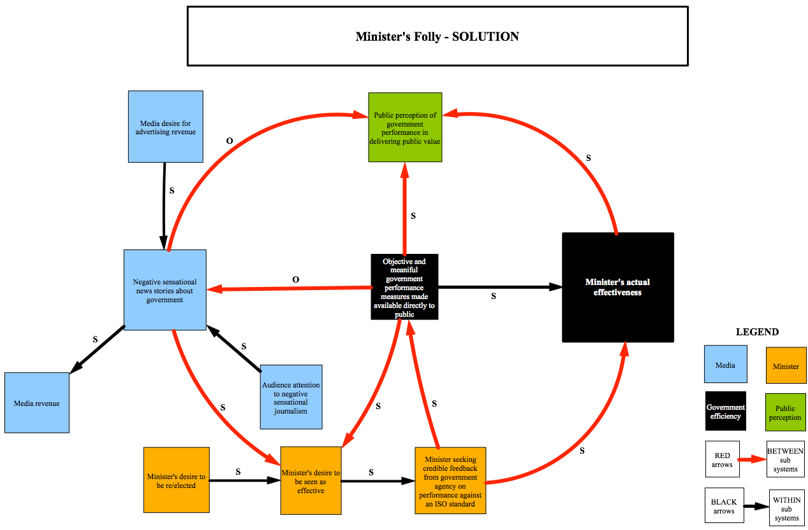
Which system amendment has the best chance of improving the system?

Figure 2. Minister’s Solution

While all of the potential system modifications proposed above address the central problem of private motivations impacting public outcomes, most would probably be considered too radical to adopt. In truth, while the first three proposed solutions have some attractive properties they are such a severe departure from the existing system that they would probably produce a large number of unintended and unpredictable outcomes; some good, some bad.

The last proposition however, to impose a publicly scrutable performance standard on ministers, may have a positive impact on system outcomes without producing too many unintended consequences. Figure 2 above explores how this proposition might function.

In this system model the news media agent might still be motivated to produce negative sensational news stories about government, but with the imposition of a publicly scrutable performance standard on ministers, the only reference those stories could make would be to the minister not observing the standard.

In the case that this happens, as it may, the minister’s private motivation to be seen as effective would make it necessary for him to adhere to the standard, and seek credible feedback from the government agency about their performance against the ISO standard.

Both of these modified interactions lead ultimately to continual improvement in ministers and government agencies in delivering public value, and so in the effectiveness of fulfilling their purpose in the system.

References

Fresco, J. 2016. The Venus Project. [ONLINE] Available at: https://www.youtube.com/user/thevenusprojectmedia. [Accessed 17 May 2016].

Psychology Today. 2016, The Most Powerful Motivator. [ONLINE] Available at: https://www.psychologytoday.com/blog/the-main-ingredient/200909/the-most-powerful-motivator. [Accessed 16 May 2016]

NSW Consolidated Acts. 2016. CONSTITUTION ACT 1902 - SECT 35CA Executive Councillor’s pledge of loyalty or oath of allegiance and oath of office. [ONLINE] Available at: http://www.austlii.edu.au/au/legis/nsw/consol_act/ca1902188/s35ca.html. [Accessed 17 May 2016].

Oxford Dictionary. 2016. Sensationalism Definition. [ONLINE] Available at: http://www.oxforddictionaries.com/definition/english/sensationalism. [Accessed 18 May 2016].

Wikipedia. 2016. New South Wales. [ONLINE] Available at: https://en.wikipedia.org/wiki/New_South_Wales . [Accessed 16 May 2016].

APPENDIX A

CONSTITUTION ACT 1902 - SECT 35CA
Executive Councillor’s pledge of loyalty or oath of allegiance and oath of office
35CA Executive Councillor’s pledge of loyalty or oath of allegiance and oath of office

(1) Before assuming office, a person appointed as a member of the Executive Council is to take:
(a) the pledge of loyalty or oath of allegiance, and
(b) the Executive Councillor’s oath of office,
before the Governor or other person authorised by the Governor for that purpose.
(2) The pledge of loyalty is to be in the following form:
Under God, I pledge my loyalty to Australia and to the people of New South Wales.
(3) A member of the Executive Council may omit the words “Under God” when taking the pledge of loyalty.
(3A) The oath of allegiance is to be in the following form (with the name of the reigning Sovereign substituted, where appropriate):
I swear that I will be faithful and bear true allegiance to Her Majesty Queen Elizabeth II, Her heirs and successors according to law. So help me God.
(4) The Executive Councillor’s oath of office is to be in the following form:
I,being appointed as a member of the Executive Council of New South Wales, do swear that I will perform the functions and duties of an Executive Councillor faithfully and to the best of my ability and, when required to do so, freely give my counsel and advice to the Governor or officer administering the Government of New South Wales for the time being for the good management of the public affairs of New South Wales, and that I will not directly or indirectly reveal matters debated in the Council and committed to my secrecy, but that I will in all things be a true and faithful councillor.
So help me God.
(5) A member of the Executive Council may, instead of taking an oath under this section, make an affirmation to the same effect.
(6) This section applies only to members of the Executive Council appointed after the commencement of the Constitution Amendment (Pledge of Loyalty) Act 2006 .

