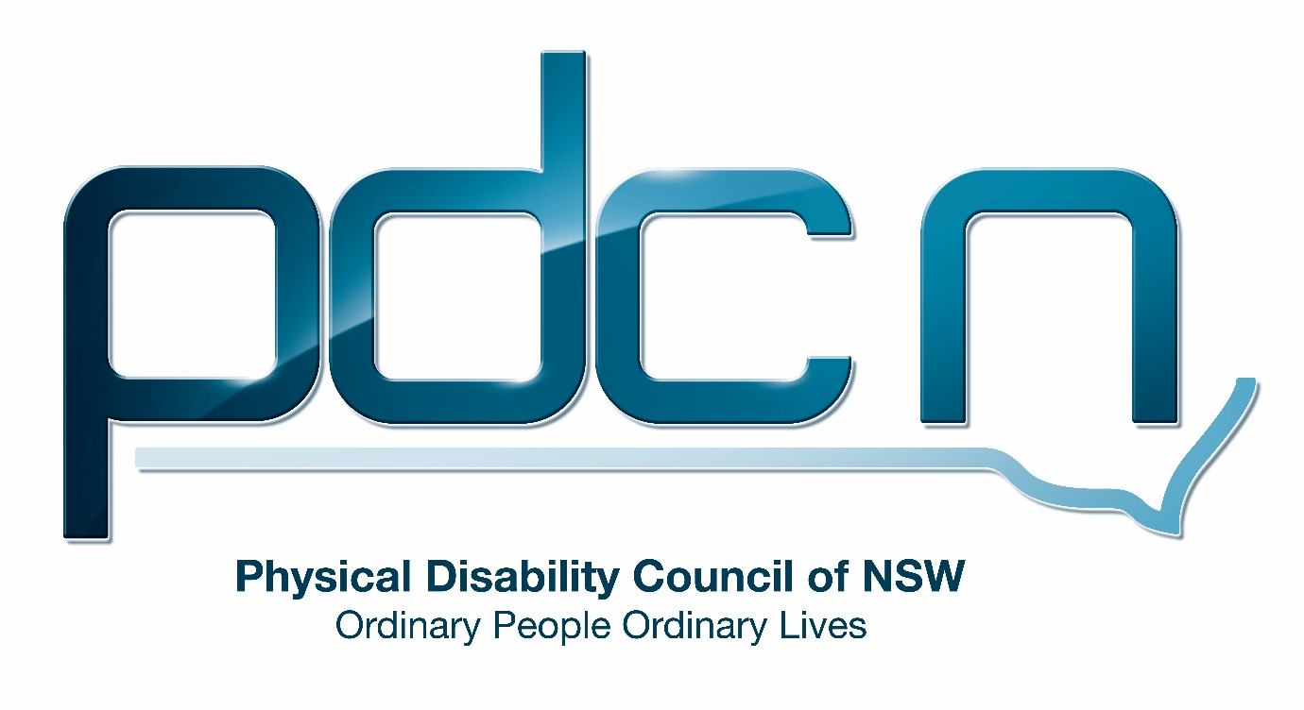

Submission for the Productivity Commission

Review of the National Disability Insurance Scheme (NDIS) Costs

24 March 2017

Serena Ovens

Physical Disability Council of NSW
3/184 Glebe Point Road, Glebe NSW 2037

www.pdcnsw.org.au

Who is the Physical Disability Council of NSW?
The Physical Disability Council of NSW (PDCN) is the peak body representing people with physical disabilities across New South Wales. This includes people with a range of physical disability issues, from young children and their representatives to aged people, who are from a wide range of socio-economic circumstances and live in metropolitan, rural and regional areas of NSW.

Our core function to is influence and advocate for the achievement of systemic change to ensure the rights of all people with a physical disability are improved and upheld.

The objectives of PDCN are:

• To educate, inform and assist people with physical disabilities in NSW about the range of services, structure and programs available that enable their full participation, equality of opportunity and equality of citizenship.
• To develop the capacity of people with physical disability in NSW to identify their own goals, and the confidence to develop a pathway to achieving their goals (ie: self-advocate).
• To educate and inform stakeholders (ie: about the needs of people with a physical disability) so they are able to achieve and maintain full participation, equality of opportunity and equality of citizenship.

Introduction:

PDCN appreciates the opportunity to comment on the commissioned study to review the costs of the National Disability Insurance Scheme (NDIS).

As part of the submission on the costs of the NDIS, PDCN will provide comment on the following issues within the terms of reference:
- Sustainability of scheme costs
  - Planning processes
  - Review processes
  - Transport allowance
  - Advocacy
- Trends in costs and emerging cost pressures
  - Low utilisation rates
- Impact on mainstream services
  - Service readiness
  - Information, Linkages and Capacity Building (ILC)

The following submission will be separated as to reflect the terms of reference above.

It should be noted that many areas of questioning cannot be faithfully addressed as much of the market is too immature, or not yet in place, to allow us to provide an informed opinion.

Sustainability of scheme costs

Planning processes

PDCN has followed several participants from pre-planning to plan implementation and has found that the initial plan being provided to participants are inconsistent in providing reasonable and necessary supports for those individuals. Participants and families who are well prepared for the initial meeting have reported higher success in attaining necessary supports, however not all participants are in a position to complete detailed pre-planning and many are unfamiliar with the change in ideology underpinning the NDIS. As noted in the issues paper:

“For many participants entering the NDIS, the ability to exercise choice and control over the quantity and scope of supports will be a new experience that will provide them with freedom, dignity and a better quality of life. For some, entering the scheme, determining a plan of supports, finding providers, and negotiating services will be daunting and difficult, and perhaps especially for self-managed participants.”

For participants who are not able to prepare extensively prior to their initial NDIS planning session, it is crucial that NDIS planners are able to manage multifaceted conversations about goals, objectives, and aspirations, as well as direct conversations to cover all possible support needs under the NDIS. PDCN acknowledges that this is a complex process that requires a high degree of skill and time to complete adequately.

As noted above, many participants who are less prepared have reported vastly differing success in achieving necessary supports in their initial plan. It is PDCN’s opinion that this is due to: variation in planner competency to direct conversation towards meaningful goals and practical support needs; as well as variation in time/resources allowed to participants during their initial planning.

Regarding time and suitable resources for initial plans, it was noted that ‘for most people, their first plan is completed over the phone’ which for many participants with complex support needs is inadequate. Phone plans to do not allow for participants to be supported simultaneously by carers or other important parties; physical sharing of important resources such as weekly planners or aspirational plans; equal access for peoples with specific communication needs; or allow planners to observe physical cues and surroundings for possible supports or equipment needs. Furthermore, PDCN has had reports from NDIS participants who were excluded from the planning process because a phone plan was created with a carer. This undermines the person-centred approach of the NDIS and personal ownership of participants’ plans.

If initial plans are not covering participants’ support needs sufficiently:

- it places additional strain on the review processes,
- puts pressure on informal care networks,
- reduces the likelihood of capacity building, and
- reduces the likelihood of participants utilising mainstream services.

Recommendation:
1: Review target operating costs for administration and planning to allow for longer planning consultations and additional training for planners. As noted in the issues paper the agency has been set an operating cost target of 7 per cent which is well below usual insurance scheme benchmarks of around 10 per cent.
This amount could be reviewed as the abovementioned issues are related directly to capacity and resources.

2: Increase availability of ‘pre-planning’ services in preparation for subsequent plans in years 2 and onwards, and for new participants entering the scheme.

Review processes

PDCN members and stakeholders have reported that the review process is cumbersome and inflexible. In order to make any changes to plans following the initial planning process, participants must either wait 12 months to add them into subsequent plans or request a review formally through submitting a change of circumstances form. This exacerbates the abovementioned issues in initial plan creation as participants are unable to make modifications to plans without significant effort and long wait times.

As witnessed in the trail sites, package costs are unexpectedly increasing as participants move onto their second and third plans. It is PDCN’s opinion that this may be due to issues in the initial planning process and inflexible review processes which force participants to add missing supports on a 12-month basis. If these review and planning issues are not addressed, participants’ subsequent plans will continue to grow in cost, and may result in ongoing cost overruns.

Additionally, PDCN believes that as the current review process is formal and time-consuming, cost pressures will emerge due to the administration costs associated with plan alteration.

Recommendation:
3: Allow for period of flexibility in early plan stages and simplified processes for review of ‘overlooked support needs’

4: Increase commitment to initial planning to ensure all support needs are adequately covered from the time of the first plan.

Transport allowance

Transport is an essential component of capacity and independence building. Under the NDIS transport costs may increase due to the removal of subsidised rates on community transport and the implementation of other systems which will charge at market rates. The current amount available for NDIS participants for transport is insufficient to cover this increase.

Lack of sufficient funding limits NDIS participants’ ability to engage in mainstream services (such as education and employment) and therefore creates long term strain on NDIS, hindering the NDIA’s goal of independence and participant progress towards exit from the scheme.

Recommendation:
5: That the NDIS monitor funding for transport and adjust the transport allowance accordingly if it is found to be insufficient.

Advocacy

As of 30 June 2018, all NSW funding for disability representative organisations will be transferred to fund the NDIS. The remaining funding under the National Disability Advocacy Program (NDAP) will only be present until August 2017, awaiting outcomes of a review. The future funding of peak bodies and disability representative organisations is uncertain and PDCN believes that this will have a direct impact on the NDIS.

Ongoing modification and growth of the NDIS requires consultation with advisory bodies, which will no longer be funded. This communication of stakeholder needs is essential to pre-emptively address issues before they become significant costs. A key example of this is the advocacy work the PDCN conducted to have adjustable height examination tables made mandatory in all NSW registered GP practices. By making practices more accessible, people with physical disabilities are more likely to seek treatment, subsequently reducing preventable sickness or disease.

Additionally, peak bodies advocate for equality for people with disabilities in all realms, including access to mainstream services. For example, PDCN has been a major advocate for accessible train stations throughout NSW. As more stations become accessible, people with disability are more likely to use public transport, reducing reliance on transport allowances and subsequently reducing costs to the NDIS. Removing this advocacy slows the implementation of accessible policies throughout the NSW community, impeding NDIS participants’ ability to utilise these services.

Specifically, systemic advocacy identifies and addresses issues on a larger scale than what is possible through individual advocacy. For this reason, systemic advocacy is a more cost-effective method of identifying grand scale issues and should be funded to complement the individual advocacy like services afforded within in the NDIS.

Recommendation:
6: Ensure ongoing funding is secured for peak bodies and disability representative organisations.

Trends in costs and emerging cost pressures

Low utilisation rates in trial phase

The issues paper highlighted that utilisation rates for plans have been low, with only 70% of the committed supports being used by participants.

The approach to service provision under the NDIS will be a new and potentially difficult process for many participants to manage. If sufficient support is not given to participants to determine a plan of supports, find providers, and negotiate with services, it is expected that utilisation rates will be low. Under current funding arrangements this support coordination role should be filled by the Local Area Coordinators (LACs). However, as we are currently observing, LACs are already at full capacity onboarding participants into the NDIS, and meeting participant number targets, and are therefore unable to provide enough support to participants to implement their plans.

Additionally, an issue raised by several PDCN members in rural and remote regions, is a lack of locally available services. Participants in remote areas have reported difficulty in sourcing suitable services and skilled workers, restricting the effectiveness and flexibility of NDIS plans. Relatedly, the NDIS should consider the added cost to services when they include significant travel distances. Service providers have less incentive to enter these markets if these additional expenses are not accounted for in NDIS price guidelines.
PDCN acknowledge that the NDIS has set varying price guides for remote and very remote areas to assist with these costs, however it is understood that they then use a guide that would consider an area like Broken Hill to fall into a more metropolitan price line, mean that services providing work to very remote areas such as Wilcannia from Broken Hill are not able to access very remote cost structures to cover the significant travel costs involved.
In many cases this means provision of services costs more than the amount they would be paid, so a decision is made not to offer the service at all.

As noted in the issues paper, low utilisation rates directly effects wellbeing of participants and future scheme costs.

Recommendation:
7: Increase funding to LACs to assist participants to implement plans following initial plan completion or allow for funding within plans for individuals to pay others to assist in plan implementation

8: Greater and more accurate commercial incentives for rural and remote services, such as rates that factor significant travel distances for services in remote areas.

9: Consider innovation centering on employment arrangements in remote areas. As an interim solution where services are not available, the NDIS could consider payment for adequately trained family and carers to provide these services (where this would not be a normal family member duty.)

Impact on mainstream services

Service readiness

A core aim of the NDIS is to build the capacity of individuals to participate with mainstream and community services. As mainstream/community services are expected to see an increase in use by people with a disability, PDCN would emphasise the importance of education in these markets to ensure they are adequately prepared.

Programs focussing on current accessibility resources (i.e. national relay service), appropriate language, and digital accessibility are examples of areas of critical importance to ensure NDIS participants can access mainstream services without disadvantage or added difficulty. Currently, there is no plan in place to ensure these services are prepared for increased interaction with people with a disability.

If mainstream services are not adequately prepared, NDIS participants will be less able to utilise them, placing further strain on the NDIS to cover these areas, and continued dependence on paid supports.

Recommendation:
10: Assist mainstream services to prepare for an increase in use by people with a disability, through mandated education (i.e. inclusion training) and other programs (i.e. development and implementation of disability inclusion action plans).

11: Ensure ILC funds adequately support community and mainstream services to maintain or increase inclusive programs for all people with disability

Information, Linkages and Capacity Building (ILC)

‘The ILC aims to provide a bridging service linking people with or affected by disability to appropriate services, as well as building the capacity of the community and mainstream services to create greater inclusivity and accessibility of people with a disability.’

Under the ILC arrangement, many services that are currently funded to provide support, will be required to lodge an expression of interest for future funding. These initiatives can address community needs for both NDIS funded participants and people with a disability who will not access the NDIS. Currently these services are crucial in assisting community development and increasing engagement with mainstream services.

LACs are expected to cover a range of community development functions, and will receive a large proportion of ILC funding accordingly. However, LACs are not currently fulfilling these functions due to the demands of planning work. The current allocation of funding for the ILC component outside of LAC funds is unlikely to cover all areas of need and could result in significant loss of non-profit organisational services.

If people are not receiving adequate support through ILC programs, cost pressures on the NDIS will increase as people with disability (both NDIS participants and non-participants) will be less likely to utilise mainstream services.

Recommendation:
11: That the level of funds allocated to the ILC outside of that provided to LAC functions, is significantly increased, in order to meet expected demand

National Disability Insurance Scheme (NDIS) Costs – Productivity Commission Issues Paper, Australian Government Productivity Commission (2017)
NDIS Fact Sheet – Developing your First NDIS Plan, NDIS (2016)
Letter to the chair of the Disability Reform Council, 22 December, Bonyhady, B. (2016), IN National Disability Insurance Scheme (NDIS) Costs – Productivity Commission Issues Paper, Australian Government Productivity Commission (2017)
NDIA Annual Report 2015-2016, NDIS (2016)
Quarterly Report to COAG Disability Reform Council 30 September 2016, NDIS (2016)
National Disability Insurance Scheme (NDIS) Costs – Productivity Commission Issues Paper, Australian Government Productivity Commission (2017)
The NDIS and mainstream interfaces fact sheet, NDIS (2014)

