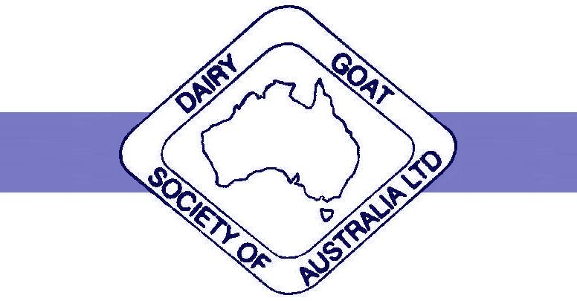
THE DAIRY GOAT SOCIETY OF AUSTRALIA LIMITED
FEDERAL COUNCIL ABN 76 082 302 565
46 Cullinan Rd, BATESFORD VIC 3213 Ph/Fax: 03 5276 1188
ALL COMMUNICATIONS TO BE ADDRESSED TO THE FEDERAL SECRETARY
The Dairy Goat Society of Australia welcomes the draft productivity commission report (http://www.pc.gov.au/inquiries/current/agriculture/draft ) into red tape in agriculture and support the majority of this report. However, we would like to point out some additional problems, and some solutions, below.
Animal Welfare
- Lack of research and development funds for Animal Welfare is an issue for Dairy goats. There is a need for a solution to the production of excess male kids. Hand rearing male dairy breed kids for meat is not economic and staff at abattoirs do not want to kill young kids. Research into an economic method of humane destruction of newborn male kids or research into Artificial insemination using sexed semen to prevent the production of excess male kids is sorely needed. The RIRDC funding available for research for dairy goats has been allocated for Q fever research, which as a zoonotic disease, has priority.
- Access to vet medicines for pain relief for goats is an on-going issue. A major requirement for pain relief is for disbudding and castrating kids. Breeding poll goats is not an option as the poll gene is linked to an intersex gene and the dairy goat industry has recognised it needs a painless method of stopping horn growth. Meloxicam injection has recently been registered for use in cattle, sheep, pigs and horses, but not goats. Meloxicam buccalgesic products are registered for cattle and will soon be registered for sheep, but will not be registered for goats, due to lack of a large enough market. These products can be prescribed by a veterinarian but many vets appear to be reluctant either due to a lack of easily accessible information about the with-holding period (WHP) or due to liability issues.
- In most Australian States the use of sheep medicine “Over the Counter” products such as worm drenches and lice treatments are not permitted in goats. This means that goats suffer from disease unnecessarily due to the lack of treatment options in the majority of Australian states. Please see further below:

- Vet medicines
- The draft paper calls for speedier and more consistent access to agricultural chemicals and veterinary medicines and this is strongly supported.

- Minor use agvet chemicals have been mentioned in this draft report. Minor species such as goats also need access to the full range of veterinary medicines available to the major species, and incentives are needed to encourage their addition to label statements. Once a drug/chemical is registered for use in a major species, then reducing the further data requirements to allow inclusion for minor species such as goats, may help. This would make registration easier and cheaper for minor uses. If laboratories have NATA accreditation and professional oversight e.g. by a university or government department, then this should be enough to ensure the minor use data is valid.

- The report mentions that more use should be made of overseas data in the registration process by the APVMA. This however will be of limited help as other countries have the same problem of a lack of registered veterinary medicines for minor species such as goats. However, New Zealand has similar agricultural systems. If a veterinary medicine has been registered in New Zealand for 5 years and no problems have been identified seriously enough for the veterinary medicine to be under review, then it should automatically be allowed to be registered in Australia or at least imported into Australia directly by veterinarians or for over the counter products, even goat owners directly. Zolvix worm drench has been registered in New Zealand for approx. 5 years and while registered in Australia for sheep, has never been registered for goats in Australia. Yet it is widely used, generally without a veterinary prescription as it can be purchased at any farm supply store by goat owners. This means that these goat owners are under-dosing and is putting the sheep industry at risk, if resistance to Zolvix becomes widespread. In New Zealand the correct dose is on the label for goats i.e. 1.5 times the sheep dose. This would be a good solution to allow currently available medicines to become available quickly to producers, however, it does beg the larger question of why a small country such as New Zealand is able to have such medicines registered, while Australia has not, and whether our industries should be relying on other countries to do the work for us.

- Victorian Control of Use legislation allows the use of sheep medicine “Over the Counter” products such as worm drenches and lice treatments, in goats but most other states do not. This means that goats suffer from disease unnecessarily due to the lack of treatment options in the majority of Australian states. Currently there are only 2 registered products to treat goats for lice (Pestene powder and Clout S, which is difficult to purchase). Neither of these products can be used in milking goats, even with a veterinary prescription, as the labels have “do not use” statements that vets cannot override under current legislation e.g. the Pestene label states “Goats - Milk: Do not use on lactating does where milk or milk products may be used for human consumption.” Again, goat owners must find a vet that is willing to prescribe products from other species and provide a written withholding period using information that is not easily accessible, and therefore often are unwilling to do so, especially for commercial enterprises.

Veterinarians require more support to provide off label prescriptions for goats and other minor species. Other countries have this support already available. While the USA has FARAD, the UK provide “Guidance Notes” documents from the Veterinary Medicines Directorate and this suggests with-holding periods if none is provided i.e. a minimum of 7 days for eggs & milk and 28 days for meat (Guidance Note 13, July 2013).

“Not to be Used in Goats” label statements should only be allowed if there is evidence to support it.
When statements such as “Not to be Used in Goats” or “Not to be Used in Dairy Goats” are added to the label of veterinary medicines, it is generally because the vet medicine company does not wish to do the research needed to obtain the residue data in goats. This is only a commercial decision. By adding these above words to labels, it makes it illegal for vets to use these vet medicines to treat goats, even though these same drugs are recommended in textbooks and used overseas. It would be better to use words such as “no residue data available for goats or dairy goats in Australia” and then the private veterinarian could still use these drugs and recommend with-holding periods from overseas or textbooks with an added safety factor based on their professional knowledge. Do Not Use statements on labels should only be used where there is a real contraindication as very toxic to a particular species. For example, monensin in horses or aspirin in cats are deadly treatments and therefore should have Do Not Use for those species. It is not necessary or even sensible to print DO Not Use, just because the registering company doesn’t want to do the R&D to determine WHP for goats milk and meat.
Vets need to be able to use their discretion and knowledge but to do so medicine companies must stop placing Do Not statements onto labels or vets must be given the legal ability to over-ride these Do Not statements.

Worm drenches
The paraboss website (www.wormboss.com.au ) recommends that all new sheep introductions be drenched with drenched with worms drenches from four different drench families, including one of the two new worm drenches ( Zolvix and Startect). However the only worm drenches registered for goats are from 2 families (plus a small paste product only suitable for 1 or 2 pet goats). Neither of the two new worm drenches are registered for goats. This puts goat farms at serious risk of introducing drench resistant worms when they purchase goats.
The paraboss website also recommends using combination drenches, yet again none are registered for goats. One drench family, levamisole or the clear drench, has no products registered for goats in Australia. However both the British Goat Veterinary Society (http://www.goatvetsoc.co.uk ) and the American Consortium for Small Ruminant Parasite Control (www.wormx.info ) recommend its use, and at a higher dose rate than sheep. Similarly many liver fluke drenches are not registered for goats reducing the rotation options, which will eventually lead to drench resistance.
Most goat owners already use sheep worms drenches and this is leading to resistance as they are not using them with a veterinarian’s prescription and hence not at the correct dose rates. Goats metabolize these drenches at a faster rate and need between 1.5 times to double the sheep dose rate.

