Emerg Solutions Pty Ltd response to Australian Productivity Commission’s “Public Safety Mobile Broadband” Issues Paper.
Summary
This submission will demonstrate how the deployment of the Public Safety Mobile Broadband would be beneficial to end-users in the field who are increasingly relying on mobile technology to receive information and provide situational awareness.
We will be relaying information pertaining to our Incident Turnout Management System BART from the view of an interested party who can show that Emergency services in Australia are already open to using Smartphones to receive information.
Reliability of the existing public data networks currently prevents this technology from being utilised as mission critical infrastructure and the extension of this to public safety related Applications would make this an even more viable option providing increased data reliability.
In respect to sustainability of arrangements, our solution works off a BYOD principle, and we continue to offer support to emerging devices, easier to stay on top of technology.
BART Background
Over the past three years Emerg Solutions Pty Ltd with input from Victorian Emergency Services Volunteers has developed an Incident Turnout System called BART (Broadcast Alert Response Technology).
The BART solution is an example of how the PSMB could be used to assist Emergency Services Personnel on the ground in their respective communities. A video on BART can be viewed on YouTube https://www.youtube.com/watch?v=EM-vMwJLPKs.
BART is a multi-device (Smartphone, tablet and desktop) solution that provides a vital link for all volunteers to important data sources and communication streams.
There are currently over 11,600 members in over 1050 brigades, units, branches and groups utilising this service, across CFA, SES, AVCG, AV & DELWP. Demonstrating the need for more reliability of data in this area.
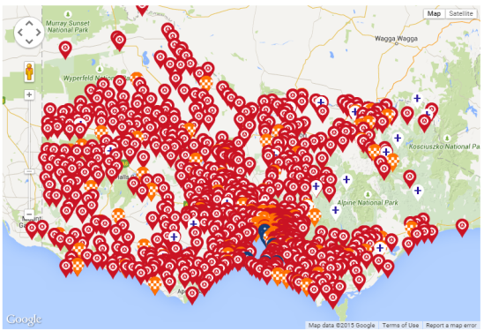

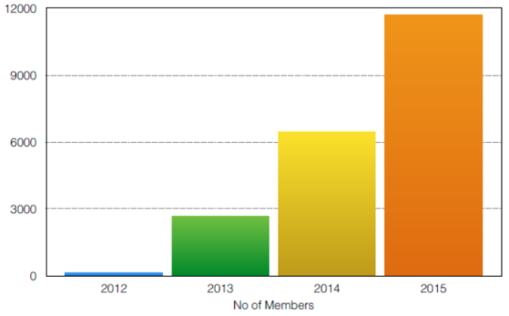

Member Survey
From the survey conducted in May 2015 the key findings were:
- BART is a major benefit to local volunteers.
- Turnout times have e improved by 1-10 times
- More volunteers were responding due to the use of BART
The results of this survey clearly provide evidence and support our views that Emergency Services Personal are looking to utilise mobile technologies in the field and will benefit from the potential for the PSMB, following is an overview of the survey results, the attached appendices include full results including related member comments.
Question 1
How important is BART to your brigade, unit or branch?
99% of our survey participants reported that BART was important to their brigade, unit or team.
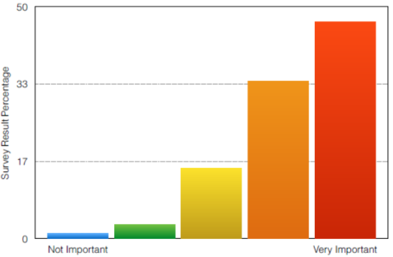

Question 2
Do you know of an instance/s where BART has helped to save property or lives?
25% of our survey participants responded YES.
Question 3
Has BART made life easier for organising crews or training?
70% of our survey participants responded YES.
Question 4
Has BART helped to improve turnout times?
55% of our survey participants said YES.
Question 5
Of these that said yes, the following time savings were recorded.

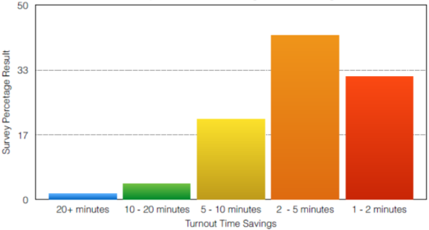
Question 6
Do you believe BART will improve team work and participation?
97% of our survey participants reported that BART improved team work and participation.

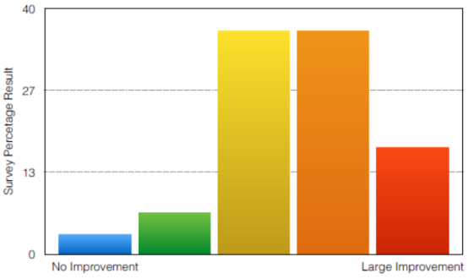
Question 7
Do you believe BART will improve participation by the younger generation?
38% of our survey participants responded YES.
Question 8
Do you believe BART will increase the number of volunteers in your brigade?
28% of our survey participants responded YES.
Question 9
Do you believe BART will improve participation by the older generation?
25% of our survey participants responded YES.
Question 10
Has BART increased the number of members that turn out to an incident?
50% of our survey participants responded YES.

