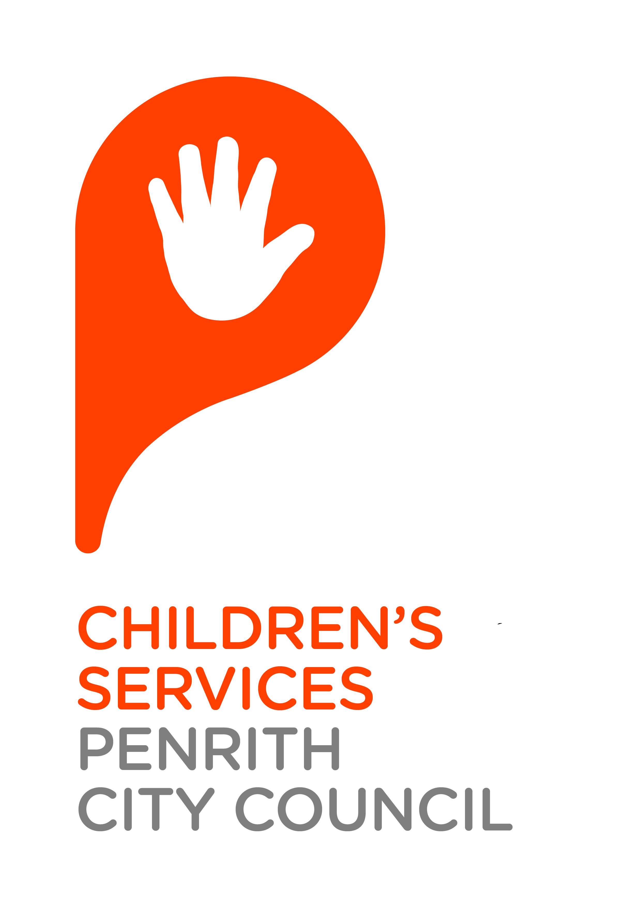

**SUBMISSION ON THE DRAFT REPORT   
OF THE PRODUCTIVITY COMMISSION ENQUIRY INTO CHILDCARE AND EARLY CHILDHOOD LEARNING**

**September 2014**

**INTRODUCTION**

Penrith City Council, as a Local Government body, has embraced the establishment of children’s services in the Penrith Local Government Area (LGA) since the 1970s and currently directly provides the following not-for-profit services and programs.

* 18 Long Day Care services
* 5 Preschool services
* 9 Before and After School Care services
* 6 Vacation Care services
* 1 Occasional Care service

In addition, Penrith City Council also provides:

* 1 Mobile Playvan service
* 1 SAACS project (Supporting Aboriginal Access to Children’s Services)
* 1 Child Care Links/Family Support project

In 2000, Council adopted a ‘Statement of Purpose for Children and Families’ which states that “Penrith City Council believes that quality early childhood experiences have a profound and lasting impact on outcomes for children and their potential to develop into the citizens who will form the social capital of the community of Penrith. Council is committed to the provision of children’s services programs for the benefit of families and children across the City. Council itself will plan and provide quality services and support and work in partnership with others to do so”. This Statement reflects Council’s acknowledgement of the role of quality early childhood experiences in the lives of families and children.

In 2002, Council delegated authority to the Penrith City Children’s Services Cooperative Ltd. (PCCSC), to manage children’s services on its behalf. The Board of the Co-operative consists of parent, staff, community and Councillor representatives and a representative of the General Manager. With key objectives to retain parent and community involvement, developing an efficient and economic management structure was critical to maintaining quality and sustainable children’s services. This management model of children’s services has served Council well since its inception.

As an experienced manager of not-for-profit children’s services, the PCCSC is well placed to make a submission to the Draft Report of the Productivity Commission Enquiry into Childcare and Early Childhood Learning.

# **SUBMISSION**

The Commission is to be commended on the following:

* Creation of the ECLS which will make accessing child care subsidies and benefits less complex for families and providers.
* The provision of 100 per cent subsidy for ECEC and up to 100 hours per fortnight of care without an activity test for children who are assessed as ‘at risk’ which will ensure that vulnerable children can access services when needed.
* Extending the scope of the NQF to include all services that receive Australian Government assistance which will provide consistency of service provision.
* Diverting funding from the Paid Parental Leave Scheme into ECEC.
* Requiring funded nannies to have a Certificate III and operate within the scope of the NQF.
* Introducing a National Working With Children Check.

**draft recommendation 12.4**

* The use of a national hourly deemed cost of care will disadvantage families in NSW. The cost of providing care in NSW is higher due to a number of factors including higher land costs, long standing higher qualification and ratio requirements, transport etc. A suggested cost of $7.53 per hour does not reflect the current cost of providing care in NSW. Families will therefore have a gap fee to pay to cover the true cost of providing care, making care more expensive for families in this state.
* Capping support for families to 100 hours per fortnight will not cover the number of hours many of our services currently operate for. This will mean that families attending services that operate for more than 100 hours per fortnight will have to pay a gap fee that is not covered by subsidies and this will make care more expensive for families. Alternatively services may decide to limit their opening hours to 100 hours per fortnight to ensure that all the hours they provide care are eligible for the subsidy. This will have the effect of making services less responsive to the needs of families.
* The proposed activity test of 24 hours of work/study/training per fortnight will exclude some children from access to early education and care. It should be the right of each child to access quality ECEC.

**information request 12.1**

* Currently. families receive an increase in subsidies dependent upon how many children they have enrolled in an approved early childhood centre. This offsets some of the costs to families with more than one child and supports the workplace participation of parents. Our experience is that when parents have more than one child, this is often when they withdraw from ECEC services and reduce hours in the workplace due to increased costs.

**information request 12.3**

A number of families access our services who would not meet the activity test but whose children benefit greatly from participation in an ECEC service. We would support families having choice and equity of access for all children to ECEC services.

**information request 12.5**

* Grandparents who have custody of their grandchildren and who meet the current means test receive free access to childcare. At any time we have a number of families in these circumstances attending our services. We believe that deferring custody of grandchildren to their grandparents when needed is necessary to ensure the health and safety of vulnerable children however, it seems unlikely that ageing grandparents on limited incomes would have the capacity to adequately provide for the health and safety of the children without the support of early childhood services and that these services would be inaccessible to many grandparents if they involved a cost. The removal of the 100% subsidy from grandparents could have the effect of forcing more vulnerable children into the welfare system and increase the costs associated with their support.

**Case Study:** At one of our services we have a grandmother who lives in public housing and who is caring for her five grandchildren. Custody of the children was given to the grandmother as the mother had drug addiction problems and was no longer considered suitable by authorities to have care of her children. The grandmother is currently not able to work due to an injury at work and lives on a reduced income from workers compensation. The grandmother would not be in a financial position to access care without free access to our service.

**draft Recommendation 8.3**

Our experience is that not for profit services who are responsive to the needs of the community offer longer hours of care at greater costs, e.g. staffing. These services are often accommodating families who travel to work and require extended hours of ECEC, children with additional needs and children aged 0-2 years of age to a greater extent than some for profit providers. There should be some recognition and incentive for these not for profit providers to continue to be responsive to the community rather than being motivated solely by profit.

**Draft Recommendation 8.5**

* This recommendation would allow nannies to operate within the NQS in a similar way to family day care providers. However, family day care providers are supported by schemes in their daily operation ensuring they comply with regulatory and NQS requirements. The provision to allow nannies eligibility for ECLS as long as they meet the NQS neglects to consider the complexity of this type of service provision without the support and oversight of an approved provider. This would also greatly increase the number of services that regulatory authorities have oversight over (they would have oversight of every nanny instead of a support body) and would dilute the capacity of the authority to adequately oversee and support all services in their jurisdiction.
* If this recommendation is adopted, nannies should be linked to an approved provider to ensure high quality service provision and to ensure they are supported to achieve quality outcomes for children.

**draft recommendation 12.6**

* There is empirical evidence that not for profit services provide more education and care for children with additional needs.
* The cost for providing quality care and education for children with complex needs is not supported with the current funding models. The ISS, ISP and SCAN funding models do not provide the true cost for children accessing care and education in ECEC services that require intensive support. The limit of 5 hours of support per individual or 8 hours for shared care does not assist services where children with complex needs require up to 11 hours of care per day. This system needs to look more closely at the needs of the child and the true cost of care to ensure children are supported for the entire number of hours they require access to care and education.
* Not for profit services have identified increasing numbers of children accessing services with complex undiagnosed needs. Services require trained educators with the skills to respond to the needs of these children and support families to access family support and referral pathways to specialists in a timely manner.

**information request 12.8**

* Our experience is that many children enter ECEC services with no diagnosis, however have complex needs. The services that are required from both an ECEC service and family perspective need to enable families to access services that can provide formal assessments in a variety of settings- such as the ECEC service, after hours in the family home, etc. Many services currently provide some level of support however they do not provide formal assessments or cover the cost associated with obtaining an assessment. Families need flexibility and the opportunity to have assessments completed with the support of ECEC services.
* Funding should be based on each child’s level of need and hours they require access to ECEC services, the block amounts do not cover the actual hours required and therefore will limit the hours children with additional needs will be able to access care and education. Services are currently covering this additional cost. PCC services receive funding through ISP, ISS and SCAN to support the inclusion of children with additional needs. The amount currently received provides around 70% of the funds required to provide the quality care and education required for children with varying additional needs.
* As a direct provider of ECEC services, during the last financial year, the additional costs for this organisation of including children with additional needs is in the order of $150,000 – this is primarily the cost of employing additional staff in order to meet the gap between external funding received (ISS, ISP, SCAN) and the actual cost of employing additional staff.

**information request 8.1**

* The barriers faced by families and ECEC services is around the funding provided to access services, families are often financially vulnerable and the cost of care can be too excessive for families on top of therapy needs.
* The cost for providing quality care and education for children with additional needs varies depending on the needs of the child. Children with complex needs may require one on one support to ensure they can fully participate in a program. As mentioned previously the current funding models do not cover the true cost and are capped on a certain number of hours or a block with no flexibility for extending hours or services.
* Many families need respite care in school holidays as well as care and education when they are working. The current funding model is not enough to cover the hours working parents require.

**information request 12.9**

* The AEDC (Australian Early Development Census) is one way to allocate funds based on levels of vulnerability. In our experience, there is a definite correlation with ECEC services operating in communities identified in the AEDC as vulnerable, having greater numbers of vulnerable children and families enrolled. However, there are more families and children presenting with complex issues in areas not identified through the AEDC. To address this ECEC services and families need access to quality parenting programs that have long term benefits. Funding to provide these programs to build the capacity of educators to identify and support families in the early years is essential in these areas.
* The SEIFA (Social-economic indexes for areas) is a tool used to identify areas that have higher levels of vulnerability. In the experience of Penrith City Council services this is evident in a number of areas that are not identified through this tool. Services need to be able to access programs that focus on early intervention for families and children experiencing vulnerability through mainstream services. One stop services and “hubs” are essential for families. Educators at ECEC services build trusting relationships with parents and carers and this model best supports families. Educators require training to build on their skills to respond to family needs and have services on hand to engage with families- such as PCC Childcare Links program, where a family support specialist is at the service regularly to assist families in crisis or experiencing challenge.

**information request 8.2**

* Integrated services are required to ensure families that are working can access the services they need- “a one stop drop” is required to support families. Currently ECEC services are providing some integrated services with very positive outcomes for families. The Childcare Links program at Penrith City Council Children’s Services is an example of how this has been effective in meeting the needs of families in vulnerable communities. The funding for this project is finishing at the end of 2014. The program outcomes have enabled PCC services to work collaboratively with a range of family support services and allied health services to provide targeted programs in vulnerable communities, building the capacity of educators and families in these areas.

**draft recommendation 12.9**

CASE STUDY: Glenmore Park Child and Family Centre is an integrated child and family service with an early childhood and care centre and professional rooms which are leased by a range of services. One of the four year old boys who attends the service has a diagnosis of autism. He attends a KU Starting Points Playgroup and Play Therapy which are offered in the professional rooms at the service. These services are targeted therapies to support his learning and development. His mother is pregnant and attends the Hospital Antenatal Clinic in another of the professional rooms. Both parents work full time and the ability to access services in the one place supports them to do this. In addition the early childhood service and the professional therapists have opportunities to discuss the child’s learning and development and strategies to support him which has positive effects on his learning and his inclusion.

The funding for preschools should not be incorporated into school funding. Preschool education funding should be allocated separately so the funding flows to preschool services.

**draft Recommendation 7.9**

This draft recommendation is not supported. Separating out care and education does not work. It has taken many years to include dedicated preschools within the scope of a quality framework and to remove them now would undermine the work undertaken by the sector in recent years to bring them within scope. This draft recommendation supports two tiers of early education, those within the NQF and those outside of it.

* The separation of preschool from long day care services will create a break between care and education for children over three years. As early childhood professionals we understand that in early childhood these concepts are not separable. Children learn in environments where their needs for care are met and children who feel comfortable and confident learn better.
* Early childhood is a time of rapid growth and development and there is a considerable body of knowledge that supports our understandings not only that early childhood is a critical time for learning but also that this learning occurs differently than it does in older children. In early childhood, learning occurs within relationships of care and within environments that provide hands on and self directed learning. Imposing curriculum expectations upon children in early childhood that are prescriptive run the risk of undermining children’s capacities to form broad understandings. There is a risk that preschools operating only within the education sector will result in a push down of curriculum due to:
* It is likely that preschools in school settings will have less than 25 children attending and so will have no requirement for an early childhood teacher. This could result in preschool services being delivered by educators with little formal training (Cert III) who will likely be guided by the expectations of the primary teachers they work with rather than by early childhood expertise.
* The Early Years Learning Framework is a comprehensive document developed to support educators working within early childhood settings. Interpreting and implementing the document requires the expertise of an early childhood teacher. In the absence of this expertise educators may make curriculum choices more reflective of primary curriculum.

**Information request 5.1**

* State funded preschool services generally provide care and education for 6 hours per day. The 15 hours per week does not fit into the current model - 15 hours equates to two and a half days. The hours and funding should be extended to 18 hours to cover 3 days of education prior to school. Children leave preschool services and then attend school 5 days per week. The investment in quality education programs prior to school entry has been well documented as a cost saving for governments in the long term.
* Six hours of attendance in a preschool day in NSW is equivalent to a school day so prepares children for transition to this environment.

**draft Recommendation 5.1**

This draft recommendation does not reflect parental choice and individual circumstances and is unfairly punitive in some areas in NSW where there is an undersupply of services providing preschool education. In the Penrith LGA there is an oversupply of services providing education and care for children aged 3-6 years.

**draft Recommendation 7.4**

* Changing ratio requirements for OSH services in line with the ratios currently acceptable for children during school hours is flawed as it fails to take into consideration the complexity of OSH services that require lower staff to child ratios such as:
* OSH services provide care for children from multiple age groups including children who have just commenced school (4½ in NSW) and children who are almost ready to transition to high school (12½ in NSW). This diversity makes meeting the needs of all children more complex, and can have a particular effect on the health and safety risks to children. Lower ratios are required to ensure all children’s needs are met.
* OSH services frequently provide care to a larger number of children with challenging behaviours and disabilities than primary classrooms as children who attend OSH are drawn from across the school, from a variety of schools and from schools dedicated to supporting children with profound disabilities. Children with additional needs are often more likely to require OSH care as a result of their disability, e.g. less independent.
* OSH services provide a recreational program that means they are not confined to classrooms or small spaces for extended parts of the program. It would not be appropriate to confine the children in this way in OSH services, particularly in after school care as the children have just finished a school day where they have been primarily in classrooms. The nature of these types of programs require more staff to support and supervise children.

**draft recommendation 8.1**

This draft recommendation is not supported. It would not guarantee the provision of quality of care to children of preschool age with the absence of ratio and qualification requirements specifically designed for preschool children in a mixed age setting. Out of school hours care services are specifically that and do not have the capacity to deliver care to large numbers of preschool children.

**DRAFT Recommendation 8.2**

This requires a planning model. Simply directing all schools to take responsibility for organising outside school hours care for their students will not work without planning as to where those services are required.

**Draft recommendation 9.1**

This recommendation is not supported. Families using community based/not for profit preschools in NSW need ongoing access to registered care CCB as this is the only means of reducing the high cost of preschool education in NSW. Preschool fees in NSW are exceptionally high compared to other states and territories and the removal of this small benefit would disproportionately impact NSW families using this service type.

**DRaft Finding 6.5**

* Planning ECEC service provision wholly around workforce participation is short-sighted and overlooks the value of ECEC in contributing to the education of children from birth and the return on this investment in the longer term.

**draft Recommendation 7.1**

* The National Quality Standard was developed through a complex process of consultation with the sector and with early childhood professionals. The range of elements and standards contained within it are reflective of the priorities of the profession and they should not be altered or minimised.
* Consideration for how OSH services document their programs, if reviewed, should include guidance on how they demonstrate they are meeting recreational outcomes.
* There should be no consideration of removal or alteration to the standards or elements until all services have been assessed and rated. It would not be equitable at this stage to assess services under differing setting as some services had not yet been assessed.

**draft Recommendation 7.2**

* The Certificate III course is designed to train people to support others in that work, not to take leadership or full responsibility. The lack of educators with specialist training in educating children birth to 36 months is problematic because:
* They are the most vulnerable group of children due to their age and they require the best of educators to ensure their needs are met.
* The developmental differences between children in this age group (range from a few weeks old to three years) mean that a high level of expertise is required to ensure that programs are offered that are responsive to the very different needs of each child. In the majority of our services children 0-3 are placed in groups that include children under two years or children under three years.
* These developmental differences also create challenges for educators as programs are often offered in the same room. This can create significant challenges for educators particularly in relation to health and safety. (While the provision of care for an infant can be very effective when offered by a parent, grandmother or other person, they are not challenged to provide care in complex and changing group environments).
* These years are critical for the development of a wide range of skills such as walking and talking and also lay the ground work for skills that will be developed later. Educators who do not have the skill, expertise or training to ensure the developmental needs of this age group are met in a challenging environment risk the child’s overall development. This age is a time that is particularly critical for brain development. Children in this age group need high quality responsive care.
* The identification of delays in children’s development is complex and often becomes evident in these early years when children are placed into group environments. This identification requires the expertise of educators who have significant training in early childhood.
* Children with diagnosed disabilities or with delays in development in this age group are at a critical time and require expertise to support their learning and development. It requires the expertise of educators who have significant training in early childhood to identify problems, implement programs provided by specialist services and to include these children.
* The draft recommendation that the number of children for which an early childhood teacher must be employed is assessed on the basis of the number of children in a service aged over 36 months is not supported. In NSW it is common for services to be 39 or 40 place due to our historical ECT requirements. This means that many services could adjust their enrolment across the service, slightly reducing their enrolments in the 3-6 group, so they would not require an ECT at the service. This has the potential to have an enormous impact on the early childhood teacher profession and the quality of care provided in the setting. If the recommendation to reduce the training required to Certificate III for children 0-3 is adopted these services would not have an ECT working with children 3-6 and would not have an ECT to support and guide the practice of educators working with children 0-3.

For example, Blue Emu Children’s Centre is approved to provide care for 40 children, at the moment they provide care to 25 children 3-6 and 15 children 0-3. Blue Emu could adjust their enrolments across the service so they provide care to 24 children 3-6 and 16 children 0-3 (without changes to the numbers of educators required). Under this recommendation this service would not need an early childhood teacher to meet the regulation as they are offering care to only 24 children 3-6.

**Information request 7.1**

Expected impacts on the development of children under 36 months being educated and cared for by educators with non degree qualifications puts the very development of children in this age range at risk for the reasons outlined above. Babies need high, if not higher access to quality early education and early childhood teachers.

**draft Recommendation 7.3**

This draft recommendation is not supported. Historically, NSW has higher level and better regulatory requirements for education and care than other states and territories. These should not be watered down for national consistency.

**draft REcommendation 7.5**

The requirement for employing staff with or working towards a qualification should not be removed in NSW. Services in NSW should not be able to operate without meeting required ratio and qualification requirements at all times. Using this model could place children at significant risk, for example, there could be a day when staff are absent and not replaced and the staff to child ratio is significantly higher than the Regulation.

**draft Recommendation 7.6**

* The design of the assessment and ratings system should remain intact, at least until such time that all eligible services have been assessed and rated for the first time. Government and ACECQA should ensure that the required resources are available to re-assess services rated as ‘working towards’ the standard in a reasonable timeframe (of say 18 months) to enable those services to demonstrate continual improvement and be rated as ‘meeting’ the standard.
* There is support to abolish the ‘excellent’ rating.

**Draft recommendation 7.11**

There has been much discussion over many years in relation to planning for ECEC services. In the Penrith LGA, there is an oversupply in some communities of ECEC services. For example, in the Cranebrook community two ECEC services have a shared back fence. In the Penrith CBD, two services operate next door to each other. Whilst some for-profit services are approved to provide places for 0-3 year olds, some do not do so in practice. An integrated planning system, rather than a purely market driven approach, would help in addressing under supply and over supply issues.

**draft REcommendation 11.1**

This draft recommendation is strongly supported. The high quality standards in the delivery of ECEC related training should include a reasonable component of centre based practicum experience especially across the birth to six years of age group.

