FLEXIBLE IN-HOME CHILDCARE (IHC) SHARE PILOT PLAN
Background:
The very large response to the Productivity Commission (PC) Inquiry into Early Childhood indicates an enthusiasm for outcomes and answers to the questions being asked regarding Early Childhood Education and Care namely flexibility and affordability.
Parents, childcare providers, business/industry groups and academics have responded with more than 1133 submissions and comments, and we anxiously await the PC draft report in early July and the final report to Government on 31 October, 2014. However, in an effort to progress possible outcomes, NICA believes this would be a good time to submit a proposal for a fixed term Flexible IHC Pilot Plan to be run under the existing In-Home Child scheme administered by the Federal Government.
We understand the Government won’t be making any major decisions until the PC hand down their report in October. However, we believe such an initiative will send positive signals to families that the Government is not standing still, but is intent to find the right solutions for families. We therefore submit this for your consideration.
In 2013, the former Gillard Government put in place a trial of flexible childcare for emergency shift workers, a trial that has been judged as a failure with as few as one-fifth of the 500 families targeted in the trial actually participating. While NICA made representations to the then government to include IHC in the trial we believe it failed as they chose a mix of FDC and LDC, and ignored the solution families are asking for and that is an uncapped and extended IHC programme.
A recent Departmental Report noted that some families could not afford to pay for more childcare, while others wanted to use only after-hours on an ad-hoc basis, there was also an incompatibility between when extra care was available and when families needed that care and where the care providers were based. In other words the Flexibility Trial was not flexible at all.
The PORSE programme in New Zealand provides families with three strands of home-based care. The first being home based child care in the home of the educator (FDC), the second being home based care in the home of the child (IHC), and the third being home based care in the home of the child where more than one family shares the services of the educator. Currently this system of home based care enjoys 38 per cent of the NZ Early Childhood space. Some families are using a combination of home-based care whether in the family home or the home of the educator.
A recent report by the Australian National University based on four waves of longitudinal data over six years found ‘significant’ negative academic outcome for pre-schoolers who attend an average of more than four hours a day at childcare centres.
Once they crossed the 21 hour-a-week threshold, children were found to have more trouble adjusting to school. This type of research re-enforces the value of IHC for many children.
While NICA has provided a submission to the Productivity Commission for an uncapped and extended IHC with three streams of care, a recent visit to PORSE in New Zealand has re-enforced my view that a flexible IHC Share option could be a part of a real solution in a suite of early childhood options for families.
In NZ Nanny Share is when one educator provides childcare for two or more families with around four children, the care can be provided in either home and can alternate between the two or more families i.e. whatever works best for the children the educator and the parents and their associated work commitments. Importantly this works under one umbrella parent agreement.
Flexible IHC Share Plan V Family Day Care
Both types of care provide a solution for families. The most obvious advantage of an IHC educator is that the children in care will receive a very high staff to child ratio (in fact as set out it currently exceeds the NQS), and parents are able to share the fees making the cost after CCB and CCR comparable to or in some cases cheaper than long day care. Additionally, the IHC Educator can offer more flexible hours than FDC including overnight care and on demand changes if parents need to travel for work or work after hours or on weekend’s requirements. In addition, unlike FDC the IHC Provider will be responsible for providing a back-up educator in time of illness or family emergency.
Flexible IHC Share Pilot Plan
It is my belief there is approximately between 400 to 500 IHC unallocated IHC places that may be available within the Department in Canberra and are currently funded but not allocated to an IHC service provider. These places could be allocated to registered IHC providers who choose to take part in the pilot plan.
We would suggest the Department would invite Expressions of Interest to experienced IHC providers interested in taking part and committing to such a pilot plan in each of these states. The pilots could work under the current and established IHC National Standards 2008, with a small modification to allow more flexibility in accessing care under the pilot plan.
The selected IHC providers would be responsible for matching educators and families that will work best with children of similar ages, interests and families with a similar working hours and living close by for convenient drop-off and pick-ups.
The successful IHC providers will provide a suitably qualified Programme Co-ordinator who would have responsibility for working with the families and the educators. The NZ experience shows us that the sharing of care not only works well with families who enjoy good communications and where children can interact with children of the same age, but when established is a viable flexible and quality alternative for parents should they so choose.
The IHC Educator will be responsible for providing an Early Childhood programme for the care of the children, and will be required to undergo a working with children police check full and hold current first aid certificates.

Sharing a Flexible IHC Educator – how it will work?
A Flexible IHC Educator share pilot will appeal to parents as it will allow each parent to hire a qualified educator at a lower fee rate, it will also offer contact with other local children who enjoy the same activities and similar needs. The following steps will need to be put in place:
- Department to invite Expressions of Interest to registered/licenced IHC Providers interested in participating in the pilot plan;
- Successful IHC Providers will put in place a to promote the pilot plan i.e. online media/advertising;
- Pilot plan will be an extension of the current Government IHC plan and as such will operate under the current IHC National Standards, with the exception of the eligibility criteria that will allow the service to be more available to families;
- Families and Educator to sign one umbrella agreement/contract;
- IHC providers will have an emergency contact person available after hours for use of parents and educators;
- Families will be able to register interest on line by completing their family profile to be matched with another like-minded family and educator;
- Neighbour families, work colleagues or close friends could apply together to participate in the share pilot;
- Educator and the family will be overseen by a qualified Programme Co-ordinator who will maintain regular contact with the families and educators, both through a schedule of regular visitation and via phone and email communications;
- Educator activities will be strictly limited to the care, play and education of the children, and will not be available for other household chores;
- The Programme Co-ordinator will arrange meetings with like-minded families looking to share an educator in the same local area to establish the compatibility of the families;
- All educators will be interviewed, and will undergo a full background check and an experienced and qualified programme co-ordinator will oversee the pilot plans;
- IHC providers will have the responsibility to organise a back-up educator where possible for the family in case of illness or family emergency;
- Programme Co-ordinators and educators providing care for families will ensure they agree on parenting philosophy i.e. approach to discipline, ages, dietary requirements, and planning for a well-rounded day of activities for the children;
- Care will primarily be provided in one home or be divided between two households depending on families schedule and suitability. The educator with put in place an exact schedule that will include some sit-down time with parents and educators to ensure for good communications;
- The pilot will be monitored for success or otherwise by Departmental officials

Flexible IHC Share Costing’s
Many families, especially mothers are finding the cost of getting back in the workforce, especially with more than one child is just not affordable. The average cost of long day-care in NSW is around $81.50 a day and can be as high as $102.16 in Sydney’s northern beaches and $111.20 a day in Sydney’s Eastern Suburbs. A basic calculation at the lower average for two children would be $163 a day, $815 a week.
Sharing an IHC Educator can be a cost effective way to get flexible, consistent and high quality care in an in-home environment. We believe that such a Flexible IHC Share arrangement can be achieved at a more affordable cost to the family budget for families who are able to claim the CCR and for those eligible for both the CCR and CCB.
This is a plan that can provide families with the flexibility and stability of care they crave for the families within a percentage ranges of the cost of LDC, but with more convenient and less stressful environment for families.
Our calculations indicate that families on an income of $80,000 a year who are eligible to claim both the CCR and the CCB, may enter into a shared care arrangement with as little as a 9 percent cost at night or 12 percent during the days to the family budget. These calculations are only intended to be indicative and are based on the best information available at the time of making them, but are not intended to be used as a finite resource, rather an indicative measure to inform broad policy direction.
The educators may be employed by the IHC providers as indicated in the tables below that also allow for the cost of administration, superannuation, and payroll tax and workers compensation for the IHC educators who will be employees. However, estimations may vary slightly where educators are self-employed.
It’s interesting to note that families using IHC pay for only the care they receive as opposed to long day care that fees are based on a 12 hour day whether the family uses it or not.

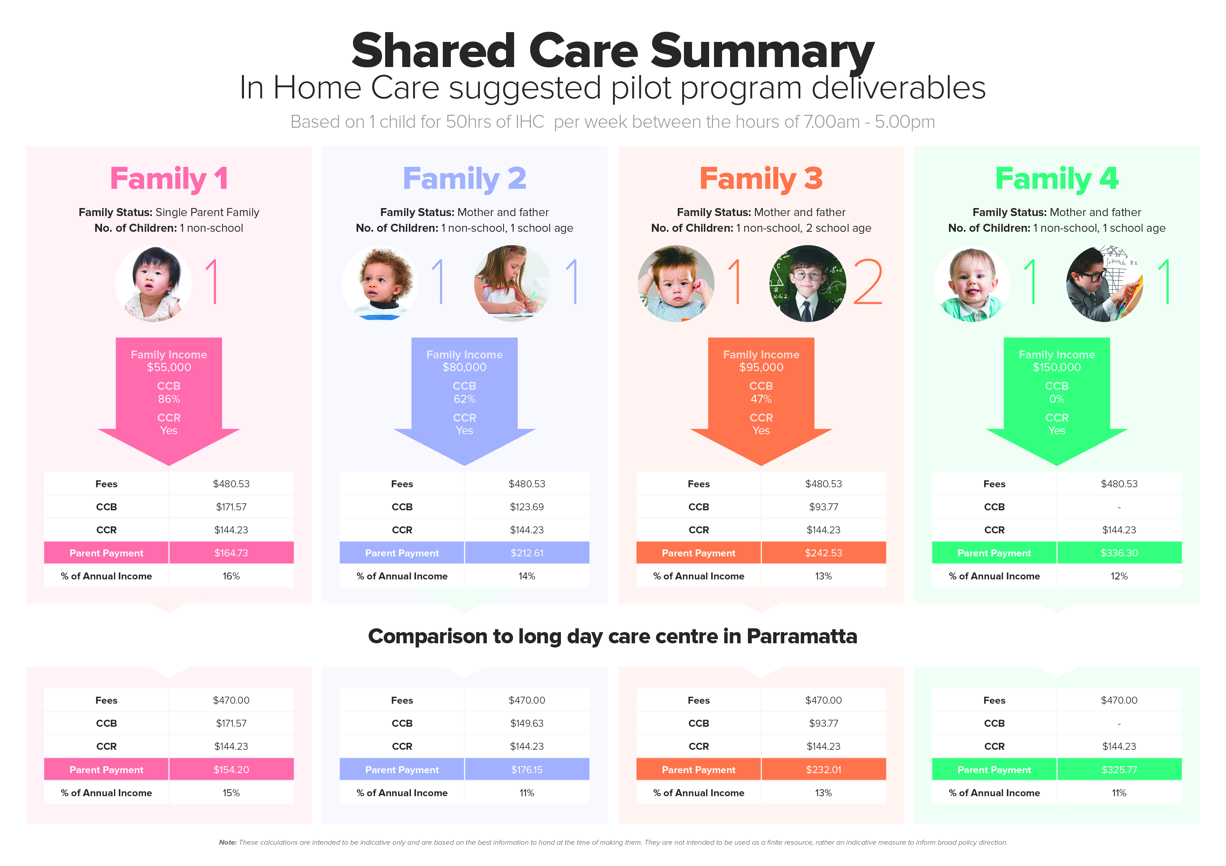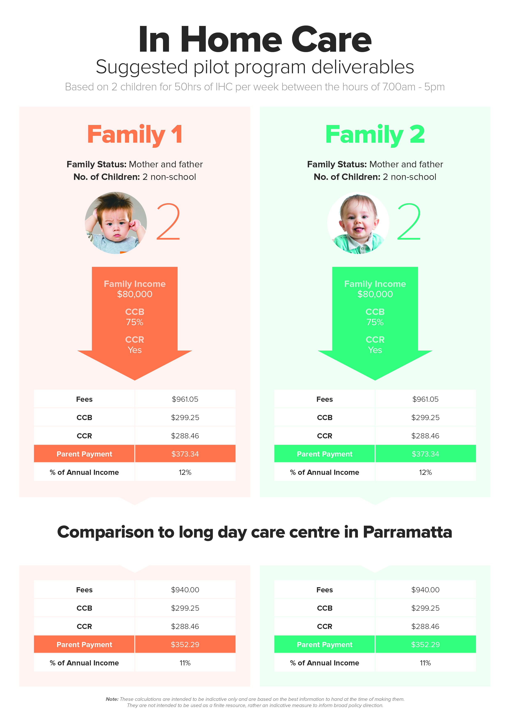

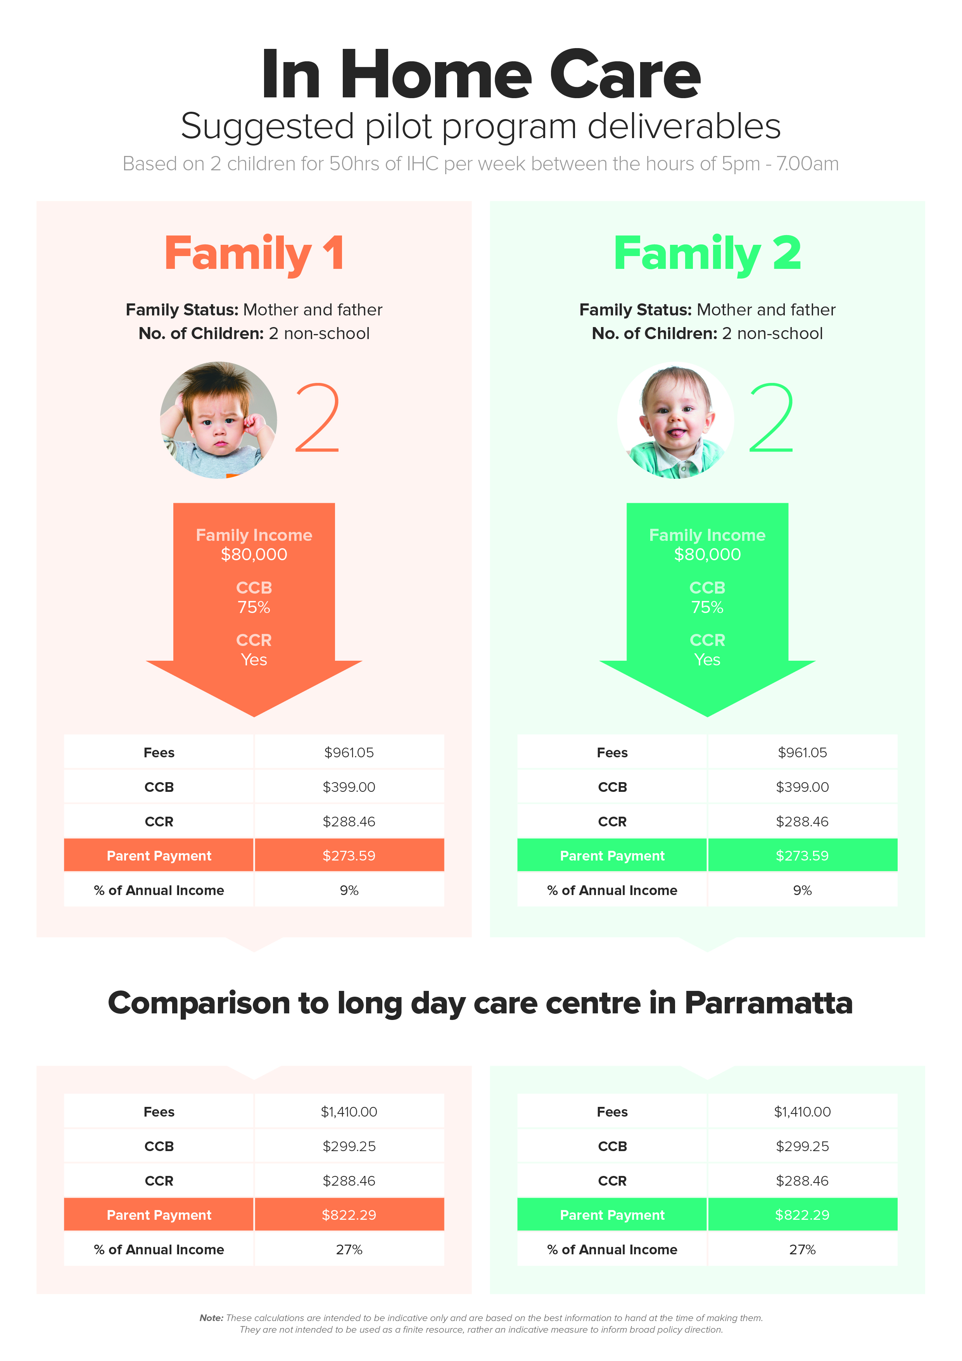

Conclusion
NICA believes the Department are correct when they say we need a new Early Childhood environment for Australian families who are trying to cope with a system that was designed for another age. We need to foster a new environment that offers families more flexible and better options to assist them balance their working and family lives while ensuring the very best of Early Education and Care for their children. Clearly, the successful operation of such a pilot plan would be a defining ‘proof of concept’ for the Government and would provide a pathway in the continuing evolution of Australia’s excellent Early Childhood Education and Care.

