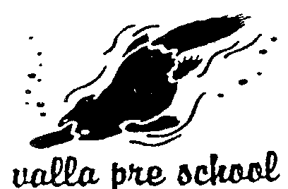
PO Box 259, Nambucca Heads NSW 2448
22 Valla Beach Road, Valla Beach
Tel: 02 6569 5274 Fax: 02 6569 6724
Email: vallapreschool@westnet.com.au
ABN: 80608 565124

4 September 2014

Valla Community Preschool is situated on the Mid-North Coast of NSW. We are a two-unit community based preschool with an enrolment of approximately 85 children and families.

Valla Community Preschool has always been guided by a clear philosophy which underpins all the decisions, policies and daily practices of the service to ensure that the educational program is stimulating and engaging and enhances children’s learning, development and well-being. We take a pro-active approach towards continuous learning and quality improvement approaches and seek quality outcomes for children and families.

In June 2012 our service underwent Assessment and Rating and was deemed to be ‘Exceeding National Quality Standard’ in all seven Quality Areas. We support the National Quality Framework and the goal of a nationally consistent system.

We are pleased that the Draft Productivity Commission Childcare and Early Childhood Learning Draft Report identifies support for the National Quality Framework and recommendation for ongoing funding for Universal Access. However, the recommendation on placing preschools within the education system and removing them from the National Quality Framework is something which greatly concerns us.

Preschools such as ours have advocated consistently for recognition of a National Quality System for Early Education and Care. We believe that the NQF is a real step forward in improving education and care for children and families across Australia. It should not matter what education and care setting children of Australia are accessing – there should be one national system to ensure that an holistic approach to the delivery of education and care is being achieved. If there is one national system, children are less likely to miss out on an early education and to fall through the ‘gaps’.

We also believe that the collaboration of all government departments would be more streamlined and cost efficient and more attention can then be given to refining a system already in place.

Removing preschools from the framework is likely to intensify the divide between care and education and see one being advantaged at the expense of the other. Rather, we believe that children and families will gain greater benefit from quality environments that do not create a false divide between education and care. Education and care do not occur separately in quality education and care settings.

