Preschool Teachers Association
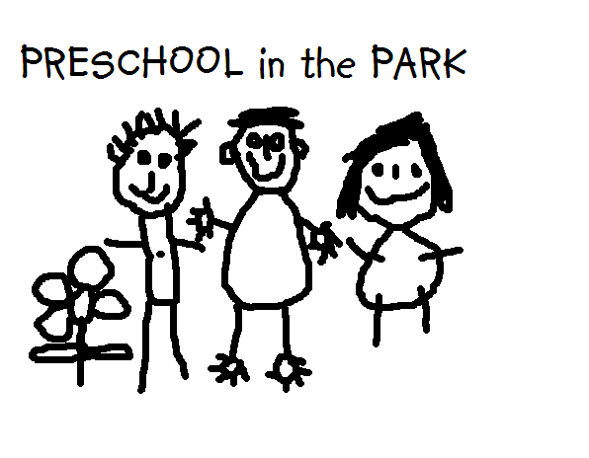
of the Northern Territory Inc.
PO Box 799
SANDERSON NT 0812
ABN: 52 430 083 906
Pre School Teachers Association
of the Northern Territory Inc.
E: info@pstant.org
W: www.pstant.org

4th September, 2014
Thank you for the opportunity to provide feedback on the Draft Productivity Commission report. The Preschool Teachers Association of the Northern Territory represents members who teach in a preschool setting within schools. We surveyed our membership to gain their view on the Draft Productivity Commission report. Our members are located in urban and remote locations and many of our members teach in NT Government preschools. The following are responses about the recommendations from the Productivity Commission regarding the impact on preschools.
- The recommendation that dedicated preschools should be removed from the NQF and regulated by state and territory governments under the relevant education legislation.
We agree that the principles of the NQF are beneficial for preschools and increases the quality and standard of education for 3-4 year olds. However, many primary schools are working towards a Strategic Improvement Plan and Annual Operations Plan to comply with the Department of Education. Preschools are already regulated under the school review process. We would recommend an amendment to the School review whereby the applicable standards, from the NQF, could be addressed as part of the school review process.

- The recommendation that governments should identify elements and standards of the NQS that can be removed or altered while maintaining quality outcomes for children.
We agree that there should be changes to the NQS for Preschools. Many Preschools have no administrative support, this has been a regulatory burden for many staff going through the assessment and rating process. The following elements should be removed and governed by the appropriate education system: ratios, staff qualifications, policies, safety and maintenance of equipment and in particular Quality Area 2 – Children’s health and safety, which can be covered by the administration of the whole school. Quality Area 3 – In particular 3.1 – the design and location of the premises is appropriate for the operation of the service. Quality Area 7 should be the responsibility of the Education Department not the responsibility of the preschool teacher in charge or principal to collate policies and procedures that oversee preschool. This separates the preschool environment from the rest of the whole school, creating a sense of exclusion rather than inclusion.

- The recommendation that all governments should allow services to temporarily operate with staffing levels below required ratios, such as by maintaining staffing levels on average (over a day or week), rather than at all times.
We agree that higher staff ratios are best practice and these should not be negotiable where children’s wellbeing might otherwise be at risk.

- The recommendation that the ACECQA and governments explore ways to determine services’ ratings so they are more reflective of overall quality, with the ‘Excellent’ rating abolished, so that ‘Exceeding National Quality Standard’ is the highest achievable rating.
We agree the ‘Exceeding National Quality Standard’. Ratings should not be dependent on a payment to be assessed at a higher level as some services are not in a financial position to afford this.
The recommended overall rating of ‘working towards’ should not be dependent on 100% of all demonstrated elements. We suggest that the rating be determined by a percentage of the overall elements met. This would be more reflective of the whole rating system as some elements are beyond the preschools control.

- The recommendation that differences in educator-to-child ratios and staff qualification requirements for children under school age across jurisdictions should be eliminated and all jurisdictions should adopt the national requirements.
We agree that all states and territories adapt the national requirements.

- The recommendation that Government funding for preschool should ensure universal access for children to 15 hours per week of a preschool program for 40 weeks, in the year prior to starting school.
We agree that 15 hours a week for a preschool program is the minimum hours for children prior to attending school. However, continuity of care is essential in the early years. Continued financial support from the relevant department is necessary.

- The recommendation that the Australian Government would provide the same level of assistance for preschool to every child, regardless of whether they participated in a dedicated preschool or a preschool program in a long day care centre.
In the current NT context, long day care preschool programs do not have the same school based pedagogy and expectations as NT Government Preschools ie. Degree qualified teachers. This could be to the detriment of the children and could impact on their readiness for school.

We believe the NQF has gone a long way to achieving higher standards and raised expectations in Preschools. However, part of the problem for governments will continue to be that the Preschool model is slightly different in every state and territory which makes it difficult to provide consistency in assessing the various standards of the NQS.

Regards,
President
Preschool Teachers Assocation of the Northern Territory Inc.
W: www.pstant.org
E: info@pstant.org

