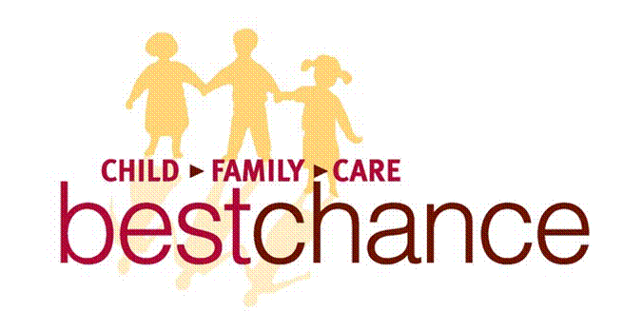

bestchance submission to Productivity Commission:
Integrated services in the ECEC Sector

Integrated services at bestchance is the seamless access to all programs - which combine elements of physical space, learning methods, daily routines and schedules, assessing development and progress and establishing and monitoring program quality –while maintaining the unique aspects of individual programs that add value for the families and individuals who use them.

Inclusion at bestchance is about creating a sense of belonging for all children, families and staff where diverse identities, experiences, skills and interests can be offered expression and the opportunity to develop (FKA). More specifically, for children:
“Inclusion is a continuous process that enables each individual opportunities for acceptance and participation in their community. It means more than just “being there”, it means “being with” i.e.: learning with, playing with, communicating with and socializing with peers. Inclusion means belonging” (Noah’s Ark, 2003, slide 3).
The benefits of providing an integrated service for families are many but include:
- They are time effective for families
  - Families only need to make one initial point of contact and assessment (intake) in order to access all services provided
  - Greater continuity of service provision (facilitating transitions across the service, and transitions over time) (Corter et al, cited in Press et al)
- Increased organisational efficiency
  - Increased productivity- maximising synergies in process, knowledge and practice.
  - Better flow of resources and support services
- Increased quality and accessibility
  - Consistent quality controls
  - Ease of access
- Decreased incidence of families “falling throught the cracks”
- Increased client satisfaction, and ultimately
- Improved well being and quality of life

Principles of bestchance intergrated service model
- Respect for diversity: having respect for children’s and family’s unique cultural histories.
- Programs built on partnership – reflected in family centred/child focused, strength based service philosophy. This applies to partnerships both with children and families, but also in the broader context – staff, programs and community. This partnership reflects the collaborative learning and service delivery can occur that is reflected in this document.
- Holistic
- Based on high expectations
- Inclusive and high quality
- Responsive coordinated and accessible

The integrated service model requires additional resources above those for a regular early childhood education and care service:
- Team manager integrated services to coordinate the work
- Team managers time to meet and discuss children & families both formally and informally
- Staff time to meet together to plan and review the work being undertaken with children
- Systems to plan, record, review and follow up for children and their families
- Wrap around services – Parent Counsellor, Early Childhood Intervention Team consulting time, emergency relief
- Time by executive level management to have successful partnerships between organisations eg local government MCH working within the integrated service

The processes for supporting integrated services are:
- Ensuring all staff (Cert 3, Diploma, Bachelor and Allied Health) are family centred. The outcome of this is a relationship between the staff and family that is sufficiently strong to allow recogntion of the presence of a life issue.
- The skill level of staff to manage a conversation with the family about avenues for appropriate support and guidance or referral. This requires adequate professional development for the staff group.
- A line of communication to ensure families with life issues are raised to the Integrated Services Group for discussion and follow up. It is at this meeting that the integated approach is driven for each family. It allows reflective practice and discussion related ot each family – this ensures that the most appropriate response is provided and maintained for as long as needed.
- Joint planning time between the key staff involved with each child and family to best meet the needs
- Joint client record management system for sharing (privacy protected)
- Annual audit of enrolment forms by qualified staff to flag children and families that may require additional assistance

The cost of these resources at bestchance for our integrated services is: to be provided

All children and their families benefit from an integrated service. However, the most vulnerable and at risk children and their families that reap the most benefit. At bestchance the integrated services are: long day care, 3 & 4 year old kindergarten, early childhood intervention, parent counselling, supported playgroup, emergency relief, occasional care, maternal and child health along with a general practitioner.

There is a wide range of additional needs within the demographic of the children and families with whom we work. As such the bestchance definiton of a child with additional needs can encompass a broad group of children:
- Those with English as a second language or no English
- Recent migrants and refugees (especially rlated to trauma)
- Children in out of home care (know to Child Protection)
- Children in the care of grandparents for a range of family reasons
- Children with terminally ill parents
- Children whose parents have a chronic illness / disability
- Children whose parents are unable to face the process needed for diagnosis of a developmental delay or disability. This can take some families up to 12 or so months to seek the appropriate advice.
- Children with a diagnosed developmental disability or delay.
- Children whose parents experience short term unemployment for a range of reasons
- Children whose parents are seperated or divorced

Not all these children and families require the same level of support and guidance nor do they need it for the same intensity over a period of time. But they do need it. And the integrated service is able to meet these needs without the parent needing to seek support themselves and from a rnage of organisations.
Inclusion Support Services (ISS)

One of the other supports availabe to services who have children with additional needs attedning is ISS. ISS assists eligible early childhood education and care (ECEC) services to include children with ongoing high support needs in environments with typically developing peers. The ISS is a contribution towards the costs associated with employing an additional educator.

ISS is available to services when the additional needs of a child are identified and/or the family is seeking assessment for possible developmental delay or disorder. This “flexible” funding which is available for services prior to diagnosis is invaluable in ensuring the child is able to fully access and participate in the program while this sometimes lengthy process occurs. The child and family are able to be fully supported. The child’s needs within the programs do not change based on a diagnostic point or outcome. Bestchance focuses on the needs of the child and family. ISS flexible funding allows us to do this immediately.

It is important to note that there are some children with quite severe behaviour presentations who have not been diagnosed and have not had any intervention. The reasons for this range greatly with some examples being: parental reluctance for hearing the difficult news, cultural non-acceptance of a child with a disability (some cultures do not even have words for this), or inability to access services to seek the information or waiting lists. The service these children attend require the additional staff member to ensure that the child can safely attend the service; and to ensure the safety of the other children in the room. The effect of the service not being able to access flexible funding for this period leading to a diagnosis could have a negative impact on the child’s inclusion and participation.

For further information please contact:

Kevin Feeney
Chief Executive Officer
bestchance Child Family Care

