Submission to the Productivity Commission on Child Care
From Wilston Kids Care, a community based service run by the Wilston State School Parents & Citizen’s Association (P&C).

Contact Details
Chris Noonan

0.5 | 2 Sept | Chris Noonan | Updated for Productivity Commission
0.4 | 23 July 2014 | Vic Ernst | Revised for Sussan Ley visit
0.3 | 5 Nov 2013 | Chris Noonan | For Teresa Gambaro visit
0.2 | 14 Oct 2013 | Chris Noonan | WKC Committee Review
0.1 | 8 Oct 2013 | Chris Noonan | 1st Draft for Committee
Version | Date | Author | Description

Objective
To raise awareness of the issues surrounding the successful running of WKC and the impacts of the National Quality Framework (NQF) on a parent volunteer run centre. To also present issues of risk adverse P&C’s and resource poor schools turning to outside commercial providers at a greater cost to parents and the government.

- WKC has leveraged the NQF to our advantage.
- We have the cost effectiveness of a community based approach, which could be saving the Government $300,000 per annum and putting $100,000 of resources back into the school community.
- We do not want to change the NQR significantly but to support the compliance burden and clarify specific requirements.
- Highlight the personal liability faced by members and to ask for support in this area.
- Exposure for the “Approved Child Care Provider”, can make people reluctant to volunteer for this role.
- We believe it is difficult for communities to “go back” once an external provider is put in place. E.g. Windsor.
- Offer WKC as a case study. How can we support the community and working parents?
- We believe the ‘Educational Coordinator’ has been a key success for us. This was introduced as a direct result of the NQF.
- We are concerned at the lack of auditing. No government NQF audit in over 3 years and our current rating is “Provisional- not currently assessed”.
- The whole village raising children. To encourage people with life skills and experience to get into the industry as role models. We have a bias of older and very young educators, with Preps being their favoured area. Engaging older children is our challenge.

Context
- WKC has a licence for 200 children for afternoon care, 100 for before school care, and typically look after 80 to 100 children in full day vacation care.
- WKC Organisational Structure
P&C Executive

WKC Sub committee

Operational Manager

Educational Coordinator

Coordinators

About 20 Part time Educators

- After school hours care is essential for many single parent families. These very busy people have been well represented on our committee with 5 volunteers in just the last two years.
- WKC experienced a large increase in enrolments from 2011 to present. Our licence was for 165 students, and the centre was run by two coordinators.
- WKC has a financial turnover around $1,000,000, (most on wages, with a substantial investment in activities and food).

Growth in Wilston Kids Care Numbers (a “Large Centre” is one over 70 kids)

Affordability, Accessibility, Quality
Access to outside school hour’s care is a significant part of a parent’s decision as to which school to send their children. Parents select WKC for the following reasons:
- Affordability: this is very important to parents with our centre costing around $29 per day as opposed to $70 at a ‘not-for-profit’ PCYC. In the 2013 calendar year our centre will return $20K in site licence fee (school rental), $20K in special projects, $80k to the P&C (includes capital and risk management) and an expected additional $10k retained for future contingencies. We do not skimp on care or income to achieve these outcomes.
- Quality: parents want us to provide programs that engage children, not just child minding, i.e. children watching movies every day. So we have engaging programmes, and regular “special programmes”.
- Accessibility: we run a service that parents need, often P&Cs see the risk and personal liability and this puts pressure on these organisations, with “not-for-profit” promising big returns. Example of Windsor going to an external provider has split the community. For the last two years WKC has guaranteed access for all prep parents prior to starting at WSS which provides assurances for working parents. This guarantee does not impact the availability for all users.

National Quality Framework
In 2012 we used the NQF to identified areas we needed to concentrate our attention. This process gave us the opportunity to:
- restructure and reassign WKC priorities;
- implement the Educational Coordinator as a role in its own right (not attaching to another person) and create the Operational Manager role; and
- plan quality programs 4 weeks in advance for 200 children.

Our engagement with risk reporting processes
- Our parent involvement has incrementally impacted our recognition of risk assessment and implementing preventative measures.
- We would rather see sharing of lessons learnt, than punitive measures.
- An example of the punitive measures that volunteers face has been included as an appendix

Benefits to having a community run centre
- Based on our anecdotal evidence, savings of about 300K for the government.
- Synergies with the school, for example the Heumi table, Robotics program, new shade sail over prep playground and more coming , which promotes shared resources.
- Enables work place participation, in particular by women and single parents.
- Parents trust the community run centre as opposed to one run by a ‘not-for-profit’ operation.
- Enables parents to have a direct input to activity planning, risk management and quality of service.
- Provides direct benefits to working parents who are “time poor” by implementing affordable activities such as Homework Club – Soccer Coaching – Music Lessons.

Threats to our organisation to maintain community run centre
- Time that working and studying parents have to volunteer for committee roles.
- Willingness to accept personal liability for the centres operation.
- Reputation as well as financial impacts for individuals volunteering.
- Lack of government audit/ little support for NQF (no audit since its inception except for licence renewal).
- Pressure on school size (900 to 1100) based on floor space. We can’t use classrooms to care for children, but we need undercover floor space. Very supportive principal who sees the community benefits of the centre, he is under pressure for increased enrolments.

Support we are seeking
We would like highlight the support we would like from the Federal Government:

On the National Quality Framework
- Bi-Partisan support. We accept there is a mandate to change the NQF it, but the cost of redesigning the reassessment every 3 years would be more than most committees could support (4 days of volunteer time working through the framework).
- Don’t throw out the NQF (rebrand it and tune it if necessary and provide specifics and documentation rather than theory).
- If the NQF is to be reviewed ensure that there is adequate supporting self-assessment tools and support for changes.
- Involve community centres in decisions about the NQR future (we see compliance as being a significant factor in the improvement in the quality of care). Commercial and ‘Not-for-Profit’ would see this as a cost of operation.
- Provision of self-audit mechanisms.
- More engagement from Government Quality Assurance and committees in coaching roles.
- The document “My Time, Our Place” is the current cornerstone of child care, however the document appears to be geared to the small-medium long day care environment. Many long day care environments offer outside school hours care but there are many centres which only offer outside school care and a consideration may be beneficial in framing ongoing requirements which separate the very diverse requirements.
- In introducing any refinement to “My Time, Our Place” It should be imperative that not only the framework be developed including specifics but also the delivery method, the training method and the support method for operatives be clarified and in place and be part of the educational curriculum (i.e. be incorporated within the Cert III course).
- Any review should include policy, procedures and documentation for key critical events to ensure conformity, compliance and regulation. I.e. all centres are required to maintain policies etc. on asthma – why don’t we have standard requirements issued for all to follow?
- Recognition that it is very difficult for a P&C run centre to be created once a private operator is in place. We should question the benefit of providing community resources (i.e. School premises and facilities) to outside parties and the true cost to the government and community of increased fees and subsidies.

On Volunteer Exposure and Accountabilities
- Consider exceptions for parents volunteering to run centres protection from personal liability. Where due consideration to risk has occurred, Government should provide assistance and guidance and remove the option of penalties or at least provide an insurance option to encourage participation.
- Change incident reporting from punitive to an opportunity to learn, by sharing with other centres. Requires cultural change by regulators to encourage support for full and thorough roots cause investigation and implementation and sharing of ‘lessons learnt’.
- Provide training opportunities for risk management, safety culture and recognition that these could be provided at a discount for community run centres.
- Risk management is punitive and “where the mining industry was 15 years ago”.
- Review the accountabilities:
  - Approved Child Care Provider –not the P&C President but “someone with skin in the game”, such as the chair of the subcommittee.
  - Nominated Supervisor- Allow for splitting of accountabilities. We have a complex accountability structure. We hold the Operational Manager accountable, where as the government holds the “Nominated Supervisor” accountable.

Working within Schools
- Recognise the needs of schools for space and the requirements for that floor space is sometimes different to that for outside school hours care. Classrooms cannot be disturbed, we need different spaces.

Funding
- We need guidance on what is available regarding grants and a review to ensure grants are reaching the right target – e.g. Active After School program not now available – concentrating on schools who already have P.E. teachers etc.
- What is being done for sustainability for parents – CCB/CCR does not cap fees therefore private sector is subsidised – Community based, not for profit, using community assets (e.g. school) should be encouraged.
- Consideration should be given to not expanding the base of funding where there is capacity – there may be a case for additional assistance during non-operating hours but funding should not be provided for direct competition as this impacts the viability of existing operations placing stress on fee structures.
- Consideration could be given to relaxing ratios/space requirements, especially for outside school hour’s care. Centres with proven risk management strategies could benefit from relaxation (subject to reciprocal fees containment) and offer a methodology to increase capacity without increasing costs.

“Our neighbourhood” example of
- First, ‘principal-agent’ problems can arise if the procurer of a service makes different choices about providers than parents would themselves.
- ‘financial return over delivery of child focused, highest quality service’.

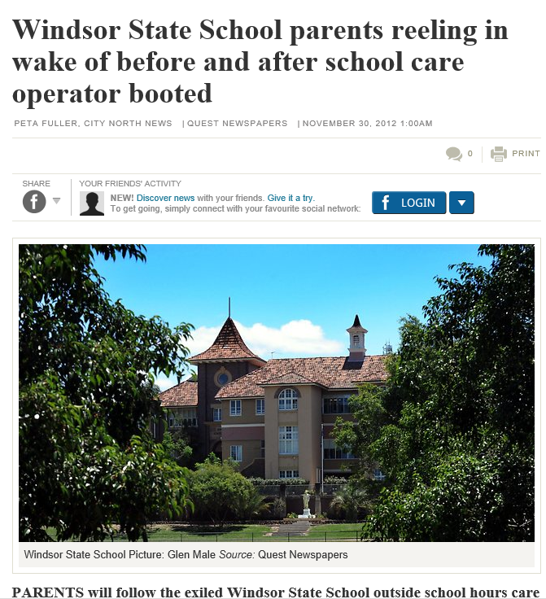

Specific Feedback on the Commissions Draft Report

Reference | Commission Statement | Our response | Our Comments
Page 2 | The National Quality Framework for ECEC services must be retained. | Yes | We agree that a national standard has given us the mandate to focus on quality and educational aspects of care in an OSHC services as opposed to “baby sitting”.
Page 15 | Promote efficient provision of services, including removal of any barriers, assistance or concessions which favour particular provider models, and address inequities in access | Yes with conditions | Large (>150 place) P&C models, once they have transitioned to a “not-for-profit” provider, are difficult to resurrect and support should be provided to communities wanting return to P&C run or this becomes a barrier to lower cost services.
Page 29 | For primary school age children, the Commission is recommending that principals in all schools be required to take responsibility for the organisation of OSHC for their children, where sufficient demand exists to ensure such a service is likely to be viable. | With reservations | For Principals with limited access to resources, an outsourced model promising large returns can be attractive over the community benefits. “Not-for-profit” organisations have offered to give the school $100,000 on top of their directors fees. This can only mean an increase in costs.
Page 36 | For OSHC, a nationally consistent set of staff ratios and qualifications for educators should be developed. These should take into account the focus of OSHC on care and recreation rather than education, the staff ratios that are considered acceptable during school hours, and the valuable contribution that can be made to OSHC services by less qualified older workers and university/TAFE students. For OSHC, occasional and mobile care services, the requirement to report against an education plan on an individual child basis should be removed, as such detailed reporting does not contribute significantly to the quality of outcomes for children and is burdensome for providers. | Yes | Risk based Average ratio over a week or similar, so higher and lower risk activities can be undertaken without impacting safety.
Page 55 | Governments should develop and incorporate into the National Quality Framework a nationally consistent set of staff ratios and qualifications for those caring for school age children in outside school hours and vacation care services. These requirements should take into consideration ratios that are currently acceptable for children during school hours, the uncertainty surrounding the additional benefits of more staff and higher qualifications, and the valuable contribution that can be made to outside school hours care services by less qualified older workers and university/TAFE students. | Yes | Risk based Average ratio over a week or similar, so higher and lower risk activities can be undertaken without impacting safety.
Page 55 | The Australian Government should ensure that the requirement (currently contained within the Child Care Benefit Eligibility of Child Care Services for Approval and Continued Approval Determination 2000) for most children attending an outside school hours care service to be of school age, is removed and not carried over into any new legislation. | Yes
Page 55 | State and territory governments should direct all schools to take responsibility for organising the provision of an outside school hours care service for their students (including students in attached preschools), where demand is sufficiently large for a service to be viable. | Yes
Page 60 | Abolish the ‘Excellent’ rating, so that ‘Exceeding National Quality Standard’ is the highest achievable rating. | Yes | Why pay $200 dollars when we are a P&C run monopoly, that parents have few alternatives. Also it doesn’t make much sense if we will be checked every 3 years.
Page 60 | Abolish the requirement for certified supervised certificates. | Yes | Accountabilities depend on the size of the organisation and the organisational structure. Operational Manager, Educational Coordinator, shift supervisor and Educator all have different accountabilities.
Page 60 | Removing the requirement for outside school hours care services operating on school facilities to provide site plans as a condition of service approval. | Yes | Agree as this is an additional cost for not much benefit.
Page 75 | Remove any barriers that may hinder the supply or type of ECEC services that families demand | With conditions | Large (>150 place) P&C models once they have transitioned to a “not-for-profit” provider, are difficult to resurrect and support should be provided to communities wanting return to P&C run or this becomes a barrier to lower cost services.
Page 75 | Remove any barriers, assistance or concessions that favour particular provider models. | With conditions | If not careful, this could favour larger external providers over community run, shifting the barriers to entry.
Page 85 | With outside school hour’s care, around 60 per cent of services were provided by for not for profit providers (table 2.4). | Point of definition | For us “Not–for-Profit” has become synonymous with organisations that take “a large directors cut”. However this is confusing these with community run centres. There should be a criteria before a centre can be called “not–for-profit”, which should be differentiated in the report.
Page 265 | Allowing services greater flexibility in the way staffing requirements are met. | Yes | If centres have demonstrated good risk management practices should this be recognised?
Page 265 | The pace of assessments must be increased. | Yes | We have not been assessed. Given staff turnover any assessment would have a life of 6 months. We would much rather see ongoing support for P&C committee run centres and regular visits. We think that if there is an incident at the site the auditing body should be held to account as much as the approved provider, if not providing regular assurance.  To cover this gap in assessment we have had to pay for our own external audit from QCan.  Also opportunities exist to accredit assessors other than the government similar to the building industry. This would bypass bottlenecked government processed and allow centres to select self-initiated assessment.
Page 271 | Reduction in the volume and complexity of professional development, training and guidance materials for providers, educators and state and territory regulatory staff. | Yes | There seems to be little support for NQF in Cert III. Why is the onus on the provider to provide NQF training, while Cert III is limited?  Also please separate Cert III and Diploma between babies and school hours. The requirement for students to volunteer to work with babies when they want a career with school aged children causes waste.
Page 271 | Increased focus of providers and educators and time spent on those standards that contribute most benefit to children. | Yes | We have focussed on play based learning and providing stimulating activities over individual assessments.
Page 273 | In particular, given that children attending OSHC will spend, or will have spent, a full day in a formal schooling environment with a degree qualified teacher, it seems excessive to require OSHC services to develop and document a curriculum and record educational outcomes for every child — especially considering that many children may be in care for as little as one hour per session and may only attend sessions sporadically. | Yes with recognition of what we have achieved with NQF and our educational coordinator | The role of educational coordinator works well for us. Their role is to focus on ways to inject learning in a fun way.  We struggle to do individual assessments that don’t really make sense in an out of school hours facility.
Page 275 | The key policy challenge regarding these ratios and qualifications is that it is impossible to tell whether they have been set at appropriate levels. | Yes | There needs to be risk and educational outcome based rather than prescriptive ratio over all.
Page 280 | A primary school leader reported her frustration with the fact one set of regulations allowed a specialist physical education teacher to supervise a class of twenty students in the school pool at five minutes to three in the afternoon while another set of regulations applying at five minutes past three the same afternoon allowed the same teacher with the same children in the same pool to supervise only five students. | Yes | There needs to be risk and educational outcome based rather than prescriptive ratio over all.
Page 283 | The Commission considers that further flexibility in staffing arrangements should be permitted under the NQF, in particular to allow educators to undertake activities such as professional development. This could be achieved by allowing all ECEC workers to be replaced by a less qualified staff member for short absences, as is the case with teachers; or by allowing services to maintain staff ratios on average, say over a day or week. However, increased flexibility should not create an undue burden for services (such as by requiring excessive paperwork or approvals to temporarily operate below staff ratios). | Yes | We want to deliver higher risk activities such as cooking without increasing costs. These would be staffed at higher ratios drawn from lower risk activities.
Page 287 | To a large extent Goodstart still has to contend with multiple regulatory bodies, each with different approaches and interpretations. Goodstart would like to see much greater consistency between the states and territories on the implementation of the NQF. While some jurisdictions have adopted a practical, risk-based approach to regulation that seeks to build partnerships with providers, others have adopted a rigid, ‘letter of the law’ approach that adds to costs and to uncertainty as decisions are often pending. (sub. 395, p. 42) | Yes | For a volunteer parent (or P&C president without children in care) as approved provider the threats of fines and publication on websites of failures to provide adequate care, will reduce the willingness of people for volunteer for such roles. There needs to be a way to recognise the volunteer contribution, as and the personal liability is driving higher costs through outsourcing.
Page 291 | Jurisdiction Number of services with a quality rating Number of services Proportion of services with a quality rating  %  ACT 125 317 39  NSW 2 035 4 864 42  NT 107 215 50  QLD 890 2 693 33 | Yes | 33% over 3 years is not good enough, see comments above.
Page 301 | Certified supervisor certificates should be abolished. Under the requirements of the NQF, all services must have a ‘Nominated Supervisor’ who is responsible for the day-to-day management of that service. Before 1 June 2014, for an educator to become a Nominated Supervisor, the service had to apply for a ‘supervisor certificate’ from their regulatory authority. However, recent reforms to the NQF (in response to concerns raised by the sector) mean that from 1 June 2014, all services will be issued with a supervisor certificate that can 302 CHILDCARE AND EARLY LEARNING apply to any person working in a service who is responsible for the day-to-day management of the service, has supervisory or leadership responsibilities, or is a FDC coordinator.29 Services will still have to apply for a separate certificate for other staff who wish to become Nominated Supervisors. Governments should give further consideration as to whether any objective is being achieved by even this reduced requirement — including questioning the purpose of issuing the ‘service wide’ certificates discussed above. | Yes | See comments above.
Page 304 | Abolish the requirement for certified supervisor certificates. | Yes | See comments above.
 | Provide more detailed and targeted guidance to providers on requirements associated with Quality Improvement Plans, educational programming, establishing compliant policies and procedures and applying for waivers. | Yes | Particularly for educational Coordinators.
Page 325 | The onus for organising outside school hours care should be placed onto schools and regulations that restrict the ability of outside school hours care providers to include preschool aged children should be abolished. | Yes | This is important to support the “dreaded double drop-off”, particularly during vacation care. However this should not be forced on a community and done with the consent of the Principal, who has accountability for what goes on, on the site.
Page 423 | Parents can make effective price-quality assessments and exercise choice. | Yes | Difficult to do if the service has been outsourced by a School seeing the revenue stream that can come from this source. Parents can’t easily put their children in another service.
Page 423 | Reducing providers’ incentives to cross-subsidise fees across users and minimising the potential for over- or under-use of services by parents when facing muted price signals. | Yes | We do this for Preps, charging a higher fee for higher ratios, and our vacation care fees are not subsidised.
Page 423 | Removing tax concessions for not-for-profit childcare providers, which create an uneven playing field across providers and, as a form of government assistance, lack transparency and accountability. | Depends | This covers a broad range of services from genuine community run to those who extract large director’s fees. The definition of “not-for-profit” should be more clearly defined.
Page 423 | As a group, there is little evidence that not-for-profit providers systematically address socioeconomic disadvantage or set lower fees | Understandably | If the definition is broad.
Page 429 | To avoid children travelling unsupervised, outside school hours care is typically provided at a child’s school. The school principal, a parent-school committee or a state government panel generally procures a service or directly employs staff to provide a service on the school site. As such, when a parent chooses a school for their child, they are also choosing an outside school hours care provider or, at least, they are implicitly nominating the school as their ‘agent’ for choosing a provider. | Yes | Agree strongly and this can create an uneven playing field for external providers to benefit from. A monopoly.
Page 429 | First, ‘principal-agent’ problems can arise if the procurer of a service makes different choices about providers than parents would themselves. | Yes | As demonstrated at Windsor State School a neighbouring school to Wilson State School.
Page 429 | ‘Financial return over delivery of child focused, highest quality service’ | Yes | The money from a broad demographic of price takers including single parents can be very attractive to those controlling the centre.
Page 429 | A particularly opaque aspect of outside of school hours care is that schools apparently negotiate an upfront sum (or return on the fees collected). It is unclear to what extent this is reflective of actual costs, such as for rent, building maintenance and utilities, or used by schools as a revenue source. | Yes | A per capita fee based on licence would be more appropriate for the use of facilities, and defined by the Education department. Clear guidelines on access to play area should continue to be defined in site usage agreements.
Page 433 | Commission’s analysis of NQS ratings, which are available for about one-third of approved childcare services, indicates that not-for-profit and government providers achieve a slightly higher average quality than for-profit providers (figure 10.3). This could explain why, as a group, not-for-profit and government providers are able to charge slightly higher prices (figure 10.4). | No | This does not align with our analysis of other schools. When we have done price comparisons, we have been much less expensive. Again this could come down to definition of “not-for-profit”.
Page 447 | That, historically, childcare services existed to meet the needs of low-income, single parents or other disadvantaged groups may, in part, account for why social equity principles are etched into many providers’ operating principles and pricing strategies. | Yes | However in most cases we rely on the government to determine the subsidy. The exception is hardship cases that we specifically become aware of. We have also been able to provide emergency care to government child protection services.
Page 465 | Wages are relatively low and job satisfaction is mixed across the sector with widespread concerns from within the sector that ECEC workers are undervalued and under paid. | Yes | This is definitely a factor in trying to retain staff. Our demographic are very young or people past child rearing, who don’t mind a few hours a week. This leads to high turnover and quality of care issues.
Page 465 | There are widespread concerns in the sector about the quality of some training received by graduates who have undertaken an ECEC qualification, particularly at the Certificate III and diploma level. | Yes | As above needs to be more closely aligned with our industry needs (not volunteering to look after babies… for outside school hours staff.)

Example of personal liability for volunteer “child care provider” reporting a medication incident.
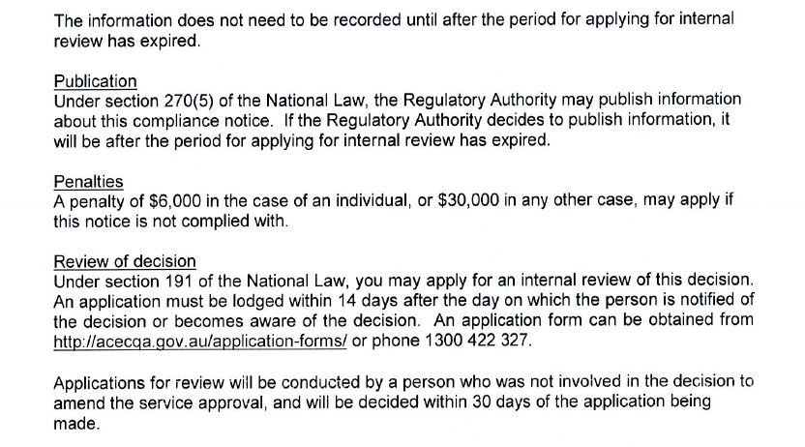
Publication of Enforcement Actions
Under the Education and Care Services National Law, the Department of Education, Training and Employment is able to publish enforcement actions taken against approved providers, approved services and individuals on its website.

The department will commence publication of enforcement actions from 1 October 2013.

Publishable enforcement action is usually taken where a breach of the National Law or Regulations has:
• compromised the safety, health or well-being of children or
• prevented the department investigating or responding to safety issues or
• been ongoing and the individual or organisation has not demonstrated a willingness to comply.

What enforcement actions can be published?
- prosecutions for an offence against the National Law or National Regulations leading to a conviction or finding of guilt, or plea of guilt
- enforceable undertakings
- compliance notices
- suspension or cancellation of a provider approval, service approval or supervisor certificate (other than a voluntary suspension or surrender)
- an amendment made to a provider approval, service approval or supervisor certificate for the purposes of enforcement

What information can be published?
- the nature of the enforcement action
- the details of the person in relation to whom action was taken including:
  - Name and provider approval number (for approved provider)
  - Address and name of service (unless service is also the home address of a family day care educator)
  - The name of the individual and their certified supervisor number if relevant for individuals)
- the reason for taking the enforcement action
- details of the enforcement action taken

When can enforcement actions be published?
The department may only publish enforcement actions after:
- the relevant person has been notified of the decision to publish
- all reviews and appeals in relation to the enforcement action have been finally determined
- all periods of time for review or appeal have lapsed

More information
Further information will be made available on the department’s website prior to 1 October 2013

