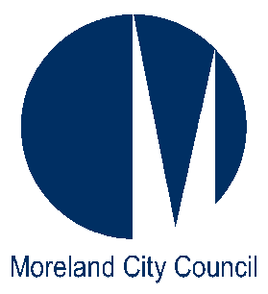
Moreland City Council
Municipal Offices
90 Bell Street
Coburg
Victoria 3058

Postal Address
Locked Bag 10
Moreland
Victoria 3058

Telephone: 9240 1111
Facsimile: 9240 1212

Moreland City Council’s Response to the Productivity Commission’s Childcare and Early Childhood Learning Draft Report July 2014
_______________________________________________________________________

Moreland City Council (Council) is an inner-urban Local Government in Victoria and we are pleased to submit our brief response to the Productivity Commission Draft Report on Childcare and Early Childhood Learning to highlight some of the local issues in Moreland.

The City of Moreland is located in the inner northern suburbs of Melbourne and has a total population of 160,029. Council is a direct provider of Family Day Care and Primary Aged School Holiday programs and has a resourcing and supportive role with the child care and kindergarten providers, together with a planning and advocacy role for early years provision in our municipality. Council owns 22 early years facilities which provide education and care programs in Moreland.

We would like to draw the Commission’s attention to some of our concerns and ask that the following issues be considered as part of the Draft Report’s review process:

Community Support Program (CSP) Funding for Family Day Care (FDC)

The Commonwealth budget announced changes to the CSP which directly affects FDC from 1 July 2015. All FDC services must make a new application for Operational Support Funding under the CSP and be assessed under the new eligibility criteria to receive CSP funding from 1 July 2015, and under the new guidelines most urban FDC providers would not be eligible to apply.

CSP funding contributes to the operations of the FDC Coordination Unit, in particular the FDC Resource and Administration staff who manage the program and support and resource the educators and families in the service.

Council currently receives approximately $120k CSP funding per year and if this funding is withdrawn it will directly affect service provision and could mean an increase to family’s child care fees of up to $1,700 per annum for a child in full-time care, making the service unaffordable for many families.

Council’s FDC program has been operating since the mid 1970’s and has over 40 years experience providing a high quality child care option for Moreland families. Our program recently received an Exceeding rating following the Assessment and Rating visit.

While the Commonwealth may be concerned about the enormous growth in the provision of privately operated FDC programs, Council sponsored FDC programs are being penalised as a result of the cessation of CSP. The provision of a not-for-profit FDC program provides a choice for families and a flexible and responsive child care option.

We urge the Commonwealth to reconsider the criteria for CSP funding to enable Council’s and other not-for-profit providers to continue providing affordable and accessible child care and education for families.

Proposed changes to Child Care Benefit and Child Care Rebate

The proposal to introduce a single subsidy to replace Child Care Benefit (CCB) and Child Care Rebate (CCR) is a welcome change to the current system, which is often confusing for families.

In Moreland 90% of families receive CCB and the average daily rate for long day care is $110. It is important that the child care subsidies provided to families are reflective of the real costs of child care provision. Otherwise the high cost of child care will continue to have a direct impact on families’ ability to pay for child care and reduce their capacity to participate in the workforce, or provide their children with early learning opportunities in a group environment.

Qualifications of staff working with children under three years of age

The importance of the early years is widely recognised, and in particular the importance of the first three years of life. The current qualifications requirements of staff working with this age group should be maintained and not reduced. Staff working with the 0-3 year age group need to be equipped with the education and training that enables them to work effectively with this age group and with their families.

Support of 15 hours of four year old kindergarten and the funding of three year old kindergarten

Funding by the Australian Government for universal access to 15 hours of preschool for the 2015 year was announced today and it is hoped that the funding will be ongoing.

We also like to support the introduction of subsidised three year old kindergarten programs. This would facilitate smoother transitions for children during their early years and also reduce the burden on families who are unable to access child care.

CCB and CCR eligibility to be extended to Special Development Schools

There is an increasing demand for child care for school aged children with high care additional needs. In order to assist working families a solution could be to enable Special Development Schools to provide vacation care programs for their students by extending eligibility for CCB and CCR to special schools.

The specialised nature of the facilities and the skilled staff would provide a program for children that would be best able to meet children’s needs. The programs could also be available for children with high needs over the age of 12 as there is only a small range of programs for this age group. The programs often have limited capacity to provide the level of care required for some of the children with complex high needs.

Increased investment in early years infrastructure

Between 2006 and 2031, the population for the City of Moreland is forecast to increase by 46,138 persons (24.48% growth), at an average annual change of 1.13%. There has been a steady increase in birth rate in Moreland with 8,799 0-4 year olds in 2006 and an estimated 11,427 0-4 year olds by 2021, an increase of 6.4%. There are currently 1,600 children on Council’s Child Care Central Registration waiting list.

During the past six years Moreland Council has invested over $9m towards kindergarten capital expansions to create additional kindergarten places for the Moreland community and assist with the implementation of 15 hours of kindergarten, and an additional four projects are currently being developed at an estimated cost of $8.7m. All of these projects have received State Government grants, but the majority of funding has been provided by Council.

Additional capital investment for long day care centres is required due to the increasing demand for child care, particularly in the southern part of the municipality which is closer to the CBD.

Kindergartens to remain part of the National Quality Framework

It is recognised that it is difficult to provide a consistent approach to kindergarten delivery across the country as there are various kindergarten models in each State. In Victoria the introduction of a unified system in the early years has strengthen the links and facilitated greater understanding between the different service types. We hope to see the current system remain and strengthen over time.

The Organisation for Economic Co-operation and Development (OECD)

Australia is a member of OECD whose mission is to promote policies that will improve the economic and social well-being of people around the world.

OECD compares a country’s investment in the early years by the percentage of GDP expended. The table below presents data collated by the OECD which indicates Australia’s expenditure is below the recommended minimum of 1% of GDP expenditure on early years. We draw the Commissions’ attention to this and trust that it will be taken into account in the development of the final report.
PF3.1: Public spending on childcare and early education

Definitions and methodology
Public expenditure on childcare and early educational services is all public financial support for families with children participating in formal day-care services (e.g. crèches, day care centres and family day care for children under 3) and pre-school institutions (including kindergartens and day-care centres which usually provide an educational content as well as traditional care for children aged from 3 to 5, inclusive).

Public spending on childcare support per child relates to the expenditure on childcare divided by the number of children in that country aged under three, while public spending on pre-school care and education per child is calculated by dividing public spending on educational institutions by the number of children enrolled in those programmes.

Key findings
Total public spending is over 1.0% of GDP in France, the Nordic countries and the United Kingdom, while it is below 0.3% of GDP in Canada, Greece and Switzerland. Most countries spend more on pre-school care than childcare, which could partly be a reflection of coverage of a larger age group. Pre-school spending is highest at over 0.7% of GDP in Denmark, Iceland, Israel and New Zealand, while childcare spending is only over 0.7% in the Nordic countries.

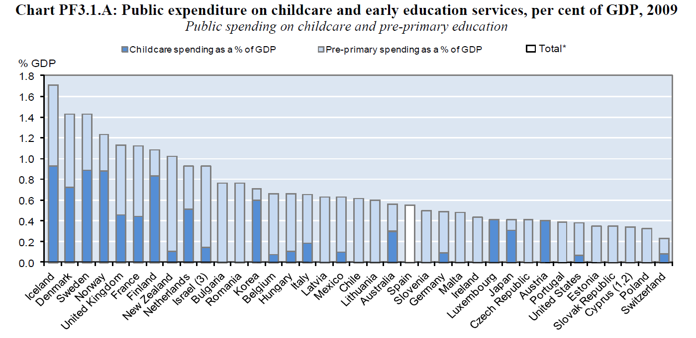
OECD Family database www.oecd.org/social/family/database OECD - Social Policy Division - Directorate of Employment, Labour and Social Affairs

