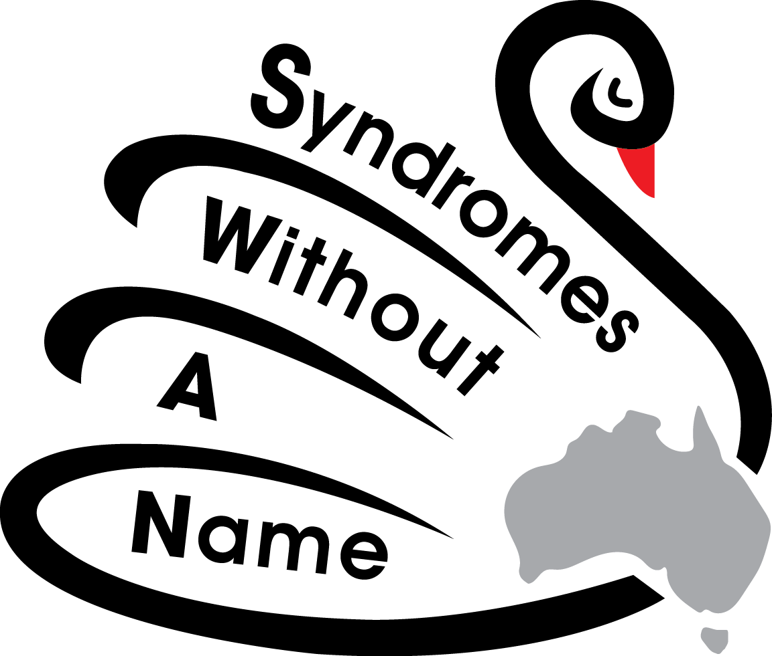

Re: Inquiry into Childcare and Early Childhood Learning

Thank you for the opportunity to submit our recommendations to the Productivity Commission Inquiry into Child and Early Childhood Learning. We are delighted to hear that our government aims to focus on ensuring “children with additional needs have access to a 'top-up' subsidy to meet the additional reasonable costs of service”.

Syndromes Without A Name (SWAN) Australia represents parents and carers who are living each day without a diagnosis for their child’s medical condition. One thing that would assist our families on their unknown journey would be to have the certainty of professional childcare, which would help in developing school readiness for our children and assist them to reach their full potential, whether it be for a main stream school environment or a specialist school setting.

It can be difficult for parents/carers of children with high medical needs and disabilities to find suitable childcare at which they are confident to leave their child whilst they attend to work. A diverse childcare system is a balanced one and should be embraced. An ideal model learning environment should support both a typical child and one with additional needs. A typical child could demonstrate social norms and development to a child with a additional needs. The presence of a child with additional needs could foster acceptance, diversity and individuality, which are desirable qualities in everyone. For this system to work, barriers need to be broken down particularly amongst childcare staff.

Early childhood staff are often not trained to know the best way to include children with disabilities at their centres. We would like to see an increase in qualifications of staff to cover a special educational component to assist them to include all children fairly. We would like to see a smooth transition to school involving the childcare centre and the school the child plans to attend, something which is often ignored for children with additional needs.

There should be an increase in the funding and subsidies for children with disabilities. If a child requires a full time aide, then this should be fully funded, with no shortfall. It should not be up to parents to top up the Government shortfall so their child can attend childcare.

We strongly agree with the commission’s recommendation that “school principals be responsible for ensuring schools offer before and after school care”. A number of specialist schools, special schools and special development schools in Victoria do not offer before and after school care, making it incredibly difficult for parents/carers of these children to find work. Ideally the before and aftercare workers should be trained in special education. Before and after school care need to be available as people who have something to contribute to the workforce should be able to, without the challenges of finding care for their children. We need flexible work places for our parents/carers to work as we often have to attend to medical appointments and therapy sessions with our children.

If followed through with care and attention, proposed changes will produce huge far-reaching returns for Australians, not only financially, but also for our communities’ social well-being as a whole.
Please do not underestimate the value and difference you would be making in people’s lives by expanding and improving Australia’s Childcare and Early Childhood Learning Services. These are, without question, supports and funding that are desperately needed for many families. As a country that would like to boast about ‘leaving no child behind’ and who takes pride in a progressive ability to listen to its people and incorporate needed changes – this is our chance to make much needed changes to help sustain a growing, diverse and healthy population.

About Syndromes Without A Name (SWAN) Australia
We aim to increase awareness and understanding of the impact and prevalence of undiagnosed genetic conditions within the wider community. We provide information and emotional support to families to assist them with establishing enduring mutually supportive relationships. We want to limit the isolation and the negative social, emotional and financial impacts experienced by families.

We advocate for further funding into genetic research, so that more testing is available, turnaround time on testing is decreased and more accurate results are achieved. We strive to obtain better resources and pathways for our children without a diagnosis in the future.

Heather Renton
President
Syndromes Without A Name (SWAN) Australia

W: swanaus.com.au

