Charles E. Pascal
Mini-bio
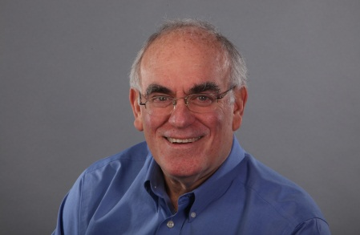

Charles E. Pascal is an internationally recognized educator with expertise in early and higher education, public policy, leadership development and strategic philanthropy. He has published extensively in the fields of psychology and education.

His 2009 seminal report to the Premier of Ontario-- With Our Best Future in Mind--is informing policy and practice in early child education within and outside of Canada.

A former Ontario deputy minister, including stints in education, social services and the Premier’s Council on Health, Charles is currently Professor of Applied Psychology and Human Development at OISE/University of Toronto where he is coordinator of the PhD. Program in Early Learning.

Charles obtained his PhD. in Psychology from the University of Michigan and when he was a professor of psychology at McGill University, he founded the McGill Community Family Centre and was a co-founder of McGill’s Centre for Learning and Development. As a college president in Peterborough Ontario, Charles became the first non-private sector person to chair the Greater Peterborough Economic Counccil.

Charles is also the Senior Advisor to the Chagnon Foundation in Montreal, special advisor to Australia’s Good Start Early Learning organization, and continues to advise governments in Canada and beyond. Charles is also a regular contributor to the Toronto Star newspaper. Charles and his teenage daughter, Tai Pascal Notar, have recently published their book, Too Far from Perfect: A Father-Daughter Conversation about Public Education. www.toofarfromperfect.com

Charles has also received recognition from many organizations to date, including five honorary diplomas and doctorates.

