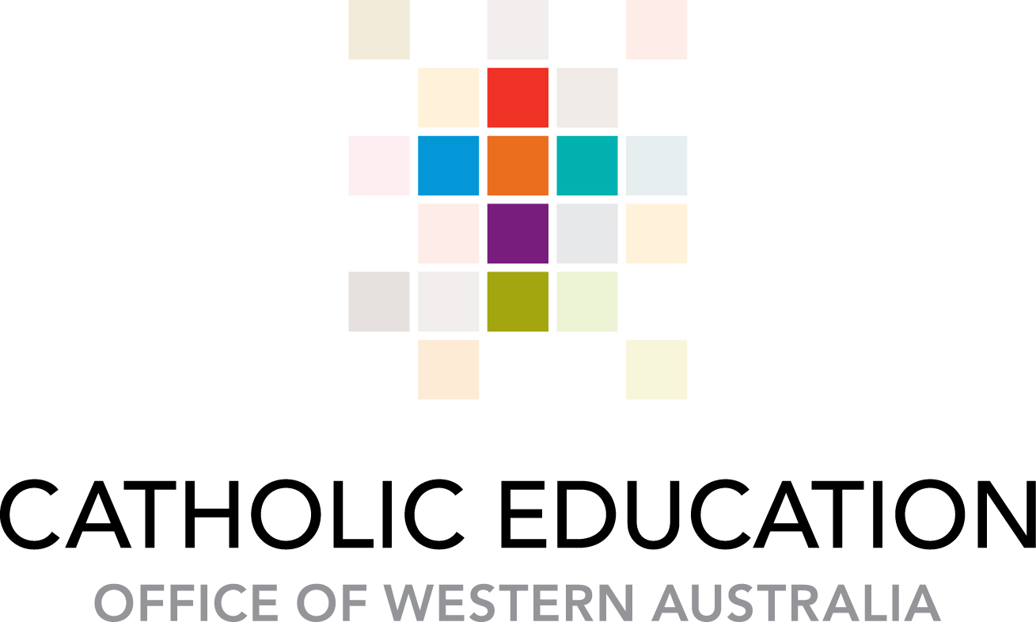

PRODUCTIVITY COMMISSION INQUIRY INTO CHILD CARE AND EARLY LEARNING

About Catholic Education in Western Australia

Catholic Education in Western Australia provides a dynamic, student centred approach to education for more than 73,000 children and young people in 159 schools and colleges across the state. There is a focus on the development of the whole person - intellectual, spiritual, social, physical and emotional development - Catholic Education is the state’s second largest education sector, educating some 18% of all school-aged children in Western Australia. Unlike any other state in Australia, Catholic schools in Western Australia are united as a system, across the state with the four dioceses - Perth, Bunbury, Geraldton and Broome.

A significant focus is placed on the early years of education. Catholic Education in Western Australia has been providing Kindergarten (preschool) on their school sites since the 1990’s Under the Universal Access program all schools now offer a minimum of 15 hours kindergarten per week. There are currently 132 of these kindergarten programs offered and 5100 children enrolled, 174 of these children identified as Aboriginal and Torres Strait Islander and 32 were identified as students with a disability.

In 2008 Catholic education began providing sessional pre-kindergarten programs. These programs operate under a user pays system and receive no funding from either the state or federal governments. There are currently 64 Catholic schools offering this program, catering for approximately 1240 children.

Catholic education moved into the provision of licensed child care services in 2008, including both outside school hours care and long day care. There are currently 13 outside school hours care services and 3 long day care services licensed under Catholic education. These services are eligible for CCB and CCR and fall under the NQF.

Terms of reference

This submission provides comment on areas Catholic education is best equipped to comment including,
- Contribution of child care to workforce participation and child development
- Current and future need for child care in Australia
- Capacity of the childcare system to ensure satisfactory transition to schools.
- Alternative models of care
- Option to increase accessibility, flexibility and affordability
- Impacts of regulatory changes

- The contribution of childcare to (a) workforce participation and (b) child development.
- Employment patterns of men and women have changed over the last 25 years. Significantly, the proportion of women who were employed has increased over the period (ABS, 2006). An increase in women entering or re-entering the workforce couples with an increase in demand for childcare.
The mining sector accounts for 1.8% of employment in Australia (ABS 2011). In WA the mining industry has significantly impacted on the employment patterns of families. Many families rely on the mining industry for their income. This most often means a Fly in Fly out (FIFO) employment pattern. Many of these families are geographically isolated from their extended family and rely on child care to provide the support and respite they need. These families require flexible child care arrangements that can fit with the FIFO employment patterns. Unfortunately for many child care providers this is not an economically sustainable option.
Australia’s economy is reliant on the mining industry. In order for the workforce to be maintained and supported, the government and mining companies must support child care provision. Child care should be more accessible to these families.
- Quality childcare makes significant contribution to child development, particularly in lower socioeconomic areas (see longitudinal studies for example Abecedarian project, EPPE project, and Perry Scope Program). These studies indicate the long reaching positive effects of quality early childhood, confirming that these programs contribute significantly to positive school and life trajectories.
In the WA context it is important to take into account the remoteness of many of the services. The children in these remote locations are often those that are most vulnerable and disadvantaged. Children in these remote locations are entitled to the same high quality care as those in metropolitan areas, however this can prove difficult. For example, it is often difficult to attract and maintain appropriately qualified staff to these locations. Often the most recent graduates are sent to these locations with little or no experience of the culture or context into which they are placed. In some cases teachers may be secondary trained and inadvertently introducing developmentally inappropriate curriculum. Building in these areas is extremely costly and accessing materials and tradesmen is another challenge. Increased government support in these locations is required if these children are to receive the same level of education and care as those in metropolitan areas.
- Current and future need for child care in Australia, particularly given changes in:
(a) work patterns – The increase in shift workers including FIFO means that child care needs to become felxible enough to meet the needs of these employees. Under the current model services can only offer regular days eah week, holding days for those on alternating work patterns is not economically viable for services.
(b) early learning needs - Quality childcare and education programs attend to early learning needs through providing supportive, engaging and holistic learning communities. The literature is rich in this area showing that high quality early years programs are essential to the education and wellbeing of these children into the future. Quality childcare and education makes significant contribution to the early learning needs of children. There is a plethora of research that has shown the significance of these programs including the Abecedarian project, EPPE project, and Perry Scope Program.
(c) childcare affordability and government assistance - It is clear from the evidence that investment in the early education and care delivers high economic returns. There is no doubt that all levels of government will need to invest in the future of Australia through affordable child care and education.
The current funding model is inequitble. It is aimed at those utilising high levels of child care and does little to take into account those most in need of child care eg: children that are vulnerable and disadvantaged. Any reform must ensure those children most vulnerable and disadvantaged can access quality early childhood programs. While the current system is closely linked to workforce participation, a reformed system should see increased investment for disadvantaged children that is not linked to workforce participation.
The current dual payment system is complex and cumbersome. A single payment model where payments are made directly to service rather than to families should be introduced. This approach will streamline the system for services, families and administrators and reduce the administrative burden.
- Capacity of the childcare system to ensure a satisfactory transition to schools.
Ensuring children have the best possible start in life is essential to the future of Australia. The longitudinal studies previously mentioned support childcares capacity to ensure satisfactory transitions to school. Both Child care and schools must be supported to work more closely to ensure these transitions are satisfactory.
In WA, pre-kindergarten or kindergarten (preschool) is mostly provided on the school site. This means transistions occur at the kindergarten on school site. Children become familiar with the school environment and staff from the commencement of pre-kindergarten or kindergarten. This gradual familiarisation across the kindergarten year ensures the transition to fulltime schooling the following year is satisfactory.
The transitions that require further attention in the Western Australian context are those between school and outside school hours care services. The schools and the OSHC service need to be supported to work closely together to share knowledge and expertise with one another in order to support the child and family.
4. Alternative models of care
The issues paper identified the move in some Canadian provinces to integrate ECEC with the formal schooling system. In WA pre-kindergarten and kindergarten are incorporated into the schooling system. This brings with it a variety of advantages such as increased numbers of qualified staff, better pay and conditions, less stressful transitions to formal schooling. It also has challenges that mostly focus around the schoolification and formalisation of early learning. Any move to a school based model needs to consider strategies to ensure that appropriate early childhood pedagogy and developmentally appropriate practice remains in the classroom and that teachers and educators are supported in this.
5. Option to increase accessibility, flexibility and affordability
- Large organisations employing shift workers may look to purchasing places for their staff. This could be included in the salary package of staff.
- Government support places for those shift and FIFO employees.
- Move to a one payment system with the payment made directly to the service.
- More focussed funding for those children that are vunerable and disadvantaged and not linked to workforce participation.
- All services are suported to meet NQS both financially and through training and development.
6. Impacts of regulatory requirement
The National Quality Framework (NQF) was introduced to both raise the quality of care and education to children and enhance consistency across jurisdictions. It is based on solid evidence that quality early years programs have positive outcomes for children. The implementation of this was delayed in WA due to legislative issues. This has meant the implementation of many of the reforms have also been delayed. To ensure children receive high quality ECEC Catholic education supports the continued implementation of the NQF within the current timelines.
The education and care sector in WA is divided into care and education with separate government departments responsible for each of these. Kindergarten (preschool) operate under the Education Act, this means they are out of scope for the NQF. Despite this the Premier has made a commitment that all pre-kindergartens and kindergartens will be required to meet the National Quality Standard (NQS). This will be achieved through an internal assessment process by the school principal. Catholic education has made significant in roads and investment into implementation of the NQS and is committed to the continuation of this within the specified timeline.
While significant inroads have been made and for example all Catholic pre-kindergartens and kindergartens have degree trained teachers and appropriate ratios there is a cost associated with the implementation of the NQS. Pre-kindergartens and kindergartens in WA are funded by state government and parent fees, they are not eligible for CCB or CCR. The key factors impacting cost includes, staffing, physical requirements, time for up-skilling and the assessment process. Funding to support the implementation of NQS in the schooling sector is essential if the NQS is to be attained.

