Childcare and Early Childhood Learning Productivity Inquiry

A Submission by Jacqui Ward

I have put together a submission as an Early Childhood professional with over 20 years’ experience in the Early Childhood Education and Care sector, in a wide range of roles from a service provider to my current role providing professional development and support to the sector.
I think the Commission needs to consider the following very important points;
- The child must remain at the centre of all decisions in this inquiry in line with Australia’s international commitment to the United Nations convention of the rights of the Child -Article 19. In summary; Respect for the best interests of the child as a primary consideration, Family is the fundamental group in society, Government obliged to support families and Government to prevent children from being separated from their families
- This means that flexibility and affordability must not come at the cost of quality standards and the model that suits the needs of the child. These considerations are currently supported by the National Quality Framework as it stands. Any burdens are far outweighed by the benefits.
- The Australian government needs to acknowledge the value of the Early years and the volumes of research that shows that the early years matter and that there is a direct link to quality early childhood education and care settings to later scholastic and life success.
The OECD’s Educational Indicators in focus 2013 states;
“Today, many OECD governments see early childhood education and care as a public investment and integrate early childhood education and care services to ensure holistic and continuous child development. Coherent, high-quality early childhood and education and care services are used as an effective tool to help children build a strong foundation for life skills and, therefore, better life chances, especially for children from disadvantaged or immigrant backgrounds”
- The Australian government needs to re-conceptualise early childhood education and the way it funds this phase of the education process.
- The Australian government needs to dramatically increase investment in the early childhood education and care sector to keep pace with other OECD countries in order to secure Australia’s economic future and to ensure every child’s right to access affordable early childhood education and care.
- This requires a National planning approach, unifying State and Federal systems that focuses on the child’s rights as opposed to only considering family’s hip pockets or workplace participation.
Heckman’s research cited in “A Practical Vision for Early Childhood Education and Care” 2011
“Early learning supports the development of cognitive, social, emotional and motivational skills, but also drives later learning and achievement which in turn contributes to the ‘human capital’ that underpins the economic wellbeing of the broader community”
- In recognition of the important role early childhood educators play in contributing to this phase of young children’s learning and to the future economic benefit, we as a society need to value, respect and honour educators including significantly better remuneration.
- The NQF is the best system we have ever had in this country that acknowledges the uniqueness of this phase of a child’s learning. We have a streamlined regulatory, quality assurance and a learning framework that work in synergy that help support services strive for quality improvement.

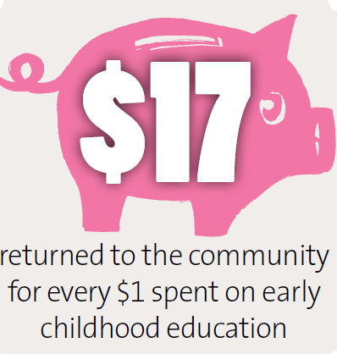
Quality early childhood education and care contributes to positive life outcomes for individuals and society as a whole.

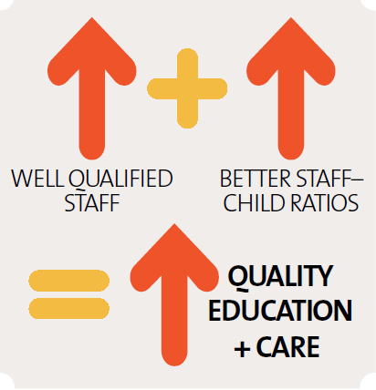
The provision of quality early childhood education and care must be the productivity inquiry’s main concern.

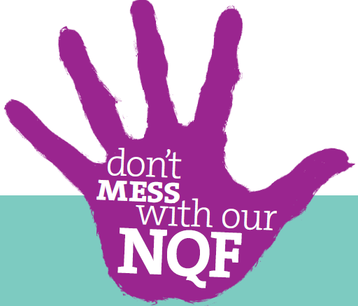
Quality early childhood education and care services have found any burdens from the NQF are far outweighed by the benefits.

Info Graphics sourced from Community Child Care Co-operative

- What are other countries doing?
In the United States;
500 Legislators Speak Up for Children
December 24, 2013
In what might be regarded as a timely gift to children, over 500 state legislators from 50 states sent an appeal to the Congressional Budget Committee to invest in early learning. In its introduction, the appeal states:
"As Democratic and Republican state legislators from across the country, we understand the challenges of balancing budgets while making critical investments that drive economic success for our constituents and states. We believe that maintaining and expanding high-quality early childhood education is an effective and efficient expenditure even when budgets are tight. We urge you to make these investments in young children a priority in your deliberations." Everyday Exchange Dec 2013.
Ted Melhuish (UK) – University of London. In the UK, they have accepted that early years spending is part of the gov'ts responsibility. Cuba has nearly 100% of children attending preschool. Also offer free health care for children and have a very low mortality rate in relation to other Latin American countries.
Iram Siraj-Blatchford (UK) – University of London. Iram’s research highlights that children attending 4-5 days of quality preschool from the age of 2 have a better start in life and better outcomes.
UK government is offering 240, 000 free positions in ECEC services the UK for 2 year olds.
Need good data sources that are useable for practitioners and support all business types to be informed.
Source; A Public Conversation 25/9/2013 held at the University of Wollongong.

Countries such as Sweden, Norway and Finland all invest heavily in quality early childhood education and care services at much greater affordability.

References

Community Child Care Co-operatives Info graphics Sources: 1. Committee for Economic Development, The Economic Promise of Investing in High-Quality Preschool: Using Early Education to Improve Economic Growth and Fiscal Sustainability of States and the Nation. 2006, Washington, DC; 2. University of Chicago economist James Heckman, via http://www.heckmanequation.org; 3. Hart & Risley (1995)

University of Wollongong, A Public Conversation 25/9/2013

Everyday Exchange, December 24, 2013

OECD, Education Indicator’s in Focus, 2013

Pricewaterhouse Coopers, 2011- A practical vision for early childhood education and care

