Submission to the Productivity Commission

Childcare and Early Learning

3 February 2014

Michael Tizard
Chief Executive Officer

The Creche and Kindergarten Association Limited t/a C&K
14 Edmondstone Street
Newmarket Queensland 4051
ABN: 59 150 737 849
TELEPHONE: 1800 177 092

Introduction
The Creche and Kindergarten Association Limited (C&K) thanks the Productivity Commission for the opportunity to provide input into the Childcare and Early Childhood Learning public inquiry.
C&K is a leading, not for profit early childhood education and care (ECEC) provider with more than 107 years of experience. C&K is proud to support more than 20,000 children, 6,000 families and 2,000 staff through our long day care and kindergarten services, family day care schemes, limited hours care, in home care and outside school hours care programs. C&K ensures that children come first, in all of its activities.
C&K’s Key Messages
This submission addresses the scope of the Commission’s Terms of Reference (TOR) and provides comments and recommendations where C&K has relevant experience, views and evidence. C&K wishes to deliver the following key messages to the Commission:

- It is imperative that the best interests of the child be the guiding principle against which any proposals for reform are tested.

- The short and long term benefits (social, emotional, academic and economic) of investing in ECEC are widely known and supported. Australia must increase investment in ECEC.

- Investment in ECEC must support accessibility and affordability for families. Evidence shows that access to a high quality ECEC program increases when parent’s out-of-pocket fees are low or no cost.

- Participation in ECEC programs continues to be lower for the most vulnerable children; therefore adequate investment is required to support families with children with a disability, living in disadvantaged communities, children at risk of abuse and neglect and children and families from culturally and linguistically diverse(CALD) backgrounds and Aboriginal and Torres Strait children and families.

- Co-ordinated Commonwealth, State and local Government involvement in ECEC policy, compliance and funding is critical to successfully implementing a universal approach to accessibility, affordability and quality of ECEC program delivery.

- The National Quality Framework is essential to maintaining minimum quality standards.

- Investment in developing and sustaining a professional ECEC workforce is the basis for delivering high quality ECEC services to families and further and ongoing investment will be required.

- Workforce participation will increase if families can access a high quality ECEC program that is affordable.

Terminology
C&K encourages the Commission to:
- use the term ‘early childhood education and care’ (ECEC) rather than ‘childcare’ as ECEC is internationally recognised and is also adopted nationally as part of the National Quality Framework (NQF) reforms. The term childcare has a primary focus on the needs of secondary stakeholders including parents, employers and government, rather than the child
- use the inclusive and gender-neutral term ‘primary caregiver’ in preference to ‘mother’
- widen the definition of ‘parent’ and ‘family’ to include care-givers, guardians, foster and kinship carer arrangements.

TOR 1 – The contribution that access to affordable, high quality childcare can make to increased participation in the workforce and optimising children’s learning and development
C&K believes that every child is entitled to access an affordable, high quality ECEC program from birth through to starting school.
In 2011, Australia’s contribution to pre-primary education as a percentage of Gross Domestic Product (GDP) was 0.1%, well short of the 0.8%+ invested by Denmark, Iceland, Israel, Luxembourg and Spain, countries that have significantly higher enrolments and outcomes than Australia. Source: http://www.oecd.org/edu/eag2013%20(eng)--FINAL%2020%20June%202013.pdf
In 2011 each of these countries had a higher enrolment rate at age 4 in early childhood education than Australia’s 67% (OECD average of 84%). Thirteen percent of Australian 3-year-olds are enrolled in early education programs, significantly lower than the OECD average of 67%. In a 2012 benchmarking study, Australia ranked 28 out of 45 nations by the Economist Intelligence Unit in its commitment to quality, accessibility and affordability of early education.
There is extensive research literature demonstrating the positive benefits of ECEC on children’s development and later life outcomes. For example, a longitudinal study conducted in Queensland showed that children who had attended a dedicated kindergarten program had higher levels of competence at entry in the preparatory year of schooling.
James Heckman, a Nobel Laureate in Economics and internationally renowned expert in the economics of human development, is a leading advocate and campaigner for investment in early childhood development, to see greater returns in education, health and productivity. He recommends a ‘sooner the better’ approach:
“The highest rate of return in early childhood development comes from investing as early as possible, from birth through age five, in disadvantaged families. Starting at age three of four is too little too late, as it fails to recognise that skills beget skills in a complementary and dynamic way. Efforts should focus on the first years for the greatest efficiency and effectiveness. The best investment is in quality early childhood development from birth to five for disadvantaged children and their families” (James J Heckman, December 7, 2012).
Twenty-two percent of Australian children are starting school developmentally vulnerable, based on the Australian Early Development Index. Evidence from international testing programs such as the Programme for International Student Assessment (PISA) shows that children from low socioeconomic backgrounds can be 2 years behind their same age cohort on starting school.
Universal access to quality ECEC services for all children from birth will bring life-long benefits for the individual child, their family, and society. The research notes the critical importance of the first 3 years of a child’s life, and while C&K supports universal access to early education programs for 4-year olds in the year prior to schooling, it is clear that additional benefits could be achieved through earlier support, particularly for those living in poverty, indigenous children, children with disabilities, children with additional needs and children with culturally and linguistically diverse backgrounds.
Recommendation
  - Australia needs to continue to increase its investment in early childhood education and care to improve universal access and participation for vulnerable and at risk children and improve its ranking with the top performing OECD countries in this area.

TOR 2 – the current and future need for ECEC in Australia
C&K holds a unique place in the sector as it operates seven types of ECEC programs:
- Stand-alone Kindergartens and Kindergarten Programs integrated into Long Day Care
- Long Day Care
- Family Day Care
- Limited Hours Care
- In Home Care
- Outside School Hours Care
- Integrated Children and Family Centres (e.g. Mackay Children and Family Centre).
Types of childcare available and hours of operation
- Kindergarten
As Queensland’s leading provider of kindergarten programs (delivered in the year prior to Prep) and operates 186 Affiliates, 5 Associates and 140 Branch kindergartens.
C&K services have, on average, maintained high occupancy rates and waitlists in some areas despite an extra 150 services (or 6,600 places) being established and kindergarten programs being introduced into long day care services in 2010. C&K kindergarten services provide a part-time early childhood education program (600 hours per year) operating only during school terms. Generally the opening hours are consistent with school hours, although some services offer two long days (7½-hours) and three shorter days (5-hours) to provide increased flexibility and choice for families.
C&K’s enrolment history demonstrates that this part-time model of ECEC remains relevant and meets the needs of many families who may have some of the following lifestyles: stay at home care-giver; parents who work from home; parents who work flexible or part-time hours; involvement of extended family members (i.e. grandparents who assist with drop off and pick up); or families who use other forms of care such as family day care together the kindergarten program.
These families report that they prefer and choose the C&K model over the long day care approach for a number of reasons including: the primary focus on the best interests of the child in terms of early education; consistency of children in the group (not different children enrolled on different days); and consistency of staff (the same teacher and assistant with the children the entire day, and year and low turn-over of staff).

Some C&K services have reported a demand for after-kindergarten care in the afternoons. As such, C&K would support investigating extended hours kindergarten models to build greater flexibility for kindergarten services to meet the needs of families, while still offering a quality early education program. Where kindergarten services are co-located on schools sites that provide Outside School Hours Care (OSHC) services, kindergarten-age children have been able to access such services in Queensland since 2012. It is C&K’s view that those OSHC services providing dedicated and separate areas for younger (e.g. kindergarten to Year 3) and older (year 4 to 7) children, provide a higher quality service that is in the best interests of the children. Where OSHC is not available or not suitable for kindergarten-age children, C&K would support delivering extended hours kindergarten models to better meet the needs of working families.

Recommendations
  - That given the high quality of service provision offered and the high demand in many areas for the kindergarten model, that this model be maintained as part of Australia’s early childhood education and care system.
  - That consideration is given to further developing the kindergarten model to increase the flexibility of hours of care offered, such as extended hours kindergarten and integration and co-location of kindergartens with OSHC and other early childhood and family support services.

- Long day care
C&K operates 29 long day care (LDC) services. Enrolment patterns in C&K LDCs show that most families enrol their child for two to three day per week and balance the LDC ECEC program with other care providers e.g. grandparents. The table below shows the number of days per week that children are enrolled in C&K long day care services and demonstrates a similar pattern for both metropolitan and rural services.
Service Location | Number of children enrolled
 | 1 day / week | 2 days / week | 3 days / week | 4 days / week | 5 days / week | Average Enrolment Booking
Metropolitan | 9 | 19 | 20 | 8 | 2 | 2.6 days
Rural | 19 | 32 | 9 | 2 | 5 | 2.1 days
All of C&K’s LDCs incorporate a kindergarten program that operates for 600 hours per year, enabling quality ECEC delivery while meeting needs of working families.
Recommendation
2.3 C&K support the LDC model with kindergarten programs incorporated as this model appears relevant in both metropolitan and rural communities.
Integrated models of service delivery
C&K supports centre based and mobile integrated models of service delivery, where families can access ECEC, maternal and child health care, family support and parenting and family support at the one service. There are numerous models across Australia such as the integrated child and family centres in Queensland (Early Years Centres), South Australia, Victoria and Tasmania and the federally funded Child and Family Centres (10 operating across Queensland) and programs such as Sure Start in the UK to explore. C&K operates one of these Child and Family Centres in Mackay. These models are based on partnership, co-location and joint planning and offer a ‘one stop shop’ for parents where a range of early childhood and family support programs are offered. . In some instances packaging funding differently can facilitate partnership and more integrated service delivery, improved service access and better outcomes for families and children.
The integrated service model helps to meet the needs of our most vulnerable children by providing a range of ‘soft entry’ points for difficult to engage and at risk families and children. Centre based and mobile models mean that services can be offered in a range of locations that help parents become engaged with the services and target those parents that may not normally access services.
Recommendation
2.4 That the Australian Government and State Governments explore the option of increasing the number of integrated child and family centres incorporating early childhood education and care, early childhood health, family support and parenting programs.
Rural, regional and remote ECEC services
While surplus or profit can be made operating services in metropolitan areas, it is more difficult to operate at a surplus or break even in regional and remote areas, resulting in reduced or limited ECEC options in such areas. The table below indicates the number of C&K Kindergarten services located in Brisbane, regional areas and remote areas.

Service Type | Brisbane | Regional | Remote
Associate | 2 | 1 | 2
Affiliate | 53 | 103 | 30
Branch | 31 | 98 | 11
Total | 86 | 202 | 43
Percentage | 26% | 61% | 13%

Flexible funding and different service delivery models may need to be considered for regional and remote services, including integrated child and family centres and long day care models including kindergarten without the rigid age criteria for kindergarten funding.
In very small communities, family day care or in home care often represents the only viable ECEC service. Strong partnerships with visiting groups like Remote Area Family Service and playgroups can help to provide opportunities for peer interaction among young children. As a not-for-profit organisation, C&K derives a surplus at services where it is viable to do so, so that it can continue to subsidise services in disadvantaged communities that would otherwise close.
ECEC services in rural and remote areas have difficulty attracting and retaining suitably qualified staff. Initiatives to support the attainment of qualifications and to financially support and reward staff moving to rural and remote locations have, to date, had minimal effect on improving the recruitment of staff in these areas. C&K requests the Productivity Commission to consider the following.2.5 Additional funding to support the payment of higher wages to staff located in rural, remote or mining locations
Recommendations
2.5 Partnerships between ECEC services and state education departments / schools to recruit and access qualified ECEC teachers to work part-time across the ECEC service and the local state school
2.6 Allow assistants to enrol in an ECEC course within 3 months of commencing a position.
Access to affordable ECEC services
A number of C&K parents have raised concerns about the cost of ECEC. During 2013, C&K experienced a significant increase in overdue fees and a number of families removed their child from the ECEC service due to financial pressures.
The current level of funding for ECEC services is insufficient. The Child Care Benefit (CCB) available to families has not kept up with the rising cost of living, wages and increasing fees. The Child Care Rebate (CCR) has not increased since 2011. Parents take the amount of rebate and subsidy into account when determining the number of days they will enrol their child into an ECEC service.
The current CCB and CCR payment systems are confusing and difficult for families to compare their out of pocket expenses for different ECEC service types. Anecdotally, families have informed C&K that some LDCs seek higher fees and payment for longer hours than that required by the family (e.g. charging for a day of education and care when a shorter session is required).
Pricing is complex and depends upon multiple factors such as government funding, location, population of eligible age children, utilisation, proximity of competitors and staffing costs. C&K is committed to paying its educators wages that are comparable to those received by educators in the state school system, which is higher than those under the modern award for the sector.
Recommendations
2.7 C&K strongly support the premise that affordability should be equalised across all ECEC service types, with out of pocket expenses for families comparable across different ECEC service types.
2.8 Eligibility of government subsidies should not be based on ECEC service type. A single payment system across all ECEC service types that allows parents to choose the ECEC program best suited to their child’s needs and obtain comparable benefits would be greatly welcomed.
The needs of vulnerable or at risk children
Participation continues to be lower for the most vulnerable children in Australia, therefore adequate funding is required to implement innovative and flexible programs and services that encourage families with children with a disability, living in disadvantaged communities, children at risk of abuse and neglect and children and families from culturally and linguistically diverse (CALD) backgrounds and Aboriginal and / or Torres Strait children and families to access ECEC programs.
Despite Queensland’s rapidly growing kindergarten participation rate, in 2012, 23 per cent of eligible children did not access a kindergarten program. Across all forms of ECEC, participation is lower for the most vulnerable children, that is, children from low socioeconomic backgrounds, Aboriginal and Torres Strait Islander children, children with a disability, children with additional needs and children from CALD backgrounds.
C&K has observed that there is an increasing complexity of children’s needs. In the area of supporting children with disability, there are pockets of success, where services have essentially specialised in providing an inclusive service for a particular disability and gained a reputation as a service of choice among that disability group. For example C&K is aware of a service with a reputation for providing quality programs for children with autism and has a high percentage of children with autism enrolled at the service. However, there is a risk that an over representation of one group of children in a service moves it away from a mainstream service. With several children meeting a diagnosis for autism, the service is able to access extra funding from government that enables the engagement of extra support staff. With only one child with disability at the service, the funding would not be sufficient to engage a full-time support worker.
Our Affiliate Services often need to fundraise to meet the extra costs of providing inclusive programs for children with disability and other high support needs. In addition some existing staff members report that they are not confident they possess the highly specialised skills needed when they have one or more child with a disability or additional needs in their group. Currently, funding for children with disability is dependent on a diagnosis and for very young children this is not always available, particularly in regional and remote areas. Some families withdraw their child from a service when there is inadequate support for a child with additional needs who can become a danger to themselves and others.
In 2013, the Australian Government changed its guidelines for Inclusion Support Services (ISS). Historically, ISS has not been available to preschool/kindergarten services; only children with disability attending a long day care service are eligible for support. In 2013, the Australian Government broadened the definition of preschool/kindergarten service to include preschool/kindergarten programs offered at long day care services. This means a child attending a kindergarten program for part of the day though their LDC is not eligible for ISS during this period of enrolment. This change has added unnecessary complexity to an already complex system and denied children with disability access to inclusion support at a mainstream long day care service because it is providing a high quality early education program. Notably, it is now a requirement for all long day care services to provide an early education program based on the Early Years Learning Framework (EYLF) and engage a qualified early childhood teacher– regardless of whether it’s called kindergarten or preschool or early learning or child care. It is C&K’s view that ISS should be available to all children with disability regardless of their choice of ECEC service.
Recommendations
2.9 C&K encourage the Government to increase funding levels for inclusion support and explore how to expand the inclusion support model to adequately provide for more vulnerable children entering the ECEC. We note that National Disability Insurance scheme will result in an increase of funding in the disability service system and the capacity of carers to access additional support services.
2.10 In relation to at risk children, children from Aboriginal and Torres Strait Islander and CALD communities refer to text at “Integrated Models of Service Delivery and recommendation 2.4”.
2.11 It is important that Government recognises that a one size fits all approach will not work as the needs of communities and client groups varies. We support design, trial and evaluation of a range of varied service delivery approaches and models.

TOR 3 - International models of ECEC
C&K is aware of and supports the Productivity Commission’s intention to research overseas models of ECEC.
The Scandinavian countries of Norway and Sweden focus on supporting families to educate and care for their children until 2 years of age, after which time financial support is provided to families to access high quality and affordable ECEC until their child commences school. (http://www.norden.org/en/publications/publikationer/2011-562)
In Italy, the Reggio Emilia approach promotes greater staff to child ratios and visiting specialist teachers. (http://www.reggiochildren.it/?lang=en)
New Zealand’s home-based care program is similar to Australia’s in-home care model. However, the New Zealand model is targeted at families and children meeting specific inclusion criteria, for example, a child with a disability, multiple births of triplets or more and where there is a lack or unsuitability of mainstream ECEC services. (http://www.lead.ece.govt.nz/ManagementInformation/EstablishingAnECEService/EstablishingAHomeBasedService.aspx)
Recommendation
3.1 C&K request that the Productivity Commission investigate the ECEC models used in Scandinavia, Italy and New Zealand.

TOR 4 – Options for enhancing the choices available to Australian families as to how they receive ECEC support
Any funding model must be highly flexible to enable families to choose the ECEC program of their choice rather than the program that is most affordable. In an equitable system, the out-of-pocket costs of each ECEC option would be comparable for families of similar income levels.
In small communities, a multi-age room operating long day care hours is likely to be the most viable ECEC option as there are often insufficient children to maximise enrolments in any one age group. If the service engages a qualified early years’ teacher, kindergarten-age children can access an approved kindergarten program prior to school, while younger children receive age-appropriate education programs. Fee models for these services need to be flexible, so families only pay for the service they need (e.g. part-day ECEC or full-day ECEC). These services require a higher level of operational funding support as the number of enrolments and thus daily fees, are generally insufficient to meet operating costs.
C&K believes that it is essential that affordable and quality education and care programs are available with subsidies to offset the out-of-pocket expenses for families. An ideal outcome would be that a broad range of ECEC services providing inclusive programs for all, regardless of a family’s ability to pay or their employment circumstances are readily accessible.
Recommendations
4.1 The Commission could consider a funding scheme whereby current funding for parental leave, preschool and child care is centrally held and accessed. Potentially up to 600 hours per year of quality ECEC could be available to all children from 12 months of age, or at least for children from disadvantaged families. With the introduction of paid parental leave, there is likely to be less demand for ECEC from external providers in the first 12 months of a child’s life. From age 12 months, the universal entitlement to ECEC programs could be provided by a range of service providers, provided quality requirements are met.
4.2 Vouchers or an access card could be provided to parents to use at any NQF service of their choice (including in-home care in the future) to access their universal entitlement for children aged 12 months to school age, with top up of fees paid for any additional education and care that is required. It is likely that ECEC fees would need to be regulated for a core, quality service to avoid price gouging. ECEC services may then choose to add extras to their core offering such as language lessons but the cost of these added extras would need to be met by families opting for the service.
4.3 Families who choose to care for their own children could claim the voucher as part of their annual tax return thereby reflecting the valid and different choices families make in raising their children. Families participating in work, study or training would continue to be able to access additional assistance to meet the costs of ECEC. It is suggested that any fee subsidies be provided directly to the service, with parents paying the fee gap as an out-of-pocket expense (similar to the approach with Medicare).
TOR 5 – Benefits and other impacts of regulatory change in the ECEC sector
C&K welcomes and strongly supports the National Quality Framework (NQF) as it provides clear and consistent standards for ECEC service delivery. The impact of the NQF on C&K services has been minimal, as most C&K services were already operating well above the minimum standards prescribed in the NQF. The table below shows the national assessment and rating summary for C&K services through to August 2013.
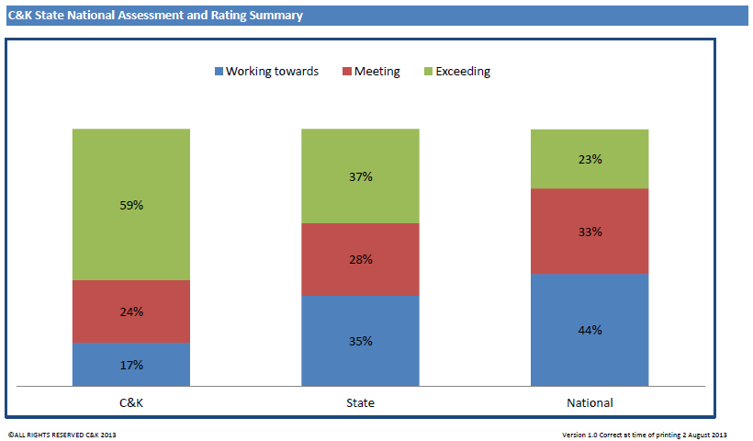
C&K believes that there will be significant impact on services when the ratio for 2 – 3 year olds changes from 1:8 to 1:5 in 2016. Sourcing appropriately qualified staff may prove difficult and the additional wages required to meet this ratio will result in increased daily fees if the current funding system remains unchanged.
As previously noted, there is difficultly attracting staff members to rural and remote areas. Under the NQF a Certified Supervisor is always required to be on site. This requirement can be difficult to meet in rural and remote areas as the sole Nominated Supervisor needs to work the full opening hours of the service to keep it complaint with the legislation.
C&K has concerns about the ability to engage a primary school teacher for 12 weeks under relief arrangements in the NQF.
Recommendations
5.1 C&K recommend that the NQF in relation to qualification requirements in rural and remote communities be reviewed to allow greater flexibility where staff with qualifications are not available or are undertaking recognised training.
5.2 C&K recommend that the NQF allow for the hiring of a relief educator with ECEC experience, in the first instance, rather than a teacher with no ECEC experience. In this regard, C&K would seek to give preference to a Diploma level qualified ECEC educator.
Government involvement in ECEC
C&K believes that the Commonwealth Government has a clear role to set ECEC policy directions, monitor and enforce compliance as well as provide adequate ECEC funding to services and / or families. It also falls within the Commonwealth’s responsibility to ensure staff members working in the ECEC sector are remunerated appropriately and in alignment with the professional qualifications that they hold.
C&K supports the role of state and territory governments as regulators of ECEC services under the National Law. C&K also supports local governments as the assessors and approvers of building planning and development applications for new and extended ECEC services.
In addition, C&K supports partnerships between all levels of governments to facilitate the delivery of quality ECEC programs in geographical areas of market failure, particularly in small, rural and remote communities. Local and State Government could provide an appropriate facility (with financial support from the Commonwealth) and engage an experienced ECEC approved provider to operate the service for the local community. This latter approach is similar to the Queensland Government’s strategy for providing universal access to kindergarten programs. The Government has constructed more than 150 high quality ECEC facilities on state school sites since 2010 and then leased these services to C&K and other experienced ECEC approved-providers to operate kindergarten and/or early learning and care centres.
With the Commonwealth focused on birth to school age, and the state and territory governments on school age, both levels of governments must work together to facilitate transitions from the ECEC sector to school.
Under the NQF, educators must be enrolled in their course before starting work. However, it would be beneficial for staff to gain some in-service experience to see if ECEC is the career field for them, before going through the expense of enrolling in a qualification. Historically, Queensland has found the requirement to be enrolled in an appropriate course within 3 months of starting work sufficient to identify those staff with an aptitude and desire to continue to work in the ECEC sector.
C&K notes that under current workplace agreements, teachers/educators in long day care services have the least non-contact time (as little as two hours per week), yet these teachers/educators have the largest number of children to plan and report on. In C&K kindergarten services with two stable groups of children attending each week, generally there are no more than 48 children to educate in a year. However, there may be up to 60 kindergarten children in a long day care service in any one-week period.
A recent market research study conducted by an independent research agency on behalf of C&K shows that parents value the standard of care provided by educators, the environment created by the service staff and how the program prepares their child for Prep / primary school the most, when deciding where to enrol their child. The study also determined that parents typically equate the quality of a service with the quality of the staff employed at the service. This is vitally important when analysing possible ECEC workforce initiatives.
Recommendation
5.3 C&K suggest that the amount of non-contact or programming time available to educators listed in the modern award needs to take account of the number of children attending each week.

APPENDIX TABLE OF CONTENTS
APPENDIX A: SURVEY FEEDBACK FROM C&K AFFILIATE SERVICES | 18
APPENDIX B: SUGGESTED RESEARCH | 37

APPENDIX A: SURVEY FEEDBACK FROM C&K AFFILIATE SERVICES
In December 2013, C&K surveyed its affiliate kindergartens, requesting feedback on the questions asked in the Productivity Commission’s Childcare and Early Learning Issues Paper. The responses are detailed below. It is worthwhile noting that C&K affiliate services are independent incorporated associations that are managed by an elected, volunteer parent management committee. The names of the service and contact details have been withheld for privacy reasons; the Productivity Commission can contact C&K for these details if they require them.
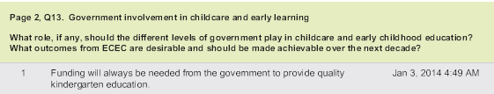
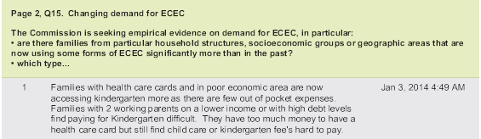
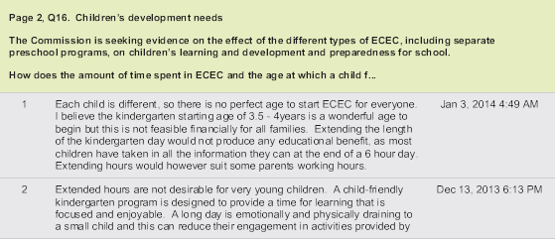
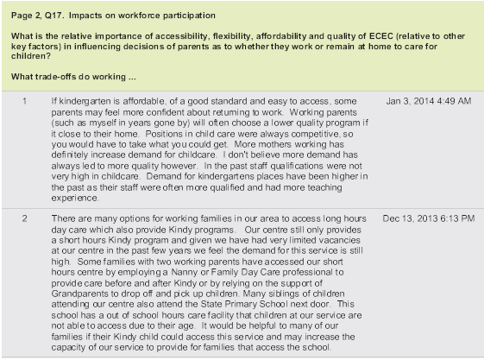
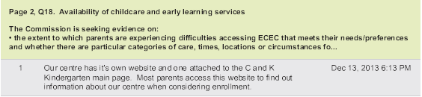
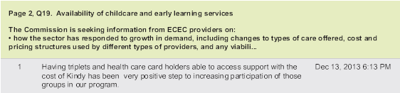
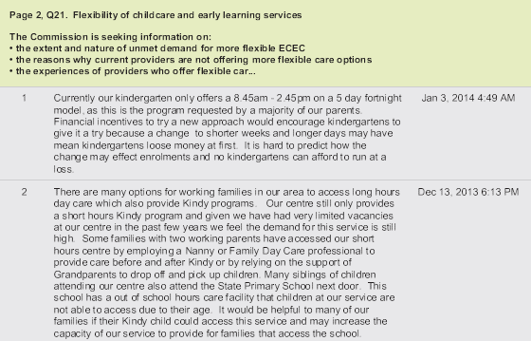
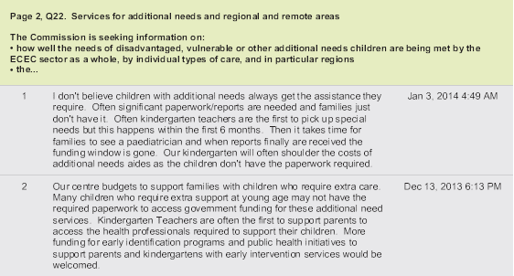
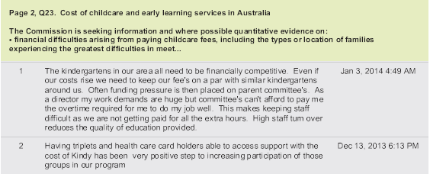
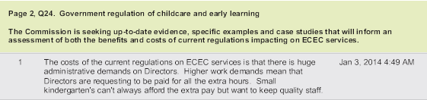
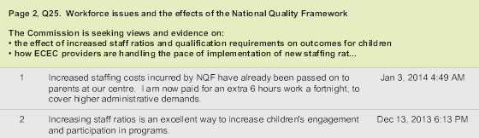
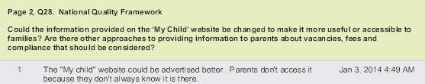
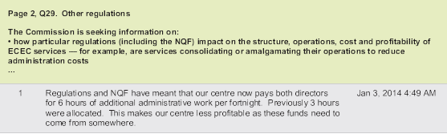
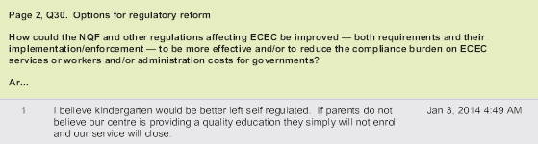
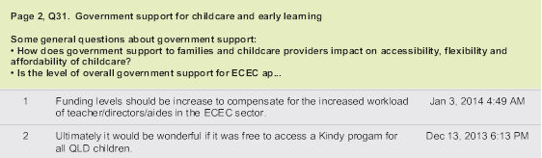
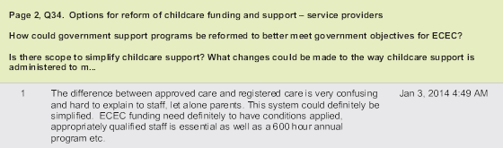
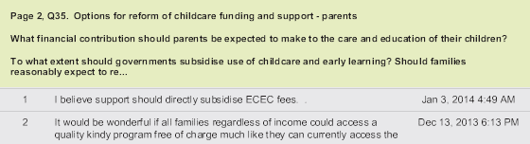
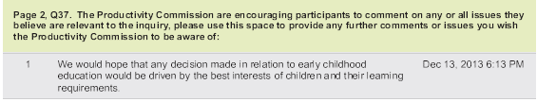

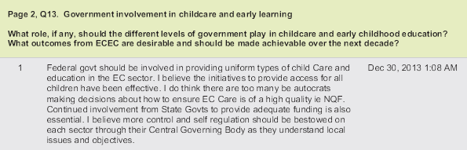
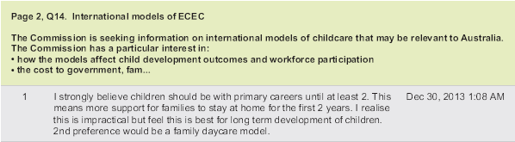
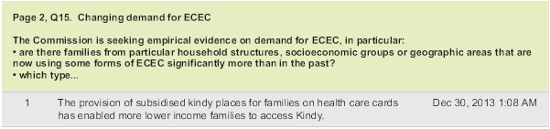
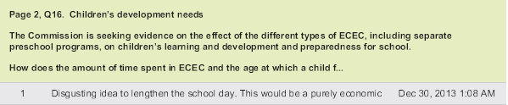
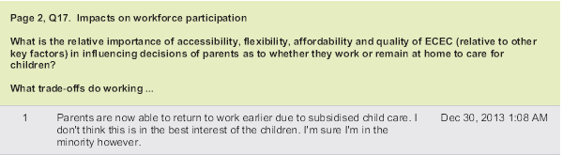

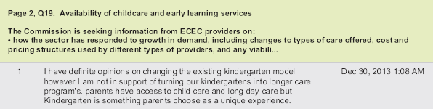
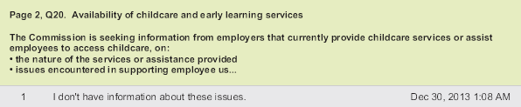
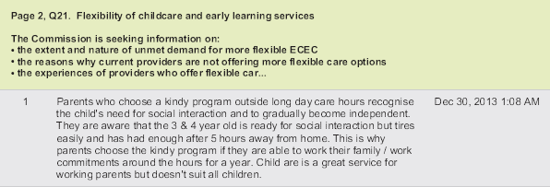
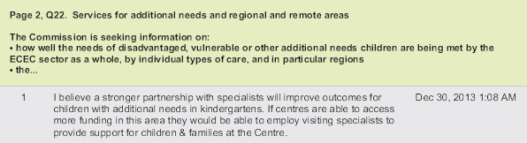
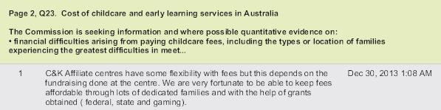
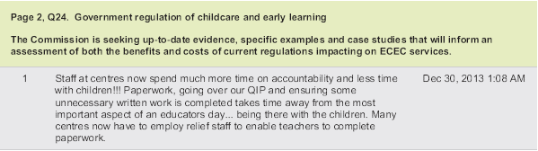
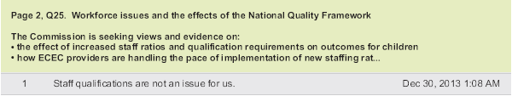
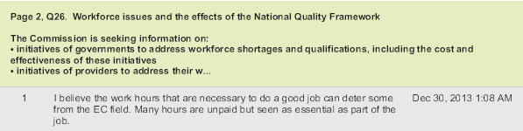
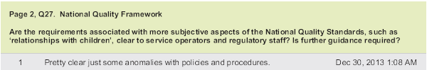
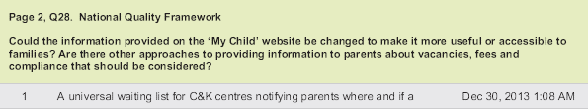
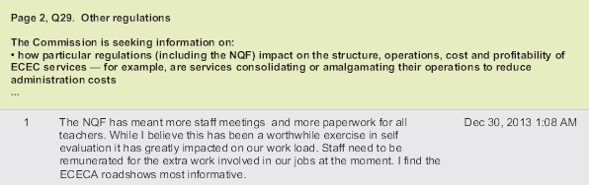
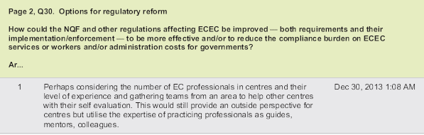
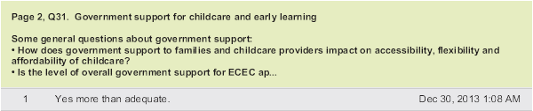
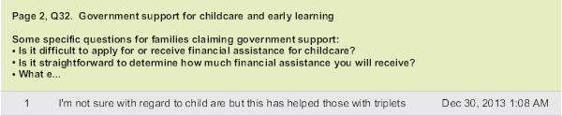
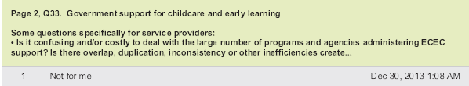
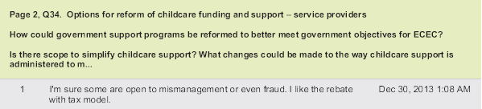
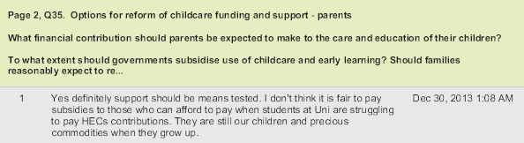
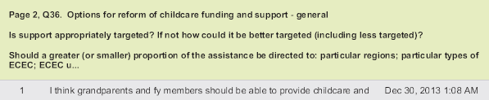
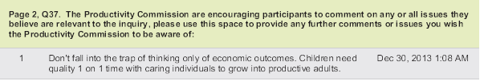

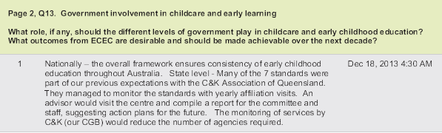
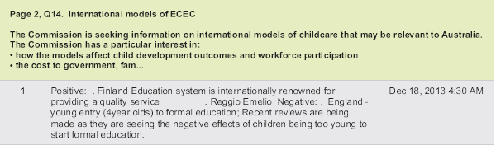
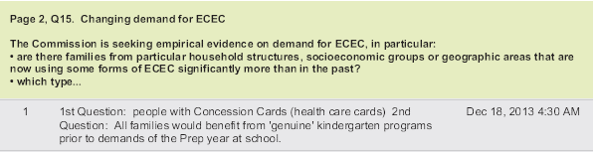
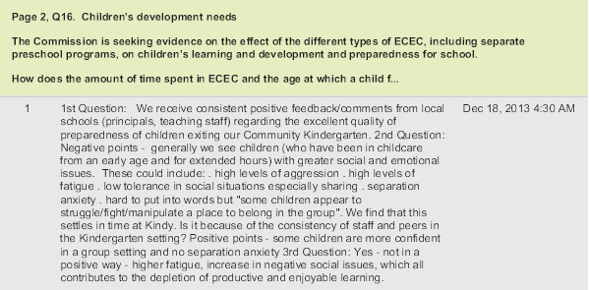
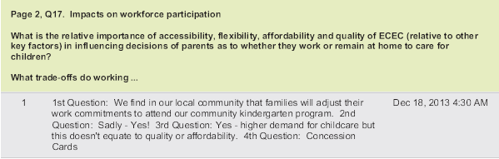
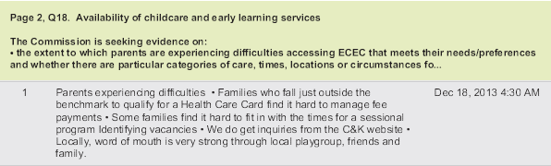
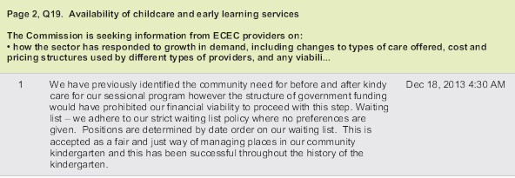
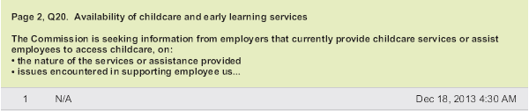
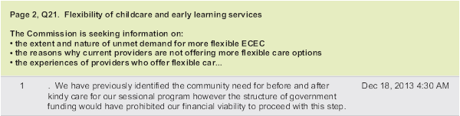
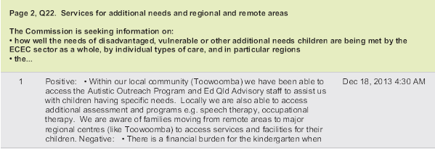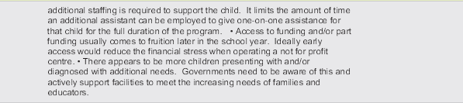
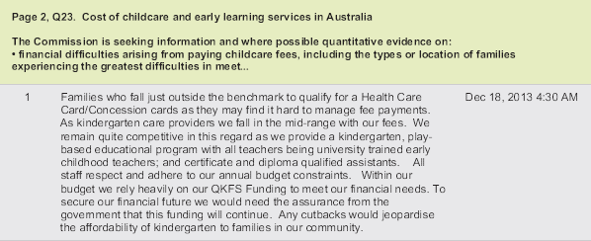
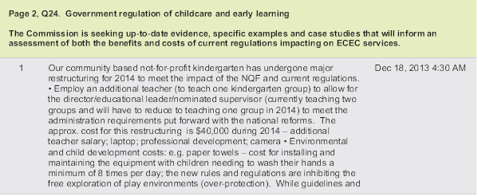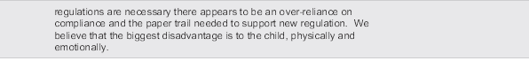
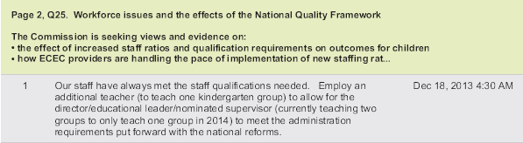
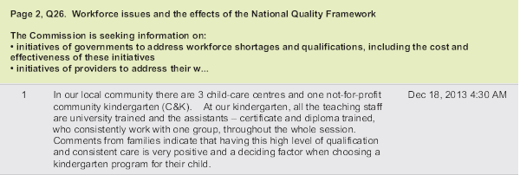
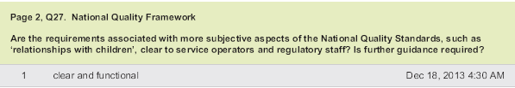
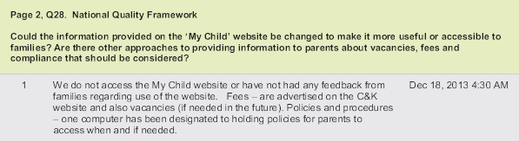
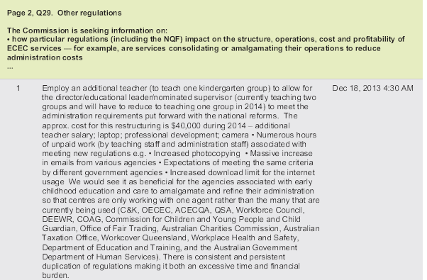
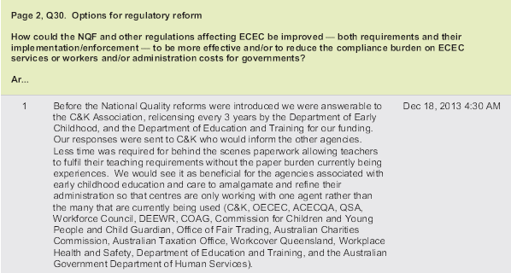
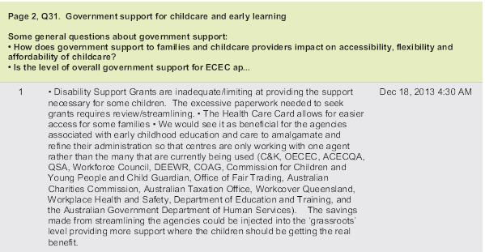
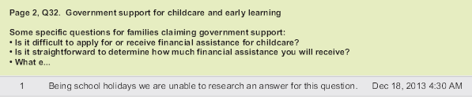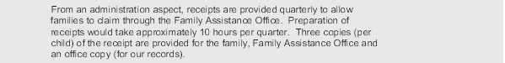
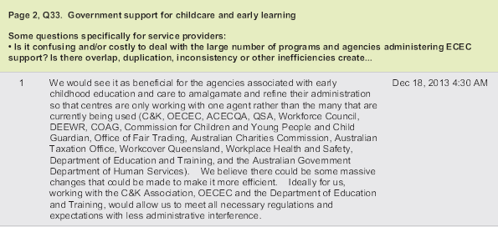
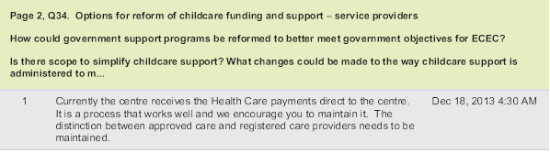
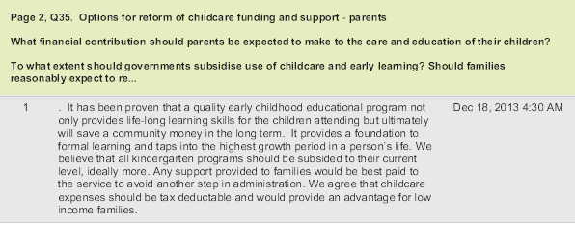
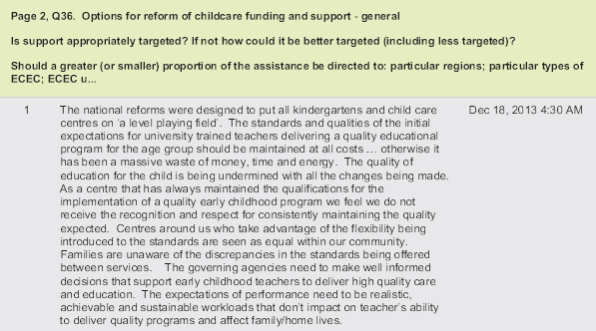
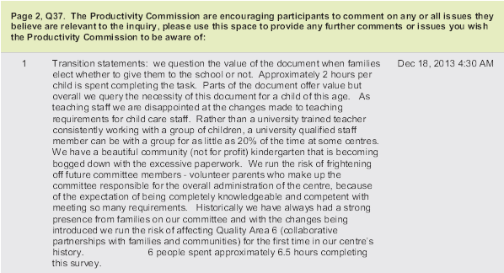

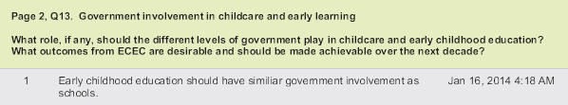
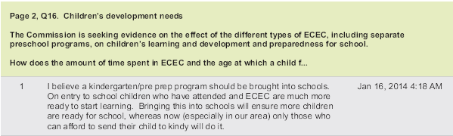
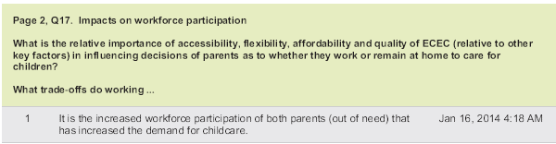
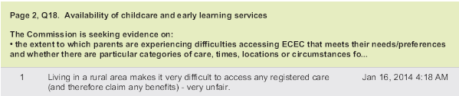
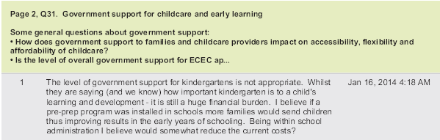
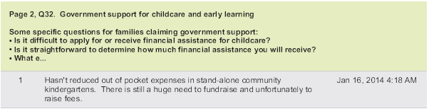
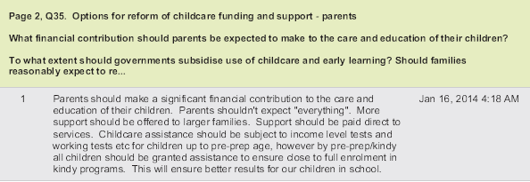
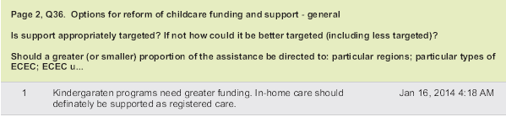

APPENDIX B: SUGGESTED RESEARCH
Suggested references for the Productivity Commission to review and consider include:
- Heckman 101 – How to invest in early childhood development for better education, health and economic returns – www.heckmanequation.org
- Organisation for Economic Cooperation and Development (OECD) including Starting Strong Reports and Education at a Glance Reports – www.oecd.org/education
- The Scottish Government (March, 2013). Early childhood education and care provision: International review of policy, delivery and funding - www.scotland.gov.uk/Publications/2013/03/4564/5
- Longitudinal studies of Australian children and Indigenous children (visit http://www.growingupinaustralia.gov.au and http://www.dss.gov.au
- Effective Early Educational Experiences (E4Kids) Australian Research Council study by the University of Melbourne and Queensland University of Technology (visit http://education.unimelb.edu.au/news_and_activities/projects/E4Kids#about)
- Rutter, Evans and Singler (December 2012). Supporting London local government to deliver free early education for disadvantaged two-year-olds -http://www.londoncouncils.gov.uk/policylobbying/children/publications/twoyearoldentitlment.htm
- Victorian Government (December 2004). Breaking cycles, building futures. Promoting inclusion of vulnerable families in antenatal and universal early childhood services: A report on the first three stages of the project - http://www.healthinfonet.ecu.edu.au/key-resources/bibliography/?lid=3504
- Preparing for school: Report of the Queensland Preparing for School Trials 2003/4 by Thorpe, Karen J. and Tayler, Collette P. and Bridgstock, Ruth S. and Grieshaber, Susan J. and Skoien, Petra V. and Danby, Susan J. and Petriwskyj, Anne (2004) - http://eprints.qut.edu.au/10192/1/10192.pdf
- The factors that influence kindergarten participation in Queensland – http://deta.qld.gov.au/earlychildhood/pdfs/access-report.pdf
- E4Kids Study - http://education.unimelb.edu.au/news_and_activities/projects/E4Kids

