Collaroy Plateau Community Kindergarten Inc.  41-43 Hall Avenue, Collaroy Plateau 2097  Phone/Fax: 9982-6167  ABN : 64 679 495 807  Email: cpck@optusnet.com.au  Website: www.cpck.com.au | 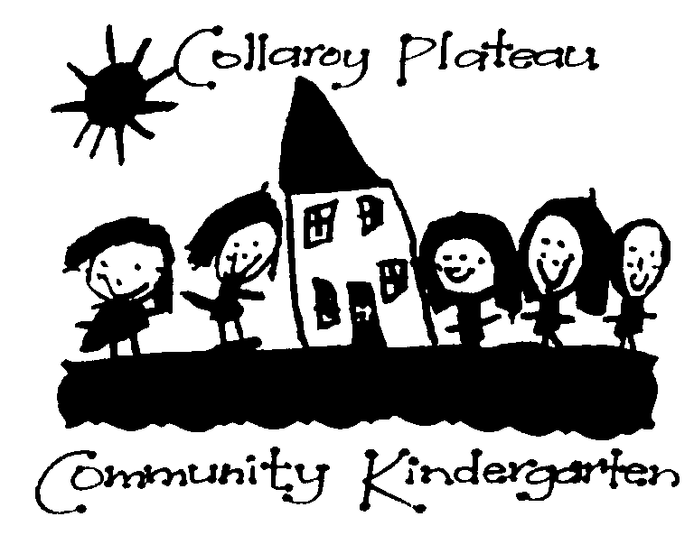

Friday 15th August, 2014

To whom it may concern,

I am a 4 year Early Childhood qualified teacher who is currently Teacher/Director at a Community operated Kindergarten providing a Preschool program for 80 children per week. I have managed and taught in Community based services since 1985 in addition to spending time in both Qld and NSW in both Preschool/Kindergarten and Long Day Care based children’s services.

While I am pleased that there has been an inquiry into the Early Childhood Education and Care sector and that there are a lot of findings and suggestions that do have some children’s best interests as the focus, there are a number of items that do not make sense. These nonsensical items are items that should not be implemented.

Care and education are integrated and a child cannot be classified as learning simply by reaching a particular age. Highly qualified staff are needed for all children, babies included, particularly when these babies are in group care. Research has shown that the first 5-8 years are the most impressionable and formative years in a child’s life. This is why this age group require highly qualified staff to ensure that young children are given the best start in life, particularly if they are spending long periods of time away from their primary caregivers- their parents. Highly qualified educators enable high quality care, education and relationships to be developed and maintained. While Certificate 111 qualified staff are capable in their ability to work with young children, it is from my experience that I have observed that they require guidance from a higher qualified staff member in regard to planning, documentation, professionalism, modelling and in managing groups of children in centre based care.

If dedicated Preschools are to be removed from the National Quality Framework then what framework will they be placed under? The NSW school curriculum - My time our place- framework for school age care? How much more will this cost in ‘training’ teachers and educators for a new framework? The NQF has ensured high quality across all early childhood services and huge amounts of money have been poured into this with huge amounts of time, effort and dedication shown by Early Childhood teachers and educators. Why remove it- particularly since it is a working model proven to enthuse, guide and inspire all who work within the early childhood field.

Community based Kindergartens and Preschools have been providing early education and care since the early 1900’s if not before. They offer a proven model of early education which remain in high demand today. These services are operating on low funding provided by the NSW state government with no other support other that a strong sense of community ownership and effort provided by volunteer parents and lower rentals in certain situations provided by local government. They need to be funded similarly to public schools, qualified degree trained teachers need to be remunerated to the same level as teachers in the Department of Education system and if Preschools are to be removed from the NQF and placed within the school structure system, then I would expect this to occur.

It appears that Preschools and Kindergartens are caught between two systems: the school state funded and supported system and the federally funded child care system. The actual system that Preschools and Kindergartens operate within is one of Education and Care and so they sit well and operate similarly to Education department run Preschools – so I believe that it is best for them to be funded similarly but still fall under the National Quality Framework as this system has proven it’s ability to lift quality and guide professionals in their teaching, care and work with children.

Community based Kindergartens and Preschools provide early education and care within a model that ensures children and parents can develop friendships, connections and support networks. This is due to the ability of community preschool and kindergartens offering the same days, the same hours, the same teachers and educators and the same group of children on any given day. Such a model allows for predictability, a sense of belonging and continuity in preschool learning. Due to poor funding in NSW of Community based Kindergartens and Preschools, one of the major issues facing parents is that fees at Community based Kindergartens and Preschools are high and because there is no child care benefit, parents are losing the opportunity to choose an early education service for their children.

Some parents choose approved care with longer hours and CCB whether they need it or not. The choices that some parents make are not related to work or study needs. If CCB and CCR are to become means tested, I would expect that subsidised care and education will be extended to Community based Preschools and Kindergartens also. If it is not to be extended to Community based Preschools and Kindergartens, then the current CCR should be retained as this assists a little in demonstrating some support for parents who use these services.

Not for profit services providing education and care need to keep their tax concessions and their peppercorn rates of rent to ensure they remain viable, after all, these services are providing so much more than the meagre funding they receive and they are providing a community service that benefits all of society. They provide high quality education to children with additional needs, to parents and families and to the general community.

In conclusion, it is my belief that Community based Kindergartens and Preschools dedicated to providing a preschool curriculum should see their qualified teachers and staff remunerated to the same level as qualified teachers and staff in the public school system. This will address staff shortages and entice new graduates to choose Preschool teaching as a career. Community based Kindergartens and Preschools must retain National Quality Framework participation, retain peppercorn rates offered by local council, retain tax concessions for education based services and either be funded similarly to Department of education operated preschools or become more adequately funded or be placed under the CCB system to ensure equity for all parents.

This submission has been based upon my own experience, observation and participation in predominantly community operated early childhood education and care services over a period of 28 years.

Susan Sorensen

