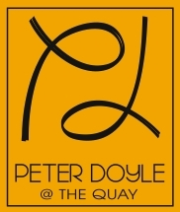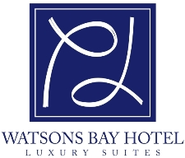

Friday, 23 March 2012

Default Superannuation in Modern Awards
Productivity Commission
LB2 Collins Street East
MELBOURNE VIC 8003

Productivity Commission Inquiry – Default Superannuation in Modern Awards

My family is the owner of a well established restaurant at Circular Quay in Sydney New South Wales. The restaurant itself is synonymous with seafood excellence, stretching back more than a century.
From my perspective it is important to partner with businesses that align with the values of my business and importantly represent a quality experience when it comes to service.
In selecting a default superannuation fund it is important to me that I don’t get bogged down with any administrative burdens and that the fund meets the basic requirements set out of a business on a legislative basis.
The restaurant industry is extremely busy and it is hard to find the time to look for relevant funds and ensure my staffs are happy with their choices.
Industry funds and those set out in the award system such as HOSTPLUS make it very easy for me to run my business and let me get on with the everyday challenges I face to remain profitable.
The thought of looking at a long list of funds and being across them all is a daunting one when it comes to selecting one as my default option.
The system in place has served me well to here and has met both the needs of my business and my employees.

Insofar as change is necessary, it should be change that ensures the businesses I operate and my staffs are protected. The choice of default superannuation fund is important. Only those funds that have demonstrated a capacity to work in my industry and deliver superior services and results should be trusted to handle our superannuation needs.

Yours faithfully,

Peter Doyle OAM

