Friday, 6 June 2014

Dear Commissioners
The Productivity Commission has been requested by the Federal Treasurer to undertake a public inquiry (Inquiry) into the efficacy of current national natural disaster funding arrangements.
Natural disaster risks are complex and catastrophes are costly; re/insurance plays an important role in managing natural disaster risk. As a global reinsurer operating in Australia, Swiss Re provides large capacities to cope with major natural catastrophes and to manage multiple large risks (refer Appendix 1). As such, Swiss Re is pleased to submit the following recommendations for consideration by the Productivity Commission.
The scope of the Inquiry includes the following key topics:
- Role and responsibilities for risk management
- Providing incentives for effective risk management
- Providing incentives to use insurance
Swiss Re recommends a principles-based approach to the assessment of the current Commonwealth, State and Territory government expenditures on natural disaster mitigation, resilience and recovery and funding arrangements. This means establishing key operating principles, without yet considering the status quo, and then assessing the changes required to adjust current practices to better follow these key risk management principles. We also recommend this approach is applied at Local government level.
Taking this approach is a critical first-step so as to inform a full understanding of the risks and costs. This fundamental understanding needs to be in place so that the most appropriate risk management solutions can be determined and effectively applied.
Swiss Re recommends the adoption of a risk management framework comprising four key principles through which to assess the efficacy of current national natural disaster funding arrangements. The four principles are:
- Risk identification
- Risk ownership/stewardship
- Risk mapping – current and future
- Risk management – accountability and incentivisation.
An example of this risk management framework applied to natural disaster risks is the Economics of Climate Adaptation (ECA). Swiss Re, together with partners, developed the ECA framework; it is a fact-based risk management approach that helps societies understand the total cost of climate risk to their economies and determine impactful cost effective strategies that can boost overall economic development (refer Appendix 2). The relevance of the ECA to the Inquiry is that it incorporates the aforementioned principles in a framework that supports decision-makers in the integration of adaptation into a risk management strategy. Most recently, this framework was applied to an impact and risk assessment for Superstorm Sandy study commissioned by the New York City Economic Development Corporation (refer Appendix 3).
Providing Incentives for Effective Risk Management and to use Insurance
Providing incentives for effective risk management and to use insurance are two key principles that go hand in hand, and should not be decoupled.
If we take the view that the Federal Government is essentially an aggregator of national risks and is the insurer of last resort, then it follows that it is the natural repository of risks at a national level. This affords the Federal Government the opportunity to align the risk management, risk mitigation and risk funding between the Federal, State, Territories and Local governments in an efficient and effective manner, which leverages the limited resources available.
A valuable analogy could be that of large corporations and the mechanisms applied to managing risks both at a corporate and at a business unit level. The challenge is to bridge the gap between a corporate's risk appetite versus that of its smaller business units, while encouraging and rewarding excellent risk management practices.
The principles at play are that of risk diversification and risk pooling, which are most effective at a corporate level, coupled with clear ownership of the risk quality by the organisational level best able to manage the risk. Optimal management ensures that good risk stewardship is rewarded, and also that the corporation as a whole maximises the risk retained within a defined appetite. Exposures exceeding this appetite are then efficiently transferred to third parties (e.g. reinsurers). Swiss Re recommends the Federal Government approach its risk management strategy in a similar manner.
Under such a model the business units (all levels of government) are responsible for risks within business unit deductibles. Exposures above this are reinsured by an in-house reinsurer or 'captive' with a risk adjusted price charged back to the business unit. The captive accumulates the risks assumed via reinsurance, determines its accumulated risk appetite, and purchases reinsurance or other risk transfer mechanisms to transfer risks that exceed that defined appetite.
Alongside traditional reinsurance, the other forms of risk transfer available include:
- Structured Reinsurance that adds the ability to fund volatility over time,
- Parametric Reinsurance that makes quick payments after the occurrence of defined physical events (such as windstorms or earthquakes of a specific magnitude),
- Insurance Linked Securities (such as Catastrophe Bonds),
- Contingent debt instruments that provide funds by issuing debt at pre-agreed terms on the occurrence of specified events.
These collectively represent a flexible suite of tools that can be deployed as part of a comprehensive risk transfer framework, via which most risk can be either fully transferred or effectively hedged. Swiss Re has extensive experience in developing solutions in all the above areas.
In most cases, the operation of the captive is managed by internal resources. However, under some models, the management of the captive is outsourced to a specialised service provider or captive manager.
There are various examples of this approach. One case in point is FONDEN, implemented by the Mexican government. Appendix 4 provides detail on the history and process followed.
Role and Responsibilities for Risk Management
Swiss Re recommends the appointment of a 'Country Risk Officer' (CRO). The CRO would take a holistic view of all risks the Federal Government carries either explicitly or implicitly on its balance sheet. Based on a rigorous risk identification, risk ownership, and risk mapping exercise, the CRO would then define the risk appetite, setting risk retention levels and a strategy for transferring risks at a national level to ensure the most efficient allocation of limited resources.
The CRO would be accountable for the implementation of a broader risk management strategy which includes:
- Developing a comprehensive database of risks
- Developing robust risk models
- Understanding the risks
- Building a disaster risk management strategy for the nation
- Executing and maintaining country risk management.
In 2013, the US Treasury created a CRO role. Recently, The Rockefeller Foundation has funded the appointment of Chief Resilience Officers (similar to a CRO) for 100 cities, including Melbourne (refer Appendix 5).

Yours sincerely

Mark Senkevics
Head of Australia and New Zealand, Swiss Re

Appendix 1: About Swiss Re
The Swiss Re Group is a leading wholesale provider of reinsurance, insurance and other insurance-based forms of risk transfer. Established in Switzerland in 1863, we have 150 years of experience and operate internationally from 60 offices.
We have proudly contributed to the industry's development in Australia and New Zealand since 1956. The quality partnerships we have built with insurers have helped make our local industry one of the most successful, innovative and robust. Our Australia and New Zealand business, based in Sydney, provides Property & Casualty (P&C) and Life & Health (L&H) reinsurance solutions, as well as insurance and specialty services. Australia is the Group's third largest market by overall net premium earned.
Dealing direct and working through brokers, our global client base consists of insurance companies, mid-to-large-sized corporations and public sector clients. From standard products to tailor-made coverage across all lines of business, we deploy our capital strength, expertise and innovation power to enable the risk-taking upon which enterprise and progress in society depend.
Swiss Re benefits from geographic and business mix diversification and has the ability to reallocate capital to achieve profitable growth. Net premiums and fee income earned¹ in 2013 was USD 28.8 billion. Our financial strength is currently rated:
- Standard & Poor’s: AA-/stable
- Moody’s: Aa3/stable
- A.M. Best: A+/stable
The role of re/insurers in disaster risk management
Natural catastrophes such as floods, storms and earthquakes constitute key risks in P&C re/insurance. Understanding these risks is critical to assessing the re/insurance industry's business accurately and to structuring sound risk-transfer solutions. This is why some re/insurers invest in proprietary state-of-the-art natural catastrophes models and collaborate with universities and scientific institutions. Urbanisation, the clustering of properties and commercial activity, and migration to high-risk areas such as coast and flood plains need to be closely monitored. This enables the industry to stay abreast of the latest knowledge on the economic impact of natural disasters.
Appendix 2: Economics of Climate Adaptation (ECA)
The Economics of Climate Adaptation (ECA) was developed by Swiss Re in partnership with the Global Environment Facility, McKinsey & Company, the Rockefeller Foundation, ClimateWorks Foundation, the European Commission and Standard Chartered Bank.
Swiss Re's research shows that Total losses from natural catastrophes such as storms and floods and other weather related events have risen significantly over recent decades (Figure 1).
Figure 1: Economic losses from extreme weather events, 1970-2013. Source Swiss Re Economic Research and Consulting 2014

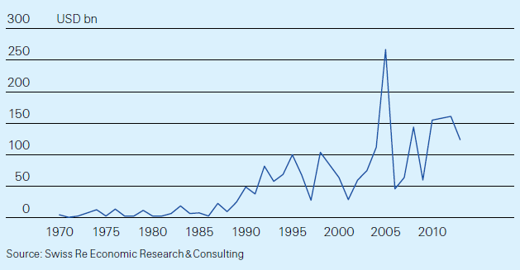

Decision-makers need facts to identify and select the most cost-effective investments to make societies more resilient. Custodians of national and local economies may ask:
- What are the potential climate-related damages to our economies and societies?
- How much of that damage can we avert, with what measures?
- What investment will be required to fund those measures, and will the benefits of those investments outweigh the costs?
Swiss Re and partners developed a quantitative decision-making framework (Figure 2) that:
- Provides tools to quantify a location’s “total climate risk”, which includes an assessment of the expected annual loss to the location’s economy from existing climate patterns; a projection of the extent to which future economic growth will put greater value at risk; and an assessment of the incremental loss that could occur over a 20-year period under a range of scenarios based on the latest scientific knowledge.
- Uses a cost-benefit discipline to evaluate a selection of feasible and applicable measures to adapt to the expected risk – infrastructural, technological, behavioural and financial solutions. The output of this exercise provides one key input – along with policy, capacity, and other considerations – for a country, region or city assembling a comprehensive adaptation strategy. Because any strategy will need to be closely integrated with the location’s broader economic development choices, many of the measures evaluated will be economic development steps.
The ECA methodology provides decision makers with a fact base to answer these questions in a systematic way. It enables them to understand the impact on their economies – and identify actions to minimise that impact at the lowest cost to society. It allows decision makers to integrate adaptation with economic development and sustainable growth.
The ECA methodology has been applied to various regions with diverse climate hazards (Figure 3).
Figure 2: The ECA framework for assessing and addressing total climate risk
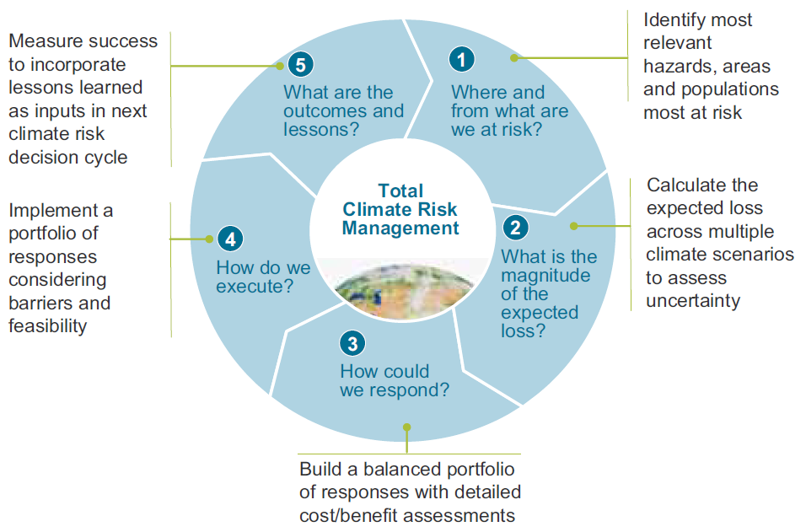
Figure 3: Cities/Regions where ECA studies have been undertaken
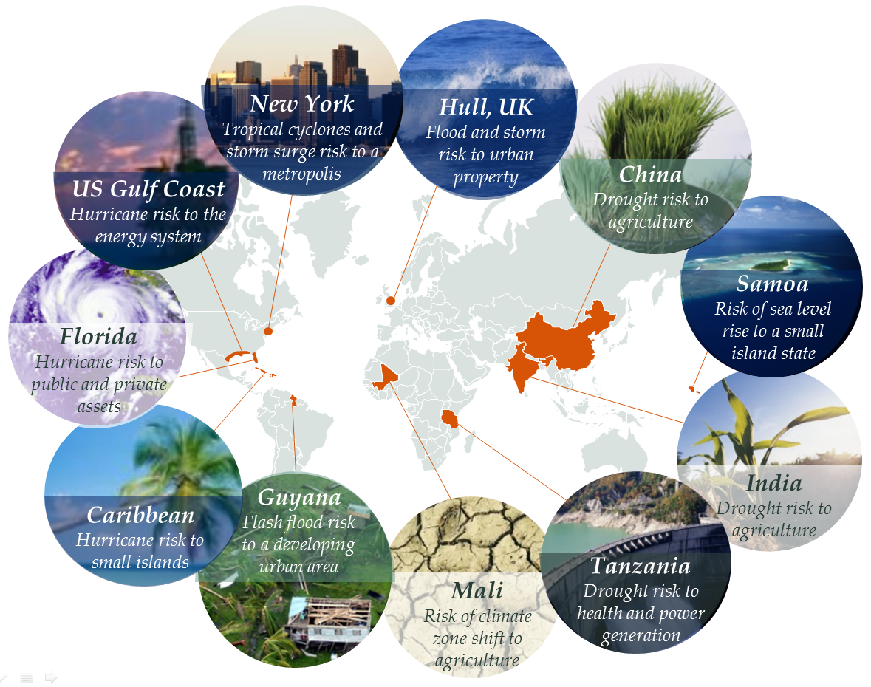
The assessments undertaken were built on broad metrics of climate-related economic loss, such as GDP, asset value and agricultural production, and in most cases did not attempt to calculate the additional social and environmental costs of climate impacts. However, selected cases were extended to incorporate human costs – including the impacts of climate risk on health, homes and livelihoods – as well as to the losses facing particular economic sectors such as power generation.
ECA studies show that a balanced portfolio of prevention, intervention and insurance measures are available to pro-actively manage total climate risk Action on climate adaptation can significantly reduce economic losses from climate risks by between 40 and 65 per cent with even higher levels of prevention possible in highly targeted geographies.
The application of the ECA framework has generated several lessons on how decision-makers can best assess and address the climate risk facing their economies and societies – not least of which is the insight that a common risk framework does indeed apply across hugely diverse locations, climate risks and economic impacts. The implication for decision-makers is that it is possible to undertake a focused, solutions-oriented climate risk assessment in a short space of time.
A second key lesson is that, even in locations where climate and economic data is sparse – as is often the case in least developed countries – it is possible to develop a robust climate loss model and quantify the economic costs and benefits of a wide range of adaptation measures. A systematic framework, combined with in-depth engagement with local experts, officials and populations, can provide a strong basis for decision-making.
The following steps would be key to implementing a comprehensive climate-resilient development strategy at the national or local level:
- Create an inclusive national or local effort – ideally an official process led by a senior government decision-maker, with significant engagement from the private sector, NGOs and academics
- Define current and target penetration of the priority measures identified
- Address existing obstacles to development implementation, such as policy frameworks, institutional capability and organisation
- Encourage sufficient funding from the international community – technical skills, institutional capacity-building, policy and planning, and knowledge dissemination
- Recognise and mobilise different roles for each stakeholder, including governments, NGOs, the private and informal sectors, communities, and individuals.
Appendix 3: Impact and risk assessment for Superstorm Sandy
Superstorm Sandy in 2012 was the most costly natural disaster to ever hit New York City; 43 New Yorkers lost their lives and many more lost homes or businesses. Economic losses for the city were $19 billion but rising sea levels mean a similar storm in the future could cause far greater losses.
In the aftermath of Hurricane Sandy, New York City's Mayor, Michael Bloomberg, announced the creation of the Special Initiative for Rebuilding and Resiliency, which aimed to identify ways to significantly improve the city's resilience to severe weather and climate change. As part of this project, Swiss Re was commissioned to provide a quantitative assessment of potential climate related risks facing the City as well as measures that could reduce those impacts.
Swiss Re's expertise, and our Economics of Climate Adaptation (ECA) methodology, contributed to a 400-page report – A stronger, more resilient New York – which contained more than 250 recommendations that could be implemented to increase the resilience of the city.
The ECA methodology provides decision-makers with a fact base to answer climate-related questions in a systematic way. It enables them to understand the potential impact of climate change on their economies – and identify actions to minimise that impact at the lowest cost to society. It therefore allows decision-makers to integrate adaptation and resilience building measures with economic development and sustainable growth.
In a first step, for a given location, economic sector and affected population, we identify the most relevant hazards and analyse historic events (e.g. from disaster data sets).
Using state-of-the-art probabilistic modelling, we estimate the expected economic loss today and any further incremental increase due to economic development paths and climate change.
Among the various factors, future change in climate risk is the most difficult to predict. We therefore use scenario analysis as the main tool to help decision-makers deal with uncertainty, constructing three potential climate risk scenarios: today's climate, moderate climate change and high (or extreme) climate change.
Figure 1: Addressing the drivers of loss (example city of New York) – Growth expected annual losses from storm surge and wind
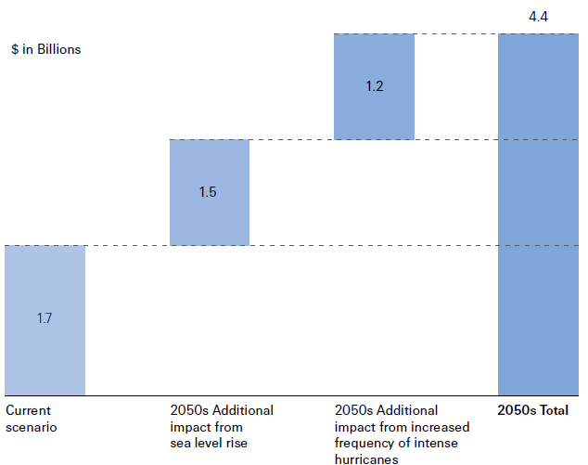
Figure 2: Cost-benefit analysis example, NYC – Numerous climate risk mitigation strategies were simulated in Swiss Re's model to determine the monetary benefit of such approaches expressed as a cost benefit ratio.
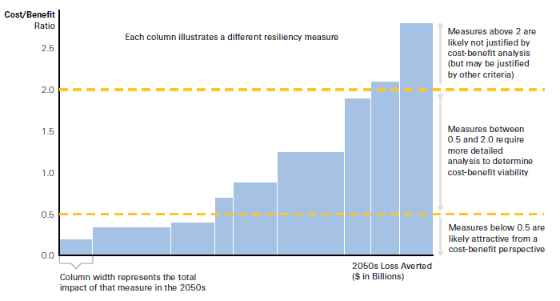
The next step is to build a balanced portfolio of resilience building measures. This is achieved by calculating the cost benefit ratio of each measure. The loss aversion potential (the benefit) is assessed by modeling the effect each specific measure has in reducing the expected loss. The cost is calculated by assessing the capital and operating expenses necessary to implement the measure.
The New York City study identifies numerous potentially attractive resiliency building measures including wetland restoration, building code improvements and the strengthening of critical infrastructure.
Insurance is an important component of any resiliency plan, and the mayor's plan is no exception. The report details how insurance can play a significant role as the city rebuilds areas devastated by Hurricane Sandy. It details 10 specific insurance related measures from launching a consumer education campaign on flood insurance to engaging the insurance industry on measures the city is taking to reduce climate risk.
ECA studies show that a balanced portfolio of prevention, intervention and insurance measures are available to pro-actively manage total climate risk. Insurance – or risk transfer – incentivises prevention initiatives by pricing risk. ECA studies have shown that insurance is an effective adaptation measure particularly for low frequency/high severity weather events.

Appendix 4: FONDEN – Insuring against natural disaster risk in Mexico
Mexico has long been vulnerable to a number of natural hazards. In 1985, two earthquakes of magnitudes 8.0 and 7.5, respectively, killed more than 10,000 people and destroyed 100,000 housing units. Direct economic losses were estimated at more than US$7 billion (2.7% of GDP).
After these disasters, Mexico’s government had to shift budgetary resources away from planned public infrastructure expenses into reconstruction efforts. It needed rapid funding to finance disaster relief efforts and also wanted to be forward looking and take necessary steps to reduce the pressure on public budgets in the future, while ensuring adequate funds were in place for relief activities.
In 1996, the government created a fund for natural disasters — FONDEN — to reduce Mexico’s vulnerability to the impact of natural disasters. Within this a trust was created, which accumulated the unspent disaster budget each year. The government also developed a framework for disaster preparedness involving risk assessment, risk reduction and the promotion of prevention and insurance.
FONDEN was managed by several government agencies, including the ministry of finance and the ministry of the interior. It used various instruments to support local states and entities in responding to natural disasters, including reserve funds and risk transfer solutions.
The objectives of FONDEN were to:
- Ensure adequate funds were in place for relief activities
- Provide resources to the 32 Mexican states and federal agencies for the recovery and reconstruction of affected infrastructure and the dwellings of the low-income population
- Transfer disaster‐related risks to the capital markets and reduce pressure on public budgets
- Prevent imbalances in federal government finances from outlays caused by natural disasters
- Cover multiple perils.
Recognising that FONDEN would not have sufficient funds to cover losses from a major event, the authorities took a further step and engaged in an international risk-transfer transaction to provide financial protection to the fund. In 2006, FONDEN issued a US$160 million catastrophe bond (CatMex) to transfer Mexico’s earthquake risk to the international reinsurance and capital markets. It was the first parametric cat bond issued by a sovereign.
After CatMex matured in 2009, Mexico decided to further diversify its coverage by pooling multiple risks in multiple regions. In October 2009, it issued a multi‐peril cat bond using the World Bank’s newly established MultiCat Program, which helped sovereign and sub‐sovereign entities pool multiple perils in multiple regions and reduce insurance costs.
FONDEN first entered into an insurance contract with Mexican state-owned insurer Agroasemex S.A. Swiss Re acted as a counterparty to the deal and wholly reinsured Agroasemex to enable them to pay any claims placed by FONDEN for qualifying catastrophes (Figure 1).
A four‐tranche cat bond (totaling US$290 million) with a three‐year maturity was then issued by a Special Purpose Vehicle (SPV) - MultiCat Mexico 2009 Ltd. The SPV indirectly provided parametric insurance to FONDEN against earthquake risk in three regions around Mexico City and hurricanes on the Atlantic and Pacific coasts. The cat bond would repay the principal to investors unless an earthquake or hurricane triggered a transfer of the funds to the Mexican government.
Swiss Re Capital Markets and Goldman Sachs were the co-lead managers on the transaction. AIR Worldwide provided risk modelling services and acted as the calculation agent. Munich Re advised on the deal and Bank of New York Mellon was the trustee.
Figure 1: Operating structure
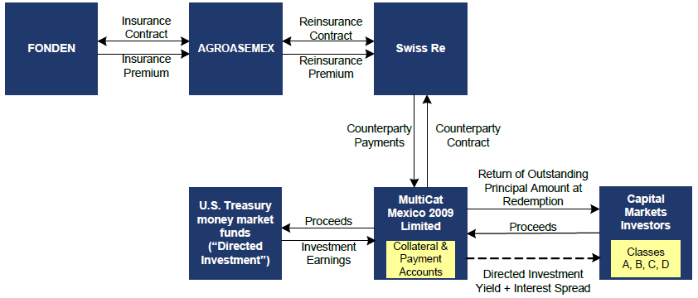
With FONDEN and the MultiCat Program, Mexico became one of the leaders among emerging economies in the implementation of innovative financial risk management solutions in order to protect itself against the impact of economic costs relating to disasters.
Mexico effectively locked in funding for disaster relief prior to the event happening, rather than relying only on public budgets after the event. The demonstration effect of this transaction for other emerging market countries was significant. It paved the way for other highly exposed countries to manage fiscal volatility and stabilise government budgets by using reinsurance and transferring extreme natural disaster risks to capital markets, while eliminating the need to build up excessive budget reserves.
Lessons learned:
- Countries need to have a strong legal and institutional framework in place for disaster risk financing to facilitate the implementation of risk transfer mechanisms, which should be part of a disaster risk management framework.
- There is potential to replicate this type of transaction for other middle-income countries. The Mexico bond was oversubscribed, showing that investors continue to exhibit strong appetite for non-peak risks.
- The availability of data and statistics about the probability and severity of a catastrophic event is key. New countries and regions attempting to tap the catastrophe bond market will need a supporting cat risk model. Donor countries with a specific interest in working on the development of disaster risk management capacity in developing countries can play an important part by financing risk modeling and transaction costs.
- The World Bank’s role as arranger significantly increased investor comfort. Future transactions will benefit from the standardized fees and design structure offered by the MultiCat Program.

Appendix 5: Country Risk Officer (CRO)
The public sector is increasingly interested in integrated risk management approaches. In the past, the primary concern was civil protection in the event of war or natural disaster. Given the diversity and interconnectivity of contemporary risks the focus has shifted to comprehensive country risk management, backed by solutions that allow governments to finance losses before a disaster occurs.
Modern risk management – both in the private and public sector – relies on integrated risk assessments (Figure 1). Many global corporations have therefore created the position of Chief Risk Officer. Such a position is still largely unknown in the public sector. Swiss Re believes that established practices in enterprise risk management could form the basis of risk principles in the public sector, including the idea of a Country Risk Officer (CRO) and Country Risk Maps.
A CRO needs to provide transparency on the risk landscape taking into account frequency and severity of occurrence with a short term and long term view. The ultimate objective is to keep risks within accepted levels of tolerance and to allocate resources efficiently.
Figure 1: Public vs private CRO responsibilities
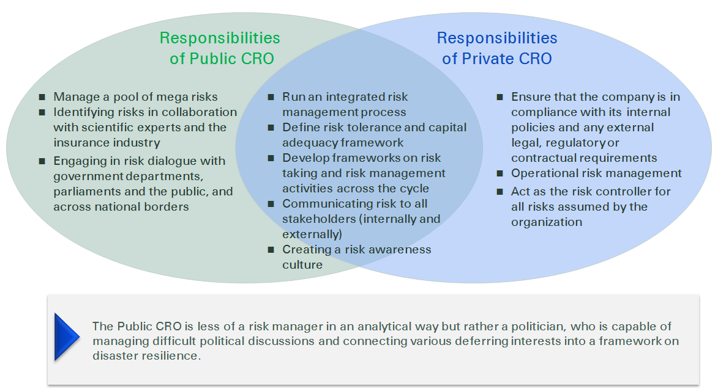
When starting out with the role of a CRO, a policy maker would likely ask the following questions:
- Who sets the overall risk appetite / tolerance? Who is the ultimate risk taker and what does that mean for a Public CRO?
- What should be minimised/maximised by a Public CRO? Public welfare, loss of life, budget?
- What is the role of a parliament vs. executive branch of a government? What is the impact of voters in the cycle?
- Hypothesis: many countries have more risks than they should have or think they have. How can this be addressed over time?
- What would be the process to establish a CRO function? At Swiss Re, it started by increasing transparency on risks and then generating a risk framework, resulting in the role of the CRO being established at the executive level.
- How is the success of the Public CRO measured? What are the appropriate KPIs?

Includes fee income from policyholders
http://media.swissre.com/documents/ECA_New_York_Gov_Factsheet.pdf
http://www.nyc.gov/html/sirr/html/report/report.shtml
http://media.swissre.com/documents/rethinking_shaping_climate_resilent_development_en.pdf
To arrive at these scenarios, we use global and regional circulation models to assess changes in precipitation and temperature, mainly based on the A2 IPCC 4th AR emission scenario. We leverage public academic research to flesh out the complex interactions between climate change and potential impact (for example, between increases in sea surface temperature and hurricane intensity).
Source: Centre for Research on the Epidemiology of Disasters (CRED)
Parametric instruments use a model to calculate the payout of the insurance policy. This payout model aims to closely mirror the actual damage on the ground and enables a much more rapid payment, since no assessment of the actual damage is required after the event.
The MultiCat Program was developed to provide a catastrophe bond issuance platform for World Bank member countries, allowing them to access financing for disaster risk insurance from the capital markets.
Source: Global Facility for Disaster Reduction and Recovery, Mexico MultiCat Bond, 2011

