Enabling Resource–Based Industry Development

Don Scott-Kemmis
December, 2012

Contents
Preface 5
Executive Summary 6
1. Introduction 10
Resource-Based Development and Capability Building 10
The Resources Curse and the Dutch Disease 10
Beyond the Resource Curse 12
Policy Foundations 14
The Overall Study 16
2. Developing Suppliers for Major Resource Projects 17
Local Content 18
What is Local Content? 18
Supplier Development in Resource Based Regions and Economies 21
Sweden and Finland 21
Norway 22
Canada 26
Chile 29
South Africa 30
Other African Countries 32
Brazil 34
Key Lessons of Capability Development 35
3. The Australian Mining Industry 42
Characteristics of the Australian Mining Industry 42
4. Australian Suppliers to the Resource Industries: Sectoral and Firm Development 51
Australian METS Sector 51
Major Segments of the METS Sector 51
The Evolution of Mining and the Growth of Australian METS Firms 54
Characteristics of the METS Segments 57
Service Companies 57
Suppliers of Specialised Equipment, Software and Related Services (Table 4.9) 61
Case Studies of METS Firms: Formation, Growth, Capability Development and Internationalisation 62
Patterns of METS Development - Summary 72
Market Entry 72
Growth and Development 75
Corporate Development: Transformation, Acquisitions and Investment 77
5. Building Industry Clusters from Resource Development 81
Introduction 81
Demand Side Drivers– Backward Linkages and Clusters 83
Scandinavia 87
Canada 89
Latin America 92
Chile 93
South Africa 95
Frameworks for Cluster Development 100
METS-Related Industry Development Initiatives in Australia 106
The METS-Related Knowledge Infrastructure 107
Evidence of ‘Cluster’ development 110
6. Identifying Capability Gaps and Capability Building Opportunities 112
7. Conclusions 115
Summary of Key Points 115
Policy Options 119
Sources 123
Appendix 1: Individuals Interviewed or Consulted for the Study 137
Appendix 2: Reviews of Australian Participation in the North West Shelf. 139
Appendix 3: Resource Project Stages and Equipment and Service Requirements 143

Preface
This study was supported by the Department of Industry, Innovation, Science, Research and Tertiary Education. This support is warmly acknowledged. Siobhan Heatwole and Shane Shergill from DIISRTE have provided continuous support and guidance throughout the ambitious and wide ranging study.
Many individuals from the METS and Mining sectors have given their time to discuss the issues explored in the study. The interest and insight of these individuals -listed in Appendix 1 – has been an essential and greatly valued contribution to the report.

Executive Summary
The mining industry in Australia is becoming increasingly knowledge intensive and this trend will continue as the industry faces new challenges and greater competition.
After a decline in profitability through the 1970s and 1980s, the mining industry is in a phase of expansion. The key driver of that expansion is rising demand from the emerging economies of Asia. The overall growth of demand is likely to be sustained for decades, although the inevitable growth of supply is likely to limit price rises. Nevertheless, both the growth of mining (and other resource projects) in Australia and the growth of global opportunities for Australian mining and mining supplier firms are of great significance for Australia.
That significance is not adequately appreciated. Policies to respond these opportunities remain underdeveloped.
Resource development has been central to the economic and industrial evolution of several countries, including the United States, Canada, South Africa, Sweden, Finland and Norway.
Given this context, four questions are the focus of this study.
What lessons can we learn from how have other resource-based economies or regions developed the firms and industries that supply mining equipment, technology and services (METS)?
Those countries that had a strong initial foundation of capability have been best able to pursue the opportunities for broader industrial development from resources projects.
Opportunities for new firm development are clearly greatest when new challenges and new technologies erode the competitive strengths of established global suppliers - many of which developed from exactly such opportunities in an earlier era – and open new paths of capability development.
Nevertheless, there are high barriers to entry in many segments of the resource project supplier sectors – and the role of mining firms and higher tier project managers is significant in maintaining or reducing those barriers. It is reasonable to expect that international investors and their project managers will actively seek to use local suppliers and actively support (possibly with additional government support) their development – as long as these local firms are, or can quickly become, internationally competitive. Relationships between mining firms and equipment, technology and services suppliers, often mediated by their Tier 1 suppliers, can be particularly significant for capability and firm development when they focus on problem solving and when the customer does not mandate the form of the solution.
Opportunities for entry by local firms are usually easier in the production and maintenance phase of major projects rather than the initial investment phase, when risk minimisation is vital. Opportunities for entry are the essential starting point for supplier development, but vigorous processes of learning that upgrade capability are vital if those opportunities are to lead to significant firm and sector development. Strong absorptive capacity in firms is a necessary base for learning, but as the capability upgrading deepens, strong management capability, access to high level human resources and linkages to responsive research organisations are often critical for enabling the search for higher performance to translate into innovation and capability development.
In most cases the capturing of industrial development opportunities from resource projects has required an active and comprehensive strategy to address barriers to entry and to augment capability development, leading to the evolution of internationally competitive firms and to higher and more widespread positive impacts from resource projects.
To what extent has Australia developed the firms and industries that supply mining equipment, technology and services (METS)?
While the core equipment and many of the Tier 1 services for major resources projects are imported, Australia has developed a strong and diverse METS sector with internationally leading firms in some segments. However, the METS sector is not clearly defined and systematic data on performance is not available. In 2011 METS sector sales were estimated to be about $40b and offshore activity (exports and the activities of overseas subsidiaries) about $15b. This level of export activity is almost three times that of the wine and automotive industry combined. This is an extraordinary and under-appreciated achievement.
It is the more specialised technology, equipment and services firms that are the most active internationally and their internationalisation has been rapid, extensive and remarkable – an exemplar for Australian industry.
The development of METS firms has been significantly enabled by the changes in the mining industry, leading to greater outsourcing and subsequently dependence on suppliers. At a more proximate level, customer supplier inter-dependence centres on relationships, built on experience and involving trust.
Mining sector – supplier interdependence is again changing as the challenges increasingly faced by the mining industry require new solutions leading to the exploration of opportunities based on new technology. These challenges arise due to lower grade ores, stronger environmental regulation and the need to lower energy and water use, and production and capital costs. The technologies of greatest and most widespread significance are those based in information and communication technologies (ICT). Australian METS firms have been early innovators in the application of ICT to mining.
The current phase of change brings new challenges to the METS sector. It is leading to greater consolidation and also to increasing acquisition of Australian firms by international competitors. The problem solving and experience-based processes of learning and capability upgrading, that have been vital for the development of Australian firms, may not be adequate for the future as knowledge intensity deepens and inter-dependence among technologies requires greater collaboration among suppliers and with customers.
Does Australia provide a supportive context for METS firm and sector development – stimulating and enabling continuous and effective learning within firms and support organisations and promoting mining cluster developing?
Australia is a major international centre of mining research. It has a range of strong mining research organisations and world class higher degree courses in a number of universities. However, there is little coordination among these organisations and, while their links to the mining industry are strong and long-standing, the linkages with the METS sector are overall quite weak. The reasons for at least the latter arise from the incentive environment for research in Australia and from the characteristics of the METS sector.
The growth in several countries of suppliers to the resources industry can reasonably be characterised as the formation of a ‘cluster’ of linked and inter-dependent organisations. This experience suggests that the development of a cluster involves four processes, which reinforce each other: the entry or formation of more, and a more diverse range of, organisations (suppliers, customers, intermediaries, sectoral organisations, research and education organisations etc.); increasing interaction (user-producer, competition, collaboration) among these organisations; increasing specialisation and capability upgrading within the organisations (and through complementarity and cooperation at the level of groups of organisations), and; the development of institutions, policies and shared priorities that enable coordination and support for ongoing evolution.
Entrepreneurship, learning, innovation, collaboration, and competition drive and support this evolution. But many of the relationships that are vital are not market-based. This is one reason why, inter-personal networks, trust-based relationships, and sectoral and regional organisations that develop shared strategies and facilitate interaction are important in all cluster development.
Australia does not yet have a coherent approach to mining cluster development – although many of the elements of an approach are in place. A more robust and coordinated policy is required.
What are the options for a more strategic approach to resource-based industrial development, beyond the short term focus on ‘local content’?
There are essentially two options for a more robust approach. In considering these and perhaps other options it is important to keep in mind the dynamics that lie behind the emergence and development of firms, industries and clusters. It is clear that these cannot be fully understood through the lens of mainstream economics. For that reason mainstream economics provides an inadequate framework for policies to promote resource-based development.
The first option involves a strengthening of the current array of policies that focus on encouraging higher levels of local content and also investing in research through CSIRO, CRCs and university research centres. These policies, organisations and investments have led to substantial achievements. But there is a real risk that the lack of coherence in policy will lead to major lost opportunities. There is a tendency to hide behind the restrictions on industry policy in WTO agreements, rather than take on the challenges of finding effective but compliant approaches.
A second option would be based on the development of a more coherent and strategic policy framework. A central dimension of this approach would involve institutional innovation to facilitate higher levels of coordination. The international experience with the development of clusters provides a useful alternative framework for this approach.

Introduction

Resource-Based Development and Capability Building
Australia is a major global producer of minerals, with major shares of the world’s known resources for several minerals. It ranks in the top six countries in the world for economic resources of black and brown coal, bauxite, copper, cobalt, diamonds, gold, iron ore, manganese ore and nickel. Australia is the world’s largest exporter of coal, iron ore, bauxite, lead, zirconium and titanium; the second largest exporter of gold, zinc and uranium; the third largest exporter of silver, nickel and aluminium; and the fourth largest exporter of diamonds.
Mining currently directly accounts for over 8% of Australia’s GDP, but Shann (2012) estimates that overall the mining and mining-related sectors accounted for about 20% of GDP in 2010-11 and probably 22% in 2011-12. Minerals account for over 50% of total exports and were worth over $140 billion in 2011. With rising demand for minerals and energy, investment in mining capacity in Australia expanded from about $10b per annum in 2009/10 to almost $86b in 2011-12. The mining industry also spent $5.7 b on exploration in 2010-11 (much of it by smaller ‘junior’ firms, and $4.2 b on research and development.The rapid development of the resource sector has the potential to transform Australian industry.
The major export markets are Japan, Korea, China and India – the last two, large economies with low levels of per capita GDP and likely to remain in the high energy and materials-intensive phase of economic development for decades. According to a recent study by McKinsey & Company, "up to 3.0 billion more middle-class consumers will emerge in the next 20 years compared with 1.8 billion today, driving up demand for a range of different resources." The study states that the world must start "mobilizing for a resource revolution" and the "the race is on to boost resource supplies, overhaul their management, and change the game with new technologies."

The Resources Curse and the Dutch Disease
Resource booms present challenges for public policy. The role of major resources projects in industry development has a long history in Australia, with particularly strong debates around the Bass Strait and North West Shelf Projects. One of the challenges arising from major resource booms is due to the ‘Dutch disease’. This refers to the consequences of large increases in foreign currency income due largely to resource booms. These consequences include: pressures on government to increase expenditure by using additional tax income for transfers to lagging industries/firms and social groups, possibly leading to structural budget problems in the future; relative price increases in the non-traded sector relative to the trade-exposed sectors, and, in particular, the possibly severe competitiveness problems for the non-resource trade-exposed sectors that arise due to a rising exchange rate and the shift of capital and labour to the resource sector. Concern about the impact of the Dutch disease on manufacturing is based on the view that:
- the loss of market share in manufactured goods markets may not be reversible;
- the loss of manufacturing may lower the longer run growth prospects for the economy, because manufacturing is assumed to be more knowledge and R&D intensive than resource sectors and to create a relatively stronger demand for highly trained personnel.
The apparent observation that many resource-based developing economies have grown more slowly than those without such natural assets has been termed the ‘resources curse’. Among the various explanations for the ‘resources curse’ are a number of factors that can combine to diminish the longer run development impact of the resource-based sectors. One factor, also related to the ‘Dutch Disease’, arises where little of the investment and production inputs required for the resource-based sectors are sourced from the domestic economy. The lack of ‘backward linkages’ leads to the development of technological ‘enclaves’ with few opportunities for local capability development. A good deal of the wider literature on the ‘resources curse’ concerns the causes and impacts of the frequent public policy failures: “The failure of states to take measures that could change resource abundance form a liability to an asset has become the most puzzling part of the resource curse.“
The scepticism about the scope for resource-based industrial development is based on the views that:
- mining and energy industries, at least in developing countries, tend to develop few local linkages;
- The extractive industries are ’low tech’ in nature and have low rates of innovation- hence providing limited opportunity for local ‘technological learning’;
- The resource-based sectors, and related infrastructure, draws investment away from other sectors;
- the symptoms of the Dutch Disease lead many countries to protect their manufacturing industries which in turn generally leads to uncompetitive firms and industries;
- in the long term the prices of commodities will fall relative to those of manufactures (which until recently has been the case), and hence the terms of trade of economies dependent on resources exports will decline over time;
- the prices of commodities are more variable than those of manufactures, leading to economic instability in economies dependent on resources exports.

Beyond the Resource Curse
For at least the period from 1950 until the late 1990s it was widely assumed that resource-based industries had limited potential to sustain economic development. There were two primary reasons for this view:
- The fact that demand for services and manufactured products had increased as incomes rose (the income elasticity of demand), whereas demand for resources had not. Consequently, specialisation in manufactured exports led to more dynamic growth than did reliance on resource-based commodity exports.
- Second, manufacturing was seen as a stronger driver of capability upgrading, due both the relatively high rates of productivity growth, innovation and knowledge absorption in manufacturing (compared to mining) and due to stronger links to upstream and downstream industries.
These two assumptions are no longer tenable and hence the case for resource-based economic development must be revisited. This paper explains why these assumptions must be questioned. It then begins to layout the foundations for a strategy for resource-based development.
Several studies of the role of natural resource exploitation in the development of countries such as the United States, Finland, Sweden and Canada bring another perspective. This is a perspective which emphasises the potential for resource-based industrial development – if the required strategies are pursued. There are two aspects to this perspective.
First, mineral resources are not simply natural endowments - a recent, if controversial, example, is that of horizontal drilling and ‘fracking’ and their role in enabling the exploitation of shale gas. Mineral and energy resources require investment before they are valuable. Such investment requirements have become larger, more complex and more knowledge intensive over time. Substantial research may be required to support exploration, mine development and efficient processing: “Because extending the ‘knowledge frontier’ can extend a countries effective resource base, it is entirely possible for resources sectors to lead an economy’s growth for extended periods of time.” Hence, the exploitation of a country’s mineral base can develop along with economic growth and technological progress. Indeed mining is (an increasingly) knowledge intensive industry. The discovery of resources requires a range of advanced technologies and investment, as well as the regulatory regimes that encourage that investment – Australia’s overall mineral resources have been increasing, despite two centuries of mining. The efficient exploitation of a mineral resource may be dependent on new processes to enable mineral extraction in addition to investment in production and transport facilities – many ore bodies are of no economic value until innovations provide an economic means to extract the minerals. As will be discussed further the decline in ore grades, the rising cost of energy and the increasingly stringent environmental and safety regulation, are driving innovation in all aspects of mining. One of the pre-conceptions that has tended to block a realistic perspective on the role of resource-based industries, is the view that innovation largely takes place in ‘high-tech’ sectors and that these should be the focus of policy. Smith (2007), among others, underlines the importance for economic growth of innovation throughout the economy showing that in many highly performing economies the contribution of the ‘high tech’ sector is small.
Second, mineral development can stimulate wider industrial and technological development. The United States provides a powerful example of linking mining development with broader industrial development - by 1913 the US was the leading producer of most of the major minerals of that time. Similarly, Smith suggests that the experience of Canada, Norway, Finland, Sweden, the Netherlands, New Zealand and Australia-all with significant resource bases - shows that the resources curse can be avoided with appropriate policy. He argues that the development of linkages between the resource sectors and other industries, and indeed the overall process of resource-based development, didn’t happen as a result of market forces but was organised. Reviewing the Norwegian experience Cappelen and Mjoset (2009) conclude:
“There is really no reason why resource extraction per se cannot lead to the development of a manufacturing sector that is characterized by learning, spillovers and the scale economies that are usually considered the core of a modern knowledge economy. In Norway, active industrial policies have been an important element in the creation of these linkages.”
In the cases of the US, David and Wright (1997) show that minerals development in the US grew in parallel with the rise to leadership in manufacturing but that the inter-industry linkages strongly supported wider industry development. David and Wright show that in the development of the mining industry in the US, three factors were vital:
- A supportive institutional environment, particularly the legal regimes clarifying ownership;
- Public knowledge infrastructure – particularly the vital role of the US Geological Survey which provided a rich base of information to guide exploration; and
- The development of specialised education and research centres – by 1890 the US had 20 universities granting degrees in mining, some of which were the leading international centres of research and education in mining – and the problem solving and innovation that supported exploration, mining and processing.
More generally they argue that the development of a competitive mining industry involves a learning process at all levels, which leads to the development of technologies, capabilities, research and education organisations, knowledge (some of which is highly location-specific) of the paths for profitable investment, appropriate regulations etc.:
“..what matters most for resource-based development is not the inherent character of the resources, but the nature of the learning process through which their economic potential is achieved. “
These evolutionary processes are at the core of cluster development – discussed further below. It is clearly the case that an understanding of the history of resource-based development must draw on insights from several perspectives: economics, the evolution of technologies, social development, policy and institutional formation and change. That is the approach that is taken in this study. It follows, then, that in identifying and assessing policy options for Australia a similarly multi-disciplinary approach should be followed. In particular, as the frameworks of mainstream economics provide only partial understanding they do not provide an adequate basis for policy development and evaluation.

Policy Foundations
The opportunities arising from resource development are more likely to be captured, and the risks of the serious market failures due to the ‘Dutch disease’ are much more likely to be minimised, through a coherent strategy. While the policy priorities and mechanisms will vary with the context of place and time, a coherent policy framework will include six strategies:
- Improving production efficiency through finding high grade deposits, efficient project development and mine planning and innovation in all aspects of mining – particularly through raising local innovation capacities through investment in research and education – and improving the commercial value of hitherto uneconomic mineral deposits, either due to new processing or mining technologies which significantly lower costs.
- Developing infrastructure for mining (transport, ports, energy, water, education, health) that also encourages or supports other regional economic (and social) development.
- Adding value through downstream processing, from low levels of processing of ores to the use of metals in the local production of final products.
- Product differentiation – selecting, sorting or some form of minimal processing (eg to remove contaminants) to differentiate the product of mining from general commodity status and so attract a price premium. In most cases the potential for such differentiation may be very limited.
- Strengthening backward linkages to develop local suppliers of equipment and services for mining investment and production. It has long been argued that manufacturing and some knowledge-intensive services provide greater opportunities for capability enhancement (learning) and innovation than does mining. It is clearly the case that many of the major international providers of drilling, mining and haulage equipment were formed in earlier clusters in Europe (see the Scandinavian cluster above) and North America. As a result of first mover advantages and continuous upgrading they now benefit from economies of scope and scale, and dominant positions (reputations, relationships, distribution and service networks) in the global mining equipment industry. For this reason the opportunities in niche equipment are services are likely to be particularly important.
- Stimulating other industrial activity, through horizontal linkages and spillovers, within the resource sector or in activities linked more distantly to mining – ie positive external dynamic externalities. The types of capability development generated in mining and related industries vary in their application specificity. Some may have few applications outside of mining, but others may have high potential to be re-used and further developed for value creation far beyond mining. Two examples illustrate this. Management competence involves a great deal of generic competence development in addition to domain knowledge. Management excellence developed through mining-related activities can make contributions to value adding in all sectors. Similarly, environmental management involves both domain specific and generic competencies such that high level capabilities developed through problem solving for mining are likely to be valuable competencies of wider significance. The key point is that the mobilisation of high level organisational and knowledge capabilities to address demanding challenges further develops those capabilities such that they are likely to become valuable assets for future value creation in a region or economy. Nokia was a forestry company and Mitsubishi a mining company.
More generally, as capabilities are more widely dispersed and the barriers to trade in products, service and knowledge are lowered, the performance of firms, regions and economies depends on their capacities to understand challenges and opportunities, acquire new knowledge, and adapt to change in technology, regulation and markets. Those capacities to understand, learn and adapt increasingly involve interaction and collaboration. To varying degrees, that interaction and collaboration is most effective when the organisations and individuals involved are geographically close – it often helps if they are also technologically, culturally and organisationally ‘close’.
As petroleum and mineral resources can generate substantial profits, governments, acting on behalf of the society, have a responsibility to capture a share of those rents for the society who are the owners of those resources. However, harnessing resource exploitation for industry development may involve higher costs in the short term. These costs can only be justified when a realistic and coherent strategy is designed and then implemented effectively. This has clear implications concerning three factors that will shape the effectiveness of efforts to leverage resource exploitation for industrial development: adequate relevant human resources; a strong pre-existing industrial base, and; a government organisation with appropriate authority and competence. In the longer run, if Australia is to capture the opportunities for more enduring industrial development, as has been the case in several other resource-based economies, an optimistic scenario would be that indicated in Figure 1.1.

Figure 1.1: Capturing Opportunities to Build Firms and Capabilities
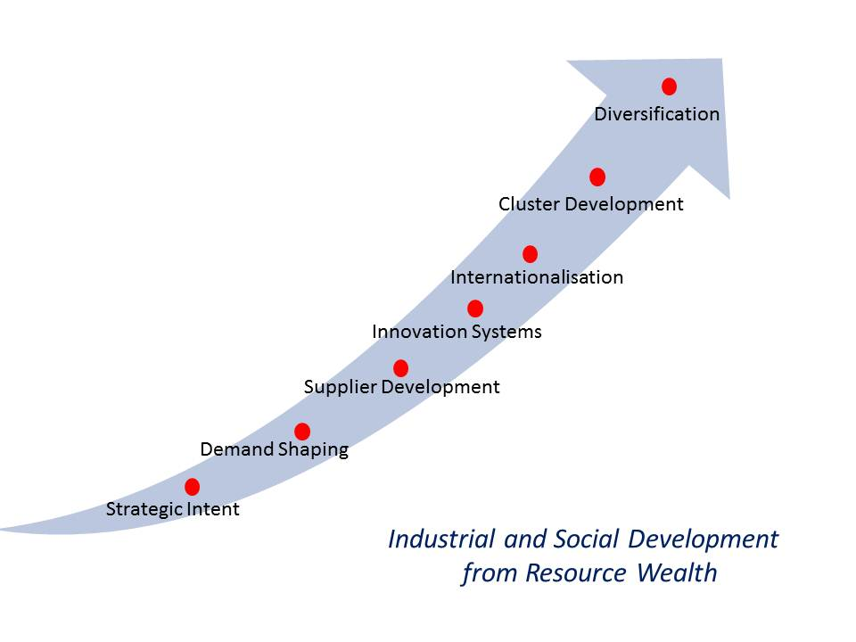

The Overall Study
This project addresses four questions:
- What lessons can we learn from how have other resource-based economies or regions developed the firms and industries that supply mining equipment, technology and services (METS)?
- To what extent has Australia developed the firms and industries that supply mining equipment, technology and services (METS)? Subsidiary questions include the characteristics of these firms, their origins and development, the challenges they face in building capability, and the scope for improving development.
- Does Australia provide a supportive context for METS firm and sector development - is a mining cluster developing? A central issue here is the extent to which the context supports continuous and effective learning within firms and support organisations.
- What are the options for a more strategic approach to resource-based industrial development, beyond the short term focus on ‘local content’? Again the key issue here is the extent to which opportunities and support for learning enables the development of internationally competitive firms and world-class resource projects.
A comprehensive assessment of the third and fourth of these questions is beyond the scope of this project, but the approach aims to provide both an initial assessment and a framework for further analysis.

Developing Suppliers for Major Resource Projects
While US and to a lesser extent European firms have long dominated the core activities of the global mining and oil industry, many new firms have emerged from mining, oil and gas producing countries. Apart from explicit local content policies, the emergence of new firms is facilitated by the often unique challenges of specific projects and the stream of problems they generate and also to the longer run changes in the technologies used in mining and energy projects. In the case of the mining sector, several trends are leading to both structural change and greater knowledge intensity:
- The declining ore grades – leading to the need to mine at deeper levels, more accurately locate ore bodies and to process more ore and develop innovations across many aspects of exploration, development and production;
- Shortages of skilled labour and increasing concerns about health and safety – leading to eg, increasing experiments with automation, new approaches to training;
- Increasing environmental concerns, regulation and monitoring – leading to more careful assessment and higher production costs.
- A trend to greater outsourcing as mining companies focus on exploration and marketing
All of these trends create new, but also often more challenging, opportunities for new suppliers across a diverse range of products and services.
As emphasised above, developing industrial capabilities is a learning process, involving five primary mechanisms of learning: through direct operational experience; through knowledge transfer from established firms; through problem solving based on the effective use of available knowledge; through research, often involving the generation of new knowledge and collaboration with other organisations; the spreading of the learning and investment processes to stimulate a wider process of learning and new firm growth. These mechanisms, summarised in Figure 2.1, involve building managerial and technological capability and production capacity:
- to provide basic design, fabrication, project management and ancillary services (eg transport, staff facilities).
- to provide more specialised and higher value equipment and services, progressing to international competitiveness- largely through knowledge transfer and operational experience.
- to master the technology and to adapt it to address new technical and managerial. This can be a key mechanism in progressing to international competitiveness.
- through problem-solving often involving significant research, to address new technical challenges, such as the exploitation of oil or gas in deep water, or low grade ores, or pursue new approaches to design or management which lower operational or environmental costs provide more specialised and higher value equipment and services. Where the challenges addressed are those that will be faced in other resource projects the innovations and capabilities provide the basis for valuable and distinctive international competitive assets.
- through linkages to first tier local suppliers which, as they grow in capability and specialisation, develop stronger links with second tier local suppliers and with local research and education organisations. This diffuses and amplifies the role of the demand for new capability, new knowledge and new investment providing the driver, if the right conditions exist, for cluster development.

Figure 2.1: Mechanisms of Capability Development
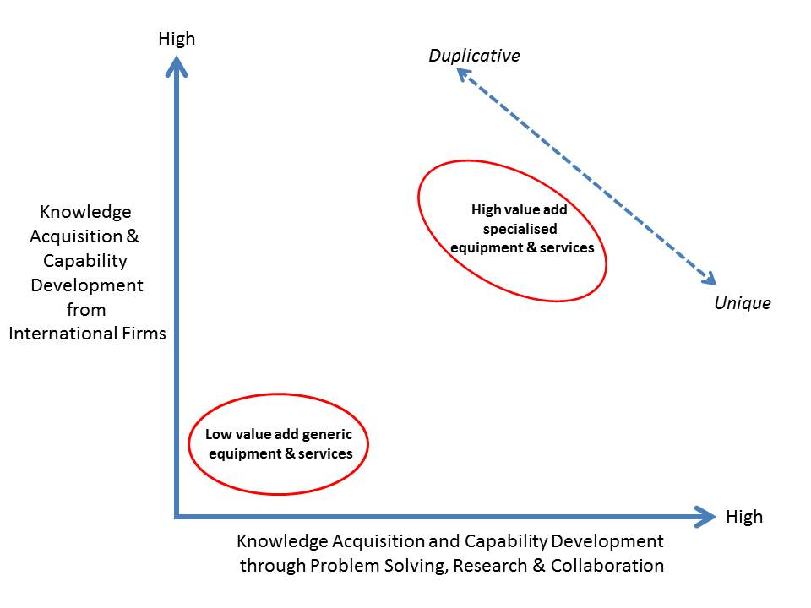

Local Content

What is Local Content?
Defining local content is not straightforward, particularly as sourcing of materials, human resources and other inputs (including design) becomes more dispersed internationally. The key issue for the purpose of this report is not the aggregate local content (however assessed) but what types of local capability are being developed, and what changes in local content and capability are taking place over time. The principle that contracts should be awarded on an internationally competitive basis is vital for a coherent national development strategy and deviations from this must be selective, temporary and justified. However, who makes procurement decisions for the initial investments and for follow on modifications and expansions, and the basis for these decisions is a key issue.
Agreements binding WTO members are relevant to local content regulations:
- Trade-Related Investment Measures (TRIMS) – requires the equal treatment of local and foreign investors and prohibits local content requirements that mandate particular levels of local content, trade-balancing requirements such that imports need to be matched by exports.
- General Agreement on Trade in Services (GATS) – aims to remove protection of national services markets such that foreign and national service providers are treated equally.
Nevertheless it is clearly the case that:
“Procurement regulations, contracting strategies, vendor pre-qualification, technical standards, bid documents, tender evaluation criteria and contract conditions: all these instruments of procurement can be formulated creatively to build national competitiveness through capital investment, technology transfer and skills development.”
It is also generally acknowledged that local firms may be disadvantaged because:
”..major international contractors frequently have long term global sourcing arrangements with key equipment and material suppliers, enabling them to drive down costs and achieve a competitive edge…these deals may crowd out domestic suppliers, even if these suppliers are capable and potentially competitive in their own right.“
In practice, procurement strategies always involve trade-offs across, for example, price, quality, volume and level of support service. The level of local content is likely to bring another dimension of trade-off. The challenge for both project manager and local industry development proponent is to find an approach that creates the greatest opportunities for local suppliers at the least cost to the project manager (and the overall performance of the project – such as time to completion, total project costs, safety and performance of the mining systems). The procurement strategies of resource project developers are likely to be influenced by the value drivers for local content, including:
- Risk – that the use of local suppliers, in response to political pressure, will lead to higher costs and project delays, reducing returns to investors;
- Compliance – meeting regulatory requirements may avoid sanctions and delays with approvals etc.;
- Reputation – with the host government as a firm able to develop strategies to effectively build local capability and potentially be a preferred investor;
- Cost reduction – greater development and use of local suppliers may lead to cost savings on imported equipment, parts and services;
- Social licence to operate – use of suppliers based in local communities can provide benefits from resource projects to those communities, hence providing some compensation for the costs of such projects.
In a context where a substantial level of local content is a major element of a resource development approach, three factors will shape the procurement strategy for the project managers and the local content strategy for government:
- The level of bundling of inputs: In situations where there is a reasonably high level of local capability a high degree of unbundling may be possible (although with retaining coordination and supervisory/quality control roles). But where a higher level of supplier development support is required a high level of bundling may enable a major international Engineering, Procurement and Construction Management (EPCM/EPC) firm to require international sub-contractors to work with and support local suppliers for those supply elements where this is feasible.
- Supplier control over procurement: When sourcing from local suppliers the level of risk and the needs for supplier development will determine the role of management control over local procurement. In cases of routine procurement where the capabilities of local suppliers are well developed, a direct contract may be sufficient. But in other cases, a higher tier contractor may be required for either or both quality control/supervision, and/or supplier development. In the later cases the issues of higher costs and how these are factored into overall project costs must be taken into account.
- Dealing with the costs of using local suppliers: How best to use compensation payments to address the risks of local souring and to provide incentives for contactors to effectively meet local sourcing targets.
A critical issue for local supplier development in most large resource projects is the role of the first tier contractors, particularly the EPCMs and EPCs, and the specific formulation of the tender documents in relation to obligations for local procurement and supplier development. There are essentially three options:
- To specify the requirements for local content and local supplier development and require tenderers to submit an overall price;
- To invite tenderers to set one or more options for how they will address for local content and local supplier development and to price the options separately – this approach has the benefit of drawing on tenderers experience and innovation for supplier development;
- Develop some form of weighting for the quality of tenderers local support proposals and arrive an integrated price/support quality assessment.
While relationships between users and producers have been a key factor in market entry and development of METS firms, these relationships are changing. These changes tend to disadvantage smaller firms and raise higher barriers to entry for new firms. Three factors are driving these changes:
- Increasing concentration in both the mining industry and the project management (EPCM) level – in both cases leading to more formalistic procurement approaches;
- Higher levels of outsourcing by mining firms, to reduce costs and risks, leading to a stronger role by EPCMs in procurement;
- Increasing technological complexity and, related to this, the increasing inter-dependence of technologies in ensuring efficient production;
- A greater emphasis on fewer suppliers and on firms able to offer ‘total solutions’, including servicing and asset management.
These factors are strongest in large greenfield investment projects by large mining firms and least important in small expansion projects where decisions may be made by the local engineering staff in mining companies. These barriers to entry for smaller and newer firms place a higher premium on having superior or new technologies or capabilities that offer strong advantages to users.
Four factors are vital for assessing the opportunities and strategies for local supplier development. These are discussed below and summarise in Table 2.1:
- Capability gaps– what is the level of local supplier capability in the various dimensions of product, service, timing, problem solving etc., in comparison with the international standard?- this may be a source of considerable contention and some objective criteria are likely to be required;
- Product/service specialisation and complexity – what is the breadth and depth of knowledge, and the level of proprietary technology, required to deliver the product or service?;
- Criticality – how critical is this project component to the overall cost, timing and performance of the overall project?
- Opportunity for repeat procurement – is the product or service one which is fairly standardised and supplied repeatedly over an extended period of time, or is it a one-off?

Table 2.1: Supplier Development Opportunities – Scope and Effort
 | Level of Challenge for Local Content and Supplier Development
 | 1 (Low) | 2 | 3 | 4 | 5 (high)
- Capability gaps
- Product or service specialisation & complexity
- Criticality
- Single supply opportunity (lack of repetition)
Supplier development potential declines from 1 to 5
Time and cost for supplier development rises from 1 to 5

Supplier Development in Resource Based Regions and Economies

Sweden and Finland
Sweden and Finland were relatively poor countries in the mid-1800s, but managed to develop an advanced industrial structure through development based on the processing of natural resources, particularly timber and iron ore. Initially suppliers of low-tech intermediate products to Western Europe they gradually upgraded the technological level of resource-based industries and diversified into related activities, such as machinery, engineering products, transport equipment, and services. Resource-based industries continue to play a major role in the economy of both countries. Blomstrom and Kokko (2007) argue that the key reason for the sustained and continuing competitiveness of resource-based sectors in what are now high cost economies is that the sectors have become increasingly knowledge-based and are supported by an infrastructure of knowledge institutions.
Sweden had two well established universities by 1800 but over the following decades there was a substantial expansion of technical education institutes. Investment in school education increased and before the end of the 1800s virtually 100% of the population were literate. The Swedish Ironmasters’ Association, which was established in 1747, began a mining journal in the early 1800s. It also played an active role in the transfer of foreign technology, for example it “..financed a very large number of foreign-study trips made by Swedish engineers and scientists, requiring detailed written reports that were made available to the rest of Swedish industry.” p219. In addition many Swedish engineers were trained in the UK Germany and several UK engineers emigrated to Sweden. Some industrial historians suggest that “..as a result of this development of technical skills and competence, Sweden already possessed the fundamentals of a modern engineering industry by about 1850.”
The production of simple handicrafts (tools, textiles, leather goods, wood items) as a household level was widespread and gradually increased specialisation, scale and technological sophistication due to growing demand and the import of foreign production equipment. Swedish merchants were trading copper and iron to Europe prior to the 1800s and some of these exporters became investors in iron and saw mills.
From about 1850 Swedish industrialisation gathered pace, due to:
- Increasing offshore demand for Swedish resources and resource-based products (eg sawn timber and grains) – which also contributed to domestic capital accumulation and hence a capacity for investment in industrial plants. In the late 1800s changes in the regulation of forestry enabled the formation of larger private forest holdings leading to investment in saw mills (also stimulated by new technology from Norway) and a focus on export markets in the UK. In the 1870s wood products constituted over 40% of Swedish exports. Exports of iron ore and of pulp and paper expanded later in the 1800s, and by 1913 Sweden was the world’s leading exporter of pulp and paper – a significant step up in capital and technology-intensity from wood sawing. Capital and capability accumulation enabled profit from sawmilling to be invested in pulp mills and world leading innovations in chemical pulping.
- Domestic demand, particularly due to heavy investment in infrastructure, grew in the late 1800s. More protectionist policies at this time restricted foreign investment and imports, emphasising domestic markets and investment. The strong industrial base and range of competencies that had been developed enabled the growth of capable import-substituting industries.

Norway
Norway has a long history of resource-based industrial development:
“While lacking manufacturing exports, a pool of manufacturing skills developed in various economic sectors. These developed as experience with up-to-date technologies was applied to traditional resource-based economic activities. A number of backward and forward linkages can be traced. Related to shipping, there was improved shipbuilding, and the production of intermediate goods related to shipping transport. Related to the fisheries, there was whaling and canning. Related to the saw mills, there was, e.g., sawing equipment, leading to steam-driven equipment that was Norway’s first manufacturing experience in the 1870s. In the 1890s, processes of copying and adaptation led to export production of pulp machinery.”
Exploration for offshore oil and gas began in the 1960s and production began in 1971. Since 1980 oil and gas have accounted for a third to over a half of Norway’s exports. Initially Norway lacked industrial capabilities specific to the offshore oil industry. Hence, initially all operations were run by international companies, using their established supply chains. Oil production peaked in 2006, and gas production continues to increase. Norway has a major national oil company, StatoilHydro which is now active internationally, specialised (and dominant) in offshore oil and gas operations. The high oil prices of the 1970s enabled high levels of profitability for the oil companies, despite marginal tax rates of 85%, and this facilitated cooperation around local content and capability building measures:
Norwegian policies in the 1970s were markedly interventionist... A condition for according licences was that the licensee use onshore Norwegian bases and use Norwegian labour as far as possible, and technology transfer agreements were entered into with companies and targeted R&D efforts. The legal framework emphasised local content until 1990, to develop the infant petroleum supply industry. Norway also pushed for state participation in the same areas, in spite of reluctance on the part of many of the international companies.
The oil and gas sector account for a small share of employment but provide a major market for Norwegian services and manufacturing firms, such as those in ICT, engineering, ship building. The development of supplier links and capabilities was strongly supported by public policies:
“One of Statoil’s main tasks was to organize learning and technology transfers. A separate government body or directorate was set up to implement part of government policy in the area. Some universities developed their education and research in areas relevant for the petroleum sector Government policies were in place to ensure that linkages could develop between petroleum extraction and the supply industry. As the new manufacturing skills spread, Statoil would place orders with a variety of old and new Norwegian firms. Crisis-ridden shipyards were restructured into producers of oil-exploration equipment. Partly due to natural trade barriers and the need to develop maritime oil platforms that could be used in rough waters, Norwegian industry developed production technologies which later turned out to be quite competitive.”
The offshore oil industry is capital and knowledge intensive:
“Off shore oil extraction is based on advanced technology and know-how and this emphasis on knowledge leads to valuable spillover effects to other sectors…an educated populace [pursued] and intensely technological extraction that also gave birth to expertise build-up and innovative research.”.
“..the shipbuilding industry has retained its economic significance within Norway by diversifying into production of equipment for exploration and production of oil and gas. ….However, Norway’s resource-based sectors (aluminium, oil and gas and fish-farming) have for decades been highly innovative, drawing on domestic sources of innovation, technology transfer from foreign sources (the success of which relied on substantial indigenous Norwegian “absorptive capacity”) and Norway’s universities and research institutes.”
Hence, Norway’s manufacturing sector developed specialised engineering strengths in deep-sea oil drilling equipment, platforms, pipelines and supply ships. Norwegian firms supplying equipment and services to the development and production phases of offshore projects have steadily increased capability to the point where most are internationally competitive and active in international – in 1995 40% of these suppliers were export active and exports (largely to the UK) accounted for 29% of aggregate sales, by 2005, 70% of these firms were exporting and export sales accounted for 46% of all sales, with total exports 300% higher than in 1995 and to a wider range of markets. These suppliers account for 3.5% of the Norwegian economy (Heum, 2008). Local content in the investment to develop a new petroleum field was 50-60%, and in ongoing maintenance and operations approximately 80%, in c.2008.

Table 2.2: Key Components of the Norwegian Policy and Strategy for Supplier Development
Strategic Intent
- The policy and organisational arrangement developed in 1972 established a wholly state-owned company (Satoil) in addition to an overall regulatory body, with the clear intent to develop offshore industrial competence in Norway. Two other Norway-based oil companies were formed, one 50% state-owned and one private. Behind this position was shared view that the resources belonged to the people of Norway and should be developed for their benefit.
- The selection of bidders for access to concessions included the consideration of their approach to enhancing local content, and hence firms competed with each other in this dimension of performance.
- Since the mid-1990s the intent of the policy and regulatory regime has been to ensure that the industrial competence developed will generate value for Norway beyond the exploitation of petroleum – ie “to transform oil wealth into broader-based industrial wealth”, not short term employment generation – and hence that the capabilities generated are internationally competitive (Heum, 2008, p7). To a significant extent the major directions of competence development built on areas where Norway had strong foundations of competence.
Demand
- All oil companies were required to develop and provide plans for how local content could be enhanced on a competitive basis, and preference for access to concessions was given to firms with the best strategies.
- Foreign oil companies were required to establish fully operating subsidiaries in Norway and were further encouraged to maximise the recruitment of Norwegians. This helped to ensure that procurement decisions were not made without any knowledge of local supplier capability.
- All oil and gas firms were required to make available to government a list of all firms on their bidders list prior to opening a tender and also the name of the selected firm before any contract was signed. The government could require that local firms be added to that list and also informally or formally exert pressure to use a local supplier.
- The high tax regime meant that any additional costs incurred in using local suppliers was essentially met by the state.
- Led by the Norwegian oil companies and later the foreign oil companies, plans and solutions for future oil field development were provided to local firms to enable them to prepare, and providing a competitive advantage to local firms.
Supply
- A strong foundation of international standard industrial competency in areas relevant to petroleum engineering – eg marine technology, mechanical engineering, mining and metal processing – hence Norway did not develop oil and gas related industrial competence from scratch. The profitable opportunities and the overall regulatory regime attracted the engagement of the most competent domestic firms, often collaborating with leading international firms.
- Local ownership of a firm was never a sufficient reason for being awarded a contract.
- The government encouraged foreign firms to provide technical support to local firms, through joint ventures or forms of cooperation. The knowledge transfer that resulted from these mechanisms is likely to have been vital for competence development.
- Engaging and developing the domestic knowledge base so as to underpin ongoing competence development.
Bridging
- Attempts in the 1970s to influence procurement decisions through informal measures had little impact.
- Some of the Norwegian shipping firms had well established international reputations and were well-known to the international oil companies. These established relationships provided a platform for developing wider links.
Capability Building
- The profitable opportunities and the overall regulatory regime attracted the engagement of leading international firms, ensuring the highest possible technical and managerial standards prevailed.
- Encouraging cooperation between industry and universities in technology development, research and teaching – again a strong foundation of research capability already existed in Norway in technology fields relevant to the offshore industry. The oil companies were encouraged to form R&D projects with Norwegian universities and research organisations, and this formed part of the local content plans set out by bidders for concessions. This deepening knowledge base contributed to a capacity for driving competence for new areas of challenge, such as into deeper water.
- Temporary protection of domestic firms led to opportunities to enter supply chains.
Context
Timing Issues
- In the 1970s as Norway began to develop its offshore supply capability, offshore industry capability internationally was also quite limited as this was a relatively new direction of development. The provided a ‘window of opportunity’ for entry and capability development, particularly as the industry faced increasing challenges.
- The economic conditions or the 1970s encourage Norwegian industrial firms to seek new markets for their capabilities.
- The geo-political situation in the 1970s (high oil prices and the exclusion of international oil firms from many major oil fields), meant that the major international oil companies were very keen to have access the Norwegian fields and prepared to do so on the terms required by the Norwegian government. This facilitated an active role in technology transfer.
- As the industry lacked proven technologies for operating in the deeper offshore conditions there was an openness to new ideas and suppliers. This situation meant low technological barriers to entry, a low level of dominance by incumbents and a potential for rapid capability building where a strong capability base existed – which it did.
Risks
- Maintaining protection for local firms leads to a lack of drive to international competitiveness. As the capability of Norwegian suppliers developed local preference measure were reduced, and this shift away from protection was accelerated by European integration and the declining price of oil.
- As non-selective support could lead to unrealistic objectives and higher costs, the approach in Norway focused on areas of industry in which international capability could be developed. For example, although projects have a substantial requirement for steel, no attempt was made to promote the use of local steel, which was not competitive in price or quality (Heum, 2008, p12)
- The risk of a state-owned oil company becoming a monopolist, and as a result the determiner of the national interest, was avoided by having three Norwegian oil companies competing with each other. In addition to structure of government, the regulatory arrangements in the sector and the democratic culture of Norway meant there was little or no scope for corruption.
Based on: Heum (2008)
Continuing Supplier Sector Development
The Norwegian Oil and Gas Partners (INTSOK) promotes the exports and the internationalisation of upstream Norwegian suppliers. The national oil company invests in a range of measures to continue the development of local supplies, including support for new products and services through technical support, project supervision, pilot tests, and end-user competence, and support for new ventures through an incubator program providing seed funds; research infrastructure, product commercialization support and direct company investments.

Canada
With a long history of significant mining activity Canada has developed a strong METS sector and broader minerals cluster. In 1998 employment in three major segments of the minerals cluster were:
- Mining – 108,000
- Suppliers to mining – 150,000
- Minerals processing – 252,000
The Canadian mining equipment sector is particularly strong in all prospecting, exploration and exploration drilling and underground equipment, but less strong in surface mining equipment. Canada has also developed strengths in firms providing airborne prospecting instruments and related computer software, and various equipment for minerals exploration (drills, rigs, bits, probes and instruments, and laboratory geophysical instruments). These firms export instrumentation and aerial services. The specialist services providers that have developed strongly in Canada, include:
- Exploration services (geo-scientific, geological surveying, aerial cartographic services, remote sensing, data management, assaying, exploration software, due diligence investigation, auditing and community relations specialists).
- Contract drilling, for exploration, mine development and mining.
- Consultants services provide specialised support in diverse range of areas including, exploration; mine construction; mine operations, management and trouble-shooting; mineral processing; smelting, refining and further processing; environmental protection; mine closure and rehabilitation; community relations; training; marketing and export services
- Specialist engineering, construction and procurement (EPC) provide service managing design, build, and procurement for new mines. The decisions these firms make will often determine the selection of the machinery and equipment procured.
- Specialist engineering firms for construction and mine development, for example: electrical systems, shaft boring and construction of lifting systems, ventilation systems, bulk management systems, water removal systems, environmental protection, and processing facilities.
In addition a key element of the Canadian mining cluster is the mining related financial services – in the late 1990s the majority of equity raising for the global mining investment was raised on Canadian stock exchanges. These are supported by a constellation of financial analysts, mining analysts, lawyers and legal firms.
The overall mining cluster also includes a range of specialist press and specialist industry organisations, including: The Canadian Mining Association (1935), Canadian Association of Mining Equipment and Services for Export (1981), The Canadian Diamond Drilling Association, Machinery and Equipment Manufacturers Association of Canada. Several Canadian universities have Departments of Mining Engineering or Mining and Metallurgy. (for example: Queen’s, McGill,University of Toronto, Universite de Montreal, University of British Columbia, and Laurentian University).
Many Canadian miners are active internationally, and the level of internationalisation grew rapidly in the 1990s – particularly by exploration firms in Central and South America. Ritter (2000) suggests that the offshore activity of Canadian mining firms leads to greater exports for Canadian suppliers because:
- familiarity, prior knowledge, confidence in established long-term links, and personal relationships leads to a preference for domestic suppliers;
- mining firms gain cost saving due to using standardized machinery and equipment across operations in different countries, due to benefits of the inter-changeability of replacement parts and reuse of technical skills;
- well-developed relationships enables effective interaction and more rapid adaptation to new requirements.
Development of Supplier Capability
The long history of mining and the diverse range of resources is the essential foundation for the development of mining suppliers. As expenditure on maintenance and repairs is, in aggregate, at a similar level to expenditure on capital, close relationships with suppliers is often vital. However, according to Ritter (2000) a key factor has also been:
“..the relationship between the mine enterprise users and the producers. In the Canadian case, some mines had relationships with foreign firms, so that new types of machinery have been suggested, modified and proven by Canadian mines but with the foreign enterprises. One exception to this appears to be Inco which has had a long-standing and close relationship with some Canadian-based machinery firms, many in the Sudbury region, and of developing new lines of machinery and processing systems in conjunction with them….INCO established the firm Continuous Mining Systems [now as Mining Technologies International] with which it developed a number of new product lines.” (p 46)
While some types of equipment and services benefit greatly from proximity (eg bulky and low value added inputs) the Canadian supply sector has developed in an economy open to competition from other countries, and particularly the United States. This proximity to the US has contributed to exposure to new developments and competition from established firms. The majority of machinery and equipment for surface mining in Canada is imported from the United States with some also from Japan and elsewhere. According to Ritter (2000) Canada is not competitive in large-scale off-road ore trucks, articulated trucks, blasting equipment, wheeled loaders, hydraulic excavators, hydraulic rope excavators, draglines, crawler-dozers, and other equipment for surface mining. He comments a small number of large international firms produce product ranges across earth-moving, construction and mining equipment, and that amalgamations and take-overs have increased the concentration in the sector such that surface mining equipment supply is dominated by: Caterpillar, Komatsu, Hitachi, Liebherr (Austria and US) and Terex (US) and Bucyrus International (US).The growing role of open pit mining around the world is increasing the dominance of these firms and reducing opportunities for Canadian firms.
The major METS ‘cluster’ in Canada is in North Ontario. The formation of this sector was stimulated by the downsizing of the mining industry in the region in the 1980s. The termination of employment of a skilled and professional labour force along with an increase in outsourcing led to the formation of many small firms. The Sudbury and Area Mining Supply and Service Association (SAMSAA) facilitates links between the many SMEs, as does the Ontario Mining Industry Cluster Council (OMICC). Technology development is supported by the Northern Centre for Advanced Technology (NORCAT), the Centre for Excellence I Mining Innovation (CEMI) and the Mining Innovation, Rehabilitation and Applied Research Corporation (MIRARCO). At the Laurentian university there were thirteen mining- related research institutes or centres and five research chairs related to mining by 2004 (Robinson, 2004).
A study of the formation of METS firms in the Sudbury area found that most had been formed since the mid-1980s. Network linkages among the METS firms were largely customers, and associations with research institutions rather than direct contact. The key factors in locating in the Sudbury area of Ontario were, in order:
- Presence of key suppliers and/or customers?
- Physical transport, communication infrastructures?
- Supply of workers with particular skills?
- Specialized research institutions and universities?
- Specialized training or educational institutions?
A recent study for the Ontario North Economic Development found that the sector:
- includes about 500 firms and organisations with at least 50% of their business from supplying the mining industry;
- had 2010 sales of C$5.6b and employs about 23,000; and
- was overwhelmingly domestic market focused (81% of sales) and most firms were dependent on one or two customers for the majority of their business.
The study surveyed about 150 firms and organisations in the sector, and on this basis concluded that the sector needed to grow through diversifying markets and products. In particular the study identified a growing demand for ‘integrated mining solutions’, rather than ‘merely parts and equipment’, and for this reason that a sector growth strategy also required an innovation strategy, including a substantial increase in the investment in R&D. The study proposed a more active role by government and more collective action by the sector, to ‘raise awareness of sector capabilities’ and support marketing, through industry organisations.
Public Policy
The scope for development of a mining cluster, including the development of a range of suppliers has been recognised since the 1970s. The Mineral Policy: A Discussion Paper of 1981 discussed the machinery and equipment sector and the role of procurement in its development. Other reports have proposed stronger support for supplier development through closer links between mining firms and suppliers and greater support for supplier-related R&D. However, in practice support has been more indirect – education, research, export support and infrastructure:
“Crucial to this relative success has been the fact that local human capital levels were already high when state-owned companies were founded, and particularly that these companies have not become vehicles for private profiteering and rent-seeking, while controlling institutions and the civil service have been of a high quality both in terms of competence and integrity. In Norway, for instance, strong industries were already present, notably in the maritime and shipping sector and pulp and paper, fertiliser and aluminium industries. Engineers and entrepreneurs could therefore change direction towards the petroleum industry. There was also an education system that could be adapted to the needs of the petroleum sector.”

Chile
Mining is a key industry in Chile – almost all of Chile’s exports are minerals and the overwhelming majority is copper. Prior to the 1970s US companies controlled copper mining in Chile and most mining services were sourced from within the mining companies in the US. The majority of the equipment and inputs for mining are imported, largely from the US, although local METS firms have been improving their share of the local market. However, the local METS firms have a low level of exports – less than 10% of production in the 2006. The state-owned mining company, Codelco, was formed in the 1970s and its growth provided a stimulus to the development of local suppliers, which it favoured in procurement contracts.
“Chilean policies have been less interventionist [than Norway], given the economic orthodoxy of the Pinochet regime, although state-owned giant Codelco’s particular role in the Chilean copper industry, and its support of smaller mining-related companies, have been helpful in developing Chilean human capital and support industries. International firms did not face any local content demands, but Codelco had an internal policy which supported the participation of local engineering competence in big projects. When Codelco entered into co-operation with the big international companies, this policy also meant that its smaller Chilean co-operating companies gained experience from the international mining companies. By comparison, the private Escondida mining company hardly used local mining services.”
While in the 1970s around 10 per cent of engineering services came from Chilean providers, in the 1990s, the proportion had increased to 90 per cent, and Codelco, as seen above, was the company working closest with local Chilean areas of competence.
Codelco deepened its technological capabilities over time and also worked with local firms to source more locally. It established an R&D Centre (The Institute for Mining and Metallurgy) in 1998, and by 2006 the centre had over 50 research staff. Codelco participates in a number of international joint ventures and research alliances to develop new mining and processing technologies. By 1990 the great majority of engineering services for investment projects was provided by local firms. However as Codelco remained a national firm its activities did not provide a route to offshore markets for local firms, which remained vulnerable to competition from more experienced international METS firms.
The rapid growth in mining investment in Chile in the late 1990s brought in new foreign mining companies and international METS firms. As a result the emerging Chilean mining supply firms faced increasing competition from experienced international firms at an early stage in their development.
The Chilean has not required royalty payments, and tax on corporations has been lower than in most other mining countries. However, in 2005 the government decided to implement a 5% mining tax for annual sales over 50,000 metric tonnes. The proceeds are directed to a special fund to support innovation.

South Africa
South Africa has both the largest, most diversified and longest established mining sector in Africa, and a strong METS sector, with some internationally competitive and active firms. A range of local manufacturing and service capabilities – underpinned by high-level research (in the public and private sector and largely industry-funded) and education institutions- developed, shaped by:
- the long history of mining;
- the scale and diversity of activity and the levels and range of demand this generated;
- the geographical concentration of the equipment industry in the Johannesburg area;
- the ore body-specific nature of the problems of exploitation and processing;
- the strong industrial base in South Africa.
For example, the low quality coals required washing, which led to world leading capabilities in washing spirals. From prior to the formation of the Union of South Africa in 1910 there had been strong government support for the development of mining-related capabilities. More recently, the South African Capital Equipment Export Council (SACEEC) has provided an effective platform and support for exporters. According to Kaplan (2011):
“SACEEC facilitates the sharing of export related facilities and manpower, researches new markets and disseminates export leads, and encourages the development of export consortia and the sharing of facilities in global markets. SACEEC also works with Government on an ongoing basis to ensure that generic policies and priorities are aligned with the sector development strategy.” p.18
Patenting in mining-related technologies is the leading concentration of patenting in South and the patents are cited more frequently than are comparable patents from Australia. The offshore expansion of South African mining firms from the early 1990s stimulated a similar internationalisation by South African METS firms. Between 2000 and 2008 exports of capital equipment for the mining industry increased from US1billion to US4billion –most was exported to other markets in Africa – and South Africa was a net exporter of mining equipment. Mining equipment exports account for over 50% of capital equipment exports and for over 8% of exports over 2005-2009. Mining services exports, for which good data is not available, would add to this export level.
The export active firms were generally those with strong technological capabilities and technology-based products. Experience shows that every deposit is different in some way and requires differences in assessment, and in mining or processing technology or organisation. This means that the mining of each deposit involves a level of problem solving and innovation, and hence draws on inputs of knowledge and skill. The location-specific knowledge, and solutions, can lead to opportunities for local suppliers and to the accumulation of local capabilities. The capabilities developed can also be the basis for services or equipment relevant to other markets – either other mining projects in the domestic market or off-shore, or horizontal markets outside mining, typically initially in the domestic market. According to Kaplan (2011) South Africa is a world leader in deep mining including in such areas as: include spirals for washing coal; pumping; hydropower; tracked mining; underground locomotives; ventilation; shaft sinking; and turnkey new mine design and operation. Like Australia, South Africa is weaker in those equipment segments, such as vehicles, dominated by scale economies. Few of the METS firms have leveraged off their mining-related capabilities to grow through developing products or services for other local or export non-mining markets.
However, Kaplan argues that the current focus of government policy on downstream processing is leading to a neglect of the opportunities from further development of the METS sector. He identified the key barriers as skill shortages, exacerbated by inadequate training, declining investment in research (there are few specialist mining research centres in universities), weak linkages between the industry and both the public sector research and universities, and problems with access to finance. The problem is skills shortages is the most severe barrier to the growth of the sector. As a consequence some firms are outsourcing some production operations, particularly to China, and some of the services firms are re-locating design and research activity to Australia.
The decline in public sector research in mining-related fields has led to weakening linkages:
“The deterioration in publicly funded research for mining, metallurgy and related activities in South Africa has resulted in firms making much more use of privately funded research. There appears to have been a significant growth in local research consultancies that serve the industry that undertake research or provide specialist consultancy services. Very few of the firms interviewed engaged with the universities – and those that did, did so in very limited ways. Local firms are increasingly accessing publicly funded research institutions and universities located abroad, particularly in Australia.” Kaplan (2011) p.20-21
With the loss of high level professionals to other countries, the relocation of some significant activities outside South Africa, the declining level of local training and the weakening research linkages, the strength of the METS cluster is declining despite the growth of the mining industry in Africa. The current 10 year national science and technology plan makes no mention of mining, although there is a policy focus on downstream processing (beneficiation), aiming to build positions as far down value chains as possible.

Other African Countries
The Making the Most Commodities Programme (MMCP)/Africa involves a collaboration between the University of Cape Town and the Open University with support from the International Development Research Centre (IDRC). The overall project examined six commodity sectors (copper, diamonds, gold, oil and gas, mining services and timber) in eight countries: Angola, Botswana, Gabon, Ghana, Nigeria, South Africa Tanzania, and Zambia. The study found strong evidence of increasing supply development and backward linkages in most of the Sub-Saharan countries. While some countries, such as Botswana and Nigeria were making rapid progress, both South Africa and Zambia were not.
One of the constraints on supplier development was the lack of a strategic policy:
“Many African governments do not recognise the potential of the commodity sector for developing linkages and hence providing a platform for an industrial growth path. There remains an ingrained and institutionalised suspicion of the commodity sector in general and of the generally foreign-owned firms driving this sector in particular. Governments also tend to see the commodity sector primarily as a source of fiscal rents. Even where governments recognised the potential importance of the commodity sector for development, they often lack the political will and capacity to act. There are very few instances in Africa where government has developed a coherent industrial policy for the commodity sector to ensure an industrial growth path through the development of linkages to its oil fields, mines or plantations. This has often resulted in a vicious circle in which government policies reinforce the enclave nature of commodity extraction and then conclude that as a result of the absence of linkages, there is nothing which can be done to promote linkages.”p12
One of the drivers for the development of linkages, as in Australia and Canada, has been the increasing level of outsourcing by the mining companies. But CSR and local regulations have also been drivers. However, the detailed studies conclude that:
“Skills and the ensemble of institutions which affect the development of firm-level and sector-level capabilities “shouts out” in all of the country-studies as being the single most important determinant of linkage development.” p.7
and that:
“Linkages are best affected where there is a coherent vision for linkage development, supported by joined-up policy instruments which embody both incentives and sanctions to foster linkage development. This applies to both firms and government. In turn these visions and policies need to be backed by appropriate skills, effective institutions and by the will to make a positive difference.” p.8
In many countries the local firms had difficulties accessing finance for development and expansion. In 2006 in Nigeria a US350 million Nigerian Content Support Fund (NCSF) was formed with support from the Nigerian National Petroleum Corporation (NNPC) and the banking industry. The fund:
“..is designed to support local supplier companies with working capital and medium to long term financing, prioritising procurement and fabrication, engineering, and construction services. ... One per cent of every contract awarded in the oil and gas sector is paid into NCDF and the fund has the potential to accrue up to $150 million annually. The alignment of local content provisions with expansion of funding opportunities for national SMEs was critical in enabling Nigeria to raise its local content from 5% in 2004 to 35% in 2010”.
The overall study found that policies for local linkage development were often not implemented effectively. One reason for this was that it was the Ministries responsible for mining, rather than the more appropriate industry department, that was responsible for the development of the mining industry suppliers, and the wider cluster. Another, and often more important factor, was the lack of collaboration and coordination among government agencies, mining firms, tier one firms and other actors in the value chains and support organisations.
The experience in South Africa and other African countries provided the basis for a set of guidelines for supplier and linkage development policies in Africa, as summarised in below.

Table 2.3: Guidelines for Promoting Local Linkage Development in Africa
Backward Linkage Development Guidelines
- Mining firms and Tier 1 project managers have a clearly set out and strongly supported vision for local linkage development;
- This vision must be articulated in specific procurement instruments be written into the job description of procurement managers;
- The corporate policies and programs are monitored and evaluated;
- The government set out a policy and strategy for supplier development;
- There is high-level ‘champion’ in government with the authority to coordinate other areas of government – and that there are incentives and sanctions to enable this role;
- This policy should be articulated in specific strategies and instruments and the staff involved trained and supported to implement these measures;
- These measures should include support for firms to build their capabilities and complement the support provided by higher tier companies, procuring inputs from local suppliers;
- These programs are monitored and evaluated;
- Build public/private partnerships and practical alignment through creating forms that bring together different stakeholders to share information, drive the strategies and implementation plans and review progress and approaches.

Brazil
Formed in 1953, the national oil company, Petrobras, began to invest in exploration in the 1970s. Through investment in research and problem solving it has now developed leading-edge technology for deep-water exploration, development and production. In 2011 its revenue was almost $140 billion and market capitalization $215 billion (the 8th largest in the world). Upstream and downstream operations in oil have 70% local content. While countries such as Indonesia have been open to foreign firms investing in the oil and gas industry, Brazil and Mexico have not been open to foreign participation – at least until recently. In the case of Brazil this approach did not lead to strong supplier development and from the early 2000s Brazil has implemented a more concerted strategy to develop local capability while allowing greater international participation.
Brazil has a substantial industrial base of locally owned and foreign-owned firms in heavy industries (steel, mining, pulp & paper), machine tools, electronic and automotive industries. The international consultants, Bain, are working with the Brazilian Government and the Brazilian Petroleum Institute on optimizing the policies around Local Content and Supplier Development. This approach also includes the Brazilian Federation of Industries in an overall development strategy.
The oil and gas resources recently discovered in Brazil are in deep water in layers (termed pre-salt) below rock and salt. The exploitation of these resources raises new technical challenges and these are the focus of intense local R&D efforts by local organisations and by international firms such as Schlumberger, Halliburton and Baker Hughes, Shell, ExxonMobil and Chevron.
In 2010 Petrobras, with partners BG Group, Galp Energia and Repsol, negotiated contracts worth US$ 3.5b with the Brazilian engineering firm Engevix Engenharai in partnership with the Swedish firm FPSO and GVA, to construct eight hulls for floating oil and gas production vessels. These were built in a Brazilian shipyard with at least 70% local content. The first hulls in the series were inevitably built at a higher cost than if procured from established shipyards in Singapore, Korea or China, involving also risks for investors in terms of costs and delays in the start of oil and gas production. However, it was expected that across the eight hulls an accelerated learning curve would bring down costs.

Key Lessons of Capability Development
This section draws on the assessment of experience discussed above and on a number of other studies that have sought to draw policy lessons from experience in one or more countries. The organising framework for this synthesis is that shown in Table 2. 4, but the emphasis is on ‘lessons’ most relevant to the Australian context
However, while the scope and content of specific strategies will vary widely, four factors are critical to any effective strategy:
Initial capabilities – the scope for market entry and capability development is highly dependent on the initial managerial and technological capabilities of potential supplier firms, including their understanding of the requirements of (and links into) the resource sector;
Significant performance limiting problems - the opportunities with the greatest scope for the development of internationally competitive suppliers will those arising from new and challenging problems and from new trajectories of innovation, in which the key knowledge is not yet appropriated by established suppliers;
Learning efforts and capacities –supply opportunities are opportunities to learn and the development of a competitive resource supplier sector is dependent on their absorptive capacities, how effectively firms upgrade their capabilities, whether those capabilities are in areas that sustain international competitiveness, and whether the research and education infrastructure effectively supports firm level efforts; and
Strategy coherence – without strategic intent and effective policy integration, implementation and review, progress is likely to be slow and opportunities forgone.

Table 2.4: Strategies for Building Local Linkages
Strategy Focus
Drivers | Enablers
Push Factors  - Policy Based Incentives  - Corporate Policy  Pull Factors  - Prices  - Effective Servicing and Support  - Local Capabilities | Linking  - Intermediaries  - Information resources  - Linking mechanisms  Capability Development  Context  - Life span of resources  - Policy vision
Source: Morris, M., Kaplinsky, R. and Kaplan, D. (2011) Commodities and Linkages: Meeting the Policy‟, MMCP Discussion Paper No 14, University of Cape Town and Open University, October 2011
Drivers of Supplier Development
Push Factors
- While attracting the participation by the leading international firms, engage them in knowledge transfer- Resource exploitation companies operating at world class technical, managerial and operational levels provide an essential foundation for supplier development. In many cases where there has been a strong development of supplier capability the major resource company has been a national company formed to exploit the resource (eg Norway and Chile).
- Include explicit strategies for developing local suppliers in the criteria for assessing investors in resource projects, as a component of the ‘Licence to Operate’- see Table 2.5;
- Recognise that barriers to entry that arise from well-developed international supply chains. These may be underpinned by framework contracts, long-term service contracts and centralised procurement.
- Avoid inflexible local content requirements as these may raise costs without commensurate benefits.
- Review the corporate social responsibility statements of resource firms and their relevance to sustaining their ‘licence to operate’.

Table 2.5: The responsibility of the lead petroleum or mining companies
The Role of Resource Companies in Supporting Local Industry Development
Mining and petroleum companies’ agreements to pursue strategies to support local industry development include responsibilities in their role as major actors in the supply chain, and should involve their global service providers in knowledge transfer arrangements. The types of measures that might be incorporated in an overall strategy include:
Technology transfer and development
- evolve and operate supplier development programs;
- encourage technology transfer programs, from training local staff to R&D cooperation with domestic companies and universities;
- train and assist local companies to meet demands for certification;
- train local staff in areas that may be crucial for participation;
- encourage joint bidding by local and foreign companies;
- contribute to identifying areas of technological challenge and capability building of long term significance for local industry.
Strategies to match local demand with local supply
- consider technological solutions which may increase the probability of local supplies;
- design contracts and specifications to fit the structure of local business;
- demand local content programs from major international contractors.
Financial agreements to compensate an inferior financial system for local companies
- design arrangements which allow loans at relatively low interest rates with the contract as a guarantee
- construct milestones in the contract which allow for more frequent payments to improve liquidity of the local companies
Awareness Raising and Collaboration
- participate in forums with local supply and service providers to inform local industry about future plans and projects and to discuss knowledge transfer approaches;
- encourage dialogue with other local capable local firms assessing supply opportunities;
Source Based on: Nordås, H. Kyvik, E. Vatne and P. Heum (2003), The upstream petroleum industry and local industrial development. A comparative study, Bergen: The Institute for Research in Economics and Business Administration, SNF-Report 08/03.
Pull Factors
- International experience indicates that it is often easier to build local content in ongoing production and maintenance activities than in the initial investment project. Opportunities for local content are generally greater in the production phase of resource projects than in the exploration and development phase, when equipment needs to be modified and maintained;
- Address skill shortages, excessive restrictions on migration of specialists, lack of access to credit and lack of infrastructure that limit local capabilities and provide barriers to entry – but focus on local firms that are can quickly become internationally competitive.
Enablers
Linking Organisations and Mechanisms
- Develop intermediaries that can help to stimulate relationships between suppliers and resource companies, provide information to potential suppliers and monitor progress;
- Develop information resources for suppliers, resource companies and higher tier suppliers;
- Encourage the use of ‘innovation’ contracts for suppliers, where appropriate, which set the performance criteria for solutions but do not prescribe the technology that must be used;
- Promote the development of effective inking mechanisms in resource companies and higher tier firms, including the appropriate training of personnel, the articulation of procurement policies and time scales, and the instruments and structures to support monitoring, evaluation, and assistance to suppliers for capability upgrading.
Capability Development Strategies and Programs
- Develop sectoral development strategies with the participation of all relevant stakeholders, including research and education organisations;
- In particular it is vital to have a strong pool of human resources - a stock of technical and managerial resources is essential to ensure absorptive capacity and effective learning
- Develop initiatives to raise local capabilities to international levels through eg: support for training, testing and accreditation of products and facilities, product development and R&D.
- Develop research and technology roadmaps, but also strengthen the capabilities of research and education organisations, beyond the capacity to respond to current knowledge demands from industry;
- Expect all major companies in the resource sector to collaborate with local research and education organisations – and facilitate the development of these relationships;
- Support and facilitate the internationalisation of supplier firms to ensure ongoing growth and capability development;
- Ensure that the supplier development activities can link their suppliers into government firm support frameworks.
- If necessary, ensure the availability of financing support for firm development through access to finance for working capital and investment in capacity, for example through the - development of a fund based on mining revenue;
- Develop specific measures to support the formation of entrepreneurial new ventures and to address capability development in SMEs (see Table 2.6) , including through ensuring links to existing programs.
Context for Supplier Development
- Develop a comprehensive long term supplier or cluster development strategy, focussing on both the factors that shape demand and supplier development, based on a vision (with strong alignment among the major private and public sector organisations) and practical mechanisms, and with a high level champion;
- Form a national government agency with the capabilities and responsibility to communicate the strategy, clarify its implications for stakeholders, work with resource and tier 1 firms in developing local content and knowledge transfer plans and ensure that they develop effective strategies and mechanisms;
- Ensure an effective regime for monitoring progress, based on well-developed set of metrics, beyond ‘local content’ and extending down into supply chains - number of systematic frameworks for monitoring local content have been developed - and review the overall strategy.
- Extend the overall strategy to developing knowledge spillovers to other sectors, based on the competencies developed in the resources cluster.
The key elements of a comprehensive supplier development strategy are summarised in Figure 2.2. As noted above, an area of particular policy challenge is that of supporting the development of SMEs. This is important because the supply chains for resource projects often create many opportunities for SMEs and these opportunities may provide entry points for capability development paths. The support of SMEs is also likely to contribute to widening the distribution of the benefits of resource projects, perhaps particularly in the local area of the project. The framework for an SME-oriented dimension of an overall strategy is summarised in Table 2.5 and Figure 2.3.

Figure 2.2: Elements of an Overall Capability Development Strategy
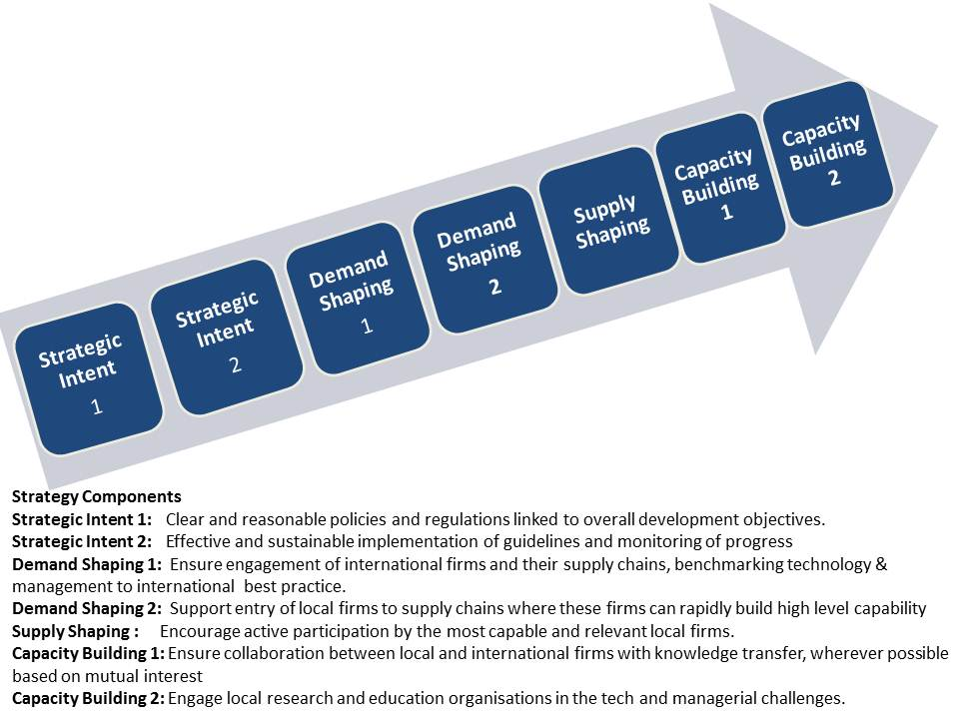

Table 2.5: Designing an Effective SME Development Strategy
Dimensions | Key Issues to Address
Access to Markets | - Target SMEs with real potential for competitiveness in specific market segments.  - Assess the demand from first and lower tier contractors- review contracting strategies and procurement management, codify supply specifications (pre-qualification, health & safety, QC, etc.  - Assess supplier capabilities and the costs, time and processes for raising those capabilities – management capabilities, business processes, and ability to meet contract award requirements (prior experience and certification).  - Assess gaps in skills, technologies, business processes, finance, and linkages.  - Develop strategies and mechanisms (specialist SME development organisation, support by lead contractors) for addressing these identified gaps within the resources and time scales available.  - Assess the scope and if possible facilitate partnerships and alliances with local and international firms for technology transfer, entry to the value chains of foreign suppliers, market access and joint bidding.
Management and Human Capital | - Assess the extent to which progressing from the entrepreneurial phase to the level of professional management is often a critical stage in the life of SMEs and weaknesses in routine management systems can be major barriers both to performance and to effective technology upgrading.  - Provide or enable participation ineffective management training programs.  - Consider specialist training in areas critical to market entry.
Business Processes and Technology | - Assess the need to strengthen the business processes of targeted SMEs in managing the procurement processes of customers, to be ‘bid ready’ and in sound and systematic health, safety and environment systems.  - Develop or use specialised training for managing procurement pre-qualification and proposal preparation – and possibly carry out initial audits, based on customer priorities, to identify and then address weak areas.  - Assess and address weaknesses in QC systems and in the capacity to use IT – for communications, to have a web-presence and for routine administrative processes. Customers may require a capability to exchange digital information.
Access to Finance | - Problems in access to working capital and capital for investment in upgrading equipment and human resources is likely to a constraint on SMEs capacity to meet procurement opportunities.  - If this is the case, then other SME support measures will have limited success without an initiative to provide financing or facilitate access to finance, eg by advice in preparing a business plan and application.
Based largely on: Based on CDC Development Solutions in Warner (2011). See also: IFC A Guide to Getting Started in Local Procurement. International Finance Corporation; IFC Small and Medium Enterprise Toolkit. International Finance Corporation.

Figure 2.3: Policy Framework for SME Development Strategies

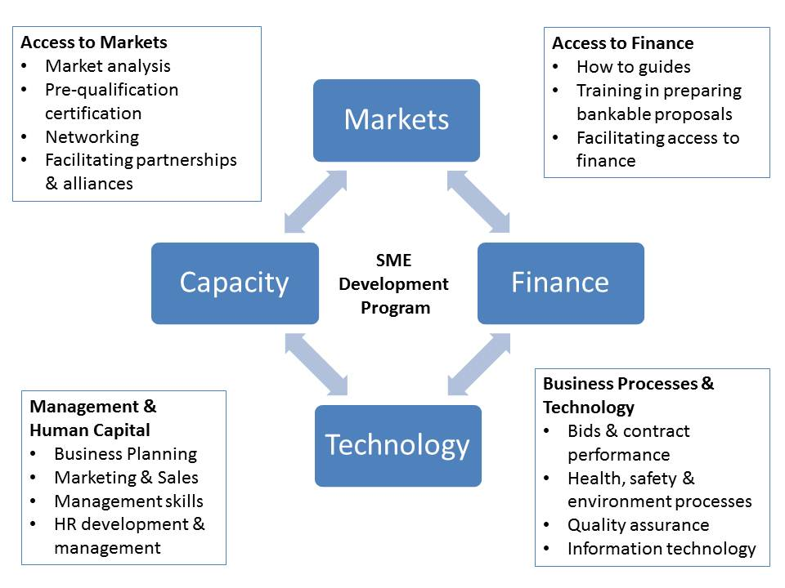
Based on CDC Development Solutions in Warner (2011)

The Australian Mining Industry

Characteristics of the Australian Mining Industry
There are at least 300 mining companies, 600 exploration companies and perhaps 300 mines in Australia. Mining has a major role in the Australian economy. Among developed countries mining has such a key role only in Canada and Norway. Australia holds substantial shares of world minerals production and known resource stocks – Table 3.1.
 | Table 3.1:.Australian Mineral Resources 2009
 |  | Share of world production | Indicative life (yrs) | Share of world est. resource | World ranking
Black coal |  | 6% | 100 | 7% | 5
Iron ore |  | 17% | 70 | 17% | 2
Gold |  | 9% | 33 | 12% | 2
Copper |  | 5% | 91 | 13% | 2
Nickel |  | 12% | 145 | 35% | 1
Zinc |  | 11% | 45 | 25% | 1
Uranium |  | 16% | 125 | 46% | 1
Source: Geoscience Australia
The mining industry accounted for about 5% of Australian GDP through the 1990s to 2004, rising to over 8% by 2011. In 2009-10, the value of minerals exports was $138 billion. Minerals exports currently account for around half of Australia’s total exports of goods and services with coal and iron ore alone making up one third. Mining investment has risen from $12 billion in 2003-04 to an estimated $56 billion in 2010-11. In 2008-9 new capital investment by the Australian mining and petroleum sector was about A$38b, of which about A$10b was for plant and equipment. With increasing demand the level of investment is rising and by the end of 2010 mining industry (ie minerals sector only) planned capital investment stood at $131.2 billion. Employment in the minerals industry was at almost 190,000 by the end of 2010.
Expenditure on exploration is less concentrated than investment in mine development and junior mining companies, which may sell identified resources to larger firms, account for a substantial share (in some years more than 50%) of exploration expenditure. Minerals exploration expenditure has grown strongly since 2000, with over 2008-9 due to the global financial crisis.
Surprisingly, multifactor productivity (MFP) in the mining industry has declined by 24 per cent between 2000-01 and 2006-07. Assuming that the methodologies used for assessing productivity are sound, the major causes of this apparent decline appear to be the declining quality of resources and the delayed impact of investment in new mines and the expansion of existing mines.
Mining industry investment in R&D grew strongly through the 2005-2009 period. By 2009-10 R&D expenditure by the mining sector was $3.7b (22% of business expenditure on R&D), a slight decline from 2008-9. The Australian Bureau of Statistics (ABS) surveyed 1,650 firms in the mining industry in 1998 to assess the levels of technological innovation over the previous three years. The survey showed that whereas 26% of manufacturing firms had undertaken technological innovation over this period, 42% of the minerals businesses had. The focus of innovation effort is on process improvement. This survey also sought information on the overall level of investment in innovation. The findings emphasise that R&D is a small component of such expenditure: 5% in the case of coal mining and 8% in the case of metal ore mining – Figure 3.1 – and hence that R&D expenditure is of limited value as an indicator of innovation activity in this industry.

Figure 3.1 Innovation in Mining in Australia: Types of Expenditure
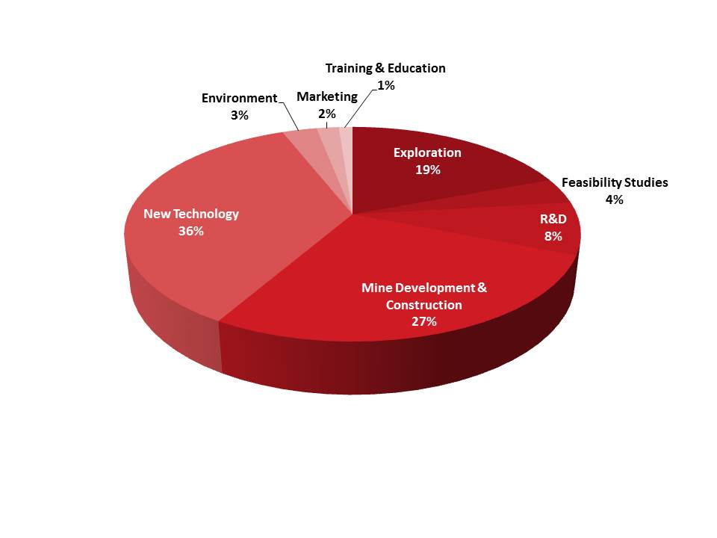
Source: ABS (1997)
The major mining companies have long been among the largest business investors in R&D. Significantly, the growing role of minerals production in Australia and the (partial) reflection of this in the development of research infrastructure led to Australian mining research accounting for a growing share of global mining research. This was both because of the sustained investment in Australia and the declining investment in mining research in Europe and the United States through the 1990s (Upstill & Hall, 2006). In a submission to the Productivity Commission in 2007, Rio Tinto claimed that the decisions over the location of R&D investments were driven primarily by “the existence of a critical mass of world class research facilities and researchers supporting basic science, with which we can establish strong relationships”.
The major mining companies operating in Australia, by mineral type are shown in Figure 3.2 companies account for 75% of the market value of the mining companies listed on the Australian Stock Exchange (ASX): BHP Billiton Limited, Rio Tinto Limited, Newcrest Mining Limited Woodside Petroleum Limited, and Fortescue Metals Group Ltd. The first three of these are majority foreign owned. Some of the major companies operating in Australia are not listed on the ASX: Xstrata, Anglo American, Peabody and Newmont. Hence, the level of foreign ownership of the Australian mining sector is high.

Figure 3.2 Major Mining Companies in Australia
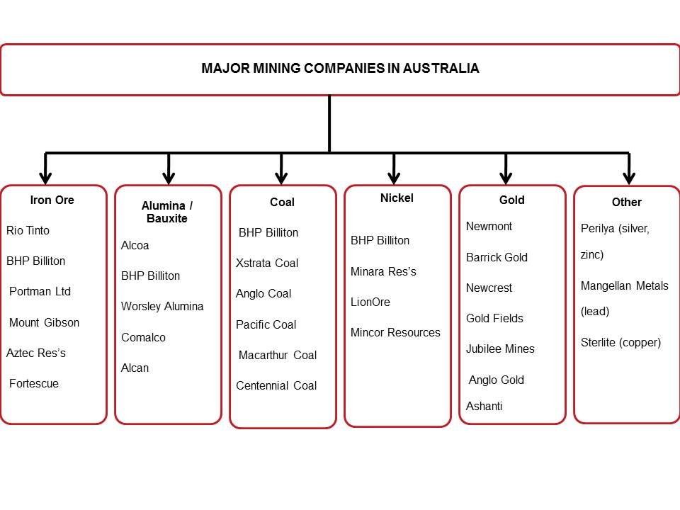
Several aspects of mining industry development in Australia shape the opportunities for METS sector development:
Consolidation and Globalisation
There are four major international mining companies operating in Australia: BHP Billiton; Rio Tinto; Xstrata and Newcrest Mining. As illustrated in Figure 3.3, Mergers and acquisitions along with a widening international dispersion of exploration and mining have changed the structure of the mining industry. Globalisation also extends beyond mining activity to research and collaboration, which, with the emergence of major global players is also more widely dispersed and coordinated. Collaboration among several of the major mining firms led to the formation of Quadrem Supply Network in 2000 as a global e-business (B2B) platform for mining-related procurement.

Figure 3.3 The Global Mining Industry in 2001 and 2011
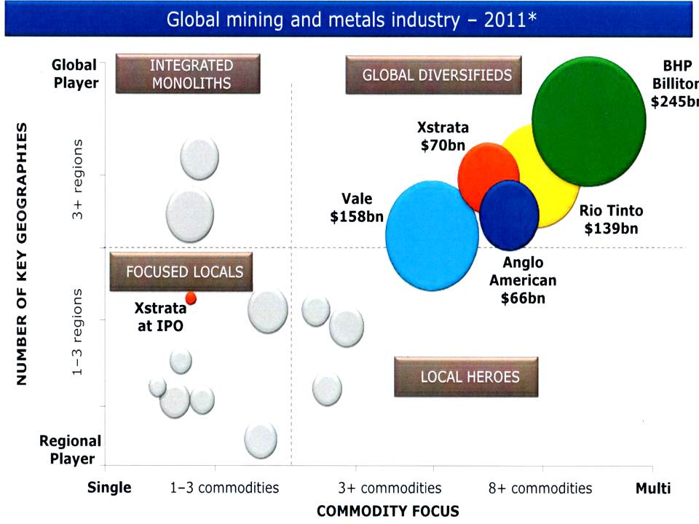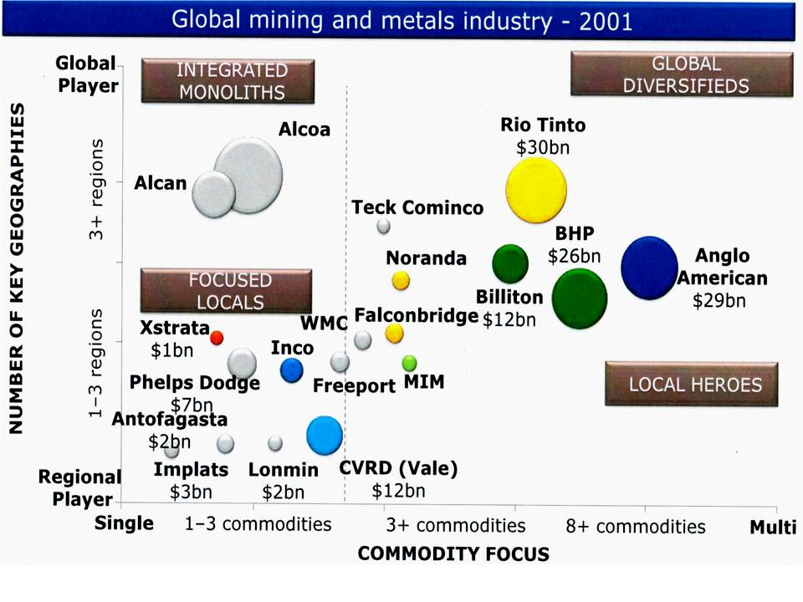
Source: Xstrata
Costs and Complexity
Competitive mining is becoming more challenging for a range of reasons:
- New resources are more likely to be in remote sites, buried more deeply and hence less evident from surface exploration, and hence exploration is increasingly difficult.
- The process of mining facing rising costs due to lower grade ores, greater concern with safety, rising energy costs and shortages of highly qualified staff.
- Processing technologies must also deal with lower grade ores and rising energy costs.
- Due to the location of mines and to increasing regulation water usage and environmental impacts need to be managed more effectively.
The increasing complexity of mining activities, from exploration to marketing and environmental management, is discussed by Upstill and Hall (2006). They emphasise that most innovation in mining is incremental and that more radical, step-jump, innovation can take many years to develop and implement, and involves substantial risks.
A recent survey of mining companies in North America, Latin America and the Asia Pacific confirmed the continuing emphasis on cost reduction, and found that the firms identified their most urgent challenges, in priority order, as:
- Optimizing/maximizing production effectiveness;
- Ensuring workforce safety;
- Recruiting and retaining a skilled workforce;
- Managing capital projects;
- Ensuring different departments work together; and
- Ensuring equipment operates reliably and predictably.
Knowledge Intensity
It appears that three trends are shaping the development of mining company – METS interaction:
- The deepening knowledge-intensity of mining as the challenges of lower-grade ores, environmental and safety goals and skill shortages are addressed through innovation;
- A higher level of outsourcing of that innovation as mining companies focus on ‘core competency’ and look to their suppliers to provide new approaches and ‘solutions’; and
- A preference for ‘whole system integrated solutions’ so that the mining company can rely on a well-established supply for a ‘wall to wall solution’ with whole of life support and upgrades.
While these trends open opportunities for new suppliers they continually raise the level of competency required for success.
The knowledge intensity of mining, from exploration, through mine development, mining, processing and site remediation, continues to deepen. While the rate of change if uneven it is clear that mining companies are increasingly looking to their major equipment suppliers to take on a more service-oriented role. This involves suppliers taking responsibility for the use of equipment, for example through maintenance and repair contracts. In some cases this trend has led to mining companies negotiating contracts to pay equipment suppliers not for availability of equipment ($/hour) but for minerals output by the equipment ($/tonne), shifting not only product support to the supplier but also the capital cost of the equipment.
The challenges outlined above have led to and increasing demand for highly qualified personnel and to rising investment by mining companies in R&D. AusIMM commented:
“In Australia we are able to increase our prospectivity through R&D and innovation that lead to better techniques and technologies for deep cover exploration, improved minerals processing techniques to render lower ore grades economic, more efficient mining methods to bring down costs, more sustainable practices to meet the conditions of the social license to operate and supporting services that increase efficiency and competitiveness.”.
In particular, the application of IT is now extensive and increasingly essential in Australian mines and more recently in mines throughout the world. Applications of IT are increasingly diverse and systemic, and include visualisation of exploration data and mine layouts, underground communication, mine planning software, remote control, asset management, supply chain management, scheduling, automation, optimisation, and systems to support training and knowledge capture.
However, a significant report in 2000 on innovation in the Australian mining industry recognised the increasing technological intensity of exploration, mining and mineral processing – particularly the growing role of IT. But the report expressed concern with the lack of private and public sector commitment to mining-related R&D, and to effective approaches to collaboration at that time:
“..government policy needs to reflect the importance of the minerals industry within the national innovation system and has an increased role to play. This includes clear assessment of the present and future role of innovation in minerals, compared with other industries which it prioritizes and where the country does not possess such a history, research infrastructure and comparative advantage. Based on this recognition there is a need for more active promotion of longer-term research in the industry and greater coherence and cogency in its support for innovation in the minerals industry.”
The report went on to argue that ensuring the future competitiveness of the mining industry in Australia required a more pro-active approach to responding to the rising knowledge intensity:
“Australia has a comparative advantage in the minerals industry; an industry with a large and historic base. Future international comparative advantages will depend on building this base, creating what is a called an international ‘centre of technological competence’.”
Drawing on evidence provided by a report drafted as part of the Minerals Technology Services Action Agenda process, a report to government claims that “..much of the 200 per cent increase in minerals industry productivity over the past 20 years can be directly attributed to the implementation of [mining technology services sector] innovation.”
Rio Tinto has a substantial Technology and Innovation Group, with several technology centres. Rio Tinto’s Mine of the Future strategy emphasises improved exploration, greater automation of mining, and improved recovery of more challenging deposits. The automation gaols are being implemented through their Remote Operating Centre in Perth, which controls some mining operations in mines in the Pilbara. Importantly, Rio Tinto aim to develop a higher degree of collaboration with suppliers and researchers to pursue these goals, and a substantial component of that collaboration is developing in Australia – although most of the supplier links are with international firms.

Entry and Development of Australian METS Firms.
The mining industry in Australia has faced a range of challenges that have driven a trajectory of increasing knowledge intensity. In addressing those challenges mining companies have drawn increasingly on specialist suppliers of services and equipment. This trend to greater outsourcing has been driven by the rising complexity of the tasks and by the shortages of specialist personnel. In such a context it appears that the changing role of innovation in the mining industry has provided a range of opportunities for new Australian METS firms. These challenges and opportunities begin with exploration in a terrain where potential mineral resources must be found under often deep regolith. As a result of sustained efforts to address those problems a number of Australian exploration equipment and service providers have developed capabilities which now provide the basis for entry to international markets. It has been both the international activities of the major Australian-based global mining firms and the increasing international exploration by the highly entrepreneurial ‘junior’ mining companies that have facilitated international market entry by Australian METS firms.
Many Australian METS firms have been pioneers in the application of ICT in mining. In particular, the increasing and pervasive importance of IT has led to many new trajectories of innovation in specific niches in which there are not established international suppliers. A study of IT applications in mining found that:
“ICT providers to the mining industry are typically much smaller in employee size and revenue terms than their clients, and generally pursue niche markets with one, or a small number of, specialised ICT products. Most ICT providers to the mining sector derive all or most of their income from the mining sector, and adapt their products for clients in other industry sectors only on an ad hoc or opportunistic basis.”
It also appears that, at least in the past, the mining industry has not been attractive to the major IT companies, such as Cisco and Siemens, and hence the scope for IT-based solutions for the mining industry has been an opportunity for small specialist firms. In addition, the relatively high level of Australian research and education in mining-related areas provides at least the potential for support of local technology development. While decisions on major investment-related equipment and services are centralised the ongoing requirements for equipment and services ( eg environment, safety, mine planning and management, mine site services) is often more localised providing opportunities for less established suppliers.
Local Content
The sourcing from local suppliers of equipment and services for major resource projects has been a controversial issue for over 20 years. For example, in 1998 a House of Representatives Committee report on Australian Participation in Major Projects updated an earlier Committee report, both focused on the North West Shelf oil and gas developments. Based on information provided by Woodside, the report estimated that overall local sourcing for the North Rankin platform, the Goodwyn platform and LNG trains 1, 2 & 3, was over 70% for investment project costs and over 80% for operational costs (totally about $10b) – these levels are very similar to earlier estimates in a 1992 Allen Consulting Group report. It is not clear, however, what proportion of the ‘local sourcing’ involved equipment although supplied by a local firm was actually imported.
The Department of State Development in Western Australia compiles detailed information on the sourcing of inputs for resource projects in that state. The findings of the most recent report are summarised in Tables 3.2 and 3.3 - more detailed information is in Appendix 1.

Table 3.2 Sourcing of Equipment and Services for Resource Projects in Western Australia
Year and Project Type | Western Australia | Other Australian | Overseas
2009
Operating Projects | 80 | 12 | 8
New Projects | 58 | 7 | 35*
2010
Operating Projects | 86 | 10 | 4
New Projects | 61 | 8 | 31*
Source: WA Department of State Development (2011)
*For some major projects the proportion of total investment goods and services sourced offshore exceeded 50%.

Table 3.3: Local Content Estimates for Resource Projects in Western Australia
Sector | Construction | Operations
Mining | 86% | 95%
Oil & Gas | 58% | 83%
Source: CME/APPEA Local Content Study (2011)
This WA Department of State Development (2011) report found that project managers tended to use local suppliers for design, procurement and contract management, but that the level of local sourcing overall is declining due to:
- the increasing exchange rate;
- the growing capability of East Asian suppliers;
- low cost steel sourced from China;
- particularly in the case of Chinese investors, a closer links between project equity and sourcing;
- easier access to remote WA sites due to advances in transport and communication technologies;
- globalisation of supply chains and marketing arrangements;
- the greater use of modular construction technology for major capital equipment,
- the shift to offshore suppliers for design, procurement and contract management services; and
- the growth of specialist engineering procurement and contract management companies undertaking out-sourced service provision for project proponents.
The report concluded:
“As a result, the market supplying goods and services to resource projects has become more complex and competitive. Overseas competition is beginning to occur in areas previously serviced almost entirely by local businesses, such as accommodation, catering, concrete walkways and equipment maintenance. Production and services capacity and specialisation is increasingly concentrated in a few global hubs, and Western Australia does not feature strongly in these commercial linkages. These factors have been evident for several years, but competition has intensified sharply since the global financial crisis…Changing conditions have been particularly pronounced in offshore energy projects. Local industry participation has fallen from a peak of 72% for train 4 of Woodside’s North West Shelf project to an estimated 45% to 55% for the Pluto and Gorgon projects”
Applications by investors under the Enhanced Project By-law Scheme (EPBS) provides some information on the significance of mining resource projects in overall major new project development. The EPBS enables tariff duty concessions for capital goods for major investment projects, but requires applicants to submit a plan for Australian industry participation in the project. Since the schemes inception in 2002 the majority of applications have been from the resources sector, by value: mining (39%); gas supply (31%); resource processing (10%). The scheme was reviewed by Access Economics in 2010, who concluded that the scheme was generally effective but needed to be more flexible, better linked to other industry support schemes and more forward looking. One of the schemes with which the EPBS links is the Industry Capability Network, which is sponsored by DIISRTE and State Governments and has state-focused offices within a national network. ICN assists project proponents to identify possible Australian suppliers of project inputs. The ICN also manages the Supplier Access to Major Projects (SAMP) Program for DIISR.

Australian Suppliers to the Resource Industries: Sectoral and Firm Development

Australian METS Sector
The Bureau of Resources and Energy Economics (BREE) estimate that the pipeline of mining industry investment is A$260 billion at April, 2012. This estimate is based on almost 100 projects at an advanced stage of planning or construction, of which 40% are mining projects, as similar percent are energy projects and the remainder are largely infrastructure projects, but only two mineral processing projects. The overwhelming majority of this investment is for coal, iron ore, or oil and gas projects, of which the majority is for several large scale oil and gas projects.
These investments and the ongoing operations of these oil, gas and mineral projects create major opportunities for Australian suppliers. The Australian mining equipment, technology and services (METS) sector comprises more than 160 companies, many privately owned. The aggregate mining-related sales of these METS firms in 2011 was $A43 billion and the overall employment was over 150,000 people. Over a third of that income was from offshore sales. While the onset of the GFC led to declines for many firms over the 2008-9 period, for many of the last several years, growth rates for the sector have exceeded 15% per annum. Two thirds of these firms are based in WA or Queensland.

Major Segments of the METS Sector
Defining and characterising the mining-(or the broader resource-) supply sector is not straightforward. This is the case for two reasons. The firms that supply resource projects are diverse and from many industries – this is evident from Table 4.1 which provides one of many possible classifications of suppliers to the mining industry. Second, for many firms the mining industry is only one of the markets they service, for example suppliers of tyres. The analysis in this report focuses on firms for which the mining sector is the main or only market.
The three major segments of the METS sector in Australia – equipment, technology and services – are summarised in Figure 4.1 along with indications of the size of each sector and examples of major firms in the segment. These major segments are:
- Technology Companies
The segment of Technology Companies includes at least 30 firms. In 2011 these firms had total sales of almost $ 900 million, of which almost 50% were exports, and employed almost 4,000 people. The segment includes two sub-segments:
    - Information Technology, and
    - Specialised Equipment (control, scanning, simulation and mineral processing)
- Service Companies
There are at least 100 service companies, including engineering and consulting firms and contract mining and construction firms, and their total sales in 2011 exceeded $36 billion. More than half of these firms are privately-owned. Over a third of total sales ($13.5 billion) are in offshore markets.
- Equipment Manufacturers
The segment of firms that manufacture and/or supply equipment includes over 30 companies which employ over 20,000 people and had total sales in 2011 of almost $6 billion.

Table 4.1: Categories of Suppliers to the Mining Industry
 | Knowledge- intensive Services Consultants | Specialized Services Contractors | Capital Goods &  Equipment Suppliers | Consumable Inputs Suppliers
Services and goods mainly for investment projects | - Exploration services.  - Investment project management.  - Engineering services such as mine planning, process design, and metallurgy engineering.  - Mine closure, reclamation and remediation design | - Development & construction services.  - Tunnelling services.  - Shaft sinking.  - Drilling services  - Sampling services | - Heavy machinery and equipment such as: mills, crushers and smelting equipment
Services and goods mainly for Ongoing operation | - Mine automation & optimisation.  - Blasting engineering.  - Equipment design and adapting.  - Equipment maintenance and repairing.  - Geological testing.  - Metallurgical analysis. | - Drilling services  - Shaft sinking  - Laboratory Services  - Mineral handling contractors  - Education & training  - Mineral processing  - Environment monitoring  - Tailing dam operating | - Light machinery & equipment  - Replacements  - Drilling equipment  - Conveyors  - Ventilation equipment  - Excavators  - Electronic equipment  - Engines and generators | - Explosives and blasting accessories  - Chemical products.  - Abrasives  - Acids.  - Drill bits.  - Tyres
Urzúa (2012)

Figure 4.1: Major METS Categories
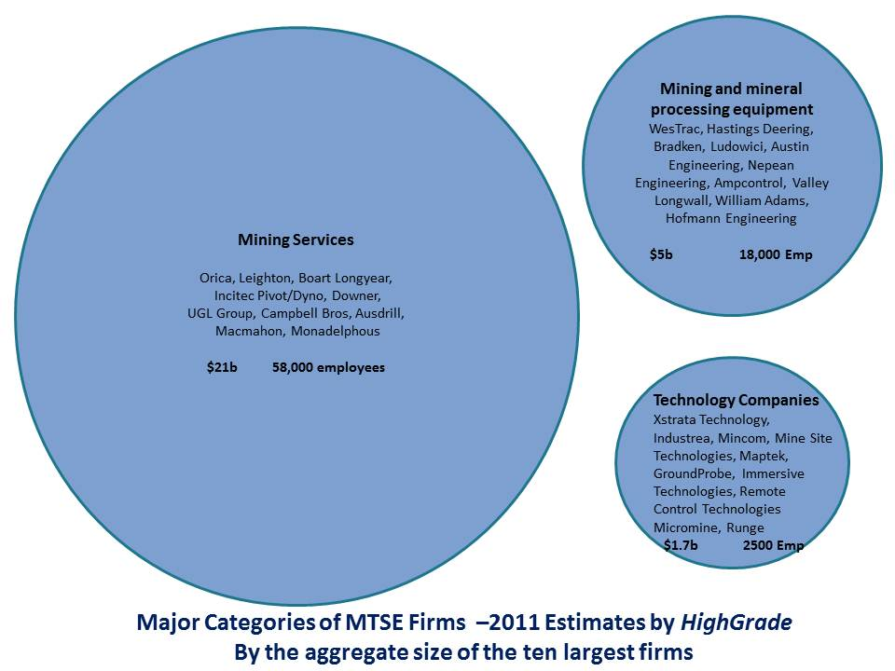
Table 4.2 provides example of the major METS firms. A more detailed breakdown, with example of the main products and activities in each segment is shown in Figure 4.2. Figure 4.3 summarises available information on the size of each segment and again provides examples of the major firms. Each of these segments is discussed in further detail below.
Figure 4.2 METS Categories and Sub-Categories with Examples of Products and Services
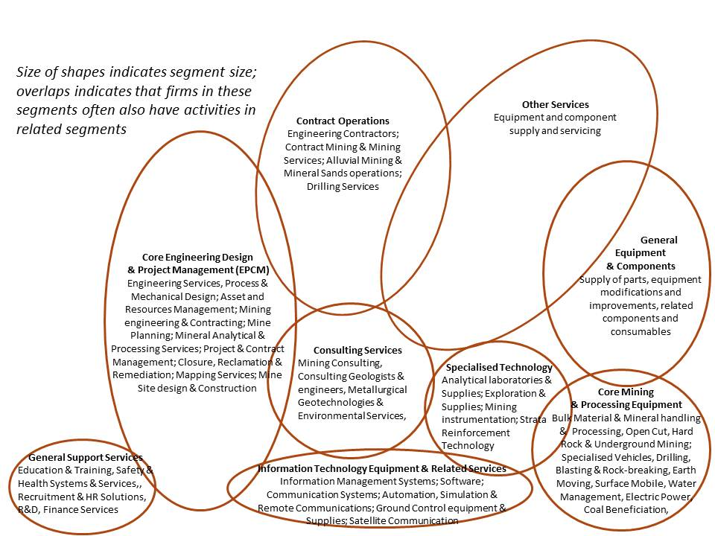
Figure 4.3: METS Categories and Sub-Categories with Estimates of Size and Major Firms.
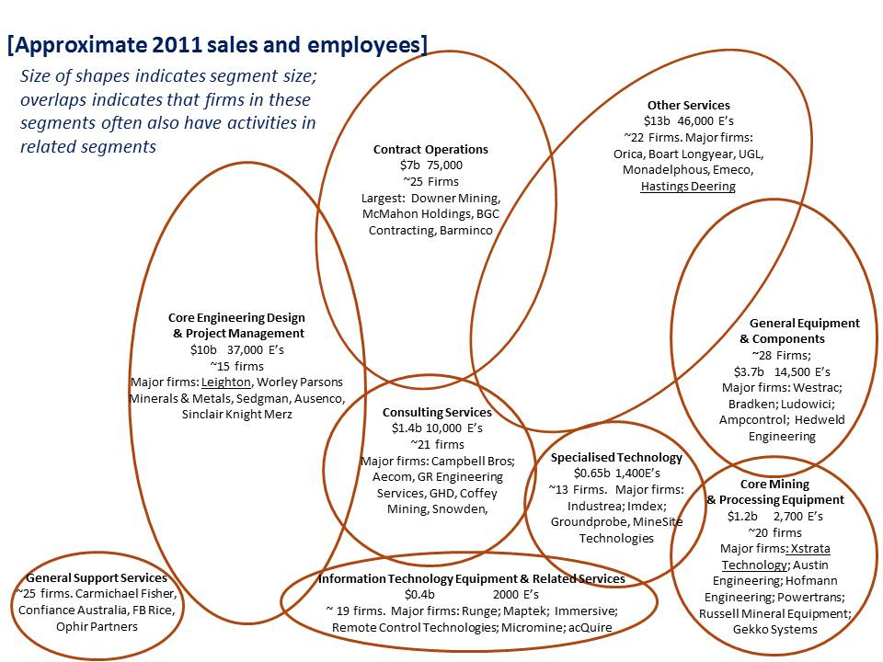

Table 4.2: Major METS Firms and 2011 Mining-Related Turnover
Company | Segment | Revenue  (A$m)
Orica | Mining services, explosives & ground support products | $6272
Leighton Group (Thiess, Leighton Contractors, John Holland)# | Mining (particularly open cut) contractor | $6150
Boart Longyear* | Drilling services and manufacturing. | $2000
Incitec Pivot (Dyno) | Explosives | $1680
WesTrac | Mining equipment supply and servicing | $1563
Downer | Contract miner and engineering and construction | $1400
Hastings Deering | Equipment supply and servicing | $1390
Bradken | Equipment manufacturing and Engineering | $1147
UGL Group | Contract construction and engineering services. | $959
Campbell Bros | Laboratory analysis services (ALS) & quality assurance | $858
- #-majority foreign owned
- *- Boart Longyear is listed on the ASX and has significant Australian institutional ownership.

The Evolution of Mining and the Growth of Australian METS Firms
As is explained in more detail below, the changes in the mining industry, due to consolidation, new performance requirements (higher productivity of labour capital, energy, water, lower value ores, labour shortages and costs and safety concerns) and the availability of new technologies have opened opportunities for new suppliers – these trends are indicated in Figure 4.4. These opportunities have been throughout the life of mine, from exploration to closure. Many of the Australian METS firms have evolved from a more limited to a broader role: engineering firms to broader project management roles; equipment service firms to component and equipment production. Many of the technology-based firms began as entrepreneurial ventures in a specific niche.
Figure 4.4: The Evolution of Mining and the Growth of Australian METS Firms
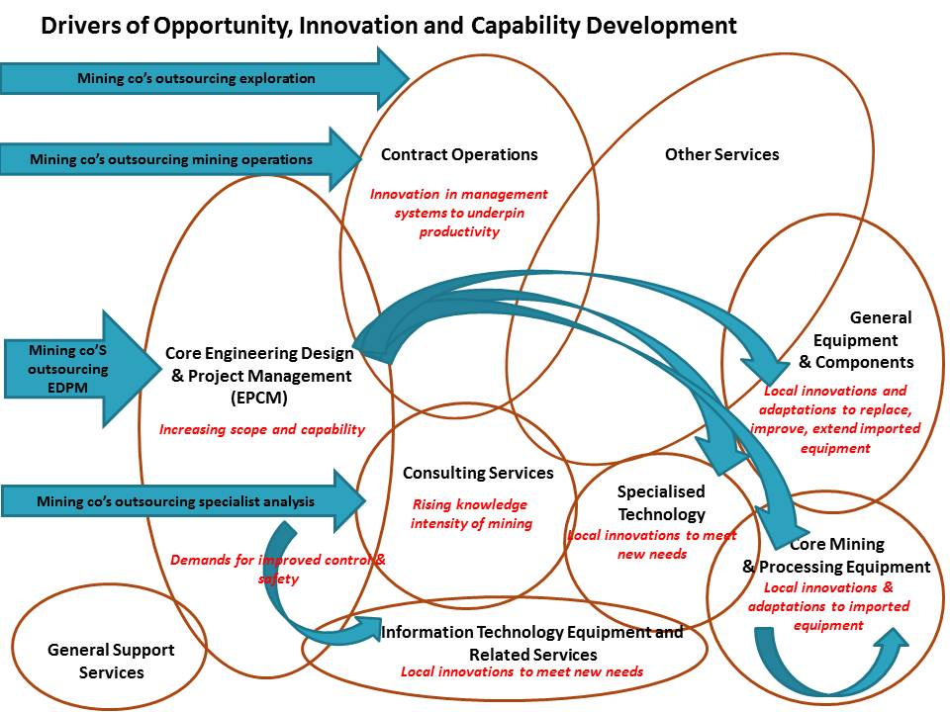

Figure 4.5: Sub-Segments of Australian METS Firms in Relation to Mining Project Stages
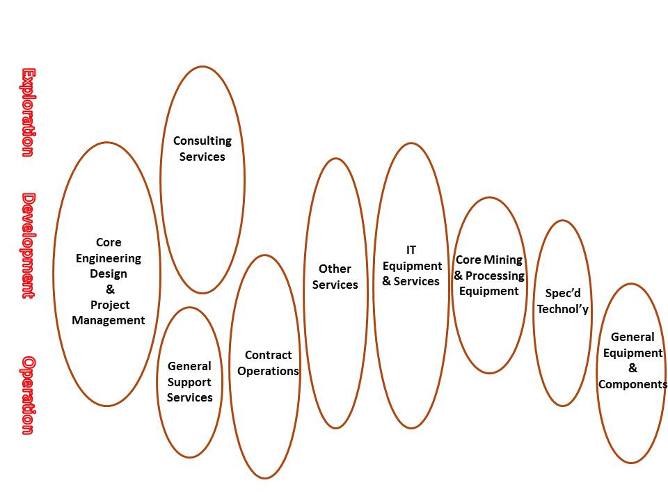
While Contract Mining and the diverse sub-segment of Other Services account for large shares of METS activity in Australia, these sub-segments are, to date, not as active internationally- Figure 4.6.

Figure 4.6: Levels of Offshore Activity in the Sub-Segments of Australian METS Firms
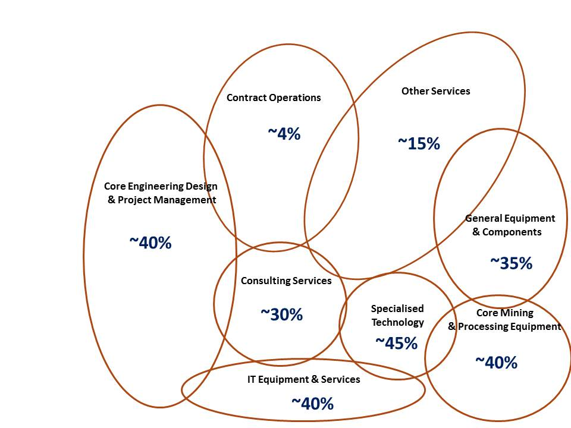Source: Export and offshore activity estimated from HighGrade survey data
A major mining equipment firms have strong positions in the Australian market and dominate the supply of the major specialised equipment – Figure 4.7. Two particular sub-segments of METS have high levels of continuing dependence on foreign suppliers: the EPCM role in large projects, and the supply of core drilling, mining, transport and processing technology- Figure 4.8. There have been several recent acquisitions of Australian METS firms by foreign firms. This reflects a global process of consolidation, but one of the challenges for METS firms is the difficulty of raising capital for growth. The opportunities for capital-raising through an ASX listing are limited by the valuations placed on equity in METS firms, particular at times when the share market is flat.

Figure 4.7: Specialised Mining Equipment and International Suppliers.
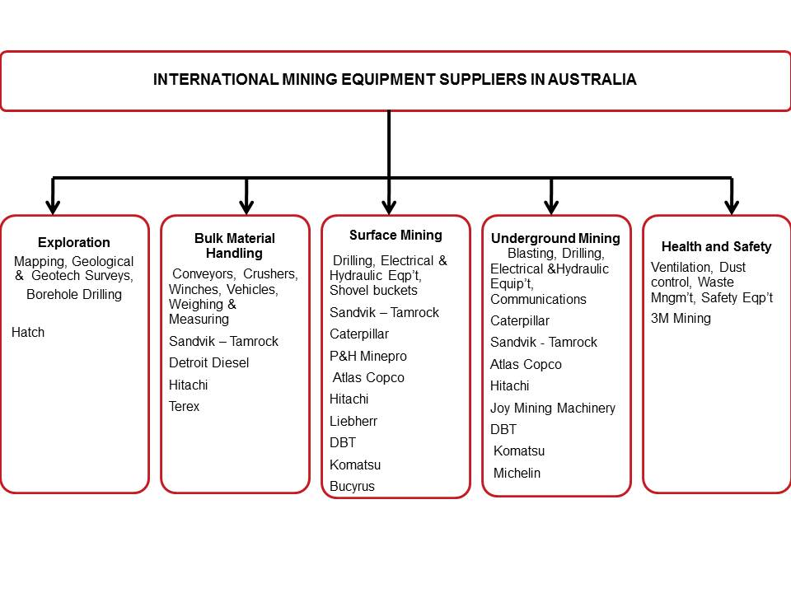

Figure 4.8: METS Sub-Segments with High Levels of Dependence on Foreign Technology/Capability and Recent Foreign Acquisition of Australian METS
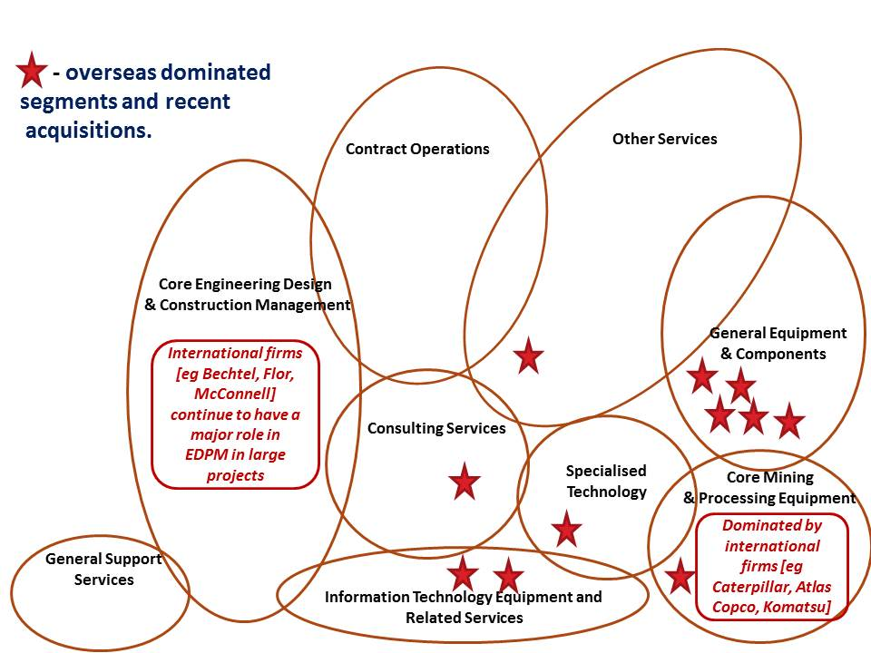

Table 4.3 Recent Foreign Acquisitions of Australian METS Firms
Acquirer | Acquired | Sector
Caterpillar (US) | Elphinstone | Equipment manufacture, distribution and support
Titan Europe (UK) | Wheel & Rims Engineering | Equipment
GE (US) | Industrea | Equipment
FLSmidth (Denmark) | Ludowici | Equipment
Gemcom (Canada) | Surpac Minex and Whittle Programming | IT / Consulting
Leica Geosystems (Swiss, now part of Sweden’s Hexagon AB) | Tritronics | IT/Software
CAE (Canada) | Datamine | Software
Triple Point Technology (US) | QMASTOR | Software
AMEC (UK) | GRD Minproc , Currie & Brown | Consulting
Thyssen Group (Germany) | Byrnecut Mining | Contract Mining
Ventyx/ABB (Swiss, Swedish | Mincom | Contract Mining

Characteristics of the METS Segments

Service Companies
Australian firms have become world leaders in many areas of mining-related services. Engineering and Project management firms such as Ausenco, Sedgman and Worley Parsons are winning EPCM contracts against leading international firms. Many of these mining service firms provide a range of services and some have also become involved in manufacturing. [Several of the mining equipment producers also provide related services – and in fact most such firms began as repair and maintenance shops before beginning a focus on product development.] Due to this diversity of services quite a few firms do not fall neatly into only one or two of the categories used here to characterise the METS sector.

Front-end design and engineering, procurement and construction management (EPCM)
The opportunity for Australian firms to enter the market and build capability in mining-related engineering design and management began when the large mining companies closed down their internal project management capability. With limited capacity and rapid growth in projects, reliance on consulting and engineering and EPCM firms grew.
As there is an overall shortage of experienced mining project engineers and managers, mining firms and the service firms are competing for talent – particularly engineers with experience on large projects. Many of these firms have rapidly grown capability and capacity. They have also developed strong offshore activities. Many of these firms are growing in scale and capability and taking on larger projects and broader EPCM roles. They are beginning to win contracts against larger global rivals, such as Bechtel, Flor and AECOM (Table 4.4).

Contract Drilling, Mining and Construction
Australian contract miners have developed high levels of capability, in underground, open cute and coal mining. Leading firms have strong systems for productivity and safety(Table 4.5)..

Table 4.4: Major EPCM Service Firms
Company | Services (& products) | Est’d | Emp’s | Revenue  (million)
Leighton Group + | Contract mining, construction and engineering services. | 1949 | 20,000 | $6150
WorleyParsons (M&M) | Engineering and project management | 1971 | 1500 | $640
Ausenco | Engineering and Consulting | 1991 | 3200 | $550
Sedgman | Engineering and consulting | 1979 | 1000 | $500
SKM (Priv) | Consulting and Engineering | 1964 | 1900 | $500
Lycopodium | EPCM for mineral processing plants | 1992 | 600 | $170

Other Mining Services
This group of firms provides a diverse range of services to mine development and operation, other than EPCM, contract operations or consulting services. These services range from the supply and servicing of plant and equipment, hiring equipment, to the conduct of ‘rock fragmentation’ by Orica Mining Services(Table 4.6)..

Table 4.5: Major Contract Mining Firms
Company | Services (& products) | Est’d | Emp’s | Revenue  (million)
Leighton Group + | Contract mining, construction and engineering services. | 1949 | 20,000 | $6150
Downer | Contract mining, construction and engineering services. | 1922 | 3500 | $1400
Ausdrill | Contract drilling services & related equipment and product manuf’g. | 1987 | 4360 | $835
Macmahon | Contract mining, construction and engineering services. | 1963 | 3540 | $825
Ausdrill | Contract drilling (and equipment) | 1987 | 4400 | $840
AJ Lucas | Contract Drilling | 1958 | 640 | $250
Barminco (Priv) | Contract mining | 1989 | 2000 | $490*
NRW | Contract mining, earthworks and construction | 1994 | 3500 | $750
BGC (Priv) | Contract mining and construction | 1957 | ~2000 | $600
Golding Contractors (Priv) | Contract mining and civil works | 1942 | 1000 | $350*

Consulting Services
The decline in in-house capability in many mining companies and the increasing knowledge-intensity of exploration, feasibility assessments, mine planning, operations and optimisation is increasing the demand for high level consultants across a wide range of geological, engineering, environmental and commercial aspects of mining. The limited supply of consultants, particularly those with experience, is a continuing constraint on growth, particularly as offshore opportunity is growing rapidly, without reducing quality or raising costs due to the upward pressure on salaries. These trends are encouraging greater consolidation through mergers or acquisitions. International mining consultants, such as SRK, Golder, AECOM and AMEC, will have greater opportunities to capture market share in a supply constrained market (Table 4.7).

Table 4.6: Major Diverse Mining Service Firms
Company | Services (& products) | Est’d | Emp’s | Revenue  (million)
Orica | Explosives manufacturing and supply; blast management services; strata support products; chemicals. | 1874 | 14,000 | $6272
Boart Longyear | Contract drilling services; drill product and equipment manufacturing. | 1890 | 9000 | $2000
UGL Group | Contract construction and engineering services. | 1971 | 5900 | $959
Campbell Bros. | Analytical laboratory services, certification | 1863 | 10,000 | $858
Monadelphous | Contract maintenance and engineering services | 1978 | 3000 | $809
Emeco | Equipment hire | 1972 | 950 | $500

Table 4.7: Major Mining Consultancy Firms.
Company | Services (& products) | Est’d | Emp’s | Revenue  (million)
GHD (Priv) | Engineering and environmental consulting services | 1928 | 1200 | ~$150
SKM (Priv) | Consulting and Engineering | 1964 | 1900 | $500
Coffey Mining | Exploration and Mining consulting | 1959 | 320 | $44*
Runge | Mine design, planning, optimisation, valuation | 1977 | 370 | $94
Snowden | Mining consulting services | 1987 | 200 | ~$40
GR Engineering Services | Engineering consulting and contracting | 2006 | 150 | $130
Xstract Mining Consultants (Priv) | Mining consulting services | 2008 | ~35 | ~$7*
Optiro (Priv) | Mining consulting services | 2008 | ~20 | ~$5*
AMC (Priv) | Mining consulting services | 1983 | 200 | ~$40*
CSA Global (Priv) |  | 1986 | 75 | ~$15*
+-majority foreign owned
*- figure is an estimate for 2009-10.
Other consulting firms include: Mining One, Whittle, IMC Mining Solutions, Beck, Arndt Engineering, Mining Plus and Cube Consulting.

Mining Equipment Suppliers and Manufacturers (Table 4.8)
There are few Australian producers of large machinery and most large equipment for drilling, mining and processing is imported. It is important to emphasise this point – Appendix 1 sets out the major products of several of the leading global equipment producers: Caterpillar, Komatsu, P&H, Atlas Copco, Sandvik and Metso (other major international suppliers include: Liebherr, Hitachi, Joy Global, and Bucyrus, Sandvik). There has been for the last few years a strong process of consolidation, through mergers and acquisitions among these major global firms. There are no Australian mining equipment producers of anything near this capability, scope or scale. Some of the major Australian-based suppliers of mining equipment and related services (eg Westrac, Hastings Deering) are (value-added) distributors of this imported equipment. There are no Australian producers of a range of large scale processing equipment.
One of the early Australian innovators in mining equipment, and an example, of the ‘adaptation to innovation’ path taken by many firms, is Elphinstone. In the 1970s, Dale Elphinstone developed a loader and later a truck, based on Caterpillar components, better suited to underground mines. The firm was later bought by Caterpillar.
Hence, Australian equipment producers have developed to serve specific niches not addressed by the major international equipment producers. Several Australian METS firms manufacture components for imported machines, for example, Ausdrill, Bradkin and Austin Engineering. Many of these firms have built a strong international position over the past ten years.

Table 4.8: Equipment Supply and Manufacturing Firms
Company | Services (& products) | Est’d | Emp’s | Revenue  (million)
WesTrac | Caterpillar mining equipment supply and servicing | 1989 | 5100 | $1560
Hastings Deering* | Caterpillar mining equipment supply |  | 3530 | $1390
Bradken | Equipment manufacturing and Engineering | 1922 | 5600 | $1150
Ludowici | Mineral processing equipment | 1858 | 1170 | $220
Austin Engineering | Mining equipment components | 1982 | 700 | $200
Nepean Engineering (Priv) | Mining & materials handling equipment. | 1975 | 450 | ~$450
Ampcontrol (Priv) | Power distribution equipment | 1968 | 900 | ~$160
RCR Tomlinson | Design & manufacture of materials handling & process | 1979 | 2300 | $390
Hofmann Engineering (Priv) | Mining & mineral processing equipment, components & servicing | 1969 | 630 | ~100
Powertrans (Priv) | Manufacturer of off-road haulage vehicles | 2001 | ~100 | ~$50
Russell Engineering (Priv) | Robotic Mill re-lining equipment | 1985 | 200 | ~$45
Gekko (Priv) | Modular mineral processing equipment | 1996 | 70 | ~$30
Valley Longwall (Priv) | Mining equipment
William Adams (Priv) | Caterpillar mining equipment supply and servicing |  | 50
*-majority foreign-owned.
There is little evidence that the major mining companies have been active supporters of Australian METS firms. However, the suppliers of equipment to the mining companies and contractors have had a closer relationship with Australian producers of components and value adding ‘add-ons’. There is some evidence that some of the OEM suppliers are discouraging their distributors from using non-OEM components and add-ons. There are also several indications that Caterpillar and other global equipment makers have realised that they risk declining share of the total value of the revenue based on the supply, augmentation and servicing of their platform. As a result they are seeking to gain greater control over the equipment value chain, through acquisition. These trends are further amplified by the trajectory toward large scale, automated and controlled, factory style mining.
Among some Australian equipment producers there is an increasing concern that Chinese suppliers will build positions through, purchasing preferences, acquisitions and copying

Suppliers of Specialised Equipment, Software and Related Services (Table 4.9)
Firms in this segment are generally smaller and younger than the METS firms in other segments but several are world leaders in their niche. Many are experiencing rapid growth, particularly in offshore markets and this is stretching all levels of capability. The increasing demands for productivity and safety is driving demand for these new technologies, and attracting new niche firms into the industry. However, the specialised mining equipment control segment is dominated by automation companies, such as GE, Honeywell, ABB, Schneider, Emerson, and Rockwell. ABB, GE and Scheider have bought Australian mining software firms in the last few years. Many of the smaller software firms have built their business in a licence plus consulting-based revenue business model, but this approach is unlikely to provide a competitive approach as the segment consolidates and leading firms build the economies of scale and scope that enable investment in new technology. This is likely to be particularly important as mining IT systems become more inclusive and integrated, linking also to the drive for automation. This trend is clearly a challenge to the Australian mining software firms.

Table 4.9: Suppliers of Specialised Equipment, Software and Related Services
Company | Services (& products) | Est’d | Emp’s | Revenue  (million)
Industrea* | Drill guidance, mine vehicle collision avoidance technologies (sales of $115m in 2011) | 1987 | 400 | ~$300
Mine Site Technologies (Priv) | Mine communications products and systems. | 1989 | 270 | $50
Maptek (Priv) | Mining/exploration software | 1981 | 330 | >$50
GroundProbe (Priv) | Mine slope stability monitoring equipment and services | 2001 | ~200 | ~$45
Immersive Technologies (Priv) | Equipment training simulation equipment | 1993 | 230 | ~$50
Remote Control Technologies (Priv) | Remote control & vehicle safety systems | 1976 | 130 | ~$35
Micromine (Priv) | Mining &exploration software | 1986 | 240 | >$30
Runge | Software and consulting | 1977 | 240 | >$90
Australian-based, now foreign owned
Xstrata Technology  (formerly MIM Process Technologies) | Mineral processing technology, engineering services, and equipment. |  | 150 | ~$690
Mincom/Ventyx | Mining software. |  | 400
*-Recently acquired by GE

Case Studies of METS Firms: Formation, Growth, Capability Development and Internationalisation

Case Study: A
Segment and Market
Diversified equipment design, manufacture and supply, largely for mineral processing - marketing both capital equipment and consumables for processing equipment. Medium sized with a turnover of more than $200m and over 1000 employees, of which about a half are in Australia. Over 35% of sales are offshore and the company has five offshore offices.
Formation
This company was formed more than 100 years ago and the evolution to a strong focus on mining, and particularly the coal industry, is more recent.
Growth
In the 1970s to the late 1980s the emphasis was on organic growth, but from this time as series of acquisitions enabled faster growth and a broadening of the product range. Acquisitions have been central to growth and widening of the product range. Recent rapid growth followed the appointment of a new MD with extensive corporate experience. The firm acquired an Australian engineering firm and a plastics firm in the mid-1990s, an environmental equipment firm in the early 2000s, and another manufacturing firm in 2010.
Internationalisation
From the late 1990s, offshore markets, supplied through exports, acquired firms and joint ventures, became more important. In the 2000s, the Chinese market became particularly important. The company has sales in over 20 countries, and has manufacturing facilities in two offshore locations. The high costs of manufacturing in Australia led to the investment in manufacturing facilities in India and China.
A firm in South Africa was acquired in 2011, and the company also formed joint ventures in South Africa and Chile.
The firm has found that developing offshore business requires an investment of scarce managerial and engineering resources to develop relationships with the clients and to recruit and manage local staff. The firm’s experience is that it is essential proceed carefully to ensure that there are sufficient resources to support the market: While overseas acquisitions have been imported for market entry and growth, we have to invest the time of experienced Australian staff to bring them up to speed and drive the required cultural change.
Capability Development
The company has had a strong investment in R&D, from at least the 1980s, and a focus on continuous product development.
The company considers that the culture and relationships within the coal mining industry, and supporting organisations, are vital for stimulating and guiding innovation for this market. For example, the Coal Preparation Society, an informal group of suppliers, customers and research organisations, facilitates dialogue. The levy-based ACART also funds some research and technology development. However, the relationships with some mining companies have been less effective:
The major mining firms are very risk averse, especially BHP, and they are cautious about new technology. If anything they are becoming more conservative and are now fast second users. This is in part because they have low internal technological capacity and staff with less experience of change. We have often found the first users for new technology offshore. Some of the ECPMs, particularly Bechtel, are also highly risk averse and conservative, requiring high levels of documentation. This makes market entry difficult for small firms
Customers have been one, but not the major source of new ideas. The firm developed a technology from a university to produce a new line of equipment. There has been only quite limited interaction with CSIRO.
Challenges and Opportunities.
There are several challenges for maintaining growth:
- Innovations and acquisitions have enabled growth and survival, and the company has the view that they must innovative more than in the past to stay in the market. However:
“The culture within the mining industry is becoming less open and knowledge transfer is declining. Large companies, in particular, are becoming more closed and focusing more narrowly on technology development for their bottom line.”
- The lack of new ‘talent’ is a constraint on growth:
There are serious skill shortages and this is leading to declining quality in some areas of manufacturing. This is particularly due to a lack of investment in apprentices, and that is in part due to the high cost of labour (and also the costs of land and factory space) – so that firms want to hire trained staff, not invest in training. The removal of the training levy in the 1990s also led a declining investment in training. It is also difficult to find engineers and managers and more are recruited by the mining industry. We recruit engineers and technicians from South America, India, Malaysia, South Africa, Poland, New Zealand and the UK.
- Copying of manufactured products by Chinese firms is becoming an issue in the Chinese market.
However, the company is currently being acquired by an overseas mining equipment firm.

Case Study B
Segment and Market
The firm is a medium sized equipment manufacturer (around $200m turnover and 700 employees) producing components and add-ons for heavy mining equipment. Offshore activities, which continue to grow rapidly, account for about a third of turnover. This requires the establishment of production and servicing capacity offshore.
In addition to the OEMs there are more than four non-OEM firms competing for this segment of the market: Austin Engineering, Ausdrill, ESCO Corporation and Duratray.
Formation
The firm was established in the early 1980s as a fabrication company.
Growth
The firm faced increasing competition from China in low value added fabrication and this was limiting, in response the firm re-oriented to heavy fabrication using imported steel. However, over time the firm became increasingly oriented to mining, focused on customised ‘add-ons’ to the core equipment of Komatsu and Caterpillar, based on large workshops in WA and Queensland.
The firm was acquired by a WA company in the early 2000s, followed by rapid growth, led by a new CEO and flotation on the ASX. A series of acquisitions around Australia has continued, since 2005.
A close collaborative link with a US firm in this segment of the industry was developed and its products provided stronger entry to the mining markets. This re-focusing around products also involved a shift in the workforce from project to product-based organisation. This US firm was acquired in the late 2000s.
Relationships with customers, who are largely the major firms, including contract miners, remain linked to personal relations and market development is by word of mouth.
Internationalisation
The firm has established offices in the US, the Middle East, Chile, Peru and Colombia. It has production facilities in Indonesia, the US, the Middle East and South America. The firm is currently focusing on markets in Chile and Russia.
Capability Development
The developments have been incremental and due to both market opportunity, competition and strategy. The key re-orientation has been from essentially a jobbing shop doing fabrication to a product and service firm focused on superior and customised design and product support services.
Over recent years the firm has developed a close working relationship with an engineer with previous experience in high tech manufacturing. This has led to process innovations based on a robot for welding. This robot replaces four men and is faster, more accurate and produces a higher quality product. This is particularly important when qualified welders are scarce.
As the world’s largest non-OEM designer and manufacturer of mining dump truck bodies Austin Engineering has harnessed a technology which accurately simulates the behavior of different densities of particles as they interact with handling equipment such as dump truck bodies and mining buckets.
The company has confidential deals with large OEMs to build truck bodies to certain specifications.
“If you look at the OEMs and mining trucks, for instance, there is a great deal of time and effort which does go into manufacturing the chassis and building the truck. The truck body – which is where we’re creating a custom, niche market – is maybe 10% of the value of the overall truck, perhaps even less, so for many of the OEMs it’s not their core business, and many don’t really have a preference for whether the client puts a custom-designed body on there from [us] or one of our competitors or goes with the OEM body. For those OEMs their focus is to get that gear out of the factory and to the work site – in a way it’s taking the burden off them. So we’re not seeing resistance, in fact we have very close relationships with the OEMs. From that perspective we’re not really competing, we’re working with the OEMs.” [Source of quote: HighGrade]
The firm has also invested in software to enable simulations that support improved product design for specific customer requirements.
Challenges and Opportunities.
The company competes against the standard add-ons of the major equipment producers and its key competitive strength has become design - to give the customer better productivity and durability for their specific location. The firm also has the advantage of fabrication facilities near to the market, some developed through acquisitions of local fabrication and servicing companies.
Australia has become a very expensive base for manufacturing due to the costs of labour and steel. This firm has established a production facility in Indonesia. The shortage of skilled workers in Australia is also a constraint on growth.
A significant path for growth is to consolidate a position in non-OEM equipment through design and manufacturing capability and also to strengthen the customer relationship and capture further value from those skills through a close servicing (repair, overhaul and machining of equipment) role. This requires investment in capacity and human resources close to customers.

Case Study C
Segment and Market
The company is a privately owned, medium sized manufacturing firm with a turnover below $200m (at least 75% from mining) and about 700 employees. The company provides components for heavy metal processing equipment and other equipment for mining, and has close links to both the OEMs of that equipment and with the users.
Formation
The company was formed in the late 1960s, initially as a repair shop for equipment, by recent immigrants with tool making skills.
Growth
Growth has been continuous with rapid growth over the past decade. The company finances all growth from internal resources, including the two acquisitions in Australia in 2009 and the opening of offshore offices and servicing capacity.
Internationalisation
Almost 50% of business is now offshore, particularly in South America, and this requires a local servicing capacity. The company has a substantial workshop in Canada and in Chile. The key enabling of offshore opportunity has been the international expansion of Australian mining companies – these have pulled the firm into markets in Mongolia, Southern Africa etc.
The company has extensive international links with supplies, customers and industry associations and keeps informed about developments in materials, metallurgy, welding and metalworking machines. It also has links with firms in Taiwan, Japan and South Africa who are used for high quality forging work [Australian suppliers are more often used when forgings are required at short notice.]
Capability Development
The firm has gradually built a very high level of capability based on skills, designs and investment in large scale advanced machinery. It has been an active user of the R&D tax incentive and has developed many innovations in the materials used, the modification of processing equipment and methods and the design of components. The company spends about $35m on R&D each year and has a dedicated R&D team.
The company has built and maintained strong links with the OEMs for processing machinery, overseas producers of metal working equipment and overseas producers of high quality steels and castings.
“In the engineering industry [we] would be considered a leader of …. there has been a constant desire to be a leader in our field and not a follower. [as] Our labour rates are among the highest in the world, for us to be world competitive we have to do it through innovation in production and how we make the parts. Technology is a real key.” [quotes from HighGrade]
Challenges and Opportunities.
The increasing demands from customers, the resurgence of competitive pressure from some OEMs, the growth of low cost Chinese suppliers, the demands of growing international business and the shortages of local talent are among the challenges:
- The lower grade ores and the high cost of labour are leading to the use of larger scale equipment – processing machinery has quadrupled in size (massification). This increases the need to minimise downtimes. The company has developed a strong service capacity and coordinates with customers so that shutdown time is minimised.
- OEMs for some mining equipment are more difficult to work with than the manufacturers of processing equipment. Caterpillar and Komatsu prefer that customers use their (OEM) components and consumables. These firms are reassessing their strategies and moving the regain control over the value chain. For example, FLSmidth is now buying firms, in Australia and elsewhere, and re-consolidating. Some of the OEMs are aiming to push firms, such as this one, ‘further down the value chain’ where margins are lower.
- The company has made some acquisitions which provide entry to markets outside of mining, eg in food packing, marine equipment, alternative energy equipment and aerospace. The firm is considering focusing more business development effort on the Oil and Gas sector.
- The local talent market is a problem as the market is tight. The firms experience is that the local management training is not very relevant to their business.

Case Study D
Segment and Market
This small to medium sized firm, now owned by a large public company, with a staff of about 200 and a turnover above $50m, provides consulting services for resource and mining assessments, throughout the mine life cycle, based on geological and economic analysis—it is one of the largest Australian-based international mining and geological consulting firms. More than 50% of the business is offshore. The most important firms in this segment are: AMC Consultants, SRK and Snowden Consulting.
Formation
The company was formed in the late 1980s by two PhD level immigrants.
Growth
The firm has widened its services beyond consulting to providing training services for a wide range of clients, and also to ‘productising’ some of the analytical software it developed to support its consulting activities – in this market segment it competes with, for example, Runge and Coffey Mining.
In the mid-2000s the firm was acquired by a large mining service firm. More recently it formed a joint venture with a specialist South African firm to collaborate in consulting services in Australia and Asia.
Internationalisation
The firm has been active in international markets from its formation and currently has offices in South Africa, Canada, the UK and Brazil. It is currently working in 40 countries, including South America, China, Central and West Africa and the CIS region, largely drawn in by clients but also as a result of market development. Austrade has been very supportive and useful.
Further internationalisation is the current priority, particularly building a presence in more emerging offshore markets.
Capability Development
The firm began with very high level capability and with established links to research organisations through the founders. These links have been maintained and two Adjunct Professors are on the staff. The firm has an innovation board and an explicit innovation process for new product and service development. Some current projects involve links with researchers in universities.
Challenges and Opportunities.
The key challenges faced by the firm include the increasingly complex demands of its customers, the shortages of experienced staff and addressing the diverse market opportunities.
- Customers increasingly require complex multi-disciplinary projects involving optimisation studies from exploration and resource through to production – they ”..now want to be able to see models for multiple scenarios and evaluate the complex relationships between many resources, mines, plants and product streams. Simplistic optimisation studies and spreadsheets are no longer adequate.” [quoted in HighGrade]
- Meeting the opportunities and demands for international growth is stretching capacities, particularly as experienced consultants are a very limited resource. The culture of the firm and the opportunities its growth provides has been important for attracting consultants. More generally the supply of engineers and technicians is below demand, and this is leading to lost opportunities to grow Australian talent. The firm commented that the search for mining engineers, geologists and metallurgists was a global one. However, when the firm was acquired by a large public company some staff left to establish new small consulting firms.
- The firm is looking more closely at the strategy for developing and marketing its software products as a distinct business.
- Competition is growing: Chinese firms are quickly building capability and have a lot of support from their government for market entry. The firms commented that it is also seeing an increasing number of US firms looking for market opportunities offshore. There are new entrants at the bottom end of consulting and these nibble into markets with low cost service offerings. Some of the EPCM are also widening their role in consulting, building a stronger internal capacity in geological and economic analysis.

Case Study E
Segment and Market
The firm, a private company, has about 150 employees and a turnover near $50m. It markets mine remote control products, technology and services and vehicle safety systems and has a dominant market share. The firm has built a strong export position in South America, Africa and parts of Asia and Europe, but continues to supply and service these markets from its Australian base.
Formation
The firm was formed in the early 1970s as an electrical service company in Kalgoorlie, servicing mining equipment. The requirements of customers led to a stronger focus on auto-electrical capability and to the development of an initial product for engine protection. This requirement arose because surface machinery was taken underground but the heat and dust damaged expensive machines.
The firm was acquired by a new public company in the mid-80s, and it grew as a part of this larger group, but in the late 1990 this company spun off, through a management buy-out, as an independent firm. The firm then focused on growth.
Growth
For the first decade of its life the firm continued as a service provider, with one simple product, and with little interest in going interstate or international. As the firm widened its product range some of its products were included in Caterpillar equipment sold by Elphinstone. This led to a stronger focus on products and on marketing. Some mining companies began to use the firm’s remote control devices, rather than build their own and this led to increasing orders. The firm developed links with the major miners, contract miners and with the suppliers of Caterpillar equipment. These relationships led to increasing inter-state and international sales. The firm grew at over 20% per annum over the last few years.
Internationalisation
The firm now exports to 60 countries and is focusing on export growth.
Offshore sales were initially the result of being pulled into those markets by customers or equipment distributors, and by Australian expats working in mining operations in many countries. Offshore sales are now substantial (over 20% of sales) and to many countries. According to the firm Austrade has been very helpful for market development.
Sales to Africa have grown rapidly and market share rises from very low in some countries to up to 50% in others. This region is the current focus for market development.
Capability Development
The initial product was developed to meet customer needs. However, the second product, a remote control device, was acquired when another firm had trading difficulties. Again, this was developed further due to customer requirements to address rising accident levels in mines. Some of the mining companies were attempting to deal with this by building their own remote control devices. The firm also bought some technology from another Australian firm, along with the product brand name.
Because the product was designed specifically for mining applications and the company was itself responsible for product servicing, the systems were designed to be sage, robust and serviceable. At present, this provides a competitive advantage over products without this genesis.
Over the last few years the commitment to product development has grown, and engineering group has been formed and R&D has grown strongly. At this stage there is no collaboration with research organisations or other companies.
The firms has developed mechatronic capabilities through engineers with a broad skill set built on electrical, mechanical, electronics and software training and expertise, required for current and emerging machine control systems. Apprenticeship training produces a mechatronics technician with electrical, RF (radio), basic electronics, hydraulics and bracket fabrication skills.
The company has been a key player in the creation of Australia’s first fully-automated stevedoring operating in Queensland and participates in the development of Rio Tinto’s automation surface production drilling capability.
Challenges and Opportunities.
The firm believes that growth will require winning market share in export markets. And that this will require building a service capacity in those markets by recruiting and training staff.
The firm considers that the mine automation trajectory with gain momentum and aims to be a strong participant in that process. However, it recognises that it must continue to invest heavily in skills to do so. As the future trajectory of technology become clearer competitors from Europe and North America are beginning to enter the Australian market and to compete in the remote control market segment.

Case Study F
Segment and Market
The firm makes buoyancy devices for drilling and underwater pipelines are the main products, with drilling-related products accounting for 70% of income. It is the market leader in its specific segment. The firm, a public company, has turnover of almost $200m and about 400 employees. It had an IPO 25 years after formation to raise capital for expansion.
The firm exports 85% of production – largely to Korea for incorporation into drilling rigs manufactured there – but increasingly to Brazil and the US. The major customers for drilling-related products are not the gas and oil companies but the OEM producers of the drilling equipment, and the contract drillers who own and operate drilling ships. For example, a drilling contractor might buy a drill rig from Samsung, installed on a Samsung built ship. For operations-related devices the major customers are the oil and gas companies or ECPMs.
Formation
The company was formed in the early 1980s, initially as a maintenance and repair service centre for engineering and mining. The service component of the business continues, for mining, drilling and construction, but is less than 20% of turnover.
Growth
After the development of flotation products for offshore drilling, which coincided with a strong growth in offshore gas and oil exploration and production, the firm experienced rapid growth. After listing the firm used the capital for the construction of a new plant, with an investment of $80m. This doubled capacity and is already in full utilisation.
Internationalisation
The firm now has offices in Singapore, Brazil, Korea, the US and the UK. Houston remains a global centre for the oil and gas industry.
Capability Development
The firm began to look at the use of new composite materials in 1999. Having recognised the market opportunities it sought a licence from a USA firm, but was rejected. The firm than hired an expert from overseas to lead in-house product development. After several years of development an initial product was established and patented. This phase, and continued product and process development has required a large and sustained investment in plant and product design.
Its capabilities are the result of long effort with the product development and deepening knowledge of the new materials – fibres and resins. An Adelaide-based engineering company developed the automated process plant, which is the most advanced in the world for this type of product.
There is scope for a wider range of products for drilling and offshore production, and the firm is working on these. To pursue these opportunities the firm has a dedicated R&D group of five staff, including 3 PhD level scientists. It has built its own hydrostatic chambers for product testing. Close relationships with customers is vital for product testing. However, there are no links with universities.

Case Study G
Segment and Market
The company is a small private mining consultancy with about 30 staff and a turnover of over $7 million. It is focused on high level consulting, for example for IPOs involving independent valuation. Its mining services also include resource evaluation, reserve audits, mining studies, optimisation, mine scheduling and planning, due diligence, risk assessments and analysis and project management. The company has rapidly built an international position and offshore business accounts for over 30% of turnover.
Formation
The company was formed in 2008, by staff leaving a larger consulting firm. Another small consulting company was also formed at that time by former staff of the larger company.
Growth
The firm has financed growth from internal revenue and has quadrupled in size since founding. Its growth stalled in the early stages of the global financial crisis but has recently been rapid.
Internationalisation
Most offshore work comes from being ‘pulled-in’ by Australian mining companies. In recent years there has been a strong increase in work in Africa.
Capability Development
The firm focuses on adding high level skills (it employs graduate and PhD level staff and recruits internationally) and new tools (to enable improved data acquisition and analysis) to the long experience of its principal consultants.
Challenges and Opportunities.
Recruiting staff with the required levels of experience is a major constraint on growth.

Case Study H
Segment and Market
This privately owned equipment manufacturer produces water and energy efficient modular ore processing equipment for gold, silver and diamond mines. It also provides plant design and project management services. It has over 100 employees and a turnover of at least $50m.
Formation
The company was formed in Victoria in 1996, by a mining industry engineer and a merchant banker as co-founders. At an early stage the company was supported by CHAMP, under the funding the Investment Fund program. CHAMP later sold its 25% equity share to Elphinstone in 2003.
Growth
The company grew slowly in the initial years by expanded rapidly in 2000 to 2004, and rapid growth continued from the 2009.
Internationalisation
The company assessed opportunities in South Africa soon after formation and established an office there in 2000, and was selling its equipment in southern Africa. It then opened an office in Canada in 2002 and now also has offices in Chile. Exports now account for over 70% of sales. In recent years sales in Russia have been growing strongly. The company now has over 350 of its processing units in operation in over 30 countries.
Capability Development
The initial technology ideas were formed by the founders but developed with support from a government grant. It collaborated with early customers, Boral and De Beers, in the early stage of development before focusing on the modular plant line, several years after formation.
However, the firm has continued to innovate new ore separation technologies for below and above ground applications. In 2004 the firm received a $1.2m R&D Grant for the development of underground processing systems, and maintains a strong R&D program. The firms has been a leader in combing the concepts of ore pre-concentration and the modularisation of processing plants, to enable applications underground, hence making very high potential savings in haulage costs. The firm is increasing its capability to design and build larger processing systems – which is attracting interest form large mining firms.
Challenges and Opportunities.
The CEO of the company comments:
“The exchange rate fluctuations, Australia being physically remote from [most] key international markets, and the fact that we don’t really have many large mining companies that are owned and run in Australia any more – we’ve seen local decision-making capacity diminish - I think are issues for Australian manufacturers. But we’re a niche technology leader and we’ve seen our technology become more accepted by companies, big and small, around the world. Innovative technology is an answer to mining and treatment cost challenges and I think that’s just more accepted now.”

Patterns of METS Development - Summary

Market Entry
The Prior Experience of Entrepreneurs
Most METS firms were formed by entrepreneurs from the mining industry (often in the firms that would be the first customers) or from firms supplying the industry. Among the 21 ‘case study’ firms almost 50% were formed by entrepreneurs who were engineers of other professionals or technicians in the industry; about a third were formed by entrepreneurs with industrial experience related to mining and about 20% by entrepreneurs from research organisations active in work related to mining. A 2005 study of five specialist service providers to the mining sector found that none were spin-offs from research organisations and all relied heavily on the technical and industry knowledge of the senior managers and other staff. Some METS firms are spin-offs from research organisations, but at this stage these are not major players in the sector.
Market Entry Paths
The entry to market of many products or services that are relatively low cost and easy to implement is often likely to be at the site of application. The mining site is often the locus of interaction with the customer and with the providers of complementary equipment and services, and hence a key focus of learning and capability development. More complex and more expensive capital items are much more likely to involve negotiations with company managers in headquarters offices. In all cases however a good relationship between the buyer and supplier is vital.
There are five paths of entry and development for new Australian METS suppliers:
- Supply chain repositioning through entry at a low level where barriers to entry are low and local factors confer some advantages followed by incrementally increasing the firms role in supply chains through raising capability via investment and acquisitions, for example, there has been a long development of local firms, in the case of equipment producers, often progressing from repair and maintenance to products.
- Locational advantage and import substitution due to competitive advantage of proximity, for example in the supply of environmental management, mine safety and catering services and low value add fabrication services – some of these areas can also provide points of entry to global opportunities.
- Responding to disruption where capability discontinuities due to new frontiers of demand open the scope for new entrants, typically based on innovations in products, services or processes. This has been a path followed by several of the software companies.
- Problem solving - among the case study firms the most common mode of entry was through collaboration with a mining industry firm, or a supplier, around problem solving, which led to a cumulative development of capabilities and technologies. In some cases this involved adaptations of imported core equipment to better meet local needs. In other cases led to a substantial product or capability development which then formed the basis for the development of the firm (eg Gekko, Russell Mineral Equipment).
- Commercialisation of a capability - the development of a foundation product platform through the commercialisation of a technology developed in a research organisation, although again often with close interaction with mining industry users (eg Scanalyse, Intellection, Benthic Geotech, GroundProbe).
In most cases the relationship with the first users and often their direct involvement in the initial trials was an essential element of the product/service development and subsequent market entry. Thorburn (2005) also found that customer feedback was a major driver of innovation in all of the six specialist service suppliers to the mining industry which she studied.
While recognising that mining firms are risk averse, particularly with regard to critical equipment, the level and quality of product support provided by Australian METS firms is a strong factor in market acceptance by mining firms in Australia and overseas. Reliability and consistent support are highly valued. The significance of the relationship with major customers is clearly indicated in the findings of the 2009 ABARE-BRS survey which four of the top five issues for integration into supply chains concerned the relationship with the customer.
In many cases the supply of equipment and services is bundled and the capacity to support a product on-site (eg effective product use, problem solving and maintenance) is essential for market entry and survival. This is the case, for example, around software and computing systems, and measurement equipment of different types. Among other things, this trend toward product-service packages has led to a greater demand for trained and capable personnel able to provide the on-site support. Information technology (IT) is clearly a product/service area of particular importance, both for mining firms where it has found application in a diverse range of areas and for suppliers of equipment, software and related services. The growing capability of IT-based hardware and software, of firms providing these products and services and of personnel in suppliers and mining firms, has coincided with increasing demands for addressing performance problems in such areas as:
- Efficient mining activities;
- Analysis of complex and diverse exploration data;
- Mine site safety;
- Scheduling of mine site activities.
In this regard a deepening range of mining-related challenges has interacted with a deepening range of capabilities – ie in this wide interface of challenges and technological opportunities, specific problems have been focusing devices for innovation that have then led to product, service, capability and enterprise development. The METS firms were both users and suppliers of IT hardware, software and services.
As there are now a much wider range of suppliers to mining based on IT capabilities (in mining-related software, services and equipment), many of them Australian, it will be more difficult for new entrants in these areas – unless they have a distinctive product or service in a specific niche.
A study of the sourcing of ICT equipment and services in the mining industry found evidence of changing customer-supplier relationships:
“Increased globalisation of mining is likely to lead to greater centralisation of purchasing, and R&D activities. This will favour the more mature mining ICT markets and providers, as they will already have established a reputation and will have the resources necessary to undertake major R&D programs. For many Australian firms, increased centralisation could be a positive development, but the benefits will fall disproportionately across the sector. With greater centralisation, including the possibility of further relocation of corporate Head Offices overseas, mining ICT firms may find sales and marketing more difficult, particularly new entrants and those offering corporate, as opposed to individual mine site, solutions.”
Resources and Support for Market Entry
For most of the ‘case study’ firms the key resource for market entry was the capabilities of the founders and their relationship with the mining company. In about 20% of cases the application of knowledge from a research organisation (university or CSIRO) was vital and in less than 20% of cases funding came from some form of venture capital. Government grants had a small role and, among these cases, and was only important where the technology came from a research organisation and/or where venture capital funding had a role.
Many links between mining companies and suppliers are initiated and developed up to a point at the site level. These tend to be for operational and problem solving expenditure, rather than major investment items. However, participation of larger projects relevant across the activities of the mining companies is managed at the corporate level and usually only involves the leading suppliers. This is in part because the mining companies are often seeking ‘total solutions’, where the supplier can integrate a range of technologies into an operating system. It is also because in more developmental projects the larger mining companies are seeking partners with deep technological capabilities.
This finding is similar to that of early studies. Martinez-Fernandez (2005), based on an extensive 2003 survey, found that customers were the most important source of ‘information, knowledge and skills’ for the firms, followed, in order of importance, by suppliers, parent companies, competitors and the internet. Again this emphasises the critical importance of the user interface and of the need to high quality personnel at that interface. Public sector research organisations were not seen as important sources by the majority of firms. Whereas the importance of customer interaction, for capability development, was increasing, that with public sector research organisations had remained at a low level. Thorburn (2005) found that all of the six specialist service suppliers to the mining industry which she studied had used internal capability for initial development and all continued to rely largely on in-house R&D.

Growth and Development
From the perspective outlined above it is not surprising that the 2009 ABARE-BRS survey found that the key strength of Australian METS firms, as perceived by the mining and METS sector, was that the firms are ‘innovative and technically advanced’. The perceived weaknesses of the METS firms were seen as those due to high costs – labour, transport, manufacturing etc. – further emphasising the extent to which competitiveness arises from capability and customer relationships.
In the context of growth and changes in the mining industry, and consolidation among suppliers following the high level of consolidation among miners, it is likely that many firms will need to build scale and breadth to survive – or be acquired by other firms. This implies that, at a young stage when small by international standards, many METS firms will need to focus on aggressive ‘business engineering’ through careful strategies of offshore development, investment, alliances and acquisitions.
Internationalisation
One of the striking features of the past decade of development of Australian METS firms is the rapid process of internationalisation. Firms are internationalising to access markets, to build offshore production capacity (due both to the high cost of manufacturing in Australia and to the need for large items to be produced close to markets), and to acquire experienced personnel. The mining industry is very international with strong inter-personal networks. This facilitates the development of international business. The ease of communication with the internet has amplified this. The international expansion of Australian mining companies, and international companies with high levels of Australian staff is creating a strong pull factor for the internationalisation of Australian METS firms. Trust in the capability and reliability of suppliers and prior effective working relationships are major factors in selecting suppliers for projects involving risks and uncertainties
Australian suppliers now have a strong global reputation and many have built a position in many overseas markets with offices in the major markets. Austrade is widely seen as having played a valuable role in supporting initial market entry, through the provision of information and the organisation of exhibitions and delegations. By 2008-9 27% of firms had opened offices in offshore markets, with the most frequent locations being North America (19% of firms) and South America (15% of firms). Significant numbers of firms had opened offices in Oceania, Asia, Africa or Europe.
A 2003 study of the interaction between mining and the ICT industries suggested that:
“In their overseas operations, some Australian mining companies have a pre-disposition in favour of Australian ICT providers, based on successful relationships in Australia. However, most adopt a pragmatic approach, selecting ICT that is fit for purpose, supported and easy to use in the overseas mining environments concerned.”
But Australian firms have learnt that it is important to endogenise, employ and develop local staff. It is often important to be seen as an insider in major markets. In some cases it is essential to redesign a product for a market, for example MineSite Technologies redesigned a product for China, reducing functions and lower the cost by 30%.
The 2010 ABARE-BRS survey and related interviews found evidence that the internet is playing an increasing role in marketing, and that many first contacts with customers began with being identified in an internet search.
For the major 100 Australian-owned METS firms the average level of offshore business in 2010 for firms from the services segment is 17%, whereas for firms from the Technology Applications and Consulting Segment the average is 31%-See also Figure 12 for a summary of offshore activity by METS Sub-segments. There is little evidence of a relationship between and the level of international business intensity and either the age of the firm and the size of the firm in terms of sales or the level of sales per employee.
In many cases the entry into offshore markets was enabled by relationships developed with major mining companies in Australia. The rapid process of internationalisation through the 1990s and 2000s is illustrated by three cases:
- Runge (Figure 4.9) formed in the 1970s based on software for mine operations management. After widening the product range and organisational structures the firm expanded into North America, Africa, and Asia. By 2010 almost 50% of its business was offshore.

Figure 4.9: Development of Runge
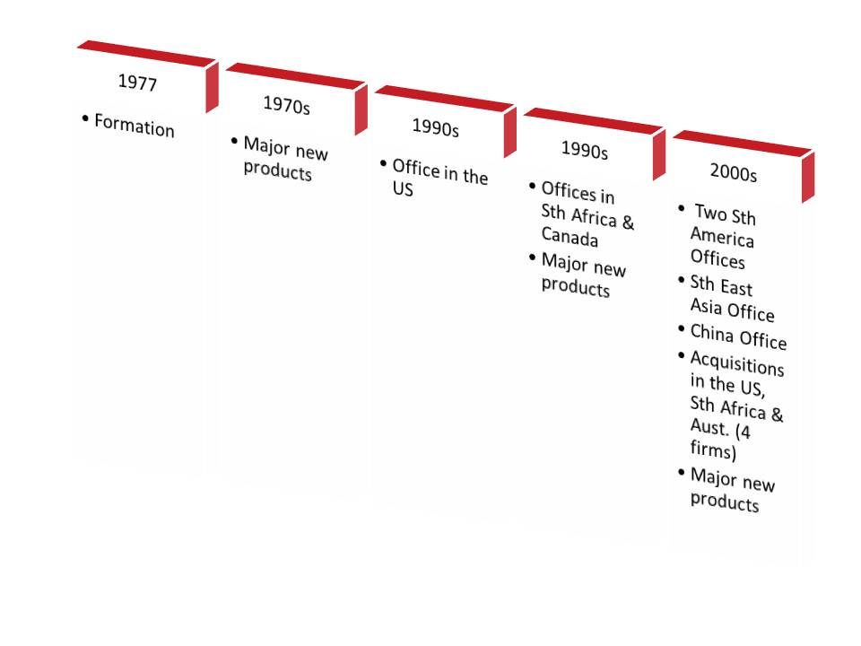
- Mincom (Figure 16) was also formed in the 1970s and developed a suite of asset management operations management software. It built offshore operations even more rapidly, until acquired by a US firm and then ABB.

Figure 4.10: Development of Mincom.
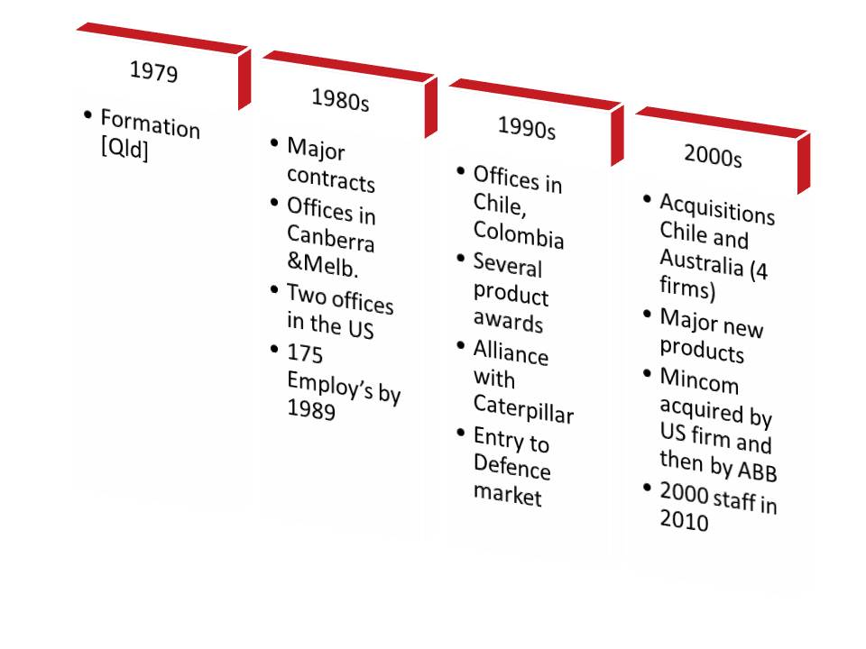
3. GroundProbe (Figure 17) has built an international position even more rapidly. This spin-off from the University of Queensland established three offshore offices and began exporting to 10 countries within its first decade.

Figure 4.11: Development of GroundProbe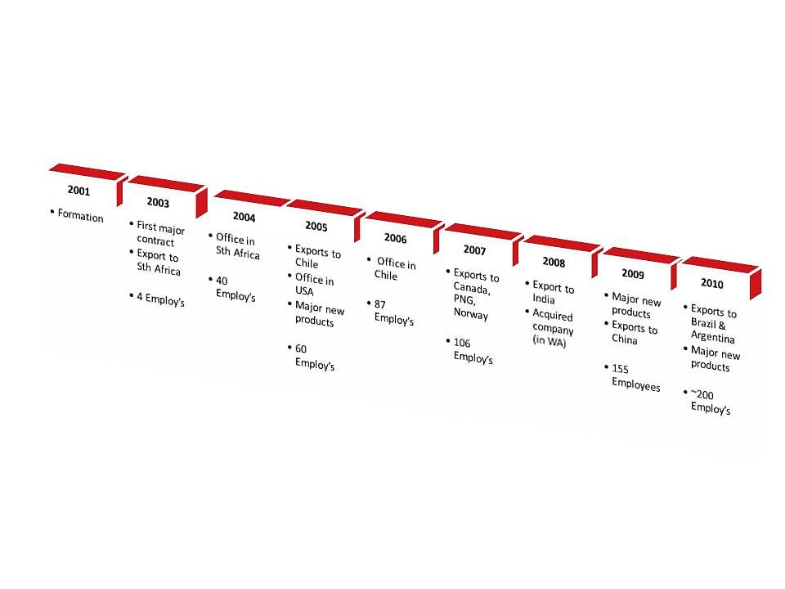
These cases and the history of other firms (discussed below) suggest that rapid international expansion is most often associated with a unique product or capability and a clear strategy, itself based on the professional development of the firm. Many firms are very extended with the rapid growth of mining in Australia and offshore. They have to be very selective in the opportunities they pursue. The availability of professional staff is appears to be a constraint on growth.

Corporate Development: Transformation, Acquisitions and Investment
Many METS have head offices in the capital cities and branch offices closer to mining regions. According to O’Connor and Kershaw, in the late 1990s many METS firms had head offices in Sydney or Perth, with some indications that the rate of growth of the sector in Perth was particularly high. The growth of METS firms through the 2000s, and the need for capital to support expansion led both to a growth in listings of METS firms on the ASX and to an increase in private equity investment into the sector.
While companies such as Austin Engineering, Bradken, Ausenco, WorleyParsons were significant acquirers of international companies, during the 2000s several leading Australian METS companies (Geologics, Tritronics, Surpac, Minex Aerodata, Warman, ANI Arnall, Cram, Prok, MIM Process Technologies, Elphinstone, Wheel and Rims Engineering) were acquired by overseas-owned firms.
Several of the METS case study firms were required to manage a process of transformation to support growth; transformation from the earlier more informal entrepreneurial stage to one with more structure with the recruitment of professional managers. In all cases this transformation was followed by a more vigorous expansion of the business For example: MineSite Technologies (MST) consolidated and brought-in additional capital to expand:
“The investment will enable MST to further reinforce its customer service offering in its current core markets of Australia, the United States and Canada and enable further expansion into rapidly growing resources markets including Africa, South America and China. MST has experienced strong growth in recent years and the investment from Macquarie will support the next phase of MST’s continued international and product expansion. Macquarie’s investment in MST gives us great confidence in being able to truly position ourselves as the leading global OEM of network and communications infrastructure for the world’s largest mining organisations. It will enable us to continue to roll out our proven sales and service support infrastructure in key markets and expand our sales capabilities to current and new customers across the globe.” Gary Zamel, CEO.
As mining has had cyclical trends in demand, and despite what many see an extended period of high levels of demand relative to supply, METS firms do need to prepare for market uncertainty. One report, noting the strong mining focus of many ICT-related METS firms, encourages the development of a broader range of business models:
“ICT providers to the mining industry generally identify very strongly with the mining industry and generally seek to expand their businesses within mining, whether domestically or overseas. This alignment generates a high level of business cycle risk for mining ICT providers, risk that they cannot manage or mitigate without changing the business model that they have followed to date. Assistance may be required to provide best practice models for them to do this. Business model change may include moves to:
- Expand into other industries in which their ICT products and services may be deployed
- Expand research and development activity to stimulate product innovation and development
- Expand into consultancy incorporating the deploying of ICT products and solutions
- Merge with other firms to provide an enterprise with sufficient product coverage and critical mass to be able to expand into other industry markets in Australia and into foreign markets. “
The probable paths of horizontal diversification will be different for different segments of the METS sector. Hausmann analyses international patterns of industry co-occurrence and identifies transition paths based on ‘product spaces’.

Capability Upgrading – extent, drivers and mechanisms.
It is clear that most of the case study firms have invested substantial effort in continuously raising their capabilities, improving their products and widening their product/service range. Such upgrading extends to the development of management systems and for most firms also a strong service orientation.
Mining companies are increasingly demanding in having suppliers address their needs for improved productivity, reliability of equipment, safety and information for decision making. Suppliers have to be able to more rapidly make use of new technology and approaches. This will require stronger in-house capabilities for technology improvement and for absorptive capacity and investment in systematic R&D or other organised improvement efforts.
Of those METS firms that do invest in R&D collaboration, the majority collaborate with exploration and mining firms – a feature that is not surprising given the importance of collaboration with customers for product and service development. The ABARE-BRS surveys of 2002, 2004 and 2010 (Tedesco et al, 2002, 2004 and 2010) had all found that collaboration was an important mechanism of capability development for METS firms. Customers were consistently identified as the most important collaboration partner. This survey data, and the case studies, also suggest that METS firms more often collaborate with universities than with CSIRO.
A range of prior surveys indicate that the majority of collaboration for the purpose of accessing external knowledge-based services (eg consulting, R&D, specialist support) is with other firms. According to a survey in 2003 the second most important source of ‘knowledge-intensive services’ purchased by Mining Technology firms was ‘universities or TAFE’, followed by CSIRO. That survey found evidence of some tensions between METS firms and CSIRO over IP issues. In a set of six cases studies of Mining Technology Service firms most acquisition of expertise from external sources focused on mining firms, suppliers and other METS firms - only one sourced expertise from universities. It is almost certainly the case that a focus on R&D collaboration underestimates significantly the level of technological collaboration that would not be characterised as formal R&D.
Such a perspective is supported by Figure 18 which provides some insights into what METS firms see as the key challenges in innovation. The issues are seen primarily in terms of in-house talent and links with customers. Nevertheless, access to professional staff is frequently identified as a constraint on growth and an increasing number of METS companies are recruiting staff from overseas. In fact, a survey of mining technology suppliers in 2003 found that collaboration was important for these firms, and that the majority of collaboration was informal and was with customers and suppliers and to a lesser extent consultancy firms. About a third of the firms surveyed had some form of ‘collaboration’ with universities or research organisations.

Figure 4.12: Importance of Challenges that affect Commercialisation and Integration of Innovation in 2008-09 (% of companies rating issues as' very important‘)
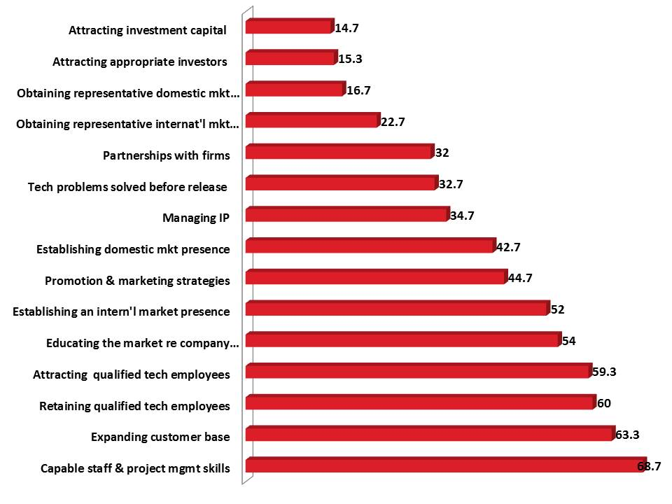
Source: Tedesco & Haseltine (2010) – 2009 ABARE-BRS Survey.
The ABARE-BRS survey of METS firms in 2009 was supplemented by discussions with both a sample of METS firms and with mining companies (ie users) (Tedesco & Haseltine, 2009). One of the issues discussed with METS firms was the constraints which limit innovation. Access to finance was a key constraint, but few firms had been successful in attracting finance from the venture capital market. Some companies were aiming to attract alternative investors: ‘sophisticated investors’; or mining companies, with an interest in the technology as a solution to significant problems. Many METS companies have used one or more of the support programs provided by the Commonwealth or State governments, for example the R&D tax concession, R&D grants, Export Market Development Grants.

Building Industry Clusters from Resource Development

Introduction
The concept of industrial clusters and the policy ideas based on this concept have become highly influential. It is important to make the point at the outset that the concepts of industrial clusters are broad and loose and there is no unified conceptual foundation – rather than providing a blueprint or roadmap the concepts identify a range of dynamics which are vital for strengthening competitiveness in linked industries. Many are critical of what they see as a bandwagon of cluster promoters, using the cluster ‘brand’, and an unproven set of techniques.
Nevertheless, while remaining sceptical of any recipes, the now extensive resource of cluster studies and cluster policy experience provides a framework or lens through which to identify opportunities and directions of change. This analysis and experience suggests that self-reinforcing dynamics, driving capability upgrading within firms and support organisations, can significantly raise competitiveness. This can lead to building higher value positions in value chains, and to entry to related value chains. These upgrading dynamics can develop, usually in a particular region, when some or all of the following are found:
- strong rivalry among leading firms that drives continuous upgrading of capability in the firms and their suppliers, leading to challenging demands - which extend also to suppliers of human resources and research services (ie universities, technical training organisations and research organisations);
- supplier firms developing in specialisation and capability, becoming more diverse, through entrepreneurship, and also continuously upgrading their capabilities and building links to external suppliers of knowledge and other service;
- key resources are available (energy, primary resources, finance, transport links, human resources) or a region develops key resources which support the ongoing competitiveness and upgrading of firms;
- challenging demands that arise from the requirements of key customers or the demands involved in exploiting the resource base (which might be a physical resource of pursuing a knowledge path (eg biotechnology) to generate value.
More generally, the core of cluster dynamics is a learning process: significant commercial opportunity generates demand; rivalry among suppliers and new requirements among customers drives upgrading; this leads to a demand for new knowledge and capability, this in turn generates a demand on research and education organisations which ‘feed’ the capability deepening of the growing ‘cluster’. While existing clusters have often been strengthened through regional or national government initiatives, there is little evidence of such initiatives generating new clusters. Cluster strategies combine regional, industry and innovation policies. But experience indicates that there is no blue print for boosting cluster development, and that flexibility is required, taking into account context, history and sector characteristics. Effective approaches have often involved keen awareness of the many regional and national programs that could be harnessed to support cluster upgrading. The dynamics which drive upgrading are often amplified when the industries and support organisations are in one region and where business, social and professional networks link and reinforce each other – although this can risk becoming inward looking in some cases.
The processes which support cluster type development do provide clear pointers to performance priorities, and include processes that:
- stimulate and support capability upgrading – competition, challenge, demanding customers, close user-producer links (user-supplier links, common technologies and common labour markets help to bind together firms);
- stimulate and support the formation and growth of new firms;
- support investment (private or public) in shared resources such as infrastructure, education, research and testing or other support organisations;
- lead to shared action, with coordination through industry or regional organisations or shared ‘visions’ or strategies, to address shared problems, including actions that mobilise external resources when required.
The clustering concepts and policy ideas, along with a range of other frameworks and studies that emphasise the processes through which technologies, firms, industries and regions evolve, have led to a policy emphasis on:
- Harnessing the demand side for industry and capability development.
The role of demand in innovation and new venture development has been increasingly recognised (for example, von Hippel). Demanding users who create early markets for innovative suppliers, and often contribute to innovation activities, have been shown to have been vital for the dynamism of clusters (eg in the work of Porter) and of highly entrepreneurial regions (for example in the work of Saxenian). The role of the military and other leading users in the development of the IT industry in the US and Israel is well known, if not systematically analysed (for example by Lerner and Connell). The role of the offshore oil industry for industry development in the UK and particularly Norway is also well recognised. Recently, awareness of the significance of the demand-side has influenced environmental policy. Almost all developed countries aim to harness environmental policy to industry development, specifically by encouraging the formation of firms to provide, for example renewable energy technologies, low emission engines, new battery technologies, recycled products, etc.
- New venture formation and growth.
Entrepreneurship and new venture development are vital for economic growth. Change in the demand and supply of new products, services and technologies, and in the use of new business models, is more rapid. As many of these changes involve high level of novelty and lead to new inter-firm and inter-industry relationships they are also more disruptive. A new venture is a business experiment. These experiments are at the core of dynamic economies. Consequently, the level and quality of those capabilities, activities and organisations that support the formation and growth of new ventures – which could be termed the ‘new venture development system’ – are of vital interest at the regional, sectoral and national level. While understanding of what constitutes a dynamic new venture development system remains limited, deepening this understanding is the focus of a good deal of current analysis.
Note that a key element of cluster policy is stimulating collective action, not to attempt to create a cluster de novo but to amplify the forces driving upgrading of a cluster and to jointly address barriers to performance improvement.
The cluster concept does not assume that all significant production, market and technology linkages are intra-cluster. Cluster development strategies should also avoid a tendency to autarky, while focusing on strengthening inter-organisational and inter-personal links at the core.

Demand Side Drivers– Backward Linkages and Clusters
Many development economists who have emphasised the risks of a resource curse point to a lack of local linkages as one reason why resource booms may contribute little to local development. Where foreign investment is used largely for imported equipment and services and most profit is repatriated, few linkages develop (Ross, 1999).
Several studies have charted the evolution of upstream supply industries in response to the (increasingly sophisticated) demand from resource-based industries and from downstream resource processing industries. A well-known example is the forest-based sector in Finland where the evolution of the industry proceeded from producing lumber through to a diverse range of milled wood, pulp, paper, and furniture, and specialised inputs and diverse goods, as shown in Figure 5.1. This evolution increasingly drives, and its survival is dependent on, a deepening and diverse knowledge base and the organisations which acquire and diffuse knowledge and develop human resources – Figure 5.2

Figure 5.1: Development of the Forest Industry and Linkages in Finland
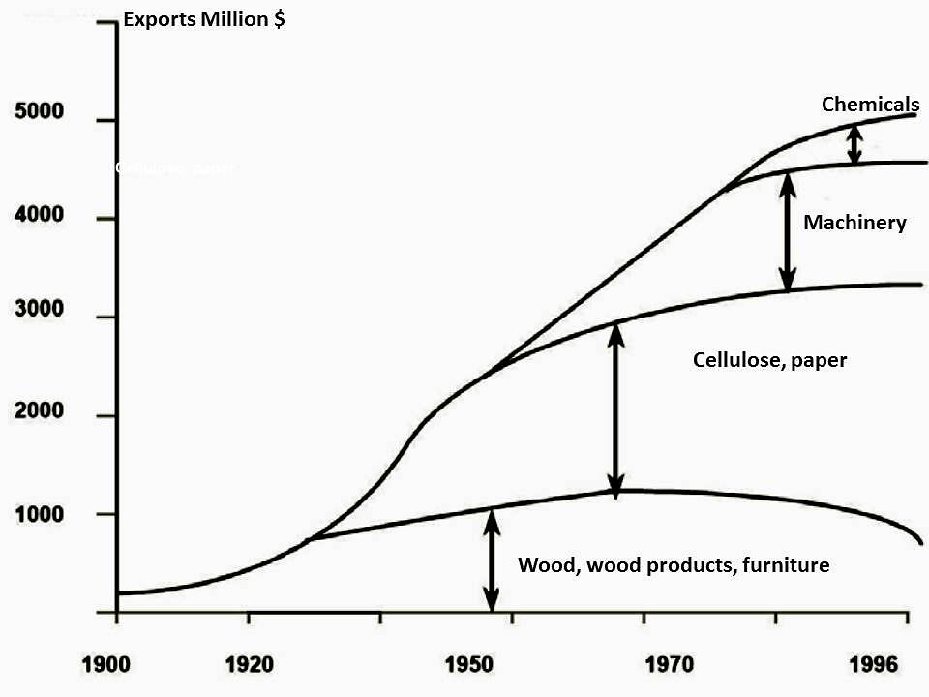
Source: Fuchslocher (2007) p9.
Many countries, both developed and developing, have sought to link capability and industry development to major investment in resource projects. Several researchers have sought to identify the factors that shape the effectiveness of measures to harness resource investment for local industry development. The factors identified in a number of recent studies are summarised in Table 5.1

Figure 5.2: Development of Backward Linkages in the Finnish Forestry Industry
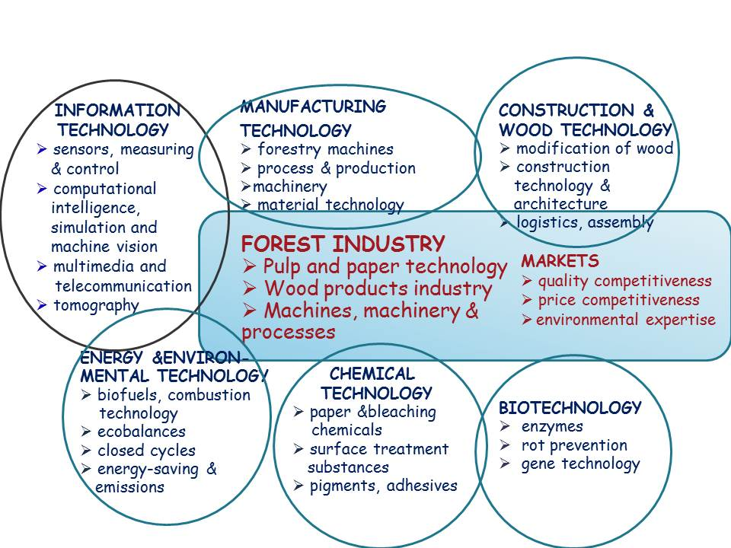
Source: Fuchslocher (2007)

Table 5.1: Main Determinants for the Development of Domestic Technology suppliers
Industry‐Level  [Mining Companies and Major Suppliers] | Supplier Firm Level | Industry and Institutional Context | Industrial Policy Level
Demand (size, growth, diversification, novelty, the cumulative effect of other domestic demanding industries, the scale and technology-level required, the age and maturity of technologies worldwide and the distance to potential international suppliers)  Customer behaviour and policies for collaboration | Competitiveness/ Competence  (position of established global producers, production and operations, | Industrial context  Financial and regulatory barriers to firm formation, inter-firm collaboration and division of labour  Level of technological interdependence or systemic links. | SMEs (innovation, venture and start-up capital, export promotion, training, technology and information transfer)
Structure (high concentration and instability have a negative influence on cooperation – rivalry favours innovation and bargaining power of technology suppliers, relationships/division of labour between large and smaller firms) | Entry strategy (acting on the competitive factors, capable entrepreneurs strategic management and cooperation), Mentoring  Entry from suppliers to other industries, ‘spin offs’ from users, spin offs from suppliers, spin offs from research organisations  Capability to attract risk capital, development of customer relationships, role of networks | Industry organisations that support networking and policy lobbying | Linkages (territorial promotion, information transfer, coordination, local content requirements, linking dynamic sector with strategic but less dynamic ones, tax incentives, encouraging the institutional role of large buyer firms)
Geographical concentration (influences through transport costs, technological spill-overs, labour pooling, cooperation, trust, low risk and transaction costs, high specialisation, institutional role of buyers, and internationalisation, local external economies and development of shared culture | Growth Strategy  Entrepreneurial intentions  Dynamic capabilities  research and development, absorptive capacity, management, financial factors, marketing and sales) | Knowledge Infrastructure  Research organisations  Education and training organisations | Industry development support (credit subsidies, tax concessions, investment in infrastructure, building capabilities, coordination of activities and investments, public procurement financing of R&D, and technology support, Export support)

Developed from: Fuchslocher (2007); Fuchslocher (2010); Maloney (2002); Stevens (2003).

The concept of cluster development is similar to that of backward linkages discussed above but takes into account a wider range of interactions (demand, competition, collaboration) and actors (firms, complementary goods and service providers, industry associations, government, research and education organisations, etc.). Value creation from mineral resources involves at least three stages: exploration; exploitation and processing, and each of these stages includes the provision of capital, equipment, services (including financial, training and research services), technology, and some forms of infrastructure. The overall value creation from mineral resources will depend, in part, on the extent to which these stages, and the provision of inputs to each, are developed and sourced locally.
However, the key factor in cluster development involves far more than import substitution and local sourcing. It requires the development of positive feedbacks and increasing returns which drive an endogenous process of capability deepening and upgrading among most actors linked through market and non-market relationships.
It is clear that resource industry development has leveraged wider industry development in several (now) advanced economies:
“..in Sweden, Finland, the United States, Canada, and to a certain extent Australia, the natural resource sector evolved from a position of low technology based on low-cost labour to one characterized by highly-skilled, knowledge intensive and export-oriented activities. Such a growth strategy was based [on] increasing the domestic value added associated with such natural resources by prompting the development of those activities which naturally tend to ‘cluster’ around resource-based processing and extraction industries. These included industries supplying critical ‘side stream’ inputs (such as capital equipment, consulting services, and consumables), and activities engaged in the further processing.. of the outputs (‘downstream’ industries). Clustering not only enhanced the productivity of the workforce, but also resulted in increased income distribution in the local population and rapid economic growth. More significantly, it prompted a shift to a more dynamic and sustainable growth trajectory..”
Similarly, Houston, Texas, established itself as the leading cluster of oil and gas industries, services, research and educational institutes related to that sector, as shown in Figure 5.3.

Figure 5.3: The Houston Oil and Gas Cluster
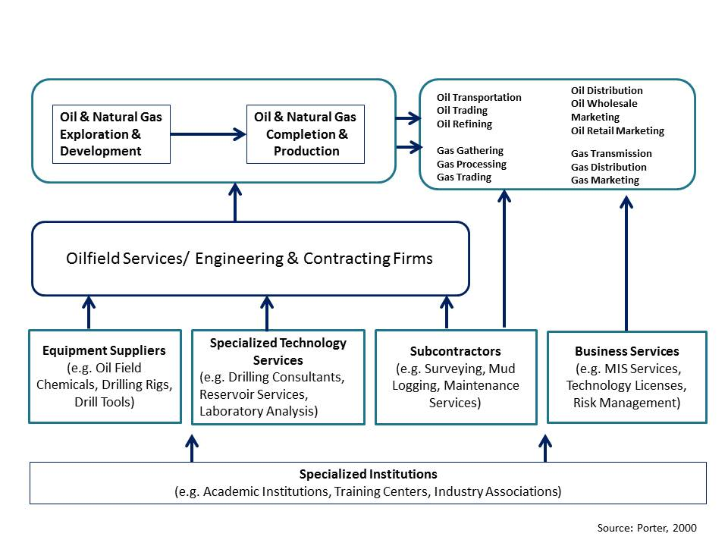
The recent improvement in the terms of trade for mineral commodities has stimulated renewed interest in the development of mining-related clusters and a good deal of research is underway in several countries (particularly Canada and Chile) and regions (including Africa and South America).
The recent improvement in the terms of trade for mineral commodities has stimulated renewed interest in the development of mining-related clusters and a good deal of research is underway in several countries (particularly Canada and Chile) and regions (including Africa and South America).

Scandinavia
Perhaps the first mining-based cluster was that in the Gulf of Bothnia and including firms from Sweden and Finland. The Bothnian Mining Cluster has been the context for the development of several of what are now leading global supplier firms, as shown in Table 2. The mining cluster in Finland continues to be technologically dynamic and supports several world leading equipment producers while the mineral resource itself is near exhaustion.

Table 5.2. Bothnian Mining Cluster
Segment Swedish Finnish
Suppliers for Mining
Exploration Hagby, Craelis, Flexit SMOY, Kati
Mine Structures ABB, Alimak, Indau, Jama Sandvik, Wartsila, Ahlstrom, Robit
Drilling Wassara, Atlas Copco, Tamrock
Blasting Dyno Nobel, Kimit Normet, Kemira
Loading Sandvik
Hauling Tora, Volvo
Suppliers for Processing
Mineral preparation Metso, Sandvik
Physical separation ITT Flygt, Grindex, Alvenius Outotec, Metso, Tamfelt
Chemical Separation Outotec, Kemira
Source: Noras, 2009.

Figure 5.4: Development of Backward Linkages in the Finnish Base Metal Industry (TEKES)
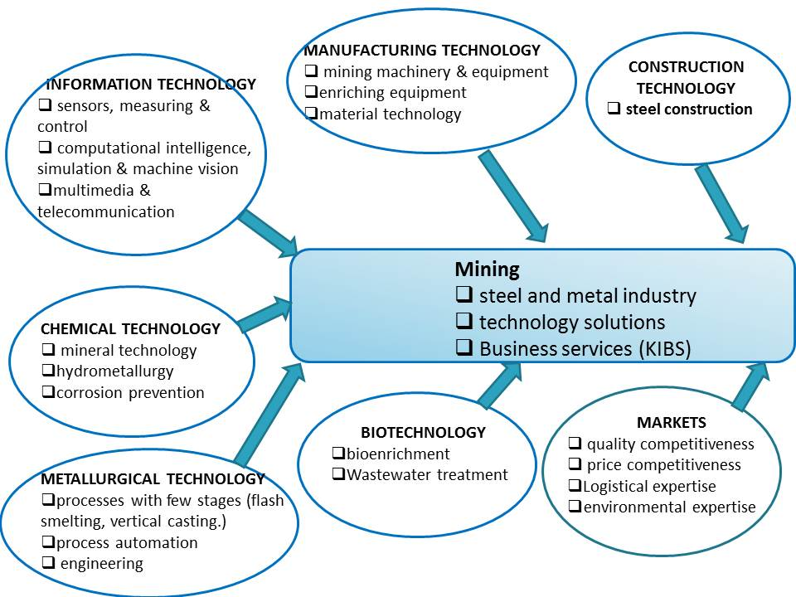
Source: Noras, 2009
An assessment of the evolution of the Bothnian Mining Cluster has provided the basis for ‘suggestions on the formula or necessary conditions for cluster creation’ in other countries:
- Macroeconomic equilibrium;
- Trade openness;
- Industry policy supporting business growth and investment with strong support for education and innovation;
- Development of ‘cluster’ strategies at the sectoral and whole of government level;
- Strong national innovation system with a long term strategy for relevant capability development;
- Networking among individuals;
- Critical mass;
- Whole of value chain approach and encouraging growth and diversification to supply other industries;
- Marketing support for small firms;
- R&D projects with the sectors technology leaders.

Canada
Similarly, Ritter has explored the development of the mineral cluster in Canada, particularly in North Ontario, and detailed the evolutionary development of an increasingly diverse range of upstream and downstream industries, linked to mining – as shown in Table 5.3.

Table 5.3. Activities Linked to Mining: The “Mineral Cluster in Canada”
Mineral Machinery, Equipment and “Consumables”
Exploration: Drill rigs, drill steel and bits;
Aerial exploration equipment;
Exploration instrumentation;
Instruments and equipment for laboratories
Mine Development:
Construction materials, for mining, processing, personnel and related activities;
Infrastructure and related building materials and equipment;
Underground Mining:
Drill rigs, steel, and bits;
Explosives and blasting equipment;
Continuous mining equipment and conveyor systems;
Shaft sinking and tunnelling equipment;
“Shaft furniture” and Hoisting Equipment;
Underground transport systems, rail or wheel;
Equipment for ventilation, electricity, water-removal;
Mining instrumentation
Open Pit Mining:
Drill rigs, bits and steel;
Explosives and blasting equipment;
Excavators and front-end loaders;
Off-road trucks and “wheel loaders;”
Concentrating, Smelting, and Refining Equipment;
Bulk Handling Equipment;
Environmental and Safety Equipment;
Personnel Equipment;
Specialized Transportation Equipment, for Road and Rail.
- Mineral Services
Services
Exploration Services;
Aerial essaying, remote sensing, and cartographic services;
Analytical Laboratories, geophysical and chemical analysis;
Consultant Services: geological, exploration, mining, processing, management,
financial, environmental; accounting;
Mine-Site Construction;
Contract Mining and Drilling Services;
Maintenance and Repairs;
Communication Equipment, Underground and Surface;
Transportation, for mineral ore, concentrate, machinery, and inputs;
Other Services
Research: Geological, Exploration, Mining Systems and Processing;
Aviation Services; For personnel, at mine-site and for fly-in: fly out mining
Education of specialized personnel: Universities, Colleges, Trades training;
Financial Services, including the stock exchanges
Specialized Mineral Cluster Press;
Legal Services
Marketing and Export Consultants
Source: Ritter, 2000
The major METS ‘cluster’ in Canada is in North Ontario. The formation of this sector was stimulated by the downsizing of the mining industry in the region in the 1980s. The termination of employment of a skilled and professional labour force along with an increase in outsourcing led to the formation of many small firms. The Sudbury and Area Mining Supply and Service Association (SAMSAA) facilitates links between the many SMEs, as does the Ontario Mining Industry Cluster Council (OMICC). Technology development is supported by the Northern Centre for Advanced Technology (NORCAT), the Centre for Excellence I Mining Innovation (CEMI) and the Mining Innovation, Rehabilitation and Applied Research Corporation (MIRARCO). At the Laurentian university there were thirteen mining- related research institutes or centres and five research chairs related to mining by 2004 (Robinson, 2004).
The formation of the Sudbury Mining Cluster
Sudbury is a major international centre of mining and mining technology development. Within the city limits there are 14 producing mines and two major smelters. In the near area there are over 270 specialized mining supply and service firms, which, average draw over half of their income from sales outside the Sudbury region. There is also a local university with a strong focus (in research and teaching) on mining-related technologies. In addition the local business service providers, whether local firms or branches of national firms, have become specialised in the services they provide to the mining and mining supply sector.
There have been four key stages in the evolution of the cluster:
- 1970s: very limited development of local suppliers – the major mining companies ( the anchor firms) imported most equipment from outside the region and provided most services (maintenance, equipment rebuilds) internally. and a high level of imports of METS
- 1980s: the major mining companies, seeking to reduce costs, downsized and began to outsource services and mining operations. This deepened the labour market with a range of expertise and created opportunities for entrepreneurs who had close links to the major mining companies. The number of local METS firms grew rapidly.
- 1990s: The expanding Sudbury METS firms began to establish offices or branches outside the region – although most remain heavily dependent on the anchor firms. Mining-related research at the local university grew and 13 research centres and five mining-related research chairs were established. The mining branch of the Canadian Mining Industry Research Organisation is also located on this campus. In the early 1990s, the provincial government relocated the provinces geological survey to the campus – which also attracted exploration companies to locate in the area and stimulated further specialization in geology at the university. Throughout the 1990s, more Canadian firms related to mining began to be active in mineral development around the world. Firms in all aspects of mining from early stage exploration, development of exploration instruments, financing of development, to environmental management have become globally competitive and active. This reminds us that as mining becomes more complex and knowledge intensive there are a widening range of opportunities for firm development and value creation.
- 2000s: Specialized legal, financial, tax and other business service firms developed in Sudbury. However, a major event in the 2000s was the gradual collective realization that a significant mining-related cluster had developed in Sudbury. Specialized training facilities, industry organisations and industry journals were formed. The increasing self-recognition among the METS firms, mining companies and the wider range of actors, that a dynamic cluster had developed provided a foundation for attracting external resources, including investment in research facilities and activities. A detailed analysis of the cluster, supported by a strong conceptual framework, helped to win external support.
The Sudbury cluster developed in response to market forces and entrepreneurship, but although it had become a significant cluster there was little recognition of its size and significance. This blindness’ was due to:
- A reliance on information based on the standard industrial classification of industries – the METS firms were distributed across many statistically defined industries. It was quite difficult to assemble data on the METS sector;
- A pre-occupation among policy makers with high tech clusters;
- A pre-conception that mining was a low tech and declining industry – which to some extent it had been through the twenty years to the mid-1990s;
- Prior about 2003 the mining companies had no particular interest in the growing METS sector and most of the METS firms were ‘too busy and too diverse to recognize their common interests’.
- There were a number of professional and industry associations that ‘cut across the cluster’, diffusing the focus for cluster self-perception.
There are some characteristics of the cluster that are also relevant to Australia:
- There are few direct links between the METS firms – as a result information flows are often via customers and through the movement of people among firms;
- The ‘shared labour market’ is important as people move between firms and the availability of specialised staff supports growth;
- The specialized business service providers (accounting, consulting, insurance, human resources) are extensively used by the METS firms and their specialized knowledge assists the METS firms.
As noted above network linkages among the METS firms were largely customers, and associations with research institutions rather than direct contact. The key factors in locating in the Sudbury area of Ontario were, in order:
- Presence of key suppliers and/or customers?
- Physical transport, communication infrastructures?
- Supply of workers with particular skills?
- Specialized research institutions and universities?
- Specialized training or educational institutions?
A 2010 study for the Ontario North Economic Development found that the sector:
- includes about 500 firms and organisations with at least 50% of their business from supplying the mining industry;
- had 2010 sales of C$5.6b and employs about 23,000; and
- was overwhelmingly domestic market focused (81% of sales) and most firms were dependent on one or two customers for the majority of their business.
The study surveyed about 150 firms and organisations in the sector, and on this basis concluded that the sector needed to grow through diversifying markets and products. In particular the study identified a growing demand for ‘integrated mining solutions’, rather than ‘merely parts and equipment’, and for this reason that a sector growth strategy also required an innovation strategy, including a substantial increase in the investment in R&D. The study proposed a more active role by government and more collective action by the sector, to ‘raise awareness of sector capabilities’ and support marketing, through industry organisations.

Latin America
Mining is a major component of the economy in several South American countries, including Peru, Bolivia, Columbia and particularly Chile. However, until recently, the contribution of mining to economic and social development has been limited. In 1999-2000 the Economic Commission for Latin America and the Caribbean (ECLAC) and the International Development Corporation of Canada (IDRC) initiated a major Mining Cluster and Local Development project, involving over 12 case studies in different economies and regions.
The project found very little evidence of cluster development in the 12 case studies. There were agglomerations related to mining, but none had strong internal capacities for learning and innovation: “Mining does develop some local agglomeration economies of a static nature, mainly in the form of specialised infrastructure, but develops little dynamic agglomeration economies in terms of learning and innovation capabilities.”

Chile
In the 1970s the local mining companies had lacked the internal capacities to undertake significant technological activity, and hence they could not be an incubator for development of suppliers. The high grade copper deposits enabled profitable production with few major problems that required new approaches.
However, in the late 1990s the cluster had the beginnings of strong internal upgrading drivers, but no overall ‘vision’. One key missing factor was that the major mining firms had not seen local development as essential for their long-run competitiveness. There had been the development of a local innovation – thin layer bacterial leaching of copper – but this had not become a source of exports of technology or equipment. Most local firms supplying to mining had low level capabilities, competed on price, and had slow rates of improvement.
More recently there has been significant development of a mining technology ‘cluster’ in Chile, particularly around Antofagasta. In 1999 the regional authority around Antofagasta proposed a strategy to develop a mining cluster, including the formation of a ‘Cluster Management System’. Prior to this the regional authority had been pessimistic about the potential for mining-related development and had focused on diversification strategies. A study in 2003 found strong evidence of enterprise development, growing local content and some exports. But the study concluded that further capability deepening was impeded by the small size of most firms, the lack of vision at the sectoral and government level and a passive role by universities. A more recent assessment of mining-related cluster development in Chile suggested that the level of government focus on mining supplier development had increased, as had the support for innovation. This assessment also found that the development of the sector had progressed with some suppliers beginning to diversify into supplying other industry markets as well as export more widely.
In Chile ”..mining has been experiencing a significant growth over the last two decades [but] only a weak growth of locally owned [Knowledge Intensive Mining Services ]KIMS firms have taken place. Chilean KIMS firms developed some strength at the local market, but were weak in developing international competitiveness. Accordingly, a major share of the significant growth of demand for KIMS derived from the rapidly expanding Chilean copper industry has been met by international KIMS suppliers.”
The context for mining investment and operation in Chile is changing. Some of these changes arise from the nature of the resource (declining ore grades and the need to mine at greater depth - both of which lead to higher energy intensities), the location (water shortages) and the policy regime (tougher environmental standards and higher expectations for benefit to local communities and regions). These changes are stimulating innovation in technology and in the approach to mine development.
BHP Billiton has developed a Cluster Program in order not only to provide opportunities for local suppliers but also to support their capability development. Importantly, this initiative is seen as a means to address BHP Billiton’s increasing need (for Chilean and global operations) for higher value-add, knowledge intensive services and equipment, and to address the Chilean aspirations for greater industry development outcomes from mining. Apparently:
The emergence of BHPB’s plans in this area were informed by insights from its earlier Australian experience in which the interactions between mining companies and suppliers had played a major role in contributing to the emergence of world class suppliers in Australia during the 1980s and 1990s.
However, a driver of this initiative has also been a recognition that capable local suppliers (whether locally or foreign-owned) are increasingly vital of the problem solving and innovation in the specific local physical, political and economic environment –and that a reliance on centralised research and overseas suppliers cannot substitute for this local capability. Hence, a specific objective of the program was to develop the innovation capacities of local suppliers.
The BHPB supported ‘cluster program’ aims to develop by 2020 over 250 ‘world class suppliers in Chile’ from the current 3000 suppliers. According to BPHB currently over two thirds of the Chilean suppliers are ‘rudimentary technology users’ and about a third are simple ‘technology adaptors’, about 2% are capable advanced design and innovation, but none are at the world frontier. To this end BHP-Billiton is working with local universities and technology centres to support a portfolio of companies, each working on a project to address a significant problem in mining, environmental management, safety, ore processing etc. The program began in 2008-9 with five suppliers, increasing to about 100 by 2011-12, and aiming to reach 250 by 2014-15 and to continue to expand through to 2020. The approach is active in that a range of mechanisms support the upgrading effort of firms and to provide access to local markets.
Overall Strategy
The Cluster Program has five key elements:
- Changing procurement practices to open opportunities for more innovative solutions- hence innovation and upgrading efforts are strongly focused on specific and ongoing demand;
- Supporting innovation capability in suppliers and in the broader supplier base;
- Working with suppliers to test ideas in practice;
- Engaging external consultants to advise suppliers regarding upgrading their managerial and organisational capabilities required to achieve world class performance; and
- Facilitating links between suppliers and research at local universities.
BHPB planned for an increasing level of participation, with the overall aim of developing 250 firms to world class standard by 2020:
- Phase 1: 2008-9 - 12-15 firms with a focus on innovation projects in five areas.
- Phase 2: 2010-2012 – scaling up to involve around 100 firms by 2012.
Mechanisms
- Formation of a Cluster Unit within BHPB.
- Identification and screening of BHPB needs and opportunities for innovative solutions – based on a review across BHPB’s s exploration, mining and processing activities in Chile.
- Assessing potential suppliers – taking into account capability to develop a solution to the identified challenges, and commitment to longer term capability development- for the first phase of the Program more than 60 firms were interviewed.
- Selecting suppliers and problem combinations (‘cluster nuclei’) that, with support from BHPB, were likely to achieve early outcomes and hence provide wider demonstration effects. In phase one there were five priority problem areas with two or three firms in each.
- Developing new approaches to procurement, based more on functional performance than a specified solution, for example:
  - Defining a dust control process requirement in terms of air quality improvement required;
  - Defining a need for new wire ropes for excavation shovels in terms of improved shovel availability with reduced downtime for rope replacement;
- Developing different forms of procurement contract to reflect the more open and innovative aims, and enabling closer interaction between the engineers from the supplier and the customer’s operational staff.
- Supplier competency strengthening through consultant advice, with strong support of the costs by BHPB, and monitoring of progress. The consultants provided development in, for example, strategy development, teambuilding, leadership; culture and brand identity; and capacities directly linked to innovation.
Progress of the Cluster Program to date appears to be very positive with significant benefits in cost saving and performance for BHPB and in growth and capability for the participating suppliers and for the wider supply sector. The nationally-owned mining firm, Codelco, is now implementing a similar program.

South Africa
South Africa produces more than 50 minerals (of which the most important are the platinum group metals (PGM), gold, silver, and coal) from over 700 mines and quarries and has developed a significant minerals cluster:
“At the core of the cluster are world-class mining companies producing gold, platinum, diamonds, coal, ferrochrome and base metals. Linked to these extractive industries is a network of downstream refining, smelting, beneficiating and processing industries. World-class engineering and other companies serving the industry support these primary and secondary activities. The minerals industry today provides the base for the country’s competitive advantage in electricity, chemicals and related industries.”

The exploitation of the major mineral deposits in South Africa has had a central role in the development of the economy and particularly the development of industrial centres such as Johannesburg. Over the late 1990s and early 2000s investment in mineral processing, largely by the major mining firms but in some cases with assistance from the national development agency, led to substantial growth in processed minerals exports. Government policy, which has strongly asserted minerals as a national rather than private asset, has aimed to increase the level of secondary and tertiary mineral-based industrial development as a strategy for diversification through the development of value-adding industries. The Integrated Research and Development
Strategy resource-based technology and knowledge is identified as a platform for wider capability development in the national system of innovation. South Africa has also developed a number of internationally competitive METS firms. It has long had technologically active mining firms such as Anglo-American. The mineral resource base was also diverse with and hence presented a range of challenges requiring innovative solutions – most recently associated with mining Platinum Group Metals, for which investment and production grew rapidly in the early 2000s. These technological capabilities were strengthened due to the period of enforced isolation due to apartheid. As the major South African mining firms developed global mining operations they often brought their South African suppliers with them. However, over the 1990s the role of the major and previously dominant mining houses changed as most listed offshore and outsourced more activities. At the same time many junior Canadian and Australian miners have entered the South African industry.
The diverse mineral deposits in South Africa are concentrated in some regions and a strong supplier base developed in the Gauteng Province. The growth of supporting industry bodies, technical, and research and education organisations deepened interaction and the knowledge base. Further discoveries enabled growth and scale and also generated continuing challenges to exploit deeper and more complex ores. While the mineral resources have become more dispersed the major companies remain geographically concentrated. Walker and Minnitt (2006) stress the significance of this concentration:
“..long standing formal and informal relationships..are of pivotal importance in maintaining and broadening existing competitive advantages. Relationships are mainly focused around R&D and procurement issues…” (p14). These relationships operate at many levels: “Proximity to the mines on which to test and refine technologies, a demanding clientele for innovative solutions, proximity to other supplier and service companies for inputs and R&D collaboration, a skilled workforce (trained in world-class tertiary, vocational and research institutions), the ability to leverage resources and capacities to adapt to changes in the markets and variations in technology, and dominance in the African market were factors that played a critical role in establishing this beneficial legacy.” P. 14.
An analysis of the South African mining cluster in 2004 identified almost 700 companies for which mining was the key industrial activity. While there were several significant South African Tier 1 suppliers of project engineering services the majority of the firms were smaller Tier 2 input and component suppliers:
- Tier 1 Suppliers: this segment has become more concentrated over time and has a much higher level of participation by international firms.
- Engineering and Service Providers – typically EPCM firms that have a major in the selection of suppliers of other inputs. There are several strong internationally competitive South African engineering service providers and these dominate EPCM work in South Africa.
- Original equipment manufacturers (OEMs) – which provide major items of equipment and in some cases after sales service. This segment is dominated by major international OEMs, eg Sandvik, Caterpillar, Atlas Copco. The role of OEMs has changed over time with a greater expectation that they offer after sales service and support
- Consumables input suppliers – supplies of eg explosives, fuel and chemicals to mining companies.
- Agents and distributors – often have a major role in supporting OEM marketing and service.
- Tier 2 Suppliers: the number of firms in this segment is far higher than in the Tier 1 segment.
- Specialised engineering and services- sub-contractors to EPCM firms and providers of specialist services directly to mining companies for ongoing operations.
- Component manufacturers- suppliers of more or less standard components used in equipment, eg electric motors, cabling, and also manufacturers of some niche components.
- Input providers – providers of basic inputs to tier 1 input suppliers, eg steel, chemicals.
South Africa also has diverse range of organisations to coordinate industrial and technological development. The central private sector organisation is the Chamber of Mines, formed in 1889, but there are several other private sector bodies at the specific industry level. Miningtek and Mintek were both formed in the 1930s to promote research, collaboration and technology transfer – the former initially within the private sector but later becoming part of the government research infrastructure.
The dynamics underpinning the recent evolution of the South African mining cluster are summarised in Table 5.3. The relatively long history of substantial mining activity has led to a broad base of high-level mining-related competencies supporting the effective use and improvement of diverse technologies. Foreign firms and their subsidiaries have a major role in the cluster - accounting for about a third of firms and they are particularly strong in the major equipment segment. The majority of locally-owned firms are SMEs involved in the sale, manufacture, service and distribution of component suppliers. However, there are a substantial number of internationally competitive South African suppliers in niche areas based on product innovation or, in the case of service firms, deep engineering and management competence, including EPCMs. Walker and MInnitt (2006) argue that the significant mining cluster did not become a foundation of broader industrial development due to the import substitution policies of government. They also identify a range of challenges for the ongoing growth and upgrading of the cluster: changes in the policy regime; the growing role of EPCM firms; the increasing technological intensity of mining; rising costs; limited effective government support; and the growing role of platinum group metals. The acquisition of local firms by MNCs and ongoing skill shortages impede the upgrading dynamic. They suggest that new mechanisms to support collaboration among suppliers, and new approaches to establish a more effective division of innovation-related effort, are required if the cluster is to address these challenges and restore declining competitiveness. Walker (2005) in particular is concerned with declining competitiveness of the South African cluster, since the early 1990s, especially in the many niche areas in which strong capabilities had been developed:
“Virtually all mining conglomerates embarked on a process of consolidation…divested all non-core activities, including in-house research laboratories…many of the engineers and scientists retrenched during this process subsequently formed new consultancies and manufacturing operations directly supporting the mines, a considerable portion of expertise was lost….Given the risk, capital intensity and long time lags involved in the research, development and final commercialisation of a product or process, most long-term R&D is now undertaken by state-funded research organisations..[t[hese developments have been matched by a gradual decline in the level of in-house R&D undertaken by the private sector… [mining] companies see their primary business to be the extraction, processing and refining of ..resources [and]engineering services companies see their role in the cluster as one of designing, building, installing and integrating …neither regards long-term R&D as their core business..[these] companies reserve involvement in ‘ground breaking’ innovations to joint ventures and partnerships with other companies, research organisations and universities..”
Walker and Minnitt emphasise that the dynamics that are vital for the continued upgrading of the cluster are different from those that formed the cluster:
“While close proximity of supplier firms to an anchor/major resource-based enterprise such as a mine was a key requirement at the outset of the cluster’s birth, with the advent of telecommunications …the geographic location of service and supplier companies no longer matters. …demand and support linkages [finance, legal, R&D, skills, graduates, industry associations] are of far greater importance to input firms than the presence of a mine or producer company.” (p. 25).
The Mineral Policy and Promotion programme of 2009 focuses on investment in the mineral cluster as an engine of national development. The Council for Mineral Technology (Mintek) has been charged with a major role, not only in improving technologies for mineral processing but also in strengthening upstream and downstream linkages and enterprise development. Employment generation is a major goal for the South African government. However, a recent OECD review questioned the effectiveness of previous research policy implementation and integration across government departments.

Table 5.3: Dynamics in the South African Mining Cluster
 | Factor Conditions  [characteristics of key inputs] | Demand Conditions | Related and Supporting Industries. | Firm Structure, Strategy & Rivalry
Drivers | Demand for skilled staff, problem solving and innovation by users- leading to the cumulative development of technologies and capabilities;  Development of strong research, education and training organisations;  Changing skill requirements due to increased use of IT and equipment;  Public sector investment in transport and energy infrastructure | Large and stable demand by mining companies;  Demanding local customer base;  Ore bodies at greater depth;  Increased emphasis on health and safety has become a major driver of innovation;  Opportunities to expand to other African markets and other sectors in SA. | Strong range of support organisations: specialist suppliers, education and research organisations, financial organisations, infrastructure. | Close links with mining companies advantaged local suppliers for investment projects and ongoing operations.  Strong entrepreneurship leading to competitive relations with also collaboration;
Shapers | Risk-averse approach of mining companies. High potential for knowledge transfer within and outside the cluster;  The specific problems due to deep but narrow seams;  Limited usefulness of government support – too bureaucratic. | Shift of emphasis from gold to platinum- which has unique characteristics;  New national policy regime | Foreign OEMs dominate the supply of major equipment.  Changes in the regulatory regime provide strong incentives for procurement from firms owned by disadvantaged social groups. | Changes in the procurement process that emphasis cost reduction, working with fewer vendors, and greater bundling and outsourcing have substantially changed competition and rivalry in the cluster;
Challenges | Continued upgrading requires higher R&D and entrepreneurial capacities – but mining firms have reduced in-house R&D and training and the public sector R&D & training is less focused;  Complementarity between public sector, mining firms and OEMs in research not clear;  Complementarity between public and private sector in training not clear;  Many smaller firms have limited capacity for significant innovation.;  Poor image of mining as a career leads to problems attracting talent. | Rising costs, currency appreciation and declining productivity are eroding international competitiveness. | Limited capacity of entrepreneurs and SMEs to raise venture capital for innovation and early stage development;  Lack of an organisation that can effectively promote collaboration among suppliers and between suppliers and other organisations. | The power of EPCMs has risen and procurement focuses on supplier capacity to provide ‘solutions’, which favours larger firms.  Smaller local suppliers have focused on incremental innovations but are less able to develop solutions.
Based on: Walker, M. I. & Minnitt, R.C.A. (2006) Understanding the dynamics and competitiveness of the South African minerals inputs cluster. Resources Policy 31: 12-26; Walker, 2005; ECA, 2004

Frameworks for Cluster Development
One influential approach to general industry cluster development is that of Michael Porter (1990, 1998) and colleagues who emphasise the role of four cluster dimensions:
- Demand – particularly whether that demand is specialised, unusual or ‘leading’, in that it anticipates patterns of demand that will be more widespread in the future;
- Input factors – The availability of high quality inputs of eg capital, labour, natural resources, infrastructure, knowledge;
- Complementary and supporting industries and organisations – which provide goods and services (including research and education) to different stages of the value chain;
- Competition and rivalry in the core sector – which drives competition and the ongoing search for sources of improved performance;
However, the analysis which informed Porter’s cluster framework was based on clusters formed largely before the era of more open markets and the growing internationalisation of trade, investment and innovation. This raises the question of the extent to which the processes of cluster formation and evolution will operate in more open markets where an increasing proportion of goods, services, investment and knowledge flows are dispersed globally. It also raises the related question of whether the strong emphasis in the cluster literature on the role of geographical concentration will remain as relevant. While these issues remain open, recent research on clusters in Canada (an economy with many similarities to Australia), among other recent cluster-related research, does emphasise two points:
- Geographical proximity remains important for the development of cooperation, where trust is often vital, and for effective knowledge diffusion, where direct and close interaction is vital for the transfer of tacit knowledge;
- However an increasing proportion of input-output flows (trade, investment and knowledge) in a cluster can be geographically dispersed as long as key factor (often the local pool of talent) shaping the dynamics of linkage and upgrading anchors the cluster to a location (Malmberg & Power, 2006; Wolfe, 2008).
Chance events can trigger the beginnings of the processes of accumulation, but the initial conditions must be favourable. A not uncommon such chance event has been the failure of a large anchor firm, liberating the managers and engineers they have brought to a location and spawning a high level of necessity-driven entrepreneurship – see the history of clusters in Ottawa and Calgary in Wolfe (2008). As a cluster develops the formation of a deeper local knowledge pool, the building of links with research and skill development organisations, the establishment of proven markets, technologies and business models and the formation of networks and sectoral and regional organisations, all contribute to ‘external economies’ which benefit all firms. These external economies lower the costs and risks of venture formation and innovation, encouraging further entrepreneurship and investment.
Drawing on an extensive research project, that involved detailed case studies of 26 diverse clusters in Canada, and on a review of prior cluster research, Wolfe (2008) identified six factors that shape the emergence and evolution of clusters:
- Entrepreneurship and Management
Through business experiments which explore areas of market, resource and technological opportunity, and through establishing new business models, entrepreneurs open new paths of profitable investment. Other entrepreneurs who replicate and extend these directions deepen and widen the cluster, extending the dynamic to further input sectors and new markets. These processes are central to the emergence of evolution of clusters. Novice entrepreneurs often benefit greatly from the support of other entrepreneurs and networking contributes to that interaction (Wolfe, 2008). In robust, knowledge-based cluster a high proportion of founding entrepreneurs of high growth firms come from existing firms, particularly innovative established firms or previous start-ups, ie many entrepreneurs build capability through forms of mentoring/apprenticeship/exemplars (Casper, 2007; Casper & Murray, 2004; Garnsey, 1998). At a later stage of evolution of a cluster management competency is vital to develop sophisticated business systems, strengthen the competitiveness of firms, manage growth and diversification and enter new markets. A lack of supply of professional managers can constrain the growth of clusters.
- Sectoral Knowledge Bases
One clear finding from the Canadian studies was that the processes of cluster formation and development have strong sectoral characteristics. Those sectoral characteristics are related to the sources of knowledge and the nature of innovation and capability development in sectors. In particular, many researchers distinguish between ‘analytical’ knowledge bases, such as those used by science-based industries working at the frontier of new knowledge, and ‘synthetic’ knowledge bases, such as those used by engineering sectors, where innovation typically involves the application and recombination of existing knowledge (Malerba, 2005; Asheim & Gertler, 2005).
- Geographical Proximity
Most cluster analysis has focussed on clusters with a high level of geographical concentration and as a result there is a strong overlap between cluster studies and the fields of regional innovation systems and economic geography.
- Research Infrastructure
The Canadian studies found no examples, outside of the few science-based sectors like biotechnology, of direct ‘seeding’ of cluster formation through spin-offs from research organisations. The presence of universities sometimes had a role in developing and attracting talent or major firms to a region, and in linking firms to global knowledge pathways. The contributions of research organisations to problem solving research, responding to rather than leading local demand, was often a contributor to the momentum of development. On the basis of these Canadian studies Wolfe (2008) concluded that the emphasis on universities and research organisations as leaders of cluster formation is misplaced.
- Talent
The role of a pool of capable human resources with relevant types and levels of knowledge has long been recognised in cluster studies. The Canadian studies found that the talent base of knowledge workers was one of the most important factors in cluster formation and development, and a factor that can be shaped by public policy. Wolfe (2008) p20 concludes: “..policies which contribute to the development of a deep pool of highly skilled talent are ultimately the ones with the greatest long-term potential for cluster promotion.”
- Sectoral and Cluster Organisations and Institutions, and Social Networks
Firms located within geographical clusters tend to have higher innovation, growth and survival performance than ventures not in clusters. [Gilbert, et al, 2008]. But the emergence of new ‘clusters’ involves institutional innovation, and hence experiment and learning, to develop policies and organisations that are effective in specific national and regional contexts (Saxenian, 2007; Feldman et al, 2005; Lester, 2003; Thornton and Flynn, 2003; Casper and Kettler, 2000; Haeussler, 2010; OECD, 2010).
The early stages of cluster development often involve the formation of sectoral or regional organisations that foster inter-firm or industry-research networking and collaboration. Such organisations, typically industry-led also provide a mechanism for coordinated action to shape public policy at a regional or wider level. This can be vital when regulatory barriers to growth arise or when new public investments in infrastructure, research or education are required to support a higher level of performance. Social capital based on inter-personal networks and shared values and perspectives is often seen as an important element of cluster development (Wolfe & Nelles, 2008). These networks can function within industries, but also between many different components of a cluster (leaders from different industry sectors and from public sector organisations) in a region. Based on the Canadian case studies, Wolfe (2008, p.28) concludes: “Many of the most successful clusters among the case studies have developed highly effective local associations that promote interaction and networking among the various members of the cluster, as well as advocating for local, regional and even national policy interventions that work to the benefit of cluster members.”
Solvel et al (2003) reviewed 500 cluster initiatives (CIs) around the world, they found that:
- Most were jointly initiated by government and industry, but over half had substantial government funding;
- Companies were the most influential parties in the governance of CIs;
- The primary objectives were typically around strengthening networking among cluster actors, increasing innovation, attracting new firms and investment, increasing exports and finding support for capability upgrading;
- Almost all CIs had a dedicated facilitator, who was typically from industry, had strong networks and worked from an office
- Most initiatives were focused on a region;
- It takes time to build momentum and achieve clear results – typically three years.
The most effective CIs were those where:
- An explicit vision, based on a strong framework and a clear identification of strengths, had been developed and specific quantitative targets and supported by a high level of consensus among the cluster actors;
- The private sector was the key driver;
- There was dedicated core funding for the CI – although related initiatives seek funding from existing competitive schemes;
- Foreign-owned firms were included at the governance level and active in the CI;
Clusters sustained growth and upgrading where:
- There was a strong internal dynamic based on competition, challenging demand, networking and collaboration;
- The cluster attracted participation (investment, new firm entry, human resources, research collaboration) from global actors;
- The cluster addressed global as well as local markets. (p25)
The Canadian ISRN studies found that government policies play a critical role at many different stages of cluster development. But they also found that the dynamics of clustering processes and the priorities for public policy interventions varied with the stage of life of a cluster. Four stages were characterised, as set out in Table 5.4. The mining ‘cluster’ in Australia, although dispersed, is certainly established and perhaps entering phase of transformation.

Table 5.4: Cluster Life Cycle Stages
Stage | Key processes | Coordination
Latent | Development of key resources, strong foundation of human resources, market or knowledge-based opportunity | Loose networks and informal coordination
Developing | Entrepreneurship,  Growing specialisation in research and education  Finance and the ‘buzz’ from exemplars and information support new ventures | Linkages & collaboration.  Development of sectoral, cluster/regional organisations
Established | Investment attraction, growth in firm size and sophistication,  Diversifying entrepreneurship  Established firms act as the incubators for new ventures  Strengthening positive feedbacks | Growing role of cross sectoral organisation to address shared interests.
Transforming | Investment, entrepreneurship, exploration of new directions, role of business angels and VC. Established firms, organisations and research/ education organisations as platforms for initiatives. | New leadership to support new organisational and policy directions
Source: Based on Wolfe, 2008.
One of the key conclusions of the several studies of the development of mining-related clusters is the importance of institutions that enable cooperation across industries, between industry and government and between industry and education and research organisations:
“One of the reasons for the successful [resource-based industrialisation] process in Sweden, Finland, Canada and the United States was that development occurred within a context of commitment and cooperation at the national and local level, which proved an essential ingredient in ensuring the sustainability of the ‘virtuous cycle of innovation’ ...Moreover, cooperation between the public and the private sectors in the shaping of national science, technology and innovation policy has provided a foundation for a committed and coordinated approach to the long-term development of knowledge and skills in these countries..”
This is a key point issue for Australia and this brief discussion raises several related issues to consider in assessing the development of mining technology, services and equipment suppliers in Australia. In particular, to what extent:
- does the wide geographical dispersion of mining activity in Australia limit the formation of clusters, or perhaps lead to smaller nodes in some areas;
- have strong links and mechanisms of coordination developed between supplier firms and the education and research sectors;
- does the overall shortage of skills limit the supply of talent for the development of the suppliers sector;
- have sectoral organisations and networks developed to champion and support the development of the supplier sector?
A particular challenge for detailed analysis is that much of what constitutes the real dynamism and development power of clusters is not easily ‘visible’ and certainly not reflected in available statistics- see Figure 5.5. A particularly important aspect of cluster formation and growth is the process of entrepreneurship/ new venture formation. It is typically new ventures that have a major role in exploring new niches, developing new business models and pioneering new technologies. Through these activities new firms contribute to the dynamism of clusters – both contesting positions with established firms and opening new paths of growth. New ventures are business experiments and the quality of those experiments is important for the health of a cluster. Hence, the extent to which a context supports the formation and growth of new firms (Figure 5.6) is a vital dimension to assess.

Figure 5.5: Cluster Dimensions- Tangible and Intangible
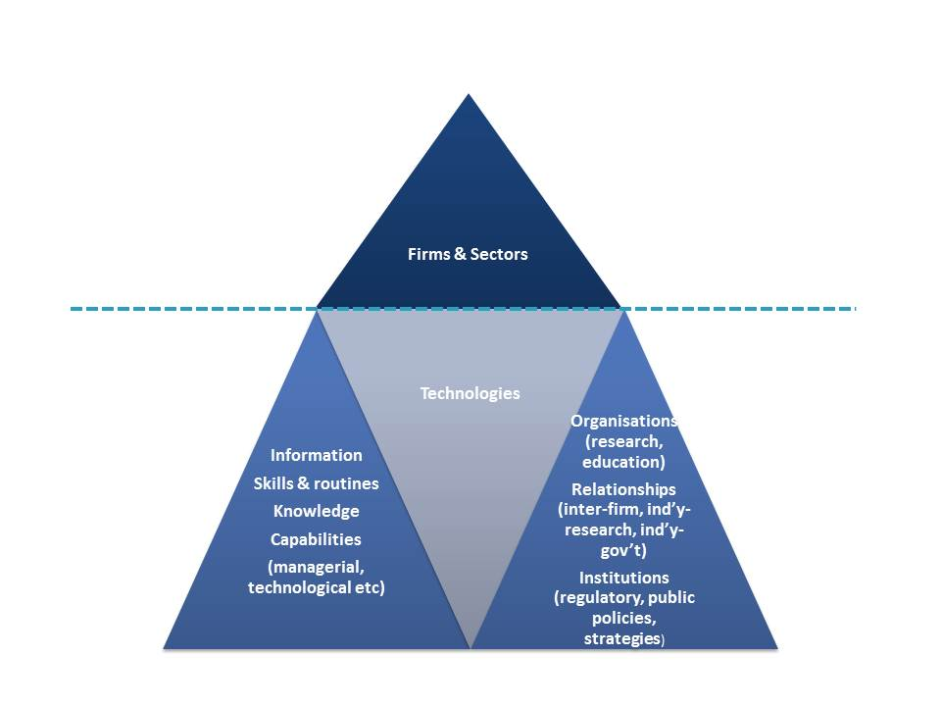

Figure 5.6: Key Dynamics for Cluster Growth: New Enterprise Formation, Growth and Upgrading
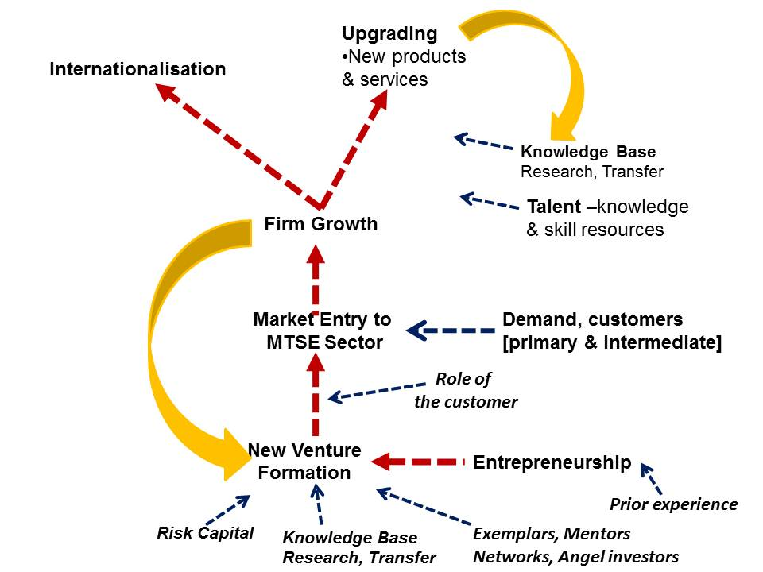
Figures 5.6, 5.7 and 5.8 summarise the dynamic factors of cluster building discussed above, and provide frameworks useful for assessing mining-related cluster development in Australia.

Figure 5.7: Cluster Dynamics: Drivers and Shapers of Specialisation and Capability Development
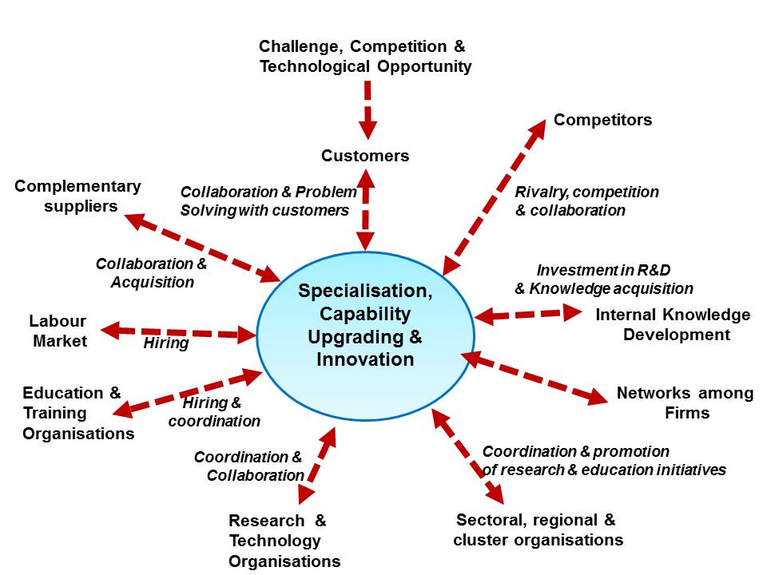

METS-Related Industry Development Initiatives in Australia
Over the period 2001-3 a Mining Technology Services (MTS) sectoral ‘strategy’ (or Action Agenda) was developed based on consultation within the sector and with related stakeholders, including mining industry associations and research organisations. The Action Agenda identified a range of challenges for the development of the sector:
- The diversity of the sector in terms of service categories and sizes of firms leading to a lack of wider profile and recognition contributing to limited attractiveness of the sector for investors;
- A lack of collaboration among METS companies and with research (although this was increasing) and education organisations;
- The importance of building positions in export markets, but the challenges in doing so for small firms, and of increasing cooperation between Austrade and Austmine; and
- The increasing demand for skilled human resources, particularly professional managers, engineers, geologists and IT professionals.
The proposed strategy, based on extensive consultations, focused on:
- A ‘vision’ of achieving Mining Technology Services exports of A$6b by 2010;
- Raising the profile of the METS ‘sector’ and increasing its attractiveness to the investors;
- Strengthening cluster relations, including collaboration among firms and with research organisations, and the depth of innovation and management capability in firms;
- Ensuring that most METS firms were fully competent in e-business;
- Attracting more graduates to careers in the sector and greater participation by the METS sector in influencing the supply of graduates. The Action Agenda stressed the need to improve the supply of high quality graduates in a range of mining and related areas, and to improve coordination among suppliers of education and training services and the mining and METS sector.
It appears that all of these issues are continuing challenges.

The METS-Related Knowledge Infrastructure
The infrastructure of mining-related research and education, organisations in Australia is a key factor in the continuing competitiveness of the mining industry. The quality of this infrastructure, which is largely focused on the mining industry rather than on suppliers to mining, has encouraged at least Rio Tinto to establish components of its global R&D in Australia. As shown in Table 5.3, there is an extensive array of organisations that conduct research in mining-related fields.

Table 5.3: Australian Mining-Related Research Infrastructure.
Research Organisations
- CSIRO (Centre for Advanced; Exploration and Mining, Minerals and the ICT Centre)
- GeoScience Australia
- National ICT Australia (NICTA)
- Australian Nuclear Science and Technology Organisation
University-Based Research and Consulting Groups
- Sustainable Minerals Institute, University of Queensland:
- Minerals Industry Safety and Health Centre
- WH Bryan Mining and Geology Research Centre
- Centre for Water in the Minerals Industry
- Centre for Social Responsibility in Mining (CSRM)
- Julius Kruttschnitt Mineral Research Centre (JKMRC)
- University of Tasmania's Centre for Ore Deposit Studies
- Western Australia School of Mines
- University of South Australia's Ian Wark Research Institute,
- James Cook University School of Earth and Environmental Sciences
- Australian Centre for Minesite Rehabilitation Research. Brisbane
- University of Sydney, Rio Tinto Centre for Mine Automation (RTCMA)
Collaborative Research Centres
- Cooperative Research Centre for Mining
- CRC for Infrastructure and Engineering Asset Management (CIEAM)
- CRC for Optimising Resource Extraction

Parker Cooperative Research Centre for Integrated Hydrometallurgy Solutions
- Deep Exploration Technologies CRC
Previous Relevant Cooperative Research Centres
- CRC for Mining Technology and Equipment (CMTE) (now CRC Mining)
- GK Williams CRC for Extractive Metallurgy
- CRC for Australian Mineral Exploration Technologies
- Australian Geodynamics CRC
- CRC for Landscape Evolution and Mineral Exploration
- CRC for Advanced Computational Systems
- CRC for Welded Structures
- CRC for CAST Metals Manufacturing
Research Intermediaries
- AMIRA International
- Australian Coal Research Association (ACARP)

The CRC Mining, based at the University of Queensland, is supported by most of the major mining companies, including: Anglo Gold Australia, AngloGold Ashanti, BHP Billiton, Freeport McMoRan, Hamersley Iron, Newcrest Mining Limited, Peabody Energy, Rio Tinto, and Xstrata. It is also supported by several supplier firms, almost all of which are international: Caterpillar Elphinstone; Computer Sciences Corporation; P&H MinePro Services; Wellard; and Herrenknecht Tunnelling Systems. The CRC’s website states: “Typically, solutions are developed for large mining corporates and spin-off companies which then market the technology across Australia as well as globally.”The website lists nine spin-off companies.
A Mining Technology Innovation Centre has been established in 2009 in Mackay (Queensland) to support capability development and innovation in SMEs that are suppliers to the mining sector. The Centre is part of the Enterprise Connect programs of the Department of Innovation, Industry, Science and Research, and provides management and strategy-related advice to firms.

Development of industry – research organisation relationships
In 2008-9 about 40% of the METS companies (included in the ABARE survey) participated in some form of collaborative R&D. The majority of these collaborations were with Australian organisations - the great majority with exploration and mining companies. Among that small proportion of METS firms that collaborated with an overseas-based partner (which may nevertheless have been a firm active in Australia) the majority were also with exploration or mining companies. Mining companies are reported to be open to R&D collaboration with potential suppliers in areas where problem solving is significant. Larger mining firms prefer to collaborate through arrangements that bring together a range of expertise and organisations, as for example, in a CRC or multi-actor research project. The most common public sector research partner was a university (14.5% of external partners among those METS firms participating in collaboration). According to the findings of the 2009 ABARE-BRS survey (Tedesco & Haseltine, 2010) CRCs and CSIRO were identified as much less frequent partners. There have been a number of CRCs in areas related to the mining industry, including the CRC Mining. It is widely recognised that the CRC model tends to be less appropriate where an industry, like the METS sector, is not characterised by a small number of large R&D active firms. An analysis in 2005 of six case studies of firms that provide knowledge-based services (largely exploration, technical and IT-related services) to the mining sector found that, despite the technical nature of the work, few had close links with research organisations. In fact some saw R&D organisations as competitors for the services they provide.
An alternative perspective, possibly very relevant to understanding METS-research relationships and the perception of competition, comes from the leader, at that time, of one of the major mining automation research centres:
“[research projects]. have placed Australia at the forefront of robotic mining R&D. Substantial research challenges in areas such as sensing, data fusion, navigation and control, have helped established Australian researchers as leading players on the world stage. However, major mining equipment suppliers have been remarkably slow on the uptake, possibly because few major equipment manufacturers have research or development divisions in Australia. This has made the transition of technology from research into products of value to the Australian mining industry, sometimes a difficult and dispiriting process. So in Australia, a significant number of smaller technology-oriented automation companies have come to the fore, ranging from companies specialising in remote control, to those providing sensors, information processing, control and planning software. Many of these companies are spin-outs from various robotics research groups around Australia. A possible industry development scenario in Australia is that one or more of these companies will turn into a systems-engineering house for mining robotics, able to source and integrate individual items of equipment and technology into a fully supported automated mine. This draws on the view that the benefits of automation will only be fully realised through an integrated system, recognising the role that large Australian-based miners play in the global resource industry.”
It is clear that despite the considerable mining-related research strengths in Australia the interaction between that rich research base and most METS firms is very limited. There are several METS firms that are spin-offs from, or based on technology derived from, research organisations. There are also several cases of interactions that were significant for the firm. However, there are few organic linkages based on strong interactions that drive both sides. The overall structure of linkages is summarised in Figure 5.8. A similar issue was identified in the recent review of the Crown Research Institutes in New Zealand the point emphasised the conclusions of that review is also relevant here:
“Currently, it is not clear if a CRI’s objective is to create value for itself, as a company, or to generate value for New Zealand. Current ownership arrangements seem to place undue emphasis on research and development that produces outputs that individual CRIs can capture in their statements of revenue and balance sheets, rather than on research that contributes to the wellbeing and prosperity of New Zealand. This can reduce quite significantly the overall impact of government investment in CRIs.”

Figure 5.8: Overall Pattern of Linkages Between the Research Base and the Australian METS Firms
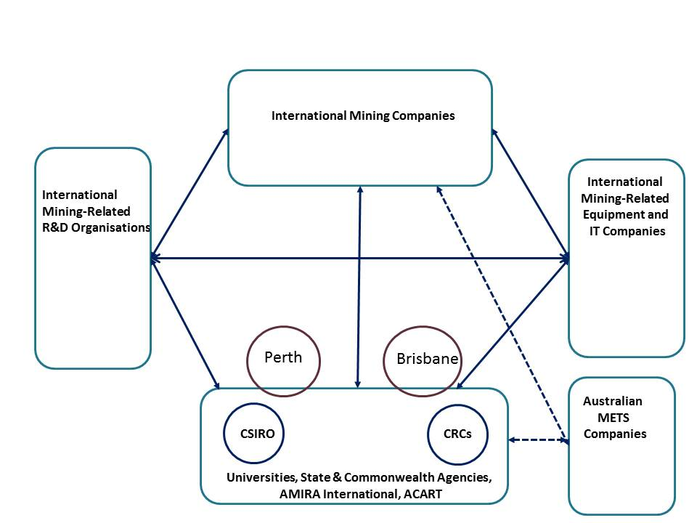
This dilemma was recognised in the AUSIMM submission to the 2008 Innovation System Review:
Noting that the CRC Mining has developed an ‘SME Club’, the submission comments
“Measures such as the SME Club are to be applauded, but a strategic review of impediments to SME collaboration is needed, together with dissemination of best practice strategies to facilitate their inclusion….The relatively small size of many mining technology services firms has also served as a major barrier to their participation in major collaborative programs with public research institutions such as CRCs.” http://www.ausimm.com/policy/no_room_small_players.pdf

Evidence of ‘Cluster’ development
It is widely recognised that the development of firms and sectors often involves the parallel development of supporting sectors, organisations and policies – ie a cluster of interacting organisations. The development of a cluster involves four processes, which reinforce each other: the entry or formation of more, and a more diverse range of, actors (suppliers, customers, intermediaries, sectoral organisations, research and education organisations etc.); increasing interaction (user-producer, competition, collaboration) among these actors; increasing specialisation and capability upgrading within the actors (and through complementarity and cooperation at the level of groups of actors), and; the development of institutions, policies and shared priorities.
Earlier sections have discussed the formation and growth of METS firms and other cluster actors, which some see as important for the development of mining in Australia. In the Hunter region of NSW the closure of the BHP steel mill left many engineers and managers without employment. Many responded by forming new firms and by forming Hunter-net an industry-driven networking and support initiative – a case of necessity based entrepreneurship mobilising and reasonably deep skill base.
The discussion above suggests that interaction with customers around problem solving is one of the key drivers of capability development in the METS sector. Rio Tinto appears to be increasing the level of their investment in mining-related innovation in Australia, developing a highly ambitious set of innovation goals, and strengthening links with research organisations and METS firms. There is little evidence that other large Australian-based mining firms have a similar level of engagement with research organisations and particularly with METS firms. However, as supply interactions are increasingly global, pursuing those opportunities provides a mechanism for Australian METS firms to build scale while remaining reasonably specialised. The evidence discussed above suggests that many METS firms are investing heavily in internal knowledge development. Linkages and collaboration among METS firms appears to be quite limited in depth. Almost all of the other drivers of capability development identified in Figure 5.7 are constrained in one way or another, although acquisition activity is increasing.
The development of sectoral organisations is an expression of shared interests in an emerging sector, and is often essential to lobby for those interests where existing policy is not supportive. The 2004 ABARE-BRS survey (Tedesco, et al., 2004) sought information on the forms of collaboration used by METS firms and this showed that forms of exchange and cooperation facilitated by industry associations were highly valued for their role in market promotion, professional development and information exchange. Thorburn (2005) found that few of the six specialist service suppliers to the mining industry which she studied had links to an industry association for the purpose of innovation. The exception was a firm in the Hunter region of NSW that was actively involved in the regional industry group. However, the firms did see that industry associations did play a major role in ‘broader knowledge acquisition’.

Identifying Capability Gaps and Capability Building Opportunities

Backward Links, Problem Solving and Innovation
The experience of such countries as the United States, Sweden and Finland has demonstrated the role that backward linkages from resources can play in capability, firm and industry development. These, and other similar experiences, emphasise the importance of focusing on the opportunities to build capabilities, technologies and firms through resource sector demand, rather than focus on local content objectives as a form of import substitution.
These international experiences point to three key criteria that signal areas of potential opportunity:
- New and challenging resource sector problems for which there are not ‘off the shelf’ solutions can be particularly important opportunities. The response to such challenging demand may lead to capabilities or ‘solutions’ with the potential to underpin significant innovation and firm development.
- Such challenging demand is particularly significant when it is the early stages of an area of challenge which is likely to become more widespread, for example, mine safety, environmental management, more energy or water efficient mining and processing.
- Similarly new solutions are more likely to be significant when they initiate the application of new generic technologies of wide potential to the resource sector, for example IT, communications and sensor technologies. New solutions based on new technologies have often been the basis for ‘disruption’ through which new entrants pioneering these new approaches displace long established firms. In addition these new capabilities are more likely to be the basis for ‘spillovers’ to related sectors leading to horizontal knowledge transfer and contributions to firm growth and value creation far beyond the resources sector.
The key requirement in pursuing a strategy based on such dynamic opportunities is to identify them. To that end it is essential to develop project maps from which to identify those inputs dominated by established suppliers and those that are more contestable. Appendix 3 provides a number of examples of these basic maps, using alternative approaches to classifying and segmenting the equipment, materials and services inputs. Both a high level of disaggregation and a grouping of project elements into systems (for example ventilation, materials handling) can assist the following stages.

Development Roadmaps
The next step is to add a ‘front end’ and an extended ‘backend’ to these simple project breakdowns. The ‘front end’ identifies the key performance requirements for a project, for example in terms of cost minimisation, safety, environmental impact, reliability. Clearly many individual project elements contribute to these dimensions of performance. Such performance requirements change over time leading to demands on improvement by suppliers and over time to significant innovation. Hence, a key issue is identifying those drivers of performance improvement, the key trajectories of such improvement and, to the extent possible, the elements of the supply side likely to be most under pressure due to these changing demands.
Adding the extended ‘backend’ involves identifying the technologies and the capabilities that underpin the major equipment and services inputs to resources projects. For example, it is clear that sensor technology, signal processing, software engineering, mechatronics and remote control, and the capabilities these require are playing an increasing role in innovation in the mining industry. The further extension of the capabilities stage of the backend’ involves linking capabilities to knowledge resources and research capabilities – in firms and research organisations within Australia or overseas.
This is a framework for a set of linkages from performance requirements in the mining sector to the knowledge underpinning solutions, and to the research capacity that is required to address unmet needs for new knowledge and the enabling capabilities likely to be critical in the future. When the time dimension is added to make these relationships dynamic this forms a technology roadmap.

Figure 6.1: Using Technology Road-mapping to Identify Opportunities and Develop Strategies.
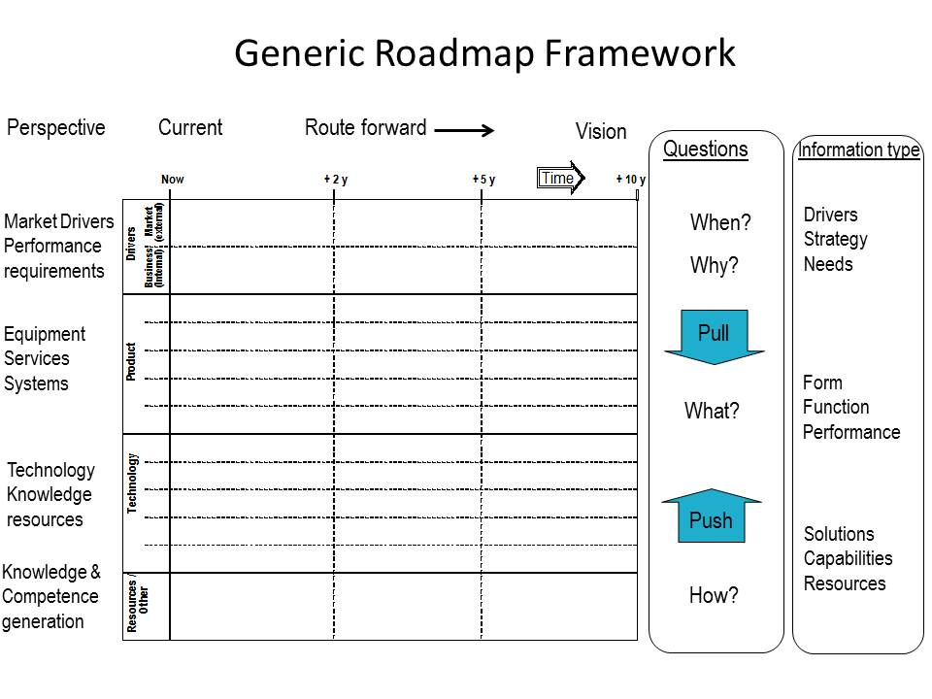
Source: Derived from Phaal, R. (2007) Technology Roadmapping: Principles, Process and Examples. UNIDO.
Such a roadmap it the key tool for demand oriented innovation and supplier development strategies. Any such roadmap must be continually updated in the light of new needs and insights, and new resources. It is important to make the point that one of the key uses of technology roadmapping is to facilitate dialogue, information sharing and joint assessment among stakeholders with interests in the different vertical stages set out in the roadmap, from mining companies to research providers and policy makers. While to tool aids planning, at the organisation and ‘cluster’ level, it is more a tool for learning. Clearly, in a complex, interactive and evolving set of drivers and relationships, planning is inherently limited and is used to guide the focus of learning as much as resource allocation.

Priority Setting
A range of other more straightforward issues, concerning the scale and duration of demand, and barriers to entry, need to be considered in identifying opportunities and priorities for supply development. In addition, some capabilities are likely to have particularly high potential for spillovers to other industries, and in general those are likely to be leading applications of new generic technologies. Some of the more important assessment criteria are brought together into a simple assessment matrix in Table 6. 1.

Table 6.1: Matrix for assessing the sustainability and spillover potential of segments
Service or Equipment Input | Potential demand: Proportion of Investment or production -related expenditure | Pattern of demand:  Single procurement to continuous demand. | Potential for market entry based on cost or service | Potential for innovation leading to international competitiveness | Potential relevance for value creation outside mining.
 | Investment costs
Services and goods mainly for investment projects
Knowledge- intensive services (KIMS) Consultants
Feasibility, design and engineering and project management services
Specialized Services Contractors
Capital Goods & Equipment Suppliers
Consumable Inputs Suppliers
Services and goods mainly for Ongoing operation | Operational costs
Specialist services to support mining operations (blasting, optimisation, M&R, testing)
Specialized Services Contractors
Capital Goods & Equipment Suppliers
Consumable Inputs Suppliers
Source: Author

Conclusions
The mining industry in Australia is becoming increasingly knowledge intensive and this trend will continue as the industry faces new challenges and greater competition.
After a decline in profitability through the 1970s and 1980s, the mining industry is in a phase of expansion. The key driver of that expansion is rising demand from the emerging economies of Asia. The overall growth of demand is likely to be sustained for decades, although the inevitable growth of supply is likely to limit price rises. Nevertheless, both the growth of mining (and other resource projects) in Australia and the growth of global opportunities for Australian mining and mining supplier firms are of great significance for Australia.
That significance is not adequately appreciated. Policies to respond these opportunities remain underdeveloped.
Given this context, this study has addressed four questions. The findings are summarised below, followed by recommendations for new policy objectives.

Summary of Key Points
What lessons can we learn from how have other resource-based economies or regions developed the firms and industries that supply mining equipment, technology and services (METS)?
- Resource development has been central to the economic and industrial evolution of several countries, including the United States, Canada, South Africa, Sweden, Finland and Norway.
- Those countries that had a strong initial foundation of capability that have been best able to pursue the opportunities for broader industrial development from resources projects.
- Opportunities for new firm development are clearly greatest when new challenges and new technologies erode the competitive strengths of established global suppliers - many of which developed from exactly such opportunities in an earlier era – and open new paths of capability development.
- Nevertheless, there are high barriers to entry in many segments of the resource project supplier sectors – and the role of mining firms and higher tier project managers is significant in maintaining or reducing those barriers. It is reasonable to expect that international investors and their project managers will actively seek to use local suppliers and actively support (possibly with additional government support) their development – as long as these local firms are, or can quickly become, internationally competitive. Relationships between mining firms and equipment, technology and services suppliers, often mediated by their Tier 1 suppliers, can be particularly significant for capability and firm development when they focus on problem solving and when the customer does not mandate the form of the solution.
- Opportunities for entry by local firms are usually easier in the production and maintenance phase of major projects rather than the initial investment phase, when risk minimisation is vital. Opportunities for entry are the essential starting point for supplier development, but vigorous processes of learning that upgrade capability are vital if those opportunities are to lead to significant firm and sector development. Strong absorptive capacity in firms is a necessary base for learning, but as the capability upgrading deepens, strong management capability, access to high level human resources and linkages to responsive research organisations are often critical for enabling the search for higher performance to translate into innovation and capability development.
- In most cases the capturing of industrial development opportunities from resource projects has required an active and comprehensive strategy to address barriers to entry and to augment capability development, leading to the evolution of internationally competitive firms and to higher and more widespread positive impacts from resource projects.
To what extent has Australia developed the firms and industries that supply mining equipment, technology and services (METS)?
- The Australian Mining Equipment, Technology and Services (METS) sector is a significant contributor to widening the benefits of the mining boom and to building enduring capability in Australian industry. The growth, diversity and significance of the sector have not been widely recognised.
- While the core equipment and many of the Tier 1 services for major resources projects are imported, Australia has developed a strong and diverse METS sector with internationally leading firms in some segments. However, the METS sector is not clearly defined and systematic data on performance is not available.
- Australian METS firms are continuing to build strengths and market share in the provision of equipment and services across the phases of exploration, assessment, mine development and operation. The major engineering consultants are winning larger roles in increasing large projects. A diverse array of specialist service firms provide design, consulting and management services. Several large and many smaller firms provide contract mining services, both for open cut and underground mining. Several METS firms are significant international mining software and related IT-service providers. While there are no major producers of large mining and processing equipment there are a number of firms that provide components and complementary products for imported equipment. More recently, a number of specialist technology firms have emerged and are winning international markets in niche areas.
- In 2011 METS sector sales were estimated to be about $40b and offshore activity (exports and the activities of overseas subsidiaries) about $15b. This level of export activity is almost three times that of the wine and automotive industry combined. This is an extraordinary and under-appreciated achievement.
- Many METS firms are building exports and offshore offices or subsidiaries. It is the more specialised technology, equipment and services firms that are the most active internationally and their internationalisation has been rapid, extensive and remarkable – an exemplar for Australian industry. The level and growth of offshore activity is stretching the human, organisational and financial capacity of many firms. Such offshore activity generates benefits beyond the firms investing in those activities. It builds the reputation of Australian capability and technology throughout many countries and it builds human resources with wide international experience. The experience has been that there is a continuous movement of mining-related engineers and managers – approaching a pooled talent market- such that human resources developed in one firm often go on to be the entrepreneurs, innovators and leaders in other firms.
- The development of METS firms has been significantly enabled by the changes in the mining industry, leading to greater outsourcing and subsequently dependence on suppliers. At a more proximate level, customer supplier inter-dependence centres on relationships, built on experience and involving trust.
- Australian METS firms have diverse origins and growth paths. Some are long established firms providing engineering services that have grown to develop large contract mining services. Others were equipment repair and maintenance service providers that, through an increasing interaction with mining, began to develop a greater capacity for product design and production. Many have been formed by entrepreneurs with backgrounds in mining companies or other suppliers to the mining industry. Few had significant interaction with government programs through their formative stages. Many now use Austrade services to assist offshore activity and a few have made use of the R&D Tax Concession and other technology development support programs. The industry culture, the remoteness of many locations and the strong inter-personal networks, have encouraged a high level of self-dependence.
- Mining sector – supplier interdependence is again changing as the challenges increasingly faced by the mining industry require new solutions leading to the exploration of opportunities based on new technology. These challenges arise due to lower grade ores, stronger environmental regulation and the need to lower energy and water use, and production and capital costs. The technologies of greatest and most widespread significance are those based in information and communication technologies (ICT). Australian METS firms have been early innovators in the application of ICT to mining.
- The current patterns of change in the mining and mining supply industry are continuing to evolve and these changes bring challenges for the Australian METS firms. One of these changes is the trajectory toward an integrated and automated mine. This may re-affirm the dominance of the leading OEM equipment and IT producers, leaving fewer opportunities for niche providers. The process of consolidation in the METS sector is continuing, both within Australia and internationally. The global shortage of mining professionals is one driver of M&A activity. The shortage of such talent in Australia opens to door to overseas suppliers of services based on such in-house talent. This is leading to the acquisition of some leading Australian METS firms by international firms and to a more assertive role by some OEMs seeking to rebuild control over the value chain related to their equipment platforms. As the overall scale, integration and knowledge intensity of mining projects grows, more METS firms are likely to be challenged in the financing and management of the level of innovation required.
Does Australia provide a supportive context for METS firm and sector development – stimulating and enabling continuous and effective learning within firms and support organisations and promoting mining cluster developing?
- Australia is a major international centre of mining research. It has a range of strong mining research organisations and world class higher degree courses in a number of universities. However, there is little coordination among these organisations and, while their links to the mining industry are strong and long-standing, the linkages with the METS sector are overall quite weak. The reasons for at least the latter arise from the incentive environment for research in Australia and from the characteristics of the METS sector.
- The growth in several countries of suppliers to the resources industry can reasonably be characterised as the formation of a ‘cluster’ of linked and inter-dependent organisations. This experience suggests that the development of a cluster involves four processes, which reinforce each other: the entry or formation of more, and a more diverse range of, organisations (suppliers, customers, intermediaries, sectoral organisations, research and education organisations etc.); increasing interaction (user-producer, competition, collaboration) among these organisations; increasing specialisation and capability upgrading within the organisations (and through complementarity and cooperation at the level of groups of organisations), and; the development of institutions, policies and shared priorities that enable coordination and support for ongoing evolution.
- Entrepreneurship, learning, innovation, collaboration, and competition drive and support this evolution. But many of the relationships that are vital are not market-based. This is one reason why, inter-personal networks, trust-based relationships, and sectoral and regional organisations that develop shared strategies and facilitate interaction are important in all cluster development.
- The fragmented and diffuse nature of the nascent mining cluster(s) in Australia limit the capacity of the METS sector to respond to these challenges. Fragmentation occurs at every level of the sector and related organisations. There is a constellation of small and medium METS firms, with little cooperation among them. While interaction with the mining firms has been vital for the emergence and growth of many METS firms, there is little evidence of significant support from mining firms for the development of Australian METS suppliers – nor has there been a sustained expectation that there should be such support. Mining activity and METS firms are widely dispersed across Australia, with strong concentrations in Perth and Brisbane. Amplifying this fragmentation, in some States ‘local content’ means local to that State. There are a number of industry organisations representing METS firms. There is clearly a strong and internationally recognised array of mining-related research organisations in Australia. But there is little coordination. Indeed there are fault lines that have led to barriers to cooperation among some of the leading research bodies. Furthermore, despite the excellence of the mining-related research in Australia, little of it is directly relevant to the METS sector – nor is there evidence of sustained collaboration between METS firms and research organisations.
- As Australia does not yet have a coherent approach to mining cluster development – although many of the elements of an approach are in place - more robust and coordinated policy is required.
What are the options for a more strategic approach to resource-based industrial development, beyond the short term focus on ‘local content’?
- There are essentially two options for a more robust approach. In considering these and perhaps other options it is important to keep in mind the dynamics that lie behind the emergence and development of firms, industries and clusters. It is clear that these cannot be fully understood through the lens of mainstream economics. For that reason mainstream economics provides an inadequate framework for policies to promote resource-based development.
- The first option involves a strengthening of the current array of policies that focus on encouraging higher levels of local content and also investing in research through CSIRO, CRCs and university research centres. These policies, organisations and investments have led to substantial achievements. But there is a real risk that the lack of coherence in policy will lead to major lost opportunities. There is a tendency to hide behind the restrictions on industry policy in WTO agreements, rather than take on the challenges of finding effective but compliant approaches.
- A second option addresses more directly three critical limitations of the current array of policies:
  - The lack of an overall coherent strategy based on understanding how internationally competitive firms evolve;
  - The lack of a central organisation driven by stakeholders and promoting greater coordination; and
  - The weak linkages within the overall ‘mining cluster’.
The perspective that underpins the current policy stance tends to underestimate: the level of market dominance and the subsequent increasing returns captured by established international suppliers; the level of opportunity arising from technological discontinuities; and the role of non-market factors in shaping the evolution of firms and clusters. The approach that is proposed below takes into account both of these sets of limitations. The term ‘cluster’ is used here as a shorthand for the relationships and dynamics that underpin firm and sectoral development, rather than a normative prescription of cluster policies.

Policy Options
Cluster Development Strategies
Australia has become a major international centre of mining-related innovation and the development of METS firms. It has the opportunity to extend and deepen those strengths to become the pre-eminent global centre of mining innovation. To achieve that and to maximise the benefits that could be achieved a coherent strategy it essential.
At the outset five key challenges need to be addressed, and any strategy must take these into account:
- The major suppliers of core mining and mineral processing equipment are large multinational firms based outside Australia;
- Many Australian METS firms are small niche-focused firms and capabilities vary widely in the METS sector;
- The Australian mining-related public sector knowledge infrastructure is widely dispersed across organisations and across States –and has not been characterised by strong collaboration;
- METS firms and significant State government agencies are similarly dispersed across States; and
- A major step change in mining technology is likely, one that will require new standards to ensure inter-operability, and that will provide pressure for capability upgrading throughout the METS sector.
The key recommendation from this survey and the related studies it that a Mining Innovation Cluster initiative should be developed. Such an initiative could and must aim to stimulate substantially higher levels of research, innovation, human resource development and collaboration. The following principles should guide the development of the initiative:
Complementarity
In the development of a cluster upgrading strategy (as in any industry or innovation development strategy) a key point is the complementarities between public and private investment in innovation support. It is clearly the case that strong public investment in basic geological knowledge and mapping provides a knowledge base which stimulates private investment in exploration. Similarly, a strong public investment in knowledge infrastructure (testing, education, research) can stimulate private investment in innovation and upgrading through providing key inputs:
- human resources that become part of the innovation capacity of firms;
- reliable information and knowledge that informs decision making – eg geological maps, performance potential of technologies- and shapes the direction of search for deposits or for paths of productivity improvement;
- problem solving and research services that contribute to improvement and innovation activities in firms;
- knowledge that becomes components of the knowledge base for an innovation by a firm; and
- ‘innovations’ that form the basis of a technology commercialised through licensing or new firm formation.
In general the importance of these types of input declines from 1 to 5, although many research organisations prefer to focus on the latter types. Hence, three critical issues for any cluster strategy are:
- The level of public investment in knowledge infrastructure- what is an optimum balance and should that balance change over time?;
- The governance of that investment – ie who decides on the priorities for investment?;
- The absorptive capacity of local industry. – are local firms able to participate in innovation, use new knowledge and express a focused demand for research services?;
- The level of linkages between local firms and the organisations in the knowledge infrastructure.
Engaging the major mining firms
Many major mining firms have become more concerned with maintaining their ‘licence to operate’ and hence wish to be seen as socially responsible. One way of doing so is through constructive contributions to local economic development, including supporting local industrial and innovation capability? Here there is the foundations of a shared interest between the major miners and industrial development and research organisations – at least in the case of innovation-active mining companies. The possibility of enabling some reduction in the MRRT for such investment should be explored as this could provide a major stimulus for behavioural change among mining firms.
Technology/Capability Roadmapping
Roadmapping should be used to identify areas of priority for technology and capability development. This approach can also facilitate the development of long term strategies based on shared perspectives and on complementarities between mining companies, METS firms and research organisations. Focusing on significant technological trajectories that lead to new capabilities is more likely to lead to high levels of spillover to other firms and to other sectors. As firms undertaking the risks of opening new paths of development and new markets do often create spillovers for other firms, leading to a high potential for market failure, these forms of new venture or corporate venturing and innovation warrant strong support.
Cluster Development Organisation and Council
A new lean organisation, jointly governed by the public and private sectors, through a Cluster Development Board or Council, would work to stimulate, coordinate, monitor and support a range of cluster development initiatives that improve the flow of information and strengthen interaction. However, the main cluster development activities are likely to be pursued through self-directed and managed working groups that, for example, would link mining firms and suppliers and all firms and research and education organisations – and which develop their own flexible governance arrangements. This organisation might also explore the scope for international collaboration. Hence, the Council and the Cluster organisation would be a foundation for the institutional innovation that will be essential to rise to a higher level of performance.
A Cluster Development Vision
A process that aims to develop a shared vision of future opportunities and broad strategies – such a shared vision become a form of institution that shapes perceptions of priorities and appropriate behaviours. The ‘vision’ would provide a long term perspective, but also set specific objectives for the shorter term. The ‘vision’ should have ambitious but realistic goals. It should also be inclusive and include human resource development and entrepreneurship.
A Cluster Development Strategy
A strategy that addresses, inter alia, improving the basic business environment to support entrepreneurship and investment. A strategy for strengthening research and education organisations and activities. To be effective it would be essential that most initiatives had a high level of private sector leadership, participation and funding.
Public Support
Significant public funding, which could come from MRRT funds, will be essential for the development of research infrastructure and longer term research and training programs. It will also be essential for ensuring the credibility of stakeholders and initiatives.
The internationalisation of mining companies and of METS firms has been a key enabler of continued capability upgrading, and firm growth. As continued internationalisation will support higher levels of innovation programs to support such international development might be a component of cluster development strategies.

Sources
ABS (1985) Foreign ownership and control of the mining industry. Cat no 5317.0.
ABS (1999): A century of mining in Australia, Special Article. www.abs.gov.au/AUSSTATS/abs@.nsf/featurearticlesbytitle/74FA506B5F19BFFFCA257100001CC885?OpenDocument.
ABS (2004) Economic Activity of Foreign Owned Businesses in Australia, 2000-01, 2000-01. Cat no 5494.0 and
ABS (2004) Economic Activity of Foreign Owned Businesses in Australia, 2000-01, 2000-01. Cat no 5494.0 and ABS (1985) Foreign ownership and control of the mining industry. Cat no 5317.0.
ABS (2010a) Business Expenditure on Research and Development, 2009-2010. Canberra. ABS
ABS (2101b) Experimental Estimates of Industry Multifactor Productivity, 2008-09 (cat. no. 5260.0.55.002)
ABS (2011) Mining Capital Expenditure in Australia http://www.abs.gov.au/ausstats/abs@nsf/products/C663DEB965257495CA257679000FA4A6?OpenDocument
ABS (2012) Feature Article: Mining Investment. ABS Publications. Canberra: ABS
Access Economics (2010). Review of the Enhanced Project By-law scheme. Access Economics.
Altenburg, T. (nd) Linkages and Spillovers between Transnational Corporations and Small and Medium-Sized Enterprises in Developing Countries – Opportunities and Policies. UNCTAD
Alvarez, I. and Marin, R. (2010) Entry modes and national systems of innovation. Journal of International Management. Volume 16, Issue 4, December 2010, Pages 340–353
Arikan, T. A. (2008). “Institutional Transformation during the Emergence of New York’s Silicon Alley,” in Emerging Regions around the World: Theory, Evidence and Implications. Eds. P. H. Phan, S. Venkataraman, and S. R. Velamuri. Northampton, MA: Edward Elgar, 92–121.
Arikan, T. A. (2009) “Interfirm knowledge exchanges and the knowledge creation capability of clusters,” Academy of Management Review 34, 658–676.
Arikan, T. A. (2010) Regional Entrepreneurial Transformation: A Complex Systems Perspective. Journal of Small Business Management. 48(2): 152-173
Arnold, E. et al. (2011) A ‘Reset’ for Norwegian Industrial Development? What can we learn from fast developers?. Technopolis Group.
Asheim, Bjorn T., and Meric S. Gertler. 2005. “Regional Innovation Systems.” In The Oxford Handbook of Innovation, eds Jan Fagerberg, David C. Mowery, and Richard R. Nelson. Oxford: Oxford University Press.
Australian Government (nd) Knowledge Intensive Service Activities in the Mining Technology Services Industry in Australia. Report for the OECD KISA project.
Australian Institute of Mining and Metallurgy (2008) Submission to the National Innovation System Review. AusIMM
Australian Treasury (2011) Budget Strategy and Outlook, 2011-2012. Budget Paper No. 1. ) www.budget.gov.au/2011-12/content/bp1/html/bp1_bst2-04.htm (Accessed 20 June, 2011)
Azulay, I. Lerner, M. and Tishler, A. (2002) Converting military technology through corporate entrepreneurship, Research Policy 31 (3): 419-435.
Barnett, A. & Bell, M. (2011) Is BHP Billiton’s Cluster-Programme in Chile relevant for Africa’s mining industry? Policy Practice Brief 7. The Policy Practice
Barrios, S., Gorg, H. and Strobl, E. (2009) Spillovers Through Backward Linkages from Multinationals: Measurement Matters! Institute for the Study of Labour, Bonn. (IZA) IZA DP No. 4477 October 2009
Bas, T. G. Amoros, E. & Kunc, M. (2008) Innovation, Entrepreneurship and Clusters in Latin America Natural Resource – Implication and Future Challenges. Journal of Technology Management & Innovation. 3(3):52-65.
Basant, R. 2002. Knowledge flows and industrial clusters: An analytical review of literature. Economics Study Area Working Papers 40, East-West Center, Economics Study Area
Baum, J. R., & Locke, E. A. 2004. The relationship of entrepreneurial traits, skill, and motivation to subsequent venture growth. Journal of Applied Psychology, 89: 587-598.
Baum, J. R., Locke, E. A., & Smith, K. G. 2001. A multidimensional model of venture growth. Academy of Management Journal, 44: 292-303.
Belderbos, R., G. Capannelli and K. Fukao (2001), “Backward vertical linkages of foreign manufacturing affiliates: Evidence from Japanese multinationals”, World Development, Vol. 29, no 1, pp. 189-208.
Belkar R, L Cockerell and C Kent (2007), ‘Current Account Deficits: The Australian Debate’, Central Bank of Chile Working Paper No 450.
Bergek, A. and Jacobsson, S. (2003): The Emergence of a Growth Industry: A Comparative Analysis of the German, Dutch and Swedish Wind Turbine Industries. Metcalfe, S. & Cantner, U.: Change, Transformation and Development. Physica-Verlag, Heidelberg, pp. 197-227.
Bergek, A., Jacobsson, S., Carlsson, B., Lindmark, S. & Rickne, A. (2008): Analyzing the functional dynamics of technological innovation systems: a scheme of analysis. Research Policy, 37 (3): 407-429.
Blainey, G (1963), The Rush That Never Ended, Melbourne University Press, Melbourne.
Blainey, G (1970), ‘A Theory of Mineral Discovery: Australia in the Nineteenth Century’, The Economic History Review, 23(2), pp298–313.
Blainey, G. (1994): The Rush that Never Ended: A History of Australian Mining, Melbourne University Press, Melbourne.
Blomström, Magnus and Ari Kokko, (2007), 'From Natural Resources to High-Tech Production: The Evolution of Industrial Competitiveness in Sweden and Finland' in Lederman, D. and W.F. Maloney (eds.) Natural Resources: Neither Curse nor Destiny, pages 213-256, Stanford University Press and The World Bank, Washington, DC
Bloodgood, J. M., Sapienza, H. J., & Almeida, J. G. 1996. The Internationalization of new high-potential U.S. ventures: Antecedents and outcomes. Entrepreneurship, Theory and Practice, 20(4): 61-77.
Bollingtoft, A., Ulhoi, J. P., Madsen, H., & Neergaard, H. 2003. The effect of financial factors on the performance of new venture companies in high tech and knowledge-intensive industries: An empirical study in Denmark. International Journal of Management, 20: 535-547.
Braunerhjelm, P., & Feldman, M. 2006. Cluster genesis, technology-based industrial development. NY: Oxford U.P.
Breznitz, D., 2002, The Military as a Public Space - The Role of the IDF in the Israeli Software Innovation System. MIT Department of Political Science Massachusetts Institute of Technology (STE-WP-13-2002).
Bruton, G. D., & Rubanik, Y. (2002) Resources of the firm, Russian high-technology startups and firm growth. Journal of Business Venturing, 17: 553-576.
Butlin MW (1977), ‘A Preliminary Annual Database 1900/01 to 1973/74’, RBA Research Discussion Paper No. 7701. http://www.rba.gov.au/publications/rdp/1977/7701.html
Butlin N. G (1964), Investment in Australian Economic Development 1861–1900, Cambridge University Press, London.
Butlin N. G (1985), ‘Australian National Accounts: 1788–1983’, Australian National University Source Papers in Economic History No 6.
Butlin N. G (1986), ‘Contours of the Australian Economy 1788–1860’, Australian Economic History Review, 26(2), pp. 96–125.
Cappelen, Å., T. Eika and I. Holm (2000) “Resource Booms: Curse or Blessing?,” Manuscript presented at the Annual Meeting of American Economic Association 2000, Statistics Norway, Oslo.
Carlsson, B., & Braunerhjelm, P. 2002. The biomedical clusters in Ohio and Sweden: An overview. Norwell, MA: Kluwer Academic Publishers.
Casper, S. and Kettler, H. (2001) National Institutional Frameworks and the Hybridization of Entrepreneurial Business Models: The German and UK Biotechnology Sectors. Industry and Innovation. 8(1):5-30
Casper, S. and Murray, F., 2004. Careers and clusters: analysing career network dynamics of biotechnology clusters. Journal of Engineering and Technology Management 22, 51–74.
Casper, S., (2007). How do technology clusters emerge and become sustainable? Social network formation and inter-firm mobility within the San Diego biotechnology cluster. Research Policy 36, 438–455.
Cereceda, E.(2008) Kindling Clusters: Adding Value to Chilean Mining. Mining Intelligence Series. Business News Americas. Santiago Chile.
Chandler, G. N., & Hanks, S. H. 1994a. Founder competence, the environment and venture performance. Entrepreneurship Theory & Practice, 18(3): 77-89.
Chandler, G. N., & Hanks, S. H. 1994b. Market attractiveness, resource-based capabilities, venture strategies, and venture performance. Journal of Business Venturing, 9: 331-349.
Chiaroni, D. and Chiesa, V. (2006) Forms of creation of industrial clusters in biotechnology . Technovation. Volume 26, Issue 9, September 2006, Pages 1064-1076
Christensen, C. M. & Bower, J.L. (1996) Customer Power, Strategic Investment, And The Failure Of Leading Firms. Strategic Management Journal, Vol. 17, 197-218
Christensen, C. M. & Raynor, M. (2003) The Innovator's Solution. Harvard University Press
Connell, D. (2007) “Secrets” of The World’s Largest Seed Capital Fund: How the United States Government Uses its Small Business Innovation Research (SBIR) Programme and Procurement Budgets to Support Small Technology Firms Centre for Business Research, University of Cambridge.
Connell, D. (2009) Innovation and Procurement Policy: Using government procurement to help grow new science and technology companies: Lessons from the US small business innovation research (SBIR) programme. Innovation: Management, Policy & Practice. 11(1): 127-134.
Connolly E and C Lewis (2010), ‘Structural Change in the Australian Economy’, RBA Bulletin, September, pp. 1–9.
Cook LH and E Sieper (1984), ‘Minerals Sector Growth and Structural Change’, in LH Cook and MG Porter (eds), The Minerals Sector and the Australian Economy, Special Study No 6, George Allen & Unwin Australia in association with Centre of Policy Studies, Monash University, Sydney, pp. 85–127.
Cooke, P. (2000) Learning Commercialisation of Science: Biotechnology and the New Economy Innovation Systems. DRUID. Aalborg.
Cooke, P., De Leurentis, C., Todtling, F. & Trippl, M. 2007. Regional Knowledge Economies: Markets, Clusters and Innovation. Northampton: Edward Elgar Publishing Inc.
Coombs M (2000), ‘Developments in the Mining Sector’, RBA Bulletin, July, pp. 1–5.
Corden, M. (1984) ‘Booming sector and Dutch disease economics: survey and consolidation’, Oxford Economic Papers, Volume 36
Council on Competitiveness (2006) Asset Mapping Roadmap: A guide to assessing regional development resources. Wired Program. Version 1.0.
Coviello, N. E., & Munro, H. J. 1995. Growing the entrepreneurial firm: Networking for international market development. European Journal of Marketing, 29(7): 49-61.
Crespo, N. and Fontoura, M. P. (2007) Determinant Factors of FDI Spillovers – What Do We Really Know? World Development Vol. 35, No. 3, pp. 410–425, 2007
David, P. and Wright, G. (1997) The Genesis of American Resources Abundance. Industrial and Corporate Change. 6: 203-45
Department of Education, Science and Training (2001) Rising to the Challenge: building professional staff capability in the Australian minerals industry for the new century. Canberra: DEST.
Department of Industry, Science and Resources, (2000), Emerging Industries Occasional Paper 5: Skills Needs of Emerging Industries. Canberra: DISR
Department of Industry, Science and Resources, (2002), Mining Technology Services Action Agenda - Background paper on issues affecting the sector. Canberra: DIISR
Department of State Development and Department of Commerce (2011), Local Content Report, May. Government of Western Australia.
Dodgson, M and Vandermark, S. (2000): Going South? The Challenges and Opportunities of Globalization and Innovation in the Minerals Industry. Paper presented at the conference: South, South, South, Sydney, 22-23 May.
Dodgson, M. and Vandermark, S., 2000, Innovation and Globalisation in the Australian Minerals Industry, Australia Asia Management Centre, Australian National University
Doran C. R (1984), ‘An Historical Perspective on Mining and Economic Change’, in LH Cook and MG Porter (eds), The Minerals Sector and the Australian Economy, George Allen & Unwin Australia, Sydney, pp. 37–84.
Doyletech (2010), Northern Ontario Mining Supply and Services Study. Final Report. Ontario North Economic Development Corporation.
Duffy, M. (1994): The Contribution of Mining to Australia’s Development, International Council on Metals and Environment, Ontario, Canada.
Economic Commission for Africa (2004) Minerals Cluster Policy Study in Africa. Pilot Studies of South Africa and Mozambique. ECA/SDD/05/08.
Edelman, L. F., Brush, C. G., & Manolova, T. 2005. Co-alignment in the resource-performance relationship: Strategy as mediator. Journal of Business Venturing, 20: 359-383.
Eichengreen, B. and I McLean (1994) ‘The Supply of Gold under the Pre-1914 Gold Standard’, The Economic History Review, 47(2), pp. 288–309
Engen, O. A. (2008) “The development of the Norwegian Petroleum Innovation System: A historical overview” in Fagerberg, J., D. C. Mowery and B. Verspagen (eds) Innovation, Path Dependency and Policy: the Norwegian Case, Oxford: Oxford University Press, forthcoming.
Enright, M.J. 2003. Regional clusters: What we know and what we should know. In J. Bröcker, D. Dohse, & S. Rüdiger, (Eds.), Innovation clusters and interregional competition. Springer
Ensley, M. D., Pearce, C. L., & Hmieleski, K. M. 2006. The moderating effect of environmental dynamics on the relationship between entrepreneur leadership behaviour and new venture performance. Journal of Business Venturing, 21: 243-263.
European Union Commission. 2008. The concept of clusters and cluster policies and their role for competitiveness and innovation: Main statistical results and lessons learned. Communication from the Commission to the Council, The European Parliament, The European economic and Social Committee and the Committee of the Regions. Brussels, 17.10.2008. SEC (2008) 2637.
Fagerberg, Jan ; Verspagen, Bart ; Mowery, David C. Innovation-systems, path dependency and policy: The co evolution of science, technology and innovation policy and industrial structure in a small, resource-based economy. GLOBELICS 6th International Conference 2008 22-24 September, Mexico City, Mexico.
Farjoun, M. (1994) Beyond Industry Boundaries: Human Expertise, Diversification and Resource-Related Industry Groups Organization Science Vol. 5, No. 2 (May, 1994), pp. 185-199
Feldman, M. P. (2002) The locational dynamics of the U.S. biotech industry: Knowledge externalities and the anchor hypothesis. Prepared for the Danish Research Unit on Industrial Dynamics (DRIUD) 2002 meetings.
Feldman, M. P., Francis, J., and Bercovitz, J. (2005). “Creating a Cluster While Building a Firm: Entrepreneurs and the Formation of Industrial Clusters.” Regional Studies 39(1, February): 129–41.
Foster R. A (1996), ‘Australian Economic Statistics 1949–50 to 1994–95’, Reserve Bank of Australia Occasional Paper No 8, revised.
Frankel, J. (2010) ‘The natural resource curse: a survey,’ Harvard Kennedy School, Faculty Research Working Paper Series RWP10-005, 2010
Freebairn J. W (1987), ‘Natural Resource Industries’, in R Maddock & I McLean (eds), The Australian Economy in the Long Run, Cambridge University Press, Melbourne, pp133–164.
Freeman, L.C. (2004). The development of network analysis: A study in the sociology of science. Vancouver, BC: Empirical Press.
Fuchslocher, C.T. (2007) The Role and Development of Technology-Intensive Suppliers in Resource-Based Economies: A Literature Review. GIGA Research Programme: Transformation in the Process of Globalisation. No. 60 November 2007.
Fuchslocher, C.T. (2010) Understanding the development of technology-intensive suppliers in resource-based developing economies. Research Policy 39: 268-277
Gaete, Pable (2007) Alignment of Goals: New Trends in the Relationship between Providers and Miners. Mining Intelligence Series. Business News Americas. Santiago Chile
Garnsey E. (1998) Dynamics of the innovative milieu: examples from Cambridge, in Keeble D. and Lawson C. (Eds) Collective Learning Processes and Knowledge Development in the Evolution of Regional Clusters of High Technology SMEs in Europe, pp.117-121. ESRC Centre for Business Research, University of Cambridge.
Gilbert, B. A., McDougall, P. P. and Audretsch, D. B. (2008) Clusters, Knowledge Spillovers and New Venture Performance: An Empirical Examination. Journal of Business Venturing 23: 405-422.
Gilding, M. (2008) ‘The tyranny of distance’: Biotechnology networks and clusters in the antipodes” Research Policy. Volume 37, Issues 6-7, July 2008, Pages 1132-1144
Gillitzer C. and J Kearns (2005), ‘Long-Term Patterns in Australia’s Terms of Trade’, RBA Research Discussion Paper No. 2005-01.
Giuliani, E., Pietrobelli, C. & Rabellotti, R. (2005) Upgrading in Global Value Chains: Lessons from Latin American Clusters. World Development. 33(4):549–573.
Gompers, P. and Lerner, J. (2001) The Venture Capital Revolution. The Journal of Economic Perspectives. 15 (2): 145-168.
Grant, A. Hawkins, J. and Shaw, L. (2005) Mining and commodities exports, Australian Treasury. http://www.treasury.gov.au/documents/1042/PDF/02_Resource_commodities.pdf (accessed 20 June, 2011)
Gregory R. (1976), ‘Some Implications of the Growth of the Mineral Sector’, The Australian Journal of Agricultural Economics, 20(2), pp. 71–91.
Gregory R. (1978), ‘Some Observations on the Relationship between the Mining Industry and the Rest of the Economy’, CEDA Policy Forum ‘Dollars for Minerals and Energy’, 8 November.
Gstraunthaler, T. & Proskuryakova,L. (2012) Enabling Innovation in Extractive Industries in Commodity Based Economies. Innovation: Management, Policy and Practice 14(1):19-32
Gylfason, T. (2001), “Natural resources, education and economic growth”, European Economic Review, Vol. 45, pp. 847-859.
Gylfason, T. (2001): Natural Resources and Economic Growth: What Is the Connection?, CESifo Working Paper 530, Münich: Center for Economic Studies & Ifo Institute for Economic Research.
Haeussler, C. (2010) The Determinants of Commercialisation Strategy: Idiosyncrasies in British and German Biotechnology. Entrepreneurship Theory and Practice. May: 1-29
Haig B. (2001), ‘New Estimates of Australian GDP: 1861–1948/49’, Australian Economic History Review, 41(1), pp. 1–34.
Hall, H. & Donald, B. (2009) Innovation and Creativity on the Periphery: Challenges and Opportunities in Northern Ontario. Rotman School of Management. University of Toronto. Martin Prosperity Institute.
Hausmann, R. and Klinger, B. (2007), ‘The structure of the product space and the evolution of comparative advantage,’ CID Working Paper No 146, Centre for International Development, Harvard University.
Hausmann, R. and Rigobon, R. (2002) ‘An alternative interpretation of the ‘resource curse’: Theory and policy implications,’ Working Paper 9424, Washington DC: National Bureau of Economic Research.
Havro, G.and Javier Santiso, J.(2008) To Benefit from Plenty: Lessons from Chile and Norway. Policy Brief No. 37. OECD, Paris
Heinrich, A. (2011) Challenges of a Resource Boom: Review of the Literature. Working Papers of the Research Centre for East European Studies, No. 114.
Hekkert, M. P., Suurs, R., van Lente, H., and Kuhlmann, S. (2004): Functions of Innovation Systems: A new approach for analysing socio-technical transformation. Paper presented at the International Workshop on Functions of Innovation Systems, Utrecht University, Utrecht, June 23-24 2004.
Hekkert, M.P., Suurs, R., Negro, S, Kuhlmann, S and Smits, R. (2007) Functions of innovation systems: A new approach for analysing technological change. Technological Forecasting & Social Change 74: 413–432
Heum, P. (2008) Local Content Development: experiences from oil and gas activities in Norway. SNF Working Paper No. 02/08. Institute for Research in Economics and Business Administration, Bergen, Norway.
Heum, P., C. Quale, J.E. Karlsen, M. Kragha and G. Osahon (2003), Enhancement of local content in the upstream oil and gas industry in Nigeria – a comprehensive and viable policy approach, Bergen: The Institute for Research in Economics and Business Administration, SNF-Report 25/03.
Holley, J. (2005) Building a Regional Entrepreneurship Network. ACNet Institute. Ohio.
Honig, B. Lerner, M. and Raban, Y. (2006) Social Capital and the Linkages of High-Tech Companies to the Military Defense System: Is there a Signalling Mechanism? Small Business Economics. 27 (4-5):419-437.
House of Representatives Standing Committee on Industry, Science and Technology (1989) The North West Shelf: a sea of lost opportunities? Parliament of Australia.
http://www.pc.gov.au/__data/assets/pdf_file/0016/37123/science.pdf p 390.
Humphrey, J. and Schmitz, H. (2000) Governance and Upgrading: Linking Industrial Cluster and Global Value Chain Research. IDS Working Paper. University of Sussex.
Iimi, A. (2007), “Escaping from the Resource Curse: Evidence from Botswana and the Rest of the World”, IMF Staff Papers, (December) Volume 54, Number 4.
Ivarsson, I. and Alvstam, C. G. (2009) Local Technology Linkages and Supplier Upgrading in Global Value Chains: The Case of Swedish Engineering TNCs in Emerging Markets Competition & Change, 13, (4) pp. 368-388
J. Sturgeon, T. J. and Gereffi, G. (2009) Measuring success in the global economy: international trade, industrial upgrading, and business function outsourcing in global value chains Transnational Corporations, Vol. 18, No. 2 (August 2009)
Jacobs, D., & de Man, A. P. (1996). Clusters, industrial policy, and firm strategy: A menu approach. Technology Analysis and Strategic Management, 8, 425-437.
Javorcik, B. S. & Spatarean M. (2008) “To share or not to share: Does local participation matter for spillovers from foreign direct investment?” Journal of Development Economics. 85(1–2):194–217
Javorcik, B. S. (2004) Does Foreign Direct Investment Increase the Productivity of Domestic Firms? The American Economic Review, 94(3):605-627
Johnson, A. (1998): Functions in Innovation System Approaches. Dept of Industrial Dynamics, Chalmers University of Technology, Göteborg. Working paper.
Johnson, A. and Jacobsson, S. (2001): Inducement and Blocking Mechanisms in the Development of a New Industry: The Case of Renewable Energy Technology in Sweden. In Coombs, R., Green, K., Walsh, V. & Richards, A. (Eds): Technology and the Market: Demand, Users and Innovation. Edward Elgar, Cheltenham/Northhampton,
Kaplan, D. (2011) South African mining equipment and related services: Growth, constraints and policy. MMCP Discussion Paper No. 5. Open University, UK
Kaplinsky R. and E. Mhlongo (1997), “Infant Industries and Industrial Policy: A Lesson from South Africa”, Transition, No. 34, pp.57-85’
Kazanjian, R. K., & Drazin, R.(1990) A stage-contingent model of design and growth for technology based new ventures. Journal of Business Venturing, 5: 137-150.
Keeble D. and Lawson C. (Eds) (1998) Collective Learning Processes and Knowledge Development in the Evolution of Regional Clusters of High Technology SMEs in Europe. ESRC Centre for Business Research, University of Cambridge
Larsen, E-R. (2004) Escaping the Resource Curse and the Dutch Disease? When and Why Norway Caught up with and Forged ahead of Its Neighbors. Research Department of Statistics Norway, Discussion Paper No. 377. http://www.ssb.no/publikasjoner/DP/pdf/dp377.pdf
Lederman, D. and Maloney, W. (2008) In Search of the Missing Resource Curse. Policy Research Working Paper 4766. World Bank
Lederman, D., Maloney, W., Dunning, T, and Cameron A. Shelton, C. (2008) In Search of the Missing Resource Curse. Economía Vol. 9, No. 1 (Fall 2008), pp. 1-57.
Lee, C., Lee, K., & Pennings, J. M. 2001. Internal capabilities, external networks, and performance: A study on technology-based ventures. Strategic Management Journal, 22: 615-640.
Leite, C. and J. Weidmann (1999), “Does Mother Nature Corrupt? National Resources, Corruption, and Economic Growth”, IMF Working Paper No. 85, International Monetary Fund, Washington D.C.
Lerner, J. (1999) The Government as Venture Capitalist: The Long‐Run Impact of the SBIR Program. The Journal of Business. Vol. 72(3).
Leslie, Stuart W. (2000. “The Biggest ‘Angel’ of Them All: The Military and the Making of Silicon Valley.” In Understanding Silicon Valley: The Anatomy of an Entrepreneurial Region, ed. Martin Kenney. Stanford, Calif.: Stanford University Press.
Lester, R. (2003) Universities and Local Systems of Innovation: A strategic approach. MIT and Cambridge University. Workshop on High Tech Business: Clusters, Constraints and Economic Development.
Lima and Meller, (2003) cited in BN Americas Mining Group (2006) Mining Clusters in Latin America: Missing the Boat. Mining Intelligence Series. Business News Americas. Santiago Chile.
Liu, J. & Chaminade, C. (2010). Dynamics of a Technological Innovator Network and its Impact on Technological Performance. Innovation: Management, Policy & Practice, 12(1): 54-75.
Lundvall B-A, Joseph K. J., Chaminade, C. (2009) Handbook of Innovation Systems and Developing Countries: Building Domestic Capabilities in a Global Setting. Edward Elgar
Lyons, T. and Kutzhanova, N. (2004) Building Entrepreneurial Communities: The Appropriate Role of Enterprise Development Activities. Journal of the Community Development Society. Volume: 35(1):5-
Maddock R. & I McLean (1984), ‘Supply-Side Shocks: The Case of Australian Gold’, The Journal of Economic History, 44(4), pp. 1047–1067.
Malerba, F., & Orsenigo, L., (2002). Innovation and market structure in the dynamics of the pharmaceutical industry and biotechnology: towards a history-friendly model. Industrial and Corporate Change, 11(4): 667-703.
Malmberg, A, and Power, D.. (2006) “True Clusters: A Severe Case of Conceptual Headache.” In Clusters and Regional Development: Critical Reflections and Explorations, eds Bjorn Asheim, Phil Cooke, and Ron Martin. London: Routledge.
Maloney, W. F. (2001): ‘Missed Opportunities: Innovation and Resource-Based Growth in Latin America’, Economía, Vol. 3, No. 1, pp. 111-167.
Maloney, W.F. (2007): Missed Opportunities: Innovation and Resource-Based Growth in Latin America, Chapter 6 in Lederman, D. and Maloney, W. F.: Natural Resources: Neither Course nor Destiny. Stanford University Press and the World Bank, Palo Alto and Washington DC.
Maloney, William F. (2002): Missed Opportunities: Innovation and Resource‐based Growth in Latin America, in: Word Bank Policy Research Working Paper, No. 2935.
Market Information and Research Section (2011) Trade in Primary and Manufactured Products Australia 2010. Canberra; Department of Foreign Affairs and Trade.
Martin, R., & Sunley, P. (2006). Path dependence and regional economic evolution. Journal of Economic Geography, 6, pp. 395–437.
Martin, R., and Sunley, P. (2003). “Deconstructing Clusters: Chaotic Concept or Policy Panacea?” Journal of Economic Geography 3(1): 5–35.
Martinez-Fernandez, M. C. (2005) Knowledge Intensive Service Activities (KISA) in Innovation of the Mining Services Technology Services Sector in Australia. AEGIS, University of Western Sydney.
Matthews, M. and Frater, B. (2003) Creating and Exploiting Intangible Networks: How Radiata was able to improve its odds of success in the risky process of innovating. A Case Study Prepared for the Science and Innovation Mapping study of the Department of Education, Science and Training
McAllister, M.L. & Alexander, C. J. (1997) A Stake in the Future: Redefining the Canadian Mineral Industry. Vancouver, UBC Press.
McKenzie I (1986), ‘Australia’s Real Exchange Rate during the Twentieth Century’, The Economic Record, Supplement, pp. 69–78.
Meldman, M. & E. Romanelli (2006) Organisational Legacy and Internal Dynamics of Clusters Working Paper. University of Toronto.; Casper, S. (2007) Creating Silicon Valley in Europe. OUP.
MGB Group (2004) Building High-Performing Clusters in Eastern Perth: Mining Services and Vehicle Related Manufacturing – A Scoping Study. Perth: MGB Group.
Michael, D (1973) On Learning to Plan and Planning to Learn The Jossey-Bass Behavioral Science Series: New York
Mincom (2011) Mincom Mining Executive Insights: 2011. Mincom
Minerals Council of Australia, (1998), Back from the Brink: Reshaping Minerals Tertiary Education in Australia. Minerals Council.
Mining Technology Services Action Agenda Globalisation Working Group (2003): Response to the Globalisation Challenge, Industry Issues Paper, Report based on material supplied Wayne Rudland, CEO, WTL Limited and Chair, MTSAA Globalisation Working Group. Mining Technology Services Action Agenda Market Share and International Competitiveness Working Group (2003): Industry Issues Paper
Mining Technology Services Action Agenda Globalisation Working Group (2003): Response to the Globalisation Challenge, Industry Issues Paper, Report based on material supplied Wayne
Mohannak, K. (2007) "Innovation networks and capability building in the Australian high-technology SMEs", European Journal of Innovation Management, Vol. 10(2): 236 – 25
Morris, M. Schindehutte, M. and Allen, J. (2005) The Entrepreneur’s business model: toward a unified perspective. Journal of Business Research. 58:726-735
Morris, M., Kaplinksy, R. and Kaplan, D. (2011) Commodities and Linkages: Meeting the Policy. MMCP Discussion Paper No 14, University of Cape Town and Open University, October 2011.p. 12
Mullins, J. W. (1996). Early growth decisions of entrepreneurs: The influence of competency and prior performance under changing market conditions. Journal of Business Venturing, 11: 89-105.
National Academy of Sciences (2002): Evolutionary and Revolutionary Technologies for Mining, National Academy Press, Washington, DC.
Natural Resources Canada (1998): From Mineral Resources to Manufactured Products: Toward a Value-Added Mineral and Metal Strategy for Canada.
Neck, H. M., Meyer, G. D., Cohen, B. and Corbett, A. C. (2004) An Entrepreneurial System View of New Venture Creation. Journal of Small Business Management. 42(2): 190-208
New, R., A Ball, A Copeland et al (2011), Minerals and Energy, Major Development Projects – April 2011 Listing, Australian Bureau of Agricultural and Resource Economics and Sciences, Canberra, May.
Noras & Ericsson, (2006) BN Americas Mining Group, Mining Clusters in Latin America: Missing the Boat. Mining Intelligence Series. Business News Americas. Santiago Chile.
Noras, P. (2009) Development of Scandinavian Mining Cluster. GTK, Finland.
Nordås, H. Kyvik, E. Vatne and P. Heum (2003), The upstream petroleum industry and local industrial development. A comparative study, Bergen: The Institute for Research in Economics and Business Administration, SNF-Report 08/03.
ODI (2004) Extractive Industries and Local Economic Development: Incentivising Innovation by Lead Contractors through Contract Tendering. (London: Overseas Development Institute, 2004)
OECD (2007) Reviews of Innovation Policy: South Africa. OECD. Paris.
OECD (2007). Competitive Regional Clusters: National Policy Approaches. OECD reviews of regional innovation. Paris: Organisation for Economic Co-operation and Development.
OECD (2010) SMEs, Entrepreneurship and Innovation. OECD Studies in SMEs and Entrepreneurship.
Orser, B. J., Hogarth-Scott, S., & Riding, A. L. (2000). Performance, firm size, and management problem solving. Journal of Small Business Management, 38: 42-58.
Ostgaard, TA & Birley, S. (1996) New venture growth and personal networks . Journal of Business Research 36(1):37-50
Ovum (2003) The Australian Mining and ICT Industries: productivity and growth. A Report to NOIE and DCITA.
Owen-Smith, J., Powell, W.W., 2004. Knowledge networks as channels and conduits: The effects of spillovers in the Boston biotechnology community. Organization Science 15, 5–21.
Oxford Research AS. (2008) Cluster Policy in Europe: A Brief Summary of Cluster Policies in 31 European Countries. Europe Innova Cluster Mapping Project. Kristiansand, Norway.
Pagan, A. (1987), ‘The End of the Long Boom’, in R Maddock & I McLean (eds), The Australian Economy in the Long Run, Cambridge University Press, Melbourne, pp. 106–132.
Papyrakis, E. and R. Gerlagh (2004), “The Resource Curse Hypothesis and Its Transmission Channels”, Journal of Comparative Economics, Vol. 32 (March) pp. 181-193.
Phaal, R. (2007) Technology Roadmapping: Principles, Process and Examples. UNIDO.
Phaal, R., O’Sullivan, E. , Routely, M., Ford, S. and Probert, D. (2011) A framework for mapping industrial emergence. Technological Forecasting and Social Change. 78:217-230.
Pietrobelli, C. (2009) Review of International Best Practice of Programs to Promote Regional Innovation Systems. IDB. Technical Note. No. IDB-TN-131
Pietrobelli, C. and Rabellotti, R (2004) Upgrading in clusters and value chains in Latin America: the role of policies. (Sustainable Development Department Best practices series.) Inter-American Development Bank
Podolny, J., Page, K., (1998). Network forms of organization. Annual Review of Sociology 24,
Pogue, T. E. (2008), “Missed opportunities? A case study from South Africa's mining sector” in J. Lorentzen (ed.), Resource Intensity, Knowledge and Development. Insights from Africa and South Africa, Cape Town: Human Sciences Research Council Press
Porter, M. E. (1995). The competitive advantage of the inner city. Harvard Business Review, (May/June): 55-71.
Porter, Michael (1998) ‘Clusters and the New Economics of Competition’, Harvard Business Review, November‐December, pp. 77‐90.
Porter, Michael E. (1990). “The Competitive Advantage of Nations.” Harvard Business Review, March-April.
Porter, Michael E. (1998). “Clusters and Competition: New Agendas for Companies, Governments, and Institutions.” In On Competition, Michael E. Porter. Cambridge, MA: Harvard Business Review Books.
Porter, Michael E., Monitor Group, on the FRONTIER, and Council on Competitiveness. (2001). Clusters of Innovation: Regional Foundations of US Competitiveness. Washington DC: Council on Competitiveness.
Powell, W.W., 1990. Neither market nor hierarchy: network forms of organization. Research in Organizational Behaviour 12, 295–336.
Power, T.M. (2002): Digging to Development? – A Historical Look at Mining and Economic Development, A report prepared for Oxfam America, September.
Productivity Commission, Staff Working Paper Industry: Measurement and Interpretation, Productivity Commission Staff Working Paper,
Ramos, J. (1998): ‘A Development Strategy Founded on Natural Resource-based Clusters’, Eclac Review, 66, pp. 105-127.
Report of the Crown Research Institute Taskforce (2010) How to enhance the value of New Zealand’s investment in Crown Research Institutes. Ministry of Research, Science and Technology, New Zealand.
Ritter, A. R. M. (2000) Canada’s “Mineral Cluster”: Structure, Evolution, And Functioning. Seminario Internacional Sobre Clusters Mineros En America Latina. CEPAL/IDRC. Santiago, Chile, p. 20.
Ritter, A. R. M.1996) The Mine Machinery and Equipment Industry in Mineral Rich Countries: Structure, Performance and Policy, Ottawa, Canada
Roberts, R. (2011) ‘Mining IT 2010 Review and 2011 Outlook’. High Grade 15 Dec. 2010
Robinson, D. (2004) Cluster evolution: in itself to for itself. Observations from Sudbury’s Mining Supply and service cluster. Prepared for the Annual Conference of the Innovations Systems Research Network, Vancouver.
Robinson, D.R. 2005. Sudbury’s Mining Supply and Service Industry: From a Cluster “In Itself” to a Cluster “For Itself”. In David A. Wolfe & Matthew Lucas (Eds), Global Networks and Local Linkages: The Paradox of Cluster Development in an Open Economy (pp.155-176). Kingston: McGill-Queen’s University Press.
Sa, J. and McCreer, J. (2011) How national oil companies can fuel economic development. Bain industry brief. http://www.bain.com/offices/london/en_us/publications/how-national-oil-companies-can-fuel-economic-development.aspx accessed 4.4.2012
Sachs, J.D. and A.M. Warner (1995), “Natural Resource Abundance and Economic Growth”, NBER Working Paper No. 5398, National Bureau of Economic Research, Mass.: Cambridge.
Sachs, J.D. and A.M. Warner (2001), “The curse of natural resources”, European Economic Review, 45(4-6): 827-838.
Saxenian, A. (2007) The New Argonauts: Regional Advantage in a Global Economy. Harvard University Press; Harvard.
Saxenian, A. 1990. Regional networks & the resurgence of Silicon Valley. California Management Review, 33: 89-111.
Saxenian, A.(1996) Regional advantage: culture and competition in Silicon Valley and Route 128. Harvard University Press, Harvard.
Schaan, S. (2002): Innovation and the Use of Advanced Technologies in Canada’s Mineral Sector: Metal Ore Mining, Science, Innovation and Electronic Information Division, working paper, Statistics Canada catalogue number 88F0006XIE No. 13, July
Scheel, C. (1997) Knowledge clusters of technological innovation systems. Journal of Knowledge Management. 6(4):356 - 367
Scott-Kemmis, D. , M. Holmen, A. Balaguer, R. Dalitz, K. Bryant, A.J. Jones, and J. Matthews (2005) No Simple Solutions. How Sectoral Innovation Systems Can be Transformed. IMPP. ANU.
Scott-Kennel, J. & Enderwick, P. (2005) FDI and inter-firm linkages: exploring the black box of the Investment Development Path. Transnational Corporations. 14 (1) 2005
Segal, N. and Malherbe S. (2000) A Perspective on the South African Mining Industry in the 21st Century. Chamber of Mines of South Africa, Graduate School of Business, University of Cape Town and Genesis Analytics.
Shane, S. (2004). Academic entrepreneurship: university spinoffs and wealth creation. Cheltenham, UK: Edward Elgar.
Simmie J. (Ed) (1997) Innovation, Networks and Learning Regions? Jessica Kingsley, London.
Smith, Keith (2007) “Innovation and growth in resource-based economies,” in CEDA Growth No 58, Committee for Economic Development of Australia, Melbourne.
Solvel, O., Linquivst, G. & Ketels, C. ( 2003) The Cluster Initiative Greenbook. Ivory Tower, Gothenburg. It is important to note that this is a fairly uncritical review by authors committed to the cluster approach.
Sousa, Cristina, Videira, Pedro, Fontes, Margarida (2008) The role of entrepreneurs social networks in the creation and early development of biotechnology companies Authors: International Conference Rent XXII - Research In Entrepreneurship And Small Business http://hdl.handle.net/10400.9/384
Spilling, O.R. (1996) The Entrepreneurial System: On Entrepreneurship in the Context of a Mega Event. Journal of Business Research 36(1): 91-103.
Stead, A. (2010) Investigating Programs that assist scientists and engineers to validate technologies and markets for research outcomes. Report to the Winston Churchill Memorial Trust of Australia.
Stevens, Paul (2003): Resource Impact‐Curse or Blessing? A Literature Survey, in: IPIECA, Vol. 13, Article 13‐14, University of Dundee, Dundee.
Stilwell, L., Minnitt, R., Monson, T. and Kuhn, G. (2000) An Input-Output analysis of the impact of mining on the South African economy. Resource Policy: 26: 17-30.
Strategic Leaders Group (2003) Mining Technology Services: Australia Leading the World. Mining Technology Services Action Agenda - Report to Government. Department of Industry, Tourism and Resources.
Tedesco, L and Haseltine, C. (2010) An economic survey of companies in the Australian mining technology services and equipment sector, 2006-07 to 2008-09, ABARE–BRS research report 10.07, Canberra, July.
Tedesco, L., Copeland, A. and Hogan, L. (2002): Mining Technology Services in Australia, ABARE Research Report 02.9, Canberra, Australia. Available at: http://www.industry.gov.au/library/content_library/mtsaaABAREreport.pdf.
Thorburn, L. (2005) Sectoral Case Studies in Innovation: Knowledge Intensive Service Activities’ Canberra, Department of Industry, Tourism and Resources.
Thorburn, L. (2005b) ‘Knowledge Management and Innovation in Service. Companies –. Case studies from Tourism, Software and Mining Technologies,’ Study for the Department of Industry, Tourism and Resources at http://www.oecd.org/dataoecd/58/39/34698722.pdf
Thornton, P.H. and Flynn, K. H. (2003) Entrepreneurship, Networks and Geographies. Chapter 16 in Z. J. Acs and D. B. Audretsch (Eds) Handbook of Entrepreneurship Research. Kluwer. Pp. 401-433.
Tiffin, S. (2008) Measuring University Involvement with Industrial Clusters: A comparison of natural resource sectors in Chile and Canada. Business School. Universidad Adolfo Ibanez, Santiago, Chile.
Topp, V., L Soames, D Parham and H Bloch (2008), ‘Productivity in the Mining Industry: Measurement and Interpretation’, Productivity Commission Staff Working Paper, December.
Torres-Fuchslocher, C. (2007) The Role and Development of Technology-Intensive Suppliers in Resource-Based Economies: A Literature Review. GIGA Research Programme: Transformation in the Process of Globalisation. No. 60
Torres-Fuchslocher, C. (2010) Understanding the development of technology-intensive suppliers in resource-based developing economies. Research Policy 39: 268–277.
UNCTAD (2007) World Investment Report 2007 Transnational Corporations, Extractive Industries and Development.
Upstill, G. and Hall, P. (2006): ‘Innovation in the minerals industry: Australia in a global context’, Resources Policy, No 31, pp. 137-145.
Urzúa, O. (2012) Emergence and Development of Knowledge-Intensive Mining Services (KIMS) Working Papers in Technology Governance and Economic Dynamics no. 41. Tallinn University of Technology, Tallinn.
Van de Ven, Al H. (1993) The Development of and Infrastructure for Entrepreneurship. Journal of Business Venturing. 8(3):211-230.
van der Valk, T. & Gijsbers, G. 2010. The use of social network analysis in innovation studies: mapping actors and technologies. Innovation: Management, Policy & Practice, 12(1): 5-17.
Van Geenhuizen, M. (2003) How can we reap the fruits of academic research in biotechnology? In search of critical success factors in policies for new firm formation. Environment and Planning C: Government and Policy. 21(1): 139-15
Vandermark, S. (2003): An exploration of innovation in the Australian minerals industry: An innovation systems approach, Doctoral Thesis, Australian National University, National Graduate School of Management.
Von Hippel, E (1988) The Sources of Innovation. Oxford University Press; New York.
von Hippel, E. (2005) Democratising Innovation. MIT Press, Cambridge, MA.
Walker, M. (2005) Unpacking the Nature of Demand and Supply Relationships in the Mining Capital Goods and Services Cluster: the Case of PGMs. Trade and Uneven Development. Annual Forum. UNU-Wider. p.16.
Walker, M. and Jourdan, P. (2003): ‘Resource-based Sustainable Development: An Alternative Approach to Industrialisation in South Africa’, Minerals & Energy – Raw Materials Report, Vol. 18, Issue 3, September, pp. 25-43.
Walker, M. I. & Minnitt, R.C.A. (2006) Understanding the dynamics and competitiveness of the South African minerals inputs cluster. Resources Policy 31: 12-26
Warner, M. (2011) Local Content in Procurement. Creating Local Jobs and Competitive Domestic Industries in Supply Chains. Greenleaf: Sheffield, UK
West, J. (2010) ‘More than a gift from the Gods.’ In: Still the Lucky Country? Griffith Review Edition 28.
Wolfe , D.A.(2008) Cluster Policies and Cluster Strategies: Lessons from the ISRN National Study. Report to the Ontario Ministry of Research and Innovation.
Wolfe, D. A., ed. (2003) Clusters Old and New: The Transition to a Knowledge Economy in Canada’s Regions. Montreal and Kingston: McGill-Queen’s University Press for the School of Policy Studies, Queen’s University.
World Business Council for Sustainable Development (2011) A Framework for Dialogue on National Market Participation and Competitiveness. (Geneva: WBCSD).
Wright, G. & Czelusta, J. (2004) The myth of the resource curse, Challenge, 47(2): 6–38.
Wright, G. (1997): Can a Nation Learn? – American Technology as a Network Phenomenon, Stanford University.
Wright, G. (2001): Resource-Based Growth Then and Now, Department of Economics, Stanford University, Palo Alto, California.
Wright, G. and Czelusta, J. (2002): Exorcizing the Resource Curse: Minerals as a Knowledge Industry, Past and Present, Stanford University.
Wright, Gavin & Czelusta, Jesse (2007) Resource-based growth: past and present, in Lederman, Daniel/ Maloney, William (eds) Natural resources: neither curse nor destiny. Stanford, CA: Stanford University Press, 183–211.

Appendix 1: Individuals Interviewed or Consulted for the Study
- Alan Broome, Chairman, Austmine
- Andrew Barnett, The Policy Practice, Brighton, East Sussex
- Ben Worst, Business Development Manager, Snowden, Perth
- Bob Chamberlain, CSIRO, Brisbane
- David Roberts, ICN, Brisbane
- Dean James, Business Development Manager, AGC, Perth
- Elizabeth Lewis-Gray, Managing Director, Gekko
- Eric Hoffman, Hoffman Engineering
- Felicity McGahan, Senior Coordinator, AusIMM, Melbourne
- Francis Norman, Engineering Manager, Kvaerner, Perth
- Gary Zamel, Latitude Investments, Sydney
- Gordon Chakaodza, National Manager, Mining and Resources, Austrade
- Ian Brazier, Senior Export Adviser, Austrade, Brisbane
- Ian Dover, Director, Business Development, CSIRO, Minerals Downunder
- Jackson Gerard, Project Manager, Department of Employment, Economic Development and Innovation, Queensland
- John Kunkel, Director, Minerals Council of Australia
- John Oliver, Process Engineer, Ludowici, Brisbane
- John Russell, Managing Director, Russell Mineral Equipment, Toowoomba
- Jonathan Law, CSIRO, Minerals Downunder Flagship
- Leanna Tedesco, Senior Researcher, AEMO
- Len Piro, Group Executive Director, Department of Manufacturing, Innovation, Trade, Resources and Energy, South Australia;
- Linus O'Brien, Manager, ICN WA
- Mark Bright, Business Development, Orelogy, Perth
- Mark Warren, Managing Director, Optiro, Perth
- Mike Foletti, Vice President, Mine Site Technologies, Sydney
- Nathan Lemire, Senior Project Officer, Department of Employment, Economic Development and Innovation, Queensland
- Neil Goodey, Managing Director, Corescan, Perth
- Osvaldo Urzu, External Affairs Manager, BHP Billiton, Chile.
- Paul Lever, CRC Mining
- Peter Clarke, CEO, Scanalyse, Perth
- Peter Griffith, Business Development Manager, Joest Australia, Perth
- Peter O’Brien, Product Line Manager, Matrix Composites, Perth
- Peter Van Iersel, Centre Director, Resources Technology Innovation Centre, (Enterprise Connect), Mackay
- Phil Goode, Senior Business Development Manager, Remote Control Technologies, Perth
- Phillip McCarthy, Chairman, Mine Site Technologies
- Prof. Martin Bell, Science Policy Research Unit, University of Sussex
- Ray Loh, ICN WA
- RCR Tomlinson
- Rhonda Bulmer, Business Solutions Executive Micromine
- Richard Roberts, HighGrade, Perth
- Robert Trzebski, Executive Officer, Austmine, Sydney
- Roy Coates, Rock Engineering, Perth
- Sonia Turner, Business Development Manager, Micromine, Perth
- Steve Craig, Managing Director, Orelogy, Perth
- Steve Hall, Hoffman Engineering
- Steve Massey, Manager, Consep, Queensland;
- Taavi Orupold, Business Product Manager, Ludowici, Brisbane
- Tony Reeves, National Marketing Manager, Austin Engineering, Brisbane

Appendix 2: Reviews of Australian Participation in the North West Shelf.
Australia North West Shelf Gas Projects
House of Representatives Standing Committee on Industry, Science and Technology (1989) The North West Shelf. A Sea of Lost Opportunities? First Report. Australian Industry Participation in the Second Stage of the North West Shelf Project. Parliament of Australia
The North Rankin field developed in the first stage of the overall project (mid 1980s) was then the largest offshore gas extraction facility in the world and the level of investment ($14b) was unprecedented in Australian resource development. The Committee argued that non-renewable resources must contribute to the development of Australia’s infrastructure and skills and industry – and that government had a responsibility to ensure that this happened. However, the Committee was “bewildered at the apparent lack of any real concern or consideration ... to the broader significance of Australian industry participation in resource development project. (p.xi).
The report concluded that Commonwealth Departments tended to pursue narrow sectional approaches. It recommended that the then DITAC take a more pro-active role, that an overall benefit assessment framework be developed and that the lessons of the project be captured for future projects. It recognised, in particular, that the more specialised and skill intensive areas were those with the greatest potential for contributing to “industrial technological capability, export growth, and import replacement”, and that these areas were primarily linked to conceptual design, project management and the supply of specialised services and equipment (p. xiv) .
However, the report recommended that levels of local content should not be mandated and that Australian suppliers must compete on their merits, and that interventions by Government should not add to project costs. It did recommend that:
- A working group…. develop and agreed national methodology for assessing, monitoring and validating Australian content in offshore oil and gas development projects (p. xiv)
- Detailed annual reports by project developers using this methodology and such information be made widely available.
- Identify areas of skill shortage and assess the levels of skill transfer and training taking place
- Applicants for project licenses should use the ISO as part of the procurement process.
- Detailed project plans with timescales, budgets and technical specifications should be made available to Australian industry.
- DITAC undertake a comparative study of Australian industry participation in Phase III of the Project as compared to I and II, to identify areas where role increased. And also undertake a market survey of domestic and export opportunities for Australian firms in the O&G industry.
Local Content
Overall aggregate Australian participation in the North West Shelf projects – based on information provided by the project managers - to mid 1989 were:
Phase I 72%
Phase 2 73%
Phase 3 75% ( with a higher level in operations than construction.)

Offshore | North Rankin | Goodwyn | Goodwyn (Aust %)
Jacket Design | 0% | JV Hardcastle and Richards (Perth) with Overseas firms | 67%
Jacket Fabrication |  |  | 0%
Pile Fabrication |  |  | 0%
Conductor Fabrication |  |  | 100%
Module design | 75% | Perth subsidiary of US company | 80%
Module fabrication | 86% | Eglo Engineering was prequalified | ?
Topside equipment | 35%
Pipeline design | 0% (Sing & US) |  | Perth based subsid of US co
Pipeline manufacture | 0% (Japan)
Pipeline coating | 100% (JV with US)
Pipeline Installation | 71% (Clough JV with French)

Onshore Facilities |  | Australian Content
Trains I and II | Overall - Design, engineering, procurement and construction by by Kaiser Japan Gasoline Kellogg (KJK | 72%
Trains I and II | Design (Design in Yokahama) and project management | 47%
Trains I and II | Equipment and materials | 58%
Trains I and II | Construction and pre-fabrication | 93%
Trains III | Design and project management | 72%
Trains III | Construction and pre-fabrication | 50%
Trains III | Construction and pre-fabrication | 99%
Goodwyn | Design (by KJK in Perth with foreign and local engineers) | 72%%
Train III & Goodwyn-related facilities | Overall | 73%
Most of the estimates were provided by Woodside
Australian firms involved in mechanical erection: Electric Power Transmission Pty Ltd and Eglo Engineering

Barriers To Australian Industry Participation

Australian industry perspective:
- dependence on overseas designers and project managers and the use of specifications and standards not familiar to Australian industry;
- lack of information with regard to timing and scope of proposed resource developments[Woodside have used the services of the Confederation of Western Australian Industry (CWAI) to disseminate information and advice to all tenderers for the North West Shelf Project- however, Woodside had rejected the offer of the then ISO to assist]; and
- insufficient time and information being given to Australian industry to enable the preparation of a comprehensive and considered bid.

Project Managers (Woodside and the Joint Venture Partners) perspective on factors which restrict Australian industry competitiveness:
- quality management;
- delays in delivery;
- price;
- safety;
- industrial relations;
- shortage of skilled engineers;
- lack of infrastructure/ fabrication sites; and
- lack of capability in many specialised equipment and materials categories.

Other factors identified:
- lack of research and development,
- the apparent inability of Australian industry to form consortia;
- transport costs;
- The shortage of engineering professionals in Australia is a significant impediment to increasing Australian industry's project management and design capabilities
- the high cost of working capital for small engineering enterprises.

Project Management
Project management and design – where specifications, standards, scheduling and tender procedures are determined - is seen by many as the key to increasing Australian industry participation. The key project management positions for Phase III were held by staff seconded by Shell. However, many of the project managers used in Phase I and II were Australian and most had prior experience in the Bass Strait. The major foreign engineering design firms involved in the project, Davy McKee/McDermott and KJK, and also Woodside itself, while carrying out some design work in Australia drew heavily on overseas engineers brought into Australia:
“The principal categories of work in which there was a low level of participation by Australian industry in Phases I and II were in the fabrication of major structural components of the North Rankin platform, conceptual design work and the supply of topsides equipment. Much of the 74 per cent Australian content comprised civil construction, the fabrication of items that could not be imported (such as the LNG storage tanks) and the supply of on-site labour, both skilled and unskilled. The impression that remained with the Committee was that Australian content was relatively poor in most of the areas where overseas supply was an option.”p69

Capability Development Benefits
'the real benefit is doing the work here, building up the management skills, building up the trade skills, building up the track record of achievement on a major and complex project and then having a pool of that expertise and corporate credibility in the country which can apply itself to a thousand different things in future years. It gives us the opportunity of developing engineered products and having engineering capabilities which can be used for exports, whether they are pumps or valves or modular components of a platform; or things not to do with the offshore industry, heavy engineering manufacturing in general. I myself came out of the offshore gas industry; I achieved a tremendous opportunity through Woodside. I am now building things which have nothing to do with offshore oil and gas platforms. We are building ships, we are doing pressure vessels.”- Dr John White, Managing Director of AMECON (a Transfield subsidiary) to the House of Representatives Committee, 1989.

House of Representatives. Standing Committee on Industry, Science and Technology (1998) . A Sea of Indifference - Australian industry participation in the North West Shelf project. Parliament of Australia www.aph.gov.au/house/committee/isr/nws/report/contents.htm
Selection of Firms for Exploration Licences
Up to 1996 issues of plans and commitments for local sourcing and knowledge transfer were never used to assess applicants for permits. (pxvii). In addition the report found that there was little clarity of the definition of ‘local content’ and no collection of detailed information on local sourcing. The report recommended that plans for local sourcing, knowledge transfer, undertaking local R&D and design activities and a preparedness to provide detailed sourcing information should be required for all bidders for exploration permits.

A number of consultative bodies have been formed to promote local sourcing: The National Liaison Group for the North-West Shelf Project (ceased operation in 1993); the Oil & Gas Consultative Group on Local Content (formed in 1990 but by 1998 appeared to be non-functional); the WA Local Content Advisory Group. However, at least up to 1998, none of these had in place even a useful monitoring of levels. The report was particularly critical of the role of DIST (now DIIRSTE). Not surprisingly the report recommended that unambiguous information on local content be collected and reported, and that more pro-active and effective measures be pursued to promote local content (Recommendations 3.6, 3.7 and 3.8).

Factors Affecting Australian Participation
The report noted significant improvements in Australian content and performance (winning open competitive tenders and exceeding quality and delivery standards) in Phase III of the NWS. However, it noted that, due to the level of outsourcing of engineering, procurement and construction management (EPCM) to large overseas firms and their sub-contracting to firms with which they have existing alliances or relationships, the Industrial Supplies Office (ICN) is not given the opportunity to identify potential local suppliers. This observation led to a view that Australian participation and capability development will be pursued more effectively if more Australian firms become prime contractors.
The report noted that new technologies have been incorporated into each stage of the NWS project. It noted also that some trends in technology may shift requirements to areas in which Australian firms are not competitive and so reduce opportunities for local firm – eg floating production, storage and offloading facilities (FPSO), and modularisation. These trends are one of the drivers for the development of the Marine Heavy Engineering Facility at Henderson in WA.

Overall the report recommended a far more proactive approach, by the Commonwealth (particularly the then DIST), the ISO (now ICN) and industry associations, to ensuring and pursuing opportunities for local content and to reporting on performance in that respect. It also recommended a strategic approach to ensuring that potential future skill shortages were overcome, including project management skills .

Other sources for NWS Developments:
- Optimising Australian industry involvement in major projects : a report / by the Joint Working Party of the Australian Manufacturing Council. Canberra, 1990. Australian Manufacturing Council. Joint Working Party on Optimising Australian Industry Involvement in Major Projects
- North West Shelf gas project development: Opportunities and outcomes for Australian industry — a stocktake, Allen Consulting Group, April 1992
- Clements, K. W., Greig, R. A. (1991) The economic impact of Australia's North West Shelf Project. W.A. : Dept. of Economics, University of Western Australia

Appendix 3: Resource Project Stages and Equipment and Service Requirements

Developing the Initial Resource Project Maps
These initial maps aim simply to establish a set of reasonably generic project stages from exploration to closure and then to characterise the key activities and inputs at each stage:
- Exploration
- Project development
- Mining Operations;
- Processing Operations (refining and metallurgy)
- Mine closure.
The major stages of offshore oil and gas projects are typically characterised as:
- Reservoir Information
- Contract Drilling
- Drilling Related Services and Equipment
- Casing and Completion
- Infrastructure and Installation
- Production & Maintenance
- Decommissioning
- Logistical Support
A basic classification of mining equipment is in Table A3.1, and services in Table A3.2. :

Table A3.1: Mining Equipment Categories
Stages & Dimensions | Equipment
Exploration | Mapping, Geological & Geotechnical Surveys, Borehole Drilling,
Material Handling | Conveyors, Crushers, Winches, Vehicles, Weighing & Measuring
Surface Mining | Drilling, Electrical & Hydraulic equipment, Shovel Buckets
Underground Mining | Blasting, Drilling, Electrical & Hydraulic equipment., Communication
Health & Safety | Ventilation, Dust control, Waste Management, Safety equipment

Table A3.2: Mining Services Categories
Group 1 | Services related to the exploration stage: geotechnical engineering, geo-statistics, geophysics, geology, geochemistry, economic geology and drilling.
Group 2 | Services mostly related to the project development stage such as project management, EPCM (engineering, procurement and construction management) services, due diligence and construction management.
Group 3 | Services mostly related to the mining stage such as Seismicity, rock mechanics, mining engineering, mine design and blasting).
Group 4 | Services most related to the processing stage such as metallurgy, leaching, hydrometallurgy and chemistry.
Group 5 | Services mostly related to environmental services and the closure stage such as paste and thickened tailings, remediation, environmental engineering and acid mine drainage.
Group 6 | Others relate to no particular stage, such as mechanical engineering, management, maintenance, electrical engineering, data interpretation services, civil engineering and biotechnology.
A similar basic characterisation of inputs for offshore oil and gas projects is at Table A3.3

Table A3.3: Service and Equipment Categories for Offshore Oil and Gas Projects
Offshore Equipment and Services | Services | Equipment
Reservoir Information | Seismic acquisition  Seismic processing  Reservoir imaging  Data management  Data integration  Geophysical equip
Contract Drilling |  | Land rigs  Jackup rigs  Semisubmersible rigs  Drillships  Tenders/barges  Submersible rigs  Workover rigs
Drilling Related Services and Equipment | Open hole wireline  Mud logging  Rental tools  Fishing services  Underbalanced drilling  Solids control  Directional drilling | Drill bits  Drill pipe  Drilling fluids  Downhole tools
Casing and Completion | Casing, cementing  Cased hole logging  Perforating  Pressure pumping  Intelligent completions | Completion fluids  Coiled tubing
Infrastructure and Installation |  | Engineering/design  Offshore fabrication  Offshore construction  Field processing equip  Offshore rig manufacturing
Production & Maintenance | Production logging  Well servicing  Compression services | Artificial lift  Subsea/surface equip  Production chemicals
Decommissioning | Seek approval services  Clean services  Treat/ store hazardous waste  Remove offshore (lift)  Dispose onshore  Site clearance /Monitor residual liabilities
Source: Based on Bain & Company
It is useful to attempt to characterise each stage in terms of the primary engineering, technical and management ‘systems’ that support outcomes and progress. If a generic map can be based on the key systems this will facilitate the later assessment of changing requirements at the system and sub-system level and then the materials, equipment and services within those systems. A basic characterisation of major ‘systems’ for offshore oil and gas projects is at Table A3.4 and a more general illustrative version of mining projects at Table A3.5.

Table A3 4: Offshore Gas Development: Services and Equipment for Major ‘Systems’
 | Exploration |  | Development |  |  | Production
 | Geology & Geophysics | Evaluation Drilling and completion |  | Gas production units (fixed) | Gas collection systems | Production & Maintenance
SERVICES | Data acquisition | Hire and operation of sensor |  |  | Services to install the subsea systems | Contracts for the operation of the facilities
 | Interpretation of the surveys | Drilling and completion |  |  |  | Maintenance services – topside and undersea
 |  | Engineering and management
 |  | Support base / Contracts for marine support vessels air transport
EQUIPMENT | Seismic and exploration equipment | Supplies for drilling and completion |  | Fabrication and integration of topside modules | Pipelines for transport of gas
 |  | Equipment for drilling, and subsea systems
 | Seismic vessels | Sensors/ probes |  | Platforms and onshore facilities |  | Shock alleviators and relief valves
 |  | Offshore support vessels
General Machinery and Equipment: Compressors, pumps, valves boilers, turbines, instrumentation, generators
Derived from work by Bain & Company

Table A.3.5: Basic generic stage and system map for Mining Projects
Overall Generic: Broad Categories
 | Key Systems Required
 | 1 |  | 2 |  | 3 |  | ..n
 | Eqpt | Services | Eqpt | Services | Eqpt | Services | Eqpt | Services
Exploration
Pre-Feasibility
Feasibility
Project Management
Concept Design
Design
Development
Fabrication
Installation
Operation
Processing
Maintenance
Technology & System Development
Shutdown/ Closure

It is also useful to identify the inputs that are generic and specialised and perhaps also those that are core (or critical to performance) and ancilliary or non-core, as in Tables Table A3.6 and Table A3.7.

Table A.3.6: Specialised and Generic Input Types for Mining Projects
 | Specialised | Generic
Exploration | geotechnical engineering, geo-statistics, geophysics, geology, geochemistry, economic geology, drilling | mechanical engineering, management, maintenance, electrical engineering, data interpretation services, civil engineering
Project development | project management, EPCM services, due diligence, construction management.
Mining Operations; | Seismicity, rock mechanics, mining engineering, mine design and blasting
Processing Operations | metallurgy, leaching, hydrometallurgy and chemistry
Mine closure. | environmental services paste and thickened tailings, remediation, environmental engineering and acid mine drainage

Table A.3.7: Specialised and Generic Equipment and Services Inputs to Mining Projects
Overall Generic: Broad Categories
 | Equipment & Materials  [Core and Non-core] |  | Services  [Core and Non-core]
 | Generic | Specialised | Generic | Specialised
Exploration
Pre-Feasibility
Feasibility
Project Management
Concept Design
Design
Development
Fabrication
Installation
Operation
Processing
Maintenance
Technology & System Development
Shutdown/ Closure
A second, and complementary, approach to that of characterising ‘systems’ is to identify key activities, as in Table A3.8 for mining projects and with a somewhat different approach in Table A3.9. This second perspective, from a Canadian study, is more concerned with characterising the inputs in terms of the levels of: specialisation; scale economies; and ‘sophistication’. Such an approach may be more useful for understanding the development of local supply opportunity and capability. Table A3.10 provides an illustrative (and incomplete) a stage- activity - input ‘map’ for offshore oil and gas projects.

Table A3 8:- Activity-input map for Mining Projects
Stages | Mining Categories of Suppliers and Examples of Product and Services
 | Knowledge intensive services Consultants | Specialized Services Contractors | Capital Goods and Equipment Suppliers | Consumable Inputs Suppliers
Services & goods mainly for investment projects | Exploration services.  Exploration services.  Investment project management.  Engineering services (mine planning, process design, & metallurgy eng’g.)  Mine closure, reclamation | Development & construction services.  Tunnelling services.  Shaft sinking | Heavy machinery & eqpt (eg mills, crushers, & smelting eqt
Services & goods mainly for ongoing operation | Mine automation & optimisation.  Blasting engineering.  Equipment design & adapting.  Eqpt maintenance & repair  Geological testing.  Metallurgical analysis. | Drilling services  Sampling services  Drilling services  Shaft sinking  Laboratory Services  Mineral handling contractors  Education & training  Mineral processing  Env’t monitoring  Tailing dam | Light machinery & equipment:  Replacements  Drilling eqpt  Conveyors  Ventilation eqpt  Excavators  Electronic eqpt  Engines & generators  Trucks | Explosives and blasting accessories  Chemical products.  Abrasives  Acids.  Drill bits.  Tyres
Source: Urzua, O. (2007) Emergence and Development of Knowledge-Intensive Mining Services (KIMS) (Background report for the 2007 UNCTAD World Investment Report

Table A3.9: Preliminary versions of a mineral project of this generic stage-activity-input map -– Specialisation and Value Add
Type | Category | Examples
I. Specialized Machinery for the Mineral Sector | A1 Specialized & sophisticated -scale economies are important | Drill systems and vehicles; UG+OP loading & hauling vehicle’s; engines, transmissions and hydraulic systems;
 | A2 Specialized sophisticated with limited scale economies | Airborne geophysical instrumentation; raise, shaft and tunnel borers; road-headers
 | B Specialized engineered mid-tech" where scale economies are less possible | Winches, hoists and related; shaft furniture; headframes; crushers; some process equipment; special purpose UG or OP carriers and vehicles
 | C Specialized "low-tech" - often high-bulk or weight to value | Sheet-metal fabrications (bins, hoppers, vats, tanks) "custom castings", conveyor components; drill steel and bits; rock bolts; grinding media; track mounted vehicles; mine supports.
II General Industrial Machinery & Equipment - also used in mining | D "High-Tech" | Process control systems; communications systems; instruments; some vehicles; exploration aircraft; laboratory equipment
 | E "Medium-Tech" | Diesel engines; compressors; electric motors; general purpose pumps; ventilation and dust collection systems; some bulk materials handling; some vehicle components
 | F "Lower-Tech" | Structural steel and construction materials; track; hose, liners and rubber products; piping; air ducts; some vehicle components (e.g. batteries); some hand tools
Source: Ritter, A. R. (2000) Canada’s “Mineral Cluster:” Structure, Evolution, and Functioning. Seminario Internacional Sobre Clusters Mineros En America Latina CEPAL/IDRC. Santiago Chile

Table A.3.10: Offshore Gas Project Version Of This Generic Stage-Activity-Input Map
 | Equipment |  | Services |  | Developmental Innovation
 | Generic | Specialised | Generic | Specialised | Equipment | Services
Exploration Drilling |  |  |  | geotechnical & oceanographic investigation  Well logging  Drilling & mud engineering
Pre-Feasibility
Infrastructure needs, costs, time scales.
Feasibility Assessment |  |  |  | Geotechnical  Pipelines  Subsea  Flow Assurance System Integration  Risk Assessment  Modelling  Environmental assessment
Concept phase |  |  |  | Power generation machinery selection  Environmental & disposal issues  Design of flow lines  Process plant technology selection  construction methods  Plant layout  Pipeline Materials selection  Power generation machinery selection
Project Management |  |  | Logistics  Construction management, certification, commissioning; operations and maintenance manuals  Community relations/ stakeholder engagement | Conceptual Design  Risk Management  Quality assurance  Design Specification  Field development planning;  Pre-qualification, Procurement & bid evaluation  Cultural heritage
Front End Engineering and Design  Major firms: SKM, Flor, Bechtel, Jacobs, AECOM |  |  |  | Offshore FEED  Specification of platforms  Specification of floating structures  (FPSO)  Specification of subsea production facilities.  Onshore FEED  Process design & specification  Instrumentation/ control system specification  Electrical, piping, civil and structural engineering  risk, safety & environmental engineering
Detailed Design |  |  | Architectural  Civil  Construction  Drilling  Electrical  Fire  Instrumentation-Controls  Mechanical-Equipment  Piping  Safety  Security  Software  Telecommunications | Topsides Risers and umbilicals  Service Vessels  Jacket design  Facilities design  Transportation analysis
Offshore Development-Subsea Gas gathering Equipment |  | Development Wells  Subsea Trees  Cluster Manifolds  Flowlines  Control System |  | Pile driving
Onshore Facilities | gas processing facilities  Power Plant  Marine Loading  Terminal Facilities | LNG trains  LPG plant  Condensate plant  Product storage | Engineering/Site Development  Site studies  Geotechnical  Facility design  Site grading and development  Drainage  Earthworks  Stormwater
Fabrication

Installation | Pipelay Barges | Multi Purpose Vessels
Operation | Accommodation Barges  Transfer vessels | Multi Purpose Vessels
Processing

Maintenance |  | Under-sea Remotely operated vehicles,  offshore work vessels  semi-submersible drilling rigs
Technology and System Development / Challenge |  |  |  |  | Sub-sea Technology | Deeper water  CO² management  Gas processing  horizontal drilling  enhanced oil recovery  Environmental management  Health and Safety
Shutdown/ Closure |  |  | Retained Liability Management  Facility Closure Management  Closure Plan Development  Construction Management  Divestiture Management  Agency Negotiation  Risk Management  Redevelopment | Wetlands Restoration  Well Plugging  Remediation

Minerals Council of Australia (2011) 2011-2012 Pre-Budget Submission. MCA
ABS (2012) Feature Article: Mining Investment In ABS Publications. http://www.abs.gov.au/ausstats/abs@.nsf/0/C663DEB965257495CA257679000FA4A6?OpenDocument accessed 31/05/2012. Mineral and petroleum exploration expenditure is published quarterly in Mineral and Petroleum Exploration, Australia (ABS Cat. No. 8412.0), and include engineering and economic feasibility studies, land access and legal fees, license fees, seismic studies, environmental evaluations and exploratory drilling. Capital expenditure (Capex) on new 'plant and equipment' and 'building and structures' (eg LNG and iron ore processing equipment, floating production storage and offloading vessels (FPSOs), offshore platforms and drilling rigs, railway lines, port construction, pipelines and mining accommodation) is in Private New Capital Expenditure and Expected Expenditure (ABS Cat. No. 5625.0). The value of Australian engineering construction activity (ECA) is in Engineering Construction Activity (ABS Cat. No. 8762.0), and mining-related engineering construction is captured in several categories, including railways, harbours (dredging work), pipelines, heavy industry and oil, gas, coal and other minerals. The value of engineering construction work undertaken in a quarter includes the value of the actual work done by the reporting unit and the value of purchases of machinery and equipment that are integral to the structure. International Merchandise Imports (ABS Cat. No. 5439.0) records imported capital goods.
Minerals Council of Australia – 2011-2012 Pre-Budget submission.
House of Representatives Standing Committee on Industry, Science and Technology. (1989)
The term was coined in 1977 by ‘The Economist’ first used the term ‘Dutch Disease’ in 1977 in reference to the negative impact of the exploitation of the Netherland’s natural gas resources (‘The Economist’, The Dutch disease, 26 November 1977, 82–83). See also Frankel, 2010, Heinrich, 2011; Corden & Neary, 1982; Corden, 1984; Gregory, 1976.
A very extensive literature discusses the occurrence and explanations for the ‘resources curse’, for example among the more recent are: Ross (1999), Frankel (2010), Hausmann and Rigobon (2002).
Arnold, E. et al. (2011).
Ross, M. L. (1999) p.307
Morris et al argue that the Resources Curse perspective has placed too little emphasise on the limitations, for building backward and downstream linkages, that arise from low local industrial capabilities in developing countries.
Sachs, J.D. & A.M. Warner (1997), “Natural Resource Abundance and Economic Growth” in G. Meier & J. Rauch (eds.) Leading Issues in Economic Development. Oxford: Oxford University Press; Sachs, J.D. and A.M. Warner (2001). ”The Curse of Natural Resources‟. European Economic Review 45, 827-838
Wright & Czelusta, (2002) p. 20
Smith, (2007)
Cappelen, Ådne; Mjøset, Lars (2009) Can Norway be a role model for natural resource abundant countries? Research paper / UNU-WIDER, No. 2009-23: 20. Similarly the analysis of Rocha (2010) concludes that natural resource exports can provide positive spillovers to the economy and that these spillovers have been at least as high as those provided by the manufacture exports sector.
Cited in Wright & Czelusta (2002).
For an analysis of the role of public and sectoral infrastructure and institutions for minerals exploration in Australia see Scott-Kemmis et al. (2006). See also Connolly E and Lewis C (2010).
Most countries that suffer from the ‘resource curse’ are those that fail to ‘learn’, in the sense used here – ie they fail to develop the institutions, organisations, capabilities and technologies required.
Cited in Wright & Czelusta (2002) .p.3
Smith (2007); Arnold et al (2011); Wright & Czelusta (2002); Lederman, et al (2008a). It is useful here to be reminded of the point made by West in his critique of the theory of comparative advantage: “..no nation has developed by applying the theory of comparative advantage, and they are aware that in the most important industries advantage is deliberately created.” West, J. (2010)
de Ferranti et al (2002)
de la Mothe and Gilles (1998) Local and Regional Systems of Innovation. Kluwer Publishers, Boston.
Warner, Michael (2011) Local Content in Procurement. Creating Local Jobs and Competitive Domestic Industries in Supply Chains. Greenleaf: Sheffield, UK. p.2. The firm Local Content Solutions has developed models which help to identify and predict the impacts on investors, government revenue and communities, of different approaches to local content regulation and management.
Warner (2011) p.62
Based on Warner, 2011, p. 66-7.
See for example, ODI (2004) Extractive Industries and Local Economic Development: Incentivising Innovation by Lead Contractors through Contract Tendering. (London: Overseas Development Institute, 2004)
Based on interviews and on the discussion of trends in South Africa in Walker (2005)
Blomström, Magnus and Ari Kokko, (2007), 'From Natural Resources to High-Tech Production: The Evolution of Industrial Competitiveness in Sweden and Finland' in Lederman, D. and W.F. Maloney (eds.) Natural Resources: Neither Curse nor Destiny, pages 213-256, Stanford University Press and The World Bank, Washington, DC. p.220
This section of the paper draws extensively on Heum, P. (2008) Local Content Development: experiences from oil and gas activities in Norway. SNF Working Paper No. 02/08. Institute for Research in Economics and Business Administration, Bergen, Norway.
Cappelen, Ådne; Mjøset, Lars (2009) Can Norway be a role model for natural resource abundant countries? Research paper / UNU-WIDER, No. 2009.23. p.5-6
Havro, G.and Javier Santiso, J.(2008) To Benefit from Plenty: Lessons from Chile and Norway. Policy Brief No. 37. OECD, Paris.
Cappelen, Ådne; Mjøset, Lars (2009) Can Norway be a role model for natural resource abundant countries? Research paper / UNU-WIDER, No. 2009.23. p.16-17
Op cit p22-3.
Fagerberg, Jan ; Verspagen, Bart ; Mowery, David C. Innovation-systems, path dependency and policy: The co evolution of science, technology and innovation policy and industrial structure in a small, resource-based economy. GLOBELICS 6th International Conference 2008 22-24 September, Mexico City, Mexico. http://hdl.handle.net/1853/39648, p.6.
Sa, J. and McCreer, J. (2011) How national oil companies can fuel economic development. Bain industry brief. http://www.bain.com/offices/london/en_us/publications/how-national-oil-companies-can-fuel-economic-development.aspx accessed 4.4.2012
Ritter, A. R. (2000) Canada’s “Mineral Cluster:” Structure, Evolution, and Functioning. Seminario Internacional Sobre Clusters Mineros En America Latina CEPAL/IDRC. Santiago Chile
Robinson, (2004)
Doyletech, (2010.
Havro, G.and Javier Santiso, J.(2008) To Benefit from Plenty: Lessons from Chile and Norway. Policy Brief No. 37. OECD, Paris.
A more detailed discussion of the recent development of the mining supply cluster in Chile is in Section 5.
Havro and Santiso.(2008)
Urzúa, Osvaldo (2012) Emergence and Development of Knowledge-Intensive Mining Services (KIMS) Working Papers in Technology Governance and Economic Dynamics no. 41. Tallinn University of Technology, Tallinn; Urzua, pers comm.
Kaplan, D. (2011) South African mining equipment and related services: Growth, constraints and policy. MMCP Discussion Paper No. 5. Open University, UK.
Pogue, T. E. (2008), “Missed opportunities? A case study from South Africa's mining sector” in J. Lorentzen (ed.), Resource Intensity, Knowledge and Development. Insights from Africa and South Africa, Cape Town: Human Sciences Research Council Press; Kaplinsky R. and E. Mhlongo (1997), “Infant Industries and Industrial Policy: A Lesson from South Africa”, Transition, No. 34, pp.57-85’ Segal, N. and Malherbe S. (2000) A Perspective on the South African Mining Industry in the 21st Century. Chamber of Mines of South Africa, Graduate School of Business, University of Cape Town and Genesis Analytics. Stilwell, L. Minnitt, R., Monson, T. and Kuhn, G. (2000) An Input-Output analysis of the impact of mining on the South African economy. Resource Policy: 26: 17-30.
Morris, M., Kaplinksy, R. and Kaplan, D. (2011) Commodities and Linkages: Meeting the Policy. MMCP Discussion Paper 14, University of Cape Town and Open University, October 2011.p. 12
Otti (2011)—cited in Morris, M., Kaplinksy, R. and Kaplan, D. (2011) Commodities and Linkages: Meeting the Policy. MMCP Discussion Paper No 14, University of Cape Town and Open University, October 2011
Based on Morris, M., Kaplinksy, R. and Kaplan, D. (2011)
Sa, J. and McCreer, J. (2011) How national oil companies can fuel economic development. Bain industry brief. http://www.bain.com/offices/london/en_us/publications/how-national-oil-companies-can-fuel-economic-development.aspx accessed 4.4.2012
Warner, Michael (2011) Local Content in Procurement. Creating Local Jobs and Competitive Domestic Industries in Supply Chains. Greenleaf: Sheffield, UK. p.40
This section draws on, in particular: Heum, P. (2008) Local Content Development: experiences from oil and gas activities in Norway. SNF Working Paper No. 02/08. Institute for Research in Economics and Business Administration, Bergen, Norway.; Morris, M., Kaplinsky, R. and Kaplan, D. (2011) Commodities and Linkages: Meeting the Policy‟, MMCP Discussion Paper No 14, University of Cape Town and Open University; Sa, J. and McCreer, J. (2011) How national oil companies can fuel economic development. Bain industry brief. http://www.bain.com/offices/london/en_us/publications/how-national-oil-companies-can-fuel-economic-development.aspx accessed 4.4.2012; Heum, P., Kasande, R. , Ekern, O. F. and Nyombi, A. (2011) Policy and Regulatory Framework To Enhance Local Content: Yardsticks and Best Practice. Institute For Research In Economics and Business Administration, Bergen, January 2011 Working Paper No 02/11
Nordås, H. Kyvik, E. Vatne and P. Heum (2003), The upstream petroleum industry and local industrial development. A comparative study, Bergen: The Institute for Research in Economics and Business Administration, SNF-Report 08/03.
For example: World Business Council for Sustainable Development (2011) A Framework for Dialogue on National Market Participation and Competitiveness. (Geneva: WBCSD).
Grant et al (2005); Australian Treasury (2011), 2011)
Minerals Council of Australia (2011) 2011-2012 Pre-Budget Submission. MCA
Tedesco & Haseltine, 2010.
ABS (2010a)
Topp, et al (2008). See also ABS (2101b)
ABS (2010a)
ABS (1997)
Productivity Commission, (2007) p. 390.
Current comprehensive information on foreign ownership is not readily available. For earlier information see ABS (2004) Economic Activity of Foreign Owned Businesses in Australia, 2000-01, 2000-01. Cat no 5494.0 and ABS (1985) Foreign ownership and control of the mining industry. Cat no 5317.0.
See eg Upstill and Hall (2006).
Upstill & Hall (2006)
Mincom Mining Executive Insights: 2011 survey – this study covered 256 companies.
Gaete (2007 )
AusIMM Submission to the National Innovation System Review. April 2008. p.5.
Roberts (2010)
Ovum (2003)
Dodgson & Vandermark (2000) p. 7
Dodgson & Vandermark (2000) p.9
Strategic Leaders Group (2003) p. 7
Technology and Innovation in Rio Tinto. RioTinto Pty Ltd. (nd); Rio Tinto Innovation. J. McGagh. June, 2011.
Ovum (2003) p.5-6
Interview with MikeFolleti, MineSite Technologies, May 2011
House of Representatives, Standing Committee on Industry, Science And Technology (1998)
WA Department of State Development (2011).
WA Department of State Development (2011), p. 5-6.
Access Economics (2010)
The information in this section is derived from interviews with participants in the industry and also draws extensively on the reports of the industry web-based publication HighGrade. I particularly acknowledge the role of HighGrade in providing insight into a diverse, fast changing and poorly understood sector.
Thorburn (2005)
Martinez-Fernandez, (2005
Ovum (2003) p.6
These findings are similar to those of Tedesco & Haseltine, (2010).
Ovum (2003) p. 6
Tedesco & Haseltine, (2010)
Analysis of firm level information provided in HighGrade Major Firms listing.
Cited in Martinez-Fernandez, 2005, p. 27-8
Richard Roberts, High Grade, 24 July, 2006.
Ovum (2003) p6-7.
Hausmann & Klinger, 2007 and further discussion in Arnold, et al 2010.
Australian Government, nd. This report, based on Thorburn, 2005, emphasises the role of incremental innovation in service firms.
Martinez-Fernandez, 2005
Martinez-Fernandez, 2005, p49
Tedesco & Haseltine, 2010.
Cited in Martinez-Fernandez, 2005. The survey sample was of 25 firms and may not provide a basis for generalisation.
For example: OECD (2009) Cluster, Innovation and Entrepreneurship. OECD; Paris; OECD (1999), Boosting Innovation: The Cluster Approach OECD: Paris; OECD (2001), Innovative Clusters: Drivers of National Innovation Systems. OECD: Paris; OECD (2005), Business Clusters: Promoting Enterprise in Central and Eastern Europe. OECD: Paris. OECD (2007) Competitive Regional Clusters: National Policy Approaches. OECD; Paris
For example, Martin, R. & Sunley, P. (2003) Deconstructing clusters: chaotic concept or policy panacea? Journal of Economic Geography. 3:5-35.
These four points are based on the widely influential Porter cluster ‘diamond’: Porter (1990) initially identified a cluster based on national statistics, but by the late 1990s his approach (1998, 2000) defined clusters in regional terms. Porter, M.E. (1990) The Competitive Advantage of Nations. New York: the Free Press.; Porter, M.E. (1998) Clusters and the New Competitive Agenda for Companies and Governments’ in On Competition. Cambridge MA: Harvard Business School Press. Porter, M.E. (2000) Location, Competition and Economic Development: Local Clusters I a Global Economy’ Economic Development Quarterly 14(1): 15-34
Von Hippel, E (1988)
Porter, M. (1990, 1998, 2000); Jacobs & de Man (1996).
Saxenian, A. (2007, 1996)
Lerner, (1999), Gompers & Lerner, (2001), Azulay et al (2002), Honig et al (2006), Breznitz, (2002)
Connell, D. (2006, 2009)
Arnold, et al (2011)
Economic Commission for Africa (2004) p.13
For example: Torres-Fuchslocher, (2010) Tiffin, (2008) Hall & Donald (2009); Economic Commission for Africa (2004); Bas, T. G. Amoros, E. & Kunc, M. (2008); Walker, M. (2005)
For example: Torres-Fuchslocher, (2010) Tiffin, (2008) Hall & Donald (2009); Economic Commission for Africa (2004); Bas, T. G. Amoros, E. & Kunc, M. (2008); Walker, M. (2005)
Noras, P. (2009)
Noras & Ericsson, (2006).
Ritter, (1996, 2000), Ramos, (1998), Robinson, (2004).
Based on Robinson, D. (200) Sudbury’s Mining Supply and Service Industry: from a cluster ‘in itself’ to a cluster ‘for itself’. Chapter 6 in Wolfe
Robinson, (2004)
Doyletech, (2010.
This overall report was published as Buitelaar, R. (2001) Aglomeraciones Mineras y Desarollo Local en America Latina, CEPAL/IDRC/ Alfaomega Bogota. This discussion of the project is based on the summary paper as Buitelaar, R. (2001) Mining Cluster and Local Economic Development in Latin America, ECLAC
Buitelaar (2001),p.16
Urzúa, Osvaldo (2012) Emergence and Development of Knowledge-Intensive Mining Services (KIMS) Working Papers in Technology Governance and Economic Dynamics no. 41. Tallinn University of Technology, Tallinn.
Buitelaar, 2000, p. 18
Lima and Meller, (2003).
Cereceda, (2008)
Urzúa, (2012)
Barnett, A. & Bell, M. (2011) Is BHP Billiton’s Cluster-Programme in Chile relevant for Africa’s mining industry? Policy Practice Brief 7. The Policy Practice
Barnett, A. & Bell, M. (2011) p.3.
ECA (2004)Minerals Cluster Policy Study in Africa. Pilot Studies of South Africa and Mozambique. ECA/SDD/05/08 Economic Commission for Africa. p.44
ECA (2004)
Urzúa (2012)
ECN (2004)
Walker, M. I. & Minnitt, R.C.A. (2006) Understanding the dynamics and competitiveness of the South African minerals inputs cluster. Resources Policy 31: 12-26.
Walker, M. (2005) Unpacking the Nature of Demand and Supply Relationships in the Mining Capital Goods and Services Cluster: the Case of PGMs. Trade and Uneven Development. Annual Forum. UNU-Wider. p.16.
OECD (2007) Reviews of Innovation Policy: South Africa. OECD. Paris; Gstraunthaler, T. & Proskuryakova,L. (2012) Enabling Innovation in Extractive Industries in Commodity Based Economies. Innovation: Management, Policy and Practice 14(1):19-32.
There is also some evidence that the closure of the BHP Steel plant in Newcastle had a similar role in stimulating entrepreneurship and regional collaboration in the Hunter region.
Solvel, O., Linquivst, G. & Ketels,C. ( 2003) The Cluster Initiative Greenbook. Ivory Tower, Gothenburg. It is important to note that this is a fairly uncritical review by authors committed to the cluster approach.
Economic Commission for Africa (2004); p. 15
Strategic Leaders Group (2003) There is considerable ambiguity regarding the definition of the sector. The surveys by ABARE, which were carried out to support the development of the Action Agenda focus on firms providing services based on ICT or ‘or products that incorporate other scientific, technical or engineering based technologies, as well as services that provide expertise within these technology areas’ whereas the industry association (Austmine) uses a more inclusive definition that includes suppliers of equipment and other services to mining such as contract mining and catering.
The report noted that the issues of human resource shortages had been raised repeatedly, for example in Minerals Council of Australia’s (1998) Back from the Brink report and the Australasian Institute of Mining and Metallurgy (AusIMM) - Department of Education, Science and Training (2001)
CRC Mining http://www.crcmining.com.au/index.php
The information base for this section is particularly limited.
Tedesco and Haseltine, 2010
Ibid
AusIMM (2008.) p.6 Ibid p.11
Thorburn, 2005.
From Hugh Durrant-Whyte, The Warren Centre's 2010 Innovation Lecture.
Report of the Crown Research Institute Taskforce (2010) How to enhance the value of New Zealand’s investment in Crown Research Institutes. Ministry of Research, Science and Technology, New Zealand. p.7
The AusIMM Submission to the DIISR National Innovation System Review (April 2008)
“Clusters of technology and services firms are an increasingly critical part of the mining supply chain…” AusIMM (2008) p.14
There is some evidence for the development of nodes of cluster type activity in some regions, particularly the Hunter Valley, Brisbane and Perth, each with their own characteristics.
The MGB Group (2004) found an increasing concentration of firms near Perth but limited links among firms.
Ideally, the majority of innovation and research policy in Australia would be based on such roadmaps.
Michael, D (1973) On Learning to Plan and Planning to Learn The Jossey-Bass Behavioral Science Series: New York
See for example, the Global Mining Initiative.

