T M Derrington
ABN 82 526 557 250
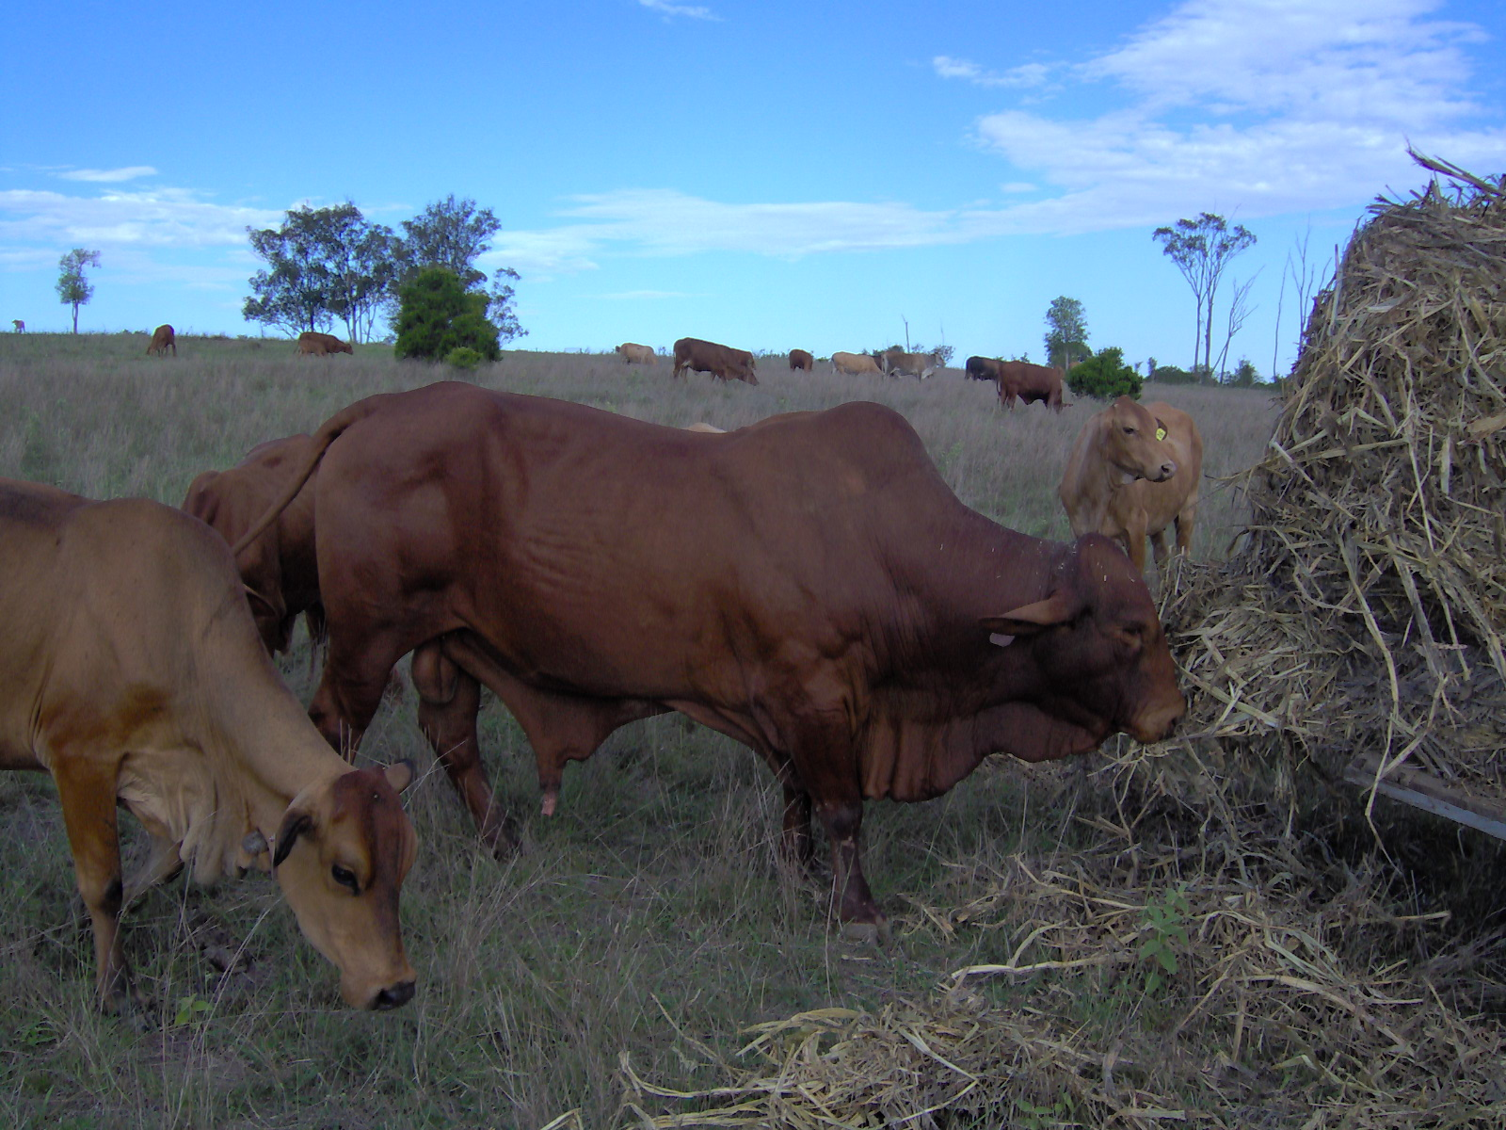
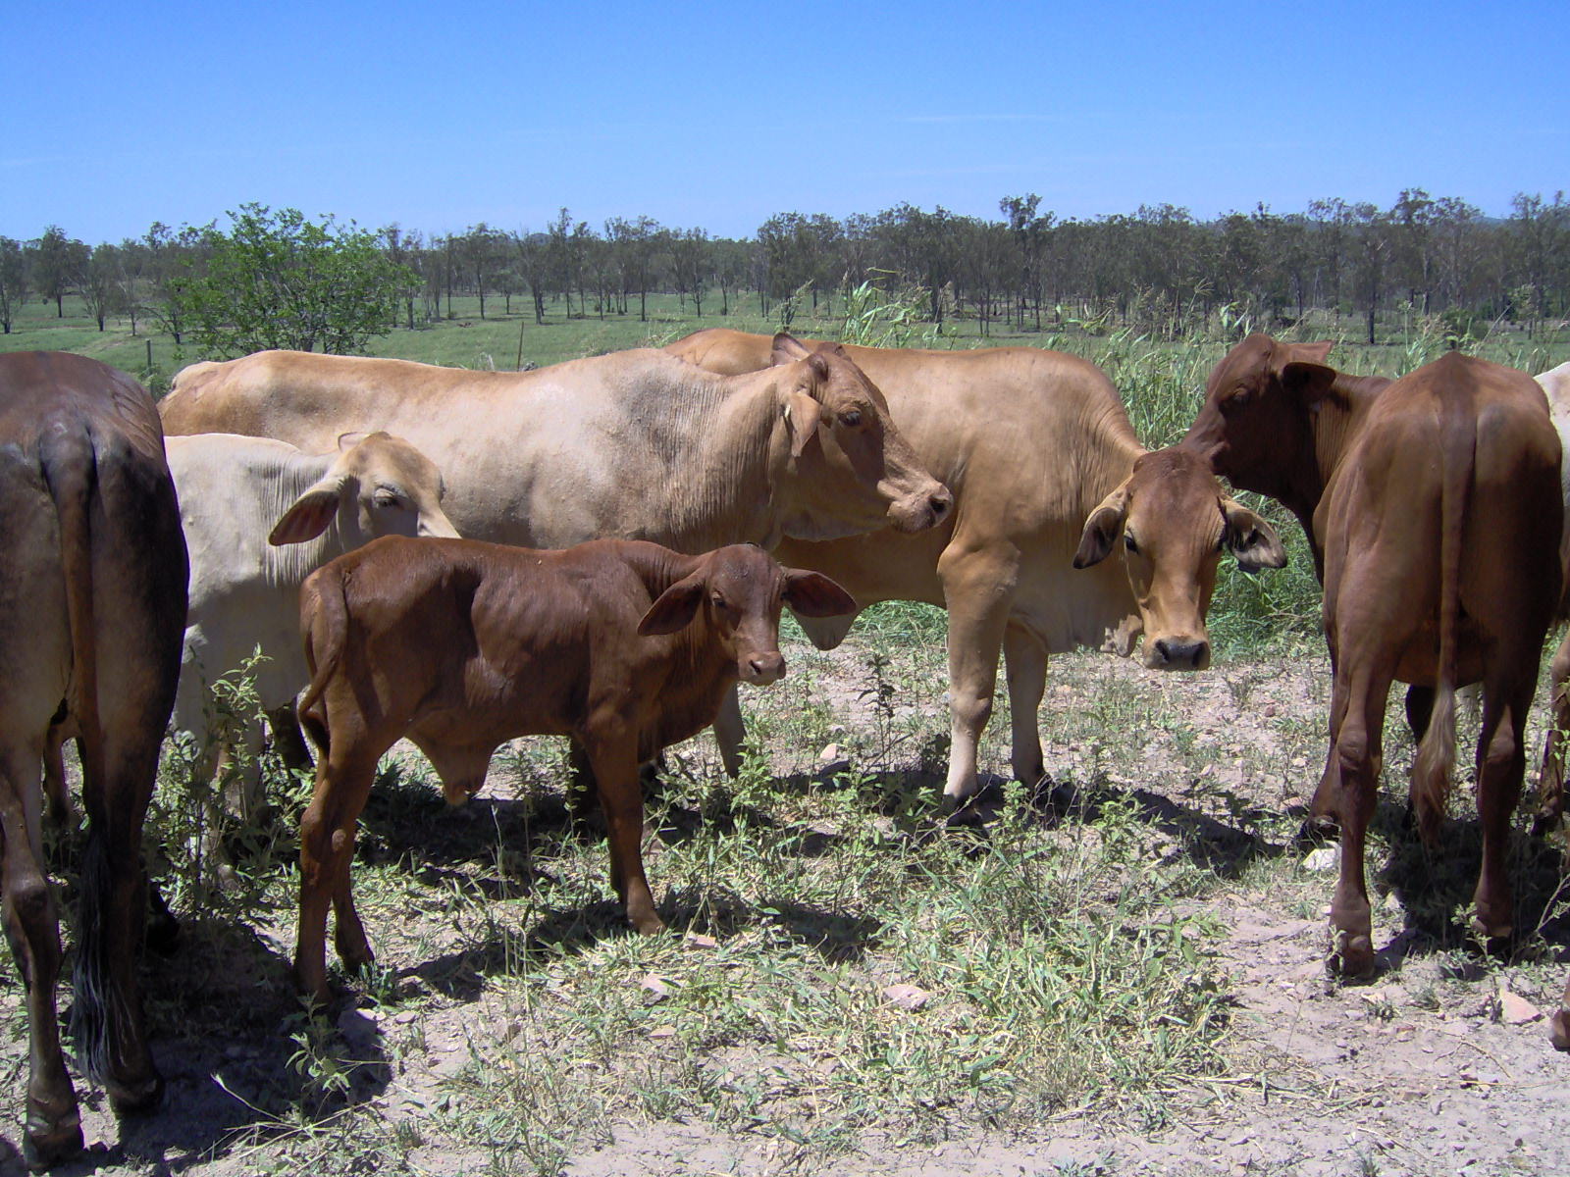
Mailing Address:  xxx  xxx  Telephone xxx | Property Address:  xxx  xxx  xxx

23rd March 2013

Major Project Development Assessment Processes,
Productivity Commission
Locked Bag 2
Collins Street East
MELBOURNE VIC 8003

Dear Productivity Commissioner

A small insight into my experiences as a cattle producer, with a holding of 225 hectares, affected by limestone mining at East End Mine, Mt Larcom, Queensland

I have found that to achieve a resolution of any issues takes a great deal of time and effort and the necessity to have access to information and support such as our landholders group - East End Mine Action Group Inc (EEMAG). I am currently the secretary of EEMAG.

Water monitoring by the mining company has been hit and miss which has allowed recordings to lapse and only for the fact that EEMAG members asked to see records, has some collection of this data been retained or continued to be collected.

In my experience I believe the EIS process is merely a furphy, seen to be done and then given automatic approval by Governments. This is due to the government allowing self regulation by Cement Australia’s East End mine which has left landholders to fend for themselves – a real David and Goliath situation. A famous quote by Harry S. Truman states “You don’t set a fox to watching the chickens just because he has a lot of experience in the hen house”.

Due to concerns about the future affects of mining in the area, the original landholders formed the Mt Larcom and District Mining Protest Group (my parents were members). This Group won the right to have the water monitoring program implemented when the East End Mine first started in the 1970s.

Loss of underground water was the big issue of concern identified by the original group of landholders, with the impending inception of the East End Mine.

My family’s property fell victim to this very predicament which has caused ongoing conflict with Cement Australia. No permanent replacement water supply, like my property’s defunct well, has ever been restored for my use.

Over the years, the trucking of water has been a “band-aid” solution for the depleted well, known as W33. The practice of trucking water has frequently failed, leaving the W33 tank dry, because the mining companies - Queensland Cement Limited (QCL) and subsequently Cement Australia were often negligent in trucking water to the tank. This practice has limited the supply of water provided by the mining company to one truck load every 3 weeks or so, to my well’s tank site and trough. Mr Arthur Murphy’s professional estimate, from having worked on Well 33 when he lined it with concrete pipes, was that W33 supplied 600 gallons per hour, without under or over estimation of the volume.

-2-

Calculation of this volume of water for 24 hours amounts to 14, 400 gallons. I provided this information to Mr Peter Hunt of AIS McCracken from which Mr Hunt determined that the amount that could be pumped within a 24 hour period, within reason, was 3,000 gallons. So I have been severely restricted with the loss of my underground water supply and not only that, I have also lost the control of my usage of my depleted underground water supply which has unjustly been taken away from me. This means I cannot run my farm to its potential and have been left to the devices of the mining company.

I have a letter written to my mother by QCL in 1996, where QCL admitted to injuriously affecting the underground water in W33 (copy of letter attached). The well was dry prior to 1996 and still is dry. There is an old 18th Century English Proverb which states “We never know the worth of water till the well is dry.”

The well was put down by my mother’s Uncle in 1927 (the original property owner) following a severe drought in 1926. Despite the many severe droughts after 1927, the well had never failed and was the only source of water for the property when the dams and waterholes went dry. This well had provided completely reliable water, diminishing as QCL’s mine, now Cement Australia’s, became progressively deeper and the mine reached sea level, and now, is below sea level.

The mining company’s attempt to drill replacement bores, in 1996, only found that they had to drill to a greater depth with the conductivity of the water found to be of high salinity, due to mining operations and totally unusable as a water supply for my cattle.

What mining has done to the district’s underground water is evidenced by the amount of water pumped from the mine pit. Mining operations directly caused the lowering of the water table, effectively drawing the underground stream which supplied our well with water, into the mine. Colin Dudgeon, the hydrologist, employed by QCL on the water monitoring program witnessed the depletion of the water in W33.

My right to have a reliable, permanent water supply at this particular position on my property still remains, however, has not been achieved. I have written a number of letters over the years to the different Mine Managers about the underground water loss problem. Also, I organised quotes from McCracken’s water services company to put in a pipeline from where the water is pumped from the mine through a corner of my property. Then, situations changed, as during drought time other affected landholders have requested pump back which would benefit them, this then made my proposal fall over. Changes of Mine Managers cause approaches and contacts to start all over again.

Trying to have a permanent water supply reinstated for my family’s property has been ongoing for over 20 years without correct and true resolution. Also should be noted, the loss of time, unpaid effort and worry involved with this ongoing problem which I have endured and the other problems caused by the mining company I have not mentioned at this point.

A good outcome for your study into Major Project Development processes, would be for the Productivity Commission to request that affected landholders be provided with case managers who can genuinely assist them and provide real support to see that mining companies do not ride roughshod over them as is currently allowed.

Also funding should be made available to landholders groups especially as these huge companies have unlimited funds to push their agenda.

Yours faithfully

Theresa Derrington
Cattle Producer

