Errata — Report on Government Services 2017
The following amendments were made to the 2017 Report since an earlier version.

Sector Overview D — Emergency management
The following data for 2015-16 have changed:
- ‘Labour costs, Total ambulance, fire and emergency service organisations’, for Tasmania and the Australian Capital Territory
- ‘Other costs, Total ambulance, fire and emergency service organisations’ for the Australian Capital Territory
- ‘Other expenses, Total ambulance, fire and emergency service organisations’ for Victoria, Western Australia, Tasmania, Australian Capital Territory, Northern Territory and Australia
- ‘Labour costs, FSO and SES’, for Tasmania
- ‘Other costs, FSO and SES’, for the Australian Capital Territory
- ‘Other expenses, FSO and SES’, for Victoria, Tasmania, Northern Territory and Australia
- ‘Other expenses, FSO’, for Tasmania.
The revised table is reproduced below.

Amended data in table DA.3
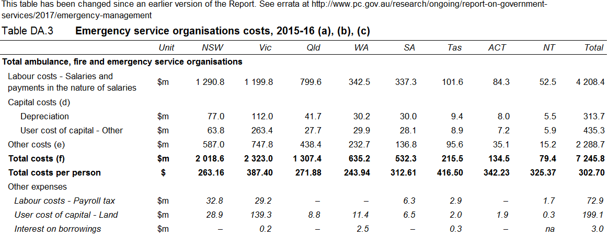
(continued next page)

Amended data in table DA.3 (continued)
