13 March 2015

Workplace Relations Inquiry
Productivity Commission
GPO Box 1428
CANBERRA CITY 2601
Via email: workplace.relations@pc.gov.au

Dear Sir Madam
Re: Workplace Relations Inquiry Submission
It is a fact that employment-related costs are most often the biggest single expense when doing business. It is also understood that providing a balance between wages and business profits is also necessary to maintain social cohesiveness and our egalitarian Australian lifestyle that most of us enjoy.
As a business sector membership organisation with 240 members, the Launceston Chamber of Commerce is pleased to provide some data from 84 businesses that responded to our questionnaire based around workplace issues for your inquiry’s consideration. We have also provided some strategic context to consider the results and comments from the survey.
Tasmania is a small sub-national peripheral economy with an aging population. Tasmania is also the only state where the population is set to decline during the period 2012 to 2101 according to projections by the Australian Bureau of Statistics. The factors are a mix of reducing natural growth (women of child-bearing age) as a result of younger people leaving the State for greater opportunities elsewhere; and attracting older interstate migrants that are exacerbating the overall national trend of an aging population.
A theme from discussion with businesses in specific sectors recently, is that flexibility is required to attract and retain skilled workers. If government is to reduce Penalty Rates in some or all sectors, there needs to be a countering opportunity to incentivise skilled people to work at times when they are needed, and meet the needs of that business/clientele.
Another theme that is referred to in the comments attached to this paper, is that Tasmanian businesses need a lower wage thresh-hold for young people to be employed on weekends, and on a casual basis so they can develop the skills they are lacking, and improve their capacity to gain fulltime employment.
It may also be appropriate to investigate options for different wage scales for employees working from home. The survey also includes concerns from employers regarding equitable processes to discontinue employment based on performance issues or job suitability.
The industry sectors that have been identified for growth in Northern Tasmania include: Hospitality and Tourism; Agriculture; and Health Services. All these sectors require flexibility of working hours; they also have times of peak demand and seasonality. These sectors again require the flexibility to offer incentives, and offer reasonable casual rates during peak times.
Some of the Key Results from the Survey are as follows:
- The majority of responses (62%) were from the retail and hospitality sectors (I would suggest due to the awareness and impact of penalty rates in those sectors).
- Interestingly other major organisations with issues around penalty rates included those in the health care sector which are required to operated 24/7 and use casual workers to meet peak demand.
- The majority (52%) responded from the CBD – and the remainder were distributed throughout the rest of the region.
- 80% of the firms responding operate on Weekends and/or Public Holidays – (however it was noted that doesn’t necessarily mean they work all available hours during these periods. It may just be Saturday mornings for example.)
- If penalty rates were either significantly reduced or abolished the firms that responded indicated there would be an additional 2094 work hours per week available – equivalent to 55 FTEs.
- If the responses are extrapolated for the retail and Hospitality sectors only, and multiply this by the number of firms in this sector within our region - this would equate to an additional 943 FTE jobs in our region. This reflects a significant increase in two major sectors that currently deliver approximately 10,400 jobs to our region.*
- 71 respondents indicated that on average they spend 11 hours per week on ‘red tape’ and compliance issues. For micro businesses of 4 employees or less, they spend over 3 hours per week on compliance. Take into account this data may be under-estimated as we have not specified how compliance is defined. Some of the onerous issues are highlighted in other comments.
- 74% of respondents (or 17 of the 23 that responded to this question) have had trouble employing people. Chefs were mentioned on a number of occasions and other specific skills.

There are also some excellent additional comments that are quoted from the questionnaire by employers. Please take into account that some of the comments may not be factually correct, but do indicate how difficult it is to keep up with all the workforce regulatory changes. If you have any queries the Chamber would be happy to provide additional information at the next stage of the review.
Yours sincerely,

Maree Tetlow
EXECUTIVE OFFICER
*Source: Latest REMPLAN data incorporating Australian Bureau of Statistics’ (ABS) June 2014 Gross State Product, 2009 / 2010 National Input Output Tables and 2011 Census Place of Work Employment Data.
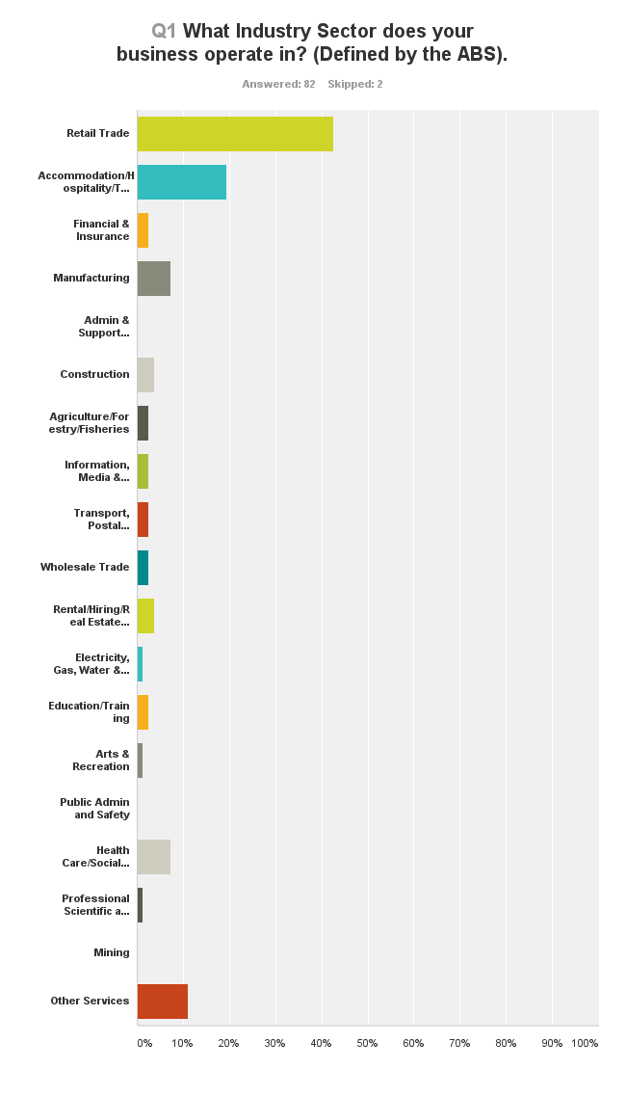
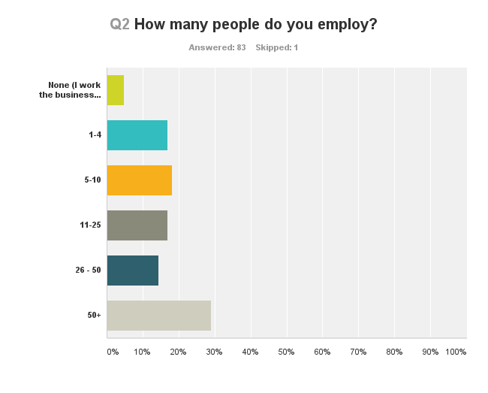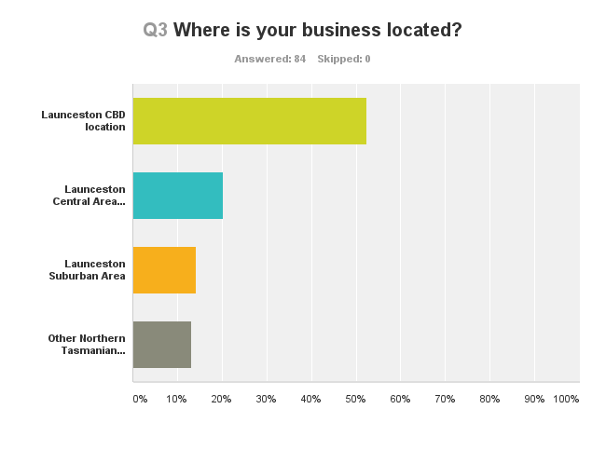
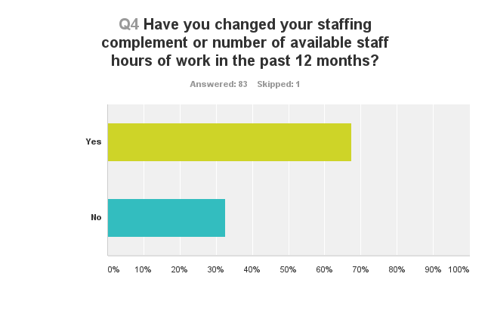
Of the specific 53 Responses to the number of staff hours that had changed over the past 12 months, the consolidated total indicated that there were negative 55 staff hours. However, the total doesn’t indicate the large swings for individual businesses within that total amount. Based on sectors, the Retail Sector was negatively impacted by -50 hours less staff time available, and in the Accommodation and Hospitality sector indicated -337.5 hours less staff time with some comments indicating that this was due to Penalty Rates impacts.
It is a concern to see this decline in the Accommodation/Hospitality Sector, which by all reports has done reasonably well over the past 12 months (+8%). Some of the potential outcomes from this result is that prices paid by consumers do not cover the costs of the labour required, so service levels may be in decline; that service hours have been reduced so the consumer is unable to access services to the same extent after regular business hours; or some of the services have been outsourced as part of managing the business model.
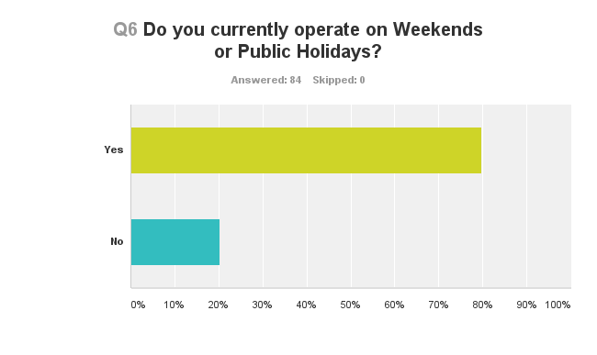Q7. If penalty rates were either significantly reduced or abolished would you consider operating on Weekends and/or Public Holidays or extending your operating hours on those days? (If yes, please provide an estimate of the additional staff hours on average per week you would consider offering. If no - leave blank.)
The total response was 2094.2 hours (equivalent to 55 FTE’s) and on average an additional 25 additional staff hours per business.
If we consider the Retail and Accommodation/Hospitality sectors only, they responded with an additional 1256.5 hours or additional 25.6 staff hours per business. If we extrapolated this to the 1369 retail and accommodation/tourism businesses in our region this may deliver an additional 943 FTEs. This reflects a big increase on two major sectors that currently deliver approximately 10,400 jobs to our region.*
Q8. If you employ people, can you advise us of how many hours you (or your business) spend on red tape and the compliance obligations of employing people on average per week in your business?
For 1-4 employee business = average of 3 hours per week
For 5-10 employee sized businesses = average of 6.75 hours per week
For 11-25 employee sized business = 8 hours per week
For 26 – 50 employee sized business = 14.7 hours per week
For 50+ employee sized business = 20.7 hours per week
*Source: Latest REMPLAN data incorporating Australian Bureau of Statistics’ (ABS) June 2014 Gross State Product, 2009 / 2010 National Input Output Tables and 2011 Census Place of Work Employment Data.
Q9 and Q10 relates to State Payroll Tax which we will raise directly with the Tasmanian Government.

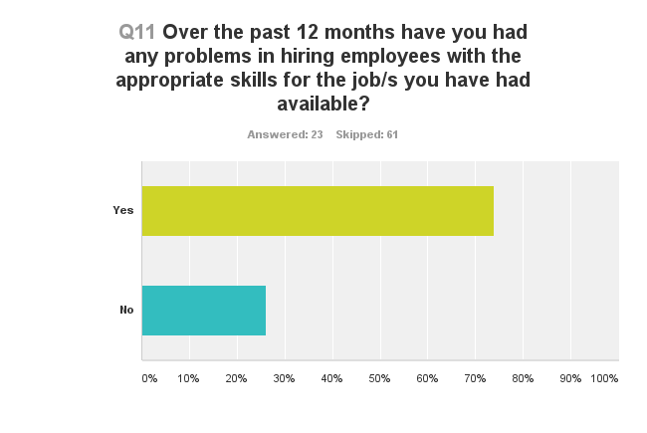Specific Comments:
- Additional contract labour used for shift work not up to our standard
- Skilled base roles - chefs, table gaming staff, management positions
- Willingness to work weekends, the lack of skills required and the lack of enthusiasm to learn additional skills.
- Qualifications and experience
- Accounting skills, financial planning and stockbroking skills, finding attentive, diligent, productive, reliable administration staff
- Diesel Motor Mechanics (Been an issue for 15 years)
- Warehousing, hospitality
- Basic customer service skills
- Motivation and sales ability in the local market
- Any fully skilled front of house and kitchen staff - we usually have to do the training ourselves
- Apprentice chefs
- Professional chefs and service persons
- Engineering/skilled construction plant operators, hospitality mgt
- Employed an intelligent junior with great grades, but very little common sense. The basics (i.e. cleaning, respect for seniors etc very lacking these days)
- chefs, sales, service staff

Q12. Other issues to raise with the Productivity Commission regarding Workplace Regulation. Specific Comments:
- Employees should be made to contribute to their own retirement super plans to match the employers’ contribution.

- As there is no longer a retirement age, does that mean every employee gets a redundancy regardless of whether the position is redundant?

- You have to hire someone for a minimum of consecutive 4 hours. Catering to all the breaks entitlements are hard in a small business, so you have to have staff to cover these, but you then have to have someone for a minimum of 4 hours.

- We offer no penalties (other than public holidays) as per our EBA from year 2000. Staff are used to it and it rarely is a problem. Having said that we did need to raise our base rate for all staff, spreading the rates over the week, instead of weekends. Common in the entertainment industry, and should be common practise in any business that operates outside "business" hours. Business hours have become very different from those of the past and needs to be reflected in modern society and pay rates. To work all people need to take time away from their families, friends and social calendar. Nights and weekends are no different to week days. I support abolishing, or at least reducing penalty rates.

- Reducing penalty rates would increase the hiring of staff and aid in having appropriate choices on weekends for locals and visitors alike in regards to the hospitality industry.

- Cut the red tape for terminating an employee, I employ my staff on a full time basis, but I feel like I'm doing myself no favours doing it. Can’t we have the right to terminate someone without being sued- does it have to be such a risk to employ full time?

- Staffing on-costs are ridiculously high. As a small business owner I work 12 - 15 hours 5 days per week, and 8 hours on a Saturday, as well as some Sundays to keep up with the work load as I cannot afford to employ additional staff. I would love to have another fulltime staff member but it is not JUST the cost of wages it is everything else that adds to it (i.e. taxes, superannuation, holiday pays etc) that makes it unaffordable.

- The on costs of the Superannuation Guarantee and its compliance. A wage bill of $2000 per week adds $200 + or over $10,000 per annum. I can employ 2 extra casuals for that.

- The ability to make sure you have the right staff, once staff are employed it is very hard to do anything with the ‘under-achievers’, for example training can still not change a personality/attitude.

- Workers Compensation in Tasmania is a joke - two year time-frame before you can settle or move on. Can be very costly for a small business. Finance industry traditionally was not covered by an award until 2010, with 8.30 to 5.30 working hours. That now dictates a sizeable overtime bill on a weekly basis for professional staff - so the award structure is putting up costs, plus additional red tape is cutting back time available for client centred work, which increases the per hour cost of advice up dramatically.

- Businesses now not only have to deal with Unions, but also Fair Work Australia. Where they try and bleed businesses to pay ‘going away $$$$’.

- We are 24/7 365 days per year Disability Support Organisation and yet we have operating hours 7am to 6pm and the rest get penalty rates of some kind limiting care and employment.

- The high penalty rates for casuals mean that they are expensive to use, therefore forcing you to employ more permanent part-time people, but you lose the flexibility needed for your business. Several years ago the retail award was amended and the levels were reclassified i.e. a level 1 was abolished and the level 2 became a level 1. This made it more expensive to employ a young (adult) person with no experience, huge disincentive to this category. The descriptions on award rates are not specific enough between the levels and the hourly rates do not vary very much. e.g. If you put an employee from a Retail Assistant Level 3 to a Level 4, they almost laugh at you as it is only a matter of cents per hour. The descriptions for the levels change by stealth, you think you were paying someone at the correct level for their duties, then check 18 months later and find it is not enough. There needs to be some sort of relief to enable business' (especially small to medium) to ensure they have enough resources to comply with the burden of compliance, not just Workplace Relations but Workplace Health and Safety as well.

- Flexibility and ability to individually negotiate mutually beneficial working arrangements.

- The Superannuation minimum of $420.00 per month should be increased!

- Can we have more personal communication please?

- The impediment to employing more people is associated with complying with all the IR laws. The increase of wages for apprentices, especially adult apprentices and imposure of study costs on employers is prohibitive to employing staff. A training wage was meant to reflect the time employers spent training. Because we would have to pay 80% of a qualified persons rate of pay for a first year adult apprentice as well as pay their school costs we cannot afford to employ an apprentice. The biggest issue we have is that young people are not job ready. For our type of work in the baking industry. We only see applicants who have poor literacy and numeracy skills, have a poor work ethic, don't like to work early mornings or week-ends.

- Minimum pay rate is high for a small business in retail in the current economy for employees under age 21. Also minimum shift reduction as many students and university students need to work around timetables and it makes it difficult for a business to give them minimum shift of 3 hours if they can only work 2 hours after school. Keeping in mind many businesses close at 5.30pm.

- Help small business by lower income taxes and abolish this stupid penalty rate system where an 18 year old unskilled Uni Student gets paid twice as much as their boss per hour.

- More flexibility would be excellent.

- A flat rate for the industry with a limit of 38-40 hours per week per employee with penalty rates to kick in after these hours are reached is a much more sensible way to deal with wages and then those who are committed industry professionals will get the benefits of any extra hours, not the casuals and second jobbers who can only work on the weekends who now benefit from the system, blatantly unfair on our key staff.

- A return to the more flexible workplace agreements during previous Coalition Government.

- So many laws and rights for employees but it is difficult as an employer to know what they all are and to keep within the law. To deal with an underproductive employee we invest in an HR consultant at great expense to our small business. We have a huge problem with corporate bullying of our small business but feel unable to address it as we then lose our role in the labour market.

- Unemployment, underemployment and job creation; productivity; Lifeless economic conditions

- Our Award (Health Professionals and Support Services) has minimum of 3 hours people can be called in to work. However a number of our staff currently work from home and arrange client appointments themselves - in the client's home, workplace or school, following the initial request to us by the client. Some staff only want to work 1-2 hours per session, as this suits their childcare arrangements. Therefore I am limited by the Award about employing them for these jobs, and the business cannot afford to pay extra for time not worked. In an area of shortage (occupational therapists) there needs to be more flexibility to suit both staff and employer.

- Public Holiday rates are far too high to be able to provide an adequate staffing level and still make money. It was a good decision making Sunday rates the same as Saturday for casual employees...this needs to be the same for fulltime employees.

- Penalty rates are strangling my business, there are no winners as we simply have to close and not offer any work during high penalty times, also has a negative impact on tourism experience.

- Some staff prefer family friendly flexibility rather than penalty rates and small business owners need a break but cannot afford Sunday penalty rates and therefore close.

- Would be good to have some clarity on casual versus PPT ... and to be able to give employees ability to opt in and out... IFA's are available, but not tried and tested.

- Until there is more flexibility for both employers and employees with penalty rates and weekends/public holidays, employees will continue to miss out on extra hours and business owners will become 'burnt out' and industries will lose experienced business owners who can add value not just to their business and community, but to organisations such as local Chambers, Newsagency groups etc. 80% of our staff would prefer Sunday and Public holidays as they don’t have to rely on family to babysit, the father/partner can.

- Inability to easily implement workplace agreements. Personal/Carers Leave exploited by Staff due to the broad definition. Super + Workers Comp + Payroll Tax = 20% On Costs.

- Penalty rates place a severe and restrictive limitation on increased employment.

- A significant amount of time is spent by the management group in dealing with industrial conflict matters. Working cooperatively with the Maritime Union to achieve constructive outcomes is at best very challenging.

- Award inflexibility around part time employees.

- The recent award change in our industry (Real Estate) includes a rate for car use and mobile phone use which in effect costs a $1000 per week when in our industry we do not recuperate money from commissions for 1-2 years after commencing. We cannot now take risks in employing salespeople and can only trial for 90 days where as we previously allowed 12 months.

- The current system is too pro- employee.

