Productivity Commission Issues Paper
Barriers to Services Exports
Submission by
The Independent Schools Council of Australia (ISCA)

Introduction: About ISCA
The Independent Schools Council of Australia (ISCA) is the peak national body covering the Independent schools sector. It comprises the eight State and Territory Associations of Independent Schools. Through these Associations, ISCA represents a sector with nearly 1,080 schools and 567,000 students, accounting for nearly 16 per cent of Australian school enrolments.
Independent schools are a diverse group of non-government schools serving a range of different communities. Many Independent schools provide a religious or values-based education. Others promote a particular educational philosophy or interpretation of mainstream education. Independent schools include:
- Schools affiliated with larger and smaller Christian denominations for example, Anglican, Catholic, Greek Orthodox, Lutheran, Uniting Church, Seventh Day Adventist and Presbyterian schools
- Non-denominational Christian schools
- Islamic schools
- Jewish schools
- Montessori schools
- Rudolf Steiner schools
- Schools constituted under specific Acts of Parliament, such as grammar schools in some states
- Community schools
- Indigenous community schools
- Schools that specialise in meeting the needs of students with disabilities
- Schools that cater for students at severe educational risk due to a range of social/emotional/behavioural and other risk factors.
Independent schools are not-for-profit institutions founded by religious or other groups in the community and are registered with the relevant state or territory education authority. Most Independent schools are set up and governed independently on an individual school basis. However, some Independent schools with common aims and educational philosophies are governed and administered as systems, for example the Lutheran systems. Systemic schools account for 18 per cent of schools in the Independent sector. Independent Catholic schools are a significant part of the sector, accounting for 8 per cent of the Independent sector’s enrolments.

Overview
ISCA welcomes the opportunity to make a submission to the Productivity Commission regarding the Issues Paper – Barriers to Services Exports. There is significant activity being undertaken in this arena currently. At this point in time
- the Commonwealth Department of Education and Training is reviewing the ESOS Act and associated regulatory framework,
- the Commonwealth Department of Immigration and Border Protection has undertaken a review of Streamlined visa Processing,
- the Draft National Strategy for International Education has been launched by Minister Pyne with consultations beginning shortly, and
- Austrade has commenced work on the AIE 2025 initiative, with the intention of significantly expanding Australia’s engagement in international education, both on and off-shore.
It is imperative that any moves to grow the international education industry, both on and off-shore, are suitable, simple and implementable. The identification of barriers, as this paper is intended to do, has great potential to assist in this process and to accurately and effectively target any proposed actions by government.
In order to address to questions posed by the Issues Paper, this submission will contextualise the place of non-government schools within the international education industry. We will then examine each of the barriers identified as hindering the non-government schools sector’s efforts to increase provision of education services. As the non-government school sector’s contribution to services exports is almost entirely through on-shore provision, this will be our focus but we will also provide some comments regarding off-shore provision.

Non-government schools and international education
Approximately 30% of all overseas students enrolled in the schools sector in Australia attend Independent schools. In 2014 there were some 5,700 overseas students enrolled at close to 340 Independent schools. ISCA estimates between 30-40% of all CRICOS registered providers in Australia are Independent schools that are individually registered and individually responsible for meeting compliance requirements. Catholic systemic schools enrol a further 10% of overseas students giving the non-government sector 40% of the overall school-level overseas student enrolments. Some schools also have ELICOS centres attached to their institutions which may also be separately registered on CRICOS.
By contrast, state departments of education (enrolling approximately 60% of overseas school students overall) hold single provider registrations covering any number of state schools enrolling overseas students within a state.
Overseas student enrolments in Independent schools vary from 1 to close to 200 overseas students. The median number of overseas students at an Independent school is 7 students.
This profile differs quite substantially from other sectors. For the vast majority of Independent schools, overseas students do not determine the school’s sustainability. Rather, overseas students provide a much valued international element and diversity to school populations.
Since 2008, declines in overseas student enrolments in the schools sector have been most significant in non-government schools. In 2013 enrolments in the government schools sector grew for the first time in 4 years and continue to recover. However non-government school sector enrolments were still declining in 2014.
Change in overseas student enrolments in the schools sector 2006-07 to 2013-14
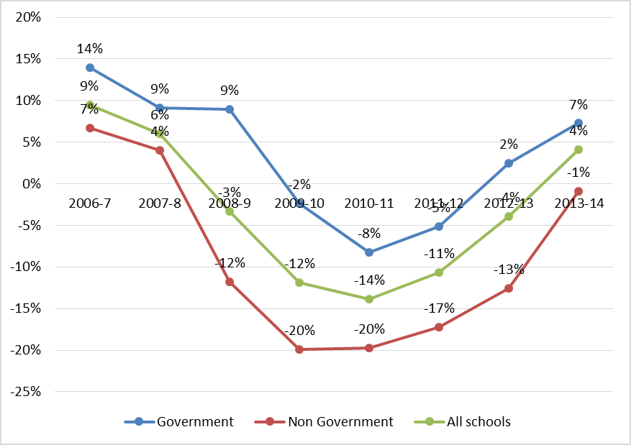
There were a range of reasons for the decline in the schools sector. Schools were caught up in the adverse media coverage overseas which focused on the private VET sector some years ago, and other factors commonly reported as influencing the rapid decline of overseas school student enrolments have been the continuing strength of the Australian dollar, and the relative ease of being granted visas to study in competitor countries.
As noted above, non-government schools have a significantly different overseas student enrolment profile to that of the other education sectors. We have large numbers of CRICOS registered providers with relatively small numbers of students in each school. The enrolment of overseas students is therefore not a question of financial viability. Rather it is one of choice. Our schools choose to engage in this arena for a variety of reasons, but always for the cultural and educational benefits to the school community and its members.
However, school level enrolments of international students provide an important element of internationalisation for many schools and are a significant part of the cultural landscape of many schools. Further, they are a valuable pipeline for higher education institutions providing tertiary applicants who already have years’ experience in the Australian education system and in living in Australia.

Domestic Barriers

Complex regulatory framework
As noted above, the Commonwealth Department of Education and Training is currently reviewing the ESOS Act and associated regulatory framework. Changes made to the ESOS Act and associated framework since the Baird Review in in 2010 have meant that the government and non-government schools sectors are no longer treated as having the same level of risk, resulting in additional fees and charges (which are not incurred by government schools) and an increase in administrative burden and reporting which individual Independent schools are not able to resource on a systemic level as the government sector is able to do.
Further, The Department has yet to provide a compelling basis for the differential treatment between the two sectors of schooling, placing the non-government sector at a competitive disadvantage.
In ISCA’s first submission to the Review in May 2014, ISCA noted that
“…it is quite clear that it is the view of schools that there is significant overlap between domestic regulation and the ESOS framework. There is also a strong view that it is not understood that schools’ primary role is in the education of children and for this reason, they are not only subject to a range of other important legislation relating to child protection but that they, more than any other sector, have experience in caring for the well-being of under-18 year old students. Schools believe that this should be acknowledged, rather than be viewed as a ‘risk’.”
ISCA believes that there would be significant benefit in the greater use of existing state and territory domestic registration and regulatory frameworks for quality assurance purposes and focussing on ESOS-specific requirements to reduce unnecessary duplication for the schools sector. For example, in the schools sector, most of the requirements for the National Code Part D Standards 9-12 are met by internal school policies and procedures.
Also in ISCA’s submission to the review in May 2014, ISCA noted that feedback from the sector is that the current level of administration and reporting required is acting as a disincentive for non-government school providers to continue to enrol overseas students. Some state and territory Associations of Independent Schools have reported that they are aware of schools that have let CRICOS registration lapse as a consequence. Because the profile of overseas students in the non-government schools sector is very different to other sectors, with most schools enrolling relatively small numbers of overseas students, the current regulatory environment creates a disproportionate workload on schools with limited administrative resources.
ISCA is concerned that after the CRICOS registration renewal process currently underway (i.e., for institutions that had to be re-registered by the end of 2010) is completed, there will be significantly fewer CRICOS registered non-government schools as a consequence of the onerous regulatory approach taken in the past five years. Increased operating costs for schools

Annual Registration Charge (ARC) calculation methodology
The revision of the ARC methodology in 2011 which increased the flat rate component and decreased the per-student component disproportionately impacted on the non-government school sector while at the same time resulting in lower fees for institutions enrolling larger numbers of students. For example, the government schools sector is now contributing a third less to overall ARC funds than pre-TPS, whilst the overall contribution of the non-government schools sector has doubled.
ISCA calculations show that in every scenario, schools with small numbers of overseas students have been financially disadvantaged. Schools with 13 or fewer overseas students are paying at least double what they were paying previously in annual registration charges. A non-government school with only one course registered would have to have at least 50 overseas students enrolled in a year to benefit from a reduction in the annual registration charge. Schools with fewer than 50 overseas students make up 87% of the total number of CRICOS registered Independent schools. This increased cost to non-government schools is mostly attributable to the introduction of the much higher ‘flat fee’ of $1,300.
Using TPS figures for 2015 ARC for the each sector, ISCA calculates that non-government schools are contributing 12% of the total ARC income whilst enrolling 1% of international students. (See Attachment 1.)
With ARC income going to the commonwealth, and schools coming primarily under the jurisdiction of the state and territory regulatory designated authorities, it has never been satisfactorily explained how the $2 million raised from the non-government schools sector by the ARC is being used by the ESOS regulator to enhance compliance in the sector.

Entry to Market Charge
In addition to the rebasing of the ARC, the Department of Education and Training introduced a $15,000 Entry to Market charge for any provider, regardless of sector. This is a particular concern for the non-government school sector which is typified by
- Small cohorts of international students on-shore
- Schools which have been in operation for many years, prior to obtaining CRICOS registration.
It is ISCA’s contention that this charge not only acts as a disincentive for schools to become CRICOS registered, but also stops schools which may have once had CRICOS registration, re-engaging in this area of activity.
In our submission to the ESOS Review Discussion Paper in October 2014, ISCA supported the recommendation that providers with an appropriate history of education provision and CRICOS registration, and no adverse compliance record be exempt from the Entry to Market Charge.
However, we also regard this charge as inappropriate for institutions which may be seeking to enrol only very small numbers of overseas students at any one time. It also ignores that fact that in the non-government schools sector, schools generally become CRICOS registered once they have been in operation and enrolling domestic students for some time.
The flat rate does not recognise or allow for the diversity of provider that exists within the industry.

Tuition Protection Scheme Levy
Recent calculations undertaken by the TPS secretariat which were presented publicly as part of the 2015 Provider Information Sessions show that of all the sectors, following the rebasing of the ARC and the introduction of the TPS, the non-government school sector is the only sector which is paying more in fees and charges merely to provide education service to overseas students on-shore. Using the TPS current calculations of combined ARC and TPS charges for 2015 for each sector, and YTD PRISMS Enrolment data for 2014, ISCA calculates that non-government schools are contributing 10% of the total amount levied on industry for ARC and TPS charges, whilst enrolling 1% of international students. (See Attachment 1). This is despite a low risk profile, particularly in comparison to some other sectors. How can this not be a barrier to export of services?
It is ISCA’s view that given the sector’s previous exemption from the financial requirements of the ESOS Act, and the sector’s overall good risk ratings, that the non-government schools sector should at least be treated in the same way as the government schools sector i.e. exempt from paying the risk component of the TPS levy.
Overall, the disproportionate combined impost of the ARC and TPS on the sector should be reduced to a more equitable level.

Visa arrangements

Streamlined visa processing (SVP)
In ISCA’s response to the DIBP Discussion Paper Future Directions for Streamlined Visa Processing, it was noted that
“…the SVP model is quite narrowly focused and is entirely unsuitable for roll-out across all providers and sectors. Indeed, the threshold requirements are such that most schools would never be eligible to participate, whether or not they had the resources to do so.

Despite the best intentions, by differentiating between providers and sectors in this way, DIBP has created an ‘un-level playing field’ in the international education industry. This comes at a time when many non-government schools are struggling to maintain their involvement in international education and ISCA is concerned that the unique role of overseas students in the non-government schools sector is in danger of disappearing altogether.”
While ISCA does not regard SVP as suitable for the schools sector, it is our view that some form of streamlined visa processing should be made available to all providers and sectors. This will encourage continued growth in what is one of Australia’s largest export industries and largest service industry.
ISCA supports the Productivity Commission’s IES report’s recommendations to consider an “alternative” approach to managing a student visa program that “would entail an integrated risk framework that incorporates education provider quality risk – the risk that a provider would not offer an international student a quality learning experience” with the DIBP proposal to combine “country of citizenship immigration risk with provider immigration risk”, as well as “enhanced coordination between the DIBP and the Department of Education and Training to ensure a consistent approach to IES policy form a whole-of-government perspective”.
However, because the Productivity Commission chose to focus on institutions regulated by TEQSA and ASQA in its IES research report, not explicitly include the school sector in its research findings, ISCA would like to be re-assured that school sector peak bodies are included in consultations any changes to ESOS regulatory requirements or student visa changes
For example, ISCA would view the Productivity Commission’s proposal for “publicly available information on the comparative quality ranking of providers in order to assist domestic and international students to make informed decisions about provider choice” with some concern if this meant providing more information on school sector outcomes than is currently available on the My School website and in school annual reports. ISCA would argue that unlike providers regulated by TEQSA and ASQA, highly regulated domestic accreditation frameworks and very detailed publically available sources of data for school providers, are already in place.

Visa costs
Australia’s student visa costs continue to be higher than those of our main competitors such as Canada and the US, and are widely regarded as un-competitive. Further, the sudden and unwarranted increase in the cost of the Subsequent Temporary Application Charge (STAC) in 2013, is seen by the industry as a revenue raising measure which acts as a disincentive to students wishing to continue studying in Australia past a certain point.
ISCA is concerned about the potential of the high cost of the STAC to discourage the lowest risk students from continuing or extending their studies in Australian institutions. As ISCA noted in our submission to the Joint Review of Border Fees, Charges and Taxes;
“As school courses (from K-12) can exceed the 5 year limit of a student visa, it is entirely possible very young students will need to apply for a visa extension in order to complete school level studies even within the one school.

There is also the scenario of a student who has applied for their first or subsequent 571 subclass visa from onshore completing school sector studies then wishing to continue studies in Australia at a tertiary level. In this case, the student will need to apply for a further student visa from offshore if he/she wishes to avoid paying the STAC of AUD $700 (in addition to the visa charge of AUD $535) for their further studies. This seems an unreasonable penalty to apply to a genuine, low risk student who has already made a significant investment in an Australian school education, and who continues to choose Australia as a quality study destination.

It also seems counter-productive to penalise an application for further studies from such a student from onshore in this way, when 571 subclass visa holders who are over 18 years on completion of school sector studies are automatically granted a visa until 15 March of the following year – specifically in recognition of timelines associated with tertiary admissions applications and to facilitate processes for enrolment in further studies.”

It is ISCA’s view that the “STAC should not apply to students completing a course of studies and seeking to enrol in higher level studies.”

Visa applications
ISCA has previously requested, via the Education Visa Consultative Committee (EVCC), that the DIBP review application processes for students under 18 years of age applying for a student visa to ensure there any barriers to applying online are minimised, i.e., that e-Visa arrangements for under 18s are as similar as possible to those for over 18s.

Export assistance schemes
The majority of schools in the non-government school sector have a religious affiliation. While many are incorporated entities, some are not. This has proven to be an on-going barrier for these schools in terms of accessing Austrade Export Market Development Grants (EMDG).
The most recent advice ISCA has received from Austrade stated that the reasons for ineligibility for these schools is that they are ‘unable to satisfy Section 6 of the EMDG Act as they are not incorporated entities. They are rolled up into the archdioceses corporation, and therefore not the principal and also unable to meet Section 37 of the EMDG Act’.
This means that a large number of non-government schools are ineligible for EMDG grants which are an important source of funding for institutions in other sectors that might be seeking to expand their offerings.
With regard to other possible export assistance schemes, ISCA would like to support the Productivity Commission’s suggestion “There may also be merit in taking a coordinated approach to international student outreach and marketing — particularly for institutions where scale is an issue — such as through peak organisations and informal partnerships.”
As most non-government schools are individually responsible for their own student marketing and recruitment activities, ISCA would welcome a greater range of options for marketing assistance that could be accessed by non-government schools.

Investment Barriers
ISCA would just like to note that while we are aware of the constraints on the provision of student accommodation facing the industry as a whole, in the non-government schools sector, most students are either living with parents or suitable relatives, or in homestay or boarding school accommodation arranged by the school.

Other Barriers
There is currently not a large amount of off-shore provision of international education in the non-government schools sector, partly because of issues related to licensing of curriculum. At the secondary level particularly, licensing of curriculum is not an option available to non-government schools as they do not hold the copyright for the curriculum. This is generally held by the Board of Studies or equivalent body in each state or territory.
One of the major elements of Austrade’s AIE 2025 Strategy is to significantly increase the quantum and type of off-shore provision of international education however, how this would best be suited to non-government schools will be an evolving discussion.

What’s at risk?
If the kinds of barriers identified in this and numerous other submissions of this kind made by ISCA over the last five years are not addressed, reduced or removed, the risk is non-government schools will stop enrolling international students on student visas. While this will not make a huge difference to Australia’s bottom line, it will have a large impact on school communities, diversity in schools, the lives of international students who successfully complete school level studies in Australia and the contribution non-government schools can make as a study pathway to other sectors.
Non-government schools do a great job of educating young people. They are low risk providers. A large number of them enrol relative small numbers of international students (compared with other sectors), and as a sector, they are often neglected in what has been until now a “one-size fits all” approach.
Non-government schools carry a very large regulatory burden – in most cases individually. It is in everyone’s interests to free up the resources of these schools to do what they do best - deliver high quality education services to all students, regardless of their country of origin - rather than exhaust resources on compliance and red tape, and make it too hard for them to recruit students and participate in this “industry”.
The focus of a good regulatory regime should be on providing high quality student experiences, learning outcomes, and welfare and pastoral care programs, rather than creating an environment where school staff live in fear of failure of having every box in every administrative checklist ticked, and every administrative deadline met.
ISCA is hopeful that the myriad international education reviews being undertaken will at some point deliver relief to non-government schools from regulatory overload and allow them to be active participants in the next iteration of international education services in Australia.

Independent Schools Council of Australia
25 May 2015

Attachment 1.
- Extract from TPS Levy 2015 – Information Sessions Presentation (available at https://tps.gov.au/StaticContent/Get/News#article-809c423d-57e1-49f7-a1d7-4786937a64c6)
- Table 1: % share of ARC + TPS contributions and ARC only by sector
- Figure 1: Sector YTD Enrolments 2014
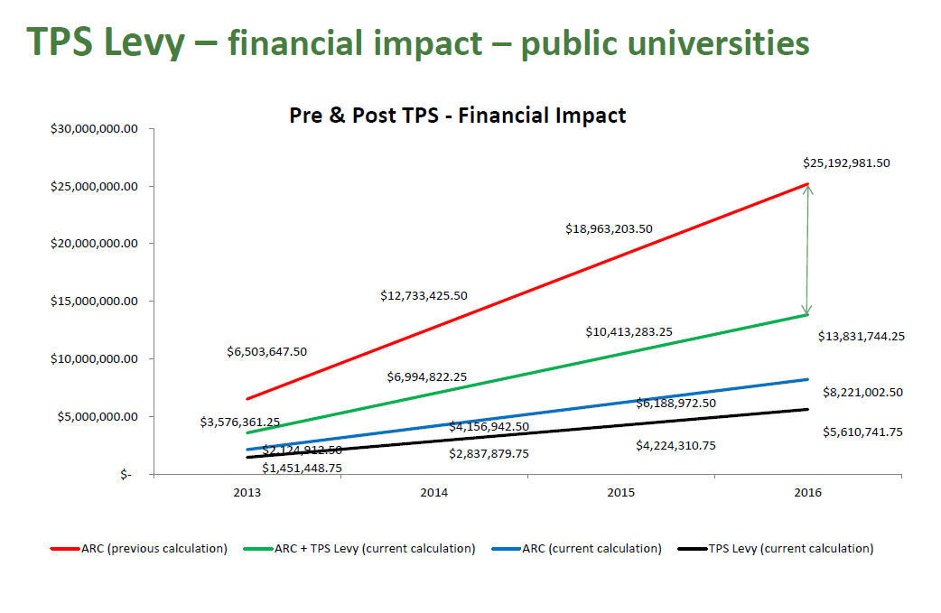
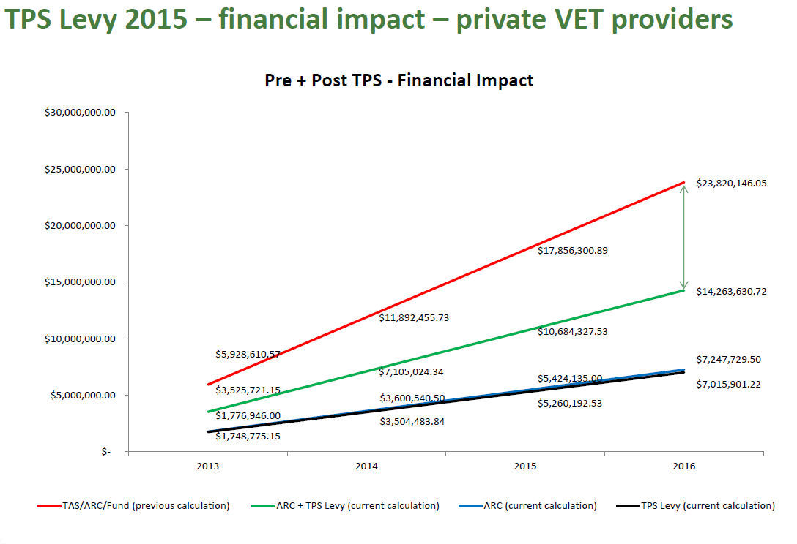
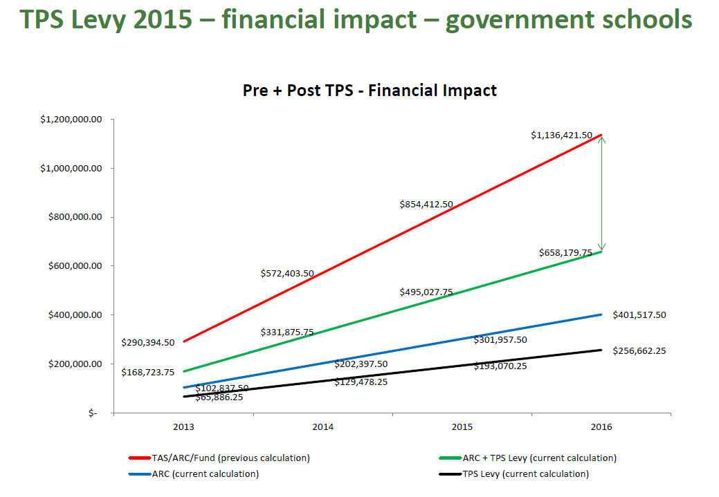

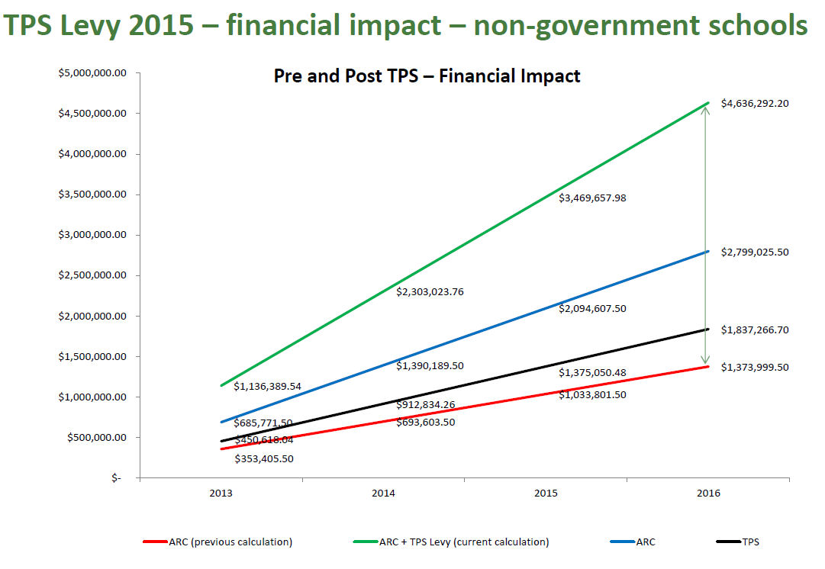

Table 1: % share of ARC + TPS contributions and ARC only by sector
SECTOR | ARC+ TPS calculation 2015 | % share | ARC calculation 2015 | % share
Non-Govt Schools | $3,469,657.98 | 10% | $2,094,607.50 | 12%
Govt Schools | $495,027.75 | 1% | $301,957.50 | 2%
Private - VET | $10,684,327.53 | 32% | $5,424,135.00 | 31%
ELICOS | $3,248,198.49 | 10% | $1,168,990.00 | 7%
TAFE | $894,560.75 | 3% | $552,047.50 | 3%
Private - Higher Education | $4,336,578.67 | 13% | $1,510,631.00 | 9%
Public - Higher Education | $10,413,283.25 | 31% | $6,188,972.50 | 36%
TOTAL | $33,541,634.42 | 100% | $17,241,341.00 | 100%

Source: 2015 data from TPS tables (above)
Figure 1: Sector YTD Enrolments 2014
- Total YTD Enrolments 589,860
- Non-Government Schools Enrolments 6,796 (1%)
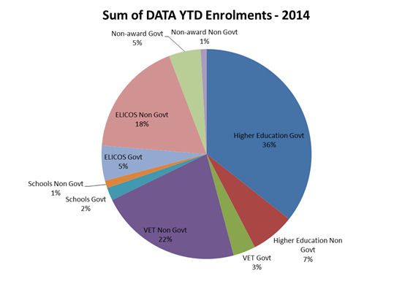
Source: Department of Education and Training PRISMS data

On matters of international education, ISCA also represents the National Catholic Education Commission, thus representing the views of the whole non-government school sector.
ISCA Submission Review of the Education Services for Overseas Students (ESOS) Framework (May 2014) p.8
ISCA Submission Review of the Education Services for Overseas Students (ESOS) Framework (May 2014) p.10
The exemption was only in place for non-government schools in receipt of Commonwealth general recurrent grants
ISCA Submission Future Directions for Streamlined Visa Processing (December 2014) p.7
Productivity Commission Research paper International Education Services April 2015 p.130 (http://www.pc.gov.au/research/completed/international-education/international-education.pdf)
Productivity Commission Research paper International Education Services April 2015 p.125 (http://www.pc.gov.au/research/completed/international-education/international-education.pdf)
Productivity Commission Research paper International Education Services April 2015 p.2 (http://www.pc.gov.au/research/completed/international-education/international-education.pdf)
ISCA Submission Future Directions for Streamlined Visa Processing (December 2014) p.11
Productivity Commission Research paper International Education Services April 2015 p.147 (http://www.pc.gov.au/research/completed/international-education/international-education.pdf)

