Written submission to the Transitioning Regional Economies Initial Report of the Productivity Commission (April 2017)
A/Prof Martie-Louise Verreynne
A/Prof John Steen
Andrew Garnett
The University of Queensland

Introduction
We are responding to your invitation to provide feedback on the Transitioning Regional Economies report. In particular, we are responding to the second and last points in your terms of reference, namely the primary factors that contribute to regional performance, and the prospects for change, including the factors that may enhance or limit change.

Aims, method and findings of our study
In this reply, we refer to our study: Measuring economic trends and benefits of CSG development on local businesses: Small and Medium Enterprises (SME) Study – Trends and Benefits. This study was conducted in regional Queensland (Western Downs) during the period 2015 to 2016, and was funded by the UQ Centre for Coal Seam Gas Research.

Considering the dramatic changes in business conditions of regional Queensland SMEs resulting from the $70 billion capital investment in coal seam gas to LNG industry (CSG-LNG), we chose to investigate how resilience factors enable small businesses to adapt through the project development cycle covering the years between 2010 and 2016. We also wanted to understand what factors engendered success when economic times are less favourable, like those associated with the ‘transition to operations’ phase at the completion of the CSG projects.

To accomplish this goal we created a means to measure and assess organisational resilience. We then surveyed 400 SMEs in regional Queensland about a range of factors including business performance, their competitive situation, innovation levels and resilience capabilities. Analysis of the survey responses found eight organisational resilience capabilities that firms may exhibit: anticipation, spare capacity (slack), innovative problem-solving, improvisation, flexibility, connectedness, adaptiveness and pro-activeness.

We were able to show that that resilience factors positively relate to performance in the peak investment period, the transition to operations period, and to perceptions of future prospects. Importantly, some factors mattered more at different phases in the economic cycle. We also conducted a series of tests to compare resilience capabilities across groups, such as those firms involved directly in the CSG supply chain compared to those in the broader business environment. From these results, we developed recommendations for the gas industry, small business and for government policy.

In the remainder of this document, we provide more details from these findings to provide an evidence base for our comments.

Adaptive capacity
There is a finding in the Productivity Commission’s report that adaptive capacity is shaped by factors such as: people (education, employment, skill levels, and income and community cohesion), degree of remoteness, closeness to infrastructure and services, natural endowments and industry diversity (p. 2).

While we agree with this assertion, we also believe that adaptive capacity is a characteristic of businesses that is less easy to measure without surveying the businesses themselves. Our study found that businesses had higher performance expectations when they were both adaptive and pro-active. Above average pro-activeness meant that firms are 4.8 times more likely to have high performance expectations, and above average adaptiveness means that firms were 3.5 times more likely to have such expectations. These results held for ongoing performance, and meant that these businesses were less likely to close.

While these resilience characteristics might be related to the education of the manager and affected by community cohesion, we suggest that understanding the resilience attributes of SMEs gives a policy target for regional development through better understanding of how these businesses can be supported

Key elements of the framework
Your report focused on understanding economic resilience and adaptation of local and regional economies, and your framework therefore analysed regional level economic performance. Your measure included people, remoteness, natural endowments and industry diversity, but exclude the explicit role of business in ensuring economic resilience. As you noted on p. 8: “it is difficult to capture the unique features of diverse regions in a single metric.” We agree with this assertion and commend you on the work you did to get to this point. However, we do urge you to include business performance and adaptation in your metric as central to the adaptive capacity of any region is the capacity of its businesses to adapt.

Again, we would argue that in rural communities, business, large companies and communities are interdependent. Businesses and resource companies rely on each other for their livelihoods. Rural communities impacted by resource projects depend on SMEs for employment and services, SMEs rely on their community for local demand, workers and other business inputs. Resource companies need local businesses capable of supporting the development and operation of resource projects. Therefore, including business in this metric is crucial.

In the following section we suggest indicators that could be used to measure the resilience of businesses through an economic cycle.

Economic fluctuations
The Productivity Commission report is particularly interested in the impact of economic cycles and these are extreme in the regional economy context due to the lack of diversity in the economy and the exposure to commodity markets. We draw particular attention to Figure 1 in the report with the contractionary and expansionary phase of employment and the similarity of this curve with our own data from the Queensland gasfields. While our study asks about growth expectations rather than employment we suggest that these are closely related variables that reflect business confidence.

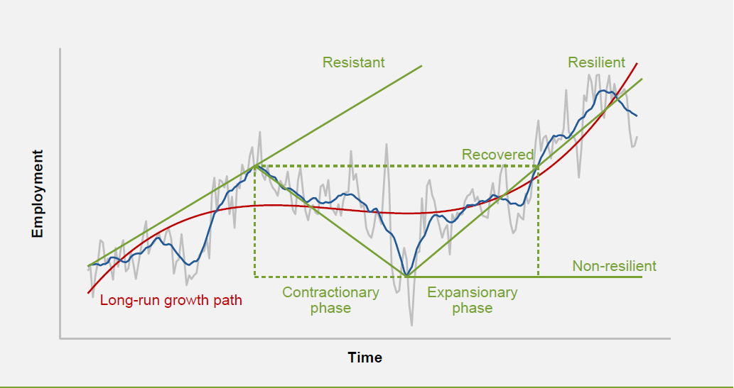
Figure 1: Economic Resilience (p. 3, box 3 of Productivity Commission report)

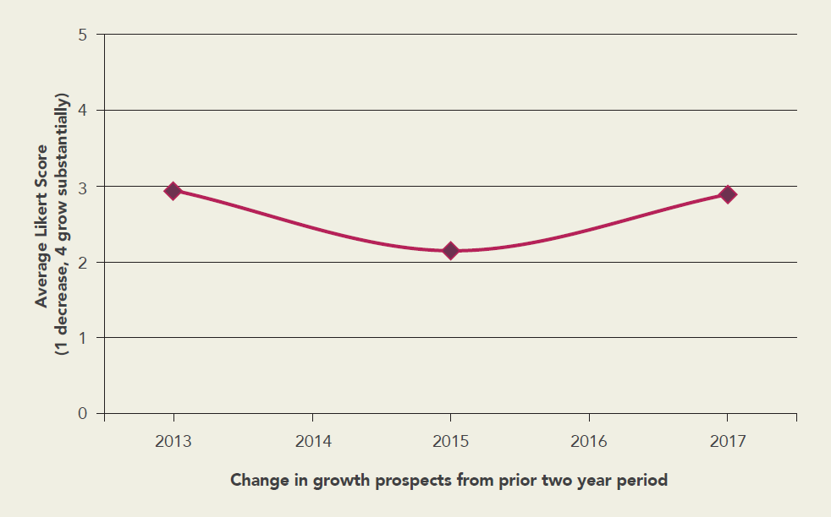
Figure 2: Average growth prospects, n=400 (p. 14 UQ report)

Figure 2 shows that SMEs in the gasfields saw better growth prospects at the construction peak in 2013 but this declined as construction neared completion in 2015 but were more optimistic looking out to 2017.

The analysis of our survey data show that different resilience factors are important through the cycle. An important part of this is finding is that resilience is not only important for recovery but also for taking advantage of business opportunities during the expansionary phase of the cycle.

The results of our analysis are shown below in Figure 3. In the boom period when money is flowing into the region and contractors are winning work the only factor that matters is having spare capacity (slack) to take advantage of opportunities. Interestingly, being low in adaptiveness is a feature at this stage of the cycle, which we interpret as being able to focus on specializing on a limited range of products and services due to the large volume of work that is available.

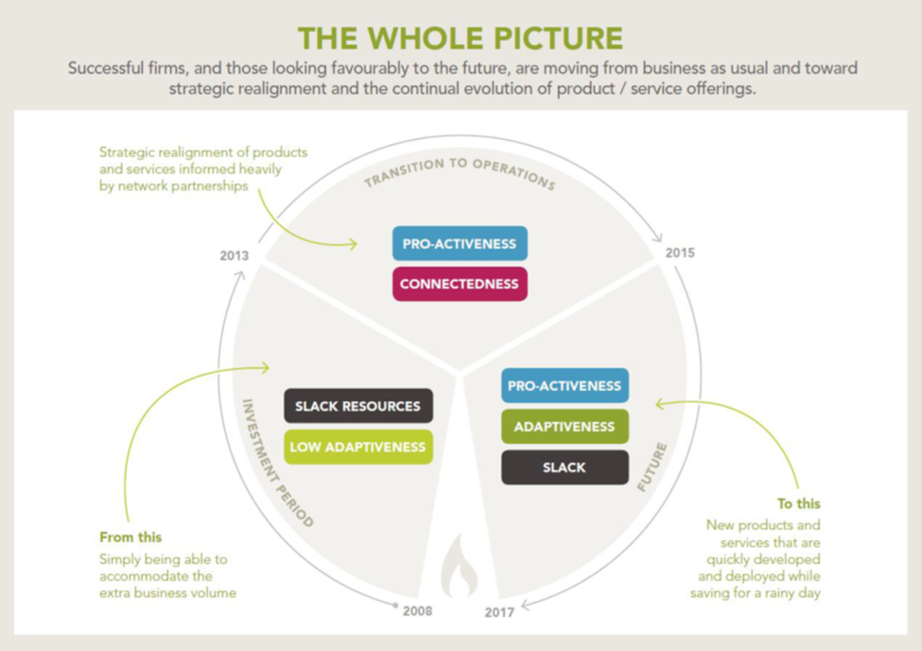
Figure 3. Diagrammatic summary of regional SME resilience factors through the economic cycle

As the cycle moves into a downswing we find that pro-activeness and connectedness is better correlated with business success. This makes sense as business owners must seek out new opportunities and use their networks to find these opportunities. This has important policy implications for helping businesses transition to the recovery phase by being connected to other parts of the national economy and beyond. Connectedness is also an infrastructure issues and we believe that fast internet, road, rail and air transport will enhance the connectedness and therefore resilience of these regional businesses.

An interesting finding is that spare capacity is not only important during the growth phase of the cycle but also for the recovery. Businesses that are not able to access capital will struggle to adapt through the cycle and this points to the importance of diversity and competition in business banking in regional economies. Equally, this also suggests that financial literacy is important for recovery as businesses that go into the downturn with excessive debt and financial risks are not resilient and are unlikely to survive through the recovery phase. This suggests that an important measure of resilience is some index of indebtedness and free cash flow that may be available from BAS data from SMEs and can be used in the productivity commission’s future work.

Adaptive capacity of Australia’s regions
While we agree with your assertion on p. 11 that regional communities are least likely to have the capacity to adapt, we assert that there are within-region differences, as well as differences among businesses within these regions. We think that it is in these differences that the most insightful inferences can be made about how regions can be supported through periods of fluctuation and uncertainty.

Our report took some initial steps towards analysing these within-region differences between businesses and found that:
- Rural versus large town businesses:
  - Rural firms are 1.6 times more likely to be below average in connectedness.
  - Rural firms are 1.8 times more likely to be below average in adaptiveness.
  - Rural firms are 1.8 times more likely to be below average in problem-solving capabilities

- Industry differences:
  - Manufacturing firms are twice as likely to be below average in improvisation.
  - Retailers were 2.5 times more likely to be above average in improvisation.
  - Wholesalers were 3.6 times more likely to be below average in anticipation.
  - Transportation and storage firms were
    - 3.7 times more likely to be below average in problem-solving
    - 3.5 times more likely to be below average in pro-activeness
    - 3 times more likely to be below average in anticipation
  - Professional services firms were
    - 2.3 times more likely to be below average in slack
    - 2.1 times more likely to be below average in improvisation.
  - Financial sector firms were
    - 2.5 times more likely to have below average problem-solving
    - 2.3 times more likely to have below average adaptiveness.

Guiding principles and policy recommendations
In addition to the policy and practice recommendations contained in your report, we point you to pp. 25-28 of our report (link) where we list a number of such initiatives that can be implemented to support regional communities, and in particular regional businesses.
In particular, we suggest the following initiatives to enhance the resilience of regional SMEs and thus improve the broader prospects for regional economies.
- Development of collaborative partnerships or alliances to share costs of transport, logistics, and storage in order to offer a broader service offering to potential clients.
- Support local industry associations and chambers of commerce.
- Promote greater awareness of procurement portals and other forms of networking to increase awareness of partnership and bid opportunities for resources projects.
- Providing training for business owners in business skills such as planning and financial management.

Summary
- SMEs are a vital part of regional economies and should be given particular attention in discussions of resilient regions
- Resilience is made up from several different business attributes that matter at different phases of the economic cycle
- We are happy to provide a text box with our findings, which focuses on a region affected by oil and gas developments, for a next iteration of your report.

References
Ford, J. A., & Steen, J. & Verreynne, M. (2016). Four qualities that helped small businesses survive the end of the resources boom. The Conversation. https://theconversation.com/four-qualities-that-helped-small-businesses-survive-the-end-of-the-resources-boom-63180.

Ford, J. A., Verreynne, M., & Steen, J. 2016. Measuring economic trends and benefits of CSG development on local businesses. no. 149312, Brisbane. http://research.ccsg.uq.edu.au/projects/small-and-medium-enterprises-sme-study-economic-trends-benefits

Ford, J.A., Verreynne, M. & Steen, J. (2016, Sep 7-9). Measuring organisational resilience: ebb and flow of onshore gas investments. 6th International Conference on Building Resilience, Auckland, New Zealand.

