Introduction

Positive Life NSW would like to thank the Productivity Commission for the opportunity to provide feedback on the National Disability Insurance Scheme (NDIS). The NDIS is a historic opportunity to improve the lives of people with disability. Positive Life NSW strongly supports the principles underpinning the NDIS of improving the wellbeing of people with a disability by implementing a person-centred model of care and providing better options and supports for employment, education, independent living and community participation.

However, Positive Life and other HIV service agencies in NSW have observed and foresee problems emerging for people living with HIV (PLHIV) who access the NDIS, particularly those with HIV associated neurocognitive impairments, mental health conditions and complex care needs. This submission attempts to describe those problems and provides potential solutions so that people with HIV and disability can maximise their chances of benefiting from the NDIS.
We also have concerns that the Productivity Commission is focusing on the economic sustainability of the NDIS, rather than on barriers to access and systemic problems. We hope that this inquiry will bring forward issues that are not purely economic and lead to a scheme that meets its intended purpose of improving the lives of people with disability.

About Positive Life NSW

Positive Life NSW is the public face and voice of all PLHIV in NSW. We’re a state-wide peer-based agency that makes a significant contribution to and positive impact across the spectrum of health and social issues on behalf of PLHIV. Positive Life collaborates with HIV specialist and mainstream organisations to improve the health and quality of life of PLHIV. We do this through evidence based health promotion, policy advice and peer support.

About this submission

This submission is based on a range of interviews with staff in HIV specialist service organisations in NSW. These organisations include:
- Adahps (formally the AIDS Dementia and HIV Psychiatry Service);
- South Eastern Sydney Local Health District HIV Outreach Team;
- Positive Life NSW CEO and staff;
- PLHIV in metropolitan and regional/rural NSW;
- HIV service partner staff in other Local Health Districts; and
- disability organisations with knowledge and experience of PLHIV.

About the services consulted

Adahps is a NSW state wide specialist service funded by the NSW Ministry of Health to provide neuropsychological assessment, case management, brokered care and specialist residential care to PLHIV with HIV Associated Dementia, HIV Associated Neurocognitive Disorder, and HIV-related impairments including Toxoplasmosis and Progressive Multifocal Leukoencephalopathy. The service currently manages 68 PLHIV in metropolitan and regional/rural NSW.

The South Eastern Sydney Local Health District HIV Community Outreach Team is a multidisciplinary team including nurses, dieticians, social workers and occupational therapists. The service is funded by the NSW Ministry of Health. The HIV Community Outreach Team provides assessment and screening, case management, counselling and medication adherence programs for PLHIV with multi-morbidity and complex care needs. The service manages approximately 150 PLHIV residing in the eastern and south Sydney areas and in addition receives referrals from the HIV Community Team in Sydney Local Health district for NDIS matters. Approximately 60% of PLHIV managed by the HIV Outreach Teams have a diagnosed mental health condition and 20% have neurocognitive disease. Approximately 60% live with multiple chronic health conditions which significantly impact on their ability to process information, mobilise safely and perform daily living tasks.

HIV, functional impairment and psychosocial disability
Despite the majority of PLHIV benefiting from the introduction of highly active combination antiretroviral therapy, some PLHIV will continue to experience impairments from HIV associated conditions that impact on their functional capacity and psychosocial functioning. We draw to the attention of the Commission, the following conditions and impairments:

Neurocognitive impairment
HIV enters the brain and central nervous system early in the course of infection. Prior to the introduction of highly active antiretroviral therapy in 1996, HIV Associated Dementia was a common source of morbidity and mortality in HIV-infected individuals. It was observed in 50% of patients. Due to effective treatment, rates of opportunistic infections associated with severe immunodeficiency are now much less prevalent, however neurological complications associated with late diagnosis and advanced disease, chronic infection, treatments, immune reconstitution, and concurrent comorbidities are increasing.

While effective combination antiretroviral therapy supresses plasma viral activity for most PLHIV, some individuals will continue to experience HIV-related cognitive impairments and dementia, either from long standing HIV infection, or from HIV infection that is undiagnosed or inadequately treated. HIV associated cognitive impairment can range from mild to severe. For the purposes of this submission, a distinction is made between the mild and severe forms of HIV associated cognitive impairment, although PLHIV will present along a spectrum of impairment. There are also PLHIV who experience Parkinson’s syndrome, epilepsy and psychosis as a result of HIV infection, or from genetic predisposition.

Mild neurocognitive disorder presents with cognitive symptoms on neuropsychological assessment as well as noticeable difficulties in the person’s day-to-day life. That is, they may complain of having trouble recalling things, mixing up appointments, forgetting if they have taken their medication, forgetting what they are about to do, forgetting people’s names etc. Because of these cognitive difficulties, people often report that they have become socially withdrawn as they either find it too difficult to socialise (for example because they can’t keep up with conversations when multiple people are talking) or because they don’t want others to notice their cognitive problems. Other mood and behaviour changes can include increased irritability or reduced interest in and initiation of activity.

There are also a range of compensatory behaviours observed in people with HIV associated cognitive impairment and mental health conditions where they develop strategies to ‘mask’ impairments. ‘Masking’ is often adopted to enable the person to be perceived as ‘normal’ by their peers and others. It should be noted that this strategy is not one of denial or avoidance, but rather, preventing the individual from needing to explain the impairment and risk being stigmatised or shunned.

HIV-associated dementia is the most severe form of HIV Associated Neurological Disorder, with severe cognitive impairments revealed on neuropsychological assessment and severe difficulties noticed in day-to-day life. Mania, seizures and motor problems are experienced by some individuals as well as inhibition and inappropriate behaviours. People with HIV Associated Dementia will require a lot of support to maintain independent living and may require accommodation in a supervised specialist residential facility.

Based on the mean estimate of prevalence, approximately 42% of PLHIV will be living with some degree of symptomatic HIV Associated Neurocognitive Disorder. HIV Associated Dementia affects an estimated 2-5% of PLHIV. In 2016, it was estimated that there were 11,500 people living with HIV in NSW, of which 86% were diagnosed. Extrapolating from these proportions it is estimated that approximately 230 to 575 PLHIV may be affected by severe forms of HIV associated cognitive impairment in NSW and approximately 4,500 PLHIV will be living with some degree of symptomatic HIV Associated Neurocognitive Disorder.

Other chronic health conditions and associated impairment
PLHIV experience higher rates of multimorbidity than the general population. In a study conducted in 2015 by Positive Life into the needs of PLHIV as they access mainstream and specialist services, it was found that 59% experienced multimorbidity with 25% experiencing three or more chronic health conditions in addition to HIV. The most common conditions are mental health conditions (22%), cardiovascular disease including heart attack and stroke (20%), musculoskeletal conditions 12%), cancers (8%), neurological disorders (8%) and metabolic disorders (7%).
Multimorbidity with serious chronic and debilitating health conditions has a substantial impact on function and on the ability of PLHIV to overcome psychosocial barriers and engage in ‘an ordinary life’. The proportion of PLHIV experiencing mental health conditions (22%) is significant and living with a mental health condition/s has been strongly associated with social withdrawal, isolation, poverty and poor quality of life. However, the combination of multiple debilitating chronic health conditions such as stroke, cancer, frailty and mental health conditions, produce permanent and progressive reductions in functionality and the ability to perform daily tasks and maintain a quality of life.

HIV Stigma and Discrimination
HIV stigma has long been recognised as a serious and debilitating feature of HIV infection. There are a number of reasons why HIV is stigmatised, including the fact that it is a serious communicable disease, it disproportionately affects groups who are already marginalised in society and it is linked with taboo behaviours such as homosexual sex and drug taking.
PLHIV have two key ways in which they can mitigate the effects of stigma and discrimination. The first is through the careful control of the process of HIV disclosure. This gives PLHIV an advantage in choosing the circumstances in which they disclose HIV to others. The second is by developing a set of skills that offer resilience in the face of stigma and discrimination.
Many PLHIV are extremely circumspect about who they disclose their HIV status to. This is particularly the case for PLHIV who live in rural areas and for those who identify as heterosexual. However, many gay men are also extremely careful whom they disclose HIV to. Engaging with the NDIS will require engagement with services other than HIV specialist services. Interactions with the NDIS and mainstream services will present challenges for some PLHIV who have experienced discrimination and self-isolate as a protection strategy.

Barriers to Engagement with the NDIS for PLHIV

Lack of knowledge about the NDIS - The NDIS is very new and unfamiliar for PLHIV. While there has been information programs run for PLHIV by disability organisations (such as People with Disability Australia and Positive Life), we consider knowledge of the NDIS amongst PLHIV with disability to be lacking. Very few PLHIV understand the scope of the NDIS or if they are eligible for NDIS support packages. There is limited understanding of how to engage with and navigate the NDIS and the supply of supports that might be useful and of benefit. Access and eligibility to support packages are clearer and less confusing for PLHIV with a specific physical or sensory disability, such as blindness, or mobility impairments.

However, there are many PLHIV who might be eligible for the NDIS who have cognitive impairment, chronic mental health conditions or complex care needs. They will however struggle to understand the scope of the NDIS and the interrelationship between cognitive impairment, mental health conditions, psychosocial disability and if/how the NDIS would benefit them. In addition, we are increasingly hearing that PLHIV who are diagnosed late (and with advanced HIV disease) often experience cognitive impairment sometime after the diagnosis, despite starting and adhering to HIV treatment. This is due to central nervous system damage being sustained prior to therapy commencement and the development of viral reservoirs, which may not be depleted when viral suppression is achieved. While the philosophy of the NDIS is to empower individuals to take control of the process from beginning to end, some PLHIV will need accessible information and support to adequately engage with and navigate the NDIS. This is particularly the case for PLHIV who do not have familial or other supports. It will also take time for PLHIV with disability to become aware of the NDIS and its benefits in the absence of NDIS communications and marketing campaigns. As individual and community knowledge about the NDIS increases, we predict that more PLHIV with disability will engage with the NDIS.

Lack of knowledge about scheme eligibility and services - PLHIV, particularly those with mild to moderate cognitive impairment, mental health conditions and multimorbidity, will be unsure if their level of impairment meets eligibility criteria. Until community experience and knowledge of the NDIS increases, many PLHIV will be reluctant to engage with the scheme and will wait until they have a better understanding of the system and if they might be eligible. In addition, PLHIV have traditionally accessed support services from state-based services (many of whom are HIV specialist services). They are comfortable and familiar with those services and the services are familiar with the needs of PLHIV. They know how to deal with HIV stigma and concerns about HIV disclosure and perceptions of discrimination. We have received reports that some PLHIV fear that if they engage with the NDIS that they will be required to source supports from mainstream services that have no or a very limited understanding of the specialist needs of PLHIV. It is unsurprising that some PLHIV will feel vulnerable about engaging with the NDIS and mainstream services. They fear being stigmatised and discriminated against and the negative impact of this could be permanent.

Some PLHIV will need support to engage with and negotiate NDIS - Adahps reports that PLHIV with HIV-related cognitive impairment, HIV-related dementia and psychosis are often delusional or not completely aware of their impairment. They do not understand the seriousness of their condition. If they were to apply for NDIS packages autonomously and unsupported, they may provide incorrect information and report that they are psychologically well. There is a very real possibility that they would give a false impression of their impairment to a NDIS assessor/planner. For this reason, Adahps will advocate for and support all 68 Adahps clients during the NDIS application process. However, it should be noted that not all PLHIV with HIV associated cognitive impairment in NSW are diagnosed or case managed by Adahps. This results in the individuals not supported by Adahps being at a severe disadvantage if they chose to engage with the NDIS without support.

There is also some confusion on the part of services as to what the NDIS will provide. For example, currently some PLHIV with HIV associated dementia have had to be housed in nursing homes and aged care facilities because there are no beds available in specialist HIV dementia residential facilities. Service providers have been told by NDIA staff that NDIS does not assist clients with accommodation, but that it does by others. Policy clarity on such issues would be helpful as housing, homelessness, supported accommodation and independent living for these individuals is fraught, if not impossible given the current siloed housing service and infrastructure arrangement.
There are also PLHIV who are extremely debilitated and socially isolated due to mental health conditions, cognitive impairment and other chronic health conditions. These individuals often live alone in public housing, in poverty and are DSP or New Start dependent. They have no familial or other support mechanisms. They live in a kind of ‘solitary confinement’ and rarely leave their accommodation except to attend medical and Centrelink appointments. These PLHIV could substantially benefit from the NDIS and the support that it can provide to increase social participation and quality of life. But, they are unaware and will likely remain unaware and unsupported without programs to help them connect to the NDIS and support from knowledgeable NDIA staff who can ‘unpick’ their issues and get to the heart of their support needs.
The ability of NDIS assessors/planners to understand the needs of PLHIV applying for the NDIS - Positive Life agrees that the planning process is about matching scheme participants with effective support packages. This will involve conversations between PLHIV and NDIA staff to identify the goals and aspirations of the person with HIV, their level of function and the appropriate support package for them. These issues can be complex. Since the object of the NDIS is to maximise participant choice and control and produce an individualised package of supports, it will be essential for PLHIV, particularly those with cognitive impairment and mental health conditions, that NDIA/NDIS staff have an understanding of HIV and its medical and psychosocial impacts. The health and social impacts of HIV infection are complex. There are intersections between HIV stigma and discrimination, homosexuality, illicit drug use, non-binary gender identification and physical and psychological impairments. Planners will require some understanding of these issues if they are to match participants with effective support packages.

We also think there is a role for HIV specialist services to support PLHIV who do not feel confident engaging with the NDIS. These agencies could act as an intermediary and support the person during the planning process so that NDIA planners accurately understand the physical and psychosocial needs of the applicant. Specialist HIV services agencies such as Adahps, Positive Life NSW and the HIV Community Outreach Teams are well placed to support PLHIV through the application process. They would provide a context to issues raised by the applicant and make sense of the relationship between medical related impairments and psychosocial disability. For these reasons we consider that there is a role for HIV services (government and non-government) in supporting PLHIV during the application process. We consider phone planning for PLHIV with cognitive impairment or mental health conditions to be problematic unless a support person is present with the applicant.

Furthermore, we strongly recommend that NDIA, NDIS and specific service staff dealing with PLHIV receive basic introductory training about HIV and the needs of PLHIV. Typically, if PLHIV have a negative experience or know the NDIA planners have no HIV knowledge, they will be hesitant to enrol and likely not to disclose the full scope of what they’re living with and what they need.

Management of support packages - While some PLHIV will be ready to manage and work with the NDIS to implement their plans, others will be less so, and may find it difficult to get the most out of the scheme. PLHIV who have been assessed as eligible for a support package - particularly those with cognitive impairment, psychosis or severe and chronic mental health conditions - will struggle or be unable to manage those support packages without a support coordinator. These individuals have difficulty negotiating simple tasks of daily living and would struggle to manage complex planning and financial matters. They will also require support when their package is reviewed and when renegotiations of supports are required.

Case Study
Jenny is a 50 year old heterosexual woman living on the Central Coast who was diagnosed with HIV when admitted to hospital for a hysterectomy last year. The doctors said she had HIV for at least 10 years. At diagnosis Jenny had a CD4 count of 154cells/ml. She thinks she got HIV from a former boyfriend, who was a truck driver who used to regularly travel to the Philippines and Thailand for holidays. Jenny is having difficulties remembering appointments and commitments she made with her daughter regarding her granddaughter’s care.
No one in her family knows she has HIV. Jenny is on the Disability Support Pension, because of liver damage from hepatitis C and she lives alone in community housing. The doctor at the hospital where she was diagnosed referred Jenny to St. Vincent’s Hospital Sydney for further test and a neuropsychological assessment but she does not want to go. She doesn’t like going to Sydney and says she already has too much on and needs to look after her granddaughter. She’s also afraid that people are asking questions about her health, and the reasons for medical appointments.

To facilitate better coordination and planning by the NDIA, it would be useful for the Commission to have an understanding of the distribution of PLHIV in NSW. There will be an estimated 11,721 PLHIV in NSW in 2020. Approximately three quarters (78%) live in the Sydney Metropolitan area with the majority of these living in a ten kilometre radius of the central Sydney business district. The remainder (2,638 or 22%) live in regional/rural NSW, with clusters in the Richmond-Tweed and Mid-North (6%), the Hunter (6%), and the Illawarra (3.5%). In other regions of NSW, the population of PLHIV is sparse. Further details can be found at (attachment 1).

Concerns that older PLHIV and those who don’t meet eligibility criteria will be left without services As the NDIS is rolled out, concerns have been raised that the NSW Government is progressively withdrawing state funded disability support services. PLHIV who don’t meet NDIS eligibility criteria or are 65 years and older, fear they may be left without services. This is particularly the case for PLHIV with mild cognitive impairments, mental health conditions and those with impairment due to other medical conditions. There are also concerns that as people age, impairment may progress and becomes more severe. That would mean that these individuals are left without services and become increasingly vulnerable for the remainder of their lives.

The Australian population with HIV is ageing. The Kirby Institute estimates that by 2020, approximately 44.3% of the Australian population with HIV will be 55 years and older and 18% will be 65 years and older. The implications for older PLHIV who are ineligible for the NDIS are profound if state based funding for disability services are withdrawn.

Individuals diagnosed in the pre- treatment era (between 1983 and 1996) are particularly prone to acquiring multiple serious and debilitating chronic health conditions. Inflammation associated with untreated HIV infection is directly linked with increased rates of cardiovascular disease, renal, hepatic, neurological disorders and cancers. In addition, pre-existing health conditions, health conditions associated with early toxic HIV treatment regimens, and health conditions acquired as part of the ageing process have contributed to the current profile of multi-morbidity in PLHIV in NSW.
Case study
John is 67 year old gay man who lives alone in a Department of Housing flat in Ashfield. He has six medical conditions that have required long-term treatment ― HIV, diabetes, high blood pressure, emphysema, arthritis and depression. He doesn’t have much energy and often can’t do what he thinks he would like to do. He constantly juggles doctors’ visits and multiple medications and feels overwhelmed with all of his medical issues. He wishes one of his doctors would coordinate, prioritise and streamline all of his visits, medicines, tests and instructions. Often he is half way home and remembers that he was going to talk with his doctor about some issue or other, but he forgot and there is never enough time. He knows he needs more help at home, but doesn’t really know where to turn for assistance. John rarely leaves his flat apart from going to the supermarket or to a doctor’s appointment. He was robbed walking home from the station last year and the experience has shaken his confidence. His ex-partner lives too far away to be helpful on a regular basis and he is estranged from his family. John’s neighbour looks in on him from time-to time, but is beginning to worry that John is getting increasingly frail and thinks he is struggling to cope.

Privacy and the interconnection between Health, NDIS and Support Service records - The privacy of PLHIV has been protected since the early days of the epidemic in Australia. There are laws in most states in Australia that protect the confidentiality of PLHIV. This means that it is generally against the law for doctors, nurses and health care providers to disclose the HIV status of a person infected with HIV without prior consent. Australian PLHIV have come to expect that their confidentiality will be maintained, at all costs because of the consequences for people when breeches occur. These privacy provisions extend to the new Electronic Health Record where users have considerable control over their health information and which healthcare professionals can access what documents.

However, as PLHIV engage with the NDIS and mainstream support services, the sharing of sensitive information, including HIV status becomes inevitable. PLHIV and agencies that represent them have serious concerns that sensitive information will be inadvertently accessed by mainstream service providers and could result in breaches of confidentiality and discrimination. For PLHIV who live in small rural and regional communities, the fear of being ‘outed’ is a constant concern. Once a breach of confidentiality has occurred, it can never be taken back and in this electronic age, this is increasingly more complicated. It can lead to social isolation; the loss of employment or a relationship; or the need to relocate to another area and the reinstalment of clinical care and support services. Such an outcome would significantly undermine the principals and values underpinning the NDIS.

We’ve received feedback from HIV service providers that they’ve supported PLHIV by providing detailed and specific information, related to their HIV within the NDIS application. PLHIV without support services and knowledge - that allow them to understand the implications of this disclosure in the application, or to be able to understand and work through the implications of the disclosure - are vulnerable and at risk. We do not have a detailed understanding of what happens to the data once it’s in the system, who owns and controls the data (PLHIV or the Commonwealth or service providers), and what security is in place to ensure other people do not access the information. There are also question as to whether a person’s information can be subpoenaed for an investigation or prosecution. This is a critical concern and would be an impediment for some PLHIV, especially those outside the gay community or those living in regional / rural NSW.

Summing up - The NDIS has the potential to significantly improve the lives of PLHIV with disability. However, few PLHIV understand the scope of the NDIS or if they would be eligible for support packages. Until PLHIV have a better understanding of the scheme and how it works, engagement will be limited to those with physical disability and those with severe HIV associated neurocognitive impairments.

Due to reduced cognition and function, problems are foreseen for PLHIV as they negotiate and engage with the assessment and planning process and manage their plans. While the underpinning philosophy of the NDIS is empowerment and personal control, some individuals with HIV will need information, education and assistance to navigate and engage with the NDIS, and to provide planners with an accurate understanding of their impairment and the supports they require to live a meaningful and participatory life. Some will also require ongoing support to manage their plans and to renegotiate new supports when they become necessary.
There are concerns for those who don’t meet eligibility criteria and have mild to moderate impairment or are over the age of 65. If the NSW State Government continues to withdraw state funded disability services, many PLHIV will be left without necessary supports and will struggle to perform the tasks of daily living. There is also a very real possibility that morbidity and mortality will increase. Having survived HIV infection and the impacts of HIV associated health conditions, it would be unacceptable for these individuals to be left vulnerable, isolated, unsupported and at an increased risk of death.
Finally, concerns regarding the sharing of sensitive personal information between health care providers, NDIA staff and support service poses potential for breaches of privacy. PLHIV fear being stigmatised and discriminated against by mainstream services with no or limited understanding of HIV and the communities it affects. If breaches of confidentiality occur, PLHIV will be reticent to engage with the NDIS. This would be unfortunate and inappropriate.

Attachment 1

Population distribution
The numbers of PLHIV by ABS statistical region in Sydney – 2014 - 2020-
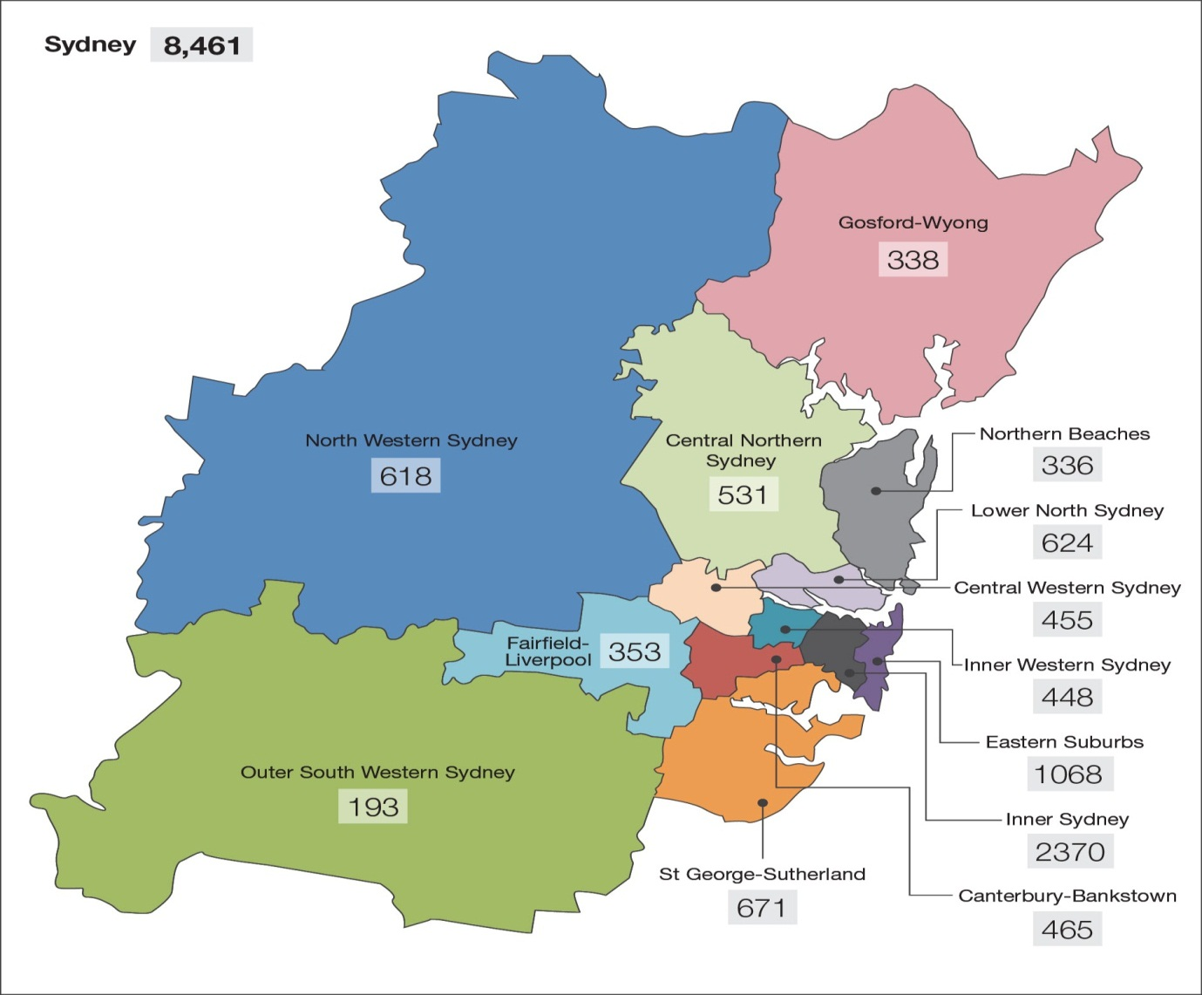
 | Year  2015 | % | Year  2020
NSW | 10867 | 100% | 11721
Sydney | 8461 | 77.86 | 9082
Inner Sydney | 2370 | 21.8% | 2471
Eastern Suburbs | 1068 | 9.8% | 1099
St George-Sutherland | 671 | 6.1% | 730
Canterbury-Bankstown | 465 | 5.3% | 507
Fairfield-Liverpool | 353 | 3.2% | 371
Outer South Western Sydney | 193 | 1.8% | 216
Inner Western Sydney | 448 | 4.1% | 481
Central Western Sydney | 455 | 4.2% | 483
North Western Sydney | 618 | 5.7% | 681
Lower North Sydney | 624 | 5.7% | 680
Central Northern Sydney | 531 | 4.9% | 601
Northern Beaches | 336 | 3.1% | 383
Gosford-Wyong | 338 | 3.1% | 380

The numbers of PLHIV by ABS statistical region in Regional NSW – 2014-
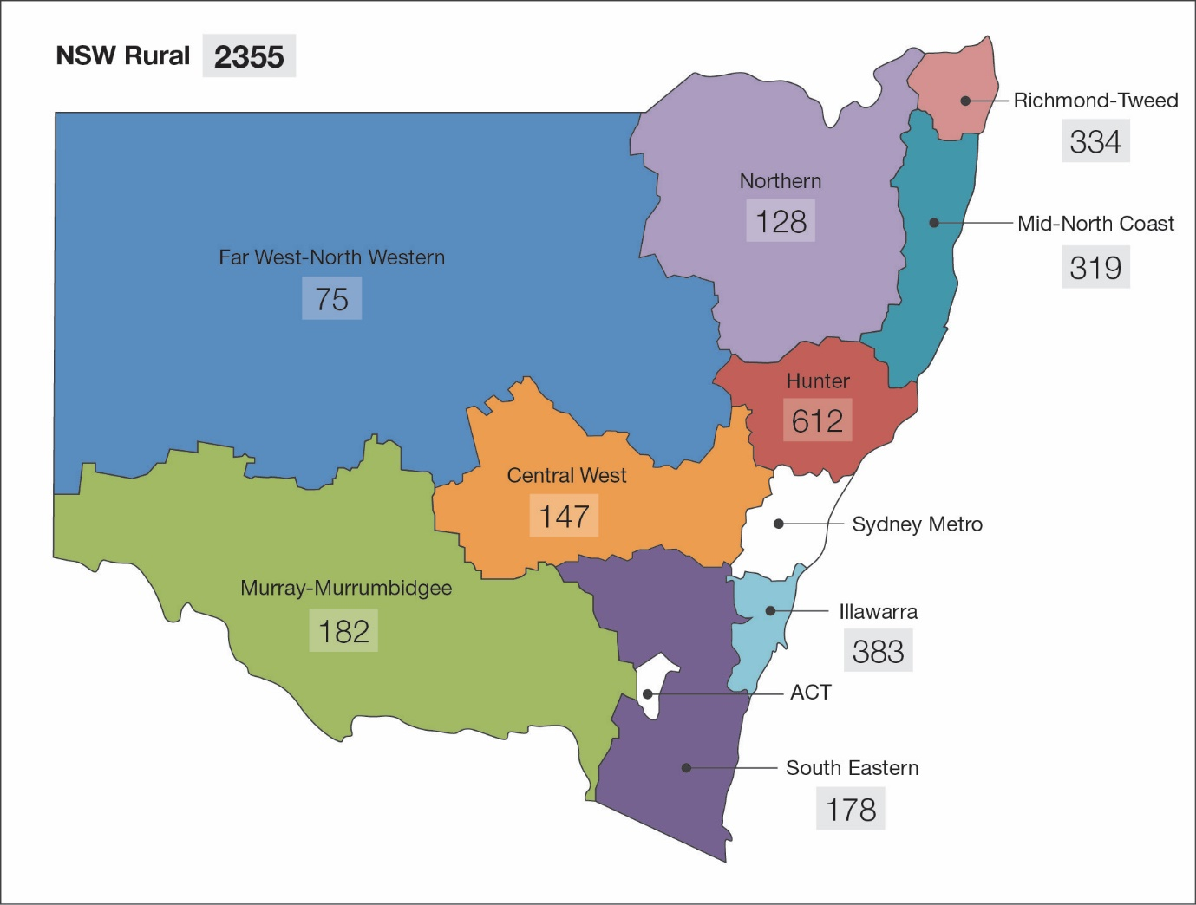
 | Year  2015 | % | Year  2020
NSW Rural | 2355 | 21.67% | 2638
Hunter | 612 | 5.6% | 681
Illawarra | 383 | 3.5% | 423
South Eastern | 178 | 1.6% | 211
Richmond-Tweed | 334 | 3.1% | 368
Mid-North Coast | 319 | 2.9% | 351
Northern | 128 | 1.2% | 146
Far West-North West | 75 | 0.7% | 85
Central West | 147 | 1.4% | 159
Murray-Murrumbidgee | 182 | 1.7% | 214

Viral and Inflammatory Markers in Cerebrospinal Fluid of Patients With HIV-1-associated Neurocognitive Impairment During Antiretroviral Treatment Switch. Tiraboschi, J., Muñoz-Moreno, J., Puertas, M., Alonso-Villaverde, C., Prats, A., Ferrer, E., Rozas, N., Maso, M., Ouchi, D., Picado, Martinez-Picardo, J., Podzamczer, D. 6, 2015, HIV Medicine, Vol. 16, pp. 388-392.
. Virologically Suppressed Patients With Asymptomatic and Symptomatic HIV Associated the Same Pattern of Immune Activation. Vassallo, M., Durant, J., LebrunFrenay, C., Fabre, R., Ticchioni, M., Andersen, S., DeSalvador, F., Harvey-Langton, A., Dunais, B., Cohen-Codar, I., Montagne, N., Cua, E., Fredouille-Heripret, l., Laffon, M., Cottalorda, J., Dellamonica, P., Pradier, C. 2015, HIV Medicine, Vol. 16 (7), pp. 431-440.
Multivariate normative comparison, a novel method for more reliably detecting cognitive impairment in HIV infection. Su, J., Schouten, J., Geurtsen, Wit, F., Stolte, I., Prins, M., Portegies, P., Caan, M., Reiss, P., Majoie, C., Schmand, B.,. s.l. : AIDS, 2015, Vol. 29 (5), pp. 547-557.
Cognitive Functioning, Wellbeing and Brain Correlates in HIV-1 Infected Patients on Long-term Combination Therapy. Marloes, J., Olga, M., Steens, S., Bozena, G., Bosch, M., Koopmans, P., Kessels, Roy. 29 (16), 2015, AIDS, pp. 2139-2148.
The Montreal Cognitive Assessment: A Pilot Study of a Brief Screening Tool for Mild and Moderate Cognitive Impairment in HIV-Positive Veterans. Chartier, M., Crouch, P., Tullis, V., Catella, S., Frawley, E., Filanosky, C., Carmody, T., McQuaid, J., Harry Lampiris, H., K. Wong, K. 14(3), 2015, Journal of International Association of Providers of AIDS Care, pp. 197-201.
A Better Screening Tool for HIV associated Neurocognitive Disorders. Brouillette, M., Mayo, N., Fellows, L., Lebedeva, E., Higgins, J., Overton, E., Ances, B., Koski, L. 2015, AIDS, Vol. 29 (8).
NSW HIV Strategy 2016-2020, NSW Ministry of Health http://www.health.nsw.gov.au/endinghiv/Publications/nsw-hiv-strategy-2016-2020.PDF
https://www.positivelife.org.au/images/PDF/2016/PLHIV-Access-to-healthcare-NSW-Report-2015.pdf
Data from D Wilson, 2011, Mapping HIV outcomes: geographical and clinical forecasts of people living with HIV in Australia, Table 5. Number of people living with diagnosed HIV by statistical region and year, p21.
ABS statistical regions from the Australian Bureau of Statistics website, 2015.
Data from D Wilson, 2011, Mapping HIV outcomes: geographical and clinical forecasts of people living with HIV in Australia, Table 5. Number of people living with diagnosed HIV by statistical region and year, p21.
ABS statistical regions from the Australian Bureau of Statistics website, 2015.

