Submission by International Association of Hydrogeologists
To: Productivity Commission
On: Issues Paper March 2018: Murray-Darling Basin Plan: Five-year assessment
Date: 16 April 2018
Terms of Reference addressed in this submission:
Specifically, the Commission should focus on progress towards a pathway for three key priorities including:
• supply measures to offset the Basin Plan water recovery target of 2,750 GL by 2019, using the Sustainable Diversion Limit (SDL) adjustment mechanism;
• constraints measures to address impediments to delivering environmental water; and
• efficiency measures to recover an additional 450 GL by 2024, consistent with the Basin Plan legal requirement to achieve neutral or improved socio-economic outcomes.

In particular the focus of this submission is on the Broken Hill town water supply and Menindee Lakes system, the inadequate process of selection of a preferred pipeline from the River Murray option by the Govt of New South Wales to date, and potential significant savings in costs and increased water security through a groundwater and managed aquifer recharge (MAR) option based on the current water supply from Weir 32 near Menindee. The principles explored in this submission indicate that MAR has broader opportunities in water banking for securing dry weather supplies in a basin that adheres to an uncontested plan.
The submitting organisation
The International Association of Hydrogeologists (IAH) is the international peak scientific professional organisation engaged in groundwater resources management. It has a global membership of more than 4000 hydrogeologists, groundwater scientists and engineers, and its largest national chapter is the Australian Chapter, with more than 500 members. This submission has been assembled by the Australian Chapter together with the IAH Commission on Managing Aquifer Recharge which is a specialist international group with expertise in advancing safe and reliable intentional augmentation of groundwater resources. The signatories to this submission are Lange Jorstad, President of the Australian National Chapter and Peter Dillon, Co-chair of the Commission on Managing Aquifer Recharge.

Lange Jorstad Peter Dillon
President, IAH Australian Chapter Co-Chair, IAH Commission on Managing Aquifer Recharge
IAH Submission to Productivity Commission on Murray-Darling Basin Plan: Five-year assessment
Broken Hill Water Supply Options
According to NSW Department of Industry (DPI, 2017), the NSW government intends supplying water to Broken Hill from the River Murray via a 270km pipeline from near Wentworth to deliver 10 GL/yr at a capital cost of around $500M.
Geoscience Australia and CSIRO explored options to use the existing Menindee water supply infrastructure, together with significant fresh groundwater reserves near the Darling River in the vicinity of Menindee and groundwater replenishment during high flow years to provide a higher reliability and quality of supply at less than half this cost. This significant work was published as a series of Geoscience Australia reports, summarised in Lawrie et al (2012) and was presented in several special sessions during the IAH 40th International Congress in Perth in 2013.
Aquifer storages found by Geoscience Australia’s geophysics and drilling program are large, containing many years of freshwater supply to Broken Hill (Lawrie et al 2012). These aquifer storages are protected from evaporation, so give resilient supplies through multiple dry years, they are replenished naturally at very high flows, but are poorly connected with the Darling at low flow. Lawrie et al (2012) proposed managed aquifer recharge (MAR) to replenish the fresh groundwater reserves when river salinity is low during occasional moderately-high flows to ensure on-going drought-resilience and assure protection of ecosystems from being impacted by increased withdrawal without replenishment. IAH observes that fresh groundwater resources are generally preferred over surface water for drinking water supplies particularly where rivers are turbid, variable in quality or suffer from algal blooms (Jekel and Grünheid 2005). Groundwater is filtered in natural aquifer materials providing a stable water quality and removes organic matter that produces unwanted disinfection by-products in drinking water supplies.
IAH understands that for less than half the capital cost of the proposed River Murray connection to Broken Hill, the following can be delivered;
- The groundwater supply and recharge infrastructure adjacent the Darling River at Menindee (referred to as the Talyawalka groundwater and MAR proposal) could be established and connected to the existing water supply by 2024,
- Finalising investigations to refine and optimise the operating strategies for groundwater extraction and aquifer recharge to ensure supplies of better quantity, quality and reliability for Broken Hill with acceptable environmental impacts,
- A public information program conducted in Broken Hill allowing tasting of the new groundwater supply, and information on the economics of this system compared with the current proposed Murray pipeline,
- Transparent and reliable accounting for entitlements and surface water-groundwater interactions can be established, and
- Refurbish as needed, or replace, the current 110 km pipeline from Menindee to Broken Hill.
Operating costs for the groundwater option are also likely to be lower than for the River Murray connection, which involves more than double the distance of pipeline.
Information inconsistencies used to support a NSW government decision on the Broken Hill Water Supply.
In July 2017, NSW Department of Water web site stated that “a shortlist of project options were evaluated” and “the analysis was performed in a transparent, robust and structured manner – overseen by experts from DPI Water, NSW Public Works and Infrastructure NSW.” When considering groundwater options, the analysis described a deep, saline groundwater option that require desalination and brine disposal. No data or reports were presented to support the Talyawalka groundwater and MAR proposal previously identified and extensively scrutinised by Geoscience Australia and CSIRO. The International Association of Hydrogeologists (IAH) wrote several times to the DPI seeking clarification on why the Talyawalka proposal was not considered but is yet to receive an explanation.
The NSW Department of Industry recently released a report entitled Summary of the Final Business Case: Broken Hill Long-Term Water Supply Solution, October 2017. It addressed the Talyawalka groundwater and MAR proposal. However, in undertaking the analysis, it appears to have adopted costs from the highly saline deep groundwater option, and not the shallow freshwater resource identified in the Geoscience Australia studies. This shallow freshwater storage zone has at least 50GL of shallow freshwater in storage and is capable of replenishment during fresh river flows to sustain the fresh groundwater resource. The DPI report also claims that the 110 km pipeline would need to be replaced at a cost of approximately $270m. This is stated without a condition assessment on the existing pipeline. As a result, the opportunity for reduced costs through repair and reuse or deferral of major capital expenditure have not been considered in the business case analysis. It is also noted that the $270m cost is out of proportion in comparison with the $470.2M for a 270 km pipeline along a new route. The overall inferred figure of $430m is between 4 and 10 times of what we understand to be the cost independently obtained within the Geoscience Australia project. DPI gives no basis for expenditure on the groundwater and MAR system and its connection to the upgraded water treatment plant. Production bores required for the borefield are now established, while bridge, power and road infrastructure is largely in place to Talyawalka. Also, most of the requisite additional studies recommended by Lawrie et al (2012) have been completed, such as detailed mapping of the borefields, surface water and groundwater dependent ecosystems studies, and groundwater modelling. Many of the costs identified in the NSW options analysis are already completed. It does not appear that the reported costs have been built up from the components of the Talyawalka project completed by Geoscience Australia.
The quantitative project risk has been pitched at $130M more than the preferred option, and yet there is no description of the risks for each option, nor how they were quantified. IAH’s review of the available information suggests unrealistically high costs have been applied to the Talyawalka groundwater and MAR option that are inconsistent with the existing Geosciences Australia cost estimate. IAH believes reassessment of the option using this information would result in the Talyawalka groundwater and MAR option being a more financially competitive proposal to the current NSW Government preferred option. The groundwater and MAR option to IAH’s best information has a lower cost, would be more reliable and would impinge less on other water users in drought conditions, than the NSW Government’s preferred option.
Water savings
Supplying Broken Hill from a replenishable groundwater resource adjacent the Darling River near Menindee would create exactly the same opportunities for operating the Menindee Lakes storages to produce water savings from reduced evaporation as supplying water directly from the River Murray. A report of NSW Office of Water (2012) and CSIRO reports cited within it, demonstrate that mean annual evaporative savings would be at least 125 GL/yr while still allowing Lakes Menindee and Cawndilla to fill during floods. That report erroneously purported that evaporation losses would be marginally increased by the managed aquifer recharge scheme. By definition, the managed aquifer recharge scheme proposed above cannot add to evaporative losses.
For a conservative estimate of 125GL/yr water savings, the capital cost for the groundwater and MAR option would amount to $2M/GL saved, compared with $4M/GL saved for the Wentworth to Broken Hill pipeline. Furthermore, an advantage with a groundwater-based scheme is that during drought no river water is needed to supply Broken Hill, whereas for a surface water supply the town competes with all other river users. Some changes to current diversion operations will need to be considered (see Appendix).
MAR precedents in Australia and MAR potential for elsewhere in the MDB
A precedent for municipal-scale MAR can be found in Perth where a 14 GL/yr scheme is under construction and will be expanded to 28 GL/yr by 2020. Water Corporation undertook a trial and adopted a groundwater replenishment option at a much lower cost than the conventional alternative drinking water supply (Vanderzalm et al 2015). Dillon (2015) summarised the state of MAR in Australia, which has now reached 400 GL/yr, and opportunities for water banking are plentiful.
Considerably more could be done with decentralised MAR in the Murray-Darling Basin to secure supplies during low flows, but this would rely on having secure and uncontested water entitlements to surface water and groundwater and appropriate rules relating to entitlement transfers between them for conjunctive water management.
IAH is aware of the magnitude of the investment and of the potential savings to be made by using groundwater and MAR. The IAH Australian Chapter and IAH Commission on Managing Aquifer Recharge are willing to offer key specialists in these fields to meet with the relevant parties at Commonwealth, State and Local levels. IAH specialists can also assist with policy and institutional matters if these impede perceived opportunities for managed aquifer recharge in the Murray-Darling Basin. IAH members in Australia and colleagues have the broad range of scientific and technical capacity to assist in all novel elements to manage real and perceived risks and enable the best value investment possible.
The IAH is ready and willing to assist with a deeper evaluation of the MAR option if the opportunity is made available (noting that some project components are common to both the MAR and River Murray pipeline options). We believe MAR can and should play an active role in best practice water management as part of the Murray-Darling Basin Plan.
References:
Dillon, P.J. (2015). Australian progress in managed aquifer recharge and the water banking frontier. Aust. Water Assoc. J. Water. 42 (6) 53-57, Sept 2015
Lawrie, K.C., Brodie, R.S., Dillon, P., Tan, K.P., Gibson, D., Magee, J., Clarke, J.D.A., Somerville, P., Gow, L., Halas, L., Apps, H.E, Page, D., Vanderzalm, J., Hostetler, S., Christensen, N.B., Miotlinski, K., Brodie, R.C., Smith, M. and Schoning, G. (2012). Assessment of Conjunctive Water Supply Options to Enhance the Drought Security of Broken Hill, Regional Communities and Industries. Summary Report. Record 2012/15 Geocat # 73823, Report 5 of 5 Final Report July 2012. www.ga.gov.au/corporate_data/73823/Rec2012_015.pdf
Jekel, M. and Grünheid, S. (2005). Bank filtration and groundwater recharge for treatment of polluted surface waters. WST Water Supply 5(5), 57-66.
NSW Office of Water (2012). Review of Hydrological Investigations Carried Out Under the Menindee Lakes Memorandum of Understanding Final Report, prepared by Bewsher Consulting, January 2012 http://www.water.nsw.gov.au/__data/assets/pdf_file/0010/548317/recovery_menindee_bewshers_report.pdf
NSW Dept. of Industry (2017). Summary of the Final Business Case: Broken Hill Long-Term Water Supply Solution, October 2017. http://www.water.nsw.gov.au/__data/assets/pdf_file/0008/739700/Broken-hill-long-term-water-supply-solution-summary-of-final-business-case.pdf
Vanderzalm, J.L., Dillon, P.J., Tapsuwan, S., Pickering, P., Arold, N., Bekele, E.B., Barry, K.E., Donn, M.J., Hepburn, P. and McFarlane, D. (2015). Economics and experiences of managed aquifer recharge (MAR) with recycled water in Australia, Australian Water Recycling Centre of Excellence Report. http://www.australianwaterrecycling.com.au/research-publications.html

Appendix 1. Flow and salinity of River Darling at Weir 32 in relation to MAR
The median salinity of river water at Weir 32 is about 500 µS/cm, and about 85% time the salinity is less than 1000 µS/cm, an essential requirement for acceptable drinking water quality. Whenever flow exceeds 3000ML/d, and frequently at lower flows, the salinity is less than the median. This allows the opportunity for replenishing and freshening the shallow groundwater storage. This is required to buffer the groundwater resource to sustain extraction at suitable quality during extensive droughts without relying on desalination.
Managed Aquifer Recharge (MAR) is a technique which can take occasional flows of fresh low security water, and bank it in an aquifer to recover it during drought or when river salinity is high to provide high quality, high security supplies. However its use depends entirely on an entitlement system that encompasses surface water and groundwater and is adhered to across the whole catchment and basin (Ward and Dillon 2011). When this is in place, and not before, MAR opportunities may commence.
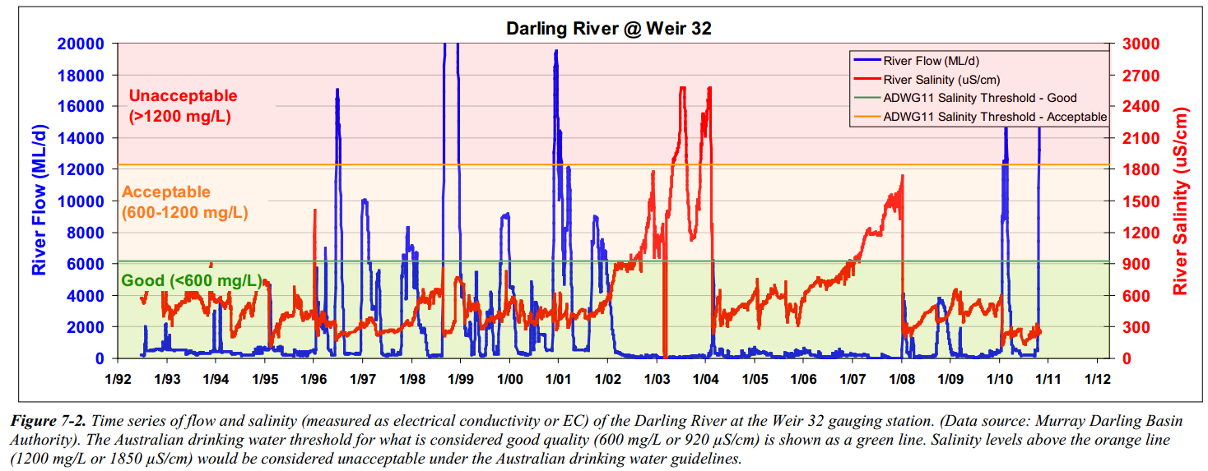

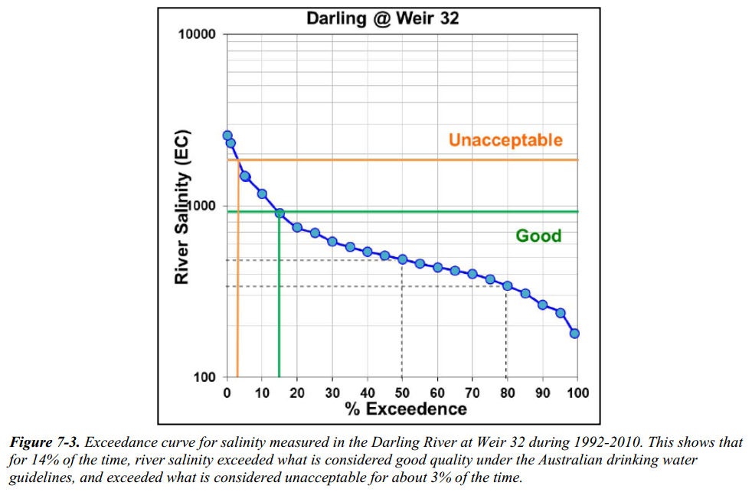
Ward, J. and Dillon, P. (2011). Robust policy design for managed aquifer recharge. Waterlines Report Series No 38, January 2011, 28p. http://webarchive.nla.gov.au/gov/20160615084848/http://archive.nwc.gov.au/library/waterlines/38 (accessed 27 Feb 2018)
Appendix 2: Menindee Lakes diversion June 2010 - and implications for possible future MAR operations

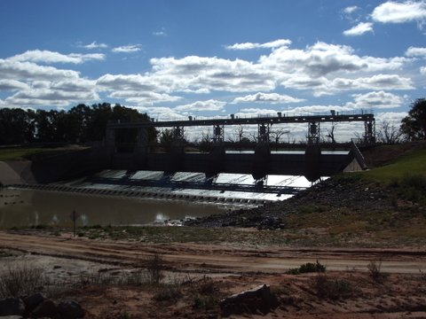
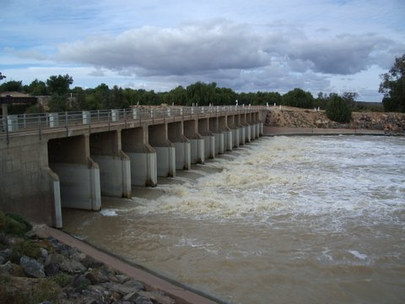
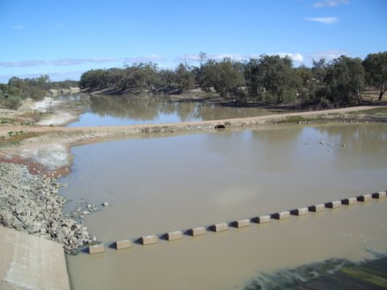
The Main Weir at Lake Wetherell allows diversion of water from the River Darling into the Menindee Lakes system.
Photo P. Dillon 7/6/2010 5:25pm

This photo shows the water being diverted by the Main Weir into the Menindee Lakes system in June 2010. There was a standing wave in the diversion structure as deep water discharged at high velocity through the diversion.
Photo P. Dillon 6/6/2010 5:52pm

This is the River Darling immediately downstream of the Main Weir that forms Lake Wetherell. No flow is being released. There is a trickle of dam leakage that passes through a 1m diameter culvert about half full at low velocity into the river bed downstream.
Photo P. Dillon 7/6/2010 5:37pm

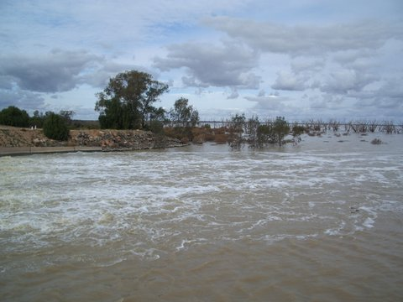
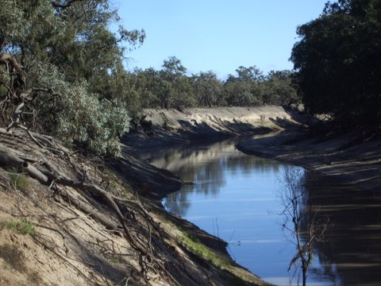
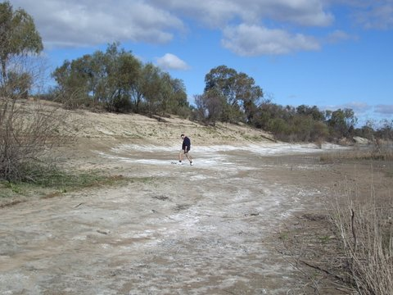
Water diverted by the Main Weir passing into the Menindee Lakes system in June 2010.
Photo P.Dillon 6/6/2010 5:54pm

The River Darling further downstream of the Main Weir at the proposed Talyawalka borefield site. Water is pooled at a low level with very low flow rate. Freshwater releases during high flow events would benefit MAR systems as well as the stream environment.
Photo P. Dillon 7/6/2010 1:57pm

Salt efflorescence on the dry banks of the River Darling about 0.5km downstream of the main weir that forms Lake Wetherell. These may increase salinity of first flush of releases and hence delay utility of the released water for recharging aquifers used as drinking water supplies.
Photo P.Dillon 7/6/2010 5:08pm

Observations and corollary for MAR:
In June 2010 a high flow came down the Darling River into Lake Wetherell. At the main weir ALL this flow was diverted to the Menindee Lake System and NONE was released downstream.
If lake levels are below the threshold for NSW management it would appear that ALL water is diverted to the lakes, with no minimum percentage of inflow released for restoring the river environment downstream of Lake Wetherell.
The establishment of a MAR system for replenishing fresh aquifers used for Broken Hill water supplies when Darling flows are inadequate or of poor quality would relax the requirement for diversions just as the proposed pipeline from the Murray would do. A high quality drinking water resource would be sustained through extended droughts by a mean annual volume of recharge, equivalent to the volume of mean annual groundwater use, and occurring only in years when flow and water quality are suitable (as per Appendix 1).

