MEASURING PERFORMANCE FOR “LONG HORIZON” INVESTING
Introduction

This paper explores the benefits of an enhanced performance measurement process i.e. “Long Horizon Investment (LHI) performance measurement”

The objective of this paper is not to introduce ground breaking new thinking but rather to leverage the research and ideas of others to highlight the potential benefits of LHI performance measurement. Although the concepts of measuring performance in the LHI world have been well documented over many years, there appears to be little evidence of the application of these performance measurement concepts by asset owners practising LHI.

Executive summary

There are many highly credentialed advocates of LHI performance measurement whose works are referenced throughout this paper. The advocates include the likes of John Maynard Keynes, Jack Bogle, Warren Buffet, Peter Lynch, Keith Ambachtsheer, Robert Merton, Robert Jeffrey, the numerous authors of papers by The World Economics Forum, John Kay and (albeit obliquely) even Jane Austen.

It is considered that LHI performance measurement can add value within a pension fund by adding another dimension to the investment performance measurement process i.e. looking through to the underlying earnings of the investment assets in addition to the current appraisal of market value movements.

The most prevalent benchmark for pension funds in many countries is peer comparison. This misses the fundamental point that a pension fund member cares deeply about “adequacy in retirement” and very little (if at all) about how well his fund compares with peers.

Whilst setting a benchmark of “adequacy in retirement” for a DC plan is problematic, many pension funds can, and do set an absolute long term objective of CPI + (say) 4%. The assumption here is that over a member’s working life (and given appropriate contributions to the fund), this realistic investment objective will indeed provide “adequacy in retirement”. The problem with performance measurement against such an absolute benchmark is how to measure performance in the short term. A trustee cannot wait 30 or 40 years to see if the investment objective is met, he must be able to assess performance along the way. The trustee needs the answer to the question “was the absolute investment return a good or not so good outcome over the most recent short term periods?” The introduction of Long Horizon Investing (LHI) performance measurement will undoubtedly help provide an answer to this question.

What is Long Horizon Investing (LHI)?

Long-term investing, as defined by the World Economic Forum, is “investing with the expectation of holding an asset for an indefinite period of time by an investor with the capability to do so.” In essence, it is investment carried out over years, and sometimes decades or generations, by institutions such as pension funds, endowment funds and sovereign wealth funds.

LHI is not trading for short term gains. LHI focuses on the generation of sustainable cash flows from quality investment earnings over the long run rather than on unsustainable short term capital gains. It could be argued that a pension fund with an objective of providing members with adequacy in retirement should be inclined to subscribe to LHI ideals and should measure investment performance and risk accordingly.

In the context of a pension fund with the expectation of positive cash flows, LHI becomes a reality at the fund level. Investment assets need not be liquidated to fund payments out of the fund but are liquidated only to enable the proceeds to be reinvested in more attractive investment opportunities.

The advocates of LHI performance measurement

In a speech given in 2005 at the NCREIF-PREA Fall Conference Robert Merton pronounced that “What matters to people, particularly in the context of the retirement part of the life cycle, is not how much wealth they have but the standard of living they can enjoy. The standard of living is much better represented as a lifetime flow or perpetuity than as a stock of wealth. What we see is another dimension of risk in addition to wealth—changes in what you can earn with that wealth…”.
In a recent article Merton points out that “The government benefit doesn’t give you a pot. The most intuitive thing for people is income. Income correlates with standard of living, in every aspect”

A greater focus on income streams as opposed to market values could provide additional and deeper insights into investment performance particularly during times of high market volatility. For example, changes in market value are driven by factors other than a manager’s skill and these factors will frequently mask what is really happening in the portfolio.

This view was recently echoed in an article by Keith Ambachtsheer in which he argued that consistent with the thinking of John Maynard Keynes the thing we should want to measure is “a process that converts savings into wealth-producing capital, which in turn pays income back to its investors. It is not trading securities in investment markets with the goal of outsmarting other traders”. (Keynes believed that people priced shares not based on what they thought their fundamental value was, but rather on what they thought everyone else thought their value was).
Ambachtsheer’s views are supported in an article by Robert Jeffrey where he states that “Unless you’re in a liquidating mode, what really matters is the growth in earnings and dividends, not the market value of your portfolio”.
Similar views are expressed in the paper “The Fecundity of Endowments and Long-Duration Trusts” written by James Garland in 2004. (Fecundity is defined as the long term ability to generate spendable cash.) In his paper Garland concludes that “In England two hundred years ago, it was not uncommon to measure wealth in terms of the income it produced rather than its market value…But in the investment community, which is dominated by retirement funds awash in transactional data, market values have become the universal denominator of wealth. Many trustees have lost their focus – they’re monitoring market values when they should be monitoring fecundity.”
Garland argued in the same paper that the concept of fecundity is actually not new it’s just been forgotten.
Jack Bogle wrote “Investing is all about the long term ownership of businesses… Over more than a century the rising value of our corporate wealth – the cumulative accretion of dividend yields and earnings growth – resembles a gently upward-sloping line with, at least during the past 75 years, precious few significant aberrations. Speculation is precisely the opposite. It is all about the short term trading, not long term holding of financial instruments … largely focussed on the belief that their prices, as distinct from their intrinsic values, will rise … A line representing the path of stock prices over the same period is significantly more jagged and spasmodic than the line showing investment returns.” Bogle adds that “in the short run, investment returns are only tenuously linked with speculative (i.e. market value based) returns. But in the long run, both returns must be – and will be – identical.” Bogle reviews stock market returns between 1900 and 2007 and concludes that “In the long run, stock returns have depended almost entirely on the reality of the relatively predictable investment returns earned by the business. The totally unpredictable perceptions of market participation reflected in momentary stock prices and in the changing multiples that drive speculative returns, essentially have counted for nothing”
Bogle has been named by Fortune magazine as one of the four investment giants of the 20th century. It is relevant to quote from another two of the “investment giants” in this context. Warren Buffet (Berkshire Hathaway) quoted “Put together a portfolio of companies whose aggregate earnings march upward over the years, and so also will the portfolio's market value”. The emphasis is that the earnings ultimately drive the market value and is consistent with Berkshire Hathaway’s benchmark of the S&P500 over a rolling five year period.
Peter Lynch (the founder of Fidelity Investments) is the third of Fortune Magazine’s investment giants. His style was to shut out market noise and concentrate on a company's fundamentals. He invested only for the long run and paid little attention to short-term market fluctuations. To quote Lynch, “Although it's easy to forget sometimes, a share is not a lottery ticket... it's part-ownership of a business”
Finally, it is interesting to note that in Jane Austen’s classic novel, Pride and Prejudice, when the author evaluates Darcy and all the other men, she didn’t say he was worth £200,000. She said he was worth £10,000 a year.
What are the issues with measuring performance for LHI?
The World Economic Forum’s report The Future of Long-term Investing noted that a major challenge facing would-be long-term investors is developing “performance measurement systems that balance fostering a long-term perspective with short-term accountability.”

In a second paper the World Economic Forum observed that “There is a natural fondness for measurement on an annual or more frequent basis. But measuring long-term investment results quarterly or annually exposes the long-term investor to the risk of mismeasurement. It is difficult to discern whether a poor short-term result indicates a bad long-term strategy or a short term market drop”.

The key issue is that in theory the performance of LHI should be measured (naturally) over a long horizon. In practice however pension fund trustees need to monitor and assess performance along the way. The question of “how might we achieve this?” is addressed in this paper.

What are the issues with traditional performance measurement methodologies in the Long Horizon Investing world?

There is an implicit assumption in market value measurement that the assets must be liquidated at a point in time. This appears to be inconsistent with the philosophy of Long Horizon Investing and indeed the reality of a pension fund with positive member cash flows.
In a recent article in the Harvard Business Review it was claimed that “asset managers with a short-term focus are increasingly setting prices in public markets. They take a narrow view of a stock’s value that is unlikely to lead to efficient pricing and collectively leads to herd behaviour, excess volatility, and bubbles”

There are many examples where short term returns (i.e. changes in market value) are driven by macro-economic factors or market sentiment rather than the fundamental earning capacity of the fund’s investments.

The charts below show five well documented examples of extremely volatile returns as measured by changes in market value.

The examples chosen are

- The 1987 stock market crash
- The “Tech Wreck” in the late 1990s
- The GFC
- The US housing market from 2006
- The Dutch tulip mania in the 1600s

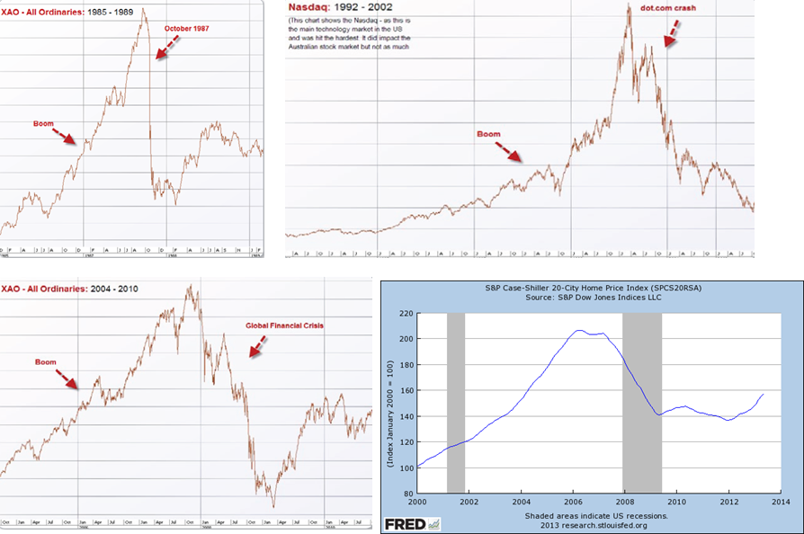

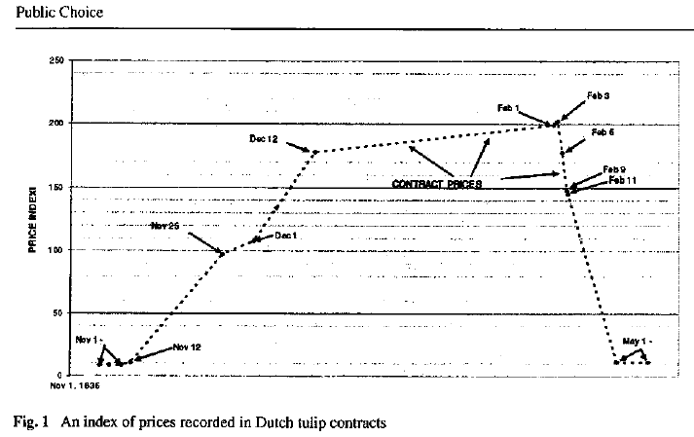 “Tulip mania” in the 1600s

The charts underline the fact that an assumption that market value fairly reflects an investment asset’s ability to deliver future income streams has been far from the truth. Given this fact, it could be argued that the use of market values to measure performance, particularly in the short term is likely to give spurious results.

A recent survey by the CFA Institute in the CFA Institute Financial NewsBrief, readers were asked whether they thought equity markets would be driven more by macroeconomic or company-specific news over the following 12 months.

The response was overwhelmingly in favour of the former.

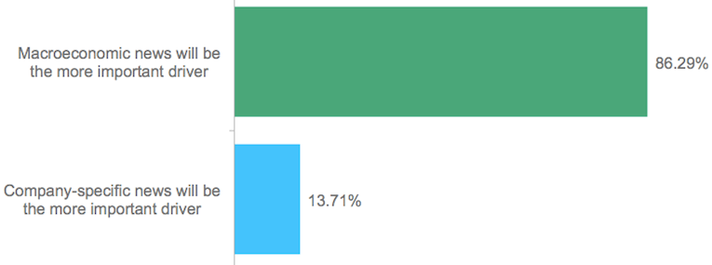

The report noted that since the onset of the 2008 financial crisis, the markets have been driven by global macro events, particularly in the form of government support and stimulus from the US Federal Reserve, large scale asset purchases by the European Central Bank and the introduction of “Abenomics” in Japan.

It can be seen that with current performance measurement methods focussing on asset valuations at a point in time, the realities of long horizon returns and true implications of price volatility can be easily misrepresented.
If a pension fund member aims to rely on an income stream from their investments to support retirement the member becomes largely immune to market volatility. On the other hand if the member relies on the liquidation of their assets they become extremely vulnerable to volatility. In reality however a pension fund member will liquidate their assets (if at all) over a period of 20 or more years during the period between retirement and death. In the UK this reality will become glaringly obvious as pension fund members will no longer be required to invest a lump sum in an annuity at retirement.

Why do current performance measurement methods prevail?
Pension funds globally focus on the value of a member’s assets at an arbitrary point in time (i.e. the day retirement commences) rather than on the income the member will receive throughout retirement.
Pension fund surveys are fixated on total return based on movements in market values and this no doubt has a major influence on how each fund’s performance is measured internally and consequently how assets are managed and how incentives are paid. This process misses the fundamental point that an increase in market value in one period does not necessarily mean an increased ability to generate income, an increase in market value in one period can frequently be reversed in a subsequent period.
Ambachtsheer sheds further light on this issue when he refers to the works of Nobel Prize Laureate George Akerlof. Akerlof showed that effective competitive markets assume informational symmetry between buyers and sellers. The point is that if sellers are better informed about what they are selling than the buyers, the latter will pay too much for the service. Ambachtsheer is firmly of the view that for investment management services evidence overwhelmingly supports the view that knowledgeable sellers have for a very long time been able to persuade unknowing buyers that “beauty contest” investing (i.e. measuring performance based on market values) is the game.
These views are echoed by Robert Merton when he argues that the culture of interpreting pensions in terms of fund values has developed because the DC sector has emerged from the mutual fund industry.
Towers Watson released a paper in May 2014 which highlighted a quote by Upton Sinclair “It is difficult to get a man to understand something when his salary depends on his not understanding it.” The paper’s focus is on research amongst industry intermediaries which suggests that the investment industry is primarily designed to help the agents working within the industry rather than the ultimate beneficiaries through, inter alia, excessive short termism. The paper notes that this does not reflect favourably on the industry.

How can we develop a suitable methodology for measuring LHI?

Earlier in this paper we refer to a letter by Keith Ambachtsheer. In this letter Ambachtsheer’s view is that “the answer (to performance measurement) lies in focussing less on short term total return outcomes and more on the size, quality and growth of the income stream the investments are producing”. He notes that only the investment income received from invested capital should be available for reinvestment or pension payments. Shorter term capital value dips should be of no consequence unless they reflect impairment on the investee organisation’s capacity to pay out future investment income.
In an earlier publication Ambachtsheer refers to the “Majority School” and the “Minority School”. To quote, “The Majority School treats the long term as a series of sequential short term periods and attempts to maximise return within each of these short term periods … The primary focus is on capital returns rather than income returns as the former dominate the latter over short horizons. The Minority School treats the long term as a multi-year, long-horizon holding period and buys, nurtures, grows an investment income stream over that period. Shorter term capital value fluctuations are viewed by the Minority School as distractions as they play no role in the success or failure of its long-term investment income generation strategy.” Ambachtsheer appears to be in good company when he quotes the support of the Minority School shown by John Maynard Keynes. He goes further to make the point that “ironically, while the Minority School approach logically offers the better odds for success, most Boards and Investment Committees continue to opt for what they see others doing. And that is what is keeping the Majority School the majority.”
The views of Merton, Ambachtsheer, Bogle, Kay, Jeffrey and Garland (and indeed Keynes) provide key insights into how a performance measurement methodology could be developed. A methodology that focuses on the fundamental earnings of the fund rather than movements in market value seems to provide one answer.
An example of an LHI performance measurement model
The key issues
Traditional “old world” market value based investment performance analytics has been evolving over a number of decades. The process and underlying methodologies have become increasingly sophisticated and the same should be expected of “new world” LHI methodologies. The model outlined in this paper is the beginning of a long road and is intended to be exactly that. Nevertheless it is a ground breaking departure from the historical thinking that has invaded and virtually mesmerised performance analysts, pension fund trustees and others for decades.
There are a number of key considerations in developing an LHI model including
  - The distinction between “Income” and “earnings”
  - The treatment of derivatives
  - The impact of tax
  - The treatment of retained earnings
  - FX gains/losses
  - The denominator for percentage return calculations
Our model outlines solutions to all these issues. There will undoubtedly be other solutions to consider and we are not suggesting that our solutions are necessarily the only or best solutions. Nevertheless they do provide an immediate way forward for the LHI journey
Income and earnings
The distinction between “income” and “earnings” is quite simple and can be summarised as follows
  - “income” = cash dividends, coupons, distributions etc. in the bank
  - “earnings” = P&L
The distinction is important because investment assets that produce earnings but distribute little or no income can nevertheless be expected to increase in value over time.
In our initial model the definition of income and earnings for each asset class is as follows
  - Income = cash income in the bank
  - Earnings
    - Equities = EPS * no of shares
      - The assumption is that market value is not primarily driven by earnings in the short term
    - All other asset classes earnings = the MV based hedged return for the portfolio or the P&L per financial statements
      - If the assumption made is that market value is primarily driven by earnings in the short term the MV based hedged return may be a good proxy. Otherwise P&L can be used
Our early model focusses on equities because equities are by far the largest contributor to volatility and is therefore the asset class that requires the greatest initial focus
How to source the data
How to source income and earnings
- Income is recorded in the custodian’s or pension fund’s book of records for every security
- EPS is available from data vendors e.g. Thomson Reuters, Bloomberg, etc.
- P&L is sourced from financial statements
Derivatives
Income and earnings for derivatives used for hedging or leverage purposes are easily derived
  - Income = zero
  - Earnings = earnings of underlying physical securities e.g. earnings of an Australian SPI futures contract = the earnings of a cap weighted basket of ASX 200 equities
In the case of a derivate based traded hedge fund it could be argued that the P&L in the fund is in fact the income and the earnings
FX
It is essential to strip out embedded FX exposures in overseas assets as their volatility can dwarf the underlying earnings of the investment asset.
All overseas portfolio returns must be calculated on both an unhedged and notionally hedged basis. It is the notionally hedged return that must be evaluated in the LHI model.
The denominator
This is critical to the construction of the LHI model. What is the denominator for return calculations? It could be
  - Market value?
  - Cost?
  - Initial MV or cost indexed by
    - CPI?
    - Other?
  - Initial MV plus earnings?
Our analysis leans heavily towards the use of market value incremented year by year by retained earnings. In theory an investment asset should increase in value by the earnings that have not been distributed to the owners of the asset. The chart below shows a comparison between returns on the ASX 200 based on (a) traditional market values (old world) and (b) initial market values incremented by retained earnings (new world)
It is apparent that returns based on traditional market values provide very little useful information in the short term in respect of progress towards the long horizon goal, whereas returns based on the incrementing of initial market values with retained earnings provides a deep insight into the actual returns of the portfolio year by year. In this sample period both measures provide near identical returns over the long horizon but the more useful measure over shorter periods is without doubt the new world LHI model.

The next chart shows a similar story with an actual portfolio with an ASX 200 market capital weighted benchmark. Again it can be clearly seen that with the use of old world market value based techniques it is impossible to form a judgement in respect of progress towards the LHI goals. The LHI returns however provide a completely different story, giving fund trustees meaningful insights into short term progress towards the long horizon goals

Reconciliation of “new world” LHI returns to “old world” market value based returns
This is surprisingly simple.
In the new world LHI thinking
Start MV + earnings = End MV (LHI return)
In the old world market value based thinking
Start MV + earnings + unexplained = End MV (MV based return)
The difference between the new world LHI return and the old world market value based return is what we term “market sentiment” i.e. the impact of macro-economic factors and irrational human behaviour.
The sample chart below illustrates how this market sentiment can be stripped out of the analysis and shown as a separate and clearly quantified number.
For example it would appear under old world market value based methods that the passive international equities portfolio returned 37.65% over the period. The new world LHI method shows that the actual return based on underlying earnings of the portfolio was in fact 5.99% and that the difference between the two numbers was made up of 17.24% in foreign exchange fluctuations and 14.28% of unexplained market sentiment. It should be expected that the market sentiment number would fluctuate markedly between positive and negative numbers year on year. This analysis enables the pension fund trustee to look into the true progress towards toward long term outcomes rather than being blinded by short term market aberrations.
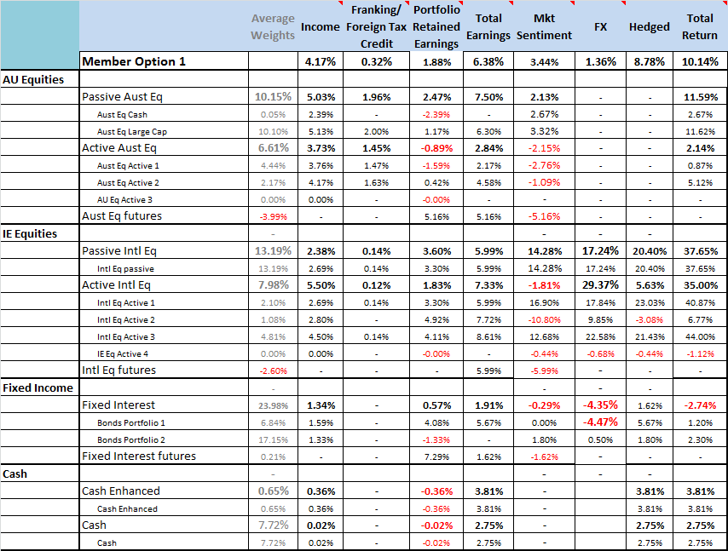
Conclusion
Much of the research referred to in this paper has been conducted over decades. It is ironic to note that in his paper written in 1977 Robert Jeffrey’s first sentence was “The concept – or at least importance – of measuring the earnings and dividend growth of a portfolio is an idea whose time is yet to come”
Jeffrey argues in a later paper that key benefits of LHI performance include the observations that
- Volatility of dividends is much lower
- Market values are driven by investors, dividends are driven by the company
- Managers can be held more accountable for income growth rate
- Income growth is long term proxy for capital growth
- Dividends have been an inflation hedge, market values have not
- Portfolio owners will better understand their investments if they focus on income
- LHI performance should be seen as complimentary to and not a replacement for
traditional methods
Since that time, Jeffrey’s views have been consistently reinforced by individuals whose credentials in the pension and investment world are of the highest order.
Ambachtsheer concludes one of his papers by asking the question “who can change the (“beauty parade”) game?” He answers this question himself when he writes “Only the owners of the assets e.g. pension fund trustees exercising their fiduciary duties”.
This sentiment is reinforced in Barton and Wiseman’s Harvard Business Review article where they state in the conclusion that “We are convinced that the best place to start moving this debate from ideas to action is with the people who provide the essential fuel for capitalism—the world’s major asset owners. Until these organizations radically change their approach, the other key players—asset managers, corporate boards, and company executives—will likely remain trapped in value-destroying short-termism. But by accepting the opportunity and responsibility to be leaders who act in the best interests of individual savers, large asset owners can be a powerful force for instituting the kind of balanced, long-term capitalism that ultimately benefits everyone.”
The application of LHI performance measurement within a pension fund today may provide a solution to a problem that the fund might otherwise be unable to fully provide in the context of meeting an objective of “adequacy in retirement” i.e. was the investment risk and absolute return of the fund a “good” or “bad” outcome over recent times.
Perhaps most importantly LHI performance measurement provides insight into the success or otherwise of a fund’s strategic asset allocation rather than measuring the often limited value added above or below this benchmark by investment management skill.

(author of The Kay review of UK Equity Markets and Long Term Decision Making commissioned by the UK government)
http://reports.weforum.org/global-agenda-council-2012/councils/long-term-investing/
http://www.people.hbs.edu/rmerton/PREA%20Journal%20Article%202%2006.pdf
Nobel Laureate Robert C. Merton, Ph.D., His roles have included University Professor Emeritus at Harvard Business School and resident scientist at Dimensional Fund Advisers
Robert Merton, MoneyMarketing - It’s the income, stupid 13 August 2013
July 2013 edition of The AMBACHTSHEER Letter
Journal of Portfolio Management 1977 Internal Portfolio Growth: the Better Measure
Economics and Portfolio Strategy September 15 2004
Garland is president at the Jeffrey Company and has authored a number of academic papers on the merits of measuring performance based on income rather than market value
Jack Bogle was the founder of Vanguard Investments and has been named by Fortune magazine as one of the four “Investment Giants” of the 20th century. The quotes are from his book “Enough” published in 2009
Warren Buffet’s letter to shareholders of Berkshire Hathaway 1996
The Greatest Investors: Peter Lynch by Richard Loth
One Up On Wall Street, Peter Lynch 1989
World Economics Forum USA Inc. The Future of Long Term Investing
World Economics Forum USA Inc Measurement, Governance and Long Term Investing March 2012
January-February 2014 Focusing Capital on the Long Term by Dominic Barton and Mark Wiseman
The Tulip mania: Fact or artefact Earl A Thompson 2006
CFA Institute Enterprising Investor 18 July 2013
FAJ Guest Editorial May/June 2013
Robert Merton MoneyMarketing – It’s the income stupid, 13 August 2013
Our industry has a problem. The investment industry has been built by the intermediaries for the intermediaries. Towers Watson May 2014
The Ambachtsheer Letter November 2012
Journal of Portfolio Management 1977 Internal Portfolio Growth: the Better Measure
Portfolio Income Growth: A Third Dimension to Performance Measurement (Spring 1980)
January-February 2014 Focusing Capital on the Long Term by Dominic Barton and Mark Wiseman

