Attachment A
Copy of a submission made in 2013

COSBOA

Super paid via Tax

A goal of COSBOA is to simplify superannuation payments for employers by incorporating them into one tax payment made with each Business Activity Statement (BAS). During the “Simple Super” negotiations COSBOA proposed that Superannuation payments were much simpler for Employers if they didn’t have to pay them separately but incorporated them into employee PAYG tax payments.

With the payment of super via the tax office now seriously being considered by the current Opposition (and potentially the alternate government) it is timely to re-visit the COSBOA proposal with further comment.

Executive Summary

Regulations and Administration processes removed.
- Separate Administration for the payment of Super to multiple funds removed.
- Choice of Super administration and multiple penalties removed.
- Employer “Default” Super Fund requirement and associated penalties removed.
- Separate reference to Superannuation Guarantee in awards not required.
- Separate late payment penalty system on employers removed.
- The “No TFN” payment system not required.
- Superannuation “failure to keep records” penalties removed
- Files and communications with multiple Super Funds (beyond payment system) not required.

Efficiencies achieved
- Communications (monthly quarterly and annually) between ~800,000 employers and ~1000 super funds regarding ~10,000,000 employees eliminated.
- Immediate capture of Lost Super by ATO
- Immediate accumulation of SG tax by ATO
- Quicker identification of non-payment of super by ATO
- Greater connection of employees with their super from their first employment event.
- Potentially two billion dollars in administration costs removed from the industry

Issues to be addressed
- Current SG calculations are based on AWOTE and would need to be on Gross Wages.
- Extra Super from overtime adjusted in SG move from 9% to 12%
- Super would be payable of all wages including payments below $450 per month ($54 extra super per month at 12% SG). This also removes Superannuation threshold anomalies in the award system
- Adjustment of the Superstream/payslip project to allow employees to authorise the transfer of gross pay information to their super fund.
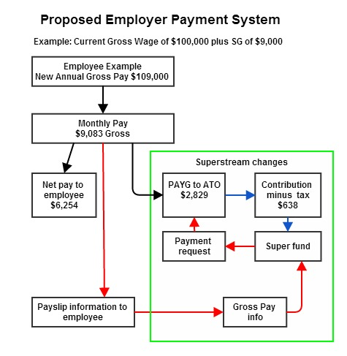

Detailed Proposal

The COSBOA proposition is for employer SG (Superannuation Guarantee) payments to be incorporated into the employee’s PAYG tax payments by adjusting the personal tax rate so that only one payment is required. The tax office would then distribute these to the appropriate Super fund.
This would eliminate a significant amount of administrative burden from the small business employer’s obligations. To provide concrete proposals to back this case a systems analysis of the SG Super system (Attachment 2) was undertaken and a draft proposal (Attachment 3) developed along with an adjusted TFN declaration so the ATO immediately captures employee superannuation details (Attachment 4). The proposed system gives significant reduction in regulation and administration for small business employers.

Basic System for SG Payments.
As both PAYG and the very basic system for paying SG payments are calculated as a percentage of Gross Wages, both can be incorporated by raising the PAYG rate by an equivalent percentage to include the SG rate, for example:
- a 9% SG rate would be achieved by raising the PAYG rate by 8.2569%.(Note: the actual increase in PAYG can be suitably rounded to a manageable number during the SG increase from 9% to 12 %.)
The Tax office identifies the amount of Superannuation included in these tax payment by applying the set SG percentage to the gross wages declared at W1 on the BAS return.
In line with current requirements the employer provides a payslip to the employee. This payslip now only has to show tax withheld and is significantly simplified by removing nominations of superannuation payments. An example of this process is attached (Attachment 1)

Employee takes responsibility using the Superstream changes.

Identification of Individual Superannuation payments
A modified Employee Tax File declaration was developed and accepted by the “Stronger Super” committees that linked an employee’s TFN directly to their superannuation fund.
The form (Attachment 3) incorporates a “Superannuation File Number” with the TFN declaration.
This gives a firm connection between the TFN and the superfund member.

Move to electronic payslips by 2016 gives employees control of their Super Payments
- The current Superstream project aims to have all participants using the new data and e-commerce standards by 2016. This includes electronic payslips to each employee.
- This process only requires minor adjustment to allow employees to authorise the forwarding of the gross wages data to their super fund.
- Employers only need forward that data to where the employee stipulates and they will have fulfilled their duties in this regard.
- The Superannuation industry can set up the protocols for gaining the employee authority to receive their pay information

The Timing of transfer of funds from the Tax Office to individual Funds.

- Annual:
  - Employee puts in their tax return and the accumulated Superannuation is determined from the tax paid on Gross Income. The Tax Office matches the accumulated Super with the Super Fund nominated on the TFN. The net funds (minus SG tax) are transferred to the appropriate Super fund.
  - This is an adaption of the current the Tax Office system where “Superannuation Guarantee Charge” from late super payments are paid by business to the ATO and then passed onto the appropriate Super Fund.
  - The annual system is appropriate where employees are in their first year of employment and have not chosen their fund as yet or they are itinerant with very patchy employment history and do not have consistent habits in consolidating their super.
- Quarterly: Employees provide details of their payslips to their Superannuation funds who make a claim against payments held by the tax office. Once the quarterly payments from the employer are received the Tax Office transfers the funds (net of tax) to the Super Fund.
- Monthly: (where employers do BAS payments monthly): Employees provide details of their payslips to their Superannuation funds who make a claim against payments held by the tax office. Once the quarterly payments from the employer are received the Tax Office transfers the funds (net of tax) to the Super Fund.
- Employer late payments: A general interest charge is applied as per the current tax payment systems.
- Employer non-payment: Normal Tax office protocols apply for non-payment of taxes.

Payments Not Part of PAYG

Personal Contributions.
Personal Contributions are not the responsibility of an employer. Where an employer wishes to provide this service (through an employee service culture or an enterprise agreement) they can do so through their own administrative choice. This option is much easier for large employers and does not need to be universally applied to all employers.

Salary sacrifice.
Salary sacrifice is the choice of the employee. Currently an agreement needs to be arranged between the employer and the employee for this to occur. This process is clumsy and subject to possible mistakes by employers e.g. overpayment and excess contribution taxes or claiming salary sacrifice as SG liability amounts.
To allow salary sacrifice to occur without having to involve employers the following procedure is proposed;
- The employee forwards the post-tax portion of a Salary Sacrifice payment to their super fund and nominates it as salary sacrifice.
- The calculation of these amounts can be carried out with the help of financial advisers associated with their super fund.
- The current pay and tax rate is identifiable from their payslip.
- The Super Fund then draws the taxed amount from the Tax Office (net of SG tax).
- With electronic payslip notification this process can be automated.

Self Employed
The self-employed (noncorporatised) are not part of the SG system and do not need adjustment.Where they choose to contribute to Super the current system of making a claim for a personal deductible contribution can continue.

Corporatised Self-employed.
There appears no impediment to this category of employee using the overall system.

SMSFs
The Superstream e-commerce standards are being extended to SMSFs and they should be able to fit in with the new SG Super payments via PAYG as applicable.

Defined Benefit/Payment Schemes
Given the complications and variations within this sector of the superannuation system it is beyond the author’s capability to provide individual options. Prima facie it appears this system should be adaptable to the new situation as the system mainly relies on calculation rather than actual cash flow and an adjustment the formulae may be all that is needed to fit the new system. COSBOA is open to feedback on any issues found.

Issues to be addressed

Extension of AWOTE coverage to include Overtime payments.
To allow the simple application of this process to all employer payments the superannuation guarantee payments would need to cover wages beyond AWOTE. Given there is a rise in the SG rate currently being implemented it is proposed that the final rate is adjusted to balance out the added costs to business.

Casual employees under $450 per month
Remove the lower limit on superannuation payments. The cost to a business per employee of approximately $50 per month is more than offset by the removal of the cost of administration of superannuation for all employees.

SBR requirements to allow Straight Through Processing of Payslips
The current Superstream programme aims at standardising the e-commerce systems for transferring superannuation payments between all participants within the industry. COSBOA is of the opinion that once an employee payment (including PAYG tax) has been made and payslip information provided the employer should no longer be part of the administration system associated with those payments. It is then the responsibility of the employee how that money is handled.
Given the whole administration system is currently being changed to an e-commerce platform the opportunity should be taken to allow the employee to forward their Gross Wages information to their chosen Super Fund. By adjusting the Superstream process this can be incorporated into the project. As part of normal employment practice the employee can nominate to the employer where they want their payslip information sent. The Superfunds arrange directly with the employee for the forwarding of their information and this process should be incorporated into the SBR project currently underway for Superstream.

Breaches and Regulations Removed
Removal of:
- Employer Requirement to choose a Default Super Fund.
- Employer requirement to provide new employees details of the default fund.
- Employer requirement to choose insurance for an employee in the default super fund.
- Employer requirement to provide a “Choice of Super” form to a new employee.
- Employer Requirement to wait up to 30 days for a Choice form to be returned (if at all) before finalising the new employee start up process.
- Requirement for separate administration of “No TFN provided” situations for Super and wages.
- Requirement for extra Employer admin each time an employee changed funds.
- Employer Uncertainty as to what Super Fund an employee will choose or change to.
- Employer “Choice Liability” breach and associated fines.
- Employer superannuation liability charge statement.
- AllEmployer correspondence with potentially multiple Superannuation funds.
- VariousSuper funds demands for a signed contract with the Employer to provide a default fund
- Various Super funds demands for a signed contract with the Employer to provide a “Choice” fund for employees who choose their fund.
- “administrative penalties”on Employers around superannuation breaches
- “failure to keep Superannuation records” fines.
- Employer “Late payment” breaches
- Employer “Incorrect amount paid” breach
- Employer requirement to lodge a superannuation guarantee charge statement
- “Not providing a Superannuation guarantee charge statement” fines
- Lodgement of “Superannuation Guarantee late payment offset election” form
- Employer Requirement to provide employee TFN details to Super Funds
- The need to advise Super Funds when employees are not paid super or face legal demands.
- Employer Reporting Superannuation on annual Tax Office employee payment summary
- Employer Providing Confusing and complicated superannuation details on pay slips.
- Employer Breaches for providing incorrect superannuation details on a pay slip
- Separate administration of superannuation liabilities
- Separate calculations of super liabilities

Administrative improvements:

- Simple collection of Superannuation obligation rather than a separate and potentially confusing employer obligation
- Immediate Tax Office collection of SG tax.
- Immediate Tax Office collection of Lost Super where casual employees ignore small amounts of Super as they move to other jobs and don’t register their payslips with their super fund.
- Immediate Tax Office collection of “No TFN provided” amounts
- Direct and timely Tax Office involvement in unpaid Super situations
- Hundreds of millions of unnecessary repetitive transactions eliminated realising extensive administrative cost savings.

Improved connection of super members:
One of the major failures of the superannuation system is the sense of ownership employees have for their Super. Despite the “Choice of Super” regime and extensive advertising very few Australians have a sense of significant ownership of their superannuation. When they do gain a sense of ownership many then move their super into their own SMSF.

COSBOA believes this is primarily due to the complete disconnect that employees have with their super from their very first day of employment because;
- The concept of an “Employer” Default Super fund immediately divorces the employee from this payment.
- The fact that in many cases making a Choice of their fund is taken away from them because they think an Award directs where their Super should go further distances them from involvement
- The fact they are rarely if ever involved in directing where the payment of their Super should go gives them no immediate or continuing connection with their funds.
The recommended process of in the first instance sending employee super to the ATO and having the ATO directly contact the employee asking for direction as to where to send their super or it will be held by the tax office immediately and starkly brings this choice to the Employee. Ownership of their Super becomes real, no one wants to willingly leave extra funds with the ATO.
This process also introduces real competition into the Super Industry with each fund needing to vie with others to educate and attract employees to consider nominating their fund as their Choice.
A win win situation, employers are removed from the process and employees much more firmly connected to their Super.

Attachment 1: Employer Superannuation Guarantee Payments via PAYG Tax
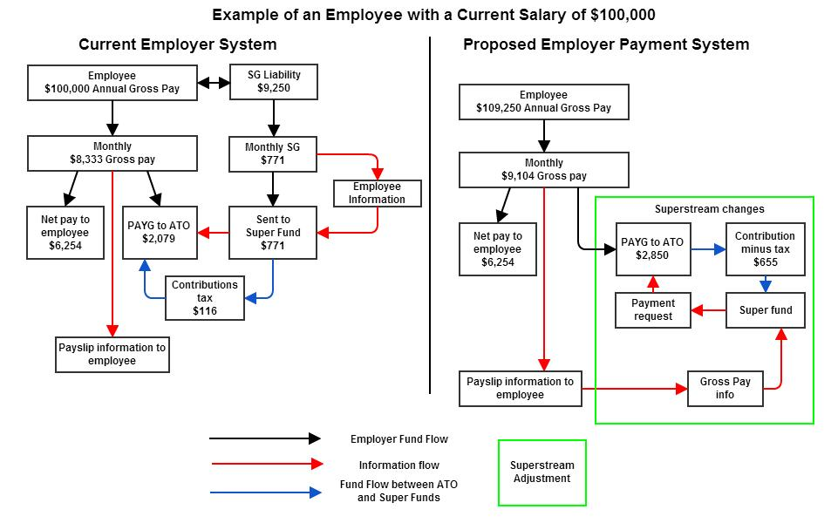

Attachment 2. Current Super System (with Stronger Super Adjustments)

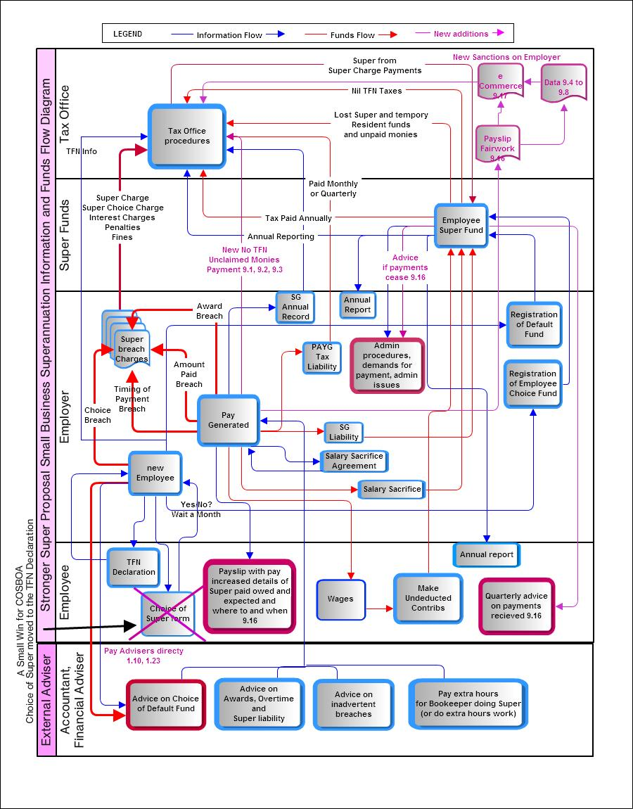

Attachment 3: Proposed Streamlined Super Process Using PAYG System

