Productivity Commission – Mental Health Submission
5 April 2019

Important Disclaimer:
Australians for Safe Medicines notes that the experiences of individuals cited in this submission include experiences of harm and distress. Australian for Safe Medicines reminds all its members and associates of the importance of making truthful and accurate statements about their experiences, but we cannot accept responsibility for the confidential and anonymous statements made by individuals in this submission or the legal risks that may arise from those statements.

About Australians For Safe Medicines

AFSM is a consumer-led incorporated association of individuals that aims to improve medicine safety.

Our objectives are to promote the safe prescribing, dispensing, and consumption of prescription medicines in Australia including to:

- Educate consumers to make informed decisions on prescription medicines.
- Collect consumer stories and data for the purposes of advocating on behalf of the consumers.
- Engage with key stakeholders (such as the Government, regulatory authorities, media, health practitioners, and manufacturers) on medicine safety initiatives and concerns.
- Any other activities consistent with the key objectives of promoting safe medicines.

We are not for medicines. We are not against them. We are better health through the quality use of medicines.

Our comments will be focused on consumer experiences around mental health medicines consistent with our objectives.

The Primacy of The Consumer
The National Strategy for the Quality Use of Medicines (QUM) states the consumer is primacy and acknowledges the wisdom of the consumer.

Research shows that medication errors occur when decisions are based on a doctor’s perception of a patient rather than the consumer’s/carer’s experience. This includes “ignoring patient’s knowledge, disrespecting patients, failing to communicate, and manipulation and deception”.

Practically, many consumers experience significant barriers to communication with key stakeholders and many key stakeholders perceive rather than seek to understand consumer experiences.

This appears particularly problematic in mental health if stakeholders presume they know the consumer’s mind better than them or their carers.

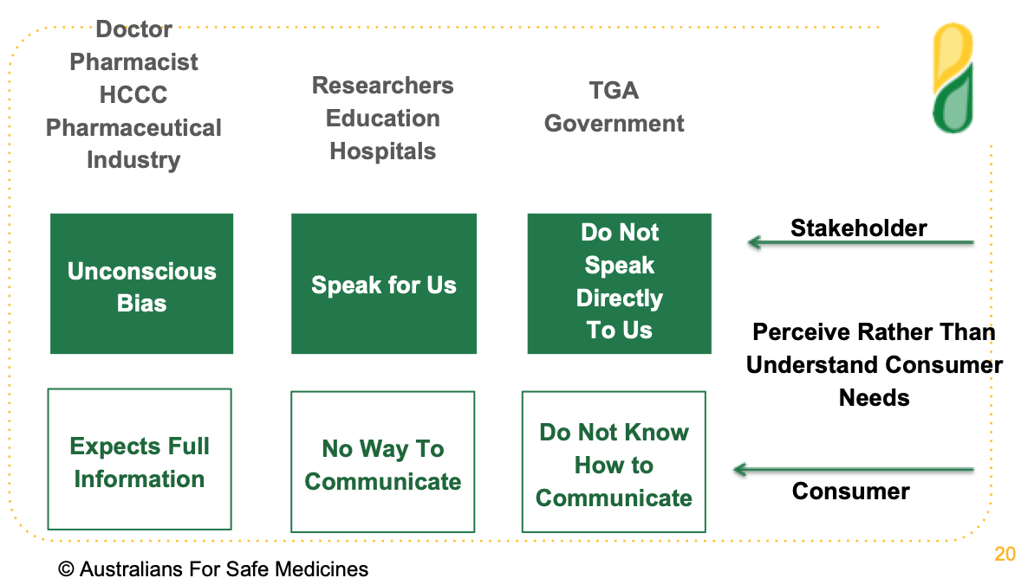
Extract from Australians for Safe Medicines Presentation to The University of Sydney
International Symposium on Public Involvement in Health Service Research, February 2019

We consider the “Choose Wisely” campaign initiated by NPS MedicineWise to be an important step to facilitating consumer engagement in their health decisions. However, when diagnosed with a mental health condition, an unconscious bias sees consumers/carers looses their right to choose.

Studies show that some key stakeholders have an unconscious bias towards medical practitioners as “the experts” despite research repeatedly showing that consumers report clinical information at a similar level as their healthcare professional.
For example, Consumer Medical Information is important to consumers. Yet Australian research shows that unconscious bias of medical practitioner (“they wont understand”) and pharmacists’ (“they are not interested”) towards consumers is a significant barrier to the provision of Consumer Medical Information.

We respectfully suggest that the importance of putting the consumer primacy in this inquiry is as follows:

- To solve the mental health medication crisis we have to start with the consumer experience and work back to the quality processes.
- Each consumer and/or their carer are the expert on his or her medicine experience. Their experiences should not be manipulated for the benefit of stakeholders.
- Healthcare practitioners and pharmaceutical companies are the experts on the science of medicines. They should be able to provide scientific evidence for their statements including what scientific evidence is missing rather than simply shutting the conversation down.
- When there is a striking contrast between consumer experiences and a medical practitioners clinical judgment, in the absence of robust scientific studies, the consumer experience must prevail until scientific studies are conducted. This is particularly relevant in cases of harm.

- It is not enough to be “content with an absence of evidence on harms … we need to move to a position where we have evidence of absence of harm”
- When the Australian Government fails to put the consumer first the taxpayer picks up the tab.

The Cost to the Australian Taxpayer

Medication errors are a very big problem in Australia.

Professor Ric Day, an internationally recognized clinical pharmacologist and expert in pharmacotherapy, drug reactions, and interactions, recently told the NSW Inquiry into healthcare services that the rate of medicine errors in Australia is very high and that in some Australian studies were almost 40 percent of admissions.

Appendix A contains the submission of Professor Ric Day to the recent NSW Public Account Committee Inquiry into the Delivery of Health Service in NSW.

This submission is further elucidated by the following facts:

- Up to 40% of mental health beds are occupied due to medication issues. For example, “A joint trial, carried out by Melbourne Health and genetic testing company GenesFX, showed that, of 170 psychiatric patients who took the test at mental health units in Bundoora and Sunshine, 36 per cent either metabolised their psychotropic medications too quickly or too slowly. Slow metabolisers, who risked dangerous side effects, stayed in hospital 27 days longer on average than patients with a normal metabolism. The trial found that personalised prescribing could have saved $1.2 million over 12 months for these psychiatric wards.”
Studies show patients who metabolize very slowly or too fast have 67% more medical visits and 4 times more disability claims than those with normal pharmacogenomic test results. There are now 12 published studies corroborating significant savings for applying pharmacogenetic.
- A Deloitte Economics report, commissioned in 2008 by the Australian Centre for Health Research, found the Australian health system could save $12 billion over five years if pharmacogenomics testing was widely adopted. These numbers did not include mental health, aged care, or government benefit payments (disability, carers, NDIS etc).
- This level of savings has been corroborated by a trial at Melbourne Health.
- An economic analysis, carried out by Victoria University, estimated that if all mental health admissions across Australia were tested, savings would be close to $500 million annually.
- In Australia, there were 57,008 adults on disability due to mental illness in 1990. The number rose to 241,335 in 2011 - a four-fold increase, despite the increased use in mental health prescription medicines.

- As June 2013, there were 821,7384 individuals receiving the DSP. At September 2013, there were 256,380 individuals receiving the DSP with a primary medical condition listed as ‘psychological/psychiatric’. This represented $4.67 billion in 2012–13.
- These numbers do not include consumers with a primary medical condition of a brain injury from mental health prescription medications (see below)
- No information was available to us for individual on newstart, the aged care pension, or the NDIS (those with brain injuries).
- As of 2016-17, there were 35.7 million mental health-related prescription written to over 4.00 million individuals. Our survey of consumers show that only 6% were not wanting to withdraw them, and that knowledge around withdrawal was a significant barrier to doing so (see below).

To say nothing of the cost to the consumer and their families.

Our Survey of Mental Health Consumers for This Inquiry
We surveyed consumers who have been diagnosed with a mental health condition and/or taken mental health medicines for this Inquiry.

Consumers or their carers were sourced from our database, via the Mental Health Carers NSW newsletter, and the NSW Health Consumers newsletter.

The survey ensured that consumers only answered questions that were relevant to them. So, for example, in question one, if consumers had not experienced a mental health condition or been placed on mental health medicines, they did not answer any questions. All consumers completed the survey.

Consumers were also asked what they want you to know and to provide us with a brief summary of their experience.

Our complete survey findings are in Appendix B. Consumer experiences with mental health are contained in Appendix C.

Productivity

We asked consumers what impact medicines had on their ability to generate income, manage financial affairs, do paid work, engage in learning and further education, undertake voluntary work, and participate in social and leisure activities.

Whilst a small number of consumers saw improvements in their productivity nearly three quarters across the board were worse off.

So for example, 2% were better able to do paid work, 25% saw no change, and 73% were worse off.

Consumers consistently told us that mental health prescription medicines were themselves were a major cause of the loss of productivity.

Mental Health Strategy
Patients on antidepressants are two to three times more likely to suicide on antidepressants than on sugar pills.
Patients are almost twice as likely to die if they are receiving mental health treatments as if they are not.
Those receiving mental health-related treatments are likely to die up to 20 years earlier due to medical complications including from the medicines prescribed.

Yet, Australia’s mental health strategy is dominated by prescription medicines (and anti-depressants in particular).

We surveyed consumers on what their doctor recommended and 97% were recommended prescription medicines, 46% were offered therapy, and 20% non-medicine strategies (including ECT).

One consumer was only offered therapy when they declined medication. One consumer was only offered medicine after seeing a psychologist.

In contrast, less than 12% of consumers reported any benefit from prescription medicines, whilst a staggering 75% of consumers suffered harm, disability, or death, from prescription medicines.

Some consumers had good outcomes with mental health medicines. However there were three significant themes on medication issues linked to loss of productivity:

- The side effects outweighed the benefits,

- Suicidal/homicidal ideation on starting, stopping, or switching of mental health medicines,

- Polypharmacy (with its increased risks), and

- Brain injury and memory loss – with over 10% of consumers having a brain injury.

Withdrawal

Nearly 47% of consumers had withdrawn their mental health medicines with only 6% not wanting to withdraw them.

The remaining 47% are at various stages of wanting to, not knowing how to, given up trying, or in the process of trying to withdraw their mental health medicines.

For those consumers who have withdrawn their mental health medicines over 60% said their doctor was not very knowledgeable about withdrawal whilst 60% said the symptoms whilst withdrawing them were very severe.

Consumers are not withdrawing mental health medicines because they are cured they are withdrawing them because the risks outweigh the benefits.

Notably, over 57% reported that their mental health was on average better compared to when on mental health medicines, whilst 43% reported their mental health was on average worse off, showing a significant unmet need for mental health services under current practices.

Non-Prescription Alternatives

Over 90% of consumers had tried non-prescription medicine strategies. A significant number of these were self-initiated by consumers.

The non-prescription medicine strategies that helped improve their mental health in order of importance were:

- Nutrition (73%)
- Exercise (70%)
- Meditation (62%)
- Walking in Nature (59%)
- Talk Therapy (74%)
- Complimentary Medicine (66%)
- Improving Gut Health (45%)
- Reducing Technology (and artificial light) (20%)
- Cannabis/CBD Oil (9%)
Other notable strategies included addressing food intolerances, sleep hygiene, electric shock therapy, and simply time (when situational).

In summary, only 13% of consumers found mental health medicines beneficial, whilst up to 73% found non-medication strategies beneficial, however of those consumers who have withdrawn their medicine, 43% of them report that their mental health remains poor compared to on medications.

This suggests to us that there is a significant disparity between the current mental health strategy and what works. As one consumer said:

“The Australian government needs to realize and understand that mental health issues are not being addressed at all.”

Consumers also repeatedly told us that they would like the option of a “stepped up” approach with ruling out medical causes, identifying the root-cause, non-prescription medicine approaches prior to starting prescription of medicines.

Only one consumer reported this approach. Numerous reported situational crisis that could have been dealt efficiently with counseling, a change of situation, or the benefit of time.

Health Strategy

There is a 30% higher incidence of metabolic disease, diabetes, cancer, arthritis, asthma, and cardiovascular disease with people on mental health medicines.
More than 10% of consumers reported the following general health concerns since commencing prescription medicines.
- Severe Weight Gain (25%)
- Sexual Dysfunction (25%)
- Gut Complications (21%)
- Sensory Disruption (19%)
- Hormonal Disruption (14%)
- Acquired Brain Injury (10%)

This list is not the complete list of health complications reported, which did include metabolic disease, diabetes, cancer, etc.

Consumers also reported being encouraged to smoke to reduce the side effects of the medicines.

De-prescribing

There have been very few rigorous clinical trials on the de-prescribing of mental health medicines to date.

An unconscious bias is that only illegal drugs cause withdrawal effects, whilst prescription drugs do not. There is no scientific basis for this statement.

Consumers repeatedly report experiencing severe withdrawal effects from mental health medicines that include suicidal and/or homicidal impulses.

There is an urgent need for the Australian Government to commission a study into de-prescribing best practices. After all, surely the aim is for consumers to recover and to be de-prescribed medicines.

Suicide

In June 2018, The Therapeutic Goods Administration issues a warning to healthcare practitioners about a significant number of medicines including mental health medicines that can cause severe neuropsychiatric adverse events including suicidal behavior.

Yet consumers repeatedly tell us that an unconscious bias automatically sees this as attributable to their poor character without regard to their safety.

Consumers want you to know that if you want to reduce the suicide rate then:

- There should be boxed warnings and pharmacogenomic information on all mental health medicines,
- Pharmacogenomic testing should be undertaken in accordance with international guidelines,
- Consumers should be actively monitored in the weeks after introducing mental health medicines, and

- Doctor should be trained on the slow taper of mental health medicines when ceasing or switching medicines.

Informed Consent
In August 2018, we conducted a survey of consumers for the Draft Boxed Warning Guidance: Therapeutic Goods Administration (TGA) Public Consultation Paper. We estimate around 50% were consumers of mental health medicines.

Our survey showed (amongst other things) that:

- 87% of consumers were not told that their medication could cause serious harm prior to taking it,
- 11% of consumers were warned by their doctor, and 3% by their pharmacist, of their medicine’s risk of side effects, and
- 67% were not given any product information.

Our current survey shows that consumers are not getting anything close to informed consent. Only 7% were advised of side effects and other information important to informed consent was scant .

Anecdotally, the consumer experience can be summarized as follows:
“When I went to the doctor to have a couple of days off work due to a death in the family, I was given anti-depressants by my GP. She didn't mention side effects, in fact told me to NOT read the insert as I would induce side effects in myself. The side effects I get are life threatening and when I told her, she just said that THESE pills are the next generation, will be fine. I was not fine, if anything, I got much worse, much quicker.”

Consumers repeatedly tell us that they take the medicine on the advice of their doctor only to find that the side-effects dwarf their mental health issues. Then find that they cannot simply stop them.

Consumers want informed consent. They are not getting anything close to it and there are no systems and processes to monitor it.

Involuntary Medications

Surveyed consumers told us that:

- 19% had been medicated against their will.
- 77% were not told what they were going to be given
- 52% were not told why they were going to be medicated
- 45% felt it was unnecessarily violent
- 74% were traumatized by the manner in which it was done
- 48% were also placed in seclusion
- 29% were discharged as soon as possible

Consumers have repeatedly told us that their diagnosed intolerances (genetic and allergic) to medications were not taken into account when medicating them.

We have also been provided with written evidence of a ruling by the HCCC that the current standard of care does not require a consultant psychiatrist to take into account these known medication issues.

To be specific, the instance was fully investigated, the facts corroborated by a senior forensic medical report, and four medical practitioners, and it was one “peer” psychiatrists decision which found that there was no obligation to either consult specialists about diagnosed intolerances, or take the individual’s known intolerances into account. That individual now has a brain injury.

Off-label Use

Anti-depressants are also being used for “off-label” purposes.

Consumers told us that they are not getting informed consent that they are being prescribed antidepressants or that there use is off-label.

Also that once prescribed their use is then presumed by other doctors to be due to an “on label” diagnosis.

A common off-label use of mental health medicines is pain relief. Anecdotally, we understand that the introduction of opioid restrictions, is seeing a significant increase in antidepressants being prescribed off-label.

Here is just one example of this practice.

“My late brother was not informed that ENDEP was an antidepressant; he refused to take any mental health medications. He was a paraplegic and the antidepressant for prescribed for nerve pain and he was lead to believe it was pain medication. This is one good reason why ENDEP should not be permitted to be prescribed off label for purposes it is not licensed to be prescribed for in Australia, which was the case when prescribed to my brother. He did not have a mental health illness or issue so very unfair he was prescribed this med for pain. Most people with Spinal Cord Injury are prescribed Endep for nerve pain and MANY are not informed it is an antidepressant. My brother was prescribed ENDEP for pain and OXYCONTIN for pain also, it does not make sense to prescribe both medications for pain. This error of judgment cost my brother his life and left a family broken and the door wide open for its next victim. How can this be ok? How can this be swept under the carpet? How can the system think its ok to send my family the message that our only son and brother's life didn't matter?”

Arguably, given the dominance of the use of anti-depressants in over 65-year olds, the largest “off-label” use of mental health medicines is in the elderly.
Concerns around the use of mental health medicines as chemical restraints and “off label” use in Alzheimer’s and dementia have been widely reported on in the media and subject to a separate inquiry.

There are also concerns with the “off label” use of medicines for veterans and their effects on suicidal ideation.

These are not the only examples of “off label” prescribing in mental health.

Off label Use – Children

Mental health medicines are also being prescribed to children despite manufacturer warnings that their safety and efficacy has not been established for children (including unborn children).

In reading the consumer stories we were struck by the number of children being prescribed mental health medicines with severe adverse events and poor health outcomes.

As one consumer told us:

“I have a long history of ingesting antidepressants going back over three decades. They were prescribed to me in the throes of a marriage breakdown. I was also in the late stages of pregnancy. It was at my psychiatrist's suggestion that I try Anafranil, a tricyclic antidepressant, after assurances it was safe in pregnancy. Within 8 hours of birth my son had convulsions as a result of withdrawal from this drug. My psychiatrist was unaware this could be a problem.”

It begs the question at what age, and at what dose, can mental health medicines be prescribed? There is no evidence of the failure to harm a child and plenty of consumer reports of harm.

Dosage
The NSW Government’s position is that “For most patients, careful titration of drug dose will be sufficient to ensure maximum benefit while avoiding serious side effects.”

What this response fails to understand is the portion of the population for which the medications will not work, or will be toxic, regardless of the dose. Simply carefully titrating the dose will not work. This is amply demonstrated through the stories we have collected including:

“I developed serotonin syndrome from 1 dose of Effexor. It was extremely traumatic and completely unexpected to occur after one dose.”

And:

“I was diagnosed with depression in 1996, l became happy then a little too happy, then suicidal again. In 2007 after trying just about every antidepressant on the market l told my then gp that l thought l was bi-polar, he said no you are severely depressed and doubled my medication and told me to come back in two weeks. The next time l saw him l was hypomanic. He doubled my dose again. Next morning l was ambulanced to hospital, after weeks of seeing a psychiatrist l was diagnosed as bi-polar. The other day l heard about serotonin syndrome and researched it and found that that was what my gp did to me. I could have died and left behind a seven year old son.”

In our opinion, guessing doses of medicine is barbaric, completely unnecessary, and contrary to international best practice.

96% of consumers want pharmacogenomic information and consumers experience it as important to informing the right medicine in the right dose (see below).

Key Recommendations

Our President gave evidence, and was able to achieve two key recommendations around mental health, in the recent NSW Inquiry.

The Committee concluded that:

“The Committee shares the concerns expressed through the evidence provided that pharmacogenomics testing is not being adequately utilized in the public mental health system. Furthermore, there is a lack of appropriately qualified healthcare practitioners in the area of clinical pharmacology to provide accurate advice on the optimal use of medicines for mental health care patients.”

And went on to recommend:

“Recommendation 24
The Committee recommends that NSW Health provides funding for clinical pharmacologists in each Local Health District to provide education about recent advances in drug therapy and adverse drug reactions, to better target pharmaceutical treatments for mental illness.”
“Recommendation 25
The Committee recommends that NSW Health actively pursues and funds the increased use of pharmacogenomic testing as a means of improving treatment for patients with a mental illness.”
It is our opinion that the implementation of these recommendations will transform medication safety not only for mental health medicines but in general.

Clinical Pharmacologist

“Clinical Pharmacologists are consultant physicians whose work is to effect safe and effective drug therapy in individual patients. They accomplish this is in a range of important ways – knowledge and understanding of pharmacokinetics (what the body does to the drug), pharmacodynamics (what the drug does to the body), pharmacogenomics, adverse drug reactions, drug-drug interactions, pharmaco-epidemiology, therapeutic drug monitoring, pharmaco-metrics (prediction of optimal dosing regimens), clinical toxicology, pharmaco-economics and finally policy, governance and process contributions at hospital, LHD, Ministry and national levels (TGA, PBS, PBAC) and NPS Medicineswise. Typically service to drug committees, research ethics committees, antimicrobial stewardship committees, and quality and safety committees are part of a clinical pharmacologists contribution and remit.

Most clinical pharmacologists are heavily involved in teaching therapeutics to medical students, nurses and allied health colleagues and medical officers across our health services. (See RACP Clinical Pharmacology Curriculum; Aronson, J, 2010 – attached)

The problem is that there are far to few clinical pharmacologists in our health services and those that are available are seriously overstretched with requests for assistance from clinicians, patients and research, safety, quality and educational sectors.

Although hospitals, LHDs and Universities highly value clinical pharmacologists, positions to attract young doctors to train as clinical pharmacologists are very few.

This is a false economy given the consequences of inadequate and dangerous practices in therapeutics for individual patients but also for society more broadly. “

Despite being a priority there are only three clinical pharmacology position, and five trainee positions, funded in NSW.

As of today, there are major teaching hospitals such as the Prince of Wales, Blacktown, Liverpool, Campbelltown, St George and Wollongong and major rural hospitals, without any clinical pharmacology personnel or resources whatsoever.

Furthermore, whole hospital districts have no doctors trained in clinical pharmacology whatsoever.

Pharmacogenomics

Pharmacogenomics is the branch of medicine that studies how a person’s genetics affects their response to prescription medicine.

The way a person responds to specific medicine depends upon their genetics that is largely determined by their race and ethnicity.

A simple genetic saliva or blood test can predict a person’s response to medicines. The test is registered with the Therapeutic Goods Administration.

Differences in drug response — efficacy and harm — exist in racially and ethnically distinct groups.

Australia’s prescribing guidelines are largely based on European (Caucasian) genetics.

Up to 10% of Caucasians, and up to 70% of South East Asian, Islander Pacific, African and Aboriginal and Torres Strait Islanders, do not share the same pharmacogenomics as European Caucasians.

Australia lags behind world’s best practice.

There are now international guidelines and recommendations for pharmacogenetic testing based on a review of the evidence that has been fully implemented into the Dutch prescribing system.

Following this successful implementation, these guidelines are now being implemented throughout the EU.
The American Food and Drug Administration now include pharmacogenomic information where there is sufficient evidence on drug literature.

Leading US hospitals have implemented pharmacogenomics.
There are now more than 6 randomized trials that show that using a multiple gene pharmacogenetic test, improves the treatment of depression in guiding drug treatment. That is, there is more than three times the number of trials, needed to list a medicine.
Studies also show that despite the availability of a wide range of different antidepressants and antipsychotics, a high proportion of patients will not respond sufficiently to treatment and that genetic variation has been identified as an important factor underlying the variation in psychiatric drug response in 36 commonly used antidepressants and 38 antipsychotics.

Informed Consent and The Role of The Pharmacist

We support any initiative that improves medicine safety.

As such, we support the leadership position assumed by the Pharmaceutical Society of Australia.

However, the placement of pharmacist into hospital teams merely deals with the consequences of a poor prescribing practices. It does nothing to reduce them and implies that medical practitioners are not the experts in medicine prescribing.

Nevertheless, research shows that consumers want to strengthen their relationship with pharmacists in relation to; Consumer Medicine Information, any adverse events they experience, and making reports to the Therapeutic Goods Administration. However, consumers need pharmacists funded for this purpose, and for the existing PBS/Medicare system to monitor compliance.

The National Health and Medical Research Council and The Medical Research Future Fund
We recommend that the National Health and Medical Research Council conduct a review, independent of entrenched political interests, and that The Medical Research Future Fund prioritize funding for crucial research identified by The National Health and Medical Research Council Review. Any research should be consumer-led.
We would like to particularly see a study on de-prescribing and a longitudinal study on the long-term effects of mental health medicines similar to the nurse’s study.
We have run out of time to expand on our evidence. However, we also believe that they should commission research to examine:
- Trauma interventions (Per the BPA)
- CBD
- Food Intolerances
- Nutrition
- Gut Health
- Hormones
- Sleep Hygiene

Inquiry into Management of Prescription Medicines

We endorse Mr. Julian Hill’s call for a federal inquiry into the management of prescription medicines in Australia.

We consider the issues of the lack of informed consent, lack of boxed warnings, and off-label prescribing to be significant contributing factors in poor mental health outcomes.

Conclusion

In conclusion, medicine safety is a very big problem in Australia, and band-aids will not suffice.

Many consumers tell us they are “suffering in bewilderment” as to the status quo.

We at Australians for Safe Medicines have played our part in helping you to illuminate the statistics. We welcome the opportunity, to give further evidence, including detailed consumer experiences.

Appendix A

Submission to Public Accounts Committee

Richard Day MD FRACP

St Vincent’s Hospital & UNSW Medicine Friday 9th March, 2018

Patient experiences. It is distressing to listen to a patient whose experiences with their illness and its treatment have been undervalued or worse, ignored. Some years ago, a gentleman in his 60s recounted his deep despair and distress with the discounting of his recurrent severe reaction to morphine injections. Every time he presented to an Emergency Department, his story was not believed and morphine administered with, to him, predictable and devastating results. He was crying as he spoke to the community consultation I was part of. Too often patients/consumers have similar stories but the stories of people with mental illness are even more likely to be dismissed. The Medication & Mental Illness:
Perspectives report of the Mental Health Commission of NSW 2016 documents

this starkly. I’ll make the case that such experiences need to be pursued and investigated in order to learn for the well being of that patient but also future patients.

Two specific issues that I have been asked to address are 1) pharmacogenetics as a major contributor to adverse outcomes and 2) adverse events and reactions as a significant impact upon patients and the health system as a whole, with implications for health care resources and costs.

Medication Errors. Medication errors (errors in the prescribing, supply, preparation, administration, or monitoring of a medication) are the single most preventable cause of patient harm. In 2010 in the USA 1.5 million people were harmed costing US$ 3.5 billion per annum.(1) This has been described as a “Modern Epidemic”. It is a global problem to the extent that WHO announced ‘Medication Without Harm’ in 2017 as the next global patient safety challenge.(2) The world wastes an ‘eye-watering’ $42 billion annually on
medication errors, approaching 1% of global health expenditure.

Every day 7 out of 100 patients admitted to our hospitals has an adverse reaction to medicines and for 80% of these, this was the reason for the admission. Medication related hospital admissions in Australia are estimated to
be around 6% in Emergency Departments, about 13% for Medical admissions, and from 15-nearly 40% for admissions to Geriatric Wards. Overall medication related admissions are 2-3%. (3, 4)

What medications is the patient actually taking? It is disturbing when a patient tells me that her GP disputes that the dose of her antihypertensive is 0.5 mg but actually 4 mg, and continues to write the prescription accordingly. This patient has a specialist cardiologist, endocrinologist, gastroenterologist and rheumatologist (me) who all prescribe her medicines for her multiple conditions.
Not surprisingly, she has had multiple falls. Knowing what a patient’s medicines are and what they are actually taking is critical when there are multiple conditions co-existing, multiple medications and multiple doctors involved.

These problems are more common when such a patient has a concomitant

mental illness and usually additional medicines for that condition. This is one of the reasons for a national effort to focus on this problem named Reducing Adverse Medication Events in Mental Health (RAMEMH) working party that I am a member of that advises State and Federal Health agencies. Hazardous times for the patient with respect to their medications are transfers between hospital, residential aged care facility, hospital, and outpatients department.

Medication Reconciliation Reviewing a patient’s actual medicines taken with the patient is a revealing and a valuable exercise – why? This is sometimes called ‘Medication Reconciliation’ and much attention has been given to implementing this effectively. (5, 6) Not uncommonly it reveals the reason for the new symptoms such as dizziness on standing, falls, fracture hip, confusion, drowsiness, constipation, urinary retention etc. For example, the discovery that a person is taking two ‘brands’ of the same popular antidepressant, sertraline, namely Setrona and Sertra 50, that have been prescribed is the probable reason for the excessive sedation and falls and also a risk for the dangerous ‘serotonin syndrome’. The rationale for psychoactive medications a patient is taking is often challenging e.g. two or more benzodiazepines at once, or prescription of antipsychotic medicines without a history of psychosis.

Additional hazards from medication for people with mental illness. Patients with mental illness have predictably and significantly lower life expectancy due to their co-morbidities such as type II diabetes and the increased cardiovascular risks thereby associated. (7) Actually some of this comorbidity is related to the adverse effect of antipsychotic and antidepressant medicines. (8) Simply the

burden of the number of medicines a patient is taking, that is polypharmacy, and uncertainties about ‘who’ if anyone is aware of all of these, their rationale, and the possibilities of interactions amongst them is unfortunately common.(9) This opens the possibility of a ‘prescribing cascade’ where an adverse reaction is unrecognized as such and leads onto a new prescription to treat the adverse reaction to the first medicine. For example, an elderly person is treated with a cholinesterase inhibitor for their dementia and develops incontinence.
Unrecognised as an adverse drug reaction, an anticholinergic drug is prescribed that worsens the patient’s mental state, causes constipation and risks an acute rise in intraocular pressure from the patient’s glaucoma.(10) Then there are important interactions with smoking, alcohol and marijuana, all more commonly encountered and experienced by persons with mental illness.

Quality Use of Medicines provides the framework for action. Before addressing the matter of pharmacogenetics as a major contributor to adverse outcomes I commend to the Committee the Quality Use of Medicines or QUM
component that is the centrepiece of the National Medicines Policy 1988 as a framework for understanding and taking action on the matter of adverse outcomes associated with the pharmacological management of mental illness. Importantly this policy was consumer driven from the outset related to the same concerns being investigated by this Committee today, that is overuse, underuse, inappropriate use and adverse consequences of medicines use. The ‘core’, as I teach my students seems disarmingly simple: 1) Selecting management options wisely 2) Choosing suitable medicines if a medicine is considered necessary
- Using medicines safely and effectively. I call this the QUM filter and

challenge them to see if any patient they are ‘clerking’ survives this test. In Australia, usefully, the term ‘medicines’ as used in the policy incorporates not only prescription medicines but also ‘over the counter’ as well as ‘complementary’ medicines, the latter not being the case in USA and New Zealand, to their detriment. For example, St Johns wort, commonly used in depression is an important cause of drug interactions as well as a potential contributor to the ‘serotonin syndrome’.(11, 12) The policy is based upon ‘partnerships’ involving all groups who influence QUM, across all settings and is reliant on ‘behaviour’ change.

Drug Therapy is best ‘individualised’. A key element pertinent to the impact of

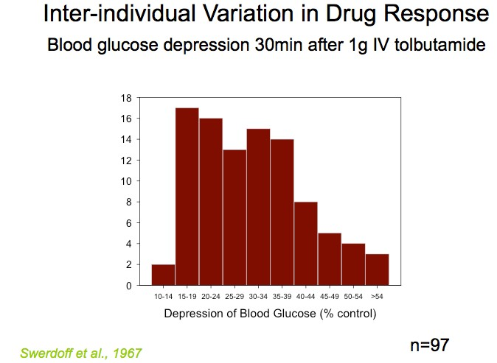
pharmacogenetics on adverse outcomes is point 3 of the ‘QUM filter’ namely Using medicines safely and effectively. A key tenant of therapeutics captured in this point is that more often than not, doses need to be
individualised. Thus, the person’s age, sex, weight, organ functions, ethnicity, concomitant medicines and alcohol and tobacco use may all need to be considered. The concentrations of medicines in blood, which we measure for critical drugs such as immune modulators for transplantation, antibiotics, antiepileptics, and some antipsychotics etc varies very widely between people. This is important because the amount of effect, both good and bad, relates to the concentration of medicine at its site of action in the body.

Pharmacogenetics has emerged in the 1970s as an important modulator of outcomes in individuals and this applies particularly to medicines used to treat Mental Illness. The first example that impacted me was in fact in the 1970s where I was involved in a clinical trial of an antidepressant. The subjects were normal volunteers, in fact medical students and each was given a single, low dose and bloods collected throughout the day to measure the concentration of the drug. One of the eight or so volunteers promptly slept and couldn’t be easily roused at the end of the day when his mother arrived to pick him up! It turned out he had a mutation in the gene that was responsible for synthesis of an enzyme/protein critical for the metabolism and detoxification of the antidepressant. This enzyme was cytochrome P450 2D6, and that student was in high demand for further clinical research studies.

Pharmacogenetic Mechanisms. Pharmacogenetics can affect the outcomes from administration of drug in two ways: its disposition in the body (Pharmacokinetics
(PK) or “what the body does to the drug”) or its effect on the body (Pharmacodynamics (PD) or “what the drug does to the body”).
Variations in our genomes leads to
variation in protein structures, and proteins carry out critical functions such as metabolising and transporting medicines across barrier membranes. The
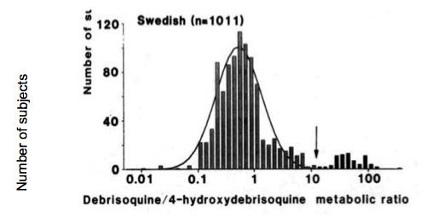
cytochrome P450 enzyme system is the primary pathway for metabolising medicines and there are 4 of many that are subject to ‘polymorphisms’, such that genetic variation can
lead to very large effects on the metabolism of drugs reliant on that enzyme. These enzymes are Cytochrome P450 (CYP) 2D6, 2C9, 2C19 and 3A5 and they

are responsible for metabolizing a very large proportion of all the medicines we prescribe.(13) These variations that can affect the function of the proteins that are formed. Important enzymes for medicines prescribed in mental illness like 2D6 and 2C19 can have no function so that the drug is much more slowly
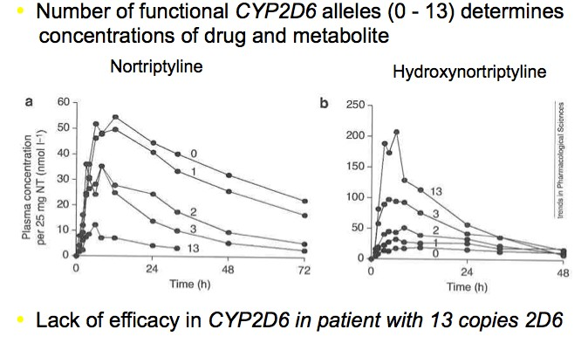
removed leading to possibly dangerous adverse effects. In Caucasian populations about 8% of people do not
have functional 2D6 and therefore will likely be over sedated, perhaps dangerously so with usual doses. On the other hand there can be variants such that the enzyme is more functional or there are multiple copies of the gene for 2D6 meaning that there is much more enzyme to metabolise the drug. In this situation the drug is removed from the body very quickly and there is no or little effect (Figure). I had a patient referred who had inflammatory bowel disease and reacted very badly to Imuran (azathioprine) due to a genetic deficiency in an enzyme that we check before prescribing Imuran (TPMT). She was commenced on a series of antidepressants, including nortriptyline, all metabolized by 2D6. She didn't improve. The diagnosis was doubted increasing her distress. She was a fast metabolizer with multiple copies of 2D6 and could not achieve effective drug concentrations. An antidepressant not metabolized by 2D6 was prescribed.

Type B (bizzare) Adverse Drug Reactions. These serious adverse reactions used to be called idiosyncratic as we were uncertain about the mechanisms.
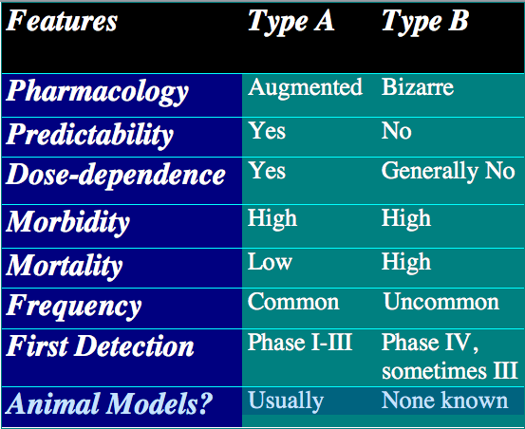
(Figure) We now know that some are strongly genetically determined. This applies to carbamazepine (Tegretol), a drug used for epilepsy, but also for bipolar mood disorder.
Thus, the feared Stevens Johnson Syndrome pictured
here (Figure) is very strongly associated with HLA-B*1502 in Han Chinese.(14) The marker in Europeans is different viz HLA-A*31:01. (15) These HLA markers can be easily tested for and are now being incorporated into electronic medical records for ‘decision support’ for prescribers in major Academic Health Centres in the US.

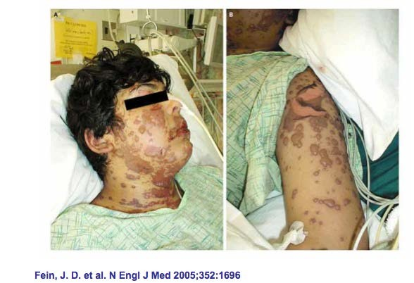

What needs attention?

  - Therapeutics education deficiencies

    - Appreciation of the additional challenges facing people with mental illness
      - Respect for lived experiences with medication

    - Gaps revealed in applying the 3 step ‘QUM filter’

    - Seeking and finding help when there is uncertainty in responses to medications
  - Access to quality information regarding medicines for patients with mental illness(16)
    - Pharmacists

    - Prescribers

  - Higher level consultative service for patients, GPs and psychiatrists regarding challenging and unusual, cases
    - Clinical Pharmacology and Therapeutic Drug Monitoring services
    - Pharmacogenetic expertise and capability

  - eHealth systems that work, connect with each other and are used

Effect of eMedication management systems

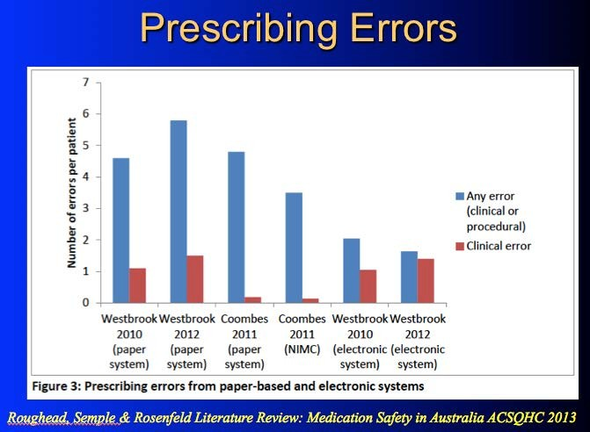
b.

References

- Landrigan CP, Parry GJ, Bones CB, Hackbarth AD, Goldmann DA, Sharek PJ. Temporal trends in rates of patient harm resulting from medical care. N Engl J Med. 2010;363(22):2124-34.
- Donaldson LJ, Kelley ET, Dhingra-Kumar N, Kieny MP, Sheikh A. Medication Without Harm: WHO's Third Global Patient Safety Challenge. Lancet. 2017;389(10080):1680-1.
- Roughead EE, Semple SJ, Rosenfeld E. The extent of medication errors and adverse drug reactions throughout the patient journey in acute care in Australia. Int J Evid Based Healthc. 2016;14(3):113-22.
- Pirmohamed M, James S, Meakin S, Green C, Scott AK, Walley TJ, et al. Adverse drug reactions as cause of admission to hospital: prospective analysis of 18 820 patients. Bmj. 2004;329(7456):15-9.
- Rose AJ, Fischer SH, Paasche-Orlow MK. Beyond medication reconciliation: The correct medication list. JAMA. 2017;317(20):2057-8.
- Pevnick JM, Shane R, Schnipper JL. The problem with medication reconciliation. BMJ Quality & Safety. 2016;25(9):726-30.

- Gur S, Weizman S, Stubbs B, Matalon A, Meyerovitch J, Hermesh H, et al. Mortality, morbidity and medical resources utilization of patients with schizophrenia: A case-control community-based study. Psychiatry Res.260:177- 81.
- De Hert M, Detraux J, van Winkel R, Yu W, Correll CU. Metabolic and cardiovascular adverse effects associated with antipsychotic drugs. Nature Reviews Endocrinology. 2011;8:114.
- Brett J, Daniels B, Karanges EA, Buckley NA, Schneider C, Nassir A, et al. Psychotropic polypharmacy in Australia, 2006 to 2015: a descriptive cohort study. Br J Clin Pharmacol. 2017;83(11):2581-8.
- Rochon PA, Gurwitz JH. The prescribing cascade revisited. Lancet. 2017;389(10081):1778-80.
- Buckley NA, Dawson AH, Isbister GK. Serotonin syndrome. Bmj. 2014;348.
- Day RO, Snowden L, McLachlan AJ. Life-threatening drug interactions: what the physician needs to know. Intern Med J. 2017;47(5):501-12.
- Somogyi AA, Phillips E. Genomic testing as a tool to optimise drug therapy. Australian Prescriber. 2017;40(3):101-4.
- Chen P, Lin JJ, Lu CS, Ong CT, Hsieh PF, Yang CC, et al. Carbamazepine- induced toxic effects and HLA-B*1502 screening in Taiwan. N Engl J Med. 2011;364(12):1126-33.
- Phillips EJ, Sukasem C, Whirl-Carrillo M, Müller DJ, Dunnenberger HM, Chantratita W, et al. Clinical Pharmacogenetics Implementation Consortium Guideline for HLA Genotype and Use of Carbamazepine and Oxcarbazepine: 2017 Update. Clinical Pharmacology & Therapeutics. 2018:n/a-n/a.
- Day RO, Snowden L. Where to find information about drugs. Australian Prescriber. 2016;39(3):88-95.

Appendix B
Survey Results

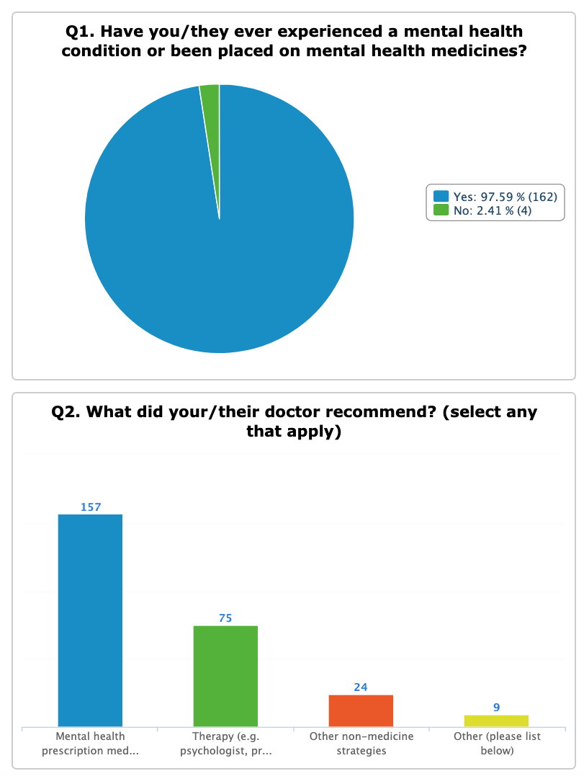
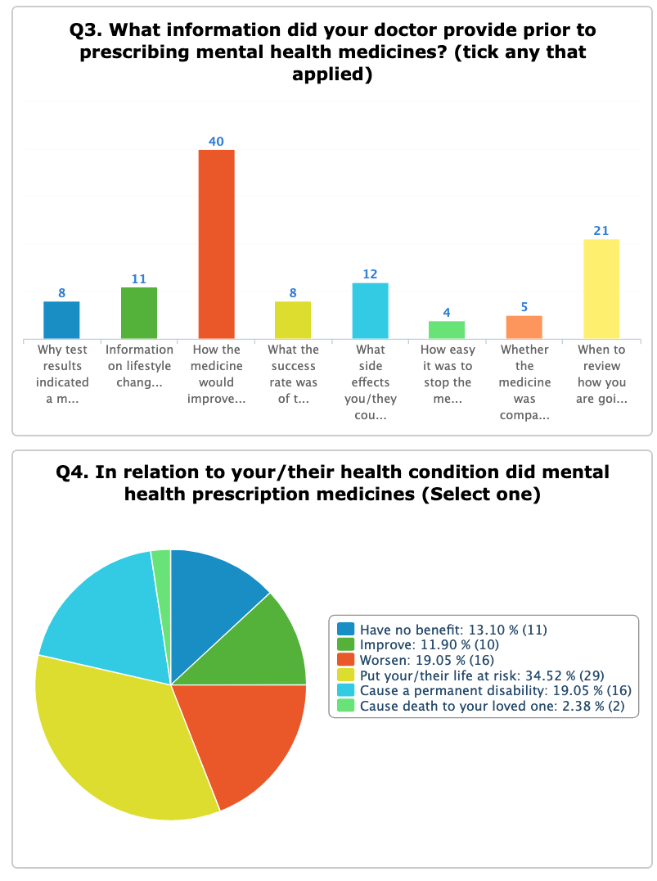

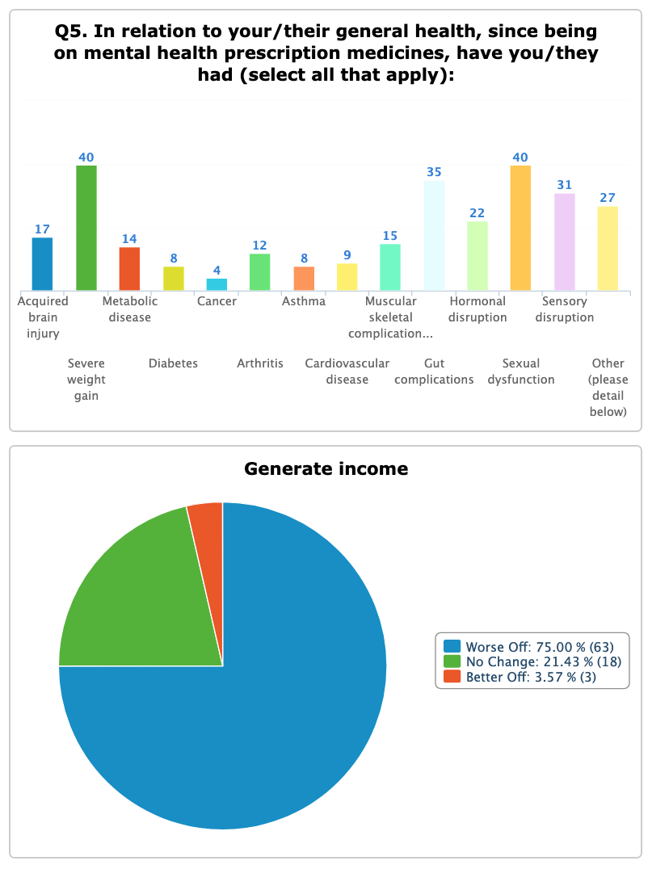

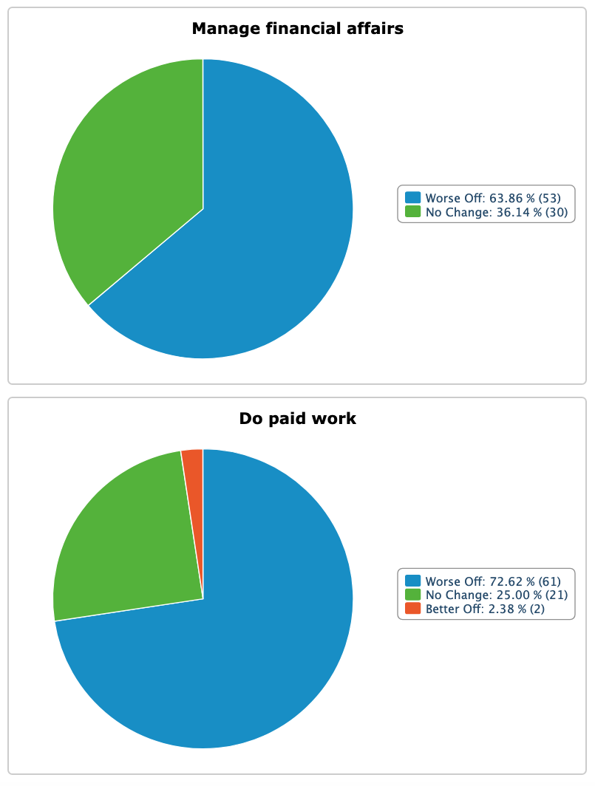

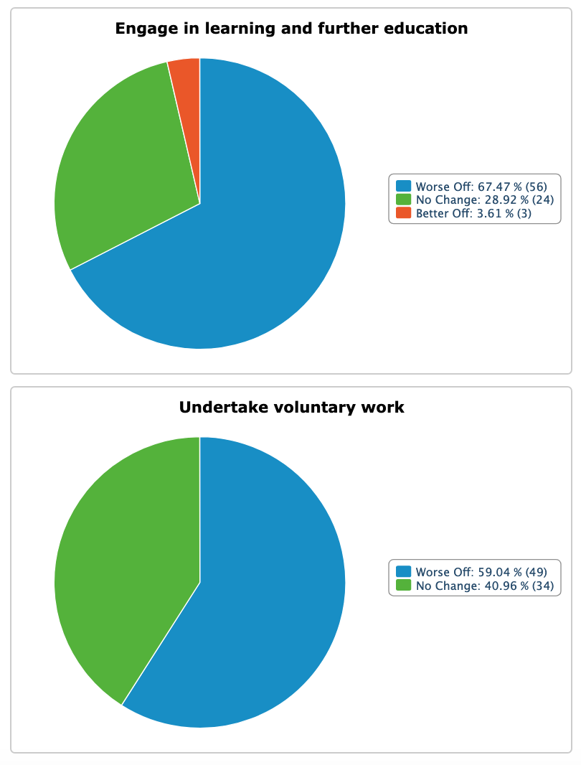

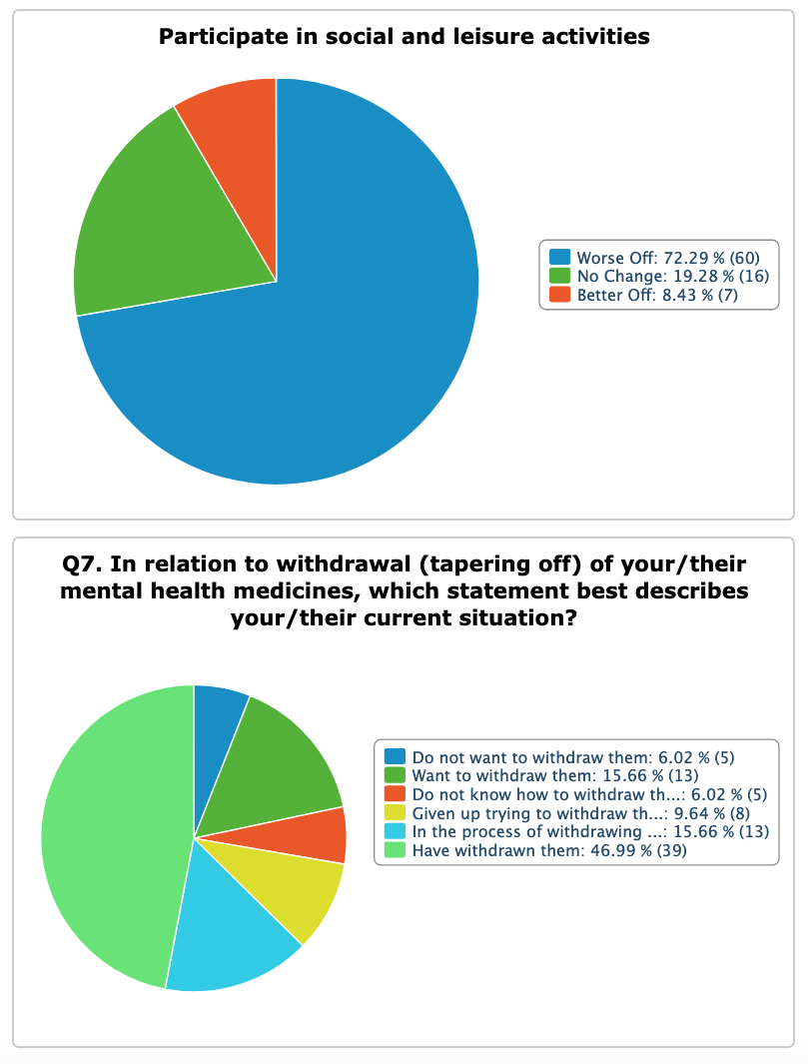

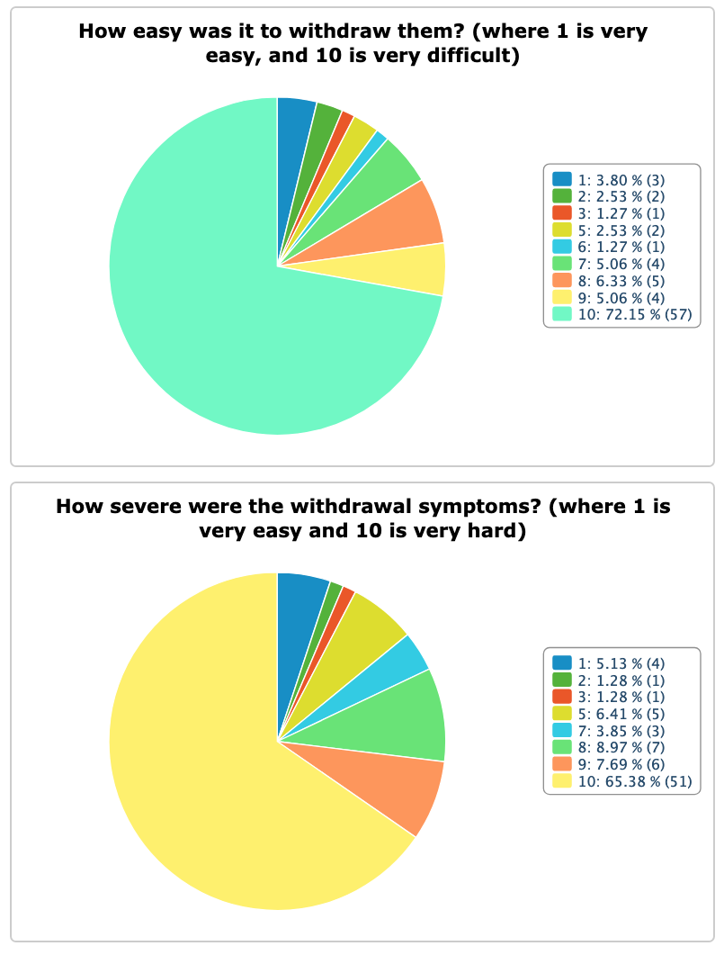

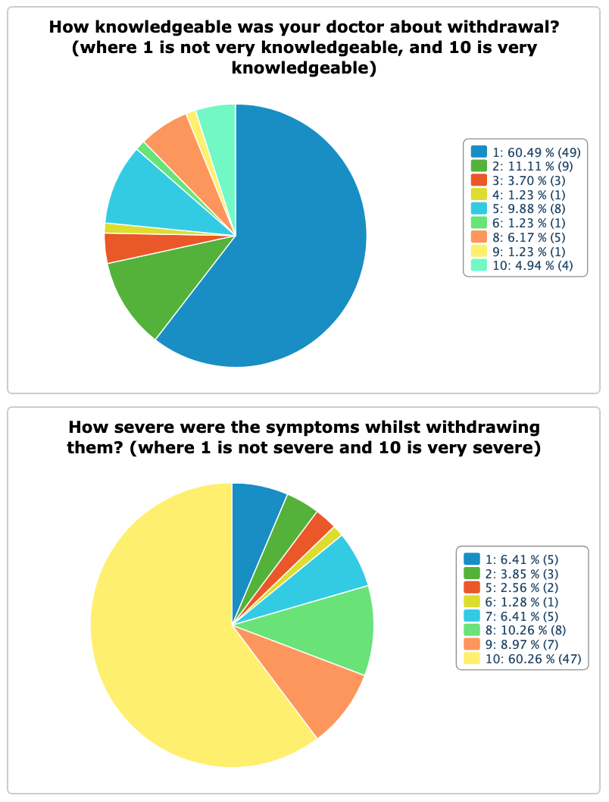

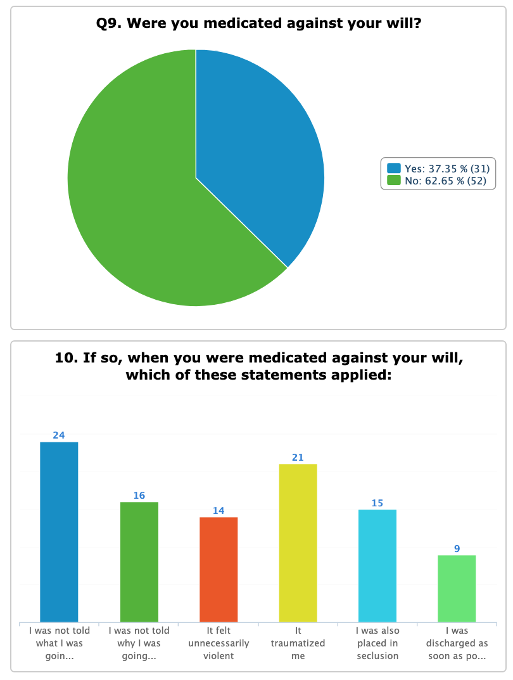

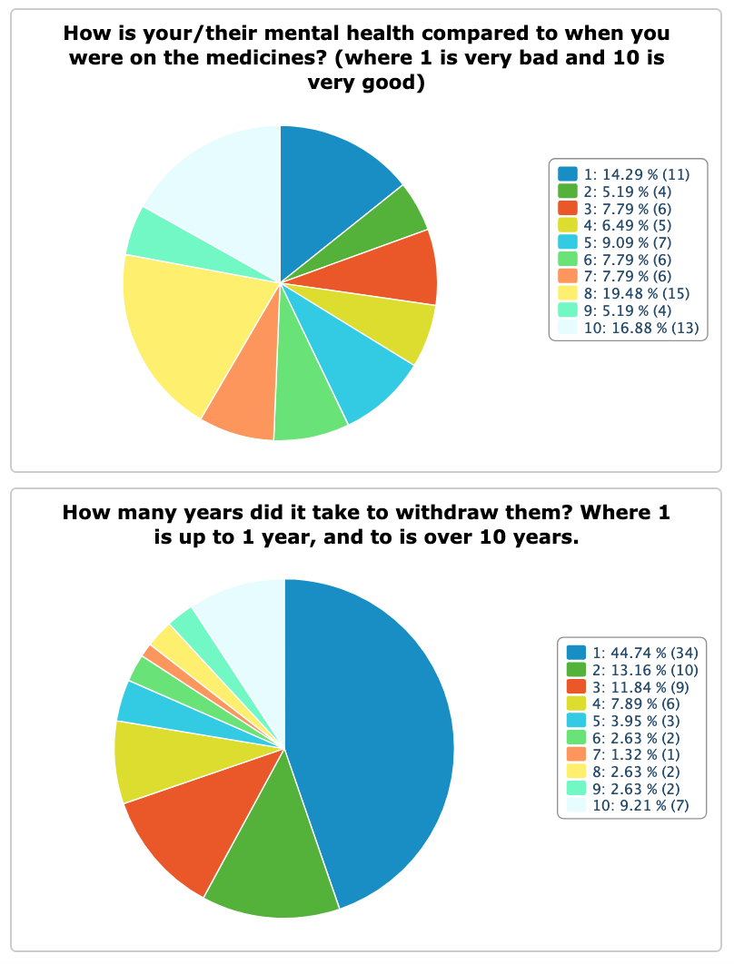

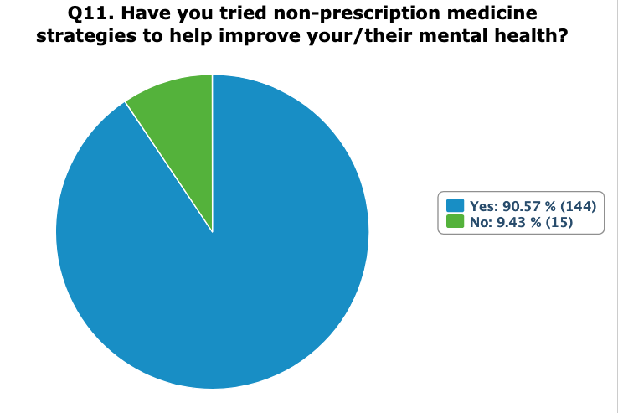

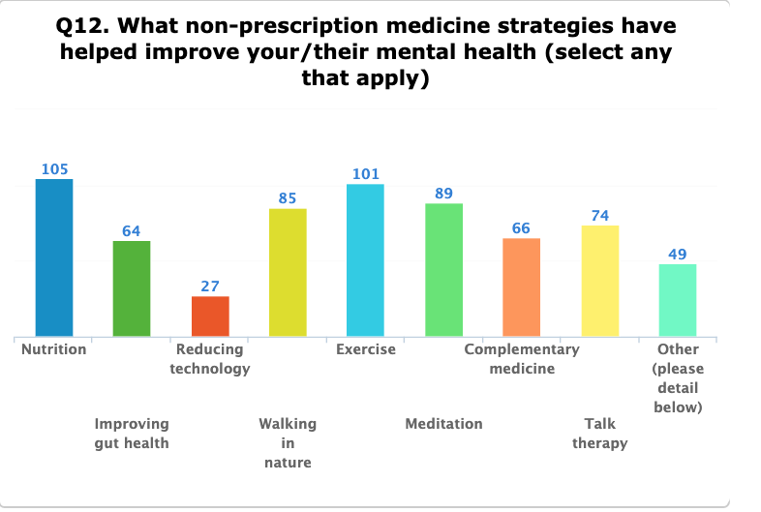

Appendix C
The Wisdom of The Consumer

- “I was diagnosed with depression in 1996, l became happy then a little too happy, then suicidal again. In 2007 after trying just about every antidepressant on the market l told my then gp that l thought l was bi-polar, he said no you are severely depressed and doubled my medication and told me to come back in two weeks. The next time l saw him l was hypomanic. He doubled my dose again. Next morning l was ambulanced to hospital, after weeks of seeing a psychiatrist l was diagnosed as bi-polar. The other day l heard about serotonin syndrome and researched it and found that that was what my gp did to me. I could have died and left behind a seven year old son.”

- “I lost my sister 6 years ago due to prescription drugs her journey started after a emotional tough patch at just 14 years of age from there it was a roller coaster ride that sadly took her life. No side effects where ever discussed and when one medication wasn’t suitable it was replaced with another until she just went to sleep and never woke up.”
- “I was prescribed medicine to help me sleep. Within 24 hours I became acutely suicidal. No one told me anything about addiction, withdrawal, or severe adverse reactions. In fact no one discussed anything with me. What’s more when I told my doctor that I was suicidal on the medication he automatically dismissed it as my poor character. I was 47 at the time, and had no history of suicidal ideation, or hospital presentations. Was not suicidal before going on it and not suicidal since coming off it.”

- “I presented to hospital having an adverse drug reaction to Ativan. I told them that I was having an adverse drug reaction, was suicidal on the medicine, and wanted help rationalizing my medicine. I also told them that I was a patient of a professor specializing in drug allergies who was overseas. The hospital dismissed both my professor’s advice and my self-reports as delusional. It is incredible that physicians are unable to even consider adverse drug reactions let alone know what to do about them, coupled with the complete deflection of responsibility if someone is suicidal. My reports to the TGA resulted in no action or even inquiry. The cause by the way was not only a drug allergy (as on testing I had an IgE of 3000) but I have little function of CYP2D6. ”

- “I had taken my son to multiple GP visits (over 10 visits) with my concerns. I did not know about the adverse side effects. When I did hear about it in the news I discussed it with the GP and he did not believe there was a link. If there was a warning on the package I would have known my son was displaying the adverse effects and taken him off the medication years earlier. Not only do we not know the long term implications this medication has had for his developing brain but all the additional medical treatment he will have to have. (Psychological). His academic performance has dropped significantly, he is considered strange amongst his peers. He has suicide ideations, depression, anxiety, trich, the list goes on. The impact this has had on him both personal, academic, social, mental has been horrendous not just for him both for our home family. The costs involved with medical visits, time off work and school, the psychological impact on other on all of us including our daughter.”

- “My son, living with Autism, was on four separate occasions over extended periods, administered medication (Lorazepam and Seroquel) known to produce paradoxical effects on him. Throughout each extended period produced the most dramatic devastating reactions. This should be criminalised for the sadistic harm perpetrated on an intellectually challenged young man. He was summarily placed into an isolation section of the service provider's residence (Autism Association), crying, disoriented, dysregulated, fearful, distressed in the worst possible manner. As a consequence of the service provider treating team's ignorance he received 120 ECT's meant to help him. Instead, in combination with the medication, they have assured the destruction of his now disrupted and dysfunctional life. ”

- “My late brother was not informed that ENDEP was an antidepressant; he refused to take any mental health medications. He was a paraplegic and the antidepressant for prescribed for nerve pain and he was lead to believe it was pain medication. This is one good reason why ENDEP should not be permitted to be prescribed off label for purposes it is not licensed to be prescribed for in Australia, which was the case when prescribed to my brother. He did not have a mental health illness or issue so very unfair he was prescribed this med for pain. Most people with Spinal Cord Injury are prescribed Endep for nerve pain and MANY are not informed it is an antidepressant. My brother was prescribed ENDEP for pain and OXYCONTIN for pain also, it does not make sense to prescribe both medications for pain. This error of judgment cost my brother his life and left a family broken and the door wide open for its next victim. How can this be ok? How can this be swept under the carpet? How can the system think its ok to send my family the message that our only son and brother's life didn't matter?”
- “Twenty years ago, my doctor prescribed an antidepressant for stress. I was given no information about what to expect. After a few days, my brain changed, best way to describe it. I was scared and stopped taking them but damage was done. I became severely depressed, suicidal and almost psychotic. This went on for 3 years, many different psychiatrists, and lots of different antidepressants etc with nothing working. I was so scared, l didn't want to die, but could see no other way out. Last resort was shock treatment which l had and ever so slowly, I began to feel better. I still take medication for depression and anxiety, I will for the rest of my life. My memory of the past and future was damaged by the ECT. If only I had been informed of what l was taking initially. It was the scariest time, fighting for my life for over 3 yrs. it could have easily taken my life. My family looked after me.”

- “Was prescribed Lyrica for spinal disc damage and sciatic pain. Missed 1 day and planned my own suicide. Never being suicidal before I knew it was the Lyrica. Told my doctor he said I was depressed and it could not be related to Lyrica. Managed to slowly taper off with horrendous side effects. 4 months off I am still partially deaf in one ear I have vision disturbances, headaches, and many other health issues.”

- “My daughter has had numerous adverse side effects from being prescribed several antidepressants and antipsychotic drugs from the age of 11 to 17. This has led to psychosis, suicide attempts and multiple hospital admissions. Sadly another medication has usually been “pushed” to try as an alternative on each admission. None of the medication has shown any effect in aiding recovery. ”
- “Tried to kill myself after taking Sertraline and ended up with an ABI.”
- “I was prescribed Sertraline by my GP. I had several adverse reactions to it and tried to take my life three times. The final time leaving me in hospital with an acquired brain injury and short-term memory loss. I was in hospital for 6 months and had to sell my home and my successful wedding photography business was ruined. My kids have been taken away from me and I now live alone in constant fear. I have been taken advantage of many times financially and life is very difficult.”
- “I almost died due you sleeping tablets given to me over the counter that triggered suicidal thoughts. Something I never before or after have had happen in my life. I am sure that people have acted on them in the same situation. Extremely dangerous stuff.”
- “I bought sleeping tablets over the counter. I was told to not take them longer than 10 days, but not about what severe effects they could have. I took them to help with jet lag, not for very long and rarely I took a whole tablet. After taking one night a whole tablet but couldn't get to sleep, I had massive suicide fantasies in the morning, all about throwing myself of a rock, something I never ever had before or after. I almost acted on them. When I communicated them I was taken to the psychological emergency ward, which in itself was a traumatic experience. I am sure a lot of suicides are due to tablets of this kind. The fantasies are extremely strong and overwhelming.”
- “Prescribed an SSRI for a situational anxiety issue. Took 14 years to be able to get off of it due to severe withdrawal issues. Over a year of severe symptoms from withdrawal. Very suicidal during all that time. Left with severe anxiety problems I had never had before. Still having side effects from it.”
- “I have been medicated since 2014 on Veneflaxine (150mg Enaflax XR) presently tapering since 13th May 2018. This poison has destroyed in so many ways on both a physical and emotional level. Destroyed relationships especially amongst loved ones and family. Since starting this poison has also been countless tests for pain and abnormalities of the eye in 2014, which despite under the care of two specialists is still inconclusive. I have since discovered a multitude of adverse reactions, which this eye condition falls under. Depersonalization, sexual dysfunction, numbness, aggression, emotionless, lack of empathy, soul less in the eyes.... so much more increasingly worsened as my dose was increased. Loved ones are the ones who notice more than I do of it’s negative effects but all I know is that I am feeling better each day that I have been tapering. Our Doctors and Pharmacists have no idea about gradual slow tapering at 5%. How is it that the initial GP subscribing this drug denied sexual dysfunction caused by Effexor XR? Doctors are becoming less competent if they not recognise side effects of SSRI & SNRI’s Antidepressants. So furious as it has affected the lives of families including ours. We and my support person have had to join support groups and doctors in the USA whom have a greater depth of understanding supporting tapering. I would like to be involved in supporting others battling such challenges in Australia when I am drug free from this poison. ”

- “My son was CYP450-2D6*4... unable to metabolize the drugs the psych doctors were forcing him to take. My son was criminalized for assaulting his own doctor, then this same doctor pressed charges against his own patient. This event caused further damage when my son was incarcerated and force drugged for a further six months.”

- “My son died because of psych drugs, he said, to wit, "Please don't give me any more of these drugs, they are making me think about killing myself". Five times this is recorded in the medical records...”

- “My first prescription of Lexapro (SSRI) at 17 triggered mania, psychosis, self-harm and an attempt on my life. I had no idea that this was a risk or if I had been misdiagnosed, despite speaking to a pharmacist & my prescribing clinician I was told that it gets better after 4 weeks. It did not. I attempted to take my life after 9 days and ceased the medication and stopped seeking help. Since then I have been prescribed multiple psychotropic, pain management and other medications. To these I have had multiple reactions of obsessive-compulsive suicidal thoughts and self-directed aggression. I remain grateful that I am not a statistic or another life loss to medication prescribed without adequate warnings.”
- “My daughter was hospitalized for four weeks and forced, against her will to take Olanzapine. The consultant psychiatrist told that if she didn’t take it she would be woken in the night, held down and injected. She complied and on release stopped taking it. As a result she spun into psychosis, then settled but was unable to sleep. She then consulted her GP and was put on Ativan. I was away from home at the time she was taking it and when I returned she still had difficulty sleeping, was highly agitated, aggressive and profoundly unsettled with scattered speech and unable to function normally. Her eyes were glassy and her hands shook. I’d never seen her like this before. She was unable to return to work for a year, due to traumatic hospital experience as well as the side effects of Olanzapine withdrawal and consequent 3 months of Ativan. She has not taken medication for over 12 months and has been employed for over 6 month as an office administrator. NOTE: The hospital did not inform her of the full effects of taking withdrawing from Olanzapine and neither did her GP give her such information about Ativan. At 50 it was the first time she taken psychiatric drugs.”

- “As a 24 year-old West Australian woman in my final year of studying to be a Primary School teacher I was put on 20mg of daily Lexapro. Having successfully completed all previous study, with 6 months to go before graduation, my GP prescribed the drug for anxiety and depression and soon after, I could no longer focus and concentrate. My anxiety and depression increased and tutors were hired to assist. At no time was I fully informed of the side effects. After taking Lexapro for 3 months I realised how the medication was affecting me and decided to ask my GP to help me taper. The reason being, I’d never had such difficulty focusing and concentrating to the extent it happened on Lexapro. The GP told me that she did not feel confident to hep taper and referred me to a psychiatrist. The psychiatrist, in a 20-minute consultation, agreed I suffered anxiety and depression and also told me that she believed I had ADHA and Bipolar. She agreed to taper me off Lexapro at a 50% reduction over 3 days (10mg daily) and then I was to immediately take Prozac. I was not informed of Lexapro withdrawal effects and neither was I given a reason for taking Prozac. Rape was the reason for my initial anxiety and depression.”
- “I am a 43-year-old mother of 2 children and was sectioned in a Western Australian psychiatric hospital and forced, against my will, to take Sodium Valproate, and was injected with Abilify. On release I was placed on a Community Treatment Order and the medication was forcibly administered for about 12 months, until the CTO was removed. I was not informed of the side defects and was threatened with further hospitalization if I discontinued treatment. I was terrified! Apart from taking my children to and form school, I was profoundly lethargic, could barely speak, slept almost all day and my pillow was saturated with drool every morning when I woke. I also stacked on weight. When I repeatedly told my psychiatric nurse and psychiatrist about this, while also requesting lower doses, my experience and concerns were dismissed. I was told it had nothing to do with the medication, my weight due to a bad diet and lack of exercise. The fact is, I had no energy to cook, primarily relied on take-away foods for my family and exercise was beyond me. With the help of my GP I have almost completely slow-tapered off Sodium Valproate but still get a monthly Abilify injection. My GP is well informed of medication side effects and withdrawals. The difference in y ability to function since tapering off Valproate is remarkable and to a large degree my energy has vastly improved. I can now communicate at length and no longer drool. “

- “I am the legal guardian of an adult son who had the misfortune of intersecting with the mental health sector approximately 15 years ago. I have been a constant, by his side through this entire ordeal and as such, I have represented him before Mental Health Tribunals, the State Administrative Tribunal and attended numerous clinical meetings, at my request. I have not once been offered any information written or oral, whatsoever in relation to psychiatric drugs, they’re supposed benefits, nor the direct adverse effects of long term psychiatric drug polypharmacy. Furthermore, I have not ever received any information regarding withdrawal or discontinuation.”
- “My son has been involuntarily injected with a number of psychiatric drugs and been subjected to as many as 18 different psychiatric drugs over the 15 years of involuntary detainment and Community Treatment Orders. He has suffered permanent brain damage as a result of 15 years of indiscriminate psychiatric drug polypharmacy. He also experienced 24-hour florid psychosis, tardive dyskinesia and akathisia. At 43 years of age, he bears the scars of multiple suicide attempts, has pulled his own teeth. The conditions upon which he subsists today gives rise to truth in the axiom ‘a fate worse than death.’”

- “I was misdiagnosed with depression back in 2002. Looking back I was overworked and just exhausted and needed a rest. When I was prescribed the antidepressant Effexor, the G.P had just been to a [company] seminar. The Doctor said that the company was talking about this new product called Effexor. I asked the doctor if there were any side effects and the doctor said there were no side effects and you can eat them like lollies. Six years of hell began, I was never given any help to come off this medication and if I missed a dose by half an hour, I felt like my head was being electrified, known as brain zaps. I had 48 out of 50 side effects listed on the product information, while I was on the medication and when I was trying to taper off the medication. My new G.P didn’t know how to taper me off this medication, the adverse effects were that bad, that I had to open the capsule and take out granule by granule over one year, so that the adverse effects weren’t so debilitating, I was suicidal on the medication, I had never been suicidal before and had serotonin syndrome on three occasions. Myself or my partner were never warned of the dangers, I told my partner, if it wasn’t for their support I would have suicided. We believe that clear warnings are desperately needed to be printed on the outside of all dangerous medications. I still have anxiety and brain zaps and I haven’t taken the medication for 9 years, I have permanent damage. I never suffered from anxiety or panic attacks prior to taking this medication. There needs to be more awareness about the dangers of many medications, and all health workers should learn about the bead method, and how to safely taper people from dangerous medications. No wonder people take their lives, if they can’t get their medication in time, or miss a dose, they would feel like they are going crazy. Most people don’t even know what a boxed warning is. I had been working full time for many years, up until I was prescribed Effexor, I was unable to work while taking this medication and while I was withdrawing from it.” It really ruined my life and nearly killed me.”
- “Over 3 years ago I was disabled after withdrawing from the drug paroxetine. When I was first put on it I was told it was one of the safest ssri's. The first year of withdrawal I experienced: Akathisia, anhedonia, severe anger moods, hallucinations, paralysis of legs, light, sound sensitivity, vertigo, hallucinations, convulsions, tremors, pains in all parts of body, diarrhoea, sweats, flu like, body, brain zaps, constant panic attacks, suicidal thoughts, manic episodes, rashes, vision problems, fatigue and more I now have trauma and still suffer some symptoms. I was diagnosed with protracted withdrawal and was given no help but was told to just do small things and hope. I was told that he gets people in weekly with the same. My life has changed, I was a first honours student who worked and had just bought a house with my partner (who now cares for me) I don't get any justice and I was lucky to get a diagnosis. I now know these drugs were near useless in treating people but cause such horrific damage. I no longer trust doctors and do my own research. I don't have hope this will change as there is too much money involved but I hope people do their own research and try alternative treatments like diet and therapy.”
- “I was first given anti depressants after the birth of my second child, that was the start of my descent into hell that ended in a suicide attempt almost 10 years later, during that time I was given several different medications, none of which worked, the last was Seroquel that I was given without a prescription when attending the emergency department with suicidal tendencies that scared me, I was sent home in a taxi with a strip of them, I took the lot because I was tired of asking for help. I am only alive because I switched Drs that helped me wean off of meds and use mindfulness. I still get angry at all the time and opportunities lost to me because of medications, especially time with my family. I believe every other avenue should have been offered to me before medication. I am no longer depressed and have worked hard to live a full life. I hope this helps others suffering. ”
- “I started taking Aropax in the year 2000 after I lost both my parents in a short space of time. I am still taking this drug due to the fact that the effects of withdrawal are so severe I cannot function. I was never told of side effects or the fact that perhaps I would have to take this drug for life. The drug is causing me health problems that impact my life and could in fact cause my death yet I cannot stop taking this drug. I have tried to withdraw several times and have not yet succeeded. If I had been aware of the consequences of taking this drug I would never have taken even a single dose. I understand the drug companies downplay side effects but the Government must be accountable to protect its citizens from these situations. I am paying a drug company to effectively kill me slowly. This situation should never be allowed to occur.”

- “My brother was prescribed an antidepressant for nerve pain. He was unaware it was an antidepressant and lead to believe it was pain medication. The antidepressant and pain medication he was prescribed together interacted with each other, which propelled the effects to a toxic level causing a fatal overdose. My brother took his meds as prescribed, 3 days later was dead, he followed the directions on his prescription meds and paid for it with his life. So what price do you put on a life? What can you do to stop another family like mine left broken with no justice for the injustice done.”
- “Over the past 4 years I have been on a roller coaster of prescribed psychiatric medications. I have spent approx. 50 weeks (over 3 years) at a private mental health facility, [name of hospital], under the care of a psychiatrist dealing with depression, anxiety and work related burnout. During this time I have undergone numerous med changes and experienced crippling side effects to medications I should never have been on. I have experienced iatrogenic harm courtesy of psychiatry. I have now walked away from psychiatry and the mental health system and have had to do my own extensive research into dealing with my benzo withdrawal syndrome after having been left on a cocktail of Lorazepam, Clonazepam and Diazepam for 3-4 years. ”
- “To witness the slow decline of my sons life through the over prescription of neuroleptics, has overwhelmed his whole family. He disappears just that bit more as time goes by. The massive doses over 15 - 20 years is nothing short of criminal. We were so naive, so desperate for help and we relied on "the doctors " To this day the hideous impact that can occur is not explained to families. ”
- “I have a long history of ingesting antidepressants going back over three decades. They were prescribed to me in the throes of a marriage breakdown. I was also in the late stages of pregnancy. It was at my psychiatrist's suggestion that I try Anafranil, a tricyclic antidepressant, after assurances it was safe in pregnancy. Within 8 hours of birth my son had convulsions as a result of withdrawal from this drug. My psychiatrist was unaware this could be a problem. My memories of the subsequent years on antidepressants are of increasing ill health due to side-effects. I gained weight, became forgetful, fatigued and had constant gastrointestinal problems. It took me sometime to realize the drugs were doing me more harm than good and I eventually realized I was now dependent on them. When I summoned up the courage to taper off Effexor in early 2011 I had no idea how debilitating antidepressant withdrawal could be. My life became a nightmare. For a year and a half I did little more than survive, I was in a constant state of high anxiety and agitation. Sleeping, eating, washing, were often beyond me. By the summer of 2012 I'd had enough and attempted suicide. I'm lucky to have survived but my health remains compromised due in no small part to other psychotropic drugs prescribed to me in antidepressant withdrawal.”
- “When I went to the doctor to have a couple of days off work due to a death in the family, I was given anti-depressants by my GP. She didn't mention side effects, in fact told me to NOT read the insert as I would induce side effects in myself. The side effects I get are life threatening and when I told her, she just said that THESE pills are the next generation, will be fine. I was not fine, if anything, I got much worse, much quicker.”
- “Getting both on and off mental health medicines was dangerous and scary. Getting off was worse. I was advised wrongly on how to taper off, so instead of being over a year or two, it was only 4 months. Most of which I spent laying in the shower due to the severe brain zaps, noise/light/smell over stimulation. I also experienced fatigue, full body pain and then huge episodes of rage when my brain got overloaded. I smashed so much of our stuff, most of our glasses, plates, phones. (Never experienced anything like it before) Three years later I still get episodes but getting less and less frequent. Mostly if I get sleep deprived. Thank God, for the ketogenic lifestyle and its brain healing capabilities.”
- “My mother developed a sudden overnight allergy to the anti-psychotic medicine Seroquel. She was taken off it over night. She committed suicide 6 months later. The Dr's told her "there were no other medicines for her to try" and that this medication withdrawal would "probably result in her death within 12 month". This isn't health care. That's throwing a prescription at it until it goes away. Disgraceful. Go home and die. That's our mental health system. My mother was only 55 years old.”
- “I had supraventricular tachycardia misdiagnosed as anxiety and put on Lexapro. After 1 1/2 years and many side effects the drug did not resolve the SVT. Withdrawal from Lexapro was not recognized by GP who then diagnosed me with major depressive disorder even after the supraventricular tachycardia was found and resolved with catheter ablation. My GP then prescribed Pristiq, Temazepam, and Diazepam. Within 8 weeks of these drugs I was suffering extreme side effects including agitation, Akathisia, nerve pain, paraesthesia, suicidal and intrusive thoughts and lost 25 kg of weight. The GP sent me to a psychiatrist when I told I wanted to get off the drugs. The psychiatrist told me to stay on the benzodiazepines and cold turkey me off Pristiq and re-prescribed Lexapro against my desire and then diagnosed me with panics disorder even after informing her that I had supraventricular tachycardia not a psychiatric illness. As no medical person would help get me off the drugs I had to do it myself. I came off the drugs in Oct 2017 and I am still bed ridden with over 30 symptoms. I have not been able to work since and do not know when or if I will get better. I have spoken with hundreds of people over the world who also suffer and have finally got some help from medical and support staff from the UK who correspond with me via email, Skype and You Tube. These drugs harm. There is zero evidence that these drugs help and many people who have no mental illness are regularly misdiagnosed and become so I'll from the drugs end up taking their own lives. We are disbelieved by the medical community that withdrawal from these drugs happen and can last many months and years before full recovery. Please follow the UK lead with the APPG, Council of evidence based psychiatry and Professor Heather Ashton (Ashton manual). The evidence of detrimental effects of these drugs is being ignored for the money being made.”
- “The first time I tried to come off the antidepressant slowly (slower than the doctor recommend), I was fine for the first 2 weeks. Suddenly for no particular reason, I started feeling odd. It was a feeling of acute sensitivity. The light, the noise, the sights looked surreal and dreamlike and with that I felt intense anxiety. I stopped sleeping completely. I became terrified. I went to the doctor who told me to take sleeping tablets till everything settled. I couldn’t bare it. I slowly reintroduced the drug. I just wanted to get back to normal. Reinstatement intensified my symptoms x10. I started feeling like my nervous system was on fire. I couldn’t sit still. I lost my appetite completely. I experienced sudden, drastic weight loss. I cried in horror. It was unbearable. Getting through the next 10 minutes was my focus all day until I could knock myself out with sleep meds. This intensity of symptoms was so relentless that I wanted to be put to sleep in hospital to get some relief. I wanted to live for my beautiful daughter but I constantly thought about killing myself. After 3 weeks the drug settled and my brain reached homeostasis. I have PTSD as a consequence of these drugs. There was NO support. No one believed me. It’s hard for anyone to understand what you’re going through. I was utterly alone like a dog on the street. Everyone thought I was mentally ill. I always knew I wasn’t but in my vulnerable state I started to believe them. Fourteen years later after repeated episodes and self-awareness, I clearly see that the drug is 100% the problem. They should not ever be used. They are unsafe. They may work for some but another time they don’t work. They are mind altering substances no less dangerous than Ice or heroin.”
- “Lyrica caused drug-induced psychosis where I believed my partner was trying to kill me. It destroyed my marriage, my family, my life and has left me with regular suicidal thoughts and feelings.”
- “It turned out my thyroid medication was no longer working so I was suicidal. So got a script for an increase in antidepressants and tried to OD on them as I obviously wasn’t thinking properly. Scary thing is after my week in hospital there was little to no follow up.”
- “I was put on Prozac and had a close suicide attempt.”
- “I have had so many mentally and physically dangerous experiences, but I will focus on the suicide ideation that often comes with psychiatric medication, especially in the first few weeks. This is a time period where many people are not adequately monitored, including adolescents who are at the greatest risk of suicide after taking medication. I was unaware when put on Cymbalta at 13 that this could be catastrophic, the doctors did not warn my parents or me. Within two weeks I went from depressed but not suicidal, to deliberate overdosing, and then attempting to slit my wrists. My cousin went on psychiatric medication as a teenager and gassed himself in an oven, my aunt hung herself within weeks on an antipsychotic. Patients need to be kept close tabs on in those first few weeks, I cannot overstate this! Meds can be a life-saver, but also ruin lives.”
- “My 17 year old only child killed himself 15 days after being prescribed the antidepressant Fluoxetine (against my strong objections as his mother) despite having no diagnosis of any mental disorder. [The drug manufacturer] conducted a causality assessment, which determined the drug was the most likely cause of his suicide. DNA testing, conducted after he died, showed my son is an intermediate metabolizer having reduced enzyme activity for drugs metabolized on the CYP4502D6 pathway.”
- “I was prescribed a birth control pill that ended up causing me to have depression and anxiety. The issue was resolved by changing to another pill, but the new pill I take is more than 3 times the cost, than the one that caused me issues.”
- “My withdrawal nearly killed me, I had no guidance from my G.P hence came off to fast. I withdrew from the SNRI Effexor XR in 5 weeks after 12 years. The side effects, brain zaps, akathisia, hallucinating, suicidality, immense psychological distress was unreal. Every medical professional needs to learn of the possible severe withdrawal side effects of this medication, and be knowledgeable enough to guide there patients off safely or warn of the precautions before dispensing.
- “My GP doubled the dosage of my antidepressant (Xyprexa) because it was “easier than writing another script” (for a 50% increase & within 3 days I was completely psychotic, experiencing overwhelming symptoms (both visual & auditory) & needed to be scheduled. The admitting hospital A&E Department asked nothing of meds changes on presentation which would have accurately described the event historically on my Medical Records, as well as informing future treatment options.”
- “My sister passed away at the age of 29 years old due to a combination of anti-depressants prescribed by her doctor of over 3 years. There was not enough information I feel relayed to her and someone who has a mental health issue - such as depression will take what they can so they don’t feel the sadness anymore.”
- “The last time I was medicated the anti-anxiety medication made me manic for over a week then the crash down into depression was so intense I tried to overdose on the remainder of my prescription.”
- “Akathesia during a taper. It was terrifying. I had a strong inner restlessness and I did not feel right. I felt unsafe and not in control of my mind or actions. I was scared I might harm myself. It was a lurking thought in my mind. Extreme confusion at this feeling and an overwhelming sense of dread. I was really scared because I did not want to die nor did I want to harm myself. I was panicked. I rang the hospital, they got me to take my dose back up and drive down and see them. I was shocked that within 30 minutes I was feeling normal again. I had never had those feelings except during some tapers.”
- “One antidepressant almost made me kill myself. One antidepressant gave me mood swings, an antipsychotic made gave me heart palpitations and I became addicted and started taking overdoses. It made me hear things that weren't there. Made me drowsy and dissociate and lose memory. Then there is the times where I don't know what I've been given and the as it's been injected forcibly. I remember passing out waking up somewhere else once.”
- “Within days of starting an antipsychotic, my son became violent, restless and aggressive. This was a complete 360 to how he usually is. Returned to doctor who told us it couldn’t possibly be the medication and said it’s because the dose wasn’t high enough - she kept upping and upping the dose - despite him continuing to worsen. He ended up in hospital. We had to do our own research and testing to discover he does not metabolize meds due to an enzyme/gene mutation. Doctors said that was BS.”
- “Doctor prescribed antidepressants when l was stressed. Did not tell me about side effects of medication. The side effects were so severe l stopped taking medication. I wasn't told not to stop taking them and the effects that has. I ended up in a psychosis, referred to a psych and for 2 years had meds changed with no change. Last resort was ECT (shock treatment), it was debilitating but it slowly helped and saved my life.”
- “My brother died by suicide May 2017 @ age 50, left a wife and 2 young boys. He did not have a history of mental illness nor thoughts of self-harm. Following his own self-diagnosis of depression (due to work-related and financial stress) he took himself off to a local GP who immediately prescribed anti-depressants for him (9 days before his suicide). He was sent home following a consult with a psychologist and GP both having been informed by his distressed wife that he had been researching methods of suicide on the internet. His wife was given no tools/strategies around keeping him safe as there was no information sharing with her despite her desperate concerns. The steps taken by both these clinicians were to have his medication increased, have him contact Lifeline and go home and meditate. The next day my brother hung himself at his workplace. According to my sister-in-law, my brother did not initially present with thoughts of self-harm to the GP. There were no warnings around adverse effects of the medications, Escitalopram (Esipram) and Temazepam, nor recognition around this by any of the clinicians. My brother's behaviour and thoughts worsened over the week, and he continued to work because no one advised otherwise. He was left to manage himself under the care of his ill-equipped wife and their 2 young boys. Strangely, I have had to write numerous letters to the NSW Health Care Complaints to gain some action for an investigation. Again, with the Coroner however the investigation has been completely lacking. There has been no communication by the HCCC nor Coroner with the TGA despite my brother's death having correlation with the drugs he was prescribed. Reports to the TGA are VOLUNTARY - an obvious problem that has led to under-reporting of adverse events. If there is to be any change/prevention cases like ours deserve proper investigation without the need for relatives to tirelessly advocate on behalf of their dead relative. As tax paying citizens our family, friends, community and above all my 50 year old brother deserve that respect from a much better system. ”

- “In a nutshell: failed to conceive so spent an incredible amount on ivf. Told them the drug (wont call it "med" any more), time and time again. Each time they said no probs no ill effects. After much heartache and failure over many years I asked for my hormones to be tested, as I was no longer trusting what I was being told by these "specialists." My testosterone was pretty low. So I took myself off this drug slower than most "doctors" would after reading real life stories and the unacknowledged (by our joke of a health system) withdrawal was something you have to go through to know the hellish and drawn out nature of. After being off this drug a while still in the grips of withdrawal I asked a gp to test my hormones again on 2 occasions. Each time I was told it was a waste of taxpayer’s money as no studies had proven my concerns. My withdrawal was dismissed and recovery of endocrine function symptoms laughed at. Finally found someone to test my hormones, it was lower again so referred to professor endocrinologist. Told him the drug I’d been using during the ivf and that I no longer trusted what I was being told by gp’s, "specialists" etc. so I’d been off it for 10&1/2 months when I saw him earlier this year. He instantly and very adamantly said these drugs can indeed affect our hormone production and damage sperm. Retested my hormones and after being off this drug for just over 10 months my testosterone had more than doubled, I’d felt significant change in myself. Especially between my 2nd low testosterone result and the test the endo did on me, which was reflected in the result. Many say not to trust what you read on the internet but sadly in this case I should've a long time ago, as what I could find was far more accurate than what these idiots were saying. This finance crippling, incredibly stressful and guilt for the rest of my life journey/discovery probably wouldn’t have been necessary if those we're supposed to be able to trust had their facts right. I was told the ivf clinic got their info about this evil drug from the TGA. I can’t confirm if this was actually the case though but what I was told none-the-less. It’s a lot to bare now after being told by specialists "it’ll only make your sperm happier", "it doesn’t affect the hpg axis" and "these drugs don’t affect sperm" to finally meet someone who knew without a doubt (I could tell by the way he said it and wrote down our ivf doctors number so eagerly) that it can and felt that’s what happened with me. I have copies of the blood tests also. The drug was Effexor.”

- “I have been given phsychiatric drugs over the years. I had a wrong diagosis of anxiety...which I now know was hypoglycemia...a major cause of panic attacks & agoraphobia. I was 22 when druged by psychiatry...I am now 64 and a very sick lady. About 4 and a half years ago I was diagnosed with pulmonary hypertension.as I had blood clots on the lungs. They put me on a blood thinner. Got rid of the clots and the pulmonary hypertension went...According to many second opionions. I was lied to by my cardiologist. He put me on Lasix a diuretic...I told him I was allergic to lasix as I had taken them in the past and ended up in hospital...with a racing heart, confusion and low blood presser. He told me if I did not take them for the rest of my life I would be in trouble...as I had fluid around my heart due to heart failure. On getting 2nd opinions I had no pulmonary hypotension...No heart failure...His own radiographer told me my heart health was fine, now that the clots had gone.....I now have a lot of damage...I can no longer walk due to the rebound effects of the fluid tablets... a lot of fluid in my legs now. All the meds I am on are killing my acetylcholine. I'm trying to come of all my meds but it is one of the hardest things I have had to do. I was told antidepressants were not addictive They are and have caused me a lot of damage. I now need carers...NDIS... and have lost all quality of life...With all my so called illnesses being mis diagnosed and drugged fo all the wong reasons. Lasix are also addictive. Your kidneys come to rely on them....I have been left fighting for my life...I know I'm not alone in this. AND I WOULD LIKE TO SEE MORE HONESTY AND LEST CORRUPTION AMOUNGST DRUG COMPANYS, AND DOCTORS....I HAVE LOST MY SISTER TO HEART ATTACK CAUSED BY ANTIDEPRESSANTS...MY NEPHEW TO SUICIDE AFTER BEING PUT ON EFFEXOR. ALL MY SUICIDE ATTEMPTS WERE DUE TO SSRI'S I HAVE LOST SO MANY FRIENDS TO DRUG COCKTAILS...THIS HAS TO STOP. PLEASE??? My Life is not worth living...I pray every day to live... ”

- “I was prescribed antidepressants 14 years ago when my daughter was 6 months old after experiencing a severe panic attack and not sleeping for 3 nights. I was given Aropax and from the day I started taking it my symptoms intensified terribly and I was unable to sit still. For the first time in my life I felt suicidal. After three weeks the symptoms settled as the doctor suggested they would. After a year of feeling absolutely fine I decided to come off the drug so I cut it in half and then stopped it. A couple of days later I experienced extreme anxiety that came out of no where along with feeling fear and dread like nothing before. I reinstated the drug, afraid that I was going back to that terrible place although I suspected it was a drug withdrawal reaction as I had never felt anything like it in my life. Reinstating the drug was a nightmare with severe agitation, rapid weightless, diorreah and relentless feelings of doom and fear and anxiety. Like last time it settled but took 6 weeks to feel totally back to normal. A year later I tried again to taper very slowly and carefully off the drug but same thing happened again. After 3 more unsuccessful attempts I had a second child on zoloft which I was switched over to for pregnancy. Since then very time I lower my dose below 50 mg I start to go into an awful withdrawal. These drugs have nearly killed me. I have wanted to die on several occasions due to the effects of tapering and reinstating. I fear I will never be free of them and I fear the long term effects. I also long for the person I was before starting these drugs - a happy carefree spirit that travelled and loved adventure. Now my confidence has been so terribly affected by these horrific episodes and I feel frightened to go anywhere.”

- “Yes I have an acquired brain injury after a suicide attempt related to the antidepressant Sertraline. I was not warned of the increased suicidality that the drug manifests. I have had to sell my house and move to the country and I have been alienated from my children. My very successful business has also been ruined.”

- “I was given Xanax at the tender age of 21 for PTSD. I experienced tolerance about 4 years ago. Debilitating panic, immune dysfunction. Loss of job, physical strength and mental abilities. I have been weaning for 2 years. I accidentally kindled or updosed. I now am experiencing brain damage. Cy Les if 3-4 days horrific panic, pain, insomnia, emotional instability. Akesthesia. Trips to er inability to parent live a functional life, drive, some days eat. It's ruined my life. Not even done tapering yet. Spent close to $20,000 on symptom relief.. this drug ate my brain and killed my nervous system. I'm angry. My life matters!”

- “My son, Timothy John, was prescribed Champix to give up smoking after going from 20 to 8 a day with Nicorette spray. Eight days later he hung himself. The Queensland Coroner stated that Champix contributed to my son's death. The June No.2 Bulletin to doctors has provided guidelines for doctors prescribing drugs which have serious side effects. The TGA has advised Pfizer that they will be required to insert warnings in the Champix packets by November, 2018. I would also like to see a sticker with a warning on the Champix packets so that everyone in the family and support system could be aware of these serious side effects and act to alievate the possible serious consequences!”

- “I am a Forced adoptee who managed to get a medical degree. I was first treated with benzos as an intern. The depression from these drugs was misdiagnosed as major depression so I started on SSRI, which made me manic. Never identifying the underlying causes, such as stress, sleep deprivation and early childhood PTSD, I ended up on a psychiatric drug roller coaster from 1993-2001 when I faced suicidal psychosis. This ended my career as doctor and I have been on DSP ever since. Each time I have social issues, I get told I am mentally ill and have SSRI again pushed on me despite previous harms. Looking back under the influence I was reckless.eg thought it was good idea to get pregnant to a stranger.which was totally unlike the unmedicated me.i also realize that many seeing me in the ED as a doc were suicidal from the drugs not the mental illness I was taught to blame. I see the undue influence from drug co, going back to SSRI invention and including medical miseducation, which harms many. I also watched my parents. Biological Mother and Adopted Father end up suicidal on SSRI/SNRI while brother has psychotic episode on same. I have done much biomedical research into the evidence vs. drug co spin used to miseducate my former profession. I am keen to right this very wrong.”

- “Seen by almost every doctor in General Hospital - no diagnosis. Five months in a psychiatric hospital - approx 12 different medications before being discharged on Sodium Valproate. Official (generic) diagnosis Bipolar - suggested diagnosis by Adverse Medical Events personnel - Serotonin Syndrome. Post traumatic stress after event. Very few medical experts know or care about adverse reactions/withdrawal and are unable to diagnose same. GP's do not believe patients who try to explain what they are going through and diagnose mental health instead of physical problems.”

- “My happy and hardworking husband of 20 years took his own life the morning he was due to fly back to his fifo job. He was prescribed ZOLOFT by our family doctor after becoming depressed. He was never told about the side effects, potential suicidal thoughts or that he should not consume any alcohol whilst taking them. I believe ZOLOFT was a huge reason WHY he was capable of checking out on his life that day. Had he been told these things, given a warning to possible consequences - he would have had a chance to still be here. ”

- “For years I thought I couldn't do anything about my debilitating anxiety. It affected my education, my job opportunities, my housing choices, my health and the health of my children. I really try not to think about the person I could have been if I had been able to finish school, hold down a stable job and be a better parent otherwise it's too much to bear. It turns it was all because of a medication for my asthma that upset my hormones. It took me years to get my life back on track and for my family to not think I was a mental case. Those are years I can never get back. If it wasn't for a specialist women's naturopath that used to be a pharmacist, I may never have recovered from the depression and anxiety.”

- “Antidepressants destroyed my career as an engineer, and anything that was dear to me; relationships, marriage, financial security, my hobbies and passions in/ and for life. They dam near killed me. And fighting consent suicide ideation from taking theses drugs, which I never experienced before. It was prescribed for nerve pain (huge mistake taking this drug) Lexapro. Have been disabled for 8yrs from it. With a drug induced brain injury ”

- Suicide was a side effect of a medication prescribed by a child health specialist. Minor physical injuries were self inflicted.

- Wow where would you begin , why on earth a simple DNA test cannot be given before any of these drugs are given to any citizen l will never know my son is so mentally ill now after the cocktails of drugs he has been forced to take at the hands of these so called mental health workers.

- I was prescribed a large amount of Seroquel by a psychiatrist and it caused me to have a cardiac event at 24 years old. I was told I was at risk of heart attack if I didn’t reduce the dosage.

- Enforced psychiatric polypharmacy destroyed the quality of life of my teenage relative who is genetically polymorphic and now lives out her life on a pension, with substance/medication induced neurocognitive deficit disorder - iatrogenic disability.

- Was prescribed Sertraline and attempted suicide on at least three occasions and ended up in hospital for several months after an acquired brain injury, which I still have.

- Was told by my doctor to quit my meds cold turkey. Went a week without sleeping had horrific akathisia and couldn't function in every day life

- Currently tapering off effexor xr. The recommended taper is too drastic. It incapacitated me when followed. Now tapering at 10% increments and still suffering like thousands others.

- Lovan made me suicidal. Pristiq has ruined my memory abilities and some cognition. Dexamphetamine has given me anxiety since adolescence.

- Both my sister and husband develop psychosis from antidepressants which led to attempted suicide. My mother is unable to stop taking antidepressants due to the negative impact of the withdrawal symptoms.

- My sister has tried many different mental health medications, all of which have caused tardive dyskenesia and retardation. She is no longer the person she used to be before medications and now has the memory of a child due the damage these medications have caused to her brain. She has constant muscle twitches and is unable to live a normal life.

- It caused my son to almost take his life.

- I have watch my wife of 20 years go though the bend with her bipolar medication time after time again they just dont work make things worse.

- My husband died as a result of a lethal prescription cocktail. He was also a nurse and questioned his doctor but she convinced him they were safe. They weren’t.

- I felt more suicidal & less in control of my violent out bursts whilst medicated... now un medicated I am in control of my emotions I feel like a human again & am still struggling but not as painful, not as teeth clenching as when I was taking my daily prescribed meds. I chose to stop taking them without informing my doctor as he continuously told me I would get worse without it... I have been nothing but happy since I have stopped taking my meds.

- 900mg of Seroquel given to my primary aged child resulted in abnormal movements in his jaw/mouth which thankfully resolved once it was reduced. At age 16 my child is clinically obese (112kg) due to the decade he has been on antipsychotic medications. This impacts every aspect of his life and little care or attention is given by the system about this dangerous consequence. I trusted these medicines. I thought they were safe.

- They initially intensified my symptoms dreadfully. I developed akathisia and became suicidal. They settled in my system after 3 weeks . After a year I tried to come off them but experienced terrifying symptoms- insomnia, feelings of high anxiety and dread, dark depression far worse than before going on the meds. I reinstated the dose, which led to worse intensification of symptoms AGAIN! This happened again when I tried a slow taper 2 years later. It’s now 14 years that I’ve been on Zoloft. It’s not working so well. I sought the help of doctors and eventually psychiatrists. They said that withdrawal is not the cause of my symptoms. They say I have a severe mental illness and need to stay on the drugs for life. They want to add other drugs or increase dose due to it becoming less effective. I have been through hell because of these drugs. I have been completely disabled at times. I am fighting for my future and independence. I have two children. Ssri’s are dangerous drugs. I am now a pharmaceutical drug addict.

- Despite trying to recover from bulimia and history of anorexia, I was placed on Olanzapine, an antipsychotic notorious for massive weight gain and metabolic change. I was not warned, and gained 13 kilos in less than 3 months, which sent me into a bulimic and restrictive tailspin. Two years after getting off the medicine I'm still bulimic. Before that I had a similar experience weight-wise with Lithium, but the main problem was that it gave me type 2 diabetes and kidney damage. In the past with anti-depressants as a teenager I wasn't warned that they could increase suicide ideation in the first few weeks, and attempted suicide two weeks after going on Cymbalta. I just wish I had been able to make a more informed choice. I am now on Lamotrigine and Amitryptaline for my rapid cycling bipolar, and I have never been more stable or happy. I now sleep well, and my emotional rollercoaster is much milder.

- I was 14 years old when a GP initially tried to prescribe me antidepressants, I was aware of the issues with side effects and coming off of the medication. I have attempted to take antidepressants many times and each time I have had to stop almost immediately due to the severe side effects.

- I got total uninformed consent. They knew nothing about the drug or me and really ruined my entire life. I have been tapering 3 years and have 4-5 to go as they put me on 2, and one too high a dose, that does not agree with me and they have no idea how to taper me. I found benzo buddies. I don’t know if I will make it or not but I can’t stay on them. So damned if I do or if I don’t. Gave up high paying job as no memory, lost math skills, sick all the time. It is indescribable and I am not alone. Something has to be done. My dr misdiagnosed me in first place as I was having a reaction to prednisone so shoved me on night dose benzo as he thought it was panic attack. Never saw me after that. I said aren’t these addictive, all he said was don’t worry we’ll get you off. Then when I tolerated 8 months later put me on another one with longer half life and even upped the doseage total incompetence in two providers AND DUMPED TO PSYCH who didn’t have any better ideas on how to get off. I lost all sleep so they gave me Siri. So I have 2 Black box drugs to taper off and I am almost 65 BUT I was a young 60ish person but life is totally ruined.
- I was put on diazepam, which only served to increase my anxiety, and stopping it was a long and difficult process. Psychological therapy (clinical), integrative medicine, mindfulness meditation and Buddhist meditation helped. I still have to manage my anxiety.

- I am lucky. I found a doctor who recommended slowly tapering off the Effexor, my sister wasn't as fortunate. She was left in screaming pain after a gp recommend coming off the medication with alternating high and low dose over 6 weeks. She asked if there would be any side affects and was told to expect slight headaches and nausea. The first two days were ok, but then she started screaming and hitting herself. We had to pin her done until she exhausted herself. She described it as electricity attacking her brain. My sister has fibromyalgia, which results in her being highly sensitive to pain. She was in agony and we went back to the gp who inferred she was exaggerating and she needed to push through. She ended up going back on the meds and doing online research where she found thousands of other people who had experienced similar symptoms. Again and again they were ignored by their doctors, told it is "all in their head" and there is no evidence of withdrawal symptoms of that magnitude from antidepressants. Because no one has conducted a study of the dangers and all the evidence is anecdotal, doctors and pharmaceutical companies aren't obligated to disclose the dangers of their medications. People’s lives are being ruined and we need help.There is no information for GP or practitioners how to come off psychiatric medication. Often if a patient wants to come off psychiatric medication they are made to feel as if they can't or of they do they and have withdrawal symptoms they are often remediated with the assumption that there condition has returned. Withdrawal symptoms can mimic many psychiatric illnesses and it can be difficult for a GP that may see a patient for ten minutes maximum if the condition has returned or not. Often unnecessary test are run because of withdrawal symptoms and not a lot of support is given to patients once the mental health tag has been given to them. All of my so-called "mental issues" were actually physical illnesses caused by low-fat/low salt dietary guidelines mixed with my own genetic mutations. (Under methylation and Pyrroles) So all the therapy and antidepressants in the world did not help! 16yrs of dangerous antidepressants for a physical illness! Then coming off them was the worst thing I've been through. Frankly, prescribing them should only happen once all other factors are ruled out, treated etc. The whole mental health system should be abolished, and a new framework of whole body/holistic care should be implemented. Dietary guidelines need to be changed too, as part of this overhaul - no grain, no veg oil. Just whole foods, on a sliding scale of low carb to keto depending on health issues

- Medical practitioners were too quick to provide me with medication without any informed consent for essentially what was just life stress. Seroquel for sleep and sertraline for ‘anxiety’. Subsequently I struggled with a dangerous and long antidepressant withdrawal over 4 years. The drugs actually affected my mental health and I had life threatening side effects during the first 12 months of withdrawal. Doctors were ill equipped to deal with the withdrawal process. I worked out my own tapering schedule only because I am a scientist and it was quite difficult. Lack of recognition & training of doctors on withdrawal is a key issue. I consider myself lucky and am still dealing with a great deal of metabolic damage some 12 months after my last taper. I went to the US to support my withdrawal to access medicinal cannabis, which greatly alleviated withdrawal symptoms and allowed larger tapers over a 3-month period. Upon return to Australia it was clear I would not be readily able to access CBD oil. The TGA approved a drug that harmed me yet could not support me in obtaining a medicine to help me deal with those affects. It was incredibly frustrating. It was 4 years of hell and my body experienced so many debilitating and varied side effects. I do not know if the drugs have done any permanent damage although my doctor suspects some metabolic damage has been done. I put on 20kgs.

- Please don't put people on anxiety medication without exhausting all other "natural" alternatives first. I was put on a medication in 1996. My child was born in 2000 and had lots of issues, my GP thinks was due to me taking the medication whilst pregnant. When I was pregnant with 2nd child, born 2005, the GP suggested I wean off, which I did. Baby was born really well, but I suffered post-natal depression. When I went back on the medication shortly after birth, it then wouldn't work. This was particularly stressful to find another medication so I could still be a mum who could cope with 2 children.
- I am tapering off paroxitine at the moment. I cant think properly I am having suicidal thoughts which is not like me at all and I fear the worst is yet to come. I am completely fearful of what myself and my family are yet to endure. I want justice. I was never notified on any complications or withdrawal effects. I am a nurse myself and have not been able to work for the past 2 years. I am worthless.

- My son has been in and out of hospital for 6 years the medication does not work it seems to make him worse and it is terrifying to be around someone losing their mind, and the only thing the professionals do is drug them and all it does is worsen the problem, there are warnings from the pharmaceutical companies that the drugs may cause what they are meant to help and when that happens they just want to drug them more.

- The prescribed medications have been the source of overdose at least in one occasion that led to an emergency.

- Neuroleptic Malignant Syndrome, caused by two medications that did not go together. Medical ward, coma, had to restart medication.

- In an attempt to commit suicide I took handfuls of medications (including anti- depressants but also paracetamol and my parents medication). I obtained valium after a traumatic experience (raided by police for making cannabis medicine for myself and a cancer patient), and I tried to commit suicide with the valium.

- Recently experienced a seizure and prolonged QT waves (can cause cardiac arrest or sudden death) due to the high does of Seroquel I have been prescribed (200mg quick release) to treat my night terrors (PTSD) and insomnia, collapsed in the shower and broke my toe

- My daughter attempted suicide using her meds. Sadly, they continue to prescribe the same meds to her. She has dreadful side effects and prefers not to use her PRN meds when needed because of it. Her regular medication requires constant monitoring of blood works due to the detrimental affects it has on her organs. If only there was something she could take that was natural and not harmful!?!?!?

- I have a mental health nursing background but was unfortunate enough to require medication myself. My pleas to change/stop medications fell on deaf ears. I’ve a thyroid condition and an autoimmune disease, which apparently (according to the doctor), both require antidepressants. I put on weight, the anticholinergic side effects were intolerable and I couldn’t think or motivate myself. My late husband died from a lethal cocktail of prescribed antidepressants and I didn’t want to go that way so I ceased taking my own. I knew what to expect withdrawing from them but even in the worst time of that period I felt more alive without them.

- My child has been on many antipsychotic medications since the age of 6 (10 years) with little improvement. At one stage when he was about age 8-10 he was on a huge dose of seroquel (800 to a max of 900 mg per day!). I felt I had no control, no choice and no power, let alone my child. We eventually moved out of area and left the public mental health system to stop the chemical abuse. No dangerous drugs for children!
- My doctor wrote me a compounding script to safely reduce my anti-d doses 10% at a time. The first compounding pharmacist did it, but when she was replaced the new guy confiscated my script and refused to make my meds and gave me 18hrs notice telling me it was safe to drop from 70mg Pristiq to 0mg Pristiq instantly and that he knew better then both myself and my Dr. He yelled at me and negligently denied me prescribed meds.
- Suicidal, couldn’t work, severe adverse effects, nearly destroyed my marriage. The medication changed me as a person; I now don’t like listening to music, but enjoyed music before Effexor. I got in trouble with the law, which was out of character. Taking the medication ruined and controlled my life; I was very lucky to live through this period of my life.
- Numerous psychotic reactions and several suicide attempts. This was despite expressing concern of adverse side effects and sensitivity to these classes of weed.
- Inappropriate assessment and inability to choose the right medication led my 10 year old child experiencing psychosis as a result of the incorrect medicine
- In 2011, I was taking many prescription medications and I was extremely angry. I lost my job, my house, and almost was arrested and was charged with a misdemeanor for an assault I committed because of my mental state on too many medications, which were making my condition worse. If my family did not come to help me, I would have been in jail. The 5 years I spent working hard for my Master’s Degree and the 6 years I spent working in a high paying government job are now worthless. I will be on disability the rest of my life because no one will hire me after all this happened and because I have a record now.
- 1993 I was prescribed Prozac, bad side effects, I persisted too long in taking it, lost the ability to realise I should see GP and ask to come off it. I would have benefited from proactive follow-up. 2001 - same experience with Ritalin: endured weeks instead of days of serious side effects, thought I was being "good" and "compliant" and that my experience was normal, became passive, lost ability to initiate an extra appointment.
- My loved one experienced shaming for taking psychiatric medication and was encouraged to take natural remedies and alternative therapies instead. They relapsed and where hospitalized for suicidal ideation soon after.
- Had paradoxical rage reactions on benzodiazepines that I needed for sleep since SSRIs gave me raging insomnia. Sleep walk, talk, eat, and write with no memory on Ambien. Seroquel made me fat as hell and probably caused adrenal suppression that I have today.
- My son tried suicide my other son had bad reactions to meds and myself bad reactions bad experiences.
- Neuro malignant syndrome. Body shuts down when two medications should not be taken together. Very severe.

- Lithium toxicity following hospitalization and a “psychiatrist” not heeding warning signs and attending a golfing trip instead of treating symptoms.
- I have been trying to slowly lower my dosage of Effexor due to dry mouth. I have reduced my dosage from 225mg to 150 my over a 6 week period. I am now in the middle of a depressive state and having suicidal thoughts.
- I have myself and my cousin has been put on medicines too. 4 years still we haven't recovered fully, unable to work or get financial support.
- I have had 14 different psychiatric drugs in my life (excluding benzodiazepines) and if I could go back 30 years I would never have accepted that first antidepressant which is I believe what led to me developing Bipolar disorder.
- Aropax made me sleep for 4 days and destroyed my appetite to the point I ended up in hospital 13 days later at dangerously low weight and treated badly by poorly informed staff (psychiatrists included).
- On a constant basis l have witnessed my sons health deteriorate especially when forcibly injecting him.
- I was given Zyprexa against my will and consent among other 'medications' over the years including many antipsychotics which made me want to commit suicide on many occasions. They made me uncharacteristically aggressive and violent. One drug Invega made me lose so much weight suddenly that I became a near skeleton. I hate their drugs, especially when forced upon oneself for no reason.
- Effexor and pristiq. Physical side effects and withdrawal. Nausea, vomiting, weakness, lethargy, panic, anxiety, depression and suicidal thoughts, high blood pressure, excessive sweating, chills, shakes, brain zaps, headaches, body pain, tingling sensation mouth, tongue, hands, feet, dizziness and extreme vertigo, confusion, anger, irritability, fidgeting, hot flushes all at the one time lasting weeks. Horrendous experience.
- Scripted Lyrica off label with no information. Almost suicided when stopping them.
- I wasn't advised about withdrawal issues and ended up having suicidal thoughts and extreme mood swings for a few months as I stopped taking the medications.
- Suicide attempt within 2 weeks of new meds X 8 events.
- My son was put on Zoloft before the age of 4 years old, because his mother alienated us and he struggled not having his dad close.
- Yes I became toxic on lithium despite telling psychiatrist my dose was too high. It was only when I began vomiting repeatedly was I listened to.
- Effexor (Venlafaxine) - 6 years of battling suicidal thoughts, behaviors & numerous overdoses
- I was taking Effexor (Venlafaxine) for about 6 years and continually fought suicidal thoughts & behaviours. This resulted in numerous prescription drug overdoses. After voluntarily admitting myself to a psychiatric facility, my medication was changed which in turn has helped me immensely.
- One antidepressant I was on caused suicidal thoughts. Another caused me to sleep behind the wheel many times but lucky no major accidents.
- She was having brain seizures (as the Dr said when I described her symptoms) - this was because she was taking too high a dose of meds & too many in the mix. The Dr said it could cause a stroke.
- Taking Cymbalta for 7 years has caused significant losses in memory and cognitive function. Trying to come off the medication has been a grueling process with severe withdrawal symptoms for over 12 months now.
- I was put on Imapramine at 21yo and told it was for migraines. It led to a loss of ability to cope and assumptions by future Drs that I had a history of depression. Trying to argue with Drs I didn't have nor ever had depression fell on deaf ears.
- Increased anxiety with suicide attempts when transitioning off various anti-depressants while under clinical care.
- Hallucinations telling me to commit murder.
- Child given increase dose and had suicidal thoughts at age 10.
- Seroquel. I was on 2000mg a day! I could not walk, talk or function. It was dangerous. I was permanently severely sedated. I am down to 200mg a day now and trying to come off it, which is really hard.

- I was placed an anti-depressant as a child that had not been tested on children, or approved for use in children. It made me suicidal when I had never been before.

- Prozac, Cymbalta, etc. made me suicidal.

- I have been offered barbiturates to help me sleep, but won't have them in the house as it would be too easy to intentionally overdose.

- Yes my mother was prescribed a medication to help reduce her panic attacks and calm her down where CBT would have worked for her. Now she is addicted to it and can’t one off it yet if she stays on it her body goes into a panic attack when it senses the reduce level of the drug in her system and she has become hyper sensitive to anything and everything. Up to the point where she has panic attacks on a daily basis for the last 5 months, where her heart is racing forever 1 hour at a very high rate.

- It was a horrible tragedy that I was never mentally ill in the first place and I was given antipsychotics for 13 years and when I tried to come off them myself without help of my doctor I became psychotic without them.

- They either make me physically sick with diarrhoea and vomiting or aggravated other symptoms like mania, hearing and seeing things or make it impossible to sleep

- My experience was horrific....forced to take drugs to the point of where I could not remember my phone number. I had no credibility with authorities or my family.I my real injury was not looked at, I was left bleeding with a rapidly beating heart....and was drugged...it has been over 2 years to work through this....it has cost me dearly.

- I was prescribed a “new” drug by a doctor I knew and trusted, who failed to tell me of the horrible side effects and how difficult it would be to discontinue. Now I am struggling to live my everyday life as I try to wean myself off this medication so I can feel normal again.

- For 36 years my experience has meant I have gained exorbitant amounts of weight in short periods and felt subdued and numb due to a variety of medications. I have tardive dyskinesia and a movement disorder. I smoke (it reduces the impact of the drugs on me) and my cardio vascular health is poor.

- They made everything worse, ruined my life, my career, my self esteem
, my finances, cost me friendships, delayed getting real medical help I needed.

- When I took Zoloft in sent my senses into overdrive and my mind fluctuating backwards and forwards but not in the present. Most awful effects. Those were prescribed by a GP. Stopped taking it after waking up screaming and crying uncontrollably. Medicated by team of psychiatrist after two or three day in hospital analysis Risperdal oral prescribed and advised how it would slow me down so I could order my thoughts to rebuild. This medication was easy to stop taking as I grew more in control of my life and thought processes. This prescription was mixed with therapy and counselling.

- Psychiatric drugs are not a long-term solution due to the damage they cause physically. I am personally better on minimal medication than I was in the 15 years I was heavily medicated. I feel the drugs did little to help my situation and actually made it worse, robbing me of what should have been the best years of my life, i.e raising my 2 children.

- In a nutshell, most doctors/specialists have no idea about the ways these awful drugs can affect us. My hormones were disrupted by Effexor and I asked many doctors if it could affect fertility many times throughout almost 5 years of ivf treatment they all said no and never tested mine. After fail after fail I started to believe what the internet was telling me over what they were telling me and found that my testosterone was low from this drug and after being off it for 10 gruelling months my testosterone had more than doubled in a test a prof of endocrinology did on me who confirmed my suspicions about these types of drugs and spoke of their damaging effect on sperm also. He really couldn.t believe that no one knew and said these effects are common and well documented. For a leading ivf provider not to mention countless know it all ignorant gp's to not know this while we blew more than 100k we didn.t have is insane. For a government to keep paying us thousands of dollars from passing the medicare safety net threshold based on misinformation and trust in a dodgy goods administration shows the blinding effect the producers of these drugs have. My faith in doctors and the mental health system is gone.
- I almost suicided when withdrawing from one med. That my gp increased 1 med to a toxic level and I was hospitalised. That within a 5 minute consult with a psych I was scripted a large, repeat script for psych meds and was then exited, never called for a review. That damage from 1 med is permanent and i can't stop it.
- I was given them for migraine headaches, not for mental health diagnosis. They didn't help the migraines and ended up causing side effects.

- The person I care for has had his life severely disabled due to the constant ,and relentless oversight of the mental illness system......too many drugs for 2 decades...his life has been stolen ...he hasn't been able to work .ever!.resulting in chronic renal disease...tachycardia....movement disorder, tardive Tourette's... akathisia .....no warnings were ever given when the drugs were prescribed, no responsibility is being taken ....

- Person has been traumatized by the earlier hospitalisations ...and forced drugging ....and CTOs .....which should not have been done.

- These medications are dangerous. At age 13 I was first put on antidepressants after a 10 minute conversation with a gp who was unqualified to diagnose mental health issues. A child should never be prescribed this poison until all other avenues have been explored e.g., nutrition, therapy, and removal from toxic environment. And only then by a specialist, not a fucking inept gp.
- At 13 I had a minor case of anxiety and depression caused by malnutrition from an eating disorder that went undiagnosed for 12 years. For 15 years I have been put on varied medications at increasingly higher doses. It has taken me 15 years to start recovering from the damage done to myself and my family. Some of the side affects I have been left with are: disordered moods, I don't feel things at the right intensity is the only way I can describe it.
- Suppressed libido, I was a young teen when I started medication I never had the chance to experience a healthy sexual drive. I have been left numb, which has ruined my adult relationships. My weight has ballooned out of control from the low metabolism no matter what I try.
- There needs to be a complete overhaul at the way society and the medical industry approaches mental health. There is a direct link between mental health and nutrition that doctors either ignore or worse weren't educated about. When the texts students learn from are sponsored by the pharmaceutical industry is it any wonder we are overmedicated and ill?
For 12 years I was never asked what I was eating, or not eating as the case was. How can a brain properly function when it is starved of nutrients? It was only when I found a doctor who asked the right questions that I have begun to heal. I was prescribed a ketogenic diet and I can't tell you the difference it has made, I finally feel as though I am alive again. I even started my own business. Something I could never have imagined beforehand. I have been slowly tapering off the Effexor the last 2 years, and have gradually started to feel again after being numb and aimless for so long.
- They destroyed my life. For 10 years I was unable to function, they made me so tired and lethargic I would sometimes sleep for 18 hours a day, I couldn’t work or study.
- My experience is that my sister has been medicated for over 40yrs.
The Drs only want to increase her dosages when she’s not doing ok - no therapy or other suggestions. Also they will give her more (either increase doses or add others) just on her say-so - they don’t bother to speak to her family or nursing home to find out how she’s really going. She was addicted to Valium for several years & it took a fight from us to convince the Drs to wean her off them and now it’s a battle to make sure she it not prescribed them again.
- She had EST and we believe it has caused brain damage. We had Drs at [hospital] tell us her treatment was none of our business. When we wanted to get outside help (psychotherapy) they told her she would be forced to leave - she had nowhere to go so she went along with them & never got real help.
- Reduced sex drive with Effexor.
- I believe anti-depressants prescribed over the years to address my chronic depression have actually altered my brain, but not in a good way. I am worse off now than when I was originally diagnosed with depression 20+ yrs ago. Whether it was a misdiagnosis I don't know, but while antidepressant's seemed to work for awhile, I always ended up on a worse state than when I started out. I'd like to see some research around the long term side effects of anti-depressant medication use - specifically relating to possible permanent (-ve) impacts on the brain (memory loss, brain fog, fatigue, sleep issues..)
- Mental health medicines forced upon me as a child permanently impaired my cognitive capacity. Their use was abusive and has ruined my life.

http://www.health.gov.au/internet/main/publishing.nsf/Content/3B48796D9E2DDD8ACA257BF00021DDB8/$File/National-Strategy-for-Quality-Use-of-Medicines.pdf
Giardina, Traber Davis, et al. "Learning From Patients’ Experiences Related To Diagnostic Errors Is Essential For Progress In Patient Safety." Health Affairs 37.11 (2018): 1821-1827.
Manary, Matthew P., et al. "The patient experience and health outcomes." New England Journal of Medicine 368.3 (2013): 201-203. Rolfes, Lean, et al.
Rolfes, Lean, et al "The quality of clinical information in adverse drug reaction reports by patients and healthcare professionals: a retrospective comparative analysis." Drug safety 40.7 (2017): 607-614.
Hamrosi, Kim K., David K. Raynor, and Parisa Aslani. "Enhancing provision of written medicine information in Australia: pharmacist, general practitioner and consumer perceptions of the barriers and facilitators." BMC health services research 14.1 (2014): 183.
https://ec.europa.eu/health//sites/health/files/files/pharmacovigilance/docs/2007_02_26/19.pdf
https://www.parliament.nsw.gov.au/ladocs/transcripts/268/Transcript.pdf
https://www.smh.com.au/healthcare/personalised-prescribing-promises-to-save-mental-health-millions-20150205-136pxz.html
Australian Centre for Health Research, “Improving the Quality Use of Medicines in Australia. Realising the Potential of Pharmacogenomics.” October 2008
Melbourrne Health and GenesFx, “MVP Proof of Concept Pharmacogenomic Decision Support System,” 18th of September 2014.
https://www.smh.com.au/healthcare/personalised-prescribing-promises-to-save-mental-health-millions-20150205-136pxz.html
Whitaker, Robert. Anatomy of an Epidemic: Magic Bullets, Psychiatric Drugs, and the Astonishing Rise of Mental Illness in America. New York: Crown Publishers, 2010
https://www.mentalhealthcommission.gov.au/media/119911/Vol%201%20Attachment%20A%20-%20Review%20of%20Mental%20Health%20Programmes%20and%20Services.pdf
https://www.aihw.gov.au/reports/mental-health-services/mental-health-services-in-australia/report-contents/mental-health-related-prescriptions
Healy D. Lines of evidence on the risks of suicide with selective serotonin reuptake inhibitors. Psychother Psychosom. 2003 Mar-Apr;72(2):71-9. Review. PubMed PMID: 12601224. https://www.ncbi.nlm.nih.gov/pubmed/12601224
Australian Bureau of Statistics. 08/09/2017 4329.0.00.006 – Mortality of People Using Mental Health Services and Prescription Medications, Analysis of 2011 data.
https://www.parliament.nsw.gov.au/ladocs/transcripts/268/Transcript
[xiv] http://www.mentalhealthcommission.gov.au/our-reports/our-national-report-cards/2012-report-card.aspx
https://www.nytimes.com/2019/03/05/health/depression-withdrawal-drugs.html?fbclid=IwAR2AyZsqNI9ZIuvVMfd7ICU-8T4_1m4mnNteSK-vAVD2MgR-UJ-9ZAhPbs8
https://www.tga.gov.au/publication-issue/medicines-safety-update-volume-9-number-2-june-2018
https://www.tga.gov.au/consultation/consultation-boxed-warning-guidance
https://www.abc.net.au/4corners/who-cares/10258290
https://www.scientificamerican.com/article/a-drug-widely-used-to-treat-ptsd-symptoms-has-failed-a-rigorous-trial/
NSW Health Estimates – Questions on Notice, ANSWER 53. (a-b), October 2018.
https://www.parliament.nsw.gov.au/la/papers/DBAssets/tabledpaper/webAttachments/74050/Inquiry%20into%20the%20Management%20of%20Health%20Care%20Delivery%20in%20NSW.PDF
https://www.racp.edu.au/trainees/advanced-training/advanced-training-programs/clinical-pharmacology
Aronson, Jeffrey K. "A manifesto for clinical pharmacology from principles to practice." British journal of clinical pharmacology 70.1 (2010): 3-13.
Letter from Professor Ric Day to Mr Brad Hazzard dated 6 October 2018.
Letter from Mr Brad Hazzard to Professor Ric Day dated 7 January 2019.
Email from Professor Ric Day to Richard Griffiths, Director of Workforce Planning, at NSW Health.
Personal correspondence with Mr Brad Hazzard available on request.
https://www.pharmgkb.org/guidelines.
http://www.eu-pic.net/
https://www.fda.gov/Drugs/ScienceResearch/ucm572698.htm
https://cpicpgx.org/implementation/
Winner JG, Carhart JM, Altar CA, Allen JD, Dechairo BM. A prospective, randomized, double-blind study assessing the clinical impact of integrated pharmacogenomic testing for major depressive disorder. Discov Med. 2013;16(89):219-27.
Singh AB. Improved Antidepressant Remission in Major Depression via a Pharmacokinetic Pathway Polygene Pharmacogenetic Report. Clin Psychopharmacol Neurosci. 2015;13(2):150-6.
Perez V, Salvart A, Espadeler J, et. al. Efficacy of prospective pharmacogenetic testing in the treatment of major depressive disorder results of a randomized, double-blind clinical trial. BMC Psychiatry. 2017;17:250.
Elliott LS, Henderson JC, Neradilek MB, Moyer NA, Ashcraft KC, Thirumaran RK. Clinical impact of pharmacogenetic profiling with a clinical decision support tool in polypharmacy home health patients: A prospective pilot randomized controlled trial. PLoS One. 2017;12(2):e0170905.
Saldivar JS, Taylor D, Sugarman EA, Cullors A, Garces JA, Oades K, et al. Initial assessment of the benefits of implementing pharmacogenetics into the medical management of patients in a long-term care facility. Pharmacogenomics Pers Med. 2016;9:1-6.
Bradley P, Shiekh M, Mehra V, et al: Improved efficacy with targeted pharmacogenetic-guided treatment of patients with depression and anxiety: a randomized clinical trial demonstrating clinical utility. J Psychiatr Res 2017; 96:100–10.
Greden, John F., et al. "Impact of pharmacogenomics on clinical outcomes in major depressive disorder in the GUIDED trial: A large, patient-and rater-blinded, randomized, controlled study." Journal of psychiatric research 111 (2019): 59-67
https://www.nurseshealthstudy.org/
https://www.slhd.nsw.gov.au/rpa/allergy/default.html
Overview of the science: Nutritional psychiatry: can you eat yourself happier? https://www.theguardian.com/food/2019/mar/18/can-you-eat-yourself-happier-nutritional-psychiatry-mental-health Recommended expert: Director of Deakin's Food and Mood Centre Professor Felice Jacka.
Recommended experts https://www.probioticadvisor.com/dr-jason-hawrelak/#.XKbhwuszZ1M
https://www.thecut.com/2018/12/is-estrogen-the-key-to-understanding-womens-mental-health.html . Recommended experts: Professor Jayashri Kulkarni, Monash Alfred Hospital, has an active interest in the effects of hormones on mental health.
Recommended expert: Elizabeth Shannon https://www.sleeplessnomore.com
https://www.smh.com.au/politics/federal/labor-mp-julian-hill-calls-for-crackdown-on-drug-safety-20190220-p50z1u.html

