Life After Scams Ltd Submission to Productivity Commission in response to
The Social and Economic Benefits to Improving Mental Health Issues Paper.

This submission specifically addresses the following question:

“Are there particular population sub-groups that are more at risk of mental ill-health due to inadequate social participation and inclusion? What, if anything, should be done to specifically target those groups?”

Prepared on behalf of the
Directors of Life After Scams Ltd
(Support and Recovery for Scam Victims)

Table of Contents
Executive summary 3
Background Information 4
How do people get scammed? How the victim “gets hooked”. 4
Who are the scammers? 5
Who are the victims? 6
What happens when people discover they might be a victim of a scam? 6
The Aftermath of the Scam - Financial and Mental Health Implications 6
Financial Impact: 6
Emotional Impact: 7
1. Grief 7
2. Anxiety 7
3. Shame 8
Social Impact: 8
Physical Impact: 9
Economic Impact on Broader Australia 9
POST SCAM 10
Effectiveness of Current Services 11
What do victims need? 11
Services that should be funded by Government to assist this group: 12
CONCLUSION 13
Appendix 13
1. Scamwatch Website 14
2. Scamwatch Statistics: 14
References: 14

Executive summary
The Australian Competition and Consumer Commission (ACCC) website Scamwatch reports that approximately $107 001 451 million dollars was lost to scammers by Australians last year. (1) (www.scamwatch.gov.au/about-scamwatch/scam-statistics)
Despite widespread media coverage to alert the community to the danger of scammers, these figures continue to increase every year: In 2017 losses were in the vicinity of $90 928 622 million dollars, up from $83 561 599 in 2016. In the last 5 years, scammers have reaped more than $500 million dollars from the bank accounts of Australian residents.
According to Scamwatch, Romance scams and Investment scams are by far the biggest trap for Australians, with consumers losing millions of dollars every month. Behind these mind-boggling statistics are real human beings, who are crippled by debt, traumatised by their ordeal and stuck wondering how to rebuild their lives.
Life After Scams Ltd is a newly formed Not-For-Profit company that has been established to provide support to people whose lives have been derailed as a result of being scammed. The age and backgrounds of victims are wide ranging but the lived experience of victims has common factors – financial strain, social estrangement and emotional distress that continues for many years after the scam has ended.
These victims are a vulnerable population who are highly at risk of experiencing physical ill health, homelessness and mental illness, including depression and suicidal ideation. The rate of completed suicide within this group is unknown and worthy of serious investigation. These individuals are widely dispersed and largely unidentified within the community, and poorly linked with the mental health service system. Without timely intervention, they are likely to develop greater symptoms and difficulties that will add to the burden of care on services that are already overloaded (i.e. mental health services, homeless services, acute medical services and community welfare supports).
This submission has been prepared on behalf of the Directors of Life After Scams to alert the Productivity Commission to the mental health issues experienced by this group of invisible victims, and to make recommendations as to how victims of scams can be proactively assisted through several relatively low-cost support initiatives, including telephone and web-based information services alongside peer support groups and targeted small group programs.
To provide more context to the commission, this submission also details the mechanisms and pathways that lead scam victims towards increasing morbidity and explains the rationale for recommended initiatives to minimise the harm resulting from involvement in a scam. Research suggests that people who have been scammed are at risk of being scammed a second time, further exacerbating their difficulties. Interventions that reduce the intensity and duration of the emotional distress of scam victims and prevent recurrence are likely to have long-term financial benefits to the community.

Background Information

How do people get scammed? How the victim “gets hooked”.
Academics such as Dr Cassandra Cross -Senior Lecturer in the School of Justice, Queensland University of Technology, and Prof Monica Whitty from University of Melbourne have published studies of scam victims which supports anecdotal evidence accumulated by Life After Scams Ltd, showing some common pathways for people who have been the victim of major scams. The grooming process for Romance scammers often unfolds like this:

Who are the scammers?
Research shows that scammers are extremely organised professional fraudsters with high levels of intelligence, business acumen and technological sophistication. They also have astounding impersonation abilities and a complete lack of empathy for their victim. Many, but not all, reside off-shore outside of Australia’s legal jurisdiction. Their primary aim is to manipulate and deceive their victim so as achieve a financially windfall for their own benefit. They are patient and prepared to work long and hard to achieve a positive outcome for themselves. ABC TV -Four Corners Program investigators have reported that scammers have a highly organised vertical business arrangement often linked to organised crime.

Who are the victims?
Preliminary research suggests that victims come from all walks of life, across all socio-economic strata and all education levels. Even people with post-graduate degrees and/or with previously successful professional careers are not exempt. While all age groups are susceptible, reports show that the over 45 years-old age groups are predominant. Certain groups, such as those with social, emotional and cognitive deficits who are particularly trusting, are especially vulnerable (Baker, 2013; . Regardless of the background of the victim, once hooked into the scam, they are convinced to part with more money than they can afford, believing that the scammer will reimburse them in the near future.
Though families and friends may suspect a scam is taking place, the power of the grooming process creates a strong alliance between the victim and scammer, so victims are resistant to taking on feedback or warnings from outsiders. This makes it very hard for families to break the hold that scammers have on their victims.

What happens when people discover they might be a victim of a scam?
Eventually this house of cards comes crashing down when the victim realises that the love/effort and money given to the scammer has been in vain.
Victims describe feeling panicky and nauseous as the reality hits them.
In the ensuing days a storm of emotions are unleashed, or conversely people report feeling emotionally empty, numb and disorientated. Either way, this represents a major existential crisis for the victim.
They have lost the most important person in their life, their savings, their credit, and their sense of self-worth. They find themselves cut off from family and friends who may express disapproval after having warned them of potential harm. Their place in the world as they know it has been shattered.

The Aftermath of the Scam - Financial and Mental Health Implications
There is a strong association between financial difficulties and mental health problems. The recent announcement by the Federal Government of additional funds to pay for more financial counsellors recognises the urgency and importance of helping people experiencing financial hardship. Unfortunately, as will be discussed later in this submission, there are many reasons why victims of scams may not approach mainstream financial support services. (ref 1)

Financial Impact:
In the days after they have been released from the grip of the scam, victims soon realise that their savings have been severely or totally depleted, while some will have accrued substantial new debts. Victims may have borrowed from friends, trust funds, their superannuation or inheritances. They may have taken out personal loans, and hit the limit on their credit card, accumulating compound interest. Some have no capacity to repay the debts apart from selling their home and/or declaring bankruptcy. Many older victims may no longer be working and have no capacity to service debt or to rebuild any financial base. Some victims may even end up homeless.
Without discretionary funds available to maintain hobbies and social engagements, scam victims may drop out of their usual leisure pursuits, placing them at risk of losing friends, fitness and community connections. A wide body of research shows that social isolation and loneliness is highly correlated with mental illness.
In summary, the victim of a romance / financial scam can:
- Lose some/all savings and assets
- Left with a legacy of debt
- Unable to get loans or credit
- Need to return to the workforce post retirement age
- Loss of own house/access to secure housing
- Homeless

Emotional Impact:
Apart from the more obvious financial outcomes of being scammed, victims of scams, especially those of romance scams, typically suffer significant further losses in terms of their emotional and social wellbeing, often resulting in serious mental and physical health problems. In turn, these poor health outcomes place a considerable strain on Government and family resources(ref2:http://www.deakin.edu.au/research/research-news/articles/high-prevalence-mental-health-disorders-cost-society-billions)
While research on the emotional suffering arising from scams is currently limited, we know from scam survivors that they experience three over-riding emotions: grief, shame and anxiety. As any one of these emotions can be debilitating, they deserve to be unpacked separately to help explain both the impact of scams on victims’ mental and physical health, and the rationale for recommended strategies to aid the recovery of victims.

1. Grief
Profound loss triggers intense sadness. Grief can follow the end of a relationship, the loss of significant possessions, loss of friendships, health, and loss of a former lifestyle. Grief may be felt both physically and mentally. Feeling both restless and exhausted at the same time, lower quality sleep and difficulties with memory and concentration are common symptoms, along with dizziness, palpitations, shakiness, headaches, nausea and changes in appetite. Left unchecked, chronic grief and sadness can metastasise into despair or depression, the costs of which are now well-established. (ref2 http://www.deakin.edu.au/research/research-news/articles/high-prevalence-mental-health-disorders-cost-society-billions Depression, sadness and grief a re associated with depressed immune functioning leading to greater physical illness. Adverse mental health outcomes may however be moderated where there is plenty of ongoing support from family and friends.
The grief experienced by scam victims is no less real. They also have suffered huge losses - the loss of their (albeit fictitious) future spouse, their hopes for a happier, better future, and their financial security - but they may also lose their sense of self worth, trust and security in the world.
In addition to the grief of loss, scam victims may also suffer the pain of rejection by family and friends, who may believe it is the victim’s fault, that “they should have known better “ and so on.

2. Anxiety
Anxiety, like grief, can lead to problems with thinking, reasoning and maintaining focus. Victims describe feeling panicky and fearful with a heightened sense of personal vulnerability. Anxiety creates elevated levels of the stress hormone, cortisol, which is associated with hypertension, cardiovascular disease and some cancers. Physical symptoms like tremors, gastrointestinal changes and sweating occur in acute anxiety, and chronic anxiety manifests in different ways, such as constant surveillance of the environment, shallow breathing and dietary changes. Romance scam victims may have a realistic fear that sexually explicit images that were shared with the scammer could be used to blackmail them further, or dispersed on social media, and victims of financial scams are fearful of the scammer “sending around heavies” to intimidate or coerce the victim in the future.
Note that while scam victims are not currently characterised as experiencing Post Traumatic Stress Disorder, they do exhibit many of the same symptoms (such as anxiety, depression and hyper-vigilance) as are also experienced by survivors of PTSD.

3. Shame
When a person suffers a major loss, e.g. losing a spouse through death or divorce, losing their wealth through a global financial crisis, or losing their health following disease or accident, there is usually plenty of support forthcoming from family, friends, health professionals and so on. It’s no-one’s fault. For the victim of a scam, however, it can be very different. They can experience deep shame, and are acutely aware of the negative stigma associated with being scammed. “How could she/I be so stupid?”
Feelings of shame can further compromise the scam victim’s mental and physical well-being. International speaker and researcher Brene Brown (2007, “I thought it Was Just Me”) defines shame as “the intensely painful feeling …of something we've experienced, done, or failed to do (which) makes us unworthy of connection”. The natural reaction of people experiencing shame is to withdraw and avoid other people (Greenberg and Johnston, and Pascual Leone), leading the person to feel further disconnected and alone, compounding the initial trauma.
Researchers Lyons and Lyons (2017) have written extensively about how shame is implicated in ill health: “people experiencing shame have poorer health and shorter life expectancy. As shame becomes chronic, it can result in variety of negative health effects as a result of the physiological strain on the body and its systems because of chronically elevated PIC and cortisol levels. A variety of conditions, such as ‘weight gain, heart disease, hardening of the arteries and decreased immune function can result”. The longer the shame and stigma persist, the worse the outcome for the scam victim.
Shame, like depression and anxiety, is therefore a major driver of disconnection between individuals and communities, contributing not only to the burden of illness, but also becoming a direct cause of ill-health.

Social Impact:
As mentioned previously, without discretionary funds available to maintain hobbies and social engagements, scam victims may drop out of their usual leisure pursuits, placing them at risk of losing friends, fitness and community connections. A wide body of research shows that social isolation and loneliness is highly correlated with mental illness
The heightened emotional reactions experienced by victims of scams are akin to the trauma and disorientation felt by survivors of natural disasters or severe assaults. There is also a strong stigma attached to those falling prey to scams. Victims are often blamed for their own circumstances and losses. As previously alluded to, this exacerbates the suffering scam victims have already experienced at the hands of the offender (Dr C Cross, 2015).
As their mental health declines, victims may progressively distance themselves from work colleagues, friends and loved ones. They may hide at home, feeling violated, abused and discarded, reluctant to seek treatment due to a reduced sense of hope and personal agency. The more depressed, anxious and/or ashamed they feel, the more they may withdraw and isolate themselves, initially as a way of coping, but a cycle of despair and loneliness can easily arise. Loneliness is highly correlated with mental ill health.

Physical Impact:
Much has already been said about the impacts of poor mental health, depression, grief, anxiety and shame on a person’s physical health. Loneliness is another risk factor, predicting increased morbidity and mortality, with its effects seeming to accrue over time to accelerate physiological aging health. (ref3)
Unhappiness and a lack of a positive social life can adversely affect a person’s immune response, increasing the body’s inflammatory response and exacerbating symptoms associated with rheumatoid arthritis, osteoporosis, Alzheimer’s, cardiovascular disease and cancer. (Bruce, 2002). Even physical wounds take longer to heal when not in a loving or caring relationship, while the quality of intimate relationships is directly linked to heart disease Smith & Baucom, 2017. Living alone in itself is not necessarily a problem if the person has access to a source of caring and supportive others in their lives, and access to joyful or meaningful activities.
To summarise the journey From Initial Financial Impacts to Impacts on Mental and Physical Health:
Potential Trajectory of Romance Scam Victims
Loss of Cash, Assets
Exhausted all savings
Unable to get loans or credit
Left with a Legacy of Debt
Need to return to the Workforce Post Retirement
Loss of secure housing and potential homelessness
Grief/Anxiety/Shame/Depression/Despair
Social Isolation
Poor Mental Health outcomes
Poor Physical Health
Increased morbidity
Sense of hopelessness and often, suicidal Ideation
Other psychological conditions*

*This includes but is not limited to Major Depressive Disorder; Panic Disorder; Generalised Anxiety Disorder; Alcohol Use Disorder; Substance Abuse Disorder; Acute Stress Disorder; Post Traumatic Stress Disorder.
Anecdotal evidence indicates that virtually all victims of large scams experience symptoms consistent with a DSM-5 diagnosis of Adjustment Disorder with Depressed Mood, however it is largely unknown as a diagnosis outside of the medical & counselling professions. This seemingly benign label belies a range of symptomatology that can be extremely disabling. People with this disorder may have trouble working, moving around in the community and carrying out every day activities. Professional help is warranted.

Economic Impact on Broader Australia
The Australian Competition and Consumer Commission (ACCC) website Scamwatch reports that the amount lost to scammers has been steadily increasing over the last 5 years, with over $107 million dollars lost to scammers by Australians last year. (www.scamwatch.gov.au/about-scamwatch/scam-statistics).
Apart from the immediate financial losses incurred by the victims, there often follows a downward spiral for these victims from losing savings and assets through to poor mental and physical health, and even the loss of their homes, and/or lives. A Victorian investigation into the costs of homelessness to government and society, reported by ABC News on 16/3/17, clearly demonstrates that the monetary costs associated with homelessness exceed the actual cost of providing homes for displaced persons. Ref4
While it is difficult to gauge the likely cost to government from scam victims over time, Associate Professor Cathy Mihalopoulos of Deakin University, reported (ref 2) in June 2017 on the high cost of depression, anxiety and substance abuse related mental health conditions in Australia, exceeding almost 27 billion dollars ($27,000,000,000) per year. The total cost was broken down into $974 million in health care costs, $11.8 billion in total productivity loss, $1.23 billion in forgone income taxes and $12.9 billion in welfare benefits. “This financial cost is in addition to the incalculable personal costs suffered by individuals experiencing these conditions, and their families”.

POST SCAM
The loss of someone who is emotionally close is a tremendous shock and when it is unexpected, the feelings are intensified. In our society, compassion and support is shown to people who have lost partners through death or divorce, but victims of scams are often derided and scorned by the general public and often withdraw from friends who may express disappointment that the victim did not heed their warnings. For romance scam victims, the loss is akin to the death of a partner. Some people experience shock for days, weeks, even months after the end of the “relationship” or the “dream”. However, once the shock wears off, other feelings surface: rage, guilt, shame, remorse and sadness, which can metastasize into depression and self-recrimination, self-harm or numbing behaviours like drinking or gambling.
Romance scam victims may also have the horror of having their intimate photos or conversations revealed. For investment scam victims, they may lose their dream of owning a home, or carving out a better life for their children.
For anybody whose once normal everyday life was suddenly shattered by an act of sexual violence– the trauma, the terror, can shatter you long after one horrible attack. It lingers. You don’t know where to go or who to turn to…and people are more suspicious of what you were wearing or what you were drinking, as if it’s your fault, not the fault of the person who assaulted you…
- President Barack Obama, September 2014
Unlike many other interpersonal crimes such as face-to-face robberies or muggings, victims of scams - like victims of sexual assault- are particularly vulnerable to being blamed for their losses. The inability of police and justice departments to provide financial restitution, compensation, or prosecution of the crime or fraud also helps to reinforce the misconception that the victim was somehow to blame. Not surprisingly, victims work hard to disguise their financial predicament and precarious emotional state from other people.
It is therefore understandable that people may want to withdraw from family, dating, social and recreational activities and even job-seeking when they feel incredibly sad, lost and vulnerable, especially if they are struggling to afford to pay for basic provisions. Withdrawing in these ways, however, increases the risk of falling into an extended state of despair and further isolation. It is imperative in the immediate period when the individual realizes they have been scammed, that they are directed to appropriate supports in a timely manner to prevent further deterioration in their social/emotional functioning.
Adjusting to the new grim reality requires professional help but typically these people cannot afford to pay for private services and may not present to outpatient services until much later when their mental health crisis peaks.
- It is imperative in the immediate period when the individual realises they have been scammed, that they are directed to appropriate supports in a timely manner tohelp alleviate their immediate suffering and prevent further deterioration in their social/emotional functioning.

Effectiveness of Current Services
There is now an extensive body of research that demonstrates that malignant shame and grief can be healed through empathy (Brown, 2007) and self-compassion (Neff, 2015) This population sub-group, however, seldom receives either. Our society tends to blame and shun people who are perceived to have brought their hardship on themselves. Research indicates that strangers are more generous and supportive of people whom they perceive to be “innocent” and therefore more “worthy“of support than they are of those who are perceived to have “asked for it”, or acted recklessly or foolishly. This is why peer support services are essential for this client group.
Scam victims do not attract the same amount of support usually afforded people who have lost their lovers, houses, finances and health. Hence they feel shunned, isolated, deeply wounded and undeserving of help.
Reasons why scam victims do not access mainstream services
- Lack of direction - not knowing who or where to turn to for help
- Lack of personalisation from current agencies- eg receiving a form letter in response
- Lack of timely response, e.g. ringing on several occasions and not receiving any call back
- Feelings of shame - unworthy of help and support
- Feelings of chronic sadness – tiredness leading to exhaustion and inability to leave the house
- Anxiety – worrying about personal safety and security, and lack of trust
- Financial constraints - unable to pay for private services
- Long waiting lists on public services and triaged lower due to perceived low needs
- Lack of appreciation by medical professionals of the pervasive and insidious nature of the emotional and psychological impact
- Ineligibility for trauma or disaster related services such as CASA, victims of crime, * (see trauma above)
- Lack of access due to transport constraints
- Older adults may not realise that there are services available to help and may not realise that their symptoms are treatable
- Lack of empathy or understanding by counsellors- minimising the magnitude of the grief

What do victims need?
As described above, victims are often in a confused, disorientated state from their encounter with a scammer. Typically they or their family member rings Scamwatch or IDCar whose websites are widely promoted and easily found. These services provide information on reporting the scam and generic services
(Note: Organisations like Scamwatch and Australian Online Cybercrime reporting network operate at a federal level to collect scam reports and data. They provide no support and very little if any personalisation of response to scam victims. Their approach is one of prevention through provision of public education and warnings. At a state level some of this is also provided by Consumer Affairs. Victims are referred to Lifeline or BeyondBlue for support.)

Victims seeking personal support are often referred on generic agencies like Lifeline and many are referred to a volunteer service provider, Jan Marshall at scamsurvivor.org. Jan is a volunteer who has been offering peer support for many years and her services have been well received by victims. However the need for services far outstrips Jan’s capacity to provide.
Access to a supportive ear that provides understanding and empathy would help them to recover more quickly, however within the current dispersed models of service, it is impractical to locate people who are suffering at the hands of scammers, whether they are hiding at home or speaking to their individual GP. Some victims may languish on waiting lists for treatment across any number of mental health facilities.

What is needed?
A service dedicated to assisting scam victims who are either in the grip of a scam, or in the “post scam” period. This service could be accessed via a web portal
- Being alone and disorientated, a victim needs someone trusted to turn to. Romance scam victims need a person to whom they can transfer their attachment.
- Life After Scams has been established to fill the service void; however, it is currently run by volunteers and reliant solely on donations and community grants.

Victim blaming presents a particular problem for a charitable organisation such as LAS which relies on community goodwill, including fundraising ventures and donations from private individuals and charitable trusts. Perceptions that victims somehow brought their suffering upon themselves reduces the chances of not for profit agencies attracting generous supporters and donors, thus making fundraising difficult in a climate where attracting donations and volunteers is very competitive between other worthy causes.
Early intervention will prevent this group from deteriorating into mental ill health and will have a net savings to the Australian economy by helping people to recover more quickly, reducing their reliance on medical, housing and other social services.

Services that should be funded by Government to assist this group:
- Phone counselling and information for family members whose relative is in the grips of a scammer
- Phone counselling and emotional support and triage for people who have been scammed and their family or friends who are worried about the person who has been scammed
- Monthly Peer support meetings for victims, families and friends – open to all
- Small group recovery workshops run by certified facilitators to assist victims to regain their sense of wellbeing, and to reduce their propensity to be re-victimized.
- Psycho-education for victims, families and service providers regarding the nature and impact of scams.
- Social media presence linking to the above services.
- Linkages to financial support or physical resources providers (e.g. Salvation Army).
- Referrals to larger community agencies for those people whose needs may be better served through public mental health services.
Concerned family members could accompany their scammed family member to a peer support meeting. Not only does the victim gain support from their peers, seeing and hearing for themselves other people in their shoes, but family members can also gain insight into the insidious, calculating and devious methods used by scammers to entrap people.

CONCLUSION
The directors of Life After Scams contend that the many behavioural, emotional, socioeconomic and environmental factors that influence the health status of this population of people are amenable to early intervention. The provision of recurrent funding to provide peer support groups, telephone counselling and professionally run recovery programs would be a cost effective way of preventing long term health- related costs to the Australian Government..
It is recommended that the Federal Government provides funding to Life After Scams Ltd to provide specialist support and recovery programs for a three year trial period to address the needs of this highly vulnerable sub-population. The service needs to be trauma- informed, non-victim blaming and trusted by scam victims.

Appendix

Scamwatch Website
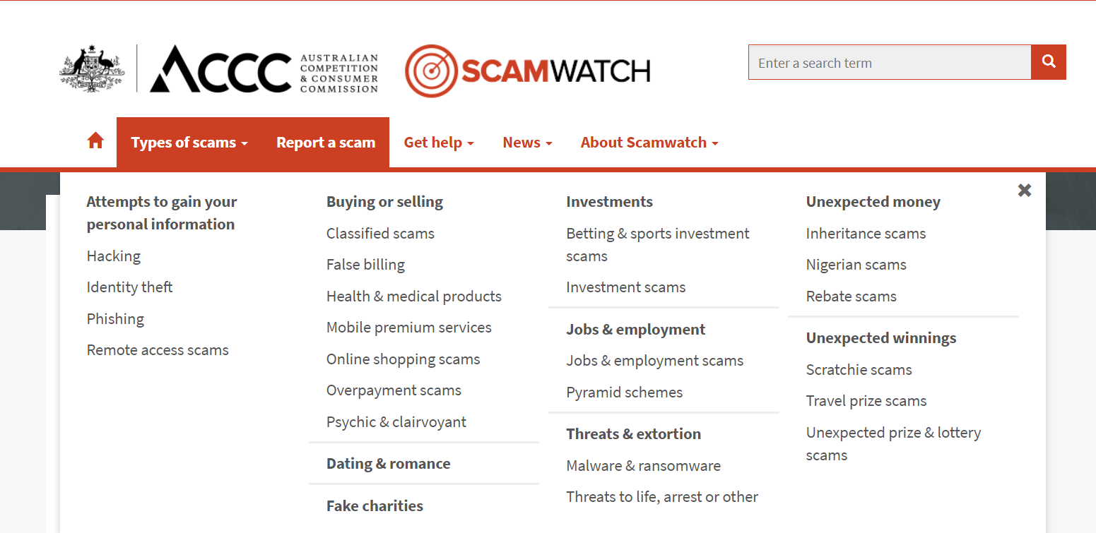

Scamwatch Statistics:
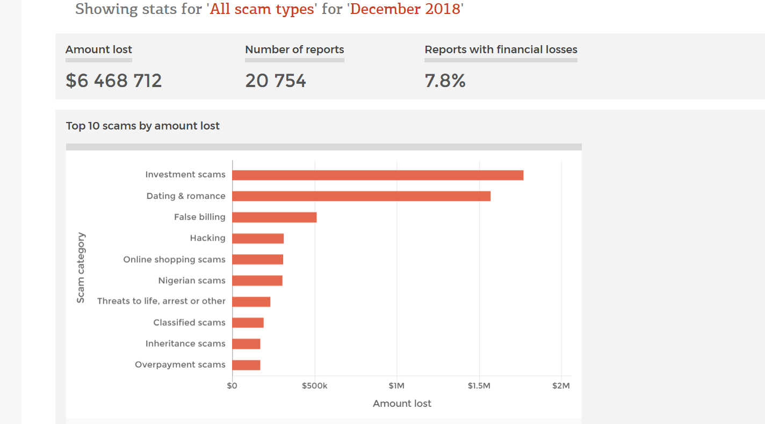

References:
Baker, Jed. 2013, No More Victims - Protecting Those with Autism from Cyber Bullying, Internet Predators, and Scams
Bruce ML. Psychosocial risk factors for depressive disorders in late life. Biol Psychiatry. 2002 Aug 1;52(3):175-84
Brown, B. 2007. I Thought It Was Just Me (but it isn't): Making the Journey from "What Will People Think?" to "I Am Enough". Penguin Books
Cross, C. No laughing matter: Blaming the victim of online fraud International Rev of Victimology. 2015, 21 (2), 187-204
Dolezal L, Lyons B. Health-related shame: an affective determinant of health? Med Humanit. 2017; 43: 257-263
Davies, K, Gray M & Butcher , Lean on me: the potential for peer support in a non-government Australian mental health service Asia Pacific Journal of Social Work and Development Volume 24, 2014 - Issue 1-2: Recovery-Oriented Practices in Mental Health
Ehret AM, Joormann J, Berking M. Self-compassion is more effective than acceptance and reappraisal in decreasing depressed mood in currently and formerly depressed individuals. J Affect Disord. 2018 Jan 15;226:220-226.
R. C. Hamdy, MD, J. V. Lewis, MD, R. Copeland, MD, A. Depelteau, PhD, A. Kinser, PhD, T. Kendall-Wilson, RN, and K. Whalen, BA Patients With Dementia Are Easy Victims to Predators Gerontology and Geriatiric Medicine Oct 2017
Lyons B, Dolezal L. Shame, stigma and medicine. Med Humanit 2017; 43:208–210
Neff, K. Self-Compassion - The Proven Power of Being Kind to Yourself. 2015, Harper Collins
Olivola, Christopher Y. The Interpersonal Sunk-Cost Effect Soc. Sci. 2014, 3(3), 404-426; doi:10.3390/socsci3030404
Smith T, Baucom, B. Intimate relationships, individual adjustment, and coronary heart disease: Implications of overlapping associations in psychosocial risk. Am Psychol. 2017 Sep;72(6):578-589
Whittle, H ,Hamilton-Giachritsis C and Beech A, 2014 “Under His Spell”: Victims’ Perspectives of Being Groomed Online. Social Sciences. 3. 404-426. 10.3390/socsci3030404.
- https://mhfa.com.au/sites/default/files/MHFA-financial-difficulties-mental-health-professional.pdf.
- http://www.deakin.edu.au/research/research-news/articles/high-prevalence-mental-health-disorders-cost-society-billions
- https://www.thelancet.com/journals/lancet/article/PIIS0140-6736(18)30142-9/fulltext and
- https://www.abc.net.au/news/2017-03-16/cheaper-to-provide-homes-for-homeless-rather-sleep-rough/8354284)
- https://journals.sagepub.com/doi/10.1177/0146167205274693 What do we regret and why?
- https://www.cambridge.org/core/journals/european-review/article/apologies-regrets-and-reparations/374BA8E1702BD89425601891D72FCF3F
- https://academic.oup.com/bjc/advance-article-abstract/doi/10.1093/bjc/azy005/4935144?redirectedFrom=fulltext
- http://tpcjournal.nbcc.org/trauma-redefined-in-the-dsm-5-rationale-and-implications-for-counseling-practice/
- https://www.ncbi.nlm.nih.gov/pmc/articles/PMC6348335/
- https://www.tandfonline.com/doi/abs/10.1080/15564886.2018.1474154
- https://www.liebertpub.com/doi/10.1089/cyber.2016.0729 -
- https://www.liebertpub.com/doi/10.1089/cyber.2016.0729 - middle aged people are more likely to be victims of romance scams than elderly people.
- https://link.springer.com/article/10.1057/s41284-019-00166-w
- https://theconversation.com/more-than-just-money-getting-caught-in-a-romance-scam-could-cost-you-your-life-97258
- http://www.peersupportvic.org/index.php/2014-12-15-22-41-32/2014-12-15-22-46-46 - Models of Support
- file:///C:/Users/Sue%20Hymus/Downloads/141020+Gray+Davies+Butcher+final+paper.pdf - Models of Support
- https://eprints.usq.edu.au/21834/1/Omura_PhD_GU_Dissertation.pdf Terry Omura.

