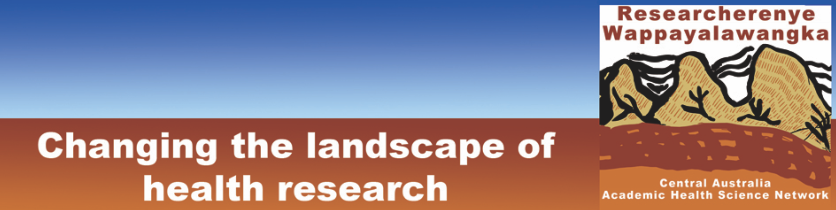

About us

Researcherenye Wappayalawangka-Central Australia Academic Health Science Network [CA AHSN] is dedicated to improving the health of people in central Australia, with a focus on Aboriginal health. It is focused on community-driven research and research translation in close collaboration with research, educational and service delivery organisations.

A major aspiration is to change the landscape of health research in order to advance Aboriginal community health research literacy; generate research that can be initiated and benefits those communities and their organisations; and accelerate the ways in which successful research is translated into action on the ground, whether through enhanced clinical and public health practice or advocacy.

Researcherenye Wappayalawangka’s 16 partners have collectively determined that its main areas of effort will be:
• Workforce and capacity building, with a strong emphasis building the Aboriginal and Torres Strait Islander research community
• Policy research and evaluation
• Health services research
• Health determinants and risk factors
• Chronic and communicable diseases

Membership of CA AHSN crosses state and territory borders, and stretches north to the Barkly. In short, it covers 10% of the Australian land mass. It is made up of the Aboriginal Medical Services Alliance NT, Baker Heart and Diabetes Institute, Central Australian Aboriginal Congress, Central Australian Health Service, Charles Darwin University, NPY Women’s Council, Ngaanyatjara Health, Nganampa Health Service, Tangentyere Council, Western Desert Dialysis, Anyinginyi Health, Centre for Remote Health, CRANA Plus, Flinders University, Poche Institute, and Menzies School of Health Research.

Our name, Researcherenye Wappayalawangka, reflects our place in central Australia—one that goes beyond arbitrary state and territory boundaries. Researcherenye is as an Arrernte rendering of a borrowed word describing a gathering of researchers. Wappayalawangka is made up of the first one or two letters of the fourteen First Nation languages represented in central Australia.

