Productivity Commission on Mental Health Submission by Dr John Bellavance
Dr John Bellavance as a PhD in Values Education from the Faculty of Education, Monash University. His expertise is in the moral use Information and Communication Technologies (ICTs) by young people and the impact of ICTs on their wellbeing. He is the founder of Cyber Values.org and has been writing and teaching values education for 30 years. He is currently an ICT teacher in a Melbourne high school.
This submission discusses the need for values education with respect to mental health and a brief description of a holistic approach to values education.
The Social and Economic Benefits of Values Education
Introduction
For the most part parents and teachers always strive to foster goodness and skills in young people so that they may be good, successful and happy people. When human desires are fulfilled, we feel happy. However, “desires” can lead individuals towards selfishness and unhappiness, and the unhappiness of others we interact with. The great contradiction of human beings is that we can be both good and immoral at times. Hence, managing our desires in a way that leads us to effective and moral in our life’s pursuits are crucial to our happiness and the wellbeing of society.
From an educational perspective educators seek to foster knowledge and skills that students will need with respect to science, mathematics and technology, to name a few. However, knowledge of the values and abilities that allow individuals to be good and happy people is also needed. Schools try to do this, but often have limited time allocated to pursue this. Additionally, teachers often lack training in values education.
I maintain that a comprehensive approach to mental health must include values education that fosters personal development. An understanding of some of the values and abilities needed for individuals to manage themselves and their relationships well; namely, how each person should be and how relationships should be is crucial. This understanding can allow individuals to be effective and successful in their lives and in their relationships. Additionally, ineffective and unethical behaviours of individuals are challenging society and educational institutions to understand the values and abilities that can mediate their lives, as well as, providing some means to meet the challenges that individuals encounter in their lives.
A teacher’s journey
I have been teaching Information and Communication Technologies (ICTs) in secondary schools in Australia for 19 years. On a regular basis, I am required to have conversations with students who violate our schools ICTs acceptable use policy. When seeking to address the misconduct of students, I have conversations with them about their values and behaviours. Through these interactions, I came to understand some of the challenges that students face with respect to their personal development and their social engagement with others; challenges associated with their own attitudes and anti-social behaviours. These challenges impact their wellbeing and the wellbeing of their peers. As a teacher, I have seen many examples of ethical and effective behaviours on the part of students, but also the opposite. At times, both practices were evident by the same students. Because this, I came to the conclusion that opportunities for learning are rich. I could see the need to provide individuals with the capacity to manage their lives morally and effectively. If left unattended this may have an impact on their capacity to live productive and happy lives. The moral component is important because it includes fostering a moral identity in people, which refers to the degree to which being a moral person is important to an individual’s identity. This can motivate more prosocial interactions with others (Narvaez & Bock, 2014; Wang, Yang, Yang, Wang, & Le, 2017). Moral experiences and abilities gained in adolescence form the foundation of adult moral character, agency and sense of responsibility toward community and society (Paciello et al., 2017). Our wellbeing relies in part on having a moral identity, but this also impact society as a whole.
My initial research interest in this area developed through my educational interactions with students in the situations I’ve described above. From these experiences, I concluded that mental health relied in part on:
- The values and abilities that underpin moral and effective practices that allow young people to respond to the challenges they face.
- An understanding of how to deal with the values that drive anti-social behaviours.
- How parents, teachers and society can help support young people in their personal life’s journey.
Why do we need values and relationships education?
There are three reasons why we need values and relationship education. First, there is a need for a proactive approach to deal with the mental health problems and low self-esteem associated with lack of values, meaning and purpose in the lives of many people. Second, is the need to foster a moral identify as a good and successful person. Third, is to need to address deficiencies in private and public values. Forth, is the need to empower individuals.
Self-actualisation - A proactive mental health approach
Finding meaning
In psychotherapy, regardless of its form, therapists help patients grow and develop. Some of the qualities shown to accompany maturity are openness to experience, self-awareness, cognitive complexity and internal locus of control. The right mindset is to view ourselves empowered to be responsible for our own destiny – to become self-actualised (Frankl, 2006). In my own research, I have found that the focus of the intervention must be the individual since the individual plays the most significant role in determining the outcomes of their lives. This requires fostering values, self-reflection, self-regulation and critical evaluations of ones behaviours. A self-actualised person knows their values and purposes.
Happiness cannot be pursued; it ensues from how we live our lives, the result our actions – the actualisation of a potential meaning or purpose in our lives. Life does not owe us happiness. One must have a reason to be happy, once found, one becomes happy (Frankl, 2006). Viktor Frankl (2006) the noted psychiatrist maintains that one of the fundamental issues of being human is the need to find purpose and meaning in our lives – to become self-actualised. This is critical for mental health. People often search for meaning and happiness in pleasure and fulfilling immediate gratifications, yet, this does not allow them to find meaning and happiness. Such widespread phenomena as depression, aggression and addiction are not understandable unless we recognise the vacuum of meaning in the lives of many people. An improvement in an individual’s mental health can provide flow-on benefits in terms of increased social and economic participation (The Social and Economic Benefits of Improving Mental Health, 2019).
One third of patients seeking help from mental health professionals present with the issue of lack of meaning in their lives, rather than chronic anxiety and depression (Frankl, 2006). We need proactive mental health education, namely, values and relationship education since it clearly points to the importance of values, purpose, human responsibility and human relationships, all of which provide meaning. Another aspect of self-actualisation involves our relationships. We become who we are through others and they through us. One study suggests that more than half the respondents considered difficulties within the family or the partnership as causes of depression (Lauber, Falcato, Nordt, & Rössler, 2003).
Self-esteem and moral identify
Another example of proactive mental health education is fostering self-esteem and a personal identity as a good and successful person. Self-esteem is an important aspect of personal wellbeing and happiness (Berkowitz et al., 2002). Low self-esteem is one factor associated with depression ("What causes depression?," 2018). Self-esteem also ensues from how we live our lives based on the values and purposes we actualise. For example, achieving gaols and having moral agency (making moral judgments and the capacity to act with reference to moral judgements) are some factors that lead to experiencing genuine self-esteem. Young people develop all types of identities such as a sport identity, a performing arts or an academic identity. We also need to foster a moral identity (being a person with high moral ideals) (Berkowitz et al., 2002).
Deficiencies in private and public values
Another reason why values education is needed is the lack of, or decline of private and public moral values. Most of our time and energy is spent on developing our careers and making money. Although these are necessary, this can lead to a pursuit of happiness that is external, often ignoring internal values and abilities that allows us to develop individually and in our relationships. For many, this self-focussed and external pursuit of happiness with respect acquiring material possessions can be unfulfilling.
More often, society focuses on the economic and skills development, but pays less attention to the ethical or social costs of development. This can lead to a decline in moral behaviour in the lives of individuals, in their relationships, in politics, in business and in the use of natural resources. The decline in moral behaviour in these spheres of activity often involve the abuse of trusted public power for personal gain. Such abuses in modern societies is often associated with the lack of consciousness of doing wrong (Vargas-Hernández, 2011). Values education must emphasise the importance of the public interest in all aspects of life. The young people we train today are the future leaders of tomorrow. Many young people are disengaged with the values of our popular culture and this as an impact on mental health. A fundamental issue of being human is the need to find purpose and meaning in our lives. This needs to become part of the conversation when it comes to mental health.
Empowering individuals
I maintain that we need a proactive approach to values education. For those who advocate a laissez-faire approach to values education there are number of issues to consider. First, this view assumes that young people actively reflect on their values, personal and relationship abilities and can thus articulate what they learn from life’s experiences. Second, it expects that they can develop on their own values and abilities that can sustain their lives and their wellbeing.
Because individuals can be both moral and immoral, and sometimes lack the abilities to manage their lives and relationships well, opportunities for learning are rich. I maintain that learning requires fostering moral values, self-reflection that leads to a critical evaluation of our behaviours and self-regulation. The focus needs to be on fostering the agency of the individual as opposed to the reactive approach that focuses on imposing policies and controls on the individuals. This was clearly demonstrated with respect to the use of ICTs by young people. A values framework can serve as a proactive means of fostering morality and as a preventive measure for addressing potential or existing concerns (Bellavance, 2018).
The “solution” is not to make the state more intrusive in the personal lives of people. The solution lies with empowering individuals and families with the values and abilities that will allow them to live successful lives. In my own research, I found that the young people who had a good sense of what their values were, mostly from their parents felt empowered to deal with situations that required a moral response on their part. Moral values provided these young with a moral identity, moral agency and a sense of wellbeing.
In the following section, a brief outline of a holistic values education approach is discussed.
A holistic approach to values education
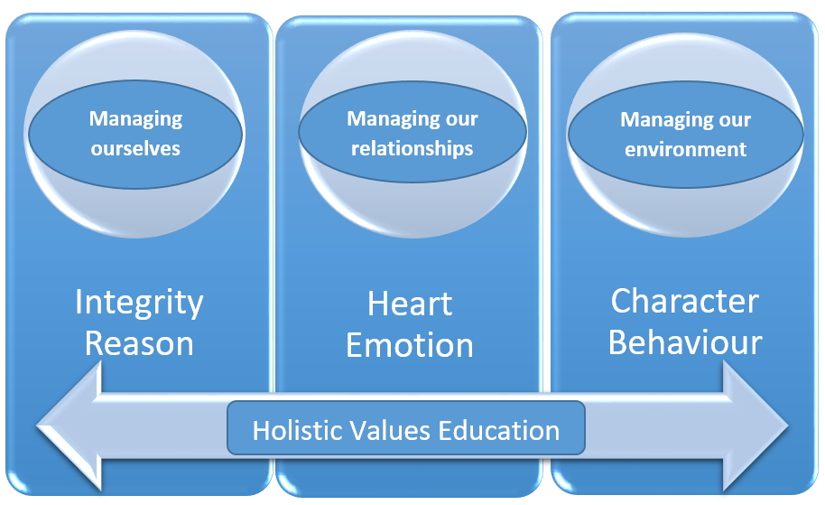
Figure 1 – A model for a holistic approach to values education
Managing ourselves, our relationships with others and with environments
This curriculum maintains that values education needs to be holistic. Holistic values education is based on three basic life goals: 1) managing ourselves well, 2) our relationships with others well (family, peers and community), and 3) our relationship with our physical and natural environments well (which includes our home, our neighbourhood, and our natural world) (Devine, Saunders, & Wilson, 2001). These life goals rely on values and abilities associated with reasoning, emotion and behaviour (Bellavance, 2018). This is discussed in the next section.
Integrity, heart and character
To do this it is necessary to foster integrity, heart and character (see Figure 1 below). Integrity, heart and character are the labels used in this curriculum to represent the three moral, psychological and behavioural domains. Integrity is the label used to represent the values and abilities associated with reasoning, heart for emotions and character for behaviours. Values education incorporates aspects of the cognitive (reasoning), affective (emotion) and behavioural domains of psychological functioning and development (Berkowitz & Bier, 2014; Berkowitz et al., 2002; Colby & Damon, 2015). It should be noted that reasoning, emotions and behaviours do not exist in isolation from each other, they are linked and each reciprocally influences the other. For example, moral development relies on moral emotions which are shaped by prior deliberative moral reasoning (Colby & Damon, 2015; Giner-Sorolla, 2012; Krettenauer & Johnston, 2011; Mercier, 2011).
First, an understanding is needed of the values and abilities that underpin integrity (such as honesty and authenticity), heart (such as love and empathy) and character (such as self-control and service to others) in order to be morally excellent, successful and happy. Second, we need to know how these values and abilities can be applied in the life of the individual, and third, how to apply these values and abilities in our relationships with others and our environment. Finally, an understanding is needed of how to foster integrity, heart and character. Such education can serve as a proactive means of fostering personal wellbeing and success, and as a preventive measure for addressing potential or existing concerns such as some mental health and wellbeing issues.
References
Bellavance, J. (2018). A digital moral framework for Australian secondary schools. (Doctorate), Monash University, Melbourne, Australia.
Berkowitz, M. W., & Bier, M. C. (2014). Research-Based Fundamentals of the Effective Promotion of Character. In L. P. Nucci, D. Narváez, & T. Krettenauer (Eds.), Handbook of moral and character education. New York, NY Routledge.
Berkowitz, M. W., Colby, A., Kristol, I., Power, C., Schwartz, A. J., Sherman, N., . . . Walker, L. (2002). Bringing in a New Era in Character Education. Stanford: Hoover Institution Press.
Colby, A., & Damon, W. (2015). The Power of Ideals The Real Story of Moral Choice. New York, NY: Oxford University Press.
Devine, T., Saunders, J. H. J., & Wilson, J. R. W. A. (2001). Educating for Life's True Purpose - Fostering Character, Love and Service. New York, NY: International Education Foundation.
Frankl, V. (2006). Man's Search for Meaning. Boston USA: Beacon Press.
Giner-Sorolla, R. (2012). Judging Passions Moral Emotions in Others and Groups London and New York: Psychology Press.
Krettenauer, T., & Johnston, M. (2011). Moral self and moral emotion expectancies as predictors of anti- and prosocial behaviour in adolescence: A case for mediation? European Journal of Development Psychology, 8(2), 228-243.
Lauber, C., Falcato, L., Nordt, C., & Rössler, W. (2003). Lay beliefs about causes of depression. Acta Spychiatrica Scandinavica, 108(418).
Mercier, H. (2011). What good is moral reasoning? Mind & Society, 10(2), 131-148.
Narvaez, D., & Bock, T. (2014). Developing Ethical Expertise and Moral Personalities. In L. P. Nucci, D. Narváez, & T. Krettenauer (Eds.), Handbook of moral and character education. New York, NY Routledge.
Paciello, M., Muratori, P., Ruglioni, L., Milone, A., Buonanno, C., Capo, R., . . . Barcaccia, B. (2017). Personal Values and Moral Disengagement Promote Aggressive and Rule-Breaking Behaviours in Adolescents With Disruptive Behaviour Disorders. International Journal of Offender Therapy and Comparative Criminology, 61(1), 46-63.
The Social and Economic Benefits of Improving Mental Health. (2019). Retrieved from https://www.pc.gov.au/inquiries/current/mental-health/issues/mental-health-issues.pdf.
Vargas-Hernández, J. (2011). THE MULTIPLE FACES OF CORRUPTION: TYPOLOGY, FORMS AND LEVELS. Contemporary Legal and Economic Issues, 3, 269-290.
Wang, X., Yang, L., Yang, J., Wang, P., & Le, L. (2017). Trait anger and cyberbullying among young adults: A moderated mediation model of moral disengagement and moral identity. Computers in Human Behavior, 73, 519-526.
What causes depression? (2018). Retrieved from https://www.beyondblue.org.au/the-facts/depression/what-causes-depression

