Right to Repair
Productivity Commission
4 National Circuit Barton
ACT 2600,
Australia

Establishing a Right to Repair Law in Australia for
environmental, social, and economic good
Submission from South Australian Repair Cafe Coordinators

Unley Repair Cafe Volunteers, 2018

Who are we?
We are a group of 8 Repair Cafe coordinators in South Australia. We are passionate about reducing waste, improving repairability and repair services, sharing repair skills and connecting communities for long-term resilience.

Each Repair Cafe has up to 40 volunteers each (including expert repairers and supporting volunteers) and is visited by hundreds of community members per year. Combined, we host 60-70 repair sessions annually across metropolitan Adelaide. Some Repair Cafes are connected with a local council, community centre or environment organisation, others are fully independent. Some of the Repair Cafes in SA have been operating for 3 years, some are a few months old.

The following submission is given on behalf of all of the coordinators of these 8 Repair Cafes:

Ruby Wake and Rose Dunne  Unley Repair Café  www.facebook.com/unleyrepaircafe/ | Andrea Ramirez  Payneham Repair café  www.facebook.com/RepairCafePayneham/
Sophie Kavoukis and Sue Lloyd  Repair Café Campbelltown  www.facebook.com/Repair-Cafe-Campbelltown-SA-103728601451735 | Matthew Taylor  City of Tea Tree Gully Repair Café  www.teatreegully.sa.gov.au/Events_and_places/Events_programs_and_activities/Repair_Cafe
Kathy Whitta  Gawler Repair Café  facebook.com/GawlerEnvironmentCentre | Paige Le Cornu  Adelaide Repair Cafe  facebook.com/adelaiderepaircafe
Sam Cooper  The Hut Community Centre Repair Café  www.facebook.com/thehutcommunitycentre/ | Robert Hart  The Parks Repair Café  www.stemlibrary.space/parks-repair-cafe/

What is a repair cafe?
In short, Repair Cafes are free community meetings, where volunteers with repairing skills teach local people how to repair their own items.

The Repair Cafe concept first began in the Netherlands in 2009, but there are now more than 1,700 across the world. While Repair Cafes connect and support each other through local and international networks, they are all independent, volunteer-run and each operate slightly differently.

Regardless of the location or specific arrangement of a particular repair cafe, all Repair Cafes share a passion for sharing skills, reducing waste and connecting people. Other key commonalities include:
- A free, (although donations are often welcome) community event, open to all
- A group of volunteers with different repair and problem-solving skills, who bring their own tools and share their expertise, usually one-on-one with visitors
- The philosophy of teaching visitors how to understand and repair their own items rather than doing it for them
- Rejecting capitalist ideals of high production, fast and mindless consumption, planned obsolescence and unsustainable use of resources (including human resources)
- Offer other concurrent activities like produce swaps, tool shares, recycling initiatives and tea/coffee

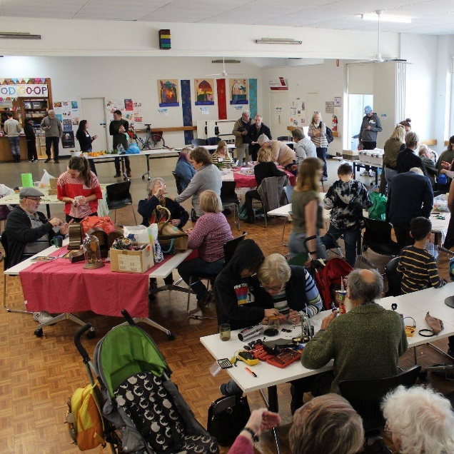
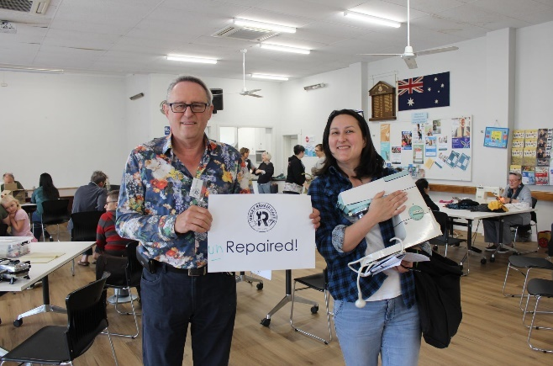

Unley Repair Café:
- Above - Volunteer Gordon, with an unrepaired (but diagnosed) Kenwood
- Right – in full swing, 2019

Why repair cafes?
Repair Cafes exist for a large number of positive reasons, which can be explained simply across the 3 pillars of sustainability:

Environmental

- Minimising waste - repairing an item rather than throwing it away reduces the amount of broken items that end up as waste to landfill
- Minimising resource needs - by extending the life of an existing item and negating the need to purchase a new one, we reduce the demand on materials needed to fabricate said new item
- Minimising carbon emissions - repairing reduces transport miles needed to purchase an entire new item (parts likely to weigh less, have less material demand)
- Encouraging environmental behaviours - The existence of repair cafes helps to shift people’s headspace around their consumption and purchase choices, encouraging them to think about the design, fabrication, materials and lifespan of items. This in turn encourages people to consider and often reduce their broader impact on the environment.

Social

- Working together - repair sessions connect diverse people over a common problem or interest - this helps build goodwill among facets of society that wouldn’t otherwise link together
- Community capacity-building - helping visitors to understand, diagnose and repair their item builds skills, knowledge and confidence in the person to do so again, and to experiment with other making/repairing/problem-solving in the future
- Rewarding experiences - research has shown that volunteering (including at a repair cafe) improves mental and physical health, increases community goodwill and generosity
- Local community bonding - while Repair Cafes are usually not geographically bound, they tend to attract people from a local radius, allowing them to connect over local issues and support each other in different ways
- Preserving endangered skills - passing unique repair skills between communities and generations helps retain those skills for myriad benefits

Economic

- Sharing economy - a more sustainable use of resources and fostering goodwill, giving and honesty
- Saving money on new items - for the vast majority of the time, fixing an existing item is cheaper than buying a new item (save for the times when those items are designed in such a way to actively be expensive to repair, to discourage repairing)
- Saving money on repair services - fixing at a repair cafe with the help of volunteers is significantly cheaper (and therefore accessible to those on low/no income or other expenditure requirements) than visiting an official repair shop

Connection between Repair Cafes and Right to Repair
Repair Cafes are at the coalface of non-commercial repair in Australia. Repair Cafes witness first-hand the negative environmental, social and economic effects of planned obsolescence, poor design and low-quality materials. We see on a hyper-regular basis the challenges that citizens have when their items break prematurely and/or are unable to be repaired, and the waste that this creates. We therefore have a very strong link to the opportunities that a Right to Repair legislation could offer.

Our position on a Right to Repair
We write in strong support of a Right to Repair law in Australia. We believe this law should uphold and promote the three pillars of sustainability as listed above, and include all elements outlined in the answered sections below.

Thanks for your consideration and for doing what is required to ensure circular economy, long term sustainability and environmental stewardship.

Please do not hesitate to get in touch with us if further information is needed.

Yours sincerely,
SA Repair Cafe Coordinators

INFORMATION REQUEST 1
What would a ‘right to repair’ entail in an Australian context? How should it be defined?

A Right to Repair law should consider all the elements of product life cycle, repair accessibility, and supporting repair industries. To be successful, and have true social, environmental and economic benefits, it should include the following:

- Better design laws
A Right to Repair Law must begin at the design end, ensuring new products created are done so with values of durability, sustainability and repairability in mind. A Right to Repair law should mandate that all new items:
- Are built to last - banning planned obsolescence. Manufacturers should have to comply with durability and lifecycle requirements, and these should be set at a minimum with environment and social needs prioritised.
- Long-life or easy to repurpose materials
- All new items can be disassembled into component parts that are individually repairable/replaceable
- Built with repairability as a focus

Addressing product durability and repairability at the start of their life will significantly reduce waste as well as lessen the load on repair services.

Thought also needs to be given to how such laws are enforced and applied given that a large proportion of goods sold in Australia are imported.

- Active repair promotion
Beyond the design and manufacturing stages of product creation, legislation around a Right to Repair Law should address the barriers to consumers choosing to repair over discarding and replacing with new purchases:
- Ensuring accessing repair services and purchasing replacement parts is cheaper than replacing the broken item
- Items purchased to be provided with information on how repairs can be made, where to go for repairs and the tools that will be required.
- Ensuring consumers have easy, affordable access to replacement parts and tools should they be required.

- Support for repair services
In the interests of waste reduction, STEM innovation, and the support of makers, thinkers and inventors, successful and holistic Right to Repair legislation should include parameters for activating repair services and communities, for example:
- Funding Repair Cafes
- Funding Makerspaces
- Supporting design innovation for durability
- Training and activating local Repair Corps

An example of this in action is as follows:
Product X was built in 2019 and has inbuilt planned obsolescence - that is, low durability. An aspect of the product is now malfunctioning. A repairer has been able to diagnose the issue, but the part required is not commercially available, as the item is no longer manufactured. Product X is taken to a local Repair/Makerspace, where the part required is 3D printed - thus the item is rendered repairable with the collaborative support of repairer, maker, and repair/maker tools and machinery. The outcome is positive for environmental reasons (low waste), social reasons (collaboration and innovation building skills and connection in the community) and economic (product owner is able to extend the life of owned product, repairer and maker skills are appropriately valued).

True Right to Repair means supporting and activating those margins of society that have the repair and design tools and skills, which can be put to use for environmental and social benefit.
INFORMATION REQUEST 2
- What types of products and repair markets should the Commission focus on?

The Commission should focus on household appliances - these are poorly made with non-durable materials, frequently break or have faults, are challenging for the average person or repairer to repair (or are designed in such a way to be unrepairable). They are so cheap to buy that often a new version of the same item is much cheaper/easier than taking the time or effort to repair, and thus these items contribute to a significant amount of waste (especially since they often have a variety of toxic and/or non-recyclable parts).

Items we see most commonly in our repair cafe sessions include the following:
Electrical
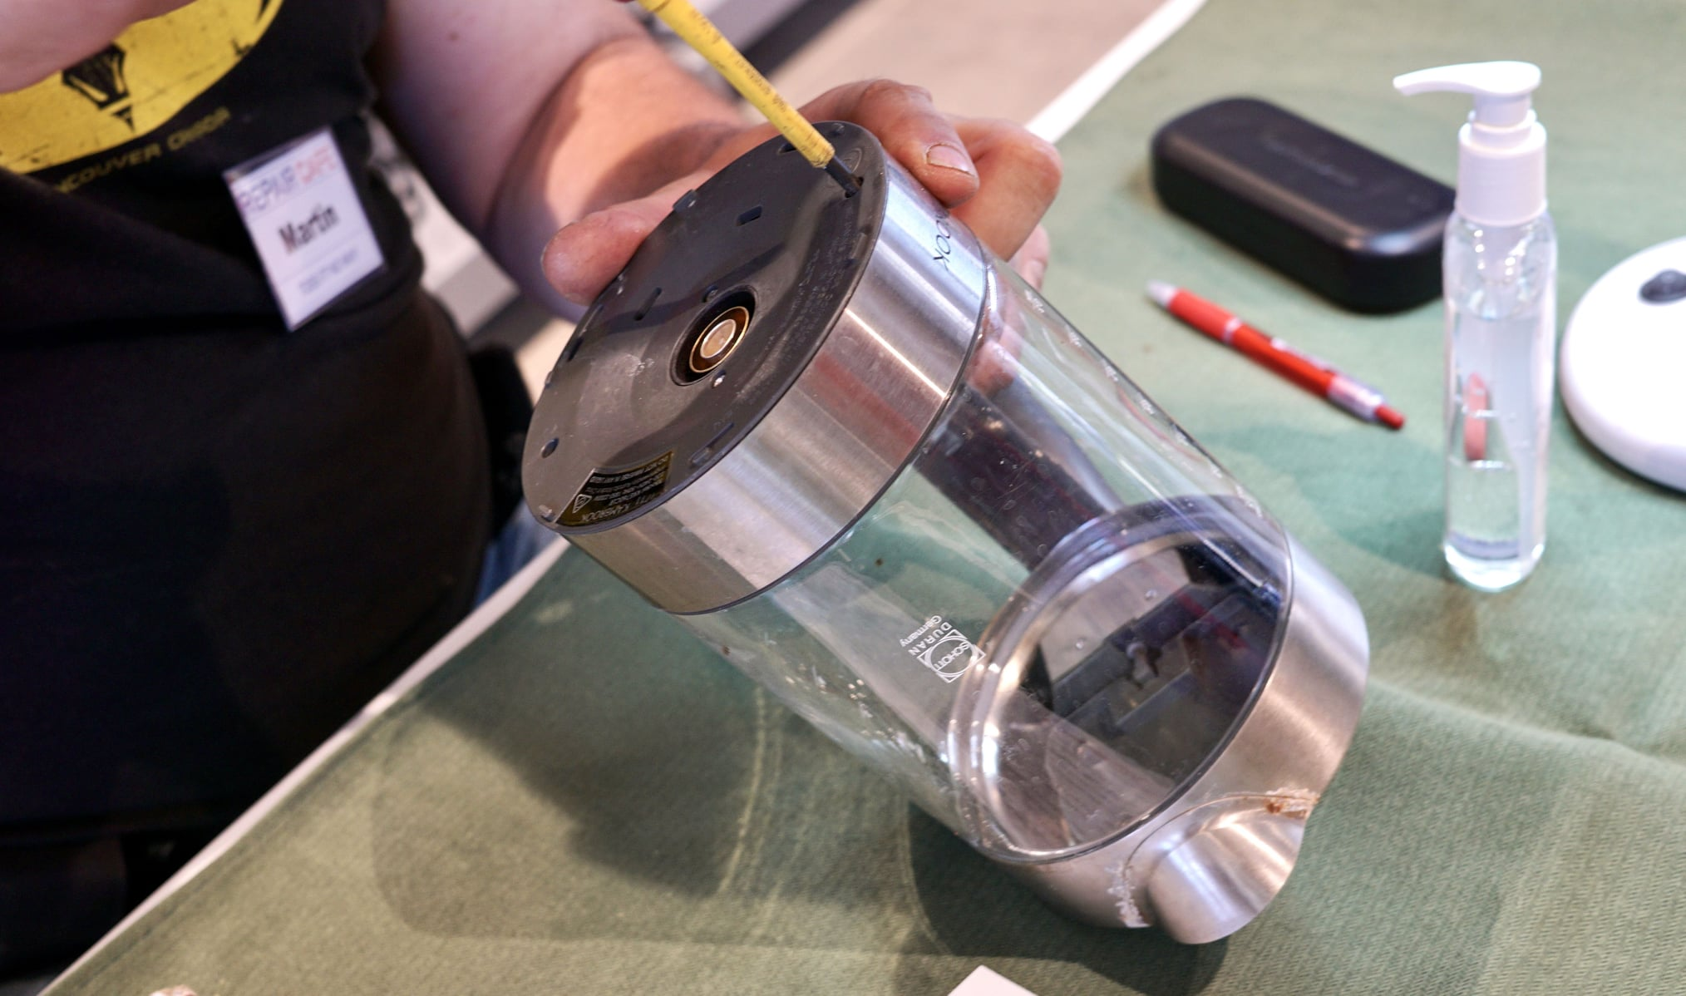
- Kitchen appliances
- Toasters
- Blenders, bullets
- Stick mixers
- Kettles
- Sandwich press machines
- Coffee machines

- Bedroom appliances
- Fans
- Heaters
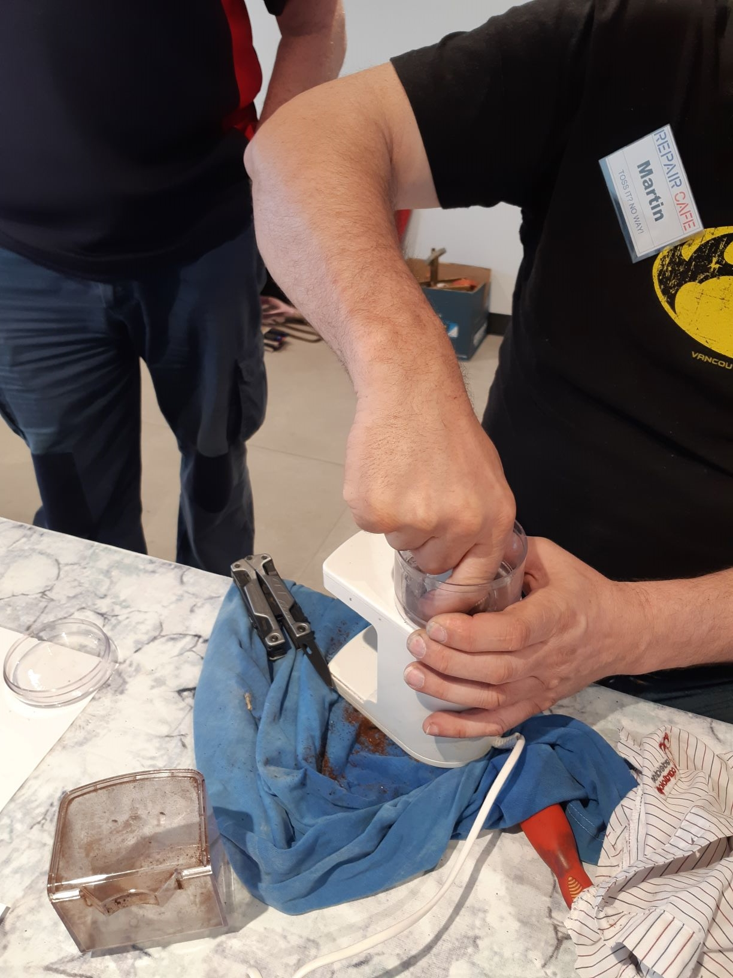
- Lamps

- Bathroom appliances
- Hairdryers
- Straighteners

- Garden appliances
- Outdoor lights
- Solar lights
- Fairy lights

Outside of the electrical realm, we also see:
- Furniture
- Chairs
- Mechanical
- Garden tools
- Umbrellas

- Textiles/Clothing
- Zip replacement
- Handles

Items that use a lot of resources in their manufacture should also be prioritized.

- Are there common characteristics that these products share such as embedded technology and software or a high/low degree of product durability), and which characteristics would allow policy issues to be considered more broadly?

Refer to answer 2 c) below.

- If there are particular products that the Commission should focus on, what are the unique issues in those product repair markets that support such a focus?

At the Repair Cafe, we find that items are commonly unable to be repaired because of one or several of the following reasons:

- Poor product design, not compatible with repairability, for example:
  - unable to be taken apart (either on purposefully or incidentally) to diagnose the issue
  - Unable to be separated into component parts to fix one aspect of the item
  - Requires a specific, expensive or not publicly available tool
  - Materials are non-durable and hard/impossible to repair
- Unavailable parts
  - The parts required to fix the product do not exist
- Cost prohibitive - cheaper to buy a new one than get a part (or pay for speciality repair/diagnosis service)
- Electrical components - for many repair cafes who do not have a qualified electrician on site, electrical defects are a common reason for being unable to repair an item. Without accreditation, Repair Cafes volunteers are unable to fix electrical defaults, and to seek these services commercially is often cost prohibitive to the visitor.
- Unable to identify the fault - product does not come with a manual or issue is otherwise unclear

For whatever the reason, an unsuccessful repair at a Repair Cafe ultimately means these products enter landfill, and resources are required to make and transport the new item.
“I have numerous pairs of secateurs at home that no longer open and close but due to their design cannot be repaired. A really old pair of secateurs was brought in to our knife sharpener who confirmed that they were at least 60 years old and besides needing some sharpening were still in great condition. He could tell this from the materials, design and construction of the item. He loves restoring items like this because with maintenance they can last another 2 generations and really are a thing of beauty not just a tool.”
Repair Cafe Campbelltown, SA
INFORMATION REQUEST 3
- Do the consumer guarantees under the ACL provide adequate access to repair remedies for defective goods? If not, what changes could be made to improve access to repair remedies? Are there barriers to repairing products purchased using new forms of payment technologies, such as ‘buy now pay later’?
These guarantees are insufficient. They do not encourage repair as they do not require the release of manuals, easy access to tools or access to repair services. They also require the person to prove they purchased the item - thereby discouraging a second hand market (which is important for both affordability of items and for reduction of waste).

The guarantees are limited as they also do not stipulate that products must be designed in a way to improve their life and repairability.

Evidence that the guarantees are insufficient include:
- Repair remedies are often not available to the public
- Manuals, tools and parts not shared at time of purchase and not easily accessible
- Can be expensive
- Companies require proof of purchase
- Guarantees often are for 12 months, but appliances etc should last for 10 years or more.
Furthermore, people are not aware of their rights as the information from ACL is not shared at the time of purchase.

Changes should also include all those things listed in Information Request 1.

The idea that buy now, pay later technologies could be a barrier is an excuse to OEMs or distributors to avoid offering repair opportunities. Regardless of who owns the item or how it was purchased, the information should be readily available online around how to repair the item.
b) Is the guarantee of available repair facilities and spare parts effective in providing access to repair services and parts? Or is the opt‑out clause being widely used, making the guarantee ineffective?
See 3 a) above.

c) Should consumer guarantees seek to balance the broader societal costs of remedy choices (such as the environmental impacts of replacements) with consumer rights, and if so how? For example, should repairs be favoured as a remedy?
Repairs should be absolutely favoured as the default remedy, for environmental and social sustainability. This will;
- force manufacturers to consider repair ability of their item
- have significant environmental benefits
- have all other benefits as listed above in the attached letter, section ‘Why Repair Cafes’ (page 3)

As it currently stands, retailers and manufactures tend to replace rather than repair items under warranty.
d) Are consumers sufficiently aware of the remedies that are available to them, including the option to repair faulty products, under the ACL’s consumer guarantees?
If not, would more information and education be a cost‑effective measure to assist consumers understand and enforce guarantees? What would be the best way to deliver this information? What other measures would be more effective?
From the experiences of Repair Cafes, it appears that a lot of consumers are not aware which is why they visit Repair Cafes. Efforts to increase awareness and educate the public should be pursued but should not be the only course of action in addressing the Right to Repair issue.
- Information should come with every item
- Information should be promoted on online stores, including second-hand selling platforms such as Ebay, Gumtree
- Outline whether these rules override product warranties
- Information should be available in various languages
INFORMATION REQUEST 4
a) The Commission is seeking information on the nature of repair markets in Australia, including detailed data on the repair markets for specific products, covering:
· market size — by employment, revenue, number of businesses, profit margins
· market composition — such as market share between authorised, independent and DIY repairers.

Repair Cafes are not technically part of the repair market, in that they do not employee people nor do they seek to make a profit. Nonetheless, we repair a large number of items annually which helps to save them from landfill. Unfortunately, there is also a large number of items which we are unable to repair because of design faults, lack of parts, etc.
For example, the Unley Repair Cafe, which is just one of the Repair Cafes in South Australia, has seen a total of 845 items (2152kg) over 19 sessions, approximately 57.6% of which are repaired. The Campbelltown Repair Café which ran 4 trial sessions in 2020 saw 138 items of which 80% were successfully repaired.

b) Is there any evidence of a difference in quality, safety or data security between authorised repair networks and independent repairers? Are there ways to address concerns around quality, safety or data security while promoting a vibrant independent repair market?
We do not believe there is a difference in safety or security with repairing at a Repair Cafe versus an official repair network. The only difference is that the item may be less likely to be repaired, as the volunteer repairer is problem solving, and experimenting, and often having to repair a large number of diverse items (as opposed to a specialised repairer who may focus on one type of item).
We believe the concerns around data security are a myth used to perpetuate the barriers to independent repair. One way to combat these concerns could be: establishing a free and easy way for repairers to be certified. This might look like a quick online test, which also serves as a portal for them to register their intentions to be responsible around data. This register could be accessed by others in their area, keen to employ their repair services - both improving access to repair and encouraging repairers to be certified.

c) Are there available examples of the contracts between OEMs and authorised repairers? Do these contracts limit effective competition in repair markets (such as by limiting the number and reach of authorised repairers or requiring authorised repairers to not be authorised by a competing brand)?
· What is the process to become authorised? Is it open and competitive?
N/a

d) Are there specific examples or other evidence of practices by OEMs or their authorised repairers that create barriers to competition in repair markets?
· Do other factors also create barriers to competition in repair markets, such as short‑sighted consumer behaviours, switching costs, poor information availability or consumer lock‑in?
Many OEMs will state that warranty is void if a consumer visits a non-authorised repairer or attempts a repair themselves. This actively discourages repairing and loses the many benefits that repairing offers.

e) What is the relationship between the intensity of competition in the primary product market and the risk of consumer harm from a lack of competition in repair markets? Can competitive primary markets compensate for non‑competitive repair markets?
· Is an absence of effective competition in the primary market a necessary condition for consumer harm from non‑competitive repair markets?
· To what extent would measures that enhance competition in the primary market address concerns about a lack of competition in repair markets?
Competitive primary markets will never compensate for non-competitive repair markets. Consumers will be driven by price and accessibility, so it is the role of decision-makers and these laws-to-be to improve repairability, access to repair services and support for repair services.

We believe that competition in both primary and repair markets is not the issue here. The true problem is:
- The way things are made and designed which prevent and discourage repair
- Large corporations establishing complex warranties and discouraging repair
- The lack of information for consumers around how to repair, their repair rights, access to parts, tools and services
- The lack of support for repair services, training and opportunities

f) Are the restrictive trade practices provisions of the CCA (such as the provisions on misuse of market power, exclusive dealing or anti-competitive contracts) sufficient to deal with any anti‑competitive behaviours in repair markets?
It would appear not, as anti-competitive behaviours are still rife, discouraging independent repair diversity and opportunities. This is evident in the lack of affordable, accessible repair options.
Again, the bigger problems here are as listed in e) above.

g) What policy changes could be introduced if there is a need to increase competition in repair markets and improve consumer access to, and affordability of, repairs?
· What are the costs and benefits of any such proposal to the community as a whole? How does it balance the rights of manufacturers and suppliers, with those of consumers and repairers?
See Information Request 1 above.

INFORMATION REQUEST 5
a) To what extent do current IP laws already facilitate repairs by consumers or independent third parties (e.g. the spare parts defence under the Design Act)?
It is clear that current laws do not facilitate broad-scale independent repairing, as repairing is still uncommon, waste is still high and knowledge of/access to repair resources and services is low.

b) Are there any aspects of IP laws where consumers’ rights with respect to repairs are uncertain?
It is clear that current laws are uncertain, as repairing is still uncommon, waste is still high and knowledge of/access to repair resources and services is low.

c) Do current IP protections (e.g. intellectual property rights, technological protection measures, end‑user licencing agreements) pose a significant barrier to repair in Australia? If yes, please comment on any or all of the following:
· the specific IP protections that prevent consumers from sourcing competitive repairs and/or inhibit competition in repair markets
· the types of products or repair markets these barriers mainly affect
· the prevalence of these barriers
· the impacts of these barriers on third party repairers and consumers (e.g. financial cost, poorer quality repairs)
· options for reducing these barriers and their associated benefits, costs and risks (including potential impact on market offerings).
Yes, these laws continue to pose a barrier to repair - consumers and independent repairers are often unable to access the information, tools and parts they need to undertake successful, long-lasting repairs.
These limitations (and their negative environmental, social, and economic impacts) could be reduced with better legislation that prevents the with-holding of crucial information pertaining to items, their functioning, structure and their repairability.

d) In what ways might government facilitate legal access to embedded software in consumer and other goods for the purpose of repairs? What are the pros and cons of these approaches?
Through enacting stronger legislation which mandates OEMs and outlets to provide all information to consumers about the product when they purchase it. This information should also be accessible online to all, so that if a person purchases the product second hand, or has the product for a long time, they still have access to all the information needed to extend the life and sustainability of their item.
The pros to this include more repairing, less waste to landfill and more responsible use of human and natural resources. The only clear ‘con’ is that the original manufacturer might lose some money in the longer-term as the originally purchased item lasts longer, so a consumer does not need to purchase (an) additional item(s) - but this con is truly a pro for social and environmental sustainability.
INFORMATION REQUEST 6
a) What evidence is there of planned obsolescence in Australian product markets? Do concerns about planned obsolescence principally relate to premature failure of devices or in them being discarded still working when more attractive products enter the market?
Planned obsolescence is clear in all markets that encourage you to buy more, that are constantly creating new models, and that do not offer high-durability, high-quality products with lifecycle assurances and appropriate warranties. Of course it is in the interests of large companies to make sure their products “time out” soon enough so that they make a large profit, but not too soon that the person is disappointed enough that they will turn to a different brand.
Both of these concerns (premature failure AND perceived obsolescence through the desirability of a newer model) are a major factor in perpetuating all the negative social and environmental impacts of planned obsolescence.
It is clear that planned obsolescence is still rife as the number of products that we see in our Repair Cafes have broken within a couple of years of purchase, but really, they should be built to last for several years further. See list of commonly repaired items Qu 2(a).
b) How can the Commission distinguish between planned product obsolescence and the natural evolution of products due to technological change and consumer demand?
By doing a study into the longest lasting product of that type of item and using it as benchmark for all others. The Commission should challenge and mandate producers to design and manufacture the longest lasting, most sustainable and repairable items possible. This would help to combat waste, other negative environmental impacts of fast production, and all of the social implications that arise from overproduction and overconsumption.

c) How does planned obsolescence affect repairers, consumers and the broader community in Australia?
It prevents repair effectiveness, as planned obsolescence comes hand in hand with unavailable parts and tools, hard-to-repair items, and low product material durability.
It affects consumers as they must spend more on items and are tricked into thinking their original item is not worth repairing.
It affects the broader community in Australia as we must suffer the negative environmental consequences of too many products being made and sold and wasted unnecessarily, and our economy continues to be unsustainably based around the myth of needing another ‘thing’.

d) What measures do governments currently use to prevent planned obsolescence or mitigate its effects (in Australia and overseas)? How effective are these measures?
A number of other countries and places (including in the USA and Europe) are investigating or have implemented the banning of planned obsolescence through various means. This should be for the Productivity Commission to research as part of their investigation into Right to Repair.

e) What are the benefits, costs and risks of Australia adopting measures similar to those currently used overseas, such as product design standards and reparability ratings?
There are infinite benefits to adopting these measures - reducing consumerism, reducing waste, reducing pollution, reducing the use of finite resources, improving STEM skills and product attachment, improving innovation, improving the value for money on products that are built to last.
The only ‘con’ is for large companies that will never pay the price of their negative environmental impacts. We should not weigh up the profit margins of exploitative companies against the protection of vulnerable communities and the environment.
In this instance, the long term benefits significantly outweigh the costs.

f) Do consumers have access to good information about durability and reparability when making purchases? If not, how could access to information be improved?
Customers have little to no information about durability and repairability when making purchases. There is no standardised system for consumers to compare products, and there is not a focus on this as important. For all the benefits of product longevity and repair, there should be a standardised rating system that every product is sold with, which covers durability and repairability, along with how to repair the item, how to access spare parts, tools and repair services.
INFORMATION REQUEST 7
a) What data are available on the amount of e‑waste generated in Australia?
· What data is there on the composition of e‑waste in terms of particular materials (such as hazardous materials) by product type?
· How does hazardous e‑waste compare to hazardous general waste in its prevalence and risks? Is there merit in distinguishing between hazardous e‑waste and non‑hazardous e‑waste? And if so, how could this be done in practice?
The Productivity Commission should contact known electronic recycling depots, including Electronic Recycling Australia (details below), and councils, to access this information.
Electronic Recycling Australia
301 Grand Junction Road, Ottoway, SA, 5013
P: 08 8374 2276
E: info@erecyclingaustralia.com.au
W: www.electronicrecyclingaustralia.com.au

b) What estimates are available on the costs of e‑waste disposal on the environment, human health and social amenity, in Australia and internationally?
· How do the impacts differ by disposal type, or by the type of product or hazardous material?
See 7 a) above.

c) How much of Australia’s e‑waste is shipped overseas for recycling? Is there evidence of circumstances where this creates problems for recipient countries?
· Are there barriers to the expansion of domestic recycling facilities or the adoption of new recycling technologies in Australia (such as plasma arc incinerators)?
See 7 a) above.

d) What are Australia’s current policy settings for managing the potential environmental and health effects of e‑waste (such as landfill bans, the National Television and Computer Recycling Scheme or Mobile Muster)? Are these policy settings broadly right — that is, are they proportional to the impacts of e‑waste on the community?
See 7 a) above.

e) How can a right to repair policy further reduce the net costs of e‑waste in Australia, and would such an approach be an effective and efficient means of addressing the costs of e‑waste to the community?
A Right to Repair policy, if covering all the things we outlined in Information Request 1, would significantly reduce e-waste as it would ensure products lasted longer, they were easier to repair, and that at the very end of its life, it could easily be broken down into component pieces to reuse in other ways, or recycle.
It would therefore be highly effective and efficient, with major social and environmental benefits.
INFORMATION REQUEST 8
a) What policy reforms or suite of policies (if any) are necessary to facilitate a ‘right to repair’ in Australia?
The Productivity Commission should act with social and environmental responsibility for the future of both people and nature and enact a Right to Repair Law in Australia. It is crucial that we take the lead on ensuring the swift development of this legislation, and that these measures come from top down, as it is clear that market forces are not sufficient to reduce waste, improve working conditions for employees of high-production, low quality goods-type manufacturers, reduce our use of finite resources, and act in a way that is considerate of the future.
Such a law would set a standard for the design, manufacturing, transport, durability and life-cycle on all goods, for the benefit of the environment, finite resources and cost to consumers (both immediate product cost, and long-term environmental cost).
A Right to Repair law should cover or catalyse the following:

- Better design laws
A Right to Repair Law must begin at the design end, ensuring new products created are done so with values of durability, sustainability and repairability in mind. A Right to Repair law should mandate that all new items:
- Are built to last - banning planned obsolescence. Manufacturers should have to comply with durability and lifecycle requirements, and these should be set at a minimum with environment and social needs prioritised.
- Long-life or easy to repurpose materials
- All new items can be disassembled into component parts that are individually repairable/replaceable
- Built with repairability as a focus
Addressing product durability and repairability at the start of their life will significantly reduce waste as well as lessen the load on repair services.

- Active repair promotion
Beyond the design and manufacturing stages of product creation, legislation around a Right to Repair Law should address the barriers to consumers choosing to repair over discarding and replacing with new purchases:
- Ensuring accessing repair services and purchasing replacement parts is cheaper than replacing the broken item
- Items purchased to be provided with information on how repairs can be made, where to go for repairs and the tools that will be required.
- Ensuring consumers have easy, affordable access to replacement parts and tools should they be required.

- Support for repair services
In the interests of waste reduction, STEM innovation, and the support of makers, thinkers and inventors, successful and holistic Right to Repair legislation should include parameters for activating repair services and communities, for example:
- Funding Repair Cafes
- Funding Makerspaces
- Supporting design innovation for durability
- Training and activating local Repair Corps

b) Are there any other barriers to repair and/or policy responses that the Commission should consider?
A clear barrier might be that manufacturers are unwilling to comply, as they will lose money from people not having to buy their item so frequently. The law should create space for a transition from unsustainable, damaging means of design and production, and importantly, prioritise repairability for social and environmental good.

c) What are the costs and the benefits of the various policy responses that have been proposed to facilitate repair (such as those outlined in table 1)?
The benefits of enacting a Right to Repair law would mean that products last longer and repairing is easier. This has a myriad of flow-on benefits which can be explained across the three pillars of sustainability:

Environmental
- Minimising waste - repairing an item rather than throwing it away reduces the amount of broken items that end up as waste to landfill
- Minimising resource needs - by extending the life of an existing item and negating the need to purchase a new one, we reduce the demand on materials needed to fabricate said new item
- Minimising carbon emissions - repairing reduces transport miles needed to purchase an entire new item (parts likely to weigh less, have less material demand)
- Encouraging environmental behaviours - Understanding repair markets and repair skills/options helps to shift people’s headspace around their consumption and purchase choices, encouraging them to think about the design, fabrication, materials and lifespan of items. This in turn encourages people to consider and often reduce their broader impact on the environment.

Social
- Working together - repairing together (through access to repair manuals, tools and parts), has the potential to connect diverse people over a common problem or interest - this helps build goodwill among facets of society that wouldn’t otherwise link together
- Community capacity-building - access to product information, tools and parts would be helping people to understand, diagnose and repair their item - which in turn builds skills, knowledge and confidence in the person
- Rewarding experiences - successful repairing and problem solving improves mental health
- Preserving endangered skills - passing unique repair skills between communities and generations helps retain those skills for myriad benefits

Economic
- Sharing economy - a more sustainable use of resources and sharing of repair knowledge, fostering goodwill, giving and honesty
- Saving money on new items - for the vast majority of the time, fixing an existing item is cheaper than buying a new item (save for the times when those items are designed in such a way to actively be expensive to repair, to discourage repairing)
- Saving money on repair services - fixing at home or a repair cafe with the help of volunteers is significantly cheaper (and therefore accessible to those on low/no income or other expenditure requirements) than visiting an official repair shop

d) Are there other international policy measures or proposals that the Commission should consider as part of this inquiry?
The Productivity Commission should research the current Right to Repair legislation being discussed (and in some places delivered) in the USA and Europe, and determine what aspects of these measures have been successful, but while always prioritising repairability above all, for environmental and social good.

